LOMA
Extended Edition
User Guide — Version 1.0.0
Extended Edition: guided web research, a live news brief, a general-purpose web viewer, and every Core Edition extension

Welcome to LOMA
LOMA (Local Orchestrated Multimodal Automation) runs on your own machine using local LLMs. It plans, generates, and compiles multimodal work — chat, documents, presentations, images, and more. Extended Edition builds on Core Edition by adding guided web research, a live news brief, and a general-purpose web viewer, so LOMA can ground answers in the open web when you choose to — while your files and models still stay local by default.

What LOMA Can Do
- Chat & quick Q&A in the workspace — LOMA decides on its own whether to reply, draft a deliverable, or edit a file you’ve attached.
- Generate documents and images from natural-language requests.
- Read documents, PDFs, presentations, spreadsheets, images, video frames, and sound files as context.
- Turn on “Search the internet for grounded replies” (Settings → Everyday) so chat can look up live information; Research and News Brief search the web independently of that toggle.
- Eight bundled extensions: Chat Archive, Document Editor, Document Intelligence, Research, Token Usage, Web Viewer, History Events, and News Brief.
- Models and inference stay local (via Ollama) — nothing leaves your machine unless an extension fetches a web page or search result you asked for.

Editions at a Glance
LOMA ships in three editions that build on each other. This guide covers Extended Edition.
- Core: simplified UI, offline only, direct mode, four bundled extensions.
- Extended: adds guided Research, a Web Viewer, and a News Brief extension — this guide.
- Complete: full multi-panel UI, every extension, plus planner mode for multi-step tasks.

Home — Workspace
The Home screen is a three-panel layout: the left sidebar for sources, output format, and the active extension picker; the middle panel for whichever extension’s tools you’ve selected; and the workspace chat on the right, where you type requests and see every result, including streamed News Brief and Research output.
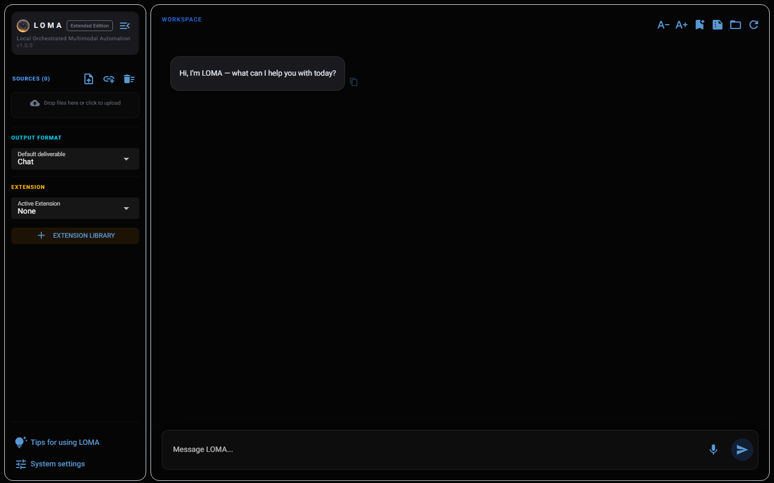
- Sources: attach files with the upload icon or drag-and-drop, for grounded, document-based answers.
- Output format: choose the default deliverable type for a typed request (Chat by default).
- Active Extension: pick which extension’s own panel appears in the middle column — select “None” to hide it and use plain chat.
- + Extension Library: browse, enable, or disable every bundled extension by category (Utility, Productivity, Ludicity).

Extension Library
Click + Extension Library to see every bundled extension, its category, and its enabled state. Disabling an extension here removes it from the Active Extension dropdown without uninstalling it.
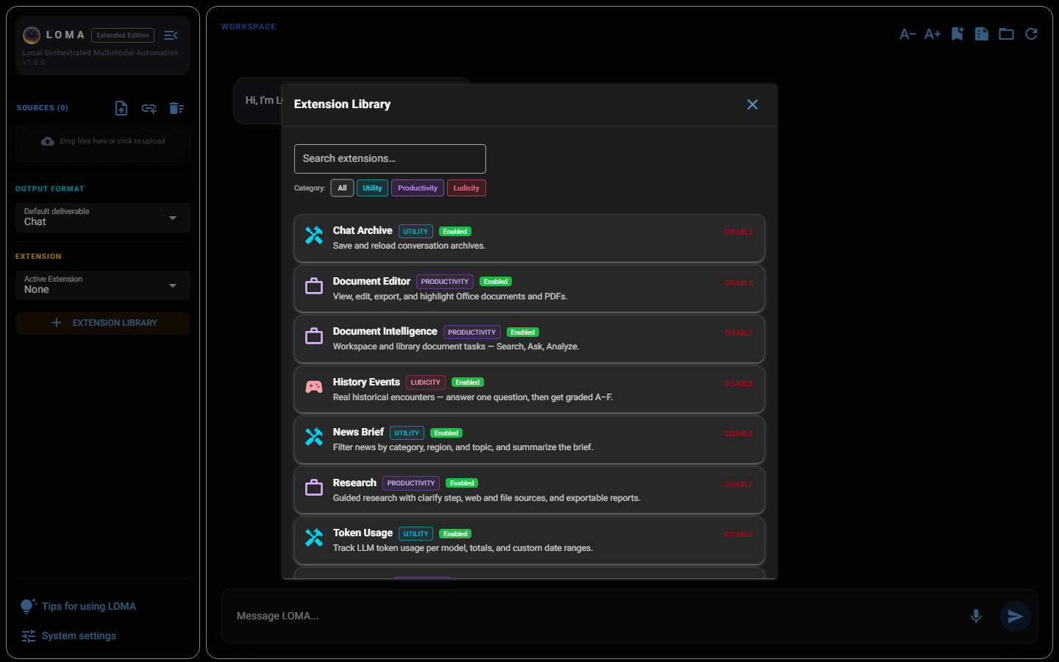

News Brief
Filter news by category, region/country, and timeline, add optional topics, then Generate Brief — LOMA searches, reads, and summarizes matching articles, streaming the result straight into workspace chat with numbered references.
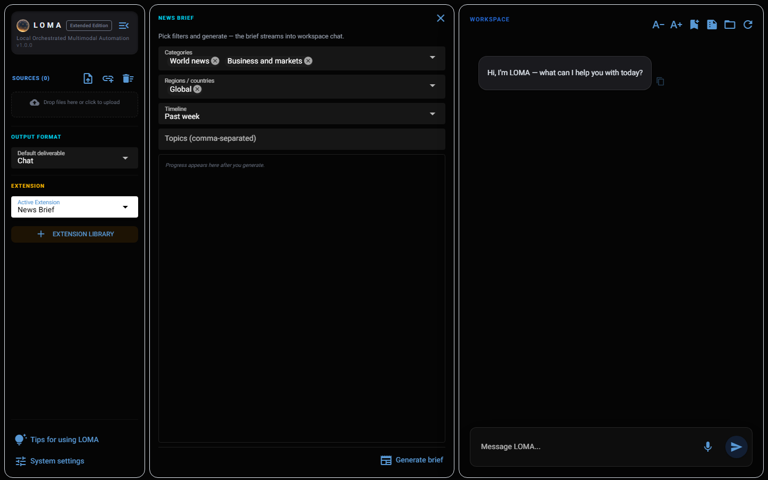

Research
Guided, multi-step research: describe your topic, answer LOMA’s clarifying questions (audience, depth, sources, tone, output), then let it search the web and your files, synthesize findings, and export a cited report. Research uses its own web search when you choose web sources — independent of the Settings → Everyday grounding toggle, which only affects plain chat.
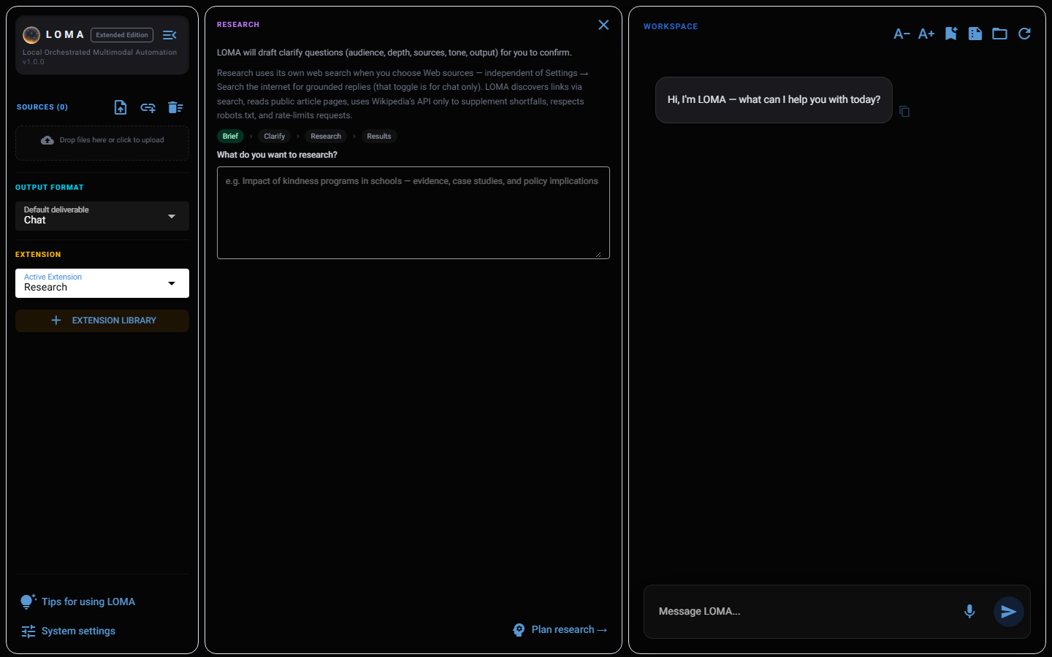
While research is running, the panel shows live progress and a Stop research button that cancels the run immediately.

Web Viewer
Browse a page by URL, then highlight any text and ask LOMA about it, summarize it, or extract key points as a bullet list — all without leaving the workspace. Web content is fetched only from URLs you provide; LOMA respects robots.txt, rate-limits repeat requests, and caches pages.
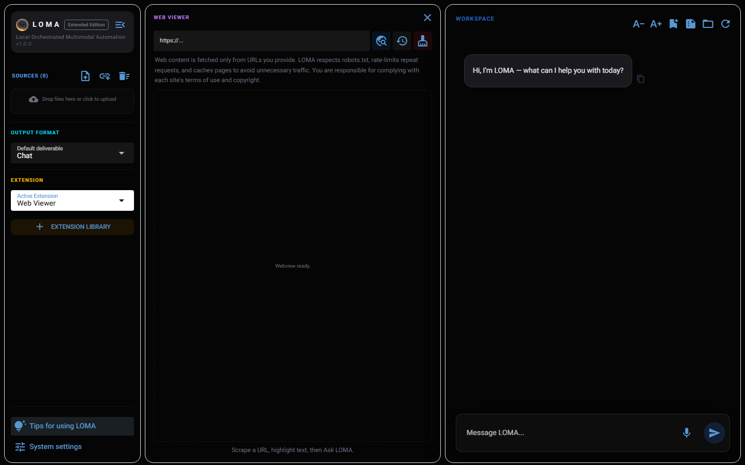

Document Editor
View, edit, export, and highlight Office documents and PDFs in place. Highlight text and ask LOMA about it directly — in-place editing works on .docx sources only.
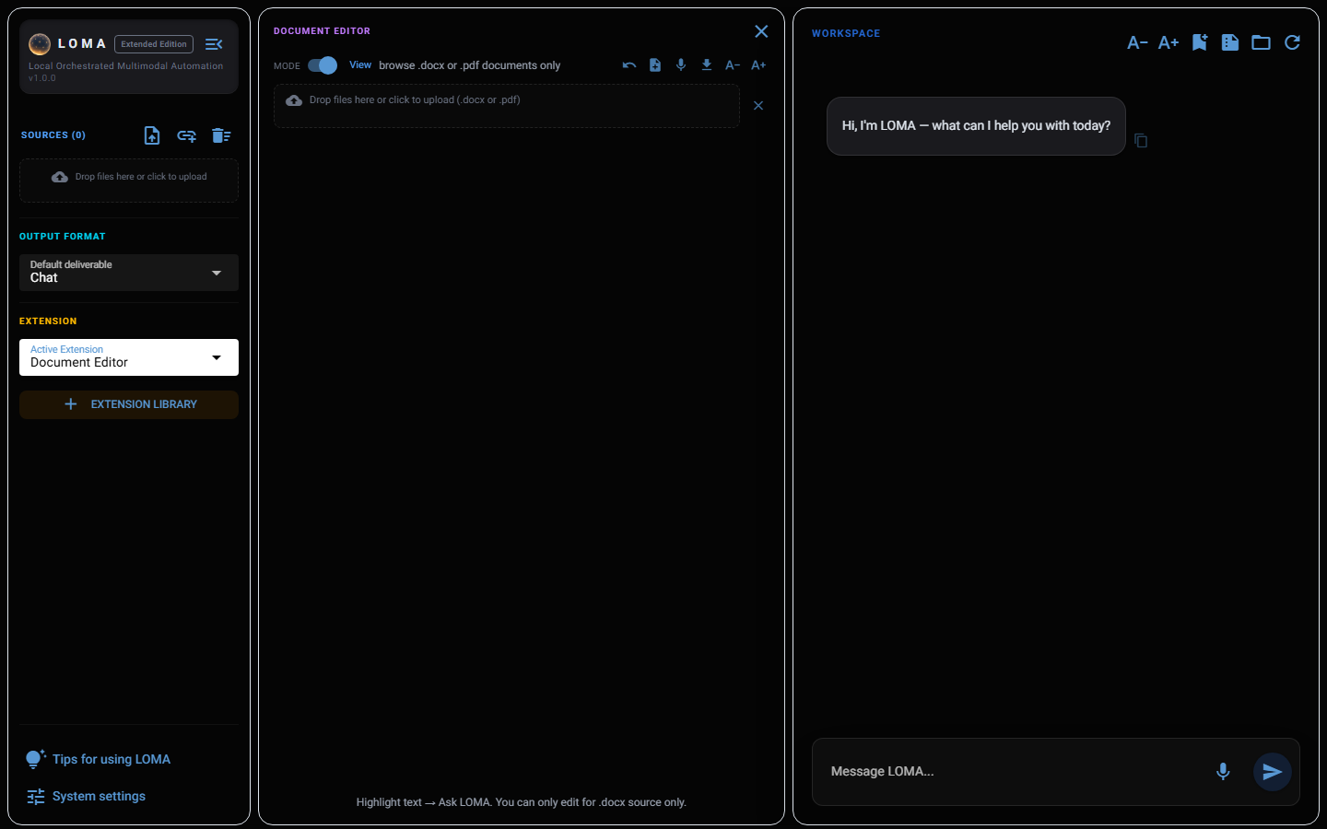

Chat Archive
Save any conversation as a permanent record, organize saves into folders, and reload or continue them later.
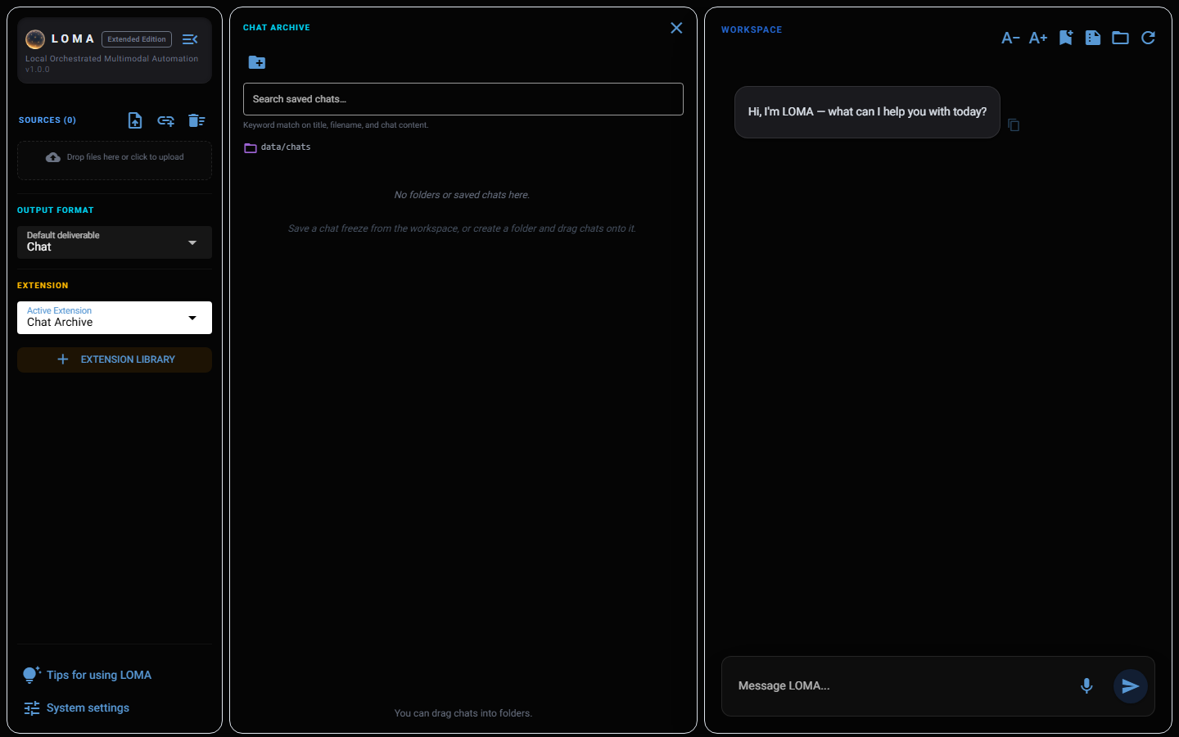

Document Intelligence
Search, Ask, and Analyze across folders and document collections — PDF, DOCX, DOC, and TXT are all indexed.

Workspace
A temporary analysis area — add a folder and indexing runs automatically; nothing here is saved permanently. Five modes are available: Search for matching files and passages, Ask for quick direct answers, Analyze for broader retrieval, Deep for the most thorough single-pass retrieval, and Agentic for multi-pass investigation.
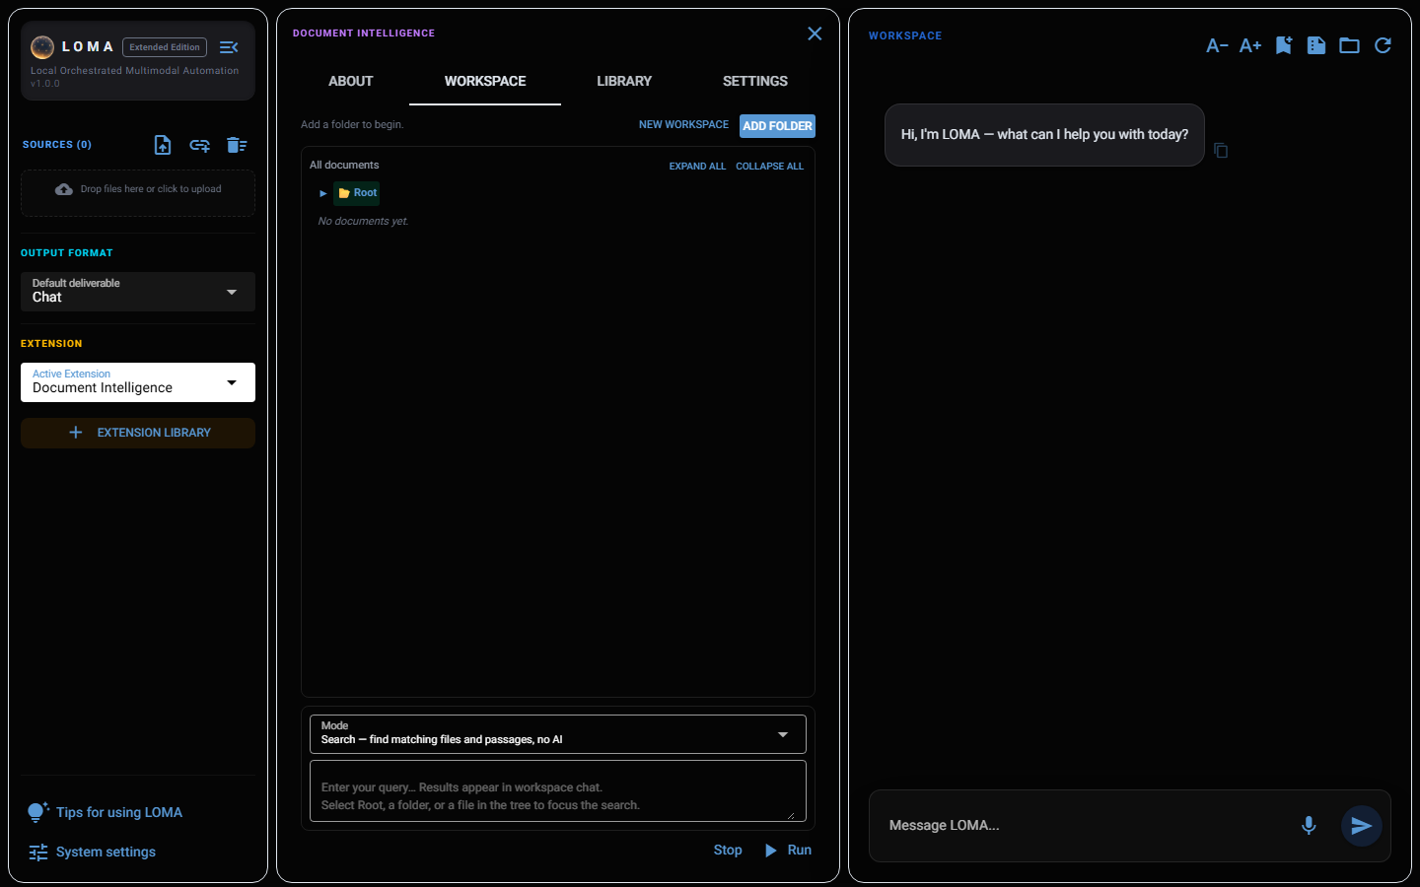

Library
Persistent catalogues that keep their index across sessions, with the same five modes as Workspace. Turn on semantic enhancement for hybrid BM25 + embedding search.

Settings
Tune chunk size, retrieval depth, and other advanced defaults — most people never need to touch this tab.

Token Usage
Track LLM token usage per model, request totals, and estimated cost over any custom date range, broken down by model and by day.
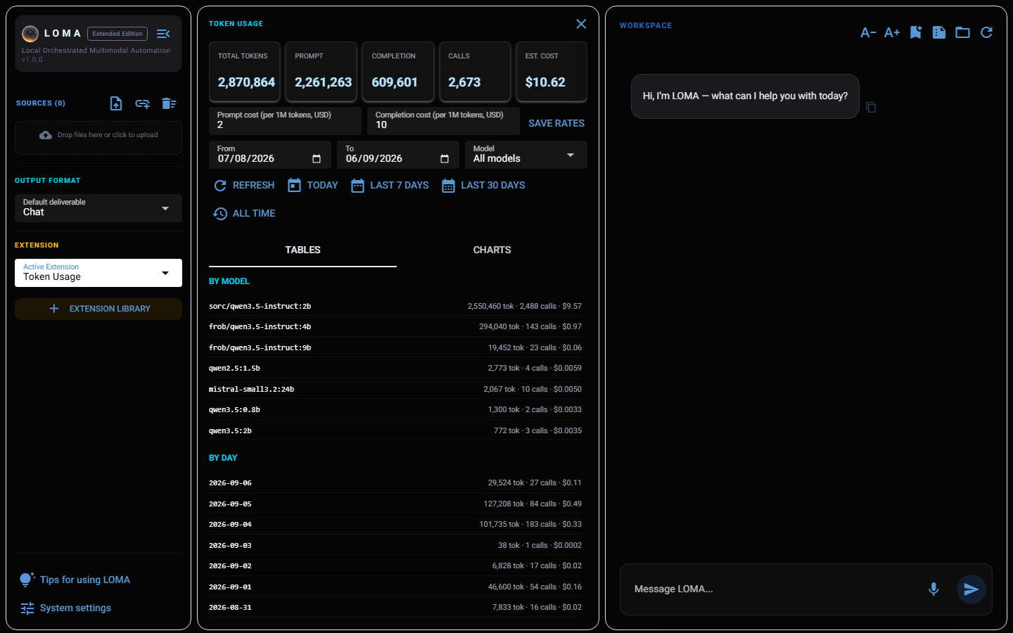

History Events
Pick an era, start an encounter, and answer it from the setup information alone in workspace chat — then get graded A–F against what actually happened.
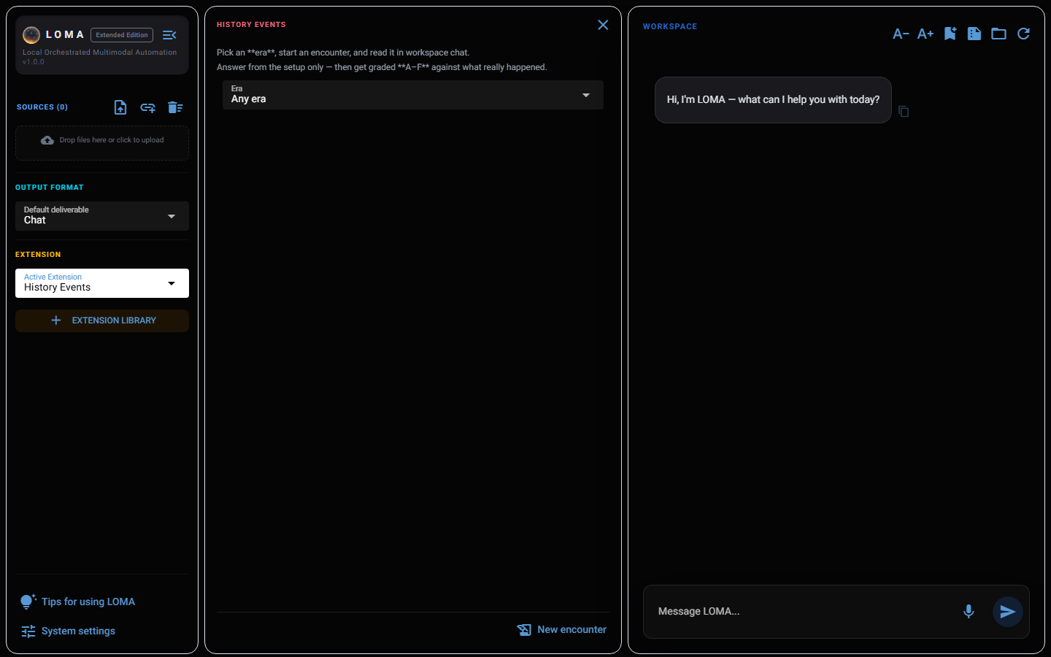

System Settings
Everything configurable in LOMA lives behind the settings gear (“System settings”) at the bottom of the left sidebar, split across four tabs.

Everyday
Language, theme, upload retention, the web-grounding toggle for chat, and voice-reply options — the settings you’ll actually touch day to day.
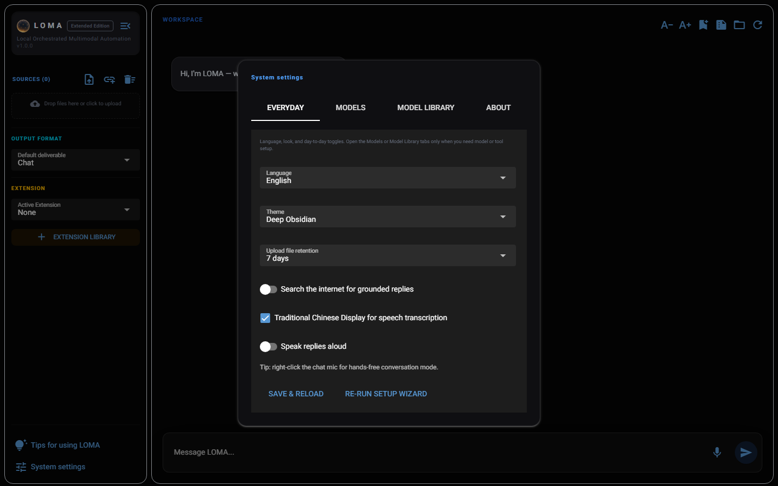

Models
Set the default chat model and multimodal defaults, including the image generation checkpoint (Realistic Vision, DreamShaper, or SDXL Lightning).
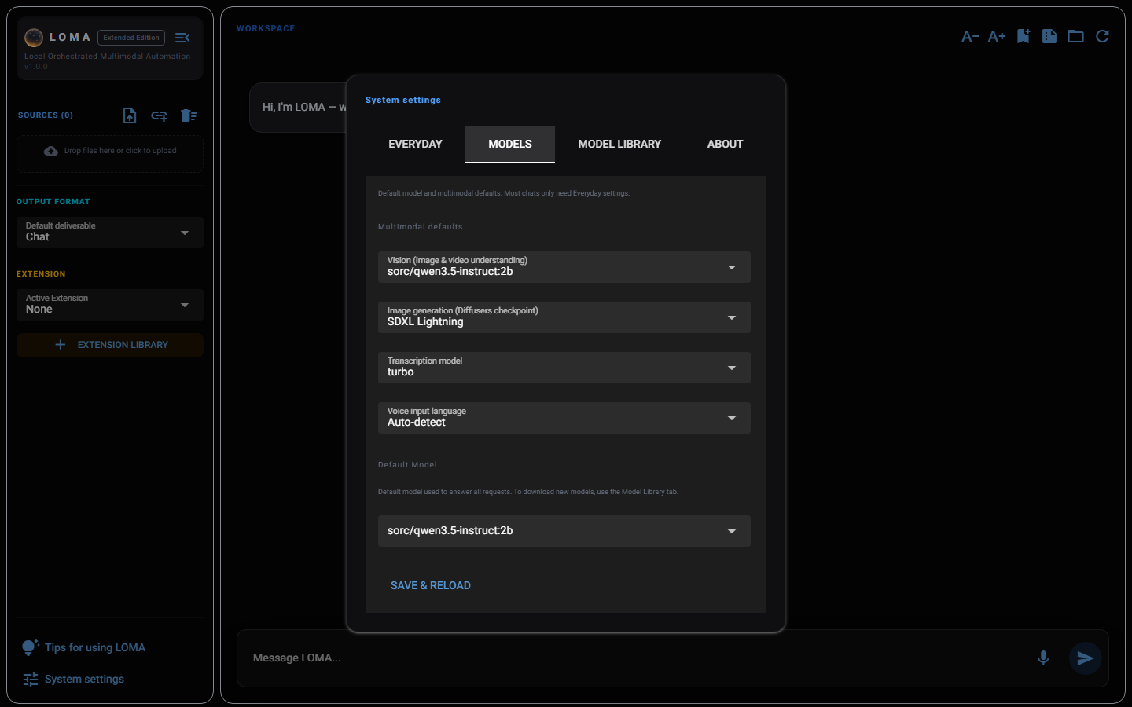

Model Library
Your hardware profile, plus install and manage local models grouped by category.
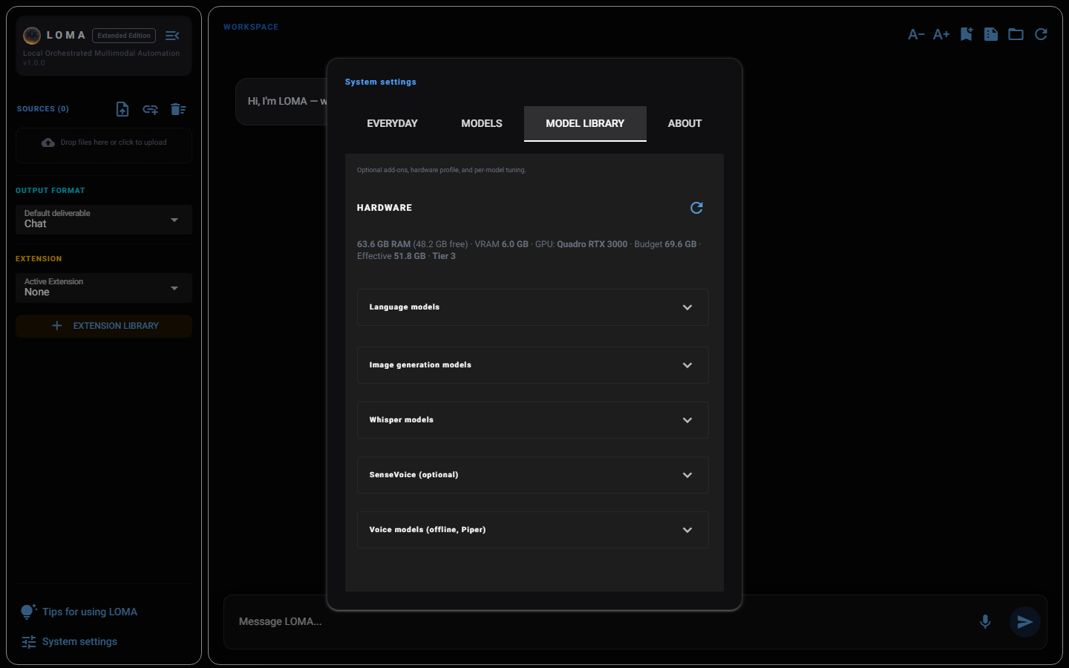
Expand “Image generation models” to see per-checkpoint controls: an Image quality toggle (Low = fast LCM/4-step path, High = slower, higher-fidelity path) and an Image shape picker — Square, Portrait, or Landscape. Square defaults to 512×512 for Realistic Vision and DreamShaper (both SD 1.5) and 1024×1024 for SDXL Lightning; Portrait and Landscape use each model’s own preset dimensions. There is no free-form pixel field — shape presets are the only way to change output size from the UI.
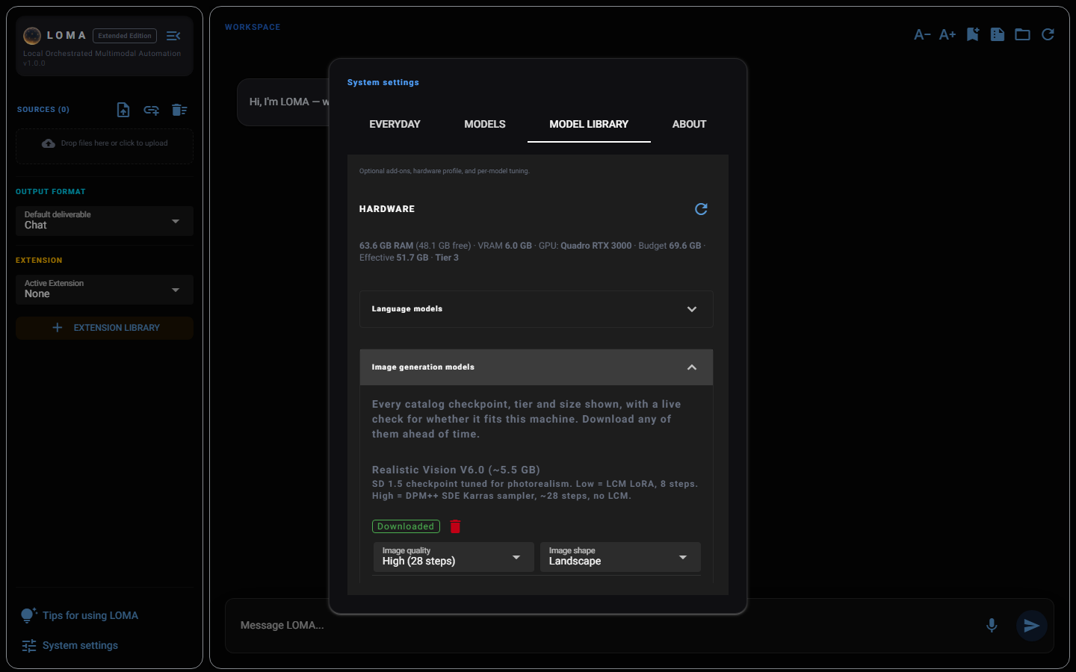

About
A summary of what LOMA can do, the current version number, and the bundled extension list.
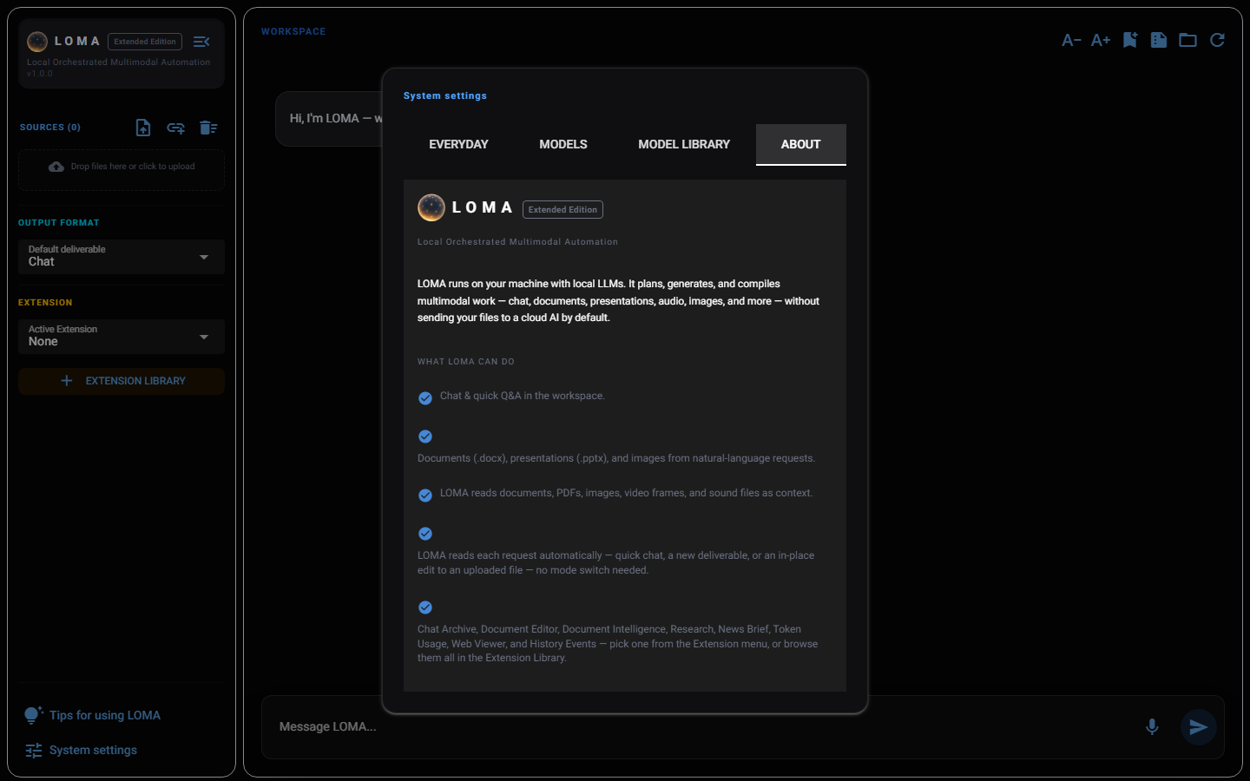

Tips
The lightbulb icon (“Tips for using LOMA”) at the bottom of the sidebar opens a short reference of practical workspace tips — worth a skim the first time you use LOMA.
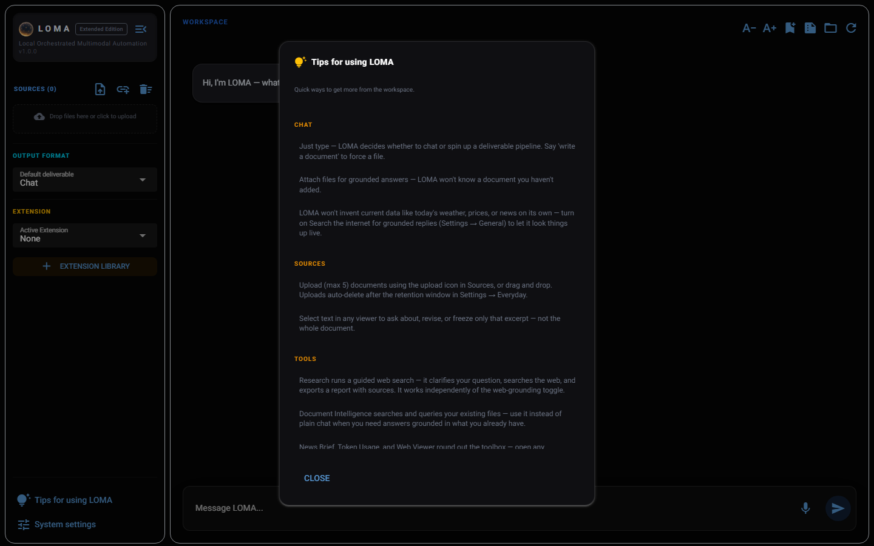

Getting Started From Scratch

Download the app
Unzip and run LOMA.exe (Windows) or LOMA.app (macOS, Apple Silicon).

First launch
A setup wizard walks you through checking connectivity, connecting a local model backend (Ollama or another provider), and picking starter models sized to your machine. You can skip any step and revisit it later from Settings → Re-run setup wizard.

Where your data lives
- Windows: %APPDATA%\LOMA
- macOS: ~/Library/Application Support/LOMA
- Chats, generated documents, and settings all live here — nothing is uploaded anywhere else unless you explicitly use News Brief, Research, or Web Viewer to fetch a page.

