Have to create a GUI using (Model, View, Controller) design principals in Java in order to maniple test files in XML format and export into another XML following manipulation. The GUI will import in XML files and store them into a Tree structure such as JTree in the Java Swing Package. Within the XML file there will be a specific format such as below:
<test>
<event>
<variant> NO_ERRORS </variant>
<constraint>
<type> dwell_cnt </type>
<bounds> CONSTRAINT_BOUND_GREATER </bounds>
<value> 2 </value>
</constraint>
<constraint>
<type> acq_complete_flag </type>
<bounds> CONSTRAINT_BOUND_GREATER_OR_EQUAL </bounds>
<value> 1 </value>
</constraint>
</event>
</test>
- The GUI must be able to manipulate Specific Tags such as <event>, <variant>, <constraint>, <bounds>, and <values>
- In the GUI there can be many events, 1 variant per event, along with many constraints types based on what variant is selected
- A test is considered the imported XML file, and within that XML there are these tags to be manipulated
- The GUI should allow for adding more events, removing events already present and switching around their order based in the exported XML and its specific GUI panel
- The Variant window will have the option to select a specific variant of its choosing per 1 event from a drop down *Variant options will be included*
- The Constraint window will also have the option to select specific constraint types from a dropdown but there can be multiple constraint types per event
- Within the constraint window there will be an option of what types of bounds the user would like to apply along with a value (*value will always be a double*)
- After all manipulation of test XML is complete, there should be an option/button to export the new revised test XML file
- Changes to new exported XML doesn’t have to occur dynamically but ability to save changes when export/save is clicked on
- Use Java packages such as Swing, DOM for GUI
UI Concept
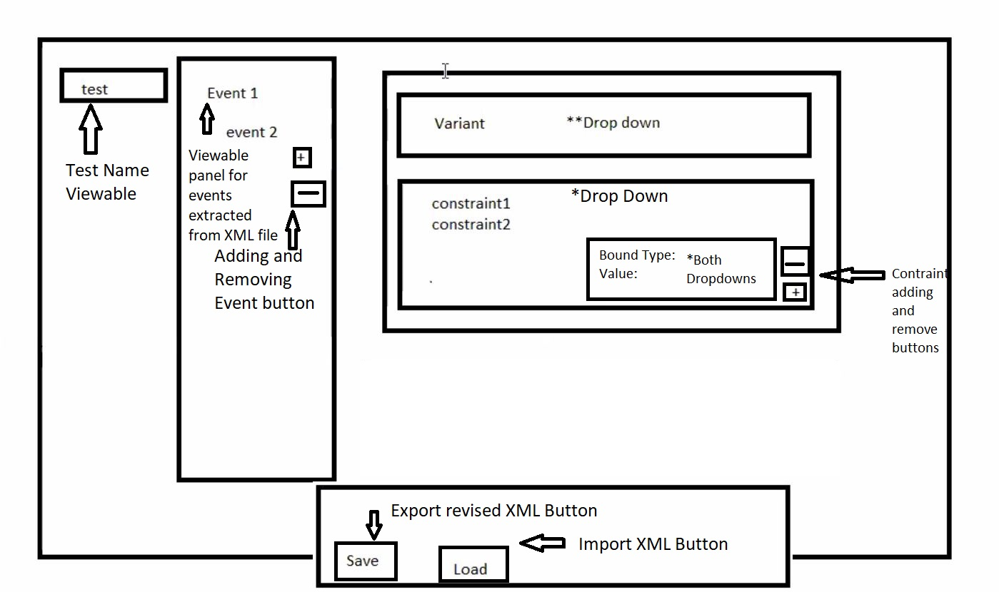

Variant Types
Display Name in GUI  Dropdown | XML Name | Mandatory Constraints present when Variant selected
Acquisition Link Errors | ACQ_LINK_ERRORS | link_event_done  link_manifest  acq_complete_flag
Acquisition Subpulse Errors | ACQ_SUBPULSE_ERRORS | link_event_done  link_manifest  acq_complete_flag
Exit After Zone | EXIT_AFTER_ZONE | link_event_done  link_manifest  acq_complete_flag
Exit On Reaquisition | EXIT_ON_REACQ | link_event_done  link_manifest  acq_complete_flag
Exit On Transition | EXIT_ON_TRANSITION | link_event_done  link_manifest
Link Errors | LINK_ERRORS | link_event_done  link_manifest
No Errors | NO_ERRORS
No Errors Ignore Reaq | NO_ERRORS_IGNORE_REAQ | acq_complete_flag
Phase 3 Link Errors | PHASE_THREE_LINK_ERRORS | link_event_done  link_manifest
Phase Transition Downlink Errors | PHASE_TRANSITION_DOWNLINK_ERRORS
Phase Transition Uplink Errors | PHASE_TRANSITION_UPLINK_ERRORS
Send SDM Parameters | SEND_SDM_PARAMETERS
Uplink Late | UPLINK_LATE
Uplink Lost | UPLINK_LOST
Burst Interrupt | BURST_INTERRUPT

Contraint Type Info
Display Name in GUI  Dropdown | XML Name
Acq Complete | acq_complete_flag
Dwell Count | dwell_cnt
Link Event Done | link_event_done
Link Sequence Done | link_sequence_done
Time of Flight | time_of_flight
Time Until Intercept | time_until_intercept
Uplink Lost Inject Count | uplink_lost_inject_count
Endless Event Flag | endless_event_flag
Link Manifest | link_manifest
Acquisition Count | acquisition_count
Uplink Count | uplink_count
Rate Change | rate_change
EGE Flag | ege_flag
Time Based Error | time_based_error
Bound Type Info
Constrain Conditionals
(Applies to all Constraints)
value | Bound name in drop down for value manipulation
Always double | CONSTRAINT_BOUND_DISABLED
 | CONSTRAINT_BOUND_GREATER
 | CONSTRAINT_BOUND_GREATER_OR_EQUAL
 | CONSTRAINT_BOUND_LESSER
 | CONSTRAINT_BOUND_LESSER_OR_EQUAL
 | CONSTRAINT_BOUND_EQUAL

Vocabulary
Test | A series that contains one to many Events.
Event | A piece of a test that contains one to many constraints and exactly 1 variant.
Constraint | A condition that must be met for an Event to be deemed complete
Variant | A type of corruption that dictates what will be done. For this exersise it is just a name.
**Note | Certain Variants have certain "available" Constraints.
Object Model Diagram of GUI
