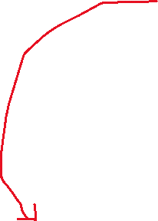

We are building a blockchain platform that focuses on solving existing problems with blockchain by introducing.



Replace Lack of Safety with Robust layer of Safety

Replace Complexity with Simplicity

Replace logo with the following: <https://imgur.com/a/bVGUip5>

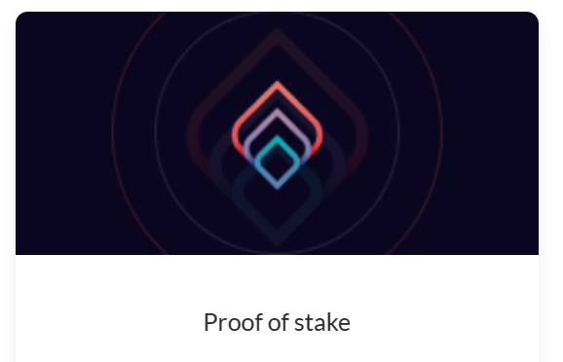

Replace logo with: <https://imgur.com/a/hI0HCDb>

Replace logo with: <https://imgur.com/a/TvYMZbS>

Replace logo with: <https://imgur.com/a/yXcUgwn>

Replace logo with: https://imgur.com/a/SLsoYD2

Replace Locker with: <https://imgur.com/a/pY94F3t>

This opens too small and use updated picture here: <https://imgur.com/a/76AY1A2>



Seems so big to me…

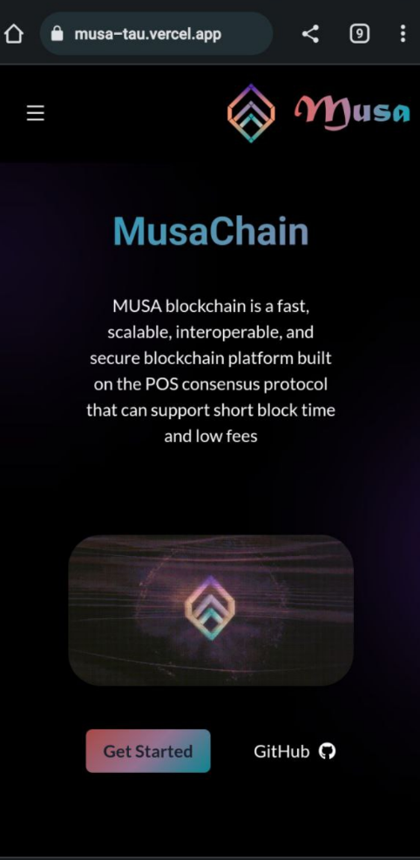

Logo should be on left and menu on right