Chapter10 Reversible reaction name: class:
1.可逆反应的特征与典型的可逆反应（hydration）
1. Which reaction is not a reversible reaction? （ ）
A combustion of alkanes
B hydration of anhydrous copper(II) sulfate
C melting lead(II) bromide
D thermal decomposition of hydrated cobalt(II) chloride

2. Anhydrous copper(II) sulfate can be made by heating hydrated copper(II) sulfate.
$$CuSO4∗5H_{2}O→CuSO_{4}+5H_{2}O$$
What can be added to anhydrous copper(II) sulfate to turn it into hydrated copper(II) sulfate? （ ）
A concentrated sulfuric acid
B sodium hydroxide powder
C sulfur dioxide
D water

3. If anhydrous copper(II) sulfate is added to water, which colour change is observed? （ ）
A blue to pink B blue to white C pink to blue D white to blue

4. Solid copper(II) sulfate can exist in two different forms, anhydrous and hydrated.
One of these forms is blue and the other is white.
The change between these two forms is reversible.
blue form ⇌ white form
Which is the blue form and how is the change from the blue form to the white form brought about? （ ）
 | blue form | change to white form
A | anhydrous | add water
B | anhydrous | heat
C | hydrated | add water
D | hydrated | heat

2.平衡的两个特征
1.In chemistry, what is meant by the term equilibrium?
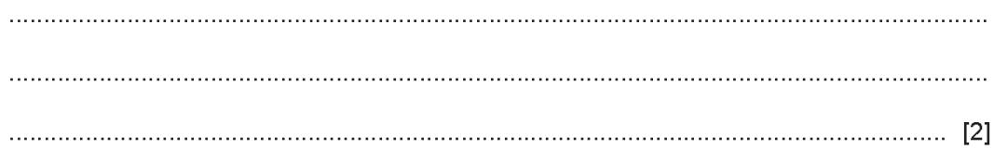
2. Describe two features of an equilibrium.
..................................................................................................................................
..................................................................................................................................
3. 外界因素对平衡位置的影响(Temperature，Pressure，Concentration)
1.The colours of the reactant and product are also shown.
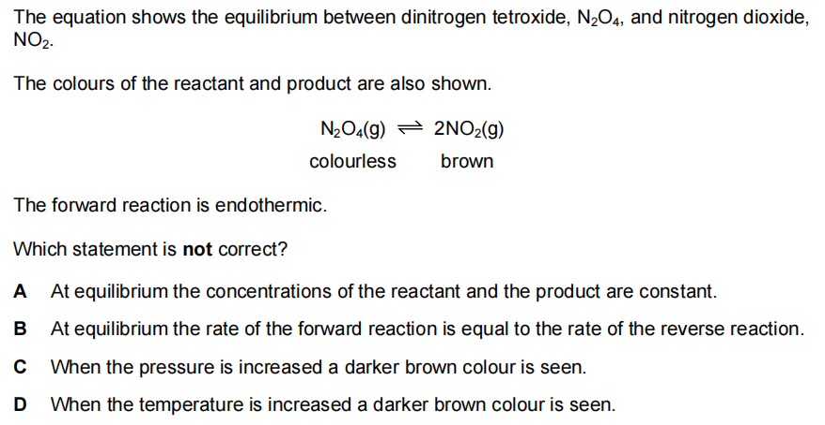
The forward reaction is endothermic
Which statement is not correct? （ ）
A At equilibrium the concentrations of the reactant and the product are constant.
B At equilibrium the rate of the forward reaction is equal to the rate of reverse reaction.
C When the pressure is increased a darker brown colour is seen.
D When the temperature is increased a darker brown colour is seen.
2. The formation of sulfur trioxide is a reversible reaction.
The equation is shown.
$$2SO_{2}(g)+O_{2}(g)⇌2SO_{3}(g)$$
The forward reaction is exothermic.
Which conditions produce the highest equilibrium yield of sulfur trioxide? （ ）
 | pressure | temperature
A | high | high
B | high | low
C | low | high
D | low | low
3. Hydrogen gas reacts with iodine gas. The equation is shown.
$$H_{2}(g)+I_{2}(g)⇌2HI(g)$$
The reaction is reversible and can reach equilibrium.
a.What is meant by the term equilibrium?
b.The graphs show how pressure affects the yield of hydrogen iodide, HI, at two different temperatures.
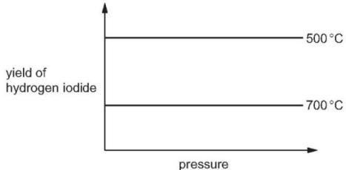
i.Explain why the yield at ${500}^{∘}C$ does not change as the pressure is increased.
ii.What can you conclude from the difference in the yield of hydrogen iodide at the two temperatures shown? Explain your answer.
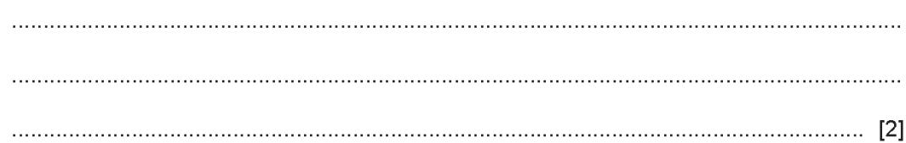
4. The chemical equation shows the equilibrium between dinitrogen tetroxide $(N_{2}O_{4}$ , a colourless gas) and nitrogen dioxide $({NO}_{2}$ , a brown gas).
$$\begin{matrix}N_{2}O_{4}(g)⇌2{NO}_{2}(g) \\ colours brow\end{matrix}$$
A mixture of dinitrogen tetroxide and nitrogen dioxide is allowed to reach equilibrium in a closed gas syringe.
ii.If the equilibrium mixture is heated at constant pressure, a darker brown colour is seen inside the gas syringe.
What does this information indicate about the decomposition of dinitrogen tetroxide? Explain your answer in terms of the position of the equilibrium.
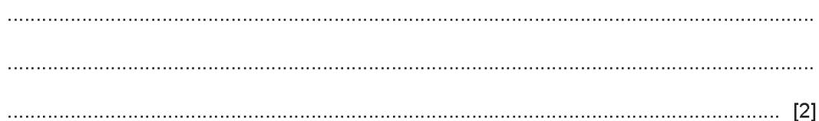
Suggest what you would see if the pressure on the equilibrium mixture were increased at constant temperature. Explain your answer in terms of the position of the equilibrium.
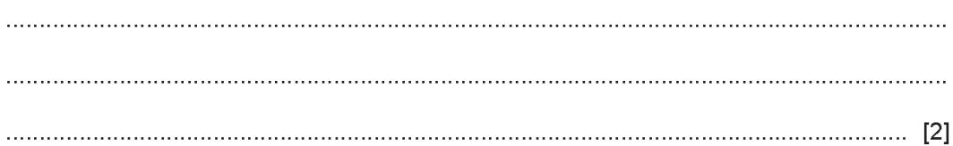

5. A sealed tube containing the equilibrium mixture is placed in ice-cold water. There is an increase in the amount of yellow solid in the equilibrium mixture.
What can you deduce about the forward reaction in this equilibrium?
$$ICl(l)+{Cl}_{2}(g)⇌ICl_{3}(s)$$
Explain your deduction.
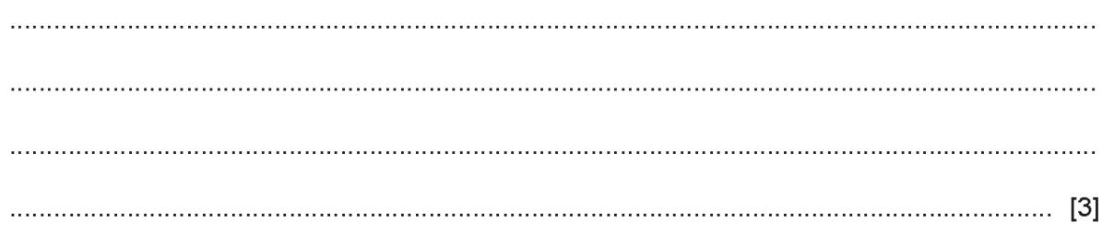
d.Chlorine is removed from the tube and a new equilibrium is formed.
Explain why there is less of the yellow solid and more dark brown liquid in the new equilibrium mixture.
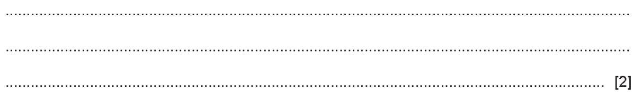

4. Haber process 的条件与原料来源
1. This question is about nitrogen and some of its compounds.
a.Complete the dot-and-cross diagram to show the electron arrangement in a molecule of nitrogen, $N_{2}$ . Show the outer shell electrons only.
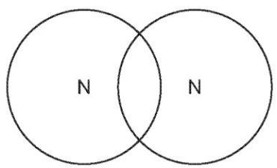 [2]
Nitrogen can be converted into ammonia by the Haber process.
Describe how nitrogen is obtained for the Haber process.
...................................................................................................................................[2]
ii.Give the essential reaction conditions and write a chemical equation for the reaction occurring in the Haber process.
Chemical equation:..................................................................................................
reaction conditions:....................................................................................................[5]

2. Some of the ammonia made by the Haber process is converted into nitric acid.
The first stage of this process is the oxidation of ammonia to make nitrogen monoxide.
$$4{NH}_{3}(g)+5O_{2}(g)⇌4NO(g)+6H_{2}O(g)$$
The process is carried out at ${900}^{∘}C$ and a pressure of 5 atmospheres using an alloy of platinum and rhodium as a catalyst.
The forward reaction is exothermic.
i.State the meaning of the term catalyst.
...........................................................................................................................[2]
ii.Complete the table using the words increase, decrease or no change.
 | effect on the rate of the forward reaction | effect on the equilibrium yield of NO(g)
increasing the temperature
increasing the pressure
3.a.Ammonia, ${NH}_{3}$ , is made by reacting nitrogen with hydrogen in Haber process.
.......................................................................................................................................
b.Write a chemical equation for the formation of ammonia in the Haber process.
...................................................................................................................................[2]
ii.Name the raw materials from which nitrogen and hydrogen are obtained. nitrogen hydrogen
..................................................................................................................................
iii.State the temperature and pressure used in the Haber process. Include the units. temperature pressure
..................................................................................................................................[2]

5. Contact process 的条件与原料来源
1. Sulfur dioxide, ${SO}_{2}$ , is used in the manufacture of sulfuric acid.
a.In the first stage of the process, sulfur dioxide is obtained from sulfur-containing ores.
Name one of these ores.
..................................................................................................................................
b.The next stage of the process is a reaction which can reach equilibrium. The equation for this stage is shown.
$$2{SO}_{2}(g)+O_{2}(g)⇌2{SO}_{3}(g)$$
i.Describe two features of an equilibrium................................................................ [2]
ii.Name the catalyst used in this stage..................................................................... [1]
iii.Why is a catalyst used? ..........................................................................................[1]
iv.Explain, in terms of particles, why a high temperature increases the rate of this reaction.
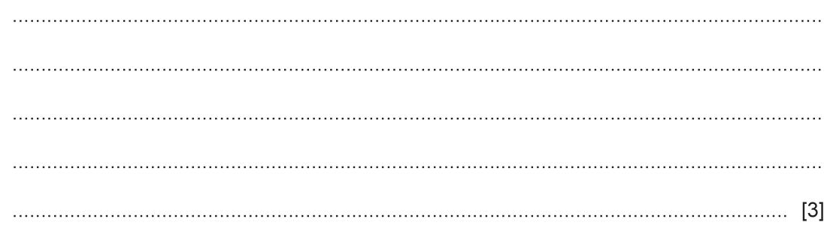
In this stage, only a moderate temperature of ${450}^{∘}C$ is used.
What does this suggest about the forward reaction?
.......................................................................................................................................
..................................................................................................................................[1]

