Chapter 3 Atoms combining Revision name: class:
1.了解并能辨认mixture，element 与 compound的区别。
Element: a susbtance contains one type of atom.
Compound: a substance formed by the chemical combination of two or more different types of atoms.
Mixture: two or more substances mixed together but not chemically combined.

1.Which statement about the boxes P, Q and R is correct? ( )
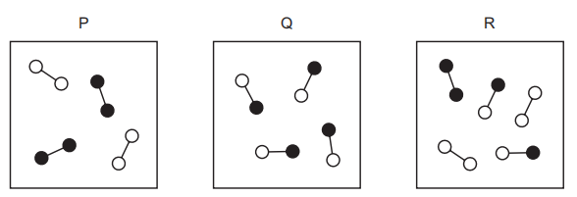
A. Box P contains two compounds and box R contains two elements.
B. Box P contains two elements and box Q contains a mixture.
C. Box P contains two elements and box Q contains one compound.
D. Box Q contains two compounds and box R contains a mixture.

2. Which diagram represents a mixture of compounds? ( )
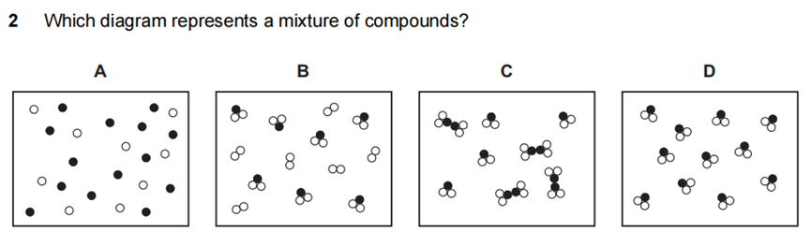

3.Which of the following statements about compounds is correct? ( )
A. Compounds can be separated into their elements by physical means.
B. The properties of a compound are the same as the properties of its elements.
C. Compounds are made up of two or more elements chemically combined.
D. Compounds always contain carbon.

2. 了解chemical bonding 的两个常见方式：covalent bond and ionic bond并懂得区分不同原子结合时的 bonding的类型及其电子交换情况
Ionic bond: A strong electrostatic attraction between ions of opposite charge
(is formed by the transfer of electrons between metal and non-metal atoms.)
Covalent bond:The strong force of electrostatic attraction between the nuclei and the share pairs of electron, when atoms share electrons with each other.
(is formed by the sharing of electrons between non-metal and non-metal atoms.)

1. Sodium reacts with chlorine to form sodium chloride.
Which statements describe what happens to the sodium atoms in this reaction?（ ）
1 Sodium atoms form positive ions.
2 Sodium atoms form negative ions.
3 Sodium atoms gain electrons.
4 Sodium atoms lose electrons.
A 1 and 3 B 1 and 4 C 2 and 3 D 2 and 4

2. The electronic structures of two atoms, P and Q, are shown.
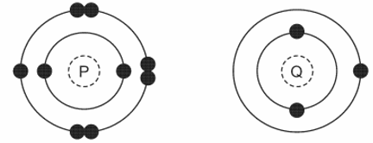
P and Q combine together to form a compound. （ ）
What is the type of bonding in compound and what is the formula of the compound?
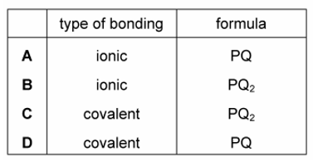
3. The table shows the electronic structures of four atoms.
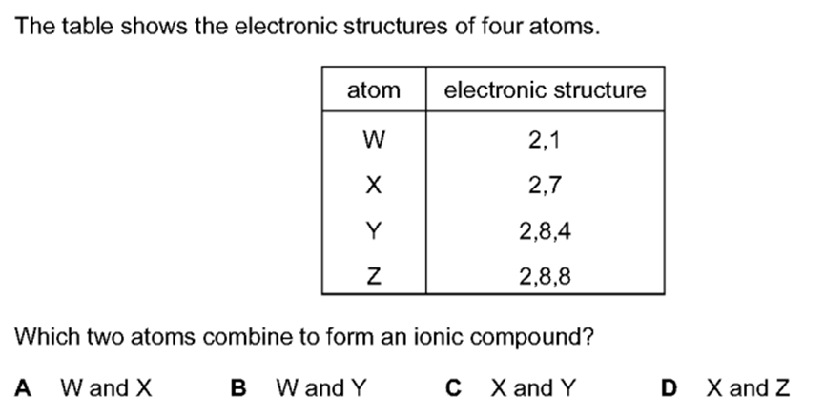
Which two atoms combine to form an ionic compound?（ ）
A. W and X B. W and Y C. X and Y D. X and Z
3.掌握从原子核外电子的数量来判断电子的得失或共享情况。
1. Element X has six electrons in its outer shell.
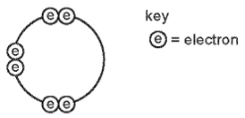
How could the element react? （ ）
A by gaining two electrons to form a positive ion
B by losing six electrons to form a negative ion
C by sharing two electrons with another element to form two covalent bonds
D by sharing two electrons with another element to form four covalent bonds

2. Rubidium is in Group I of the Periodic Table and bromine is in Group VII.
Rubidium reacts with bromine to form an ionic compound.
Which row shows the electron change taking place for rubidium and the correct formula of the rubidium ion? （ ）
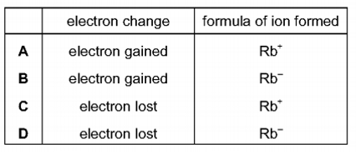

3. The electronic structures of atoms Q and R are shown.
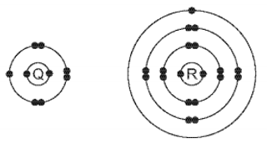
Q and R form an ionic compound.
What is the formula of the compound? （ ）
A. QR₇ B. Q₂R₄ C. QR D. Q₇R

4. Which statement about the bonding in a molecule of water is not correct? （ ）
A Both hydrogen and oxygen have a noble gas configuration of electrons.
B Each hydrogen shares its one electron with oxygen.
C Oxygen shares one of its own electrons with each hydrogen.
D Oxygen shares two of its own electrons with each hydrogen.

5. In the molecules CH₄, HCl and H₂O, which atoms use all of their outer shell electrons in bonding?（ ）
A C and Cl B C and H C Cl and H D H and O

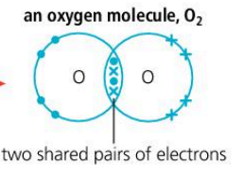
4.并掌握dot-and cross diagram的画法。
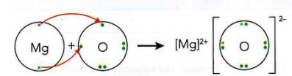
1. Which dot-and-cross diagram shows the outer shell electron arrangement in a molecule ofcarbon dioxide? （ ）
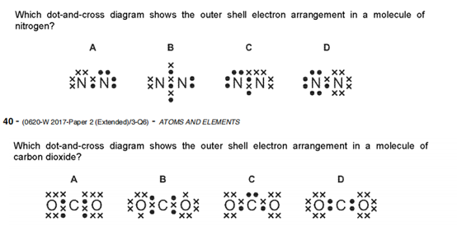
2. In the following diagrams, X and Y are atoms of different elements.
Which diagram correctly shows the arrangement of outer electrons in a molecule of methane( CH₄ )? （ ）
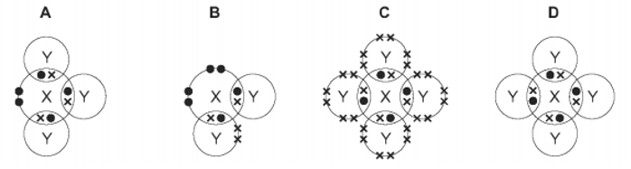

3. Draw a dot - and - cross diagram for the substances below (only outer electrons)
MgCl₂
MgO

AlCl₃
CO₂

5.了解covalent compound 与 ionic compound的性质差别（solubility，melting point）
- ionic compounds have higher melting point and boiling point
离子化合物有更高的熔沸点
- ionic compounds can conduct electricity when dissolved in water or melted ,
离子化合物在溶解或者熔融状态下可以导电，而共价化合物不能导电。
1. Which is a simple covalent molecule? （ ）
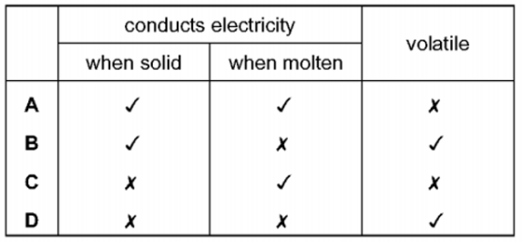

2. The table contains information about four substances
Which substance is potassium chloride? （ ）
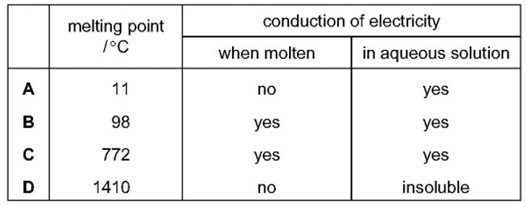

3. Sodium chloride is an ionic solid.
Which statement is not correct? （ ）
A. lons are formed when atoms lose or gain electrons.
B. lons in sodium chloride are strongly held together.
C. lons with the same charge attract each other.
D. Sodium chloride solution can conduct electricity.

4. Compound X melts at 801℃and is a good electrical conductor when dissolved in water.
Compound Y boils at 77℃, is insoluble in water and is a non - conductor of electricity.
Which type of bonding is present in X and in Y? （ ）
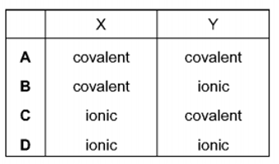

5. (i) Explain why potassium iodide has a high melting point.
............................................................................................................................
.............................................................................................................................
(ii) Explain why potassium iodide (KI) has higher melting point than H₂O.
....................................................................................................................................................................................................................................................................
6. 掌握物质中常见的structure 与 bonding 类型，尤其掌握 giant covalent structure和molecular covalent structure的区别。
Giant covalent structure: attraction force: Strong covalent bond
molecular covalent structure: attraction force: Weak Intermolecular force

1. Which statement explains why methane has a lower boiling point than water?（ ）
A Methane has weaker covalent bonds than water.
B Methane has weaker attractive forces than water.
C Methane molecules are heavier than water molecules.
D Methane molecules have more bonds than water molecules.

2. The bonding, structure and melting point of sodium chloride and sulfur dichloride are shown.
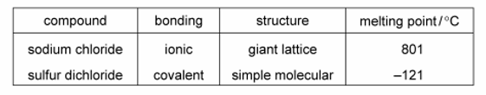
Why does sulfur dichloride have a lower melting point than sodium chloride? （ ）
A The covalent bonds in sulfur dichloride are weaker than the attractive forces between molecules in sodium chloride.
B The covalent bonds in sulfur dichloride are weaker than the ionic bonds in sodium chloride.
C The attractive forces between molecules in sulfur dichloride are weaker than the attractive forces between molecules in sodium chloride.
D The attractive forces between molecules in sulfur dichloride are weaker than the ionic bonds in sodium chloride.

3. Solid sodium chloride does not conduct electricity. However, it conducts electricity when molten. Explain why solid sodium chloride does not conduct electricity, whereas molten sodium chloride does conduct electricity.

4. The melting points of silicon tetrachloride and silicon(IV) oxide are shown in Table
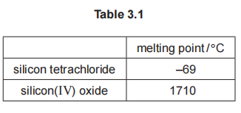
(i) Silicon tetrachloride has a low melting point because it has weak forces of attraction between particles.
Name the type of particles that are held together by these weak forces of attraction.

(ii) Explain in terms of structure and bonding, why silicon oxide has high melting point.

7.掌握Diamond，SiO₂ and graphite性质与用途，并从其结构角度出发分析原因。
一、Melting point is determined by how strong the attraction force.
Strong attractions: 1. Ionic bond 2. Covalent bond 3. Metallic bond
Weak attraction : Intermolecular force (between simple molecules)
二、Structure: 1. Giant Ionic structure (Metal and non-metal)
2. Giant metallic structure (Metal)
3. Giant covalent structure（graphite，diamond，SiO₂)
4. Molecular covalent structure /Simple molecular structure )
三、Electric conductivity ：Free moving charged particles( ions or electrons )
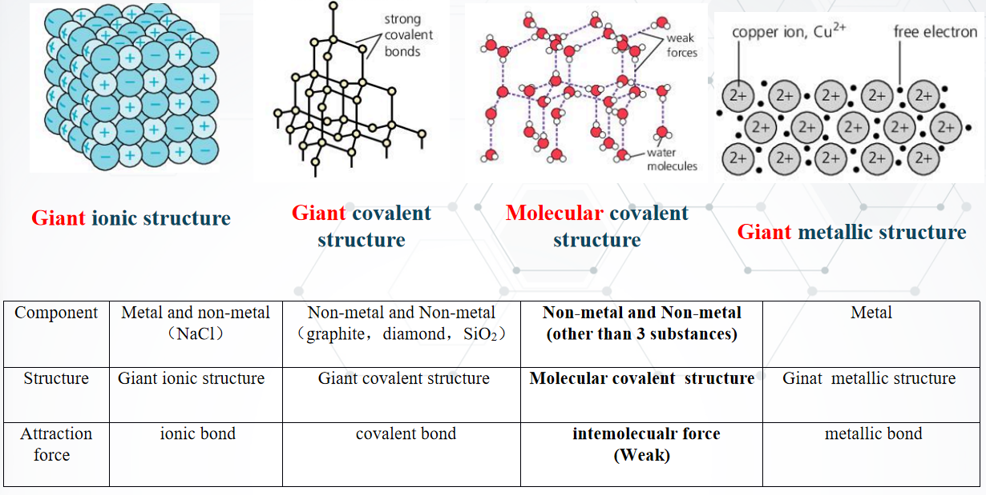
1. Diamond is extremely hard and does not conduct electricity.
Which statement explains these properties? （ ）
A. It has a lattice of positive carbon ions in a 'sea of electrons'
B.lt has delocalised electrons and each carbon atom forms three covalent bonds with other carbon atoms.
C.It has no delocalised electrons and each carbon atom forms four covalent bonds with other carbon atoms.
D. It has strong ionic bonds between each carbon atom.

2. The diagrams show the structures of two forms, P and Q, of a solid element.
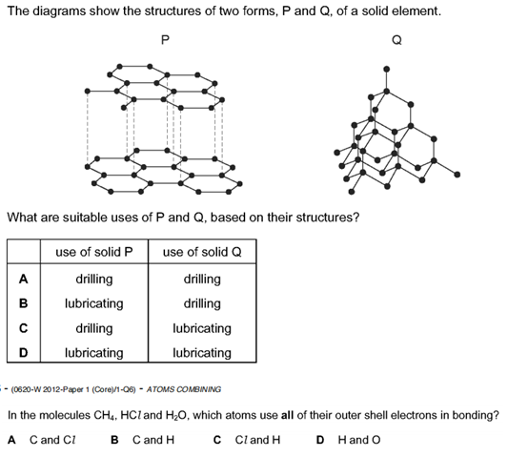
What are suitable uses of P and Q, based on their structures? （ ）


3. Rescuers are drilling through fallen rock in order to rescue some men trapped in a cave. The drill needs lubricating from time to time.
The following statements were made about the materials used for the drill tip and the lubricant and the reasons for their use.
1 Diamond was used for the drill tip as it does not conduct electricity.
2 Diamond was used for the drill tip as it is very hard.
3 Graphite was used as the lubricant as it conducts electricity.
4 Graphite was used as the lubricant as it is soft and flaky.
Which statements are correct? （ ）
A 1 and 3 B 1 and 4 C 2 and 3 D 2 and 4

4. Which substance is a macromolecule? （ ）
A. Ammonia B. carbon dioxide C. diamond D. Water

5. Diamond and graphite are both macromolecules.
Which statement is not correct? （ ）
A Diamond and graphite contain carbon atoms only.
B Diamond and graphite contain charged ions.
C Diamond and graphite have high melting points.
D The atoms in diamond and graphite are held together by covalent bonds.

6. X is a solid at room temperature.
X has a high melting point.
Solid X conducts electricity.
Which diagram shows how the particles are arranged in solid X? （ ）
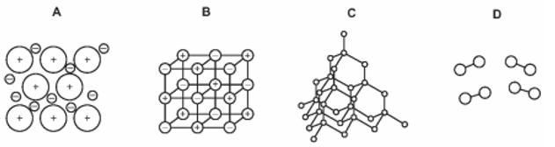
7. How are the structures of diamond and silicon(IV) oxide similar? （ ）
A Molecules of both diamond and silicon(IV) oxide are held together by weak attractive forces.
B They both contain atoms arranged in planes held together by weak bonds.
C They both contain ions that are free to move.
D The carbon in diamond and the silicon in SiO₂ each have four covalent bonds.

9. Explain in terms of structure and bonding why graphite is slippery and soft.

10. Describe the structure and bonding of diamond.
(i)

(ii) Explain in terms of structure and bonding why diamond is hard.

11. Explain in terms of structure and bonding why graphite has a much higher melting point than carbon monoxide.

8.了解metal的性质(malleable，electric conductivity, melting point)
并从其structure与bonding角度分析。
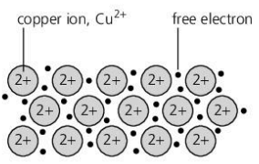
Metallic bond: electrostatic attraction between the positive metal ions and a 'sea' of delocalised electrons.
Structure：Giant metallic structure

1. High melting point and boiling point → Strong metallic bond
2. malleable and ductile → layers of metal ions can slide over each other, new metallic bonds then form between metal ions and electrons in the new position

1.The diagram represents the general structure of a solid Z
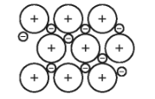
What is Z? （ ）
A. Aluminium B. iodine C. silicon dioxide D. Sulfur

2. Metals consist of a lattice of positive ions in a 'sea of electrons’.
Why is aluminium malleable? （ ）
A. lts ions are attracted to the 'sea of electrons'
B.lts ions are tightly packed together.
C. Its ions repel each other.
D. Its layers of ions can slide over each other.

3. Iron is a metal. Its structure consists of a giant lattice of positive ions in a ‘sea of electrons’.
Which statements about solid iron are correct? （ ）
1 Iron conducts electricity because the electrons are free to move.
2 Iron conducts heat because the positive ions are free to move.
3 Iron has a high melting point due to the strong covalent bonds.
4 Iron is malleable because the layers of ions can slide over one another.
A 1 and 3 B 1 and 4 C 1 only D 2, 3 and 4

4. Metals are malleable
Which statement explains why metals are malleable? （ ）
A. Metallic bonding is very strong.
B. Metals are good conductors of electricity.
C. Positive metal ions are arranged in a regular lattice structure
D. The layers of positive metal ions can slide over each other.

5. Which statement describes the lattice structure of a metal? （ ）
A The lattice consists of alternating positive ions and negative ions.
B The lattice consists of neutral atoms arranged in layers.
C The lattice consists of positive ions in a ‘sea of electrons’.
D The lattice consists of neutral atoms in a ‘sea of electrons’
6. Sodium reacts with chlorine to form sodium chloride.
Which row describes the bonding in the three substances? （ ）
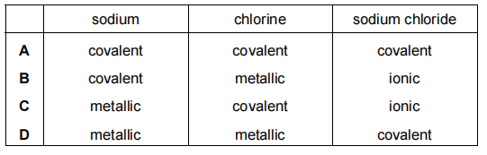

7. Magnesium is a metal.
(a) Describe the structure and bonding in magnesium.
(b) Why can magnesium conduct electricity when solid?
(c) Why is magnesium malleable?

