Chapter 6 Redox reaction name: class:
1.从三个方面(得失electrons，得失Oxyegen，oxidation number) 分析redox reaction。
解题速记口诀：“升失被氧还原剂，降得被还氧化剂”
oxidation：反应物oxidation number上升，其失去氧，被氧化，在反应中作为还原剂。
reduction：反应物oxidation number下降，其得到氧，被还原，在反应中作为氧化剂。
1. Which change is an oxidation? （ ）
A FeO to Fe₂O₃
B Fe₂O₃ to FeO
C H₂O₂ to H₂O
D H₂O to H₂.

2. In which reaction is lead(II) oxide, PbO, oxidised? （ ）
A PbO + C → Pb + CO
B PbO + CO → Pb + CO₂
C PbO + H₂ → Pb + H₂O
D 2PbO + O₂ → 2PbO₂

3. Which statement describes what happens in the reaction shown? （ ）
2Mg + CO₂ → 2MgO + C
A Carbon and magnesium are both oxidised.
B Carbon is oxidised and magnesium oxide is reduced.
C Magnesium is oxidised and carbon dioxide is reduced.
D Magnesium oxide and carbon dioxide are both reduced.

4. Which equation represents a reduction reaction? （ ）
A. Fe²⁺ + e⁻ → Fe³⁺
B. Fe²⁺ → Fe³⁺+ e⁻
C. Fe³⁺ + e⁻ → Fe²⁺
D. Fe³⁺ → Fe²⁺+ e⁻

5. Four ionic half - equations are shown.
1. Cu ²⁺ (aq) + 2e⁻ → Cu(s)
2. I₂ (aq) + 2e⁻ → 2I⁻ (aq)
3. Fe²⁺(aq) → Fe³⁺(aq) + e⁻
4. Cl₂ (g) + 2e⁻ → 2Cl⁻ (aq)
Which statement is correct? （ ）
A In equation 1, copper(II) ions are oxidised to copper.
B In equation 2, iodide ions are reduced to iodine.
C In equation 3, iron(II) ions are oxidised to iron(III) ions.
D In equation 4, chlorine is oxidised to chloride ions.
6. The ionic equation for the reaction of aqueous potassium bromide with chlorine gas is shown.
2Br ⁻ + Cl₂ → Br₂ + 2Cl ⁻
Which statement is correct? （ ）
A Bromide ions are oxidised by gaining electrons.
B Bromide ions are oxidised by losing electrons.
C Chlorine is oxidised by gaining electrons.
D Chlorine is oxidised by losing electrons.

2.掌握如何判断化合物中各元素的oxidation number
Oxidation number tells you how many electrons each atom of an element has lost, gained, or shared, in forming a compound.（化合价是微粒之间相互作用的标志.）

规则：
1.The oxidation number of an uncombined element is 0.（单原子或单质的化合价为0）
(如 oxidation number of ：O₂ , H₂ , Fe，Cu = 0 ）
2. The oxidation number of a simple (monatomic) ion is the same as its charge.
带电荷的简单离子的化合价等于其电荷，如：Cl⁻ = -1, Fe³⁺ =+3 Cu²⁺=+2 O²⁻ = -2
3. The oxidation numbers in the formula of a compound add up to zero.
化合物中，各原子化合价之和为0, 如Fe₂O₃由于O为-2，则2个Fe为-6，一个Fe为-3。
4. The oxidation number of O is always -2，unless it's element，H is always +1
除了作为单质或者原子存在，O的化合价永远是-Ⅱ，H的化合价永远是+Ⅰ

1. The equation for the reaction between zinc and aqueous copper(II) sulfate is shown.
Zn + CuSO₄ → ZnSO₄ + Cu
Which statement is correct? （ ）
A The oxidation state of the oxidising agent has changed from 0 to +2.
B The oxidation state of the reducing agent has changed from 0 to +2.
C The oxidation state of the reducing agent has changed from +2 to 0.
D This is not a redox reaction. The solution changes from colourless to blue.

2. In which change is N₂O₃ oxidised? （ ）
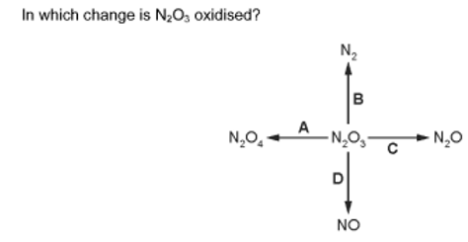
3. In which change is chromium(ll) oxide, CrO, reduced? （ ）
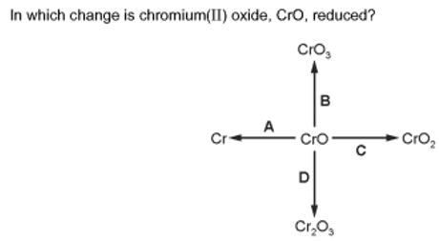

4. The reaction between chlorine and bromide ions is a redox reaction.
Cl₂ + 2Br⁻ → Br₂ + 2Cl⁻
What is the change in oxidation state of the reducing agent in this reaction?（ ）
A -2 to 0
B -1 to 0
C 0 to -1
D 0 to +1

3.掌握如何判断一个反应中的reducing agent and oxidising agent.
Oxidising agent: oxidse other substance and be reduced，oxidation number ↓。
氧化剂氧化其他物质，自己被还原，化合价下降。
Reducing agent: reduce other substance and be oxidised，oxidation number ↑。
还原剂还原其他物质，自己被氧化，化合价上升。
1. In which equation is the underlined substance acting as a reducing agent?（ ）
A. 3CO + Fe₂O₃ → 2Fe + 3CO₂
B. CO₂ + C → 2CO
C. CuO + H₂ → Cu + H₂O
D. CaO + H₂O → Ca(OH)₂

2. Copper(II) oxide reacts with hydrogen.
CuO + H₂ → Cu + H₂O
Which row is correct? （ ）
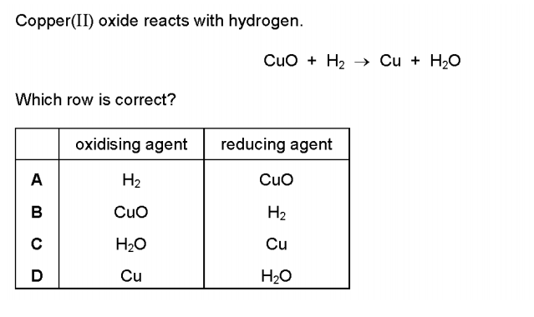
3. The equation for the reaction between iron(II) sulfate and bromine is shown.
6FeSO₄ + 3Br₂ → 2Fe₂(SO₄)₃ + 2FeBr₃
Which row identifies the oxidising agent and the reducing agent? （ ）
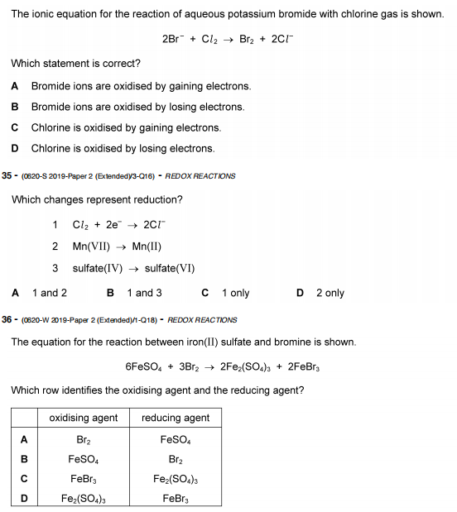

4. An example of a redox reaction is shown.
Which statement about the reaction is correct? （ ）
A Zn is the oxidising agent and it oxidises Cu²⁺.
B Zn is the oxidising agent and it reduces Cu²⁺.
C Zn is the reducing agent and it oxidises Cu²⁺.
D Zn is the reducing agent and it reduces Cu²⁺.

4.从是否有oxidation number改变的角度分析一个化学反应是否为redox reaction.
Redox reactions 的标志： 1. 反应物有oxidation number 的改变
2. 反应物有得失电子的情况
1. Which equation shows an oxidation reaction? （ ）
A C + O₂ → CO₂
B CaCO₃ → CaO + CO₂
C CaO + 2HCl → CaCl₂ + H₂O
D N₂O₄ → 2NO₂

2. The equations for two reactions P and Q are given.
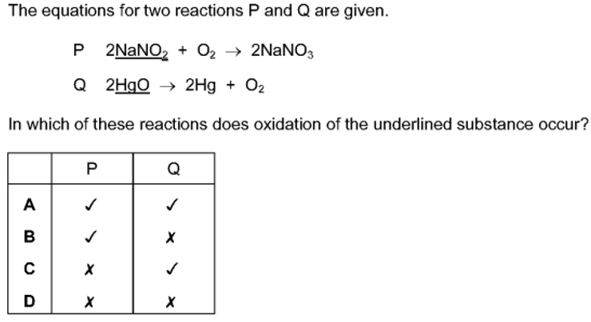
In which of these reactions does oxidation of the underlined substance occur?（ ）

3. (a) When magnesium is added to aqueous copper(II) sulfate a reaction occurs.
The ionic equation for the reaction is shown.
Mg + Cu²⁺ → Mg²⁺ + Cu
(i) Explain why this is a redox reaction. ................................................................
.......................................................................................................................................
(ii) Identify the oxidising agent in this reaction. Give a reason for your answer.
.......................................................................................................................................
.......................................................................................................................................
(iii) Identify the reactant that is oxidized in this reaction. Give a reason for your answer
.......................................................................................................................................
.......................................................................................................................................
5.掌握如何写出一个化学反应中的half-equation
Half equation 把氧化还原反应中得失电子的反应物单独拿出来展现其得失电子情况的方程。
1. The ionic equation for another displacement reaction is shown.
Pb(s) +2Ag⁺ (aq) → 2Ag(s) + Pb²⁺ (aq)
Write the two ionic half - equations for this reaction.
1 ....................................................................................................................
2 ....................................................................................................................

2. Please write down the half-equation for the following reactions
(a) 2Mg + O₂ → 2MgO
Oxidation:
Reduction:

(b) 2NaI + Cl₂ → 2NaCl + I₂
Oxidation:
Reduction:

(c) 2Fe(Ⅱ)Br₂ + Br ₂ → 2Fe(Ⅲ)Br₃
Oxidation:
Reduction:

(d) 2Na + 2H₂O → 2NaOH + H₂
Oxidation:
Reduction:

6.从多个知识点出发的综合大题
1. Iodine is extracted from seaweed using acidified hydrogen peroxide, in a redox reaction. The ionic equation for the reaction is:
2I⁻(aq) + H₂O₂(aq) + 2H⁺(aq) →I₂(aq) + 2H₂O(l)
a Give the oxidation number for iodine in seaweed.
b i Is the iodide ion oxidised, or reduced?
ii Write the half - equation for this change.
c In hydrogen peroxide, the oxidation number for hydrogen is +I.
i What is the oxidation number of the oxygen in hydrogen peroxide?
ii How does the oxidation number for oxygen change during the reaction?

iii Copy and complete this half - equation for hydrogen peroxide:
H₂O₂(aq) + 2H⁺(aq) + →2H₂O(l)

2. When chlorine gas is passed through aqueous potassium bromide, a redox reaction occurs.
The ionic equation is shown.
Cl₂ + 2Br⁻ → 2Cl⁻ + Br₂
(i) Write an ionic half - equation showing what happens to the chlorine molecules,Cl₂, in this reaction.
.......................................................................................................................
(ii) Explain why the bromide ions,Br⁻, act as reducing agents in this reaction.
.......................................................................................................................
.......................................................................................................................

