Chapter 8 Energy changes in reactions name: class:
Exothermic reaction：The reaction gives out the thermal energy to the surroundings 放热反应是向环境释放热能的反应
chemical energy of reactants converts to thermal energy to the surrounding.
在放热反应中，反应物的化学能转化成了环境的热能。
The temperature of surroundings ， the chemical energy of chemicals .
在放热反应中，环境（包括反应物的温度上升），反应物的化学能下降。）
The energy of the reactants The energy of the products
反应物的能量高于生成物的能量
Common example ： Combustion reaction(燃烧反应)， respiration reaction(呼吸）

Endothermic reaction: The reaction takes in thermal energy from the surroundings. 吸热反应是从环境吸收热能的反应。
Energy changes：The thermal energy of the surrounding converts to chemical energy of reactants 吸热反应中，环境的热能转化为反应物的化学能。
The temperature of surroundings ， the chemical energy of chemicals .
在吸热反应中，环境（包括反应物的温度下降，反应物的化学能上升。）
The energy of the reactants The energy of the products
反应物的能量低于生成物的能量
Common example ： thermal decomposition(热分解反应）
1.了解exothermic reaction 与 endothermic reaction的定义以及对环境温度的影响。
The temperature of surroundings ，the chemical energy of chemicals .
在放热反应中，环境（包括反应物的温度上升），反应物的化学能下降。）
在吸热反应中，环境（包括反应物的温度下降，反应物的化学能上升。）
Endothermic reaction: The reaction takes in thermal energy from the surroundings. 吸热反应是从环境吸收热能的反应。
1. The diagrams show the difference in energies of the reactants and products in two types of reaction. 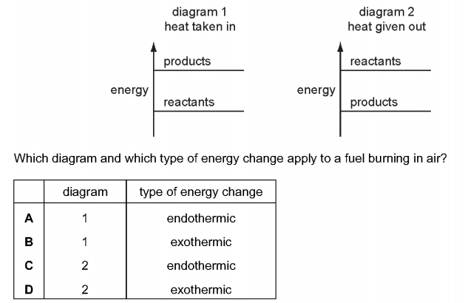
Which diagram and which type of energy change apply to a fuel burning in air?（ ）


2. When anhydrous copper(ll) sulfate is added to water a solution is formed and heat is given out.
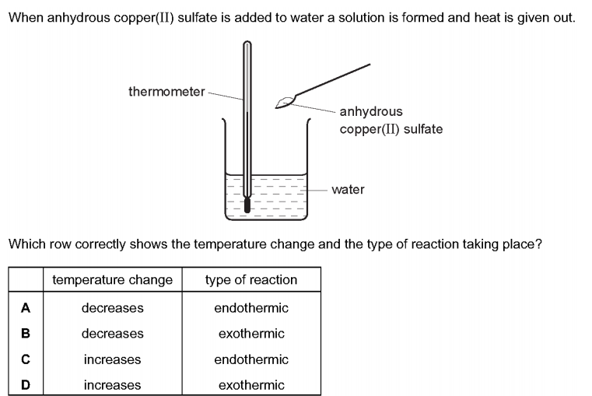
Which row correctly shows the temperature change and the type of reaction taking place? （ ）


3. The temperature of the water in two beakers, X and Y, is measured as 21.5 °C.
5 g of sodium chloride is dissolved in the water in beaker X.
The temperature changes to 18.0 °C.
5 g of calcium oxide is dissolved in the water in beaker Y.
The temperature changes to 29.4 °C.
Which types of process are occurring in beakers X and Y? （ ）
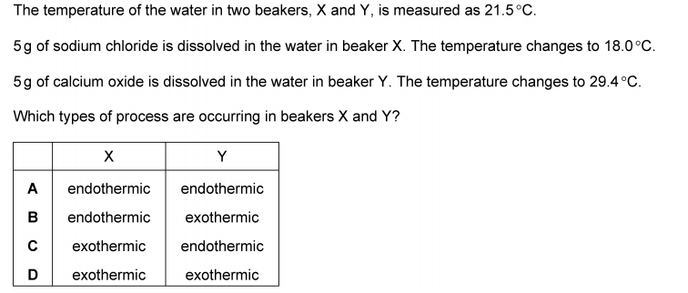
2.掌握exothermic 与 endothermic reaction中的能量转化
Energy changes：The thermal energy of the surrounding converts to chemical energy of reactants 吸热反应中，环境的热能转化为反应物的化学能。
chemical energy of reactants converts to thermal energy to the surrounding.
在放热反应中，反应物的化学能转化成了环境的热能。
1. Which statements about endothermic reactions are correct? （ ）
1 The energy of the products is greater than the energy of the reactants.
2 The energy of the reactants is greater than the energy of the products.
3 The temperature of the surroundings increases during the reaction.
4 The temperature of the surroundings decreases during the reaction.
A 1 and 3 only B 1 and 4 only C 2 and 3 only D 2 and 4 only

2. Which experiment is the most exothermic? （ ）
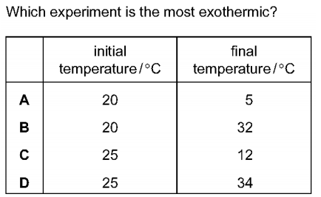

3. A diagram for the energy change during an exothermic reaction is shown.
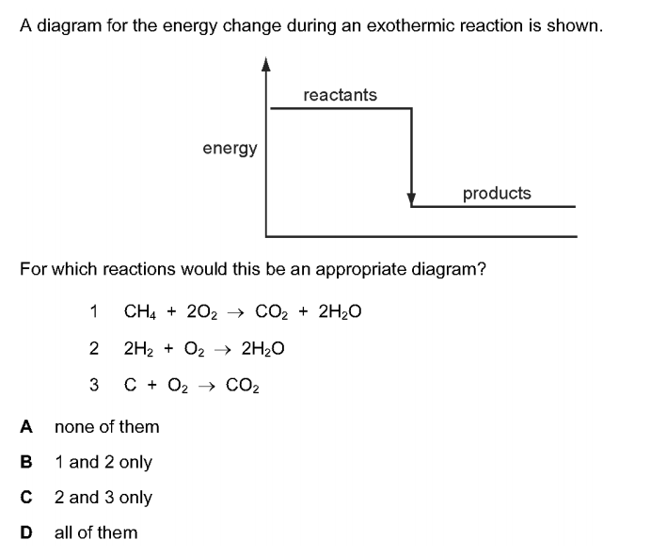
For which reactions would this be an appropriate diagram? （ ）
1. CH₄ + 2O₂ → 2H₂O
2. 2H₂ + O₂ → 2H₂O
3. C + O₂ → CO₂
A none of them B 1 and 2 only C 2 and 3 only D all of them
4. A metal reacts with an aqueous solution.
The graph shows the temperature before, during and after the reaction.
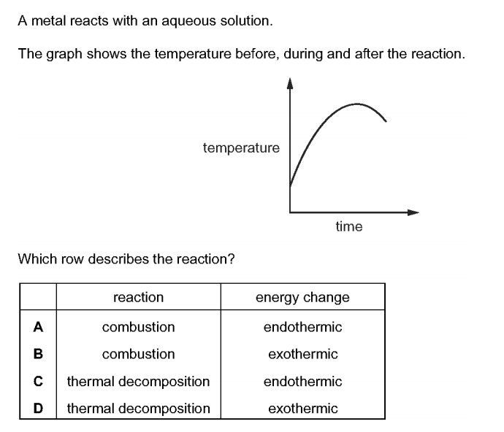
Which row describes the reaction? （ ）

3.认识 energy level diagram 并能够从中辨别出（Ea and ΔH），并能判断反应为exothermic 还是endothermic
1. The energy level diagram for a reaction is shown.
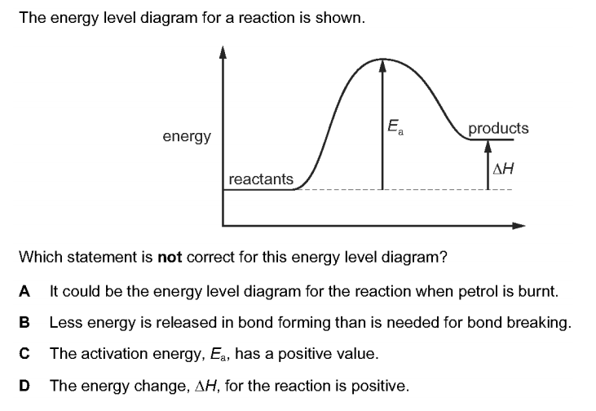
Which statement is not correct for this energy level diagram? （ ）
A It could be the energy level diagram for the reaction when petrol is burnt.
B Less energy is released in bond forming than is needed for bond breaking.
C The activation energy, Ea, has a positive value.
D The energy change, ΔH, for the reaction is positive.

2. An energy level diagram for a reaction is shown.
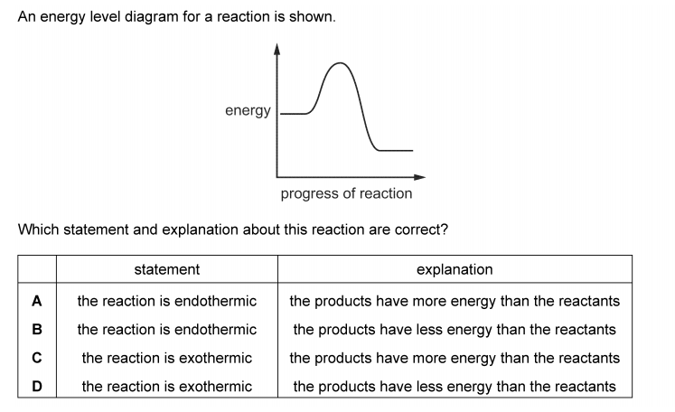
Which statement and explanation about this reaction are correct? （ ）


3. The energy level diagram for a reaction is shown.
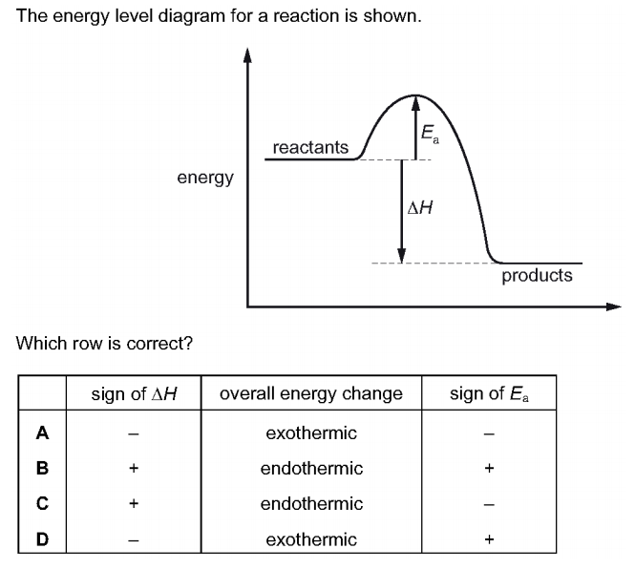
Which row is correct? （ ）

4. The reaction in following is exothermic.
4NO₂ + 2H₂O + O₂ → 4HNO₃
Complete the energy level diagram for this reaction. Include an arrow that clearly shows the energy change during the reaction.
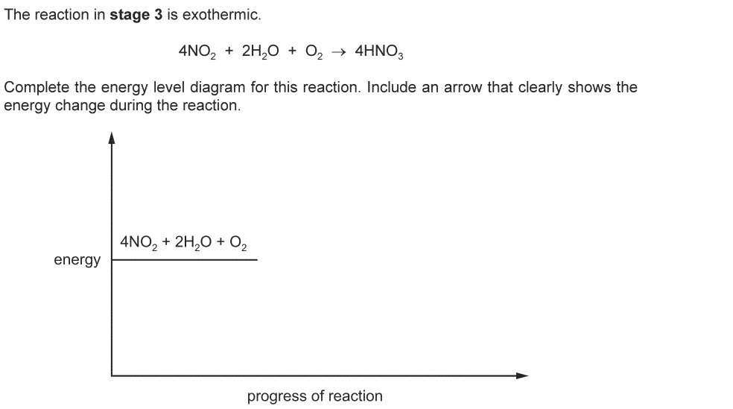
5. The chemical equation for the complete combustion of ethanol, C₂H₅OH, is shown.
C₂H₅OH + 3O₂ → 2CO₂ + 3H₂O
The energy released when one mole of ethanol undergoes complete combustion is 1280 kJ.Part of the energy level diagram for this reaction is shown.
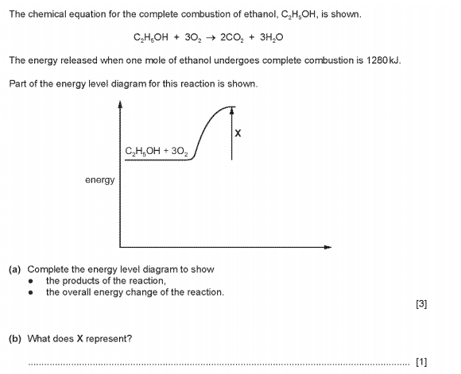
(a) Complete the energy level diagram to show
• the products of the reaction,
• the overall energy change of the reaction.
(b) What does X represent?

4.了解化学反应发生过程中能量的变化，从bond forming 与bond breaking角度分析。
For a chemical reaction to take place, there are always two phrases:(每个反应都有二阶段）
1. Bond breaking ( need to take in energy) 把反应物中的化合键断开，需要吸收能量。
2. Bond forming(need to gives out energy) 形成产物中的新化学键，需要释放能量。
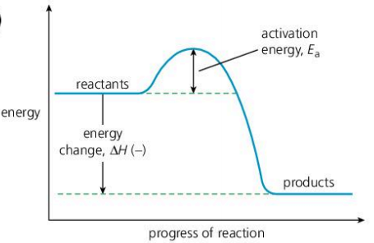
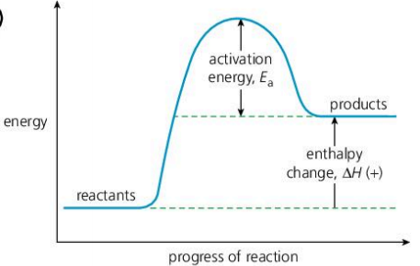

The activation energy（Ea）：the he energy needed to break all the attraction force in reactants
活化能是化学反应需要发生所要吸收来破坏化学键所需要的能量。其标志为Ea
Enthalpy change（ΔH）：the overall energy change during a reaction
（焓变，是在一个反应中总体的能量变化。 其标志为ΔH。）
ΔH= the energy taking in - the energy given out，
若ΔH＞0，则为endothermic reaction 若ΔH＜0，则为exothermic reaction
1. Which statement describes an exothermic reaction? （ ）
A The energy absorbed for bond breaking is greater than the energy released by bond formation.
B The energy absorbed for bond breaking is less than the energy released by bond formation.
C The energy released by bond breaking is greater than the energy absorbed for bond formation.
D The energy released by bond breaking is less than the energy absorbed for bond formation.

2. For a reaction to take place, two steps must occur. What are they?

3. Explain why combustion reaction is exdothermic overall, in terms of bond making and bond breaking.

5.了解bond energy的定义，并掌握从给出的数据中计算反应焓变。
Unit of energy: Joule symbol: J or kilojoule symbol: KJ
（能量的单位为焦耳，标志为J；也可以用千焦，标志位KJ。）
The energy change of the chemical reaction = Enthalpy change(ΔH）
反应中释放或者吸收的能量就等于焓变(ΔH）
ΔH= the energy taking in - the energy given out
O₂ + 2 H₂ → 2 H₂O
Bonds need to break：O=O , 2 H-H
Bonds need to form： 4 H-O
Bond energy: The energy needed to break chemical bonds
键能：是破坏化学键所需要的能量
对于特定的化学键来说，破坏键所要吸收的能量 = 形成键所要放出的能量
破坏一个C-H键需要吸收413KJ能量，形成一个C-H键需要释放413KJ能量。
ΔH = 2 × O=O + 2× H-H - 4× O-H

1. Hydrogen burns exothermically in oxygen.
The equation for the reaction is:
2H₂ + O₂ → 2H₂O
The table shows the bond energies involved.
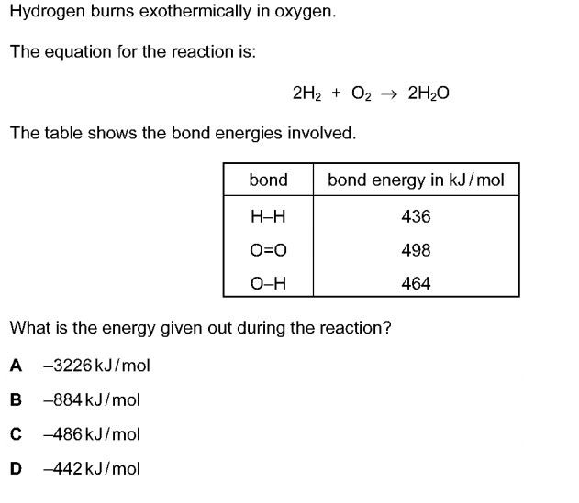
What is the energy given out during the reaction? （ ）
A −3226 kJ/mol B −884 kJ/mol C −486 kJ/mol D −442 kJ/mol

2. The equation for the complete combustion of methane is shown.
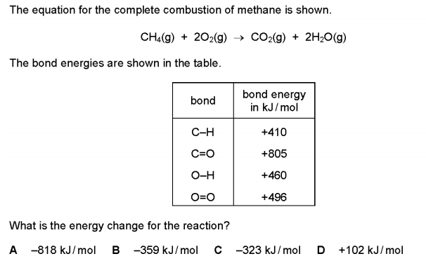
What is the energy change for the reaction? （ ）
A −818 kJ/mol B −359 kJ/mol C −323 kJ/mol D +102 kJ/mol

3. The equation for the formation of ammonia is shown.
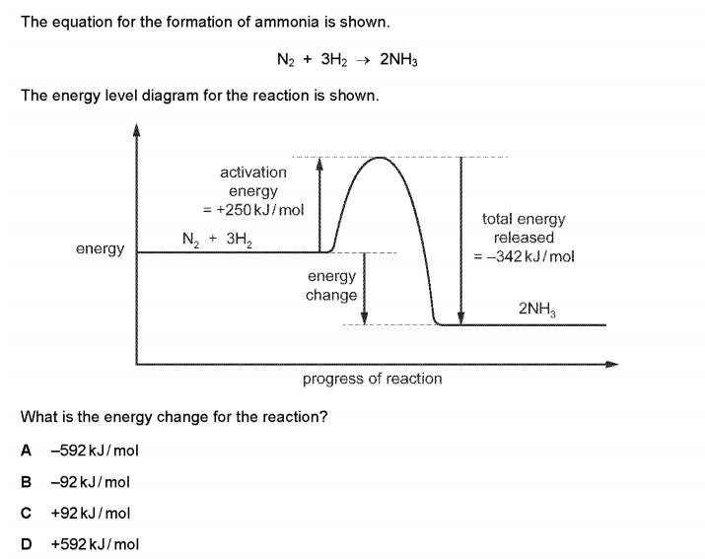
What is the energy change for the reaction? （ ）
A −592 kJ/mol B −92 kJ/mol C +92 kJ/mol D +592 kJ/mol

4. Bond breaking is an endothermic process. Bond energy is the amount of energy needed to break or form one mole of the bond. Complete the table and explain why the forward reaction is exothermic.
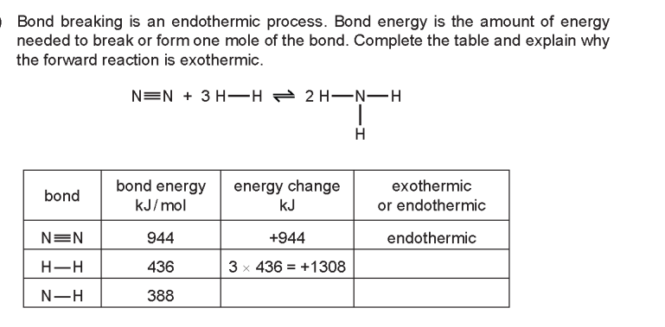

5. Propene also reacts with bromine.
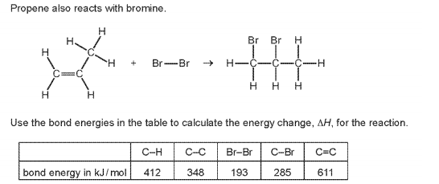

Use the bond energies in the table to calculate the energy change, ΔH, for the reaction.

6. Bond breaking is an endothermic change and bond forming is an exothermic change.Bond energy is the amount of energy in kJ/mol needed to break one mole of the specified bond.
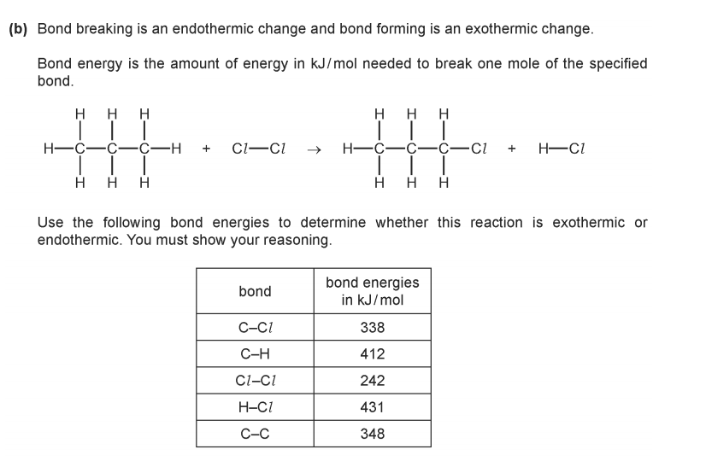
Use the following bond energies to determine whether this reaction is exothermic or endothermic.You must show your reasoning.


