Chapter9 Rate of reaction revision name: class:
1.测量不同反应的速率的实验方式
1 .The apparatus shown is used to measure the speed of a reaction.
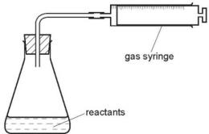
Which equation represents a reaction where the speed can be measured using this apparatus? （ ）
A $Mg(s)+2HCl(aq)→MgCl_{2}(aq)+H_{2}(g)$
B $HCl(aq)+NaOH(aq)→NaCl(aq)+H_{2}O(l)$
C $Fe(s)+CuSO_{4}(aq)→Cu(s)+FeSO_{4}(aq)$
D $2Na(s)+Br_{2}(l)→2NaBr(s)$

2. A student was asked to measure the rate of reaction between dilute hydrochloric acid and marble chips at different temperatures.
Some of the apparatus used is shown.
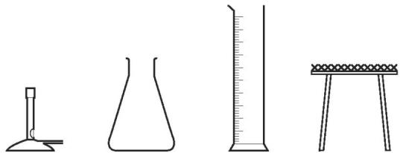
Which two other pieces of apparatus would be needed? （ ）
A balance and pipette
B balance and stopclock
C beaker and stopclock
D burette and pipette

3. A liquid X reacts with solid Y to form a gas.
Which two diagrams show suitable methods for investigating the rate (speed) of the reaction? （ ）
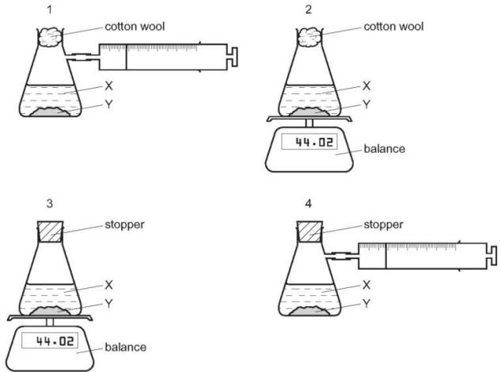
A 1 and 3 B 1 and 4 C 2 and 3 D 2 and 4
2. 描述不同的因素对反应速率的影响(Concentration, catalyst, temperature, pressure and surface area)
1. The rate of a reaction depends on temperature, concentration, particle size and catalysts.
Which statement is not correct? （ ）
A Catalysts can be used to increase the rate of reaction.
B Higher concentration decreases the rate of reaction.
C Higher temperature increases the rate of reaction.
D Larger particle size decreases the rate of reaction.

2. In separate experiments, a catalyst is added to a reaction mixture and the temperature of the mixture is decreased.
What are the effects of these changes on the rate of the reaction? （ ）
 | catalyst added | temperature decreased
A | faster | faster
B | faster | slower
C | slower | faster
D | slower | slower

3. Which of the following changes decreases the rate of the reaction between magnesium and dilute hydrochloric acid? （ ）
1 diluting the acid
2 using larger pieces of magnesium
3 cooling the mixture
A 1,2 and 3 B 1 and 2 only C 1 and 3 only D 2 and 3 only

4. A simple way of making bread includes
1Mixing flour with a small amount of yeast and some water to make a ‘dough’.
2 Leaving the dough in a warm place for the yeast to act on the dough to form carbon dioxide which increases the volume of the dough.
Which factors affecting a reaction rate are involved in bread making? （ ）
 | temperature | use of an enzyme
A | ✓ | ✓
B | ✓ | ×
C | × | ✓
D | × | ×

5. The diagram shows an experiment to measure the rate of a chemical reaction.
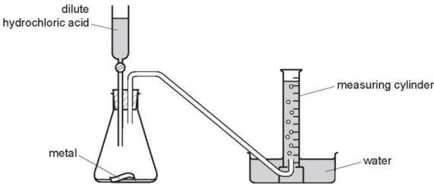
Which change decreases the rate of reaction? （ ）
A adding water to the flask
B heating the flask during the reaction
C using more concentrated acid
D using powdered metal
3.从collision theory 的角度分析各个因素对反应速率的影响。
1. Which row explains why increasing temperature increases the rate of reaction（ ）
 | particles collide more often | particles collide with more energy
A | ✓ | ✓
B | ✓ | ×
C | × | ✓
D | × | ×

2 .Ethanoic acid reacts slowly with calcium carbonate.
Which statements explain why an increase in temperature increases the rate of the reaction? （ ）
1 The activation energy of the reaction is decreased.
2 There is an increase in collision rate.
3 The particles have more energy.
4 There will be fewer successful collisions.
A 1 and 2 B 1 and 3 C 2 and 3 D 2 and 4
3. A sample of dilute nitric acid is added to lumps of limestone in a conical flask. The conical flask is placed on a balance and the loss in mass is measured.
A second sample of nitric acid of a different concentration is separately tested. All other conditions are kept the same.
The loss in mass in 1 minute at each concentration of nitric acid is shown.
concentration in mol/dm³ | loss in mass in 1 minute/g
0.5 | 0.15
1.0 | 0.25
Which row describes and explains the results obtained using $1.0mol/{dm}^{3}$ nitric acid compared with $0.5mol/{dm}^{3}$ nitric acid? （ ）
 | description | explanation
A | decrease in reaction rate | decrease in particle collision energy
B | decrease in reaction rate | increase in particle collision rate
C | increase in reaction rate | increase in particle collision rate
D | increase in reaction rate | increase in particle collision rate and collision energy
4. Which statements explain why increasing temperature increases the rate of a chemical reaction? （ ）
1 Heat makes the molecules move faster and collide more often.
2 Heat makes the molecules collide with more energy so they are more likely to react.
3 Increasing temperature lowers the activation energy for the reaction.
A 1 and 2 B 1 and 3 C 1 only D 2 only

5. Explain in terms of collisions between reacting particles each of the following.
The reaction rate would be slower if $20.0\text{g}$ of larger lumps of calcium carbonate and $40{\text{cm}}^{3}$ of hydrochloric acid, concentration $2.0{\text{mol / dm}}^{3}$ , were used.
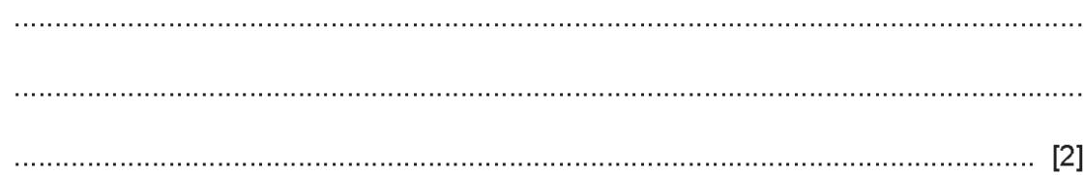

6. Explain in terms of collisions between reacting particles why the increase of temperature increases the rate of reaction


7. Explain in terms of collisions between reacting particles why the increase of pressure increases the rate of reaction with gas involved


8. Explain in terms of collisions between reacting particles why the increase of surface area increases the rate of reaction with gas involved


4. 掌握如何分析反应速率图，并掌握如何画出每个反应条件对反应速率图的影响
1. A student investigates the rate of reaction between zinc and an excess of sulfuric acid.
The graph shows the results of two experiments, X and Y.
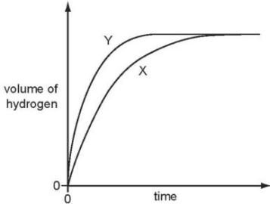
Which change explains the difference between X and Y? （ ）
A A catalyst is added in Y.
B A lower temperature is used in Y.
C Larger pieces of zinc are used in Y.
D Less concentrated acid is used in Y.

2. Which graph shows the effect of increasing temperature on the rate of reaction of calcium carbonate with dilute hydrochloric acid? （ ）
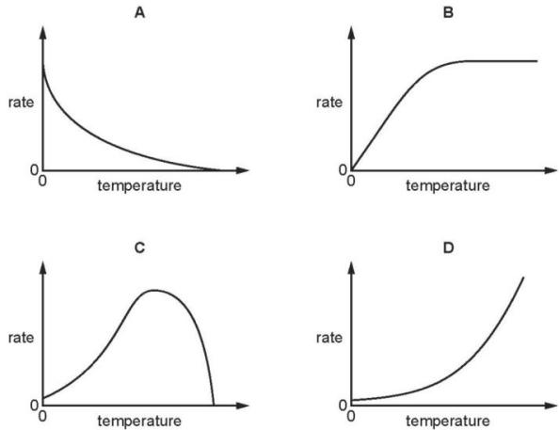
3 An organic compound decomposes to give off nitrogen.
$$C_{6}H_{5}N_{2}Cl(aq)→C_{6}H_{5}Cl(I)+N_{2}(g)$$
The speed of this reaction can be determined by measuring the volume of nitrogen formed at regular intervals. Typical results are shown in the graph below.
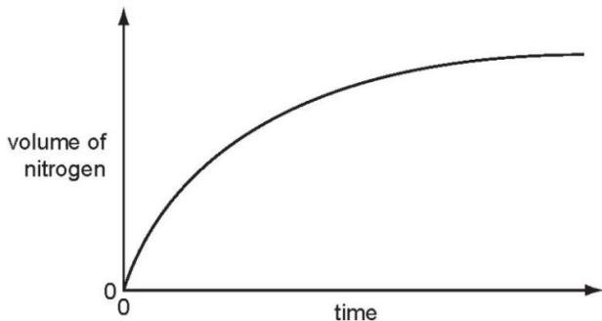
The reaction is catalysed by copper.
Sketch the graph for the catalysed reaction on the diagram above. [2]
4. The rate of reaction between magnesium and excess dilute hydrochloric acid was followed by measuring the mass of magnesium present at regular time intervals.
Two experiments were performed.
Both experiments used $0.1g$ of magnesium ribbon.
The acid in experiment 1 was less concentrated than in experiment 2.
Which graph shows the results of the experiments? （ ）
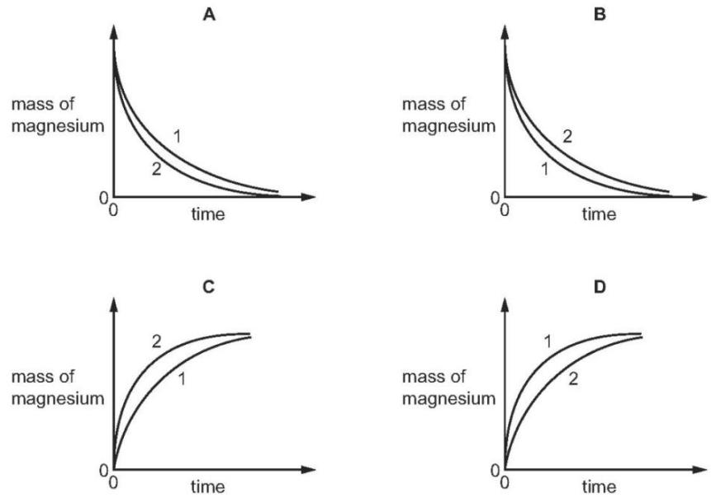

5. An excess of calcium carbonate is added to dilute hydrochloric acid, X.
The carbon dioxide gas given off is collected and its volume recorded at regular time intervals.
Line X on the graph shows the results obtained.
The experiment is repeated using dilute hydrochloric acid, Y.
Line Y on the graph shows the results obtained.
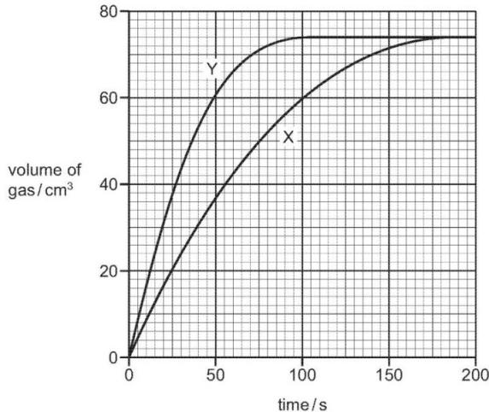
Which statement about the two hydrochloric acid samples, X and Y, is correct?（ ）
A They had the same volume but Y had higher concentration.
B They had the same concentration but Y had a larger volume.
C X had a higher concentration but Y had a larger volume.
D Y had a higher concentration but X had a larger volume.
6. Zinc granules are reacted with excess dilute hydrochloric acid.
The volume of hydrogen given off is measured at different times.
The results are shown on the graph, labelled experiment 1.
The results for a second experiment are shown on the graph, labelled experiment 2.
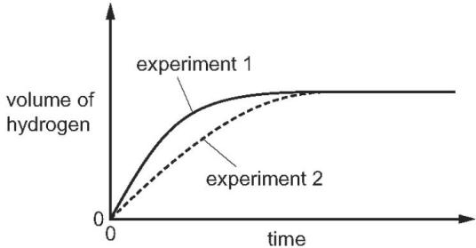
Which change to the conditions was made in experiment 2? （ ）
A The concentration of the hydrochloric acid was decreased.
B The size of the zinc granules was decreased.
C The surface area of the zinc granules was increased.
D The temperature was increased.

8. An experiment X is carried out between a solid and a solution using the apparatus shown.
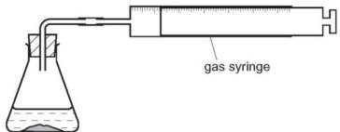
The volume of gas given off is measured at different times and the results plotted on a graph.
In a second experiment Y, the surface area of the solid is increased but all other factors remain the same.
Which graph shows the results of experiments X and Y? （ ）
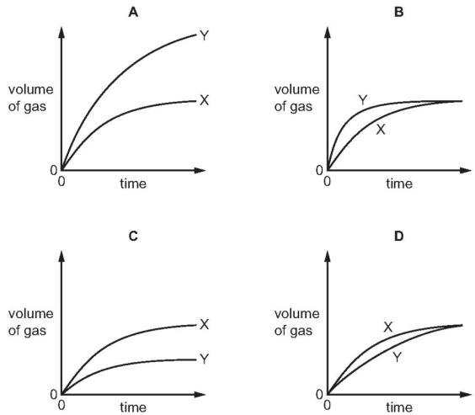

5. 测量反应速率的实验设计
1. The effect of temperature on this reaction can be studied by the experiment shown below. Starch and iodine form a blue-black colour. Glucose and iodine do not form a blue-black colour.
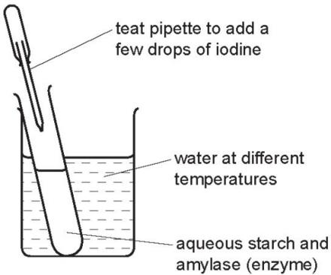
The experiment is set up as in the diagram and the time measured for the mixture to change from blue- black to colourless. The experiment is repeated at different temperatures. Typical results of this experiment are given in the table below.
experiment | temperature /℃ | time for blue-black colour to disappear /min
A | 20 | 30
B | 40 | 15
C | 70 | remained blue-black
Put the experiments in order of reaction rate - slowest first and fastest last.
.......................................................................................................................................
..................................................................................................................................[2]
2. precipitate of insoluble sulfur is produced. This makes the mixture difficult to see through.
$${Na}_{2}S_{2}O_{3}(aq)+2HCl(aq)→S(s)+2NaCl(aq)+H_{2}O(l)+{SO}_{2}(g)$$
The time taken for the cross to disappear from view is measured.
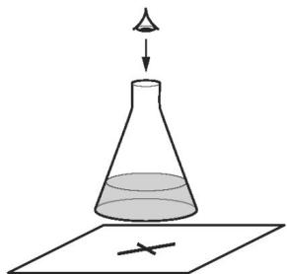
A student adds the following volumes of aqueous sodium thiosulfate, dilute hydrochloric acid and distilled water to the conical flask.
The time taken for the formation of the precipitate of sulfur to make the cross disappear from view is recorded.
experiment number | volume of sodium thiosulfate /cm³ | volume of hydrochloric acid /cm³ | volume of distilled water /cm³ | time taken for cross to disappear from view/s
1 | 10 | 10 | 40 | 56
2 | 20 | 10 | 30 | 28
3
In experiment 3 the student wanted the sodium thiosulfate to be double the concentration used in experiment 2.
(a). Complete the table to show the volumes which should be used and the expected time taken for the cross to disappear from view in experiment 3. [2]

(b). Use collision theory to explain why increasing the concentration of sodium thiosulfate would change the rate of reaction.
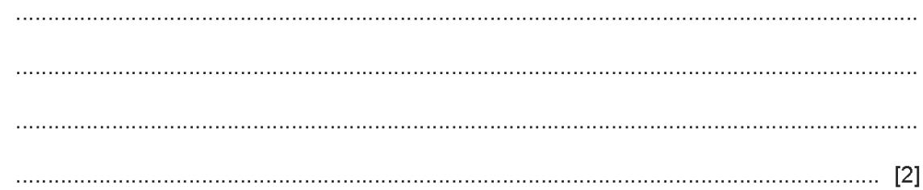

(c). The student repeated experiment 1 at a higher temperature.
Use collision theory to explain why the rate of reaction would increase.
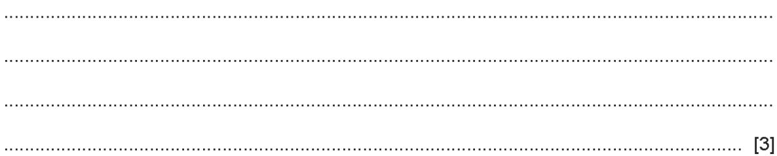

3. A small piece of marble, $CaCO_{3}$ was added to $5.0cm^{3}$ of hydrochloric acid, concentration $1.0mol/{dm}^{3}$ ,at ${25}^{∘}C$ . The time taken for the reaction to stop was measured. The experiment was repeated using $5.0cm^{3}$ of different solutions of acids. The acid was in excess in all of the experiments.
Typical results are given in the table.
experiment | temperature/℃ | acid solution | time/min
1 | 25 | hydrochloric acid 1.0 mol/dm³ | 3
2 | 25 | hydrochloric acid 0.5 mol/dm³ | 7
3 | 25 | ethanoic acid 1.0 mol/dm³ | 10
4 | 15 | hydrochloric acid 1.0 mol/dm³ | 8
Explain why it is important that the pieces of marble are the same size and the same shape.
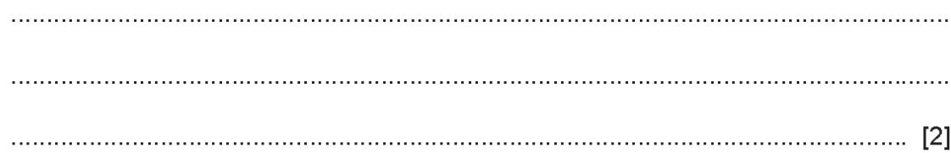
How would you know when the reaction had stopped?
..................................................................................................................................[1]

