Chapter 1 States of matter Key point list name: class:
- States of matter
Features | volume | fluidity | shape
solid | Fixed volume | Do not flow | Keep its own shape
liquid | Fixed volume | Flow easily | Take the shape of container
gas | No fixed volume | Flow easily | Take the shape of container

- Kinetic particle theory
Features | arrangement | distance | movement
solid | regular | Packed closely | Vibrate in the fixed position
liquid | irregular | Packed closely | Move around past each other
gas | irregular | Far apart | Move randomly

3) Changes of states
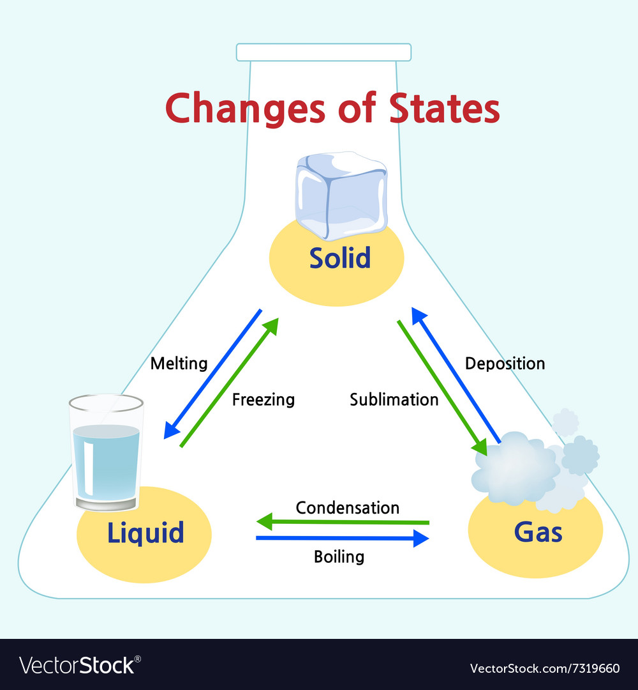

4) Diffusion
Particles move from a region of higher concentration towards a region
of lower concentration, eventually, the concentration is evenly spread.

Rate of diffusion is affected by:1. temperature
2. mass of the gas particles

