1.3 Cooling curve
Name: ____________________ Class: ____________________ Due date: 9.12
1. The boiling point of a substance is the temperature at which （ ）
A. It changes from solid to liquid
B. It changes from liquid to gas throughout the liquid
C. It changes from gas to liquid
D. It changes from solid to gas directly

2. During the melting process of a substance, the temperature （ ）
A. Increases
B. Decreases
C. Stays the same
D. First increases then decreases
3.The melting points and boiling points of three elements, at 1 atm pressure, are shown.
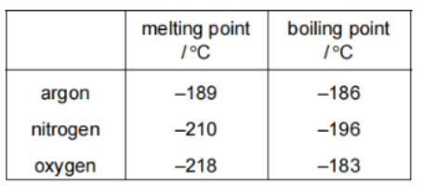
Separate samples of argon, nitrogen and oxygen are stored at -200℃ and at 1 atm pressure. How many samples are liquids? （ ）
A.0 B.1 C.2 D.3

4. The melting points and boiling points of four elements are shown.
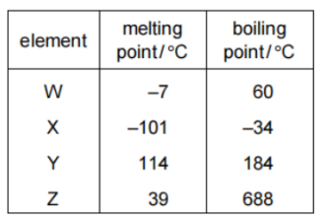
In which elements do the particles vibrate about fixed positions at 0 ℃? （ ）
A W and X B W and Z C X and Y D Y and Z

5. - (0620- S 2020- Paper 2 (Extended)/1- Q1) - STATES OF MATTER
A mixture of ice and water is left to stand and the ice melts.
Which row describes what happens as the ice is melting? （ ）
 | temperature of mixture | energy changes
A | increases | average kinetic energy of particles increases
B | increases | energy is used to overcome attractive forces
C | stays the same | average kinetic energy of particles increases
D | stays the same | energy is used to overcome attractive forces
6. Substance M is a solid at 30 C.
The substance is heated to 80 C and its temperature measured as it cools down
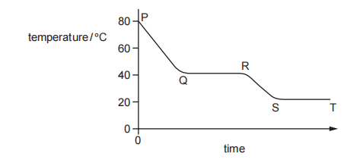
Between which times is substance M freezing? （ ）
A P to Q B Q to R C R to S D S to T

7. Substance M is a solid at 20 C.
The substance is heated to 80 C and its temperature measured as it cools down
Between which times is substance M in both solid and liquid state ? （ ）
A P to Q B Q to R C R to S D S to T

8 - (0620- W 2012- Paper 4 (Extended)/2- Q2) - STATES OF MATTER
The diagram shows a heating curve for a sample of compound X.
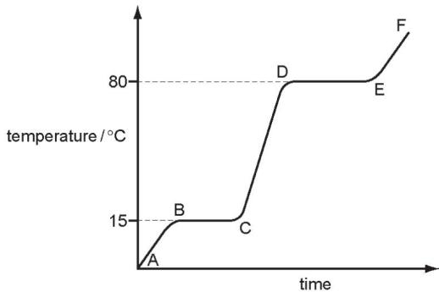
- ${20}^{∘}$Is X a solid, a liquid or a gas at room temperature, C?
.........................................................................................................................[1]
b.Name the change of state which occurs in region DE.
.........................................................................................................................[1]
9. The graph shows the change in temperature as a sample of a gas is cooled.
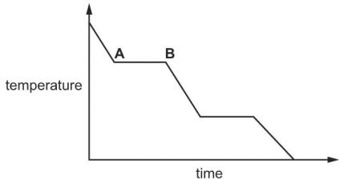
Name the change of state taking place between A and B.
..................................................................................................................................[1]
8. Look at graph for iron.
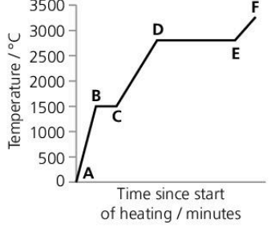
a What is happening between points D and E?

b Between which points is iron turning into a liquid?

c Give approximate melting and boiling points for iron.

8 - (0620- W 2017- Paper 4 (Extended)/1- Q2) - STATES OF MATTER
The graph shows how the temperature of a substance changes as it is cooled over a period of 30 minutes. The substance is a gas at the start.
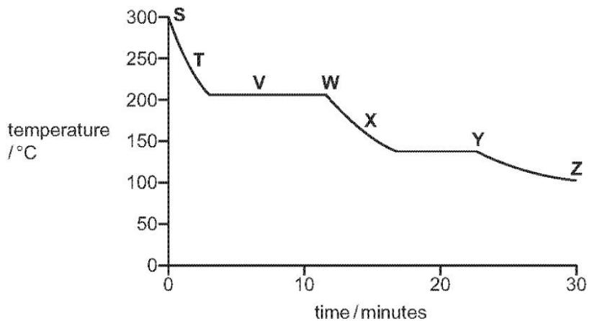
Each letter on the graph may be used once, more than once or not at all.
a.Which letter, S, T, V, W, X, Y or Z, shows when
b.the particles in the substance have the most kinetic energy,
............................................................................................................................[1]
(ii) the particles in the substance are furthest apart,
..................................................................................................................................[1]
(iii) the substance exists as both a gas and a liquid?
.................................................................................................................................. [1]
c.Use the graph to estimate the boiling point of the substance........................... [1]
d.Name the change of state directly from a solid to a gas..........................

