1.4 Diffusion
Name: ____________________ Class: ____________________ Due date: 9.19
1 - (0620- W 2014- Paper 1 (Core)/1- Q1) - STATES OF MATTER
Which statement is an example of diffusion? （ ）
A. A kitchen towel soaks up some spilt milk.
B. Ice cream melts in a warm room.
C. Pollen from flowers is blown by the wind.
D. The smell of cooking spreads through a house.

2 - (0620- W 2012- Paper 1 (Core)/3- Q1) - STATES OF MATTER
‘Particles moving very slowly from an area of high concentration to an area of low concentration.’
Which process is being described above? （ ）
A a liquid being frozen
B a solid melting
C a substance diffusing through a liquid
D a substance diffusing through the air

3- (0620- S 2013- Paper 1 (Core)/1- Q1) - STATES OF MATTER

The diagram shows a cup of tea.

Which row describes the water particles in the air above the cup compared with the water particles in the cup? （ ）
 | moving faster | closer together
A | ✓ | ✓
B | ✓ | ×
C | × | ✓
D | × | ×
4.The diagram shows an experiment to demonstrate diffusion.
Hydrochloric acid ：HCl ammonia ： NH₃₂
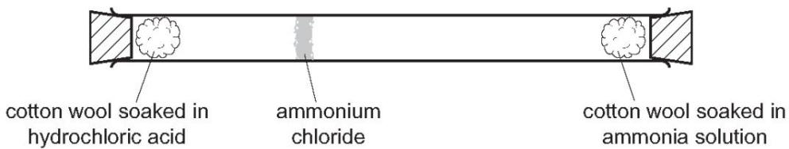
Which statement explains why the ring of ammonium chloride appears as shown? （ ）
A. Ammonia solution only produces a gas which moves until it meets the hydrochloric acid.
B. Both solutions produce a gas, but ammonia moves quicker than hydrogen chloride because it is lighter.
C. Hydrochloric acid produces hydrogen chloride which stays at one end of the tube until the ammonia reaches it.
D. The two solutions run along the tube until they meet.

5 - (0620- W 2018- Paper 2 (Extended)/2- Q1) - STATES OF MATTER
Oxygen and fluorine are gaseous elements next to each other in the Periodic Table.
Under the same conditions of temperature and pressure, oxygen(O₂) diffuses ….1. ..than fluorine (F₂) because its ….2. ..is less than that of fluorine.
Which words correctly complete gaps 1 and 2? （ ）
 | 1 | 2
A | faster | molecular mass
B | faster | reactivity
C | slower | molecular mass
D | slower | reactivity

6 - (0620- W 2019- Paper 2 (Extended)/1- Q1) - STATES OF MATTER
Samples of four gases are released in a room at the same time.
$HCl$$H_{2}S$$NO_{2}$The gases are carbon dioxide, CO₂ hydrogen chloride, , hydrogen sulfide, , and nitrogen dioxide, .
Which gas diffuses fastest? （ ）
A carbon dioxide B hydrogen chloride C hydrogen sulfide D nitrogen dioxide
7 - (0620- S 2015- Paper 1 (Core)/2- Q1) - STATES OF MATTER
The diagram shows a sugar lump in a cup of tea.
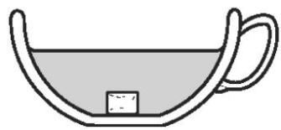
Which two processes must happen to spread the sugar evenly in the tea? （ ）
 | first process | second process
A | diffusion | dissolving
B | dissolving | diffusion
C | dissolving | melting
D | melting | diffusion

8 - (0620- W 2019- Paper 2 (Extended)/2- Q1) - STATES OF MATTER
The rate of diffusion of a gas depends on its molecular mass and the temperature.
Which combination of molecular mass and temperature gives the slowest rate of diffusion? （ ）
 | molecular mass | temperature
A | high | high
B | high | low
C | low | high
D | low | low

9 - (0620- W 2019- Paper 2 (Extended)/3- Q1) - STATES OF MATTER
Which two gases will diffuse at the same rate, at the same temperature? （ ）
A carbon monoxide (CO) and carbon dioxide (CO₂)
B carbon monoxide (CO) and nitrogen (N₂)
C chlorine (Cl₂)and fluorine ( F₂)
D nitrogen and oxygen

10. i. Different gases diffuse at different speeds.
What is meant by the term diffusion?
.......................................................................................................................................
.......................................................................................................................................
.......................................................................................................................................
ii.What property of a gas molecule affects the speed at which it diffuses?
.......................................................................................................................................
11. Concentrated ammonia solution gives off ammonia gas.
Concentrated hydrochloric acid gives off hydrogen chloride gas.
${NH}_{3}$$HCl$Ammonia, , and hydrogen chloride, , are both colourless gases.
Ammonia reacts with hydrogen chloride to make the white solid ammonium chloride.
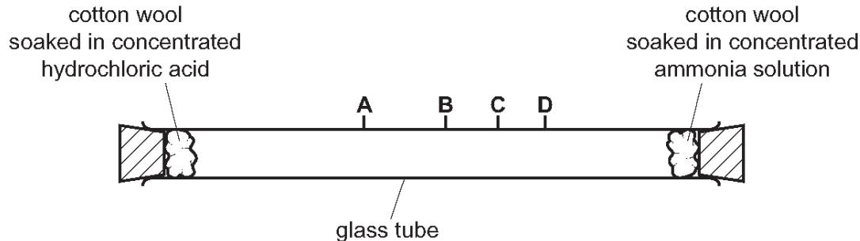
After ten minutes a white solid forms in the tube where the gases meet.
i.Name the process by which the ammonia and hydrogen chloride gases move in the tube.
...................................................................................................................................[1]
ii.At which point, A, B, C or D, does the white solid form? Explain why the white solid forms at that point.
the solid forms at ...........................
explanation.............................................................................................................................................................................................................................................................
iv.The experiment was repeated at a higher temperature.
Predict how the results of the experiment would be different. Explain your answer.
......................................................................................................................................
......................................................................................................................................
...................................................................................................................................[3]

