11.7 Titration
Name: ____________________ Class: ____________________ Due date: 12.11
1. Which salt preparation uses a burette and a pipette? （ ）
A calcium nitrate from calcium carbonate and nitric acid
B copper(II) sulfate from copper(II) hydroxide and sulfuric acid
C potassium chloride from potassium hydroxide and hydrochloric acid
D zinc chloride from zinc and hydrochloric acid

2. Crystals of sodium chloride were prepared by the following method.
$25.0cm^{3}$1 of dilute hydrochloric acid was accurately measured into a conical flask.
2 Aqueous sodium hydroxide was added until the solution was neutral. The volume of sodium hydroxide added was measured.
$15cm^{3}$3 Solution was evaporated and crystals washed with approximately of water.
$25.0cm^{3}$Which row shows the pieces of apparatus used to measure the of HCl,
$15cm^{3}$the volume of aqueous sodium hydroxide and the of water? （ ）
 | 25.0cm³ of hydrochloric acid accurately | the volume of aqueous sodium hydroxide added | 15cm³ of water approximately
A | burette | pipette | measuring cylinder
B | measuring cylinder | burette | pipette
C | pipette | burette | measuring cylinder
D | pipette | measuring cylinder | burette

3. The four pieces of apparatus shown below are used in chemical experiments.
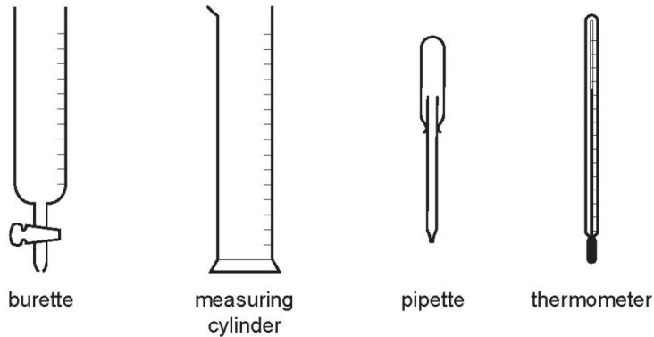
Which statement about the apparatus is correct? （ ）
A The burette measures the volume of liquid added in a titration.
B The measuring cylinder measures the mass of a substance used in an experiment.
C The pipette measures the volume of gas given off in a reaction.
D The thermometer measures the density of a solution.

4. A student did a single titration to find the concentration of a solution of dilute H₂SO₄.
The student added 25.0 cm3 of aqueous sodium hydroxide to a conical flask, followed by a fewdrops of indicator. Dilute sulfuric acid was then added to the aqueous sodium hydroxide until thesolution was neutral.
The apparatus used is shown in the diagram.
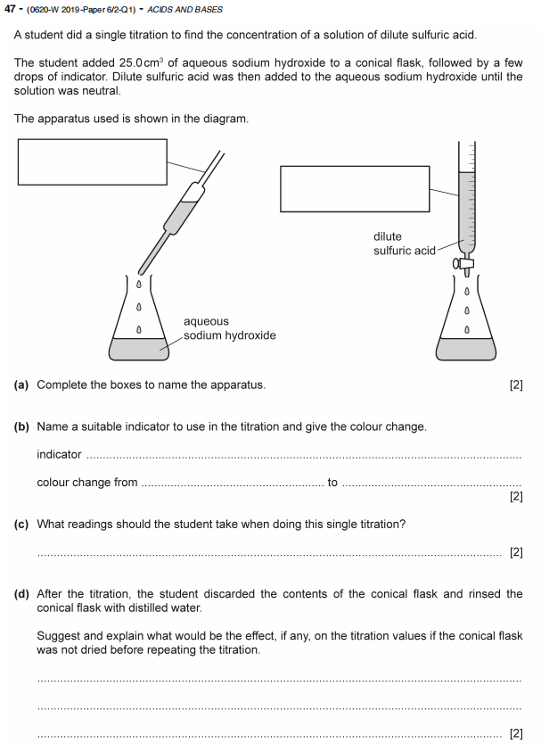

5.
