2.1 and 2.2 Proton number
Name: ____________________ Class: ____________________ Due date: 9.22
1. Which statements comparing the properties of electrons, neutrons and protons are correct? （ ）
 | neutrons and protons are both heavier than electrons | only electrons and neutrons are charged
A | ✓ | ✓
B | ✓ | ×
C | × | ✓
D | × | ×

2. Which statement about a neutron is not correct? （ ）
A It can be present in different numbers in atoms of the same element.
B It has no electrical charge.
C It is always found in the nucleus of an atom.
D It weighs much less than a proton.

3. Which statement about atoms is correct? （ ）
A Atoms contain protons and electrons in the nucleus.
B Neutrons are negatively charged.
C Protons are positively charged.
D The nucleon number is the number of neutrons.

4. Atoms contain particles called electrons, neutrons and protons.
a.Complete the table.
particle | where the particle is found in an atom | relative mass | relative charge
 | orbiting the nucleus | 1/1840
 | in the nucleus |  | +1

6. Atoms contain electrons, neutrons and protons.
What is the definition of nucleon number? （ ）
A the number of neutrons in the nucleus of an atom
B the number of protons in the nucleus of an atom
C the total number of neutrons and protons in the nucleus of an atom
D the total number of particles in an atom

7. The diagram shows the structure of an atom of element X.
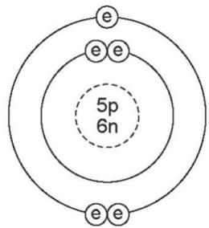
Key : e = electron n $≡$ neutron $\text{p}$ = proton
What is X? （ ）
A boron B carbon C sodium D sulfur
8 .The diagram shows the atomic structure of an element X.
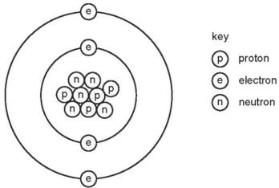
What is X? （ ）
A aluminium B beryllium C boron D fluorine

10. How many neutrons are present in the atom $​_{21}^{45}×$ （ ）
A 21 B 24 C 45 D 66

11. Which statement about an atom of fluorine, $​_{9}^{19}F$ , is correct? （ ）
A It contains more protons than neutrons.
B It contains a total of 28 protons, neutrons and electrons.
C Its isotopes contain different numbers of protons.
D Its nucleus contains 9 neutrons.
12. The table shows information about atoms of three different elements.
element | proton number | nucleon number | number of protons | number of neutrons | number of electrons
chlorine | 17 | 35 | 17 | W | 17
chlorine | 17 | X | 17 | 19 | 17
argon | Y | 40 | 18 | 22 | 18
potassium | 19 | 39 | 19 | 20 | Z
What are the values of W, X, Y and Z? （ ）
 | W | X | Y | Z
A | 18 | 35 | 18 | 19
B | 18 | 36 | 18 | 19
C | 19 | 35 | 19 | 18
D | 19 | 36 | 19 | 18

13. The table shows the composition of four atoms or ions, A, B, C and D
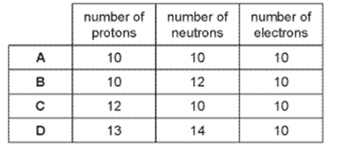

(i)What is the atomic number of A?
(ii)What is the nucieon number of B?
14. The table below gives the number of protons, neutrons and electrons in atoms or ions. Complete the table. The first line is given as an example. You will need to use the Periodic Table.
particle | number of protons | number of electrons | number of neutrons | symbol or formula
A | 4 | 4 | 5
B | 19 | 18 | 20
C | 30 | 30 | 35
D | 8 | 10 | 8
E | 31 | 31 | 39
15. Complete the following table which gives the number of protons, electrons and neutrons in eachof the five particles.
