2.3 Isotopes
Name: ____________________ Class: ____________________ Due date: 9.29
1. - (0620- W 2013- Paper 1 (Core)/3- Q4) - ATOMS AND ELEMENTS
The atomic structures of four atoms are shown.
atom | number of neutrons | number of protons | number of electrons
W | 6 | 6 | 6
X | 7 | 7 | 7
Y | 8 | 6 | 6
Z | 8 | 8 | 8
Which pair of atoms are isotopes? （ ）
A W and X B W and Y C X and Y D Y and Z

$​^{35}Cl$$​^{37}Cl$2. Chlorine exists as two common isotopes, and .
Information about these two isotopes is shown.
 | number of protons | number of neutrons | number of electron shells
35Cl | 17 | 18 | 3
37Cl | 17 | 20 | 3
Which statement explains why the two isotopes are of the same element? （ ）
A Both have the same number of electron shells.
B Both have the same number of protons.
C Both have 7 outer shell electrons.
${}^{37}Cl$${}^{35}Cl$D has 2 more neutrons than

3. - (0620- W 2018- Paper 2 (Extended)/3- Q3) - ATOMS AND ELEMENTS
Which statement describes isotopes? （ ）
A Isotopes of the same element have different electron arrangements.
B Isotopes of the same element have different nuclear charges.
C Isotopes of the same element have nuclei with masses that are the same.
D Isotopes of the same element have the same number of protons.
4. - (0620- S 2019- Paper 2 (Extended)/3- Q4) - ATOMS AND ELEMENTS
The structure of an atom is shown.
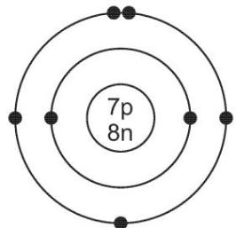
$•=$$n=$$p=$key electron neutron proton
Which element is the atom an isotope of? （ ）
A nitrogen B oxygen C phosphorus D titanium

5. - (0620- S 2016- Paper 2 (Extended)/1- Q4) - ATOMS AND ELEMENTS
Which statements about isotopes of the same element are correct? （ ）
1 They are atoms which have the same chemical properties because they have the same number of electrons in their outer shell.
2 They are atoms which have the same number of electrons and neutrons but different numbers of protons.
3 They are atoms which have the same number of electrons and protons but different numbers of neutrons.
A 1 and 2 B 1 and 3 C 2 only D 3 only

6. The table shows the nucleon number and the number of neutrons in one atom of isotopes W, X,Y and Z.
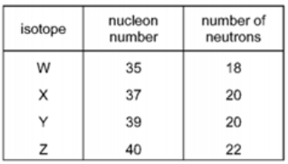
Which statement about W, X, Y and Z is correct? （ ）
A. W and X are isotopes of the same element.
B. X and Y are isotopes of elements in the same group of the Periodic Table.
C. Y and Z are isotopes of elements in the same period of the Periodic Table.
D. Z has a higher proton number than Y.

7. - (0620- S 2016- Paper 4 (Extended)/1- Q1) - ATOMS AND ELEMENTS
Bromine has two isotopes.
I. Define the term isotope.
.......................................................................................................................
.......................................................................................................................[2]
ii.Explain why the two isotopes of bromine have the same chemical properties.
.......................................................................................................................
....................................................................................................................... [2]

8. Lithium has two naturally occurring types of atoms, 6Li and 7Li.
(i) State the name given to atoms of the same element with different nucleon numbers.
................................................................................................................................. [1]
(ii) Complete Table 2.1 to show the number of protons, neutrons and electrons in the atom and ion of lithium shown.
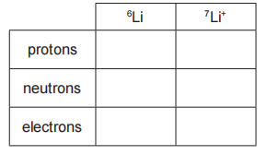
(iii) Table 2.2 shows the relative abundance of the two naturally occurring atoms of lithium.
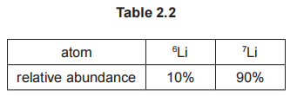
Calculate the relative atomic mass of lithium to one decimal place.

relative atomic mass = .............................. [2]

9. Cobalt and copper are transition elements.
(a) Copper has two naturally occurring isotopes, 63Cu and 65Cu. Cobalt has only one naturally occurring isotope, 59Co.
(i) Complete Table 2.1 to show the number of protons, neutrons and electrons in the 59Co atom and the 65Cu₂+ ion.
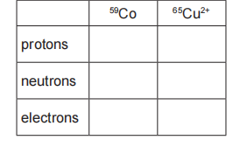
(ii) Table 2.2 shows the relative abundance of the two naturally occurring isotopes of copper.
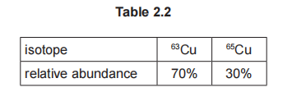
Calculate the relative atomic mass of copper to one decimal place.

relative atomic mass = .............................. [2]

10.The table shows the composition of four atoms or ions, A, B, C and D.
 | number of protons | number of neutrons | number of electrons
A | 10 | 10 | 10
B | 10 | 12 | 10
C | 12 | 10 | 10
D | 13 | 14 | 10
i.What is the atomic number of A?
.......................................................................................................................
ii.What is the nucleon number of B?
.......................................................................................................................
iii.Which of A, B, C and D are isotopes of each other?
.......................................................................................................................
iv.Which of A, B, C and D are atoms?
.......................................................................................................................
v.Which of A, B, C and D are positive ions?......................................
w.Complete the table.
 | number of protons | number of electrons
Na
S²-
Cl-

