2.4 Electronic configuration
Name: ____________________ Class: ____________________ Due date: 9.26
1.Which row gives the number of electrons in the outer electron shell of fluorine and of neon? （ ）
 | 19F | 20Ne
A | 7 | 8
B | 7 | 10
C | 9 | 8
D | 9 | 10

2.The diagram shows the electronic structure of a particle with a nucleon number (mass number) of 40.
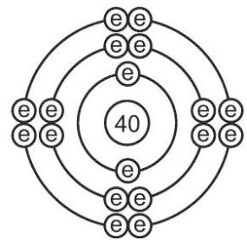
The table shows the suggestions that three students, 1, 2 and 3, made to identify the particle.
student
 | 1 | 2 | 3
particle | Ar | Cl | Ca₂+
Which students are correct? （ ）
A 1 and 2 only B 1 and 3 only C 2 and 3 only D 1, 2 and 3
3. (0620- W 2016- Paper 2 (Extended)/3- Q4) - ATOMS AND ELEMENTS
An atom has three electron shells. There are three electrons in the outer shell.
How many protons and how many neutrons are in this atom? （ ）
 | protons | neutrons
A | 13 | 14
B | 13 | 27
C | 14 | 13
D | 21 | 24
4. - (0620- W 2015- Paper 1 (Core)/3- Q3) - ATOMS AND ELEMENTS
Argon, Ar, has a higher relative atomic mass than potassium, K, but appears before it in the Periodic Table.
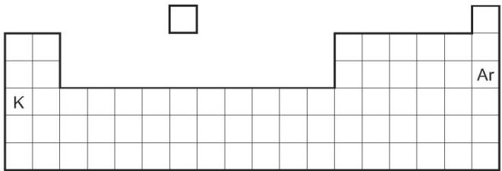
Why is argon listed before potassium in the Periodic Table? （ ）
A Argon has fewer neutrons than potassium.
B Argon has fewer protons than potassium.
C Argon has more neutrons than potassium.
D Argon has more protons than potassium.

5. The diagram shows an atom of an element.
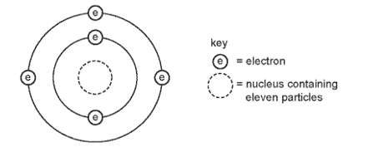
How many protons and neutrons are in the nucleus of the atom and in which group and period of the Periodic Table is the element found? （ ）
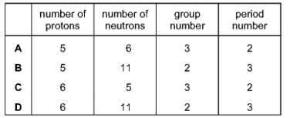

7. Element X has 7 protons.
Element Y has 8 more protons than X.
Which statement about element Y is correct? （ ）
A Y has more electron shells than X.
B Y has more electrons in its outer shell than X.
C Y is in a different group of the Periodic Table from X.
D Y is in the same period of the Periodic Table as X
8.The atomic structure of four particles are shown.
 | electrons | protons | neutrons
P | 18 | 17 | 18
Q | 18 | 17 | 20
R | 17 | 17 | 18
S | 17 | 17 | 20
Which particles have the same chemical properties? （ ）
A P and R only B P and S C P, Q and R D R and S

9. The table shows the nucleon number and the number of neutrons in one atom of isotopes W, X, Y and Z.
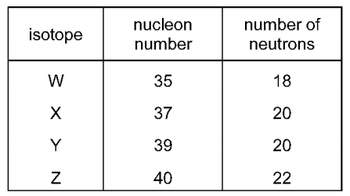
Which statement about W, X, Y and Z is correct? （ ）
A W and X are isotopes of the same element.
B X and Y are isotopes of elements in the same group of the Periodic Table.
C Y and Z are isotopes of elements in the same period of the Periodic Table.
D Z has a higher proton number than Y.
10. - (0620- W 2017- Paper 4 (Extended)/2- Q2) - ATOMs AND ELEMENTS
a.Complete the table to show the electronic structure of the atoms and ions.
 | electronic structure
F | 2,7
Si
Ca₂+
N3-
b.Complete the following table which gives information about carbon atoms and silicon atoms.
 | carbon | silicon
proton number
electronic structure
nucleon number | 12 | 28

11 - (0620- S 2014- Paper 4 (Extended)/1- Q1) - ATOMS AND ELEMENTS, ATOMS COMBINING
The table below gives the composition of six particles which are either atoms or ions.
particle | number of protons | number of neutrons | number of electrons
A | 33 | 40 | 33
B | 19 | 20 | 18
C | 34 | 45 | 36
D | 33 | 42 | 33
E | 13 | 14 | 13
F | 24 | 28 | 21
a.Which particles are atoms? Explain your choice.
b.Which particle is a negative ion and why has this particle got a negative charge?
c.Which particles are positive ions?

