3.1 Ionic bond
Name: ____________________ Class: ____________________ Due date: 10.10
1. Sodium chloride is an ionic solid.
Which statement is not correct? （ ）
A Ions are formed when atoms lose or gain electrons.
B Ions in sodium chloride are strongly held together.
C Ions with the same charge attract each other.
D Sodium chloride solution can conduct electricity.

2. The electronic structures of atoms P and Q are shown.
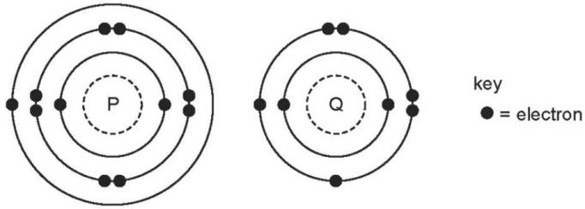
P and Q react to form an ionic compound.
What is the formula of this compound? （ ）
A PQ2 B P2Q C P2Q6 D P2Q2

3. - (0620- W 2013- Paper 1 (Core)/1- Q6) - ATOMS COMBINING
Rubidium is in Group I of the Periodic Table and bromine is in Group VII.
Rubidium reacts with bromine to form an ionic compound.
Which row shows the electron change taking place for rubidium and the correct formula of the rubidium ion? （ ）
 | electron change | formula of ion formed
A | electron gained | Rb+
B | electron gained | Rb−
C | electron lost | Rb+
D | electron lost | Rb−

4. - (0620- W 2012- Paper 1 (Core)/2- Q6) - ATOMS COMBINING
The table shows the electronic structures of four atoms.
atom | electronic structure
W | 2,1
X | 2,7
Y | 2,8,4
Z | 2,8,8
Which two atoms combine to form an ionic compound? （ ）
A W and X B W and Y C X and Y D X and Z

5. - (0620- W 2014- Paper 1 (Core)/3- Q7) - ATOMS COMBINING
$​_{9}^{19}X​_{19}^{39}Y$Element X, , forms a compound with element Y,
Which statement describes the bonding in the compound formed? （ ）
A X and Y share electrons.
B X gives away one electron to Y.
C Y gives away one electron to X.
D Y gives away two electrons to X.

6. Three ionic compounds of vanadium have the formulae V₂O, VCl ₂ and V₂O₃.
What is the charge on the vanadium ion in each compound? （ ）
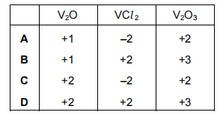

7. - (0620- W 2015- Paper 1 (Core)/1- Q7) - ATOMS COMBINING
$MgO_{2}$Two atoms of magnesium, , react with one molecule of oxygen, .
What is the formula of the product? （ ）
A MgO B MgO₂ C Mg₂O D Mg₂O₂
8. - (0620- W 2016- Paper 2 (Extended)/2- Q5) - ATOMs COMBINING
In which ionic compound do the metal ion and the non- metal ion have the same electronic structure? （ ）
A CaO B KBr C MgO D NaCl

9. Elements X and Y react to form a compound.
Element X loses two electrons and element Y gains one electron.
What is the charge on the ions of elements X and Y and what is the formula of the compound? （ ）
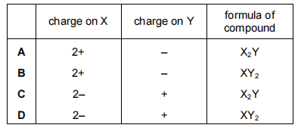
10. Potassium iodide (KI) is an ionic compound.
(i) Describe what happens, in terms of electron loss and gain, when a potassium atom reacts with an iodine atom.
..................................................................................................................................
.................................................................................................................................
(ii) Describe the structure of the following susbtances. You may draw a diagram.
KI
CaCl₂

CaO
(iii) Explain why potassium iodide has a high melting point.
.....................................................................................................................................
......................................................................................................................................

12.The symbols of six particles are shown below.
Na+ Ca₂+ Kr P Si O2-
Select from the list of particles to answer the following questions. A particle may be selected once, more than once or not at all.
(i) Which two ions have the same electronic structure? ................................. [1]
(ii) Which ion has the same electronic structure as an atom of argon? .................[1]

