3.3 properties with bonds
Name: ____________________ Class: ____________________ Due date: 10.13
1. The electronic structures of two atoms, X and Y, are shown.
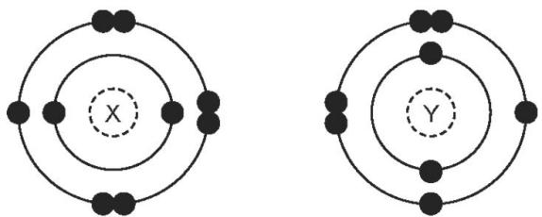
X and Y combine together to form a compound.
What is the type of bonding in the compound and what is the formula of the compound? （ ）
 | type of bonding | formula
A | covalent | X₂Y
B | covalent | XY₂
C | ionic | XY₂
D | ionic | X₂Y

2. In which compounds are pairs of electrons shared between atoms? （ ）
1 methane (CH₄)
2 lead bromide (PbBr₂)
3 sodium chloride(NaCl)
A 1 only B 2 only C 1 and 3 D 1, 2 and 3

3.Metal P reacts with non- metal Q to form a compound.
Which process takes place and which type of compound is formed? （ ）
 | process | type of compound
A | electrons are transferred from P to Q | covalent
B | electrons are transferred from P to Q | ionic
C | electrons are transferred from Q to P | covalent
D | electrons are transferred from Q to P | ionic

4. The table contains information about four substances.
Which substance is potassium chloride? （ ）
 | melting point /℃ | conduction of electricity
 | melting point /℃ | when molten | in aqueous solution
A | 11 | no | yes
B | 98 | yes | yes
C | 772 | yes | yes
D | 1410 | no | insoluble

5.Which substance is methane (CH₄)? （ ）
 | volatility | electrical conductivity at room temperature | solubility in water
A | high | good | soluble
B | high | poor | insoluble
C | low | good | soluble
D | low | poor | insoluble

6. Which statement describes the attractive forces between molecules (intermolecular forces)? （ ）
A They are strong covalent bonds which hold molecules together.
B They are strong ionic bonds which hold molecules together.
C They are weak forces formed between covalently- bonded molecules.
D They are weak forces which hold ions together in a lattice.

7. Which statement about an ionic compound is not correct? （ ）
A It conducts electricity when dissolved in water.
B It has a high melting point due to strong attractive forces between ions.
C It has a regular lattice of oppositely charged ions in a ‘sea of electrons’.
D The ionic bonds are formed between metallic and non- metallic elements.

8. Compound X melts at 801 °C and is a good electrical conductor when dissolved in water.Compound Y boils at 77 °C, is insoluble in water and is a non - conductor of electricity.
Which type of bonding is present in X and in Y? （ ）
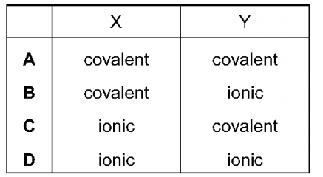
9. Explain why potassium iodide (KI) has higher melting point than H₂O.
.......................................................................................................................................................................................................................................................................................................................................................................................................................
.......................................................................................................................................
10. Explain why potassium iodide (KI) can conduct electricity only when melten.
.......................................................................................................................................................................................................................................................................................................................................................................................................................

11. Explain why water (H₂O).can not conduct electricity in terms of structure.
.......................................................................................................................................................................................................................................................................................................................................................................................................................
12. Draw a dot - and - cross diagram to show the electron arrangements for the following compounds

MgCl₂
MgO

NH₃
CO₂

