4.2 equations
Name: ____________________ Class: ____________________ Due date: 9.30
1. The equation for the reaction between phosphorus and oxygen is shown.
xP4 + yO₂ → zP2O₅
Which values of x, y and z balance the equation? （ ）
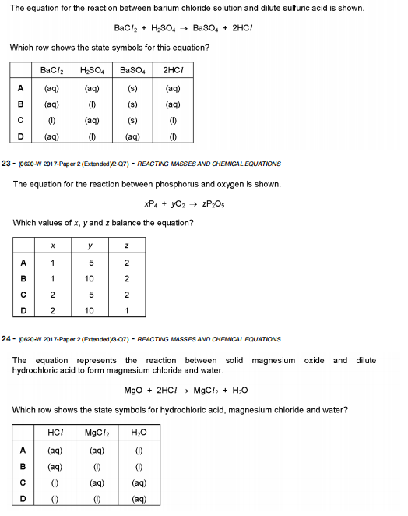

2. Propane burns in oxygen.
C₃H₈ + xO₂ → 3CO₂ + yH₂O
Which values of x and y balance the equation? （ ）
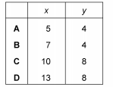

3. Aluminium metal reacts with iron(III) oxide to form aluminium oxide and iron.
Which chemical equation for the reaction between aluminium and iron(III) oxide is correct? （ ）
A FeO + Al → AlO + Fe
B Fe₂O₃ + 2Al → Al₂O + 2Fe
C Fe₂O₃ + Al → Al₂O₃ + Fe
D Fe₂O₃ + 2Al → Al₂O₃ + 2Fe

4. Ethyl methanoate, HCOOC₂H₅, burns in excess oxygen to produce carbon dioxide and water.
The equation is shown.
2HCOOC₂H₅ + xO₂ → 6CO₂ + 6H₂O
What is the value of x? （ ）
A 2 B 7 C 9 D 18

5. Sodium carbonate reacts with sulfuric acid to form carbon dioxide, water and a sodium salt.
An incomplete equation for the reaction is shown.
Na₂CO₃ + H₂SO₄ → CO₂ + H₂O +...............
What is the formula of the sodium salt? （ ）
A Na₃(SO₄)₂ B Na₃SO₄ C Na₂SO₄ D NaSO₄
6. When propane burns in air, carbon dioxide and water are formed.
What is the chemical equation for this reaction? （ ）
A C₃H₈ + 2O₂ → CO₂ + 2H₂O
B C₃H₈ + 3O₂ → 3CO₂ + H₂O
C C₃H₈ + 4O₂ → 3CO₂ + 4H₂O
D C₃H₈ + 5O₂ → 3CO₂ + 4H₂O
7. Lead(II) nitrate, Pb(NO₃)₂, reacts with potassium iodide, KI, to form a yellow precipitate, PbI₂, and a soluble salt, KNO₃.
What is the equation for the reaction? （ ）
A Pb(NO₃)₂ + KI → PbI₂ + KNO₃
B Pb(NO₃)₂ + 2KI → PbI₂ + KNO₃
C 2Pb(NO₃)₂ + 2KI → PbI₂ + 2KNO₃
D Pb(NO₃)₂ + 2KI → PbI₂ + 2KNO₃

8. Which equations are balanced? （ ）
1 Fe₂O₃ + 3CO → 2Fe + 3CO₂
2 ZnCO₃ + 2HCl → ZnCl₂ + CO₂ + 2H₂O
3 Mg(NO₃)₂ + NaOH → Mg(OH)₂ + 2NaNO₃
4 CaCO₃ + H₂SO₄ → CaSO₄ + H₂O + CO₂
A 1 and 2 B 1 and 4 C 2 and 3 D 3 and 4

9. The equation for the reaction between barium chloride solution and dilute sulfuric acid is shown.
BaCl₂ + H₂SO₄ → BaSO₄ + 2HCl

Which row shows the state symbols for this equation? （ ）

10. Calcium metal reacts with water to form a solution of calcium hydroxide and hydrogen gas.
Which equation is correct? （ ）
A Ca(s) + H₂O(aq) → CaOH(aq) + H(g)
B Ca(s) + 2H₂O(aq) → Ca(OH)₂(s) + 2H₂(g)
C Ca(s) + 2H₂O(l) → Ca(OH)₂(aq) + H₂(g)
D Ca(s) + H₂O(l) → CaOH(l) + H(g)

11. Aqueous iron(III) sulfate and aqueous sodium hydroxide react to give a precipitate of iron(III) hydroxide and a solution of sodium sulfate.
What is the balanced equation for this reaction? （ ）
A Fe₂(SO₄)₃(aq) + 2NaOH(aq) → Fe(OH)₃(s) + Na₂SO₄(aq)
B Fe₂(SO₄)₃(aq) + 3NaOH(aq) → Fe(OH)₃(s) + 3Na₂SO₄(aq)
C Fe₂(SO₄)₃(aq) + 6NaOH(aq) → 2Fe(OH)₃(s) + 3Na₂SO₄(aq)
D 2Fe₂(SO₄)₃(aq) + 6NaOH(aq) → 4Fe(OH)₃(s) + 6Na₂SO₄(aq)

12. What do + and → mean, in an equation

13. Balance these equations:
a Na (s) + Cl₂ (g) → NaCl (s)
b H₂ (g) + I₂ (g) → HI (g)
c Na (s) + H₂O (l) → NaOH (aq) + H₂ (g)
d NH₃ (g) → N₂ (g) + H₂ (g)
e Al (s) + O₂ (g) → Al₂O₃ (s)
14. Now write a word equation for each of the symbol equations in 14.

15. Aluminium burns in chlorine to form aluminium chloride, AlCl₃, a solid. Write a balanced equation for the reaction.

