Chapter 11 review
Name: ____________________ Class: ____________________ Due date:
1. Solutions of acid R and acid S have the same concentration.
The same volume of each acid at the same temperature is reacted with the same mass of magnesium ribbon.
The volume of hydrogen produced is measured.
The results are shown.
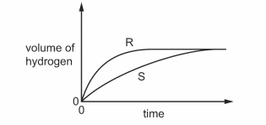
Which statement about the reactions is correct? （ ）
A Acid S reacts faster than acid R.
B The final volume of hydrogen produced in each reaction is different.
C Acid R is a stronger acid than acid S.
D Acid S is a stronger acid than acid R.

2. Some reactions involving sodium are shown.
Which reaction does not involve the formation of a base? （ ）

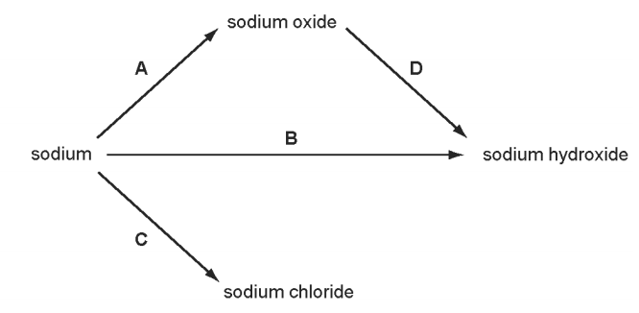

3. Only two elements are liquid at 20 °C.
One of these elements is shiny and conducts electricity.
This suggests that this element is a ……1…… and therefore its oxide is ……2……
Which words correctly complete gaps 1 and 2? （ ）
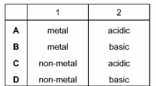
4. Hydrochloric acid is used to clean metals. The acid reacts with the oxide layer on the surface of the metal, forming a salt and water.
Which word describes the metal oxide? （ ）
A alloy
B base
C element
D indicator
5. Which statement about oxides is correct?
A A solution of magnesium oxide has a ph less than pH 7.
B A solution of sulfur dioxide has a ph greater than pH 7.
C Magnesium oxide reacts with nitric acid to make a salt.
D Sulfur dioxide reacts with hydrochloric acid to make a salt.
6. In which row are the oxides correctly identified? （ ）
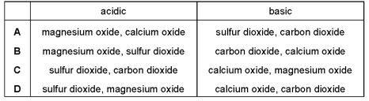
7. Which statement about amphoteric oxides is correct? （ ）
A Made by combining acidic and basic oxides
B React with water to give pH 7 solution
C React with both acids and bases
D Don't react with acids or bases
8. What is not a typical characteristic of acids? （ ）
A They react with alkalis producing water.
B They react with all metals producing hydrogen.
C They react with carbonates producing carbon dioxide.
D They turn blue litmus paper red.

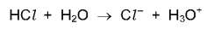
9. Hydrogen chloride gas reacts with water to produce an acidic solution. The equation for the reaction is shown.

Which statement describes what happens during the reaction? （ ）
A The chloride ion is formed by accepting an electron from the water.
B The hydrogen chloride loses an electron to form the chloride ion.
C The water accepts a proton from the hydrogen chloride.
D The water donates a proton to the hydrogen chloride.

A student investigated the diffusion of ammonia gas (${\text{NH}}_{3}$) and hydrogen chloride gas ($\text{HCl}$).
The damp red litmus paper in apparatus 1 changed colour after 30 seconds.
How long does it take for the damp blue litmus paper to change colour in apparatus 2?
A 64 seconds
B 30 seconds
C 21 seconds
D The blue litmus paper would not change colour.

Which statement about acids and bases is correct?
A A base is a donor of hydrogen ions.
B An acid is an acceptor of protons.
C A strong acid is fully ionised in aqueous solution.
D A weak acid cannot be used to neutralise a strong base.

Aqueous sodium hydroxide is added to solid Q in a test-tube.
A gas is produced which turns damp red litmus blue. What is Q?
A aluminium B ammonia C ammonium chloride D sodium nitrate

Ethanoic acid is a weak acid. Hydrochloric acid is a strong acid.
Which statements are correct?
1 Ethanoic acid molecules are partially dissociated into ions
2 $1.0 {\text{mol/dm}}^{3}$ ethanoic acid has higher pH than $1.0 {\text{mol/dm}}^{3}$ hydrochloric acid
3 Ethanoic acid is always more dilute than hydrochloric acid
A 1 and 2 B 1 and 3 C 2 and 3 D 1，2 and 3

Solutions of acid R and acid S have the same concentration.
The same volume of each acid at the same temperature is reacted with the same mass of magnesium ribbon.
The volume of hydrogen produced is measured.
The results are shown.
Which statement about the reactions is correct?
A Acid S reacts faster than acid R.
B The final volume of hydrogen produced in each reaction is different.
C Acid R is a stronger acid than acid S.
D Acid S is a stronger acid than acid R.
13. Carbonic acid is a weak acid formed when carbon dioxide dissolves in water.
What is the pH of the solution?
A 1 B 5 C 7 D 9

14. Which statements about dilute sulfuric acid are correct?
1 It turns red litmus paper blue.
2 It reacts with magnesium(II) oxide to form magnesium(II) sulfate and water.
3 It reacts with magnesium to form magnesium(II) sulfate and carbon dioxide.
4 Its pH is below pH 7.
A 1 and 2 only
B 1 and 3 only
C 2 and 4 only
D 3 and 4 only

12 Solution Q is warmed with ammonium chloride In a separate experiment,solution Q is added to methyl orange.
Which observations show that solution Q is basic?
