Chapter3 review
Name: ____________________ Class: ____________________ Due date: Optional
1 - (0620- W 2016- Paper 2 (Extended)/1- Q7) - ATOMS COMBINING
X is a solid at room temperature. X has a high melting point. Solid X conducts electricity.
Which diagram shows how the particles are arranged in solid X? （ ）
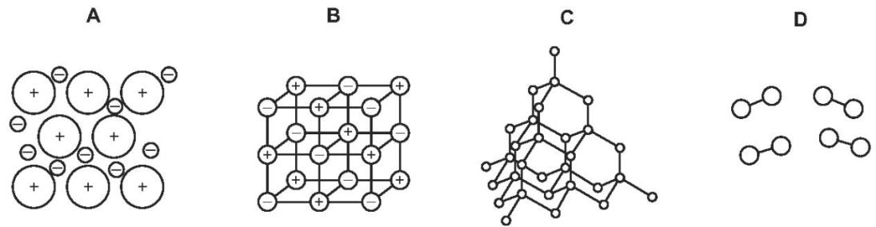
- (0620- S 2014- Paper 1 (Core)/3- Q7) - ATOMS COMBINING
Solid F is an element of Carbon . Solid G is a compound.
Neither solid conducts electricity but G conducts electricity when dissolved in water.
These properties suggest that F is ….1. ..and that G is ….2. ..with ….3. ..bonds.
Which words correctly complete gaps 1, 2 and 3? （ ）
 | 1 | 2 | 3
A | diamond | AgCl | covalent
B | diamond | NaCl | ionic
C | graphite | AgCl | ionic
D | graphite | NaCl | covalent

- (0620- S 2013- Paper 1 (Core)/1- Q6) - ATOMS COMBINING
For which substance is the type of bonding not correct? （ ）
 | substance | type of bonding
 | substance | ionic | covalent | metallic
A | chlorine | ✓ | ✓
B | potassium bromide | ✓
C | sodium |  |  | ✓
D | sodium chloride |  | ✓

- (0620- W 2016- Paper 2 (Extended)/2- Q7) - ATOMS COMBINING
Iron is a metal. Its structure consists of a giant lattice of positive ions in a ‘sea of electrons’. Which statements about solid iron are correct? （ ）
1 Iron conducts electricity because the electrons are free to move.
2 Iron conducts heat because the positive ions are free to move.
3 Iron has a high melting point due to the strong covalent bonds.
4 Iron is malleable because the layers of ions can slide over one another.
A 1 and 3 B 1 and 4 C 1 only D 2, 3 and 4

. - (0620- S 2020- Paper 2 (Extended)/2- Q7) - ATOMS COMBINING
The bonding, structure and melting point of sodium chloride and sulfur dichloride are shown.
compound | bonding | structure | melting point/℃
sodium chloride | ionic | giant lattice | 801
sulfur dichloride | covalent | simple molecular | -121
Why does sulfur dichloride have a lower melting point than sodium chloride? （ ）
A The covalent bonds in sulfur dichloride are weaker than the attractive forces between molecules in sodium chloride.
B The covalent bonds in sulfur dichloride are weaker than the ionic bonds in sodium chloride.
C The attractive forces between molecules in sulfur dichloride are weaker than the attractive forces between molecules in sodium chloride.
D The attractive forces between molecules in sulfur dichloride are weaker than the ionic bonds in sodium chloride.
. - (0620- S 2020- Paper 2 (Extended)/3- Q6) - ATOMS COMBINING
Caesium is a metal in Group I of the Periodic Table.
Which description of the bonding in caesium is correct? （ ）
A electrostatic attraction between oppositely charged ions
B electrostatic attraction between positive metal ions and mobile electrons
C neighbouring metal atoms sharing pairs of electrons
D strong attractive forces between atoms
. - (0620- S 2020- Paper 2 (Extended)/3- Q7) - ATOMS COMBINING
Why does magnesium oxide, MgO, have a very high melting point? （ ）
A There is a very strong double bond between magnesium and oxygen.
B There is a very strong attractive force between the magnesium oxide molecules.
C The oxide ions are strongly attracted to positive ions.
D The magnesium ions are strongly attracted to a sea of electrons.
. Draw a dot - and - cross diagram to show the electron arrangements for the following compounds
MgCl₂
Na₂O

NH₃ | CO₂

11. The table gives the melting points, the boiling points and the electrical properties of six substances A to F. 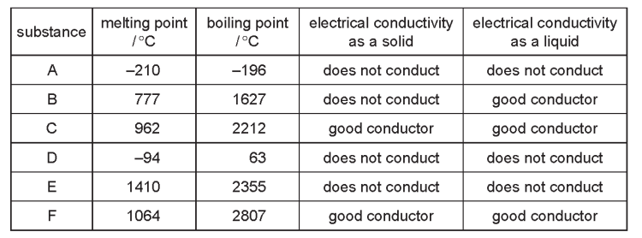
(a) Which two substances could be metals? ......................................................
(b) Which substance could be nitrogen（N₂）? ......................................................
(c) Which substance is an ionic solid? ......................................................
(d) Which substance is a liquid at room temperature? ...............................................
(e) Which substance has a giant covalent structure similar to that of diamond? ...........
(f) Which two substances could exist as simple covalent molecules? ...........................
12. Diamond and graphite are different forms of the same element, carbon.
Explain the following in terms of their structure and bonding.
(a) Graphite is a soft material which is used as a lubricant.
.................................................................................................................................
.......................................................................................................................[4]
(b) Diamond is a very hard material which is used for drilling and cutting.
.................................................................................................................................
.......................................................................................................................[4]
(c) Graphite is a good conductor of electricity and diamond is a poor conductor.
...................................................................................................................................................................................................................................................................... [4]
(d) Explain in terms of structure and bonding why Copper has a much higher melting point than carbon monoxide(CO).
...................................................................................................................................................................................................................................................................................................................................................................................................................[6]

