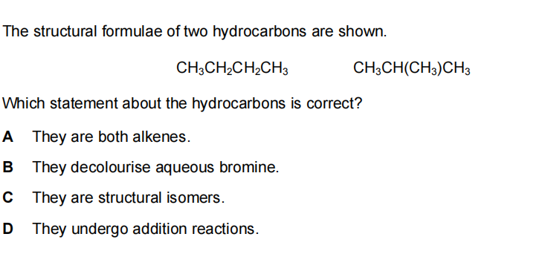6. Butane and methylpropane are isomers with molecular formula $C_{4}H_{10}$
Which statements are correct? （ ）
1 They have similar chemical properties.
2 They have the same general formula.
3 They have the same structural formula.
A 1,2 and 3 B 1 and 2 only C 1 and 3 only D 2 and 3 only

The structure of an alkene molecule with the molecular formula $C_{4}H_{8}$ is shown.
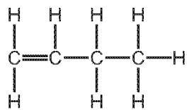
Draw the structure of a different alkene molecule with the molecular formula $C_{4}H_{8}$ .
Show all of the atoms and all of the bonds.
What term describes molecules with the same molecular formula but different structural formulae?
................................................................................................................................[1]

ii.A compound containing bromine is formed in this reaction. Draw the structure of this compound. Show all of the atoms and all of the bonds.
Draw the structure of an unbranched isomer of compound S. Show all of the atoms and all of the bonds. Name this unbranched isomer of compound S.
structure.........................................................................................................................
name..........................................................................................................................[2]

Iv.Explain why the following two alcohols are isomers.
.......................................................................................................................................
.......................................................................................................................................
.......................................................................................................................................
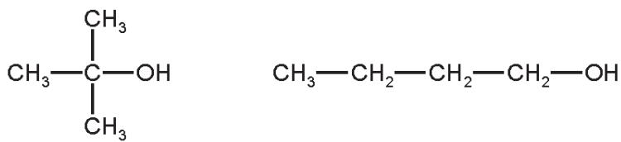
[2]

