53. Which row identifies a chemical and a physical change?
 | chemical change | physical change
A | boiling ethanol | burning ethanol
B | burning ethanol | evaporating ethanol
C | dissolving ethanol in water | burning ethanol
D | evaporating ethanol | dissolving ethanol in water

54. A sequence of changes involving sulfur is shown.
$$S(s)\overset{change1}{→}S(l)\overset{change2}{→}SO_{2}(g)$$
Which row describes the changes?
 | change 1 | change 2
A | chemical | chemical
B | chemical | physical
C | physical | chemical
D | physical | physical

105. Which diagram represents a chemical change?
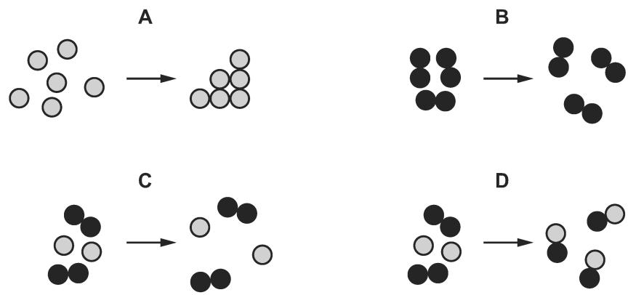
106 .Which list contains only chemical changes?
A melting, evaporating, dissolving
B rusting, freezing, subliming
C neutralisation, polymerisation, combustion
D boiling, condensing, distillation
107 . In which tube is a physical change taking place?
