
WEBSITE BLUEPRINT & DESIGN SYSTEM
Detailed Site Outline • Components • Buttons • Forms • UX • SEO
Version 2.0

1. Purpose of This Blueprint
This document is the working specification for the Right Away Lending website. It expands the high-level sitemap into detailed page sections, reusable components, button behavior, form requirements, visual rules, conversion paths, accessibility standards, SEO requirements, and development guidance.

2. Approved Brand Foundation
The current approved website direction uses the uploaded official logo and the premium navy-and-green website palette. The logo should be used as supplied and should not be redrawn or recolored without owner approval.
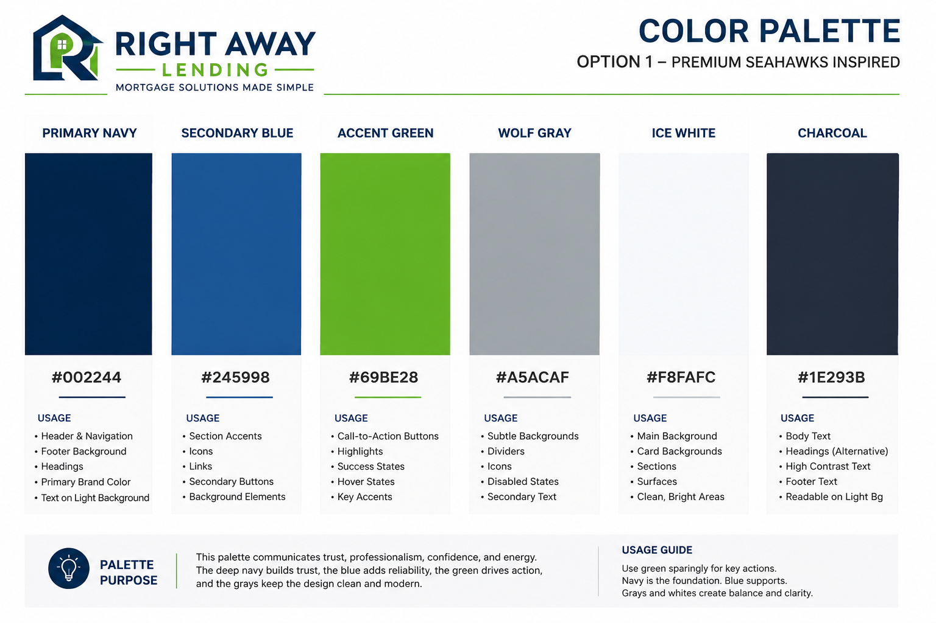
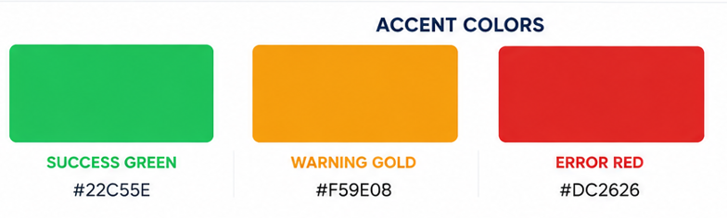
Token | Hex | Primary Use | Restrictions
Brand Navy | #002244 | Header, footer, major headings, primary dark surfaces | Do not use for dense body text on dark backgrounds
Support Blue | #245998 | Links, secondary actions, icons, informational accents | Use less frequently than navy
Action Green | #69BE28 | Primary CTA, active states, selected controls, highlights | Reserve for actions; avoid large text blocks
Wolf Gray | #A5ACAF | Borders, separators, muted icons, disabled states | Not for small text on white
Ice White | #F8FAFC | Page backgrounds, alternating sections, card areas | Use true white for elevated cards
Charcoal | #1E293B | Body copy and high-contrast text | Default text color
Success | #22C55E | Successful submission and completion states | Status only—not a brand accent
Warning | #F59E0B | Warnings and attention states | Status only
Error | #DC2626 | Errors and validation messages | Status only

3. Site Architecture
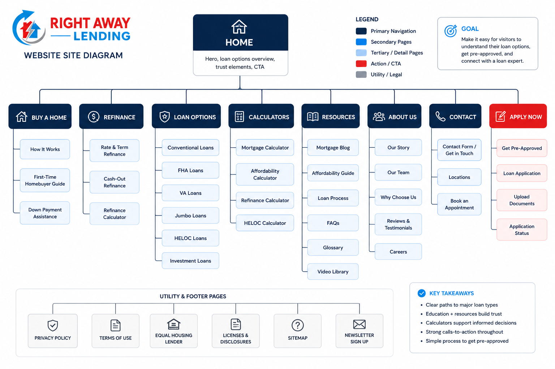

Primary Navigation
- Home
- Loan Programs
- First-Time Buyers
- Resources
- About
- Reviews
- Contact

Loan Programs
- Conventional
- FHA
- VA
- Jumbo
- USDA
- HELOC
- Refinance
- Investment Property
- Down Payment Assistance

Resources
- Mortgage Calculator
- Affordability Calculator
- Homebuyer Guide
- Document Checklist
- FAQs
- Knowledge Center

Local SEO
- Phoenix
- Scottsdale
- Mesa
- Tempe
- Chandler
- Gilbert
- Glendale and future service-area pages

4. Button and Call-to-Action System
Buttons must be consistent across every page. They should use sentence case, action-oriented language, a minimum 44-pixel touch target, visible keyboard focus, and clear hover/pressed/disabled states.
Button Type | Visual Style | Primary Labels | Placement | Behavior | Accessibility
Primary CTA | Action Green background; white bold text; 12–14px radius; subtle shadow | Get Pre-Qualified; Start My Application | Hero, sticky header, final CTA, mobile bar | Hover darkens 8%; pressed reduces shadow; opens secure prequalification flow | Contrast ≥4.5:1; visible focus ring; aria-label when context is unclear
Secondary CTA | White or Ice White; navy border; navy text | Explore Loan Options; Learn More | Beside primary CTA and inside content cards | Hover fills navy and text becomes white | Same dimensions as primary; never rely on color alone
Tertiary/Text Link | No fill; support blue or navy; arrow icon optional | View All Programs; Read the Guide | Cards, article lists, resource modules | Underline or arrow moves slightly on hover | Underline remains available for keyboard focus
Call Button | Navy background or white outlined style; phone icon | Call (602) 465-2800 | Desktop header, contact sections, mobile action bar | Uses tel: link on mobile | Accessible phone label includes full number
Text Button | White/outlined style with message icon | Text Our Team | Header utility area, contact page, mobile bar | Uses approved SMS destination | Clearly states messaging may apply if required
Destructive/Cancel | White with error-red text or subtle red border | Cancel; Remove | Only where a user reverses an action | Requires confirmation for irreversible actions | Never use as a marketing CTA

Primary Button Specification
- Height: 48–52px desktop; minimum 48px mobile
- Horizontal padding: 22–28px
- Font: 15–16px, weight 700
- Border radius: 12px
- Default: #69BE28 with white text
- Hover: darker green treatment; no sudden movement
- Focus: 3px visible ring with offset
- Disabled: reduced contrast, no pointer cursor, disabled attribute

Button Copy Rules
- Use a verb and describe the next step
- Preferred: “Get Pre-Qualified”
- Use “Apply Online” only when it opens the full application
- Avoid vague labels such as “Submit,” “Click Here,” or “Go”
- Do not use urgency claims unless accurate and approved
- Keep labels under approximately 24 characters when possible

Mobile Sticky Action Bar
- Displayed after the hero scrolls out of view
- Two actions maximum: Get Pre-Qualified and Call
- Safe-area padding for modern phones
- Must not cover form controls, consent language, or footer disclosures

5. Reusable Component Specifications

Header and Navigation
White or translucent surface; logo left; core navigation center/right; primary green CTA; sticky after scroll. Desktop dropdowns must support keyboard navigation. Mobile uses a full-height drawer with clearly separated links and contact actions.

Hero
Two-column desktop and single-column mobile. Includes eyebrow text, benefit-led H1, short support statement, primary and secondary CTA, trust proof, and premium Arizona home/family imagery. Avoid unverified rate claims.

Trust Bar
Compact strip containing NMLS #2412327, licensed mortgage professionals, service-area statement, review signal, and secure-application messaging. It should reinforce credibility without resembling paid certification badges.

Borrower Goal Cards
Cards for Buy My First Home, Buy My Next Home, Use My Equity, Refinance, and Invest. Each card includes icon, one-sentence explanation, and text-link CTA.

Loan Program Cards
Icon, program name, concise two-to-three-line description, ideal borrower/use case, and Learn More link. Equal heights on desktop; natural height on mobile.

Testimonial Cards
Source, rating where verifiable, testimonial excerpt, reviewer first name/last initial or approved display name, and disclosure/source link when needed. Never invent testimonials.

Team Cards
Approved headshot, full name, title, NMLS identifier when applicable, short expertise line, and contact/profile link.

FAQ Accordion
One question per control. Closed by default except optional first item. Supports keyboard operation and FAQ schema only when the content is visible and accurate.

CTA Banner
Navy or approved gradient background, concise headline, one support sentence, one primary action and one optional secondary contact action.

Footer
Logo, contact details, office address, service links, loan-program links, legal links, NMLS, Equal Housing information where appropriate, social links, copyright, and required state/licensing disclosures.

6. Forms and Lead Capture
The site should offer both a low-friction inquiry/prequalification path and a clear route to the full secure application. A website inquiry must not be presented as loan approval or underwriting.
Form | Recommended Fields | CTA | Destination | Notes
Pre-Qualification Inquiry | Name, email, phone, state, loan purpose, timeline, preferred contact method | Get Pre-Qualified | Approved CRM/loan system plus notification | Moderate length; use step indicator if multi-step
Contact Form | Name, email, phone, message, preferred contact method | Send My Message | Email/CRM | Display response expectation only if operationally reliable
HELOC Inquiry | Name, contact, property state, estimated property value range, mortgage balance range, purpose | Explore My Options | CRM/loan officer queue | Use ranges and avoid requesting sensitive documents in unsecured form
DPA Inquiry | Name, contact, state/city, purchase timeline, first-time buyer status | See What Options May Be Available | DPA campaign CRM flow | Do not promise eligibility or zero cash-to-close
Newsletter/Guide | First name and email | Send Me the Guide | Email platform | Include consent and privacy link

Form UI Rules
- Persistent labels above fields; placeholders are examples only
- Required fields identified in text, not by color alone
- Inline validation after interaction and clear error summary on submit
- Phone, email, and numeric fields use the correct mobile keyboard
- Privacy link and consent text displayed before submission
- Confirmation page states the next step and expected response channel
- Do not collect Social Security numbers, documents, or full financial details through an unsecured marketing form

7. Homepage Detailed Outline

1. Utility/Header
Logo, navigation, phone, optional text link, Get Pre-Qualified button.

2. Hero
H1 focused on trusted personalized mortgage guidance; support text explaining broker access to multiple wholesale lenders; primary CTA Get Pre-Qualified; secondary CTA Explore Loan Options; trust microcopy.

3. Trust Bar
NMLS, Arizona/Phoenix roots, licensing, reviews, secure process.

4. Choose Your Goal
First home, next home, home equity, refinance, investment.

5. Broker Advantage
Explain one application/multiple lender options, wholesale access, specialized products, and personal processing support in consumer-friendly language.

6. Featured Loan Programs
Conventional, FHA, VA, Jumbo, HELOC, Refinance, Investment, DPA; link to full program directory.

7. Four-Step Process
Discover, compare options, process/underwriting support, close with confidence.

8. Calculator/Resource Feature
Monthly payment or affordability tool with educational disclaimer and CTA to discuss results.

9. Testimonials
Verified Google/Facebook testimonials and link to review page.

10. Leadership/Team
Owner message, team preview, responsiveness, transparency, technical competence.

11. Knowledge Center
Three to six priority resources: affordability, down payment, credit, documents, FHA vs. conventional, prequalification vs. preapproval.

12. FAQ
Five to eight most common questions.

13. Final CTA
Get Pre-Qualified plus Call or Text option.

14. Footer
Full contact, NMLS, address, legal links, service-area and licensing disclosures.

8. Core Page Templates

Loan Program Page
- Program-focused hero and educational disclaimer
- Who the program may fit
- Key benefits and considerations
- General qualification factors without promises
- Documents/process
- Related calculator/resources
- FAQs
- Primary CTA and contact CTA
- Breadcrumb and Product/FAQ schema recommendations

City/State SEO Page
- Unique local introduction
- Services available in that market
- Local homebuyer considerations
- Relevant loan programs
- Local testimonial/team/service proof where available
- FAQs written for the location
- Contact and prequalification CTA
- No copied city text or unsupported “best lender” claims

About Page
- Company story and broker model
- Mission and values
- Leadership message
- Team profiles and NMLS identifiers
- Community involvement
- Service areas
- Trust and review proof
- CTA

Contact Page
- Phone, email, text, office address
- Business hours and response expectations
- Contact form
- Map/directions if approved
- Licensing/NMLS information
- Privacy and communication consent links

9. Typography, Layout, and Visual Rules
- Heading font: Manrope or Plus Jakarta Sans; body font: Inter or approved system fallback
- H1 desktop approximately 52–64px; mobile 38–44px
- Body copy 16–18px with comfortable line height
- Maximum text line length approximately 65–75 characters
- Grid max width approximately 1200–1280px
- Section spacing approximately 80–112px desktop and 56–72px mobile
- Card radius 16–20px; buttons 12px; form fields 10–12px
- Use subtle shadows and thin borders; avoid heavy glow effects
- Motion duration approximately 180–350ms and respect prefers-reduced-motion
- Photography should show homes, families, team members, and authentic Arizona context without implying protected-class targeting

10. SEO, Accessibility, and Compliance Requirements

SEO
- Unique title and meta description for every indexable page
- One clear H1 per page
- Descriptive URLs and internal links
- Organization/MortgageBroker, Breadcrumb, FAQ, and Article schema where applicable
- Optimized WebP/AVIF images and descriptive alt text
- XML sitemap, robots controls, canonical tags, Open Graph data
- Local business information must remain consistent across the website and profiles

Accessibility
- WCAG-aware color contrast
- Keyboard-accessible navigation, dialogs, accordions, and forms
- Visible focus states
- Semantic HTML and proper heading order
- Alt text for meaningful imagery; decorative images ignored
- Form errors announced to assistive technology
- Touch targets at least 44 by 44 pixels

Mortgage Marketing Guardrails
- Display NMLS #2412327 and applicable licensing information
- Avoid guaranteed approval, guaranteed rates, and unsupported superlatives
- Do not imply underwriting approval through a marketing quiz
- Rate/payment examples require current data, assumptions, and disclosures
- DPA language must say eligibility and program availability vary
- Fair housing and privacy disclosures reviewed before launch
- Final compliance review by the company’s qualified compliance/legal representative

11. Measurement Plan
- Primary CTA clicks
- Prequalification/application starts and completions
- Qualified contact submissions
- Phone and text clicks
- Loan-program page engagement
- Calculator use
- Organic search impressions, clicks, and local rankings
- Google Business Profile actions
- Review growth
- Page speed and Core Web Vitals

12. Recommended Build Order

Phase 1 – Foundation
Finalize content, design tokens, typography, reusable buttons/forms/cards, header/footer, analytics and compliance requirements.

Phase 2 – Homepage
Build and approve the production homepage across desktop, tablet, and mobile.

Phase 3 – Core Conversion Pages
About, Contact, Reviews, Loan Program index, First-Time Buyers, DPA, HELOC.

Phase 4 – Product and Resource Expansion
FHA, VA, Conventional, Jumbo, USDA, Refinance, Investment, calculators, FAQs and Knowledge Center.

Phase 5 – Local SEO and Growth
Location pages, content publishing, review workflow, campaign landing pages, testing and optimization.

13. Approval Checklist
☐ Owner approves messaging hierarchy and CTA priority
☐ Official logo file and usage confirmed
☐ Color system approved
☐ Application and CRM destinations supplied
☐ Phone, text, email, address, hours, and NMLS confirmed
☐ Team bios/headshots supplied or scheduled
☐ Testimonials approved and sourced
☐ Legal/privacy/licensing language supplied or reviewed
☐ Analytics ownership and access confirmed
☐ Content approval process assigned

