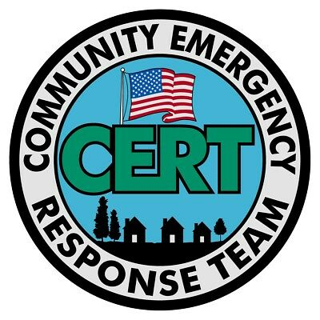

Please Begin Using: “Local-Community-Currency”,
of & for: “Coleman County, Texas”.
As with most US-States, Three Texas Statutes Affirm the “Uniform Commercial Code”, which may be reviewed here:
http://ConstitutionalGov.us/sub/PoliticalSubdivisions-Local/
09-TexasSS/Z-Statutes/04-Business&CommercialCode/
This Local Community Currency process is based firmly there-on. Once this More Constitutional Economic System is Established, Immense Economic Benefits will Immediately Appear for All Local Community Members.
These Benefits will Include:
1: Minimal Basic Economic Needs of All Good-Faith Participants Will Be Met.
2: Local Participating Small Businesses Will Flourish; because,
2a: They Will Receive “Lines of Local Community Credit”, where-under
they can offer better bargains to their customers; &
2b: Local Customers Will Have More Money To Spend In Their Businesses.

This Process Encourages More Government Participation By Religious Communities.
This is all Based On “Common-Law Tradition”; which, in turn, is based on the “Biblical Torah-Law” Mandate of “Honest Weights & Measures”. The Bible Identifies how the Conflict Between Good Vs Evil is Related to these “Economic Issues”. In the book of Revelation, 18, 9–13; is described the “Great Whore Babylon”, & the “Merchants” through whom she gained her evil control; & how that Despotic Commercial Empire also Bought & Sold “Slaves, & the Souls of Men” (King-James Version).
These Biblical verses, clearly describe, a System of Economic Tyranny & Despotism, which is substantially Similar to the Despotic Economic-System which is Modernly Extorting & Brutally Squeezing Economic Resources from our Local Small Business & Common People.
This Tyrannical Economic & Military System is a deep study, about which more info is available here:
http://ConstitutionalGov.us/SupremeCourtOfLaw/Treason-USA/
1-TreasonComplaint-ConstrctiveNotice-AllOfficers&Agents-V1.5.pdf
Here-under; Many Good Local Public-Servants are Under Immense Peer-Pressure to Continue Supporting the Oppressive Babylonian-Whore Slave-Trading British/Roman-Empire Economics-Model.
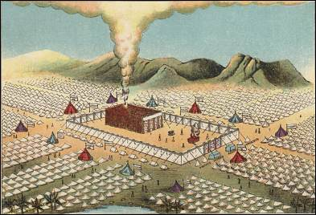
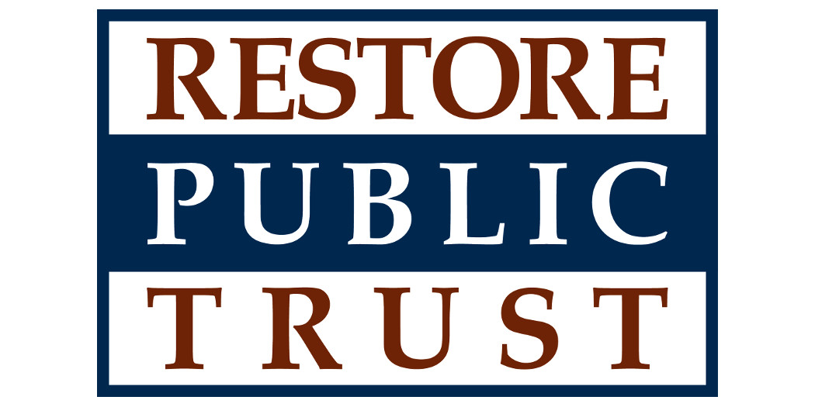
But; When This Alternative-Currency Effort Gains Enough Support, & Soon;
2c: Many Forms of City, County, & State Taxes & Fees Will Become Trivial or Non-Existant. This Alternative Currency Has Lawful Authority to Immediately “Discharge” (& effectively pay) All Real-Property Taxes, all Utility Bills, All Court Fines, & All Licensing Fees. As our honorable Religious Communities become more involved in this process; All Coercive-Taxes Will eventually Be Replaced by Non-Coercive & Completely Voluntary Economic “Tithing Donations”.
Local Community Meetings Will Soon Be Scheduled to Discuss This Process. Contact This Local Community Organizer “Charles Stewart”. Charles@ConstitutionalGov.us / 325-603-0334.

