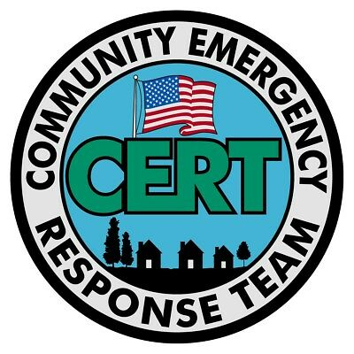

Please Help Organize
Socially-Responsible Local-Community Members to
Build ‘Responsibly-Self-Governing Local Communities’.
This is Mandated in Texas Constitution’s Bill of Rights:
Article 1, Section 1, for: “… the Preservation Of
The Right of Local Self-Government …”.
Once This Constitutionally Mandated Procedure is Completed,
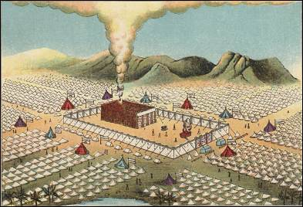

Immense Benefits will Immediately Appear for You & All of Our Neighbors.
These Benefits will Include:
1: Better Accountability & Integrity in Elections & Political Process, Through
Smaller Communities Counting & Certifying Our Own Elections Results.
2: Much Better Health-Care; Law-Enforcement Security, & Emergency-Preparedness,
& Much More Responsible Local Community Control Of Judiciary & Courts.
3: This Greater Accountability Will Eliminate Most Economic Waste & Corruption,
which Will Free Up Enough Economic Resources To Provide Economic Security, Prosperity, & Cover the Minimal Basic Economic Needs of All Good-Faith Participants.
All of this is Based on the Biblical Torah-Law Model of
Organizing Local Self-Governing Communities, as described in Exodus 18: 17-26; Deuteronomy 1: 9-17, Mark 6: 40; & Luke 9: 14. All Coercive Taxes Will Be Replaced By Non-Coercive Economic “Tithing Donations”. This Process Encourages
More Government Participation By Religious Communities.



These Biblical Torah-Law Mandates Are Preserved under Constitutional Common-Law. Texas Statutes & Government Code, at Section 418.151, Declares, Every Person in Texas has Duties under Common-Law, To Participate in Local Community Organizing & Emergency-Preparedness.
Many Documents are available which Explain in Greater Detail
this Constitutional Local Community Organizing Process; as here:
http://ConstitutionalGov.us/SupremeCourtOfLaw/SelfGoverningCommunityBuilding/
Local Community Meetings Will Soon Be Scheduled to
Discuss This Process Further.
Please Contact Local Community Organizer “Charles Stewart”.
Charles can discuss these issues in person, or in Phone &/or Video Conferences.
Charles@ConstitutionalGov.us
325-603-0334.

