Reproduction Report: Feng et al., Attribute Inference Attack of SER in Federated Learning
Oct 14, 2026 · @Charles Ugwute

Summary and relevance to the thesis
The federated emotion recogniser reproduced. The paper's cross-corpus gender attack did not: it stayed at chance (43–56% UAR) against the reported 74–91%. A same-corpus probe still recovered gender from first-layer updates with 66–71% UAR on CREMA-D, so the leak the paper describes is real. What failed is the attacker's transfer from small public shadow corpora.
This report documents the reproduction for the PhD thesis Paralinguistic Inference Attacks on Emotion Recognition Systems: Threat Modelling and Federated Privacy-Preserving Defences. Feng et al. is the closest prior work to the thesis. It is the first study to show that model updates shared in federated speech emotion recognition (SER) can reveal a speaker's paralinguistic attributes. The reproduction tests how robust that claim is outside the authors' data and compute, and so marks where the thesis can contribute.
- Threat modelling: the paper defines the attacker (an honest-but-curious server or an eavesdropper), their knowledge (model architecture, training hyper-parameters, public shadow data) and their goal (client gender). The thesis can adopt and extend this model.
- Attack evaluation: the reproduction shows that attack success depends heavily on how well the shadow data matches the private data, and on how the attack is validated.
- Defences: the paper only briefly touches defences (user-level differential privacy in the official code). Federated defences evaluated against both in-domain and cross-domain attackers are an open gap.
Code, raw results and an executed results notebook are in the reproduction repository.

The original paper
Feng, Hashemi, Hebbar, Annavaram and Narayanan (USC) show that a server can infer a client's gender from the updates that client shares while training an SER model with federated learning (arXiv:2112.13416; official code).
Problem. Federated learning is often presented as private because raw audio never leaves the device. Speech, however, carries much more than emotion: gender, age, identity, accent and health. If the shared gradients or weights encode these attributes, federated SER leaks exactly what users expect it to protect.
Threat model.
Element | Paper's assumption
Adversary | Honest-but-curious server, or an outside eavesdropper on the client-server channel
Observed | Each participating client's update in every round: gradients (FedSGD) or model parameters (FedAvg)
Knowledge | Model architecture, training hyper-parameters and feature type; public SER data with gender labels (shadow data)
Not known | The clients' audio, features or labels
Target | Binary gender of the client (one speaker per client)
Success measure | Attack success rate: the share of correct predictions per client, averaged over clients
Contributions claimed.
- A shadow-training attack framework, adapted from membership inference (Shokri et al., 2017), that infers a sensitive attribute from shared SER updates.
- Evidence across 3 corpora, 6 feature sets and 2 FL algorithms that gender is inferable with 71–97% success.
- A layer analysis showing that the first dense layer's updates leak most.
- An observation that more dropout in the SER model increases the leak.

Methodology
The reproduction re-implements the paper's pipeline from the paper and its official code. It runs in four stages: feature extraction, federated SER training, shadow training and attack training, and attack evaluation.
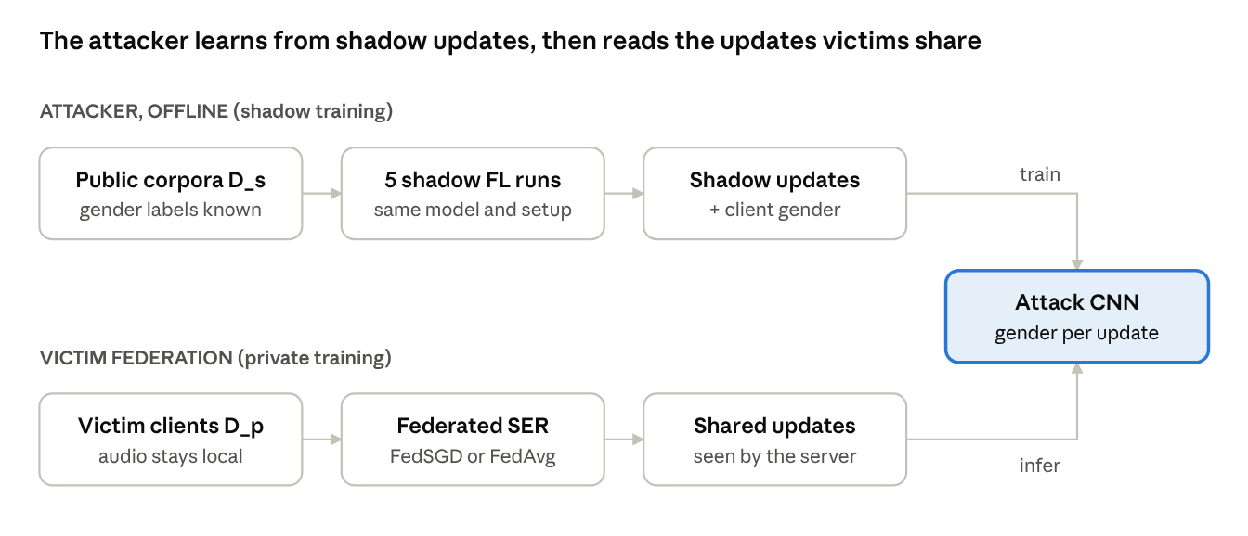
attack pipeline · shadow training, then inference on victims' updates
The attacker never sees victims' audio. It learns what gender looks like in updates from its own shadow runs, then applies that model to every update the victims send to the server.

Datasets
The paper used IEMOCAP, CREMA-D and MSP-Improv. IEMOCAP and MSP-Improv require a signed licence, so each was replaced by an open corpus of similar speaker count. All corpora are reduced to the paper's four emotions: neutral, happy, sad and angry.
Corpus | Role | Speakers (M/F) | 4-class utterances | Clients per speaker | Source
CREMA-D | same as paper | 91 (48/43) | 4,900 | 1 | GitHub
EmoDB | replaces IEMOCAP (10 speakers) | 10 (5/5) | 339 | 5 | audb emodb 1.4.1
RAVDESS (speech) | replaces MSP-Improv (12 speakers) | 24 (12/12) | 672 | 5 | GitHub mirror of the Zenodo release
CREMA-D labels come from the acted emotion in the file name; the paper used the crowd-sourced majority vote. Gender comes from the corpus metadata: CREMA-D's demographics file, odd versus even RAVDESS actor numbers, and the EmoDB speaker list.

Features
Each utterance is described by the openSMILE emobase functionals: 988 statistics of pitch, energy, MFCCs, line spectral pairs and voicing. These are the paper's hand-crafted baseline. The paper also used five self-supervised representations (APC, Vq-APC, NPC, TERA, DeCoAR 2.0). Their checkpoints are hosted on sites the compute environment could not reach, so they were not reproduced.
As in the paper, every feature is z-normalised within each speaker:
\tilde{x}_{s,i} = \frac{x_{s,i} - \mu_s}{\sigma_s + 10^{-5}}
Here μ and σ are the mean and standard deviation over all utterances of speaker s. A second condition, global z-norm, uses the statistics of the training speakers instead. It was added because within-speaker normalisation removes most first-order gender cues (see Results).

Federated SER system
- Clients. Each CREMA-D speaker is one client. Each EmoDB or RAVDESS speaker is split into 5 clients (the paper split IEMOCAP and MSP-Improv speakers into 10), because these corpora hold only about 30 four-class utterances per speaker. Inside each client, 80% of the data trains and 20% validates.
- Model. A multilayer perceptron: 988 → 256 → 128 → 4, ReLU, dropout 0.2 after each hidden layer, log-softmax output, Kaiming initialisation.
- FedSGD. Each selected client computes the gradient of one local batch of 20 utterances and sends it. The server averages the gradients, weighted by sample count, and takes an SGD step with learning rate 0.05.
- FedAvg. Each selected client trains one local epoch with Adam (learning rate 0.0005, weight decay 1e-4, batch 20) and sends its weights. The server averages them, weighted by sample count.
- Schedule. 200 global rounds, with 10% of clients chosen at random in each round.
For FedAvg, the attacker sees parameters rather than gradients. Following the official code, it converts them to a pseudo-gradient, where t is the number of local steps:
\hat{g}_k = \frac{w_{\text{global}} - w_k}{\eta \cdot t}

Attack
- Shadow training. The attacker trains 5 shadow FL models on the public shadow corpora, one per speaker fold, with the same architecture and hyper-parameters as the private training. It records every participating client's update together with that client's gender.
- Update normalisation. Every element of every update is z-normalised with the mean and standard deviation over all shadow updates.
- Attack model. A CNN that reads one layer's weight update as a one-channel image (256 × 988 for the first layer). It has three blocks of 5 × 5 convolutions with ReLU, max-pooling and 2D dropout, the last with batch normalisation. The flattened maps are joined with the bias update and passed through dense layers of 256 and 128 units to a 2-way gender output. Training uses Adam (learning rate 1e-4, weight decay 1e-4), batch 20, a plateau learning-rate scheduler, and an 80/20 random split of shadow updates. The checkpoint with the best validation UAR is kept.
- Inference. The attack model labels the gender behind each update shared during private training on the held-out corpus.

Implementation
Item | Detail
Language and libraries | Python 3.13, PyTorch 2.14 (CPU), scikit-learn, pandas, opensmile, audb
Hardware | 4-core Intel Xeon at 2.8 GHz, 15 GB RAM, no GPU
Code | src/extract_features.py, data.py, models.py, fl_train.py, attack.py, pipeline.py, summarize.py, probe_indomain.py
Seeds | 8 for model initialisation and client sampling; client selection seeded by round number, as in the official code
Runtime | About 1 hour per setting; the first-layer attack CNN takes about 0.1 s per update per training step
Outputs | Per-fold CSVs, attack training curves and logs under results/; executed notebook notebooks/results_viewer.ipynb

Experimental design
The design crosses 3 private corpora × 2 FL algorithms × 2 normalisations, giving 12 settings. Each setting gets 5 speaker folds of private training and 5 shadow models. A separate same-corpus probe tests whether the leak exists at all when the attacker's data matches the victim's.
Rotation (leave-one-corpus-out). Each corpus is the private corpus D_p once. The other two together form the shadow corpus D_s, as in the paper.
D_p (private) | D_s (shadow) | Paper's analogue
EmoDB | CREMA-D + RAVDESS | IEMOCAP ← MSP-Improv + CREMA-D
CREMA-D | RAVDESS + EmoDB | CREMA-D ← IEMOCAP + MSP-Improv
RAVDESS | CREMA-D + EmoDB | MSP-Improv ← IEMOCAP + CREMA-D
Independent variables.
- FL algorithm: FedSGD (one-batch gradients) or FedAvg (one local epoch, pseudo-gradients).
- Feature normalisation: within-speaker (the paper's protocol) or global (training-speaker statistics).
- Leaking layer: first (256 × 988), second (128 × 256) or last (4 × 128) dense layer, each with its bias.
Folds. Speakers are split into 5 folds without shuffling (KFold). Each private run trains on 4 folds and tests SER on the 5th. Shadow model k trains on fold k's training speakers of D_s.
Metrics.
- SER: accuracy and unweighted average recall (UAR) on the held-out speakers, taken at the round with the best client-weighted validation UAR after round 100. This is the paper's protocol.
- Attack: per-update accuracy and UAR over every shared update, plus the paper's attack success rate (ASR), the correct-prediction share per client averaged over clients. The paper samples 10 updates per client; the reproduction uses all updates from every second round, which estimates the same expectation.
- Chance level is 50% for gender and 25% for 4-class emotion.
Same-corpus probe (not in the paper). For each corpus, normalisation and FL algorithm, one private FL run is recorded. Its clients are split by speaker into two gender-balanced halves. A logistic regression is trained on one half's updates and tested on the other, both ways round. First-layer updates are first reduced to 200 principal components. This isolates the question of whether updates encode gender from the question of whether an attack transfers across corpora.
Budget versus the paper. Compute forced three reductions:
Setting | Paper | Reproduction
Shadow updates kept | every update from 5 × 200 rounds (≈15–20k) | ≈500 per shadow model (≈2.2–2.6k)
First-layer attack epochs | ≈50 (best after epoch 30) | 8
Private updates evaluated | 10 random per client | all updates from every 2nd round
Second and last layer epochs | ≈50 | 30

Results
Federated SER reproduces and beats the paper's UAR on every corpus. The cross-corpus gender attack falls to chance in all 12 settings. The same-corpus probe finds a real leak on CREMA-D, with 66–71% UAR from first-layer updates.

R1. Federated SER
UAR % on held-out speakers, mean of 5 folds. FedSGD and FedAvg perform within 3 points of each other, matching the paper's finding that both algorithms reach similar accuracy.
D_p | FL | Ours, within-speaker norm | Ours, global norm | Paper (emobase, analogue corpus)
EmoDB | FedSGD | 83.4 | 78.9 | 61.6 (IEMOCAP)
EmoDB | FedAvg | 86.9 | 81.3 | 61.3 (IEMOCAP)
CREMA-D | FedSGD | 76.8 | 68.2 | 64.2 (CREMA-D)
CREMA-D | FedAvg | 79.0 | 68.8 | 66.4 (CREMA-D)
RAVDESS | FedSGD | 71.0 | 62.1 | 47.2 (MSP-Improv)
RAVDESS | FedAvg | 69.4 | 61.2 | 47.7 (MSP-Improv)
Only the CREMA-D rows compare like with like. EmoDB and RAVDESS are acted, studio-recorded corpora and much easier than IEMOCAP and MSP-Improv. Within-speaker normalisation helps SER by 5–10 points because it removes speaker identity from the input.

R2. Cross-corpus gender attack
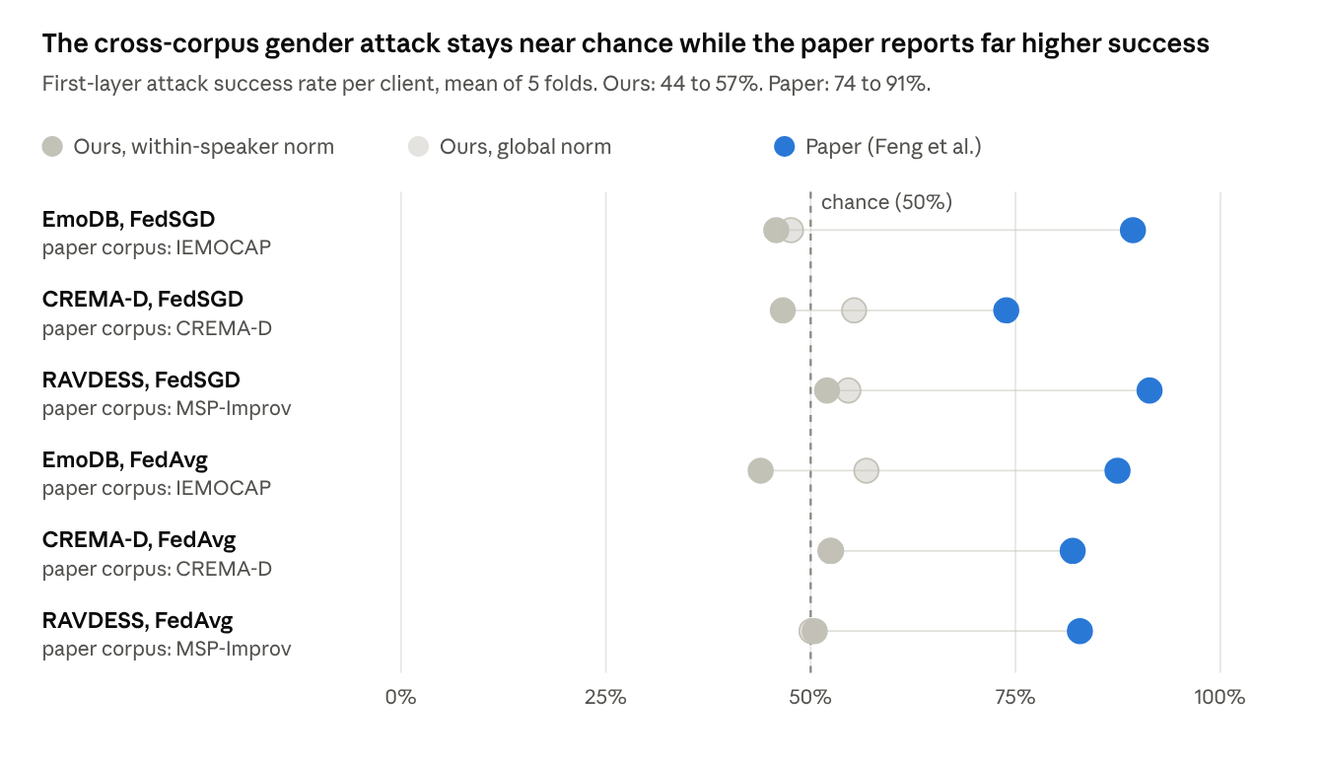
results/<norm>_norm/<fl>/<D_p>/private_results.csv, attack_first_client_asr, mean of 5 folds; paper: Table 4, emobase rows
Every one of the 12 reproduced settings lands within 7 points of chance, while every paper value is about 24 points or more above it.
On the shadow corpora's own validation split, the first-layer attack reached 57–64% (within-speaker norm) and 68–75% (global norm), and the last-layer attack up to 91%. That split shares clients between training and validation, so it rewards recognising a client's updates across rounds rather than recognising gender. On the private corpus the advantage vanished.

R3. Which layer leaks
Attack success rate %, mean over the 6 settings of each normalisation. The paper's emobase values are averaged over its 6 settings.
Layer | Ours, within-speaker norm | Ours, global norm | Paper
First (256 × 988) | 48.6 | 52.8 | 84.5
Second (128 × 256) | 50.7 | 54.2 | 58.5
Last (4 × 128) | 49.5 | 56.5 | 56.0
The paper's second- and last-layer numbers sit close to ours. The gap is concentrated in the first layer, the input the paper identifies as the main leak and the one our reduced budget trained least.

R4. Same-corpus probe
UAR % of a linear probe on unseen speakers, 2-fold, one private FL run per row.
Corpus (train speakers) | Norm | FL | First | Second | Last
CREMA-D (72) | within-speaker | FedSGD | 66.5 | 67.1 | 64.0
CREMA-D (72) | within-speaker | FedAvg | 66.1 | 69.0 | 68.1
CREMA-D (72) | global | FedSGD | 66.0 | 63.4 | 60.9
CREMA-D (72) | global | FedAvg | 70.6 | 78.2 | 68.9
RAVDESS (19) | within-speaker | FedSGD | 56.5 | 61.2 | 56.8
RAVDESS (19) | within-speaker | FedAvg | 59.5 | 67.9 | 64.5
RAVDESS (19) | global | FedSGD | 57.2 | 54.3 | 52.3
RAVDESS (19) | global | FedAvg | 78.0 | 80.0 | 67.0
EmoDB (8) | within-speaker | FedSGD | 55.7 | 55.7 | 54.2
EmoDB (8) | within-speaker | FedAvg | 53.4 | 49.6 | 48.1
EmoDB (8) | global | FedSGD | 54.4 | 50.0 | 48.0
EmoDB (8) | global | FedAvg | 78.8 | 76.0 | 59.6
With enough speakers (CREMA-D), every layer leaks gender under both normalisations, even to a linear model. FedAvg leaks more than FedSGD, and global normalisation more than within-speaker normalisation. EmoDB's 4 test speakers per half make its rows noisy.

R5. How much gender the features themselves carry
A speaker-disjoint gender classifier on the input features bounds what any update can reveal.
Features | CREMA-D | RAVDESS | EmoDB
Raw emobase, linear | 93.3 | 92.3 | 87.9
Within-speaker z-norm, linear | 52.7 | 42.0 | 55.9
Within-speaker z-norm, gradient boosting | 73.7 | 63.0 | not run
Within-speaker normalisation removes the mean pitch and energy differences that make gender easy. What remains is non-linear and weaker.

Discussion
The reproduction supports the paper's qualitative claim, that federated SER updates encode gender, but not its quantitative claim, that a shadow-trained attacker reliably extracts it across corpora. The difference matters for threat modelling: the danger depends on what data the attacker holds.
1. The leak is real, but its size depends on the attacker's data. Given updates from the same corpus, a linear probe reads gender from unseen CREMA-D speakers at 66–71% UAR. Given only other corpora, a CNN reads nothing. The paper's attacker used IEMOCAP, MSP-Improv and CREMA-D: three naturalistic or semi-naturalistic corpora with thousands of utterances each. Ours used EmoDB and RAVDESS, about 1,000 acted utterances in total, with 3–7 training utterances per client. Recording conditions, speaking style, language (EmoDB is German) and client size all change the update statistics, and the attack does not survive the shift.
2. Validation on shared clients overstates attack strength. The paper validates the attack on a random 80/20 split of shadow updates. Updates from one client in different rounds are highly correlated, so the same client sits on both sides of the split. Our last-layer attack scored up to 91% on that split and about 50% on new speakers. Speaker-disjoint validation is needed before an attack's success is reported.
3. Feature normalisation acts as a partial, accidental defence. Within-speaker z-normalisation removes mean pitch and energy differences. A linear gender classifier on the normalised features falls from 88–93% to 42–56%. The paper normalises the same way and still reports high leakage, which suggests its self-supervised features, its larger shadow data and its longer attack training recovered the remaining non-linear cues. In the same-corpus probe, global normalisation leaked more than within-speaker normalisation under FedAvg (CREMA-D first layer 70.6% against 66.1%). Normalisation is therefore a lever a defence can use.
4. FedAvg leaks more than FedSGD under global normalisation. In the probe, FedAvg's first-layer UAR was 70.6–78.8% on all three corpora against 54.4–66.0% for FedSGD. Under within-speaker normalisation the two were within 3 points. A full local epoch accumulates more client-specific signal than a single 20-utterance gradient. The paper found FedSGD ahead on two of its three corpora, so this ordering is worth testing at full scale.
5. Layer-wise leakage only partly agrees. The paper finds the first layer dominant (84.5% average against 58.5% for the second layer). Our global-norm second- and last-layer numbers are within about 4 points of the paper's, but the first-layer attack failed. The first layer is also the one our compute budget limited most: about 1/6 of the paper's shadow updates and 1/6 of its epochs on the largest input (256 × 988). In the same-corpus probe, the first and second layers leaked similarly.
6. SER utility is unaffected by the federated setting. FedSGD and FedAvg reach similar UAR, matching the paper. Any defence the thesis proposes must be judged against this utility baseline: 77–79% UAR on CREMA-D with emobase features.

Limitations and research gaps
The reproduction's limits are mostly about data and compute. The paper's limits leave six open problems that map directly onto the thesis.

Limitations of this reproduction
Limitation | Effect on the results | How to remove it
EmoDB and RAVDESS replace IEMOCAP and MSP-Improv | Shadow data 10–20× smaller, acted rather than improvised, partly German | Obtain the IEMOCAP and MSP-Improv licences; rerun with the paper's corpora
Only emobase features | The paper's strongest leaks came from self-supervised features (NPC up to 96.9%) | Extract APC, Vq-APC, NPC, TERA and DeCoAR 2.0 (or WavLM, HuBERT) on a machine with Hugging Face access
CPU budget: 8 attack epochs, about 2.5k shadow updates | First-layer attack undertrained; validation was still rising | Run pipeline.py with --shadow_per_model 100000 --epochs_first 50 --private_every 1 on a GPU
5 clients per speaker instead of 10 for small corpora | Different client sizes from the paper's IEMOCAP/MSP setup | Use 10 splits once the paper's corpora are available
CREMA-D acted labels instead of the crowd vote | SER UAR not directly comparable on CREMA-D | Use summaryTable.csv MultiModalVote labels
One seed, one private FL run per probe setting | No confidence intervals on the probe | Repeat over seeds and folds

Research gaps for the thesis
- Attributes beyond gender. The paper attacks only binary gender. Paralinguistic inference covers age, speaker identity, accent or first language, and health or affective traits. Multi-class and continuous attributes need their own attack models and metrics.
- Threat models graded by attacker knowledge. The paper assumes one attacker with public shadow data. This reproduction shows that success swings from chance to about 70% depending on shadow-data match. A thesis threat model can define tiers: no auxiliary data, cross-corpus public data, same-domain data, and partial access to the victim's data, each with its expected attack strength.
- Rigorous attack evaluation. Speaker-disjoint validation, per-client aggregation over rounds, confidence intervals, and reporting against a feature-level upper bound (R5) are needed so that attack success is not overstated or understated.
- Modern SER architectures. The paper uses a 3-layer MLP on utterance-level features. Federated fine-tuning of wav2vec 2.0, HuBERT or WavLM, parameter-efficient updates (adapters, LoRA) and sequence models change which updates are shared and may change leakage.
- Federated defences evaluated against these attacks. The paper evaluates no defence beyond user-level differential privacy in its code. Open options include differential privacy (DP-SGD, DP-FedAvg) with measured privacy-utility curves, secure aggregation, update sparsification and quantisation, adversarial or disentangled representation learning that removes attributes before training, feature-level anonymisation (pitch or formant shifting, voice conversion), and protecting or freezing the first layer, which the paper identifies as the main leak.
- Privacy-utility trade-off as the core metric. Every defence should be reported as attack success against SER UAR, at the same attacker tier, so defences can be compared.

Weaknesses of the original paper
- Attack validation on randomly split updates, with clients shared between training and validation.
- No released trained models or shadow updates, so the reported numbers cannot be checked without the licensed corpora.
- The dropout table cannot be checked. In the official repository it repeats the layer-wise table's numbers under dropout labels (only one cell differs), and its values fall as dropout rises, while the text says more dropout strengthens the attack.
- One sensitive attribute, one SER architecture, and no confidence intervals.

Conclusion
Federated SER does leak speaker gender through its shared updates, but how much an attacker recovers depends on how closely their shadow data matches the victims'. With same-corpus data, a linear probe reached 66–71% UAR on unseen CREMA-D speakers. With small cross-corpus public data and a CPU budget, the paper's CNN attack fell to chance (44–57%), against the reported 74–91%. The federated SER pipeline itself reproduced, with FedSGD and FedAvg at similar accuracy.
For the thesis, three things follow:
- Threat models for paralinguistic inference should grade attackers by their auxiliary data, because that is what decides attack success.
- Attacks should be validated on speakers disjoint from training and reported against a feature-level upper bound.
- Federated defences (differential privacy, secure aggregation, attribute-removing representations, first-layer protection) should be judged on a privacy-utility curve, against both a same-domain attacker and a cross-domain one.
The immediate next step is a full-scale rerun with the paper's corpora, self-supervised features and GPU budget. That would separate the effect of data mismatch from the effect of compute, and give the thesis a validated baseline attack on which to test defences.

References
- T. Feng, H. Hashemi, R. Hebbar, M. Annavaram, S. Narayanan. Attribute Inference Attack of Speech Emotion Recognition in Federated Learning Settings. arXiv:2112.13416, 2021 (v3, 2022). Official code.
- R. Shokri, M. Stronati, C. Song, V. Shmatikov. Membership Inference Attacks Against Machine Learning Models. IEEE S&P 2017. arXiv:1610.05820.
- H. B. McMahan et al. Communication-Efficient Learning of Deep Networks from Decentralized Data (FedAvg). AISTATS 2017. arXiv:1602.05629.
- F. Eyben, M. Wöllmer, B. Schuller. openSMILE: the Munich versatile and fast open-source audio feature extractor. ACM MM 2010.
- H. Cao et al. CREMA-D: Crowd-sourced Emotional Multimodal Actors Dataset. IEEE Trans. Affective Computing, 2014. Data.
- S. R. Livingstone, F. A. Russo. The Ryerson Audio-Visual Database of Emotional Speech and Song (RAVDESS). PLoS ONE, 2018.
- F. Burkhardt et al. A Database of German Emotional Speech (EmoDB). Interspeech 2005.
- Reproduction repository: Charles9257/Attribute-Inference-Attack-of-SER-on-Federated-Learning-by-Feng-et-al, including notebooks/results_viewer.ipynb.

