**Select a 2D image to recreate as a 3D scene**.

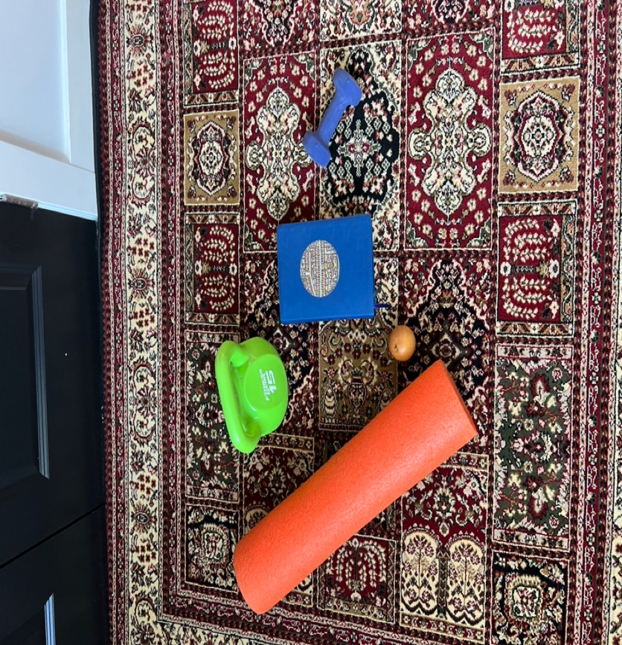

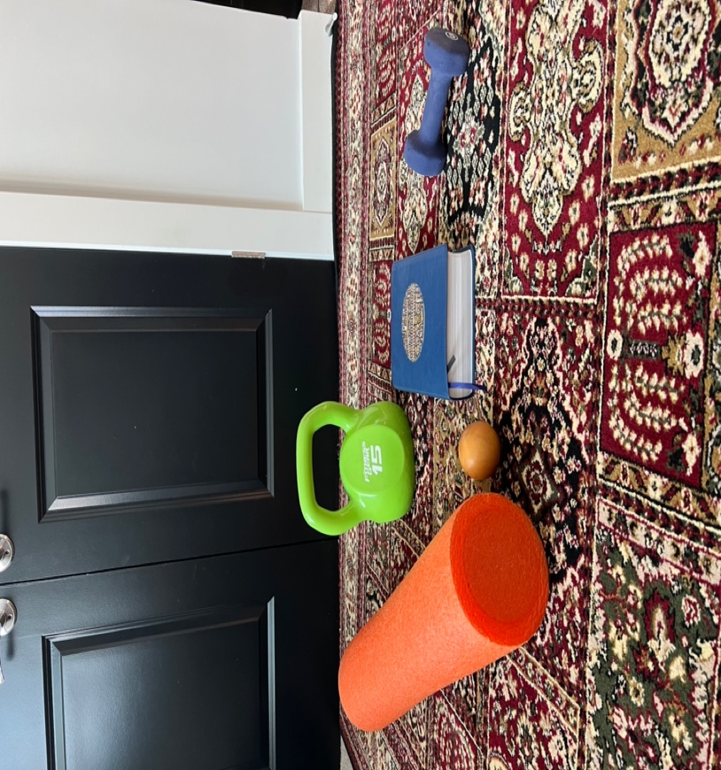

**Discuss which objects will be created in 3D**.

I will be creating the cylinder foam roller (orange object), the lacrosse ball, the book and the small dumbbell (blue) in 3D. These are good choices to use for my work because they are all different shapes, requiring me to learn the differences in their design requirements. Additionally, the small blue dumbbell combines shapes, with two cubes on each end of a cylinder, which adds a bit of complexity to the exercise.

**Explain which primitive shapes will be used to create 3D representations of the 2D objects**.

As mentioned above, the foam roller (orange cylinder), is a cylinder shape, laid down horizontally. The lacrosse ball will use a sphere. The book will use an elongated cube. The blue dumbbell is a combination of two cubes attached to the end of a cylinder. Lastly, there will be a plane that represents the floor that the items are resting upon.