CS 255 System Analysis and Design

Charles Adkins

Charles.adkins@snhu.edu

Southern New Hampshire University

**System Components and Design**

**Purpose**

**What is the purpose of this project? Who is the client and what do they want their system to be able to do?**

* The purpose of the project is to design, develop and deploy a system that provides students with more effective driver training resources through online classes, practice tests, training reservation capabilities, as well as the ability view their training progress and scores.
* The client is DriverPass, a new company formed by Liam, who desires to provide an online platform that provides students with training resources to help address the high failure rate of current students.

**System Background**

**What does DriverPass want the system to do? What is the problem they want to fix? What are the different components needed for this system?**

* The current means of training students has fallen short, as many have continued to fail their driving test. DriverPass wants to provide both current and future students with access to accommodating, reliable and interactive resources that will set them up with the ability to successfully complete their driver training.
* The proposed system will host online classes, practice tests and a student information overview landing page. The system will allow for training reservations, package selection options, testing and progress history, notes/comments and a contact page.

**Objectives and Goals**

**What should this system be able to do when it is completed? What measurable tasks need to be included in the system design to achieve this?**

* Once implemented, the system will allow for students to register their driver profile and reserve training time, select and pay for the appropriate training package, track their testing scores and history, submit notes/comments, view feedback from instructors, mitigate login/password issues, and contact administrators for system support.
* The system will need to be accessible from both desktop and mobile devices. It will use a role-based access control framework, with Liam and Ian having global administrator privileges, the secretary with read/write permissions to update certain aspects for students, and students with read/write/delete permissions of their own data. It will also be cloud-based, as to avoid having to purchase and manage on-premise assets. Finally, the system will allow for exporting reports for operations analysis, minor changes to data such as user password resets, reservation adjustments, training package archiving and training material updates in accordance with DMV rules, policies and sample questions.
* These measurable goals will evaluate the effectiveness and reliability of the system’s ability to deliver on the requirements outlined by DriverPass, as well as addressing the needs of the students.

**Requirements**

**Nonfunctional Requirements**

**Performance Requirements**

**What environments (web-based, application, etc.) does this system need to run in? How fast should the system run? How often should the system be updated?**

* + - Processing power (CPU), memory, storage remain at a satisfactory level of delivery for users/content to ensure that the system can meet the needs of students at various times.
    - The DriverPass training platform will be web-based and therefore will need to be able to handle traffic from across various geographical regions, as well as scale out/up depending on the volume of traffic, with full functionality.
    - The platform can be backed up on a static schedule, perhaps bi-weekly and updated with new content when the DMV publishes new information and resources.

**Platform Constraints**

**What platforms (Windows, Unix, etc.) should the system run on? Does the back end require any tools, such as a database, to support this application?**

* The platform can run on Windows and can be connected to a cloud-based database or storage account offered by a cloud solution provider, such as Azure.
* The database can be managed from the Azure portal, by an administrator with some exposure to the Azure environment.

**Accuracy and Precision**

**How will you distinguish between different users? Is the input case-sensitive? When should the system inform the admin of a problem?**

* + - Each user will create a username and password to login into the platform. The users can use their email or create a unique username. The input values must match exactly to grant access. In addition to the username and password, users must confirm and verify a OTP sent to their mobile devices for multifactor authentication.
    - Administrators and IT personnel will be notified of any platform or data issues or bugs encountered.

**Adaptability**

**Can you make changes to the user (add/remove/modify) without changing code? How will the system adapt to platform updates? What type of access does the IT admin need?**

* + - Administrators and other IT analysts with proper permissions will be able to implement changes to users’ profiles and information, if changes otherwise initiated by system functions triggered by time-based values or the actions of the user, but the code will need to be adjusted accordingly, in that particular scenario.
    - Updates performed on the system will be carried out at the discretion of the IT teams and the administrators, based upon the updates provided by the material/content sourcing agents, the DMV. When updates are published, the teams must remove the outdated content and insert the most recent information.

**Security**

**What is required for the user to log in? How can you secure the connection or the data exchange between the client and the server? What should happen to the account if there is a “brute force” hacking attempt? What happens if the user forgets their password?**

* + - The user is required to enter their username/email and password to gain access to the learning platform system.
    - In order to circumvent hacking attempts, multi-factor authentication will be used. The users must provide both their username/email and password and confirm a OTP value that is sent to their mobile device, of which is to be provided back to the platform login screen to verify their identity and access.
    - If the user forgets their credentials, they can reset it themselves by providing the email they used at the time of registration.
    - If a user enters their username and password incorrectly more than 5 times within 30 minutes, the account will be locked for one hour and a notification email will be sent to the user to communicate the recovery steps.

**Functional Requirements**

**Using the information from the scenario, think about the different functions the system needs to provide. Each of your bullets should start with “The system shall . . .” For example, one functional requirement might be, “The system shall validate user credentials when logging in.”**

* The system shall validate user credentials when logging in and verify their identity with a OTP via mobile device.
* The system shall allow students to register/sign up for courses through the course catalog and administrators approve/deny registrations
* The system shall display the student and driver pairings.
* The system shall offer and display various training packages for the students to choose from.
* The system shall display user profile information, scheduled tests, results, progress and driver notes.
* The system shall provide content by pure e-learning, blended or instructor-led training, which dictates the means by which and how the students interact with the course content and instructor.
* The system shall allow for backups, updates, modifying users’ permissions and access.
* The system shall have some form of auditing and historical data to allow internal stakeholders to evaluate and analyze platform utilization and issues encountered for the purpose of platform modernization and optimization

**User Interface**

**What are the needs of the interface? Who are the different users for this interface? What will each user need to be able to do through the interface? How will the user interact with the interface (mobile, browser, etc.)?**

* + - The interface must provide the user with an overview section with their profile, course status, test history, driver notes, driver/student photo and miscellaneous information.
    - The different users for the platform include the students, the drivers, administrators and IT personnel.
    - The students must be able to see the details of their tests (progress, time taken, score, status) as well as any driver notes. The Drivers will be able to see the students that are assigned to them and any scheduled events, test history, etc. The administrators and IT personnel may want access to the interface as a test user to run simulations on new features, updates and modifications on the system.

**Assumptions**

**What things were not specifically addressed in your design above? What assumptions are you making in your design about the users or the technology they have?**

* + - The course content will be procured and provided by the client, DriverPass.
    - They will maintain the security, modifications, updates and backups of their system, as they see fit.
    - The maintenance of the system will require technical knowledge and experience, which the client, DriverPass, must be able to uphold the necessary requirements for optimal performance of the platform.
    - The requirements communicated by the client are included and accounted for within the project budget.

**Limitations**

**Any system you build will naturally have limitations. What limitations do you see in your system design? What limitations do you have as far as resources, time, budget, or technology?**

* + - The estimated delivery target date will not allow for scope changes for the project, as all requirements, design considerations and discussions have taken place.
    - Limitations for the system include the desire to add new, complex features to the platform after deployment, as this would require technical understanding of the current infrastructure and skills to modify said structure.
    - Time constraints, per the project schedule, only allow for design and deployment - the monitoring and maintenance phases will be the responsibility of the client.
    - The project budget was not declared; therefore a follow up discussion will ultimately determine the tools that can be utilized for the implementation portion of the project.

**Gantt Chart**

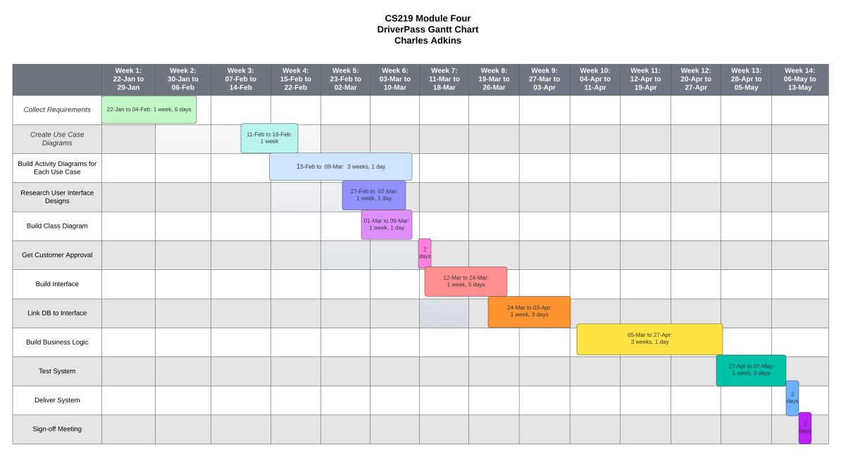

**Resources**

Butcher, A. (2022). What is an LMS? – Learning Management System Guide. Retrieved September 10, 2022 from <https://www.softwareworld.co/what-is-an-lms-complete-guide/>

Cole, J. (2019). What the state of learning management systems can tell us about digital innovation. Retrieved September 11, 2022 from https://medium.com/learning-futures/what-the-state-of-learning-management-systems-can-tell-us-about-digital-innovation-bddfb613332a#:~:text=The%20modern%20LMS%20expresses%20a%20particular%20set%20of,an%20individual%20instructor%20or%20a%20professional%20learning%20designer.

Colman, H. (2022). Learning Management System Requirements: An Ultimate Checklist. Retrieved September 11, 2022 from <https://www.ispringsolutions.com/blog/lms-requirements/>

Emmerson. (2022). Non-Functional Requirements for E-Learning System. Retrieved September 9, 2022 from <https://emmersoninsurance.com/2022/03/18/non-functional-requirements-for-e-learning-system/>

GoGuardian Team. (2021). The Pros & Cons of Learning Management Systems. Retrieved September 11, 2022 from https://www.goguardian.com/blog/learning-management-systems-pros-cons