Document generated by [Gendoc](http://www.eclipse.org/gendoc)

Table of contents

1 Diagram : Actors 2

2 Diagram : One-Pass Tax - Sequence 3

3 Diagram : One-Pass Tax - Use Case 4

4 Diagram : XA-Models 5

# Diagram : Actors

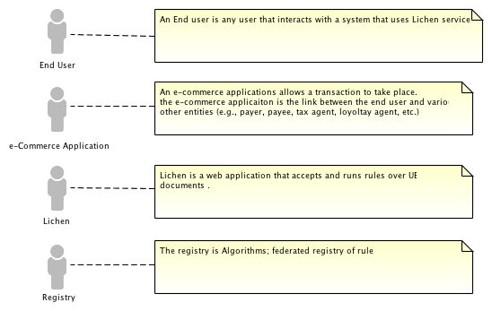

This diagram contains the following elements :

* Actor Registry
* Actor Lichen
* Comment Lichen is a web application that accepts and runs rules over UBL documents .
* Actor e-Commerce Application
* Comment An e-commerce applications allows a transaction to take place. the e-commerce applicaiton is the link between the end user and various other entities (e.g., payer, payee, tax agent, loyoltay agent, etc.)
* Comment The registry is Algorithms; federated registry of rules.
* Comment An End user is any user that interacts with a system that uses Lichen services.
* Actor End User

# Diagram : One-Pass Tax - Sequence

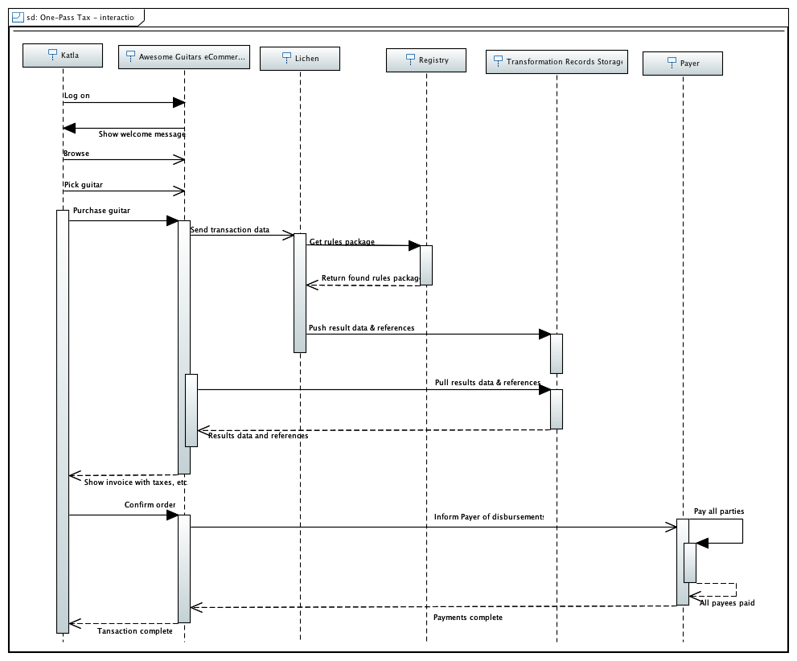

This diagram contains the following elements :

* Lifeline Lichen
* Behavior Execution Specification BehaviorExecSpec3
* Action Execution Specification Pay all parties
* Lifeline Awesome Guitars eCommerce
* Lifeline Payer
* Behavior Execution Specification BehaviorExecSpec5
* Behavior Execution Specification BehaviorExecSpec0
* Lifeline Katla
* Behavior Execution Specification BehaviorExecSpec7
* Behavior Execution Specification BehaviorExecSpec1
* Lifeline Transformation Records Storage
* Behavior Execution Specification Buy guitar
* Lifeline Registry
* Behavior Execution Specification BehaviorExecSpec
* Behavior Execution Specification BehaviorExecSpec2
* Behavior Execution Specification BehaviorExecSpec6

# Diagram : One-Pass Tax - Use Case

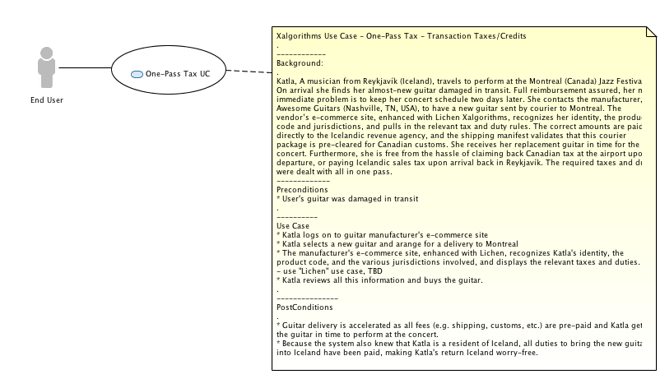

This diagram contains the following elements :

* Comment Xalgorithms Use Case - One-Pass Tax - Transaction Taxes/Credits . ------------ Background: . Katla, A musician from Reykjavík (Iceland), travels to perform at the Montreal (Canada) Jazz Festival. On arrival she finds her almost-new guitar damaged in transit. Full reimbursement assured, her more immediate problem is to keep her concert schedule two days later. She contacts the manufacturer, Awesome Guitars (Nashville, TN, USA), to have a new guitar sent by courier to Montreal. The vendor's e-commerce site, enhanced with Lichen Xalgorithms, recognizes her identity, the product code and jurisdictions, and pulls in the relevant tax and duty rules. The correct amounts are paid directly to the Icelandic revenue agency, and the shipping manifest validates that this courier package is pre-cleared for Canadian customs. She receives her replacement guitar in time for the concert. Furthermore, she is free from the hassle of claiming back Canadian tax at the airport upon departure, or paying Icelandic sales tax upon arrival back in Reykjavík. The required taxes and duties were dealt with all in one pass. ------------- Preconditions * User's guitar was damaged in transit . ---------- Use Case * Katla logs on to guitar manufacturer's e-commerce site * Katla selects a new guitar and arange for a delivery to Montreal * The manufacturer's e-commerce site, enhanced with Lichen, recognizes Katla's identity, the product code, and the various jurisdictions involved, and displays the relevant taxes and duties. - use "Lichen" use case, TBD * Katla reviews all this information and buys the guitar. . --------------- PostConditions . * Guitar delivery is accelerated as all fees (e.g. shipping, customs, etc.) are pre-paid and Katla gets the guitar in time to perform at the concert. * Because the system also knew that Katla is a resident of Iceland, all duties to bring the new guitar into Iceland have been paid, making Katla's return Iceland worry-free.
* Use Case One-Pass Tax UC
* Actor End User

# Diagram : XA-Models

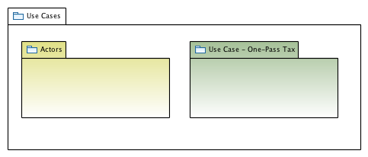

This diagram contains the following elements :

* Package Use Case - One-Pass Tax
* Package Use Cases
* Package Actors