## CS/SE 2340 Computer Architecture

## Homework: BMI Calculator

Objective: To gain proficiency in coding MIPS floating-point operations.

### Instructions

Write a MIPS program that calculates bmi. Use the following C++ code as pseudocode. The variable **bmi** can be single or double precision.

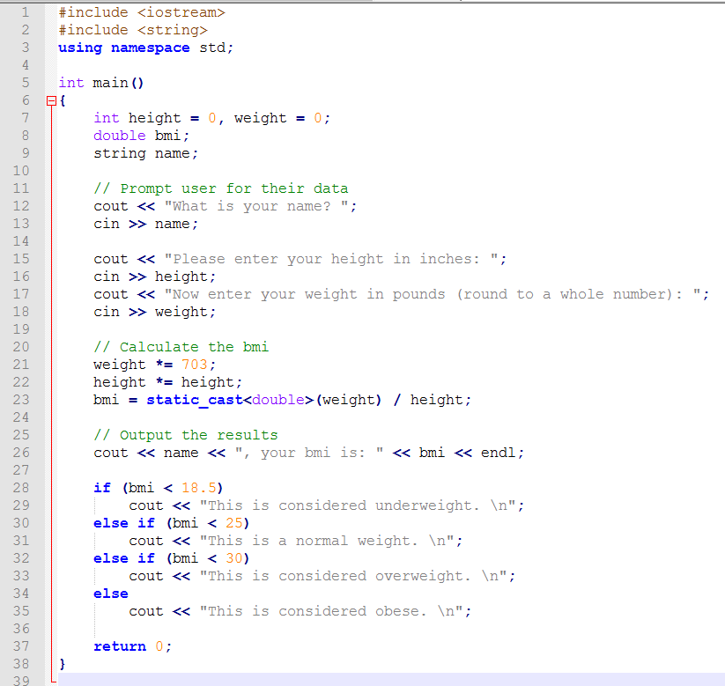

Sample run:

What is your name? Michael

Please enter your height in inches: 68

Please enter your weight in pounds: 145

Michael

your bmi is: 22.044765

This is a normal weight

-- program is finished running –

***Upload your .asm file to eLearning***