Charles Clark Module 4 Ex 3

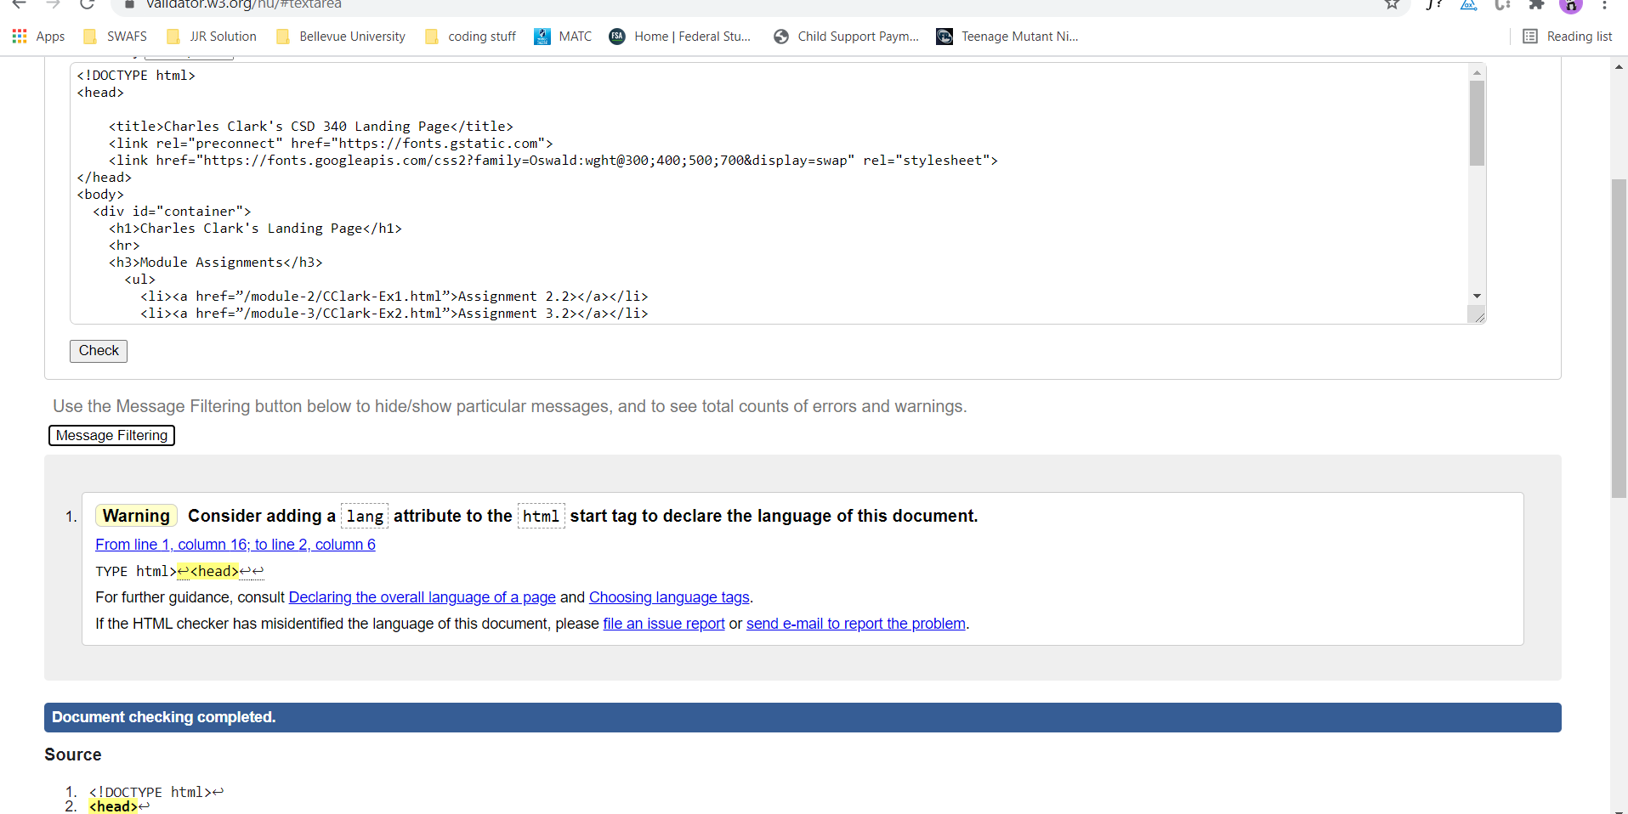

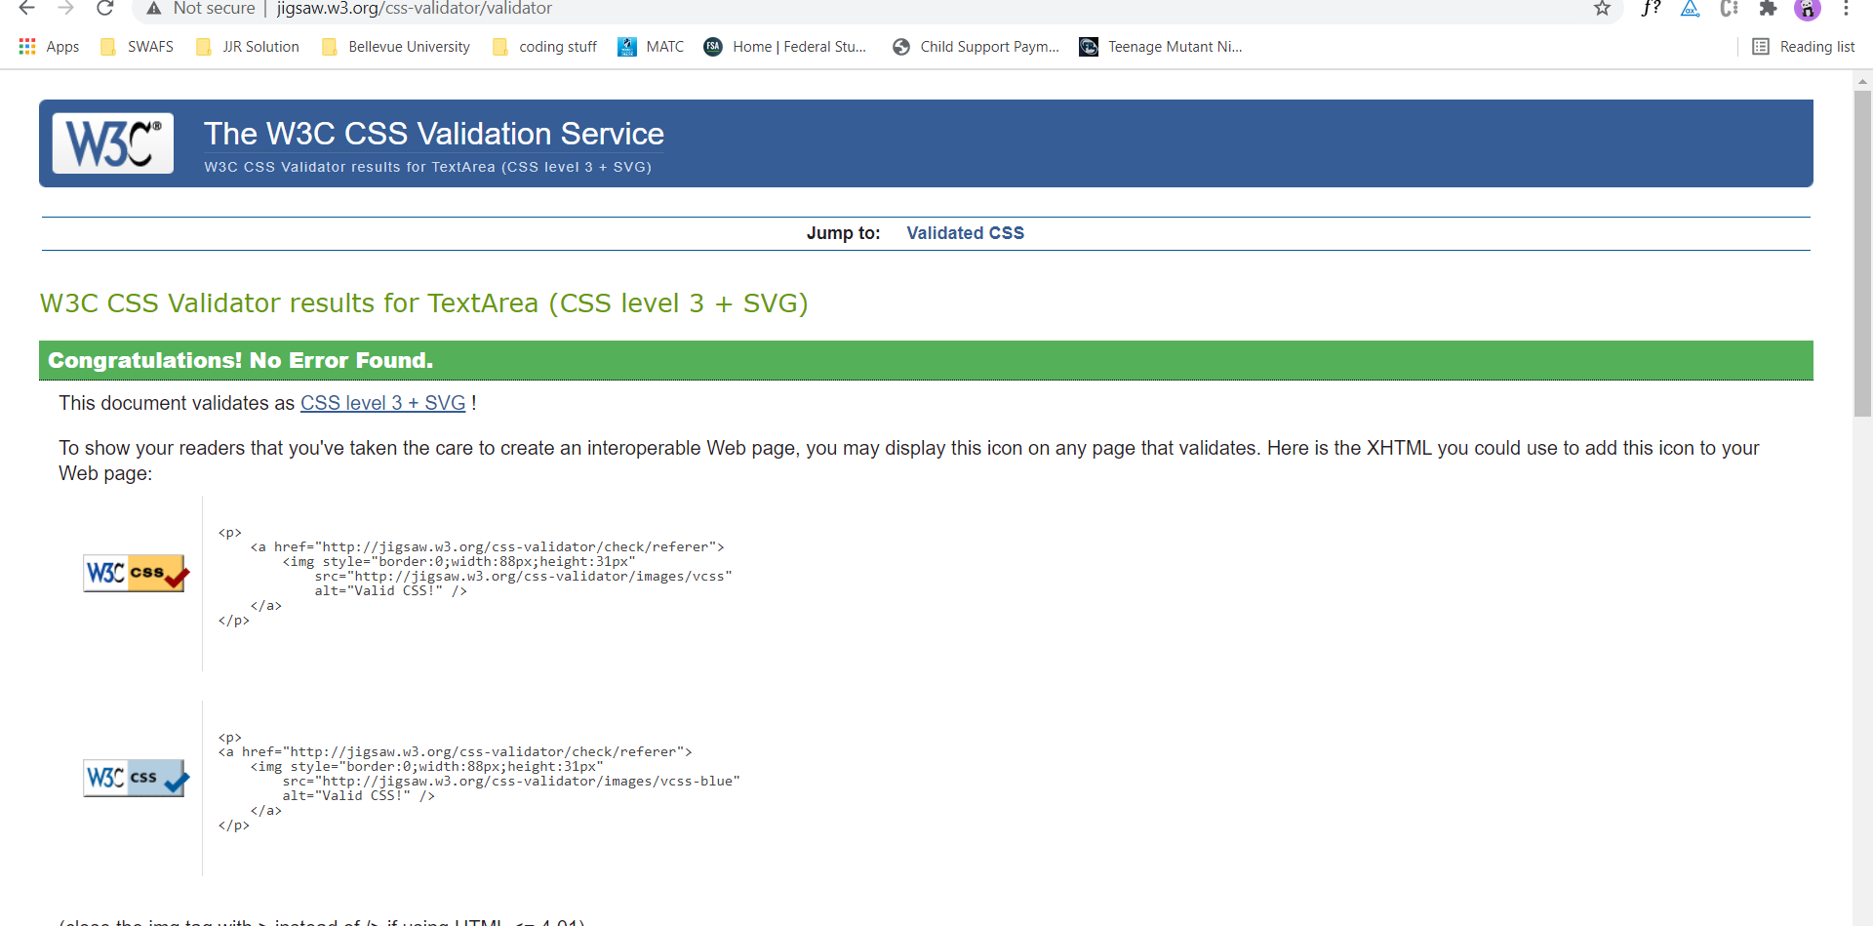

https://github.com/CharlesClark84/csd-340