Data Type: | Example Data(Price(Only thing that can error)): | Results:
Normal | 53, 90, 10, 20, 4 | 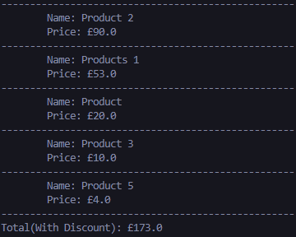  Success
Normal | 900, 234, 566, 321, 766 | 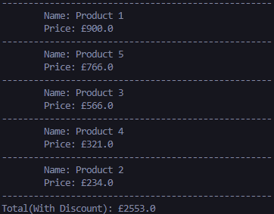  Success
Normal | 2.50, 4.21, 5.6, 1.92, 3.23 | 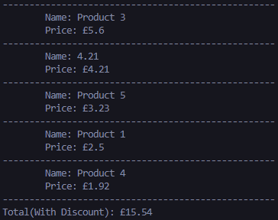  Success
Extreme | 0, 0, 0, 0, 0 | 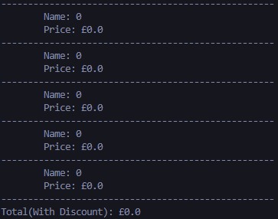  Success
Extreme | 9999999999999, 9999999999, 999999999, 999999999999, 999999999 (I couldn’t think of anything else. There’s no limit. Except the floating point limit, but I’m not going to type all of that.) | 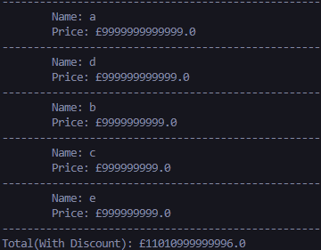  Success
Exceptional | -23, -45, 435345, 34324, -0 | 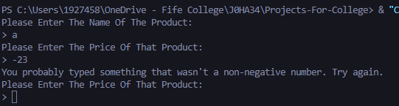  Errors
Exceptional | Hello, My, Fellow, Human, Beings | 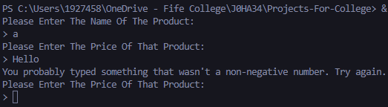  Errors

