Udacity Cloud Developer Nanodegree
Project 3
Refactor Udagram App into Microservices and Deploy
Charles Doyle

Docker Hub: https://hub.docker.com/repository/docker/char2pie/

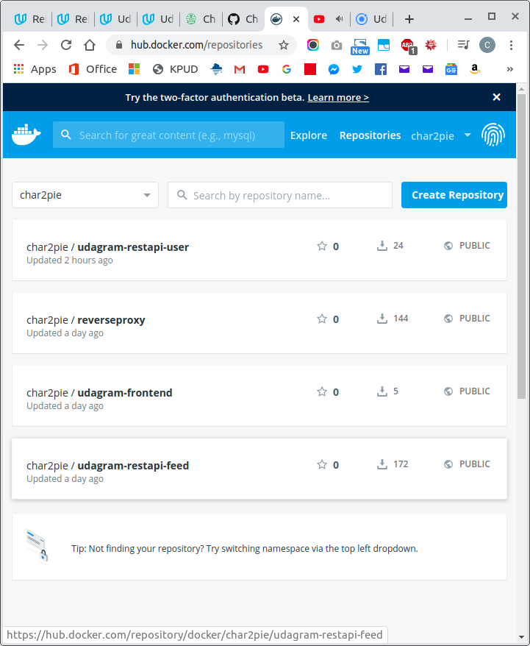

Here are my Travis images. I have Travis set up to fire on a push to the master branch of CharlesDoyle/udagram GitHub repo. It will fire on a push to the dev branch, but with flags on the .travis.yml file I prevent that.

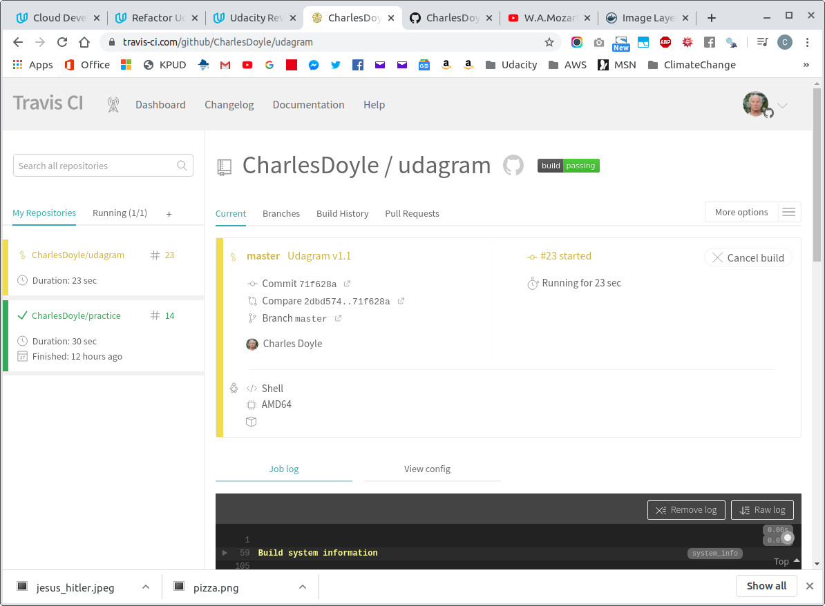
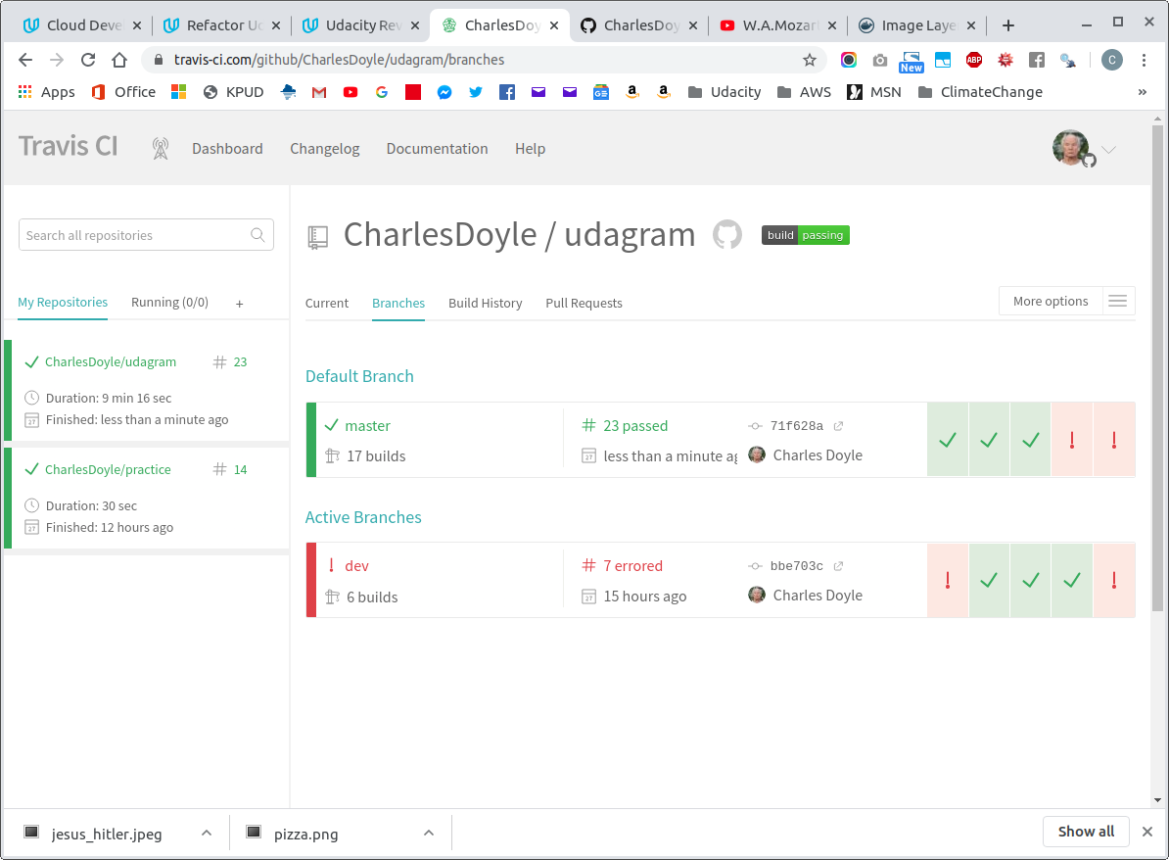

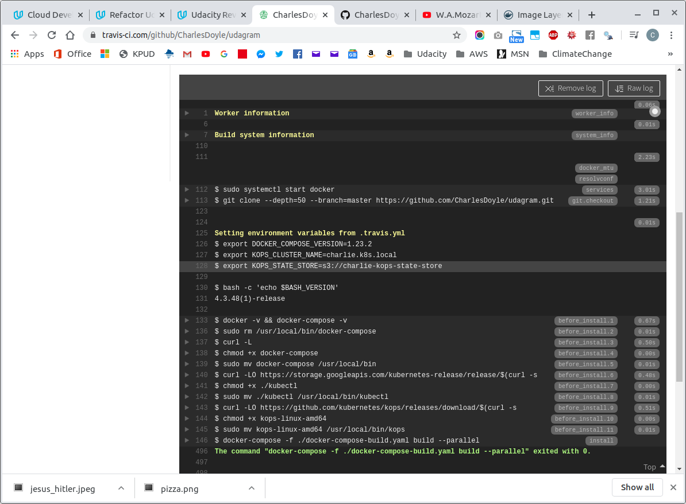

Here is proof of my cluster running in the cloud.
I show the master-node pods with 'get pods' and then I call for a rolling update by resetting an image to udagram-restapi-user:v1.2.

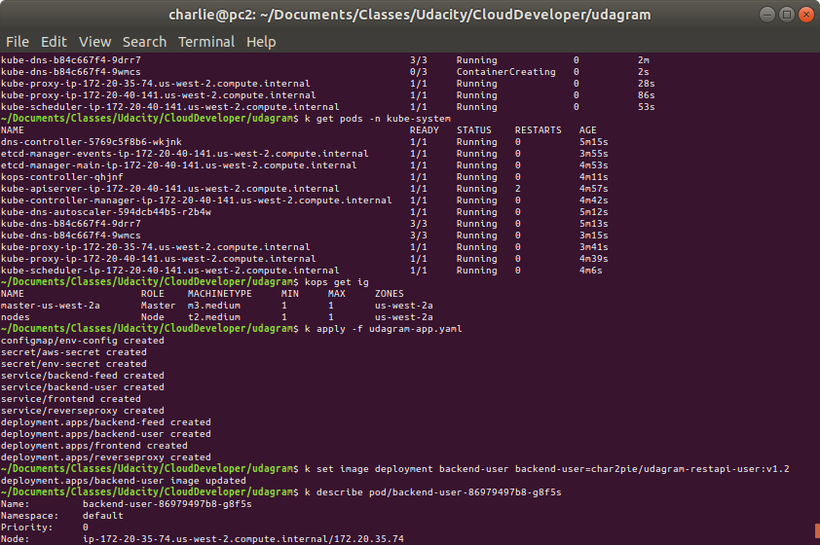

I monitored the cluster with 'watch kubectl get all -o wide'
The following are images of the 'watch' window.

The app starting up on AWS:
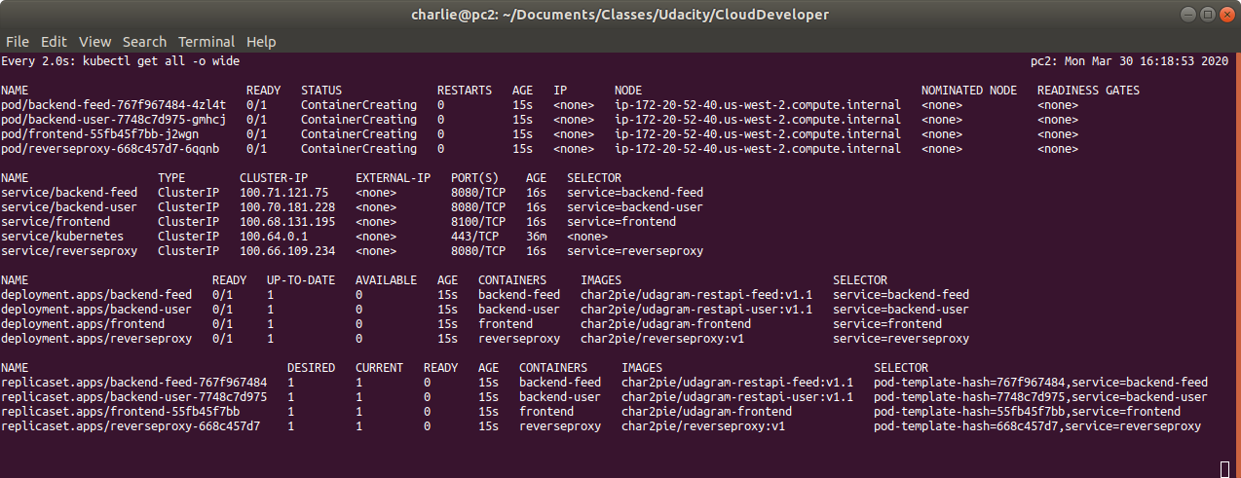
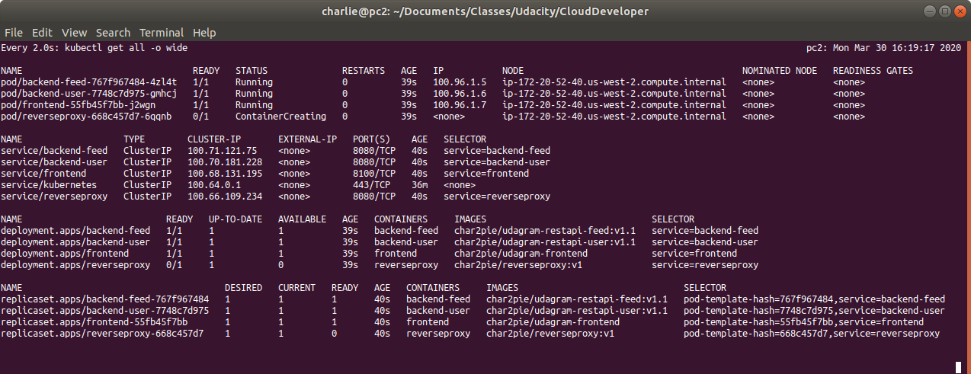
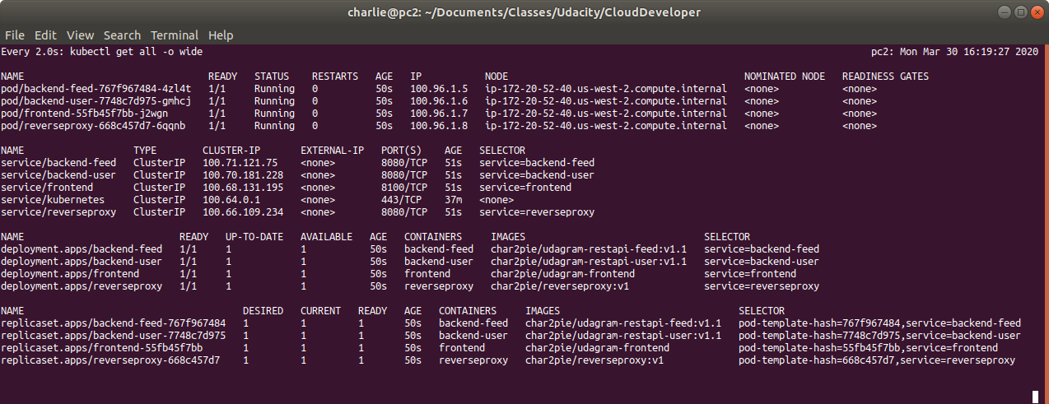

A Rolling Update of both backend-feed and backend-user from v1.1 to v1.2:
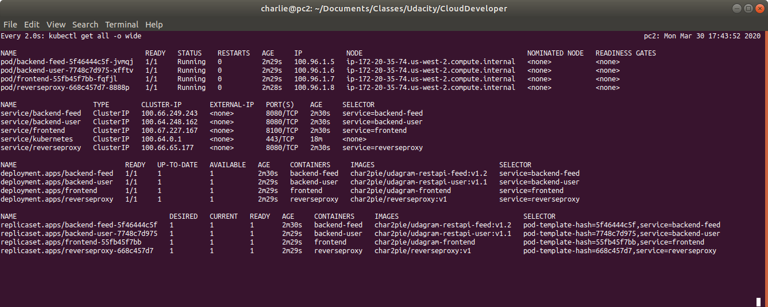
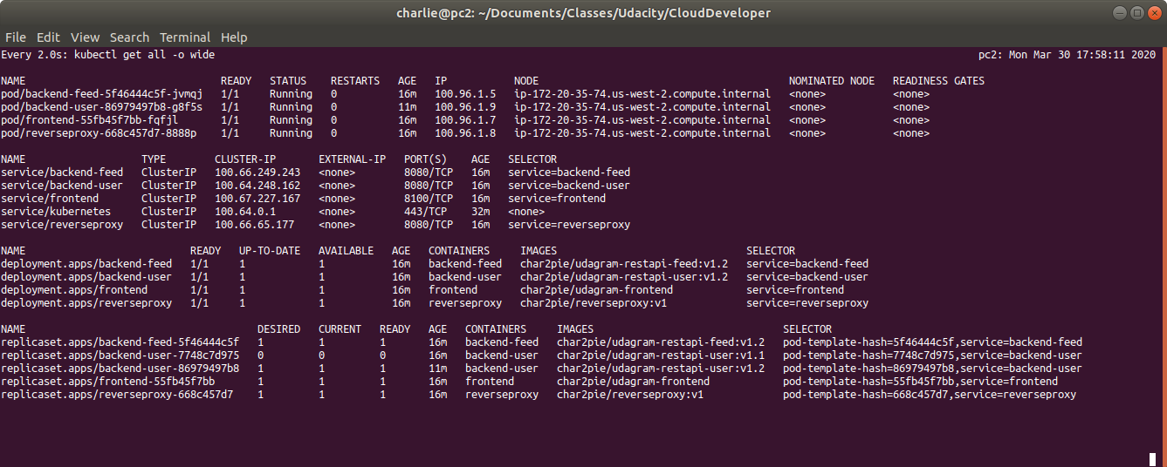
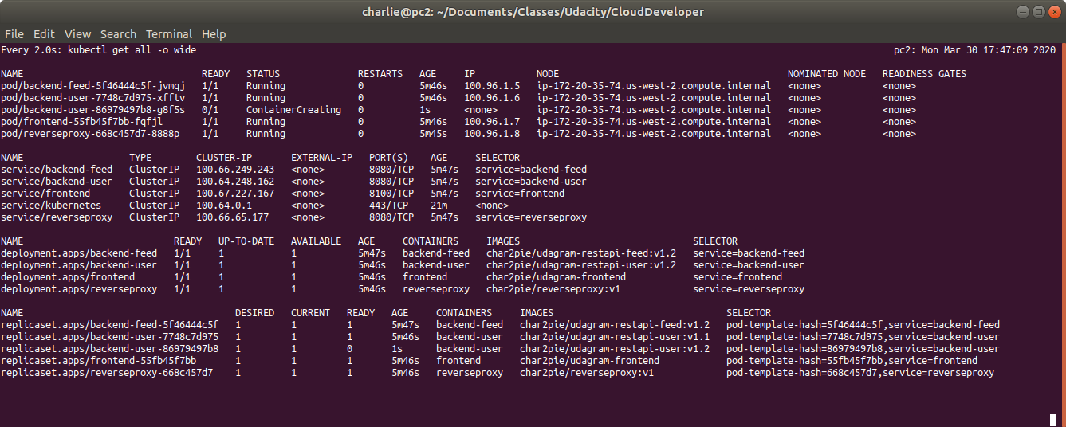
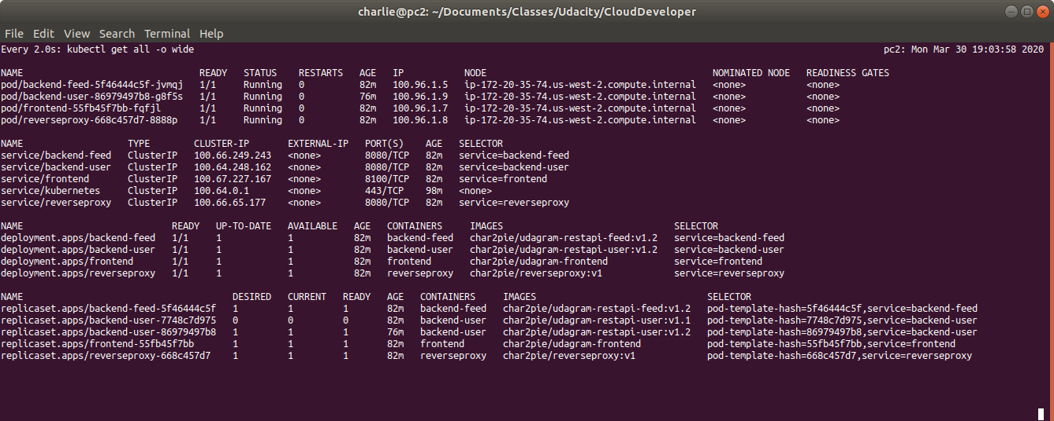

Two versions of the same application can run simultaneously and serve traffic. Here is a rolling update of a replicaSet=3 for the backend-user deployment, where two container versions run simultaneously: v1.1 and v1.2
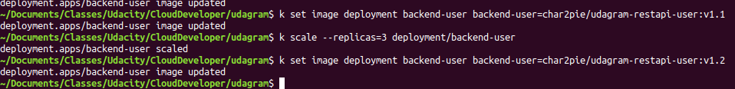
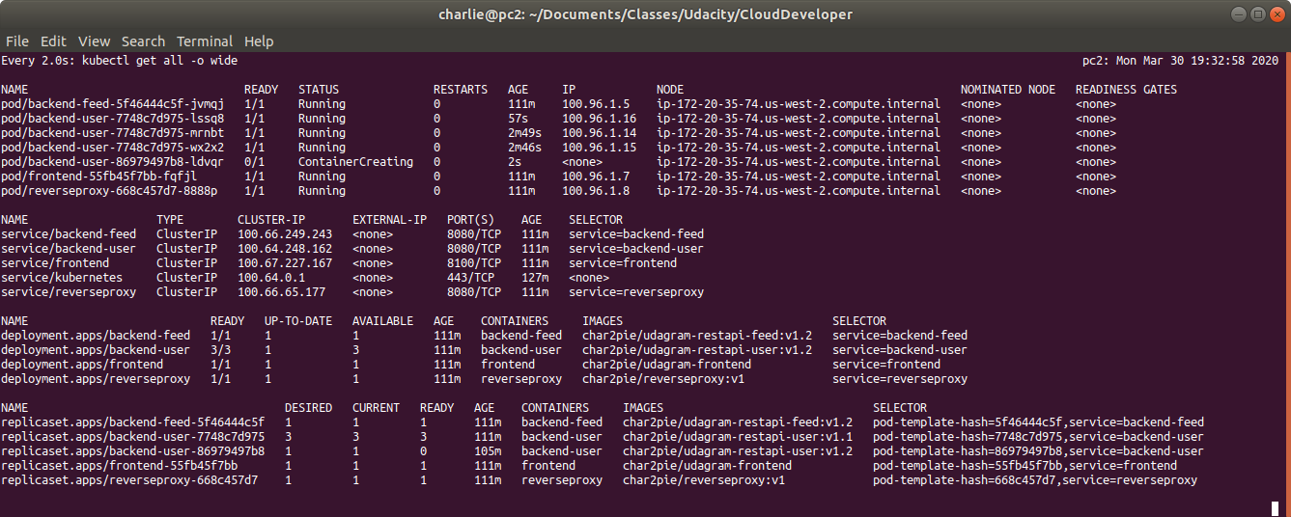
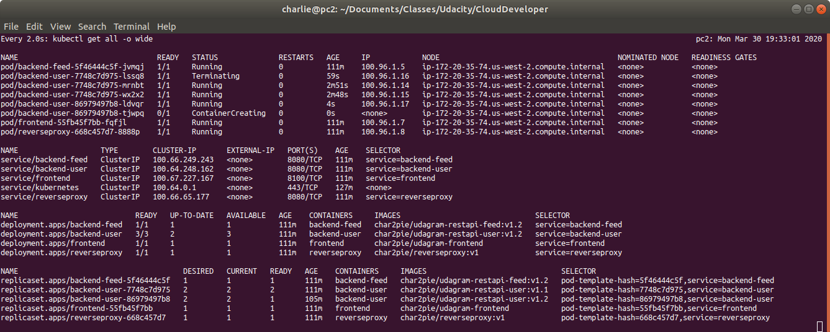
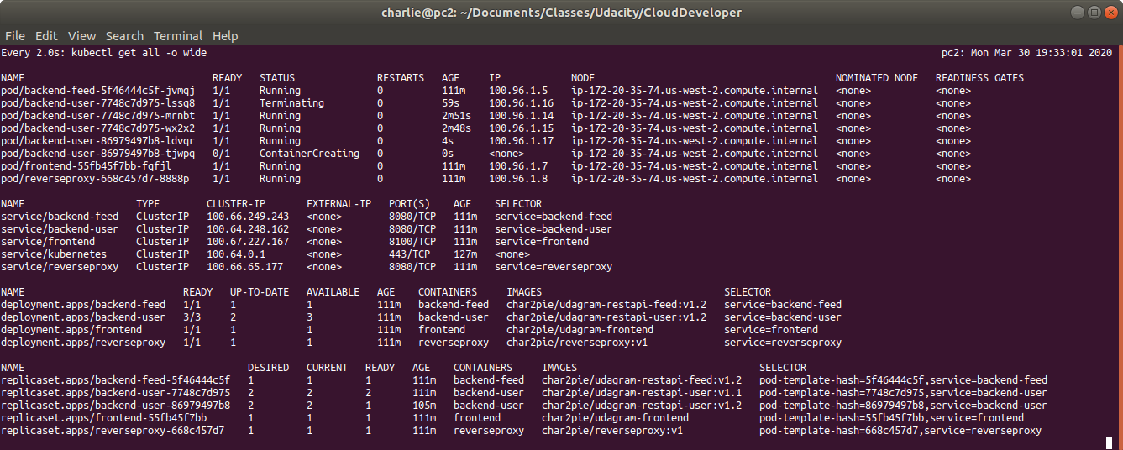
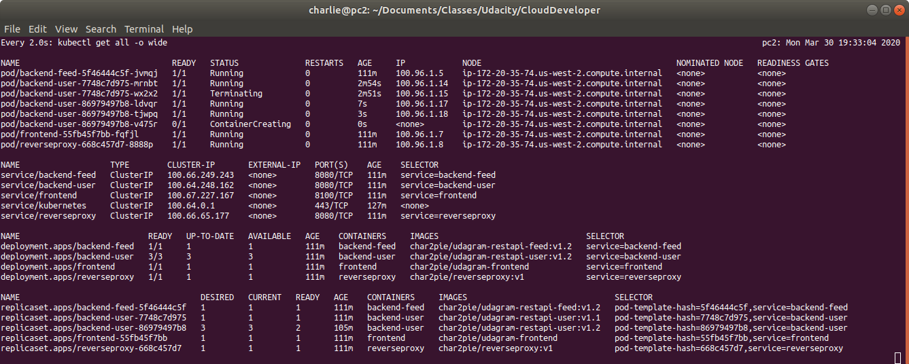
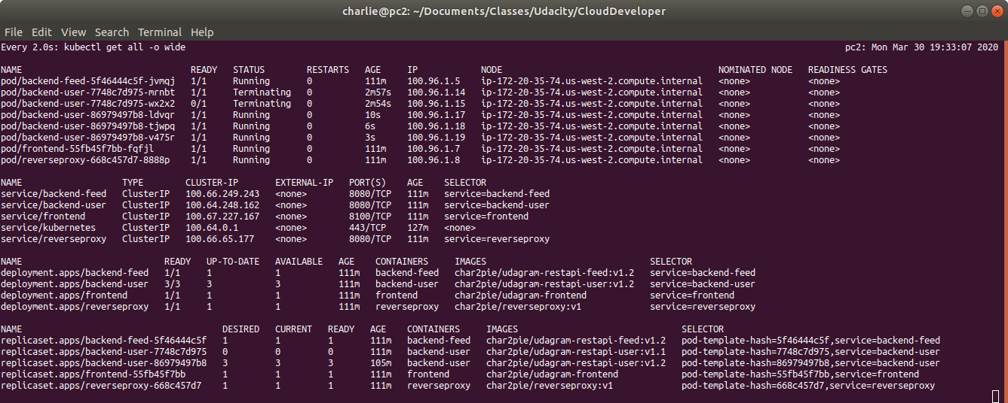
Here is the app running on AWS:

