HVE-720: Mathematical Foundations of a Harmonic Encoding over a Finite Abelian Group
Charles de Paula Eugênio*
Independent Researcher, Parauapebas, PA 68515-000, Brazil
Corresponding author: charles.dir13@gmail.com; Tel.: +55-94-98156-1009
Code repository: https://github.com/CharlesEugeniodr/HVE-720-6480--Harmonic-Vector-Encoding-
Abstract
Conventional character encodings preserve symbol identity but do not make relational structure explicit in their numerical organization. This work formalizes HVE-720 as a finite and exactly enumerable state architecture. The core is modeled as the finite Abelian group G = Z₃₆₀ × Z₂ × Z₅ × Z₉, with 32,400 states, decomposed into 720 symbolic positions and 45 auxiliary states per position. A mixed-radix bijection and its inverse are proved, and exhaustive verification confirms 32,400 distinct indices with zero round-trip errors. Circular metrics, a 7-regular Cartesian-product graph, finite-group characters, a discrete harmonic transform, and a refinement family Gₘ are defined. The formal chromatic extension HVE-χ introduces C* = {∅} ⊔ Z₂₅₆³, distinguishing no color from RGB black, and yields 543,581,830,800 BASE states. Its monolithic encoding is bijective and requires 39 bits, while an aligned profile uses 40 bits. The results establish HVE as a specialized algebraic encoding framework rather than a real vector space or differentiable manifold. The architecture separates mathematical core, protocol, chromatic extension, and applications, providing a rigorous basis for serialization, graph and spectral analysis, structured embeddings, multimodal states, and reproducible implementation.
Keywords: Harmonic Vector Encoding; Finite Abelian Groups; Mixed-Radix Bijection; Discrete Harmonic Analysis; Character Encoding; Chromatic State Space; Graph-Based Representation
MSC: 20K01; 43A40; 05C50; 68P30; 94A15

1. Introduction
Conventional encoding systems, such as ASCII, Unicode, and UTF-8, were designed primarily to identify symbols, ensure interoperability, and enable lossless transmission. These systems are not intended to make the numerical position of each code point express, by itself, geometric, categorical, or operational relationships among symbols. This is neither a logical deficiency nor a violation of information theory; it is a design decision.
HVE-720 starts from a different decision. Instead of treating each symbol merely as an opaque integer, it associates the symbol with a position in a discrete state architecture. The design hypothesis is that an explicit organization of coordinates may be useful when downstream applications require categorical ordering, modular transformations, per-symbol metadata, geometric representations, or discrete spectral operators.
The previous version of the manuscript combined, in a single text, the encoding, a virtual machine, a domain-specific language, experimental ciphers, steganography, embeddings, software infrastructure, and analogies with field theories. That breadth obscured the scientific core. The present work removes the associations with Maxwell's equations and focuses on the mathematical and architectural formulation of HVE and its states.
The contributions of this paper are:
- modeling HVE-720 as the finite Abelian group G = Z₃₆₀ × Z₂ × Z₅ × Z₉;
- decomposing the system into a visible alphabet A, with 720 positions, and an auxiliary space M, with 45 states per position;
- formally proving the mixed-radix bijection between the coordinates and the monolithic index;
- defining group operations, circular metrics, and neighborhood graphs;
- providing a foundation for the term harmonic through group characters and a discrete transform;
- defining a family of resolutions Gₘ and the maps between different levels;
- rigorously separating encoding, serialization protocol, and higher-layer applications.
Figure 1 summarizes the adopted separation among the mathematical core, the encoding protocol, and higher-layer applications.
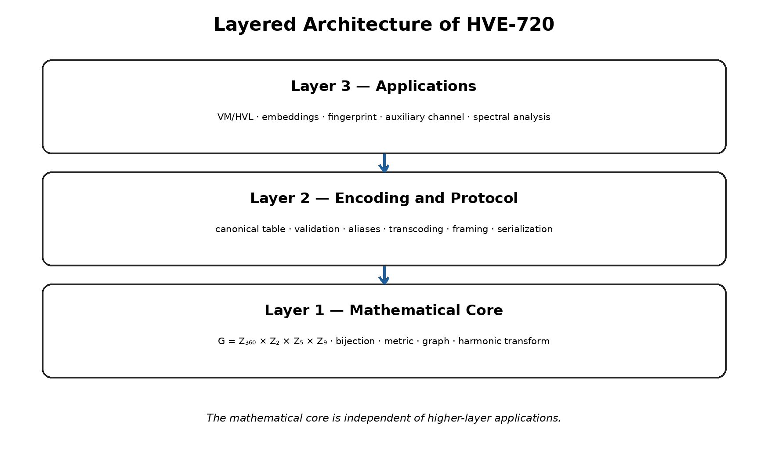
Figure 1. Layered architecture of HVE-720.
2. Scope, Terminology, and Mathematical Limits
2.1. State, Symbol, and Metadata
An HVE state is a quadruple g = (θ, s, τ, φ). In the base configuration, the visible symbol is determined by the projection (θ, s), while (τ, φ) constitutes an auxiliary state. This distinction prevents the incorrect interpretation that the system has 32,400 independent characters. It has 720 symbolic positions, each accompanied by 45 auxiliary combinations.
A = Z₃₆₀ × Z₂, M = Z₅ × Z₉, G = A × M. (1)
|A| = 720, |M| = 45, |G| = 32,400. (2)
2.2. HVE Is Not a Real Vector Space
The term “vector” in the name HVE must be understood in a computational sense: a state is stored as a coordinate vector. It is not claimed that G is a vector space over R or C. In particular, multiplication by real scalars, linear basis, linear independence, and vector-space dimension are not defined. The natural mathematical structure of G is that of a finite Abelian group.
2.3. HVE Is Not a Differentiable Manifold
Because G is finite, its natural discrete topology does not produce a four-dimensional differentiable manifold. Consequently, gradient, divergence, curl, and other continuous differential operators are not automatic properties of HVE. Discrete operators may be defined on graphs or complexes associated with the system, but this requires additional constructions and is not assumed in this paper.
3. Mathematical Core of HVE-720
3.1. Coordinate Domains
We define the following residue-class sets: θ ∈ Z₃₆₀ is the angular position; s ∈ Z₂ is the binary polarity coordinate; τ ∈ Z₅ is the discrete torsion state; and φ ∈ Z₉ is the plane state. The external representation σ ∈ {+1, −1} is obtained by σ = (−1)ˢ.
Table 1. Coordinate domains of the HVE-720 core.
Coordinate | Domain | Cardinality | Operational interpretation
θ | Z₃₆₀ | 360 | base angular position
s | Z₂ | 2 | polarity; σ = (−1)ˢ
τ | Z₅ | 5 | auxiliary torsion state
φ | Z₉ | 9 | auxiliary plane state

The decomposition G = A × M, with 720 symbolic positions and 45 auxiliary states per position, is summarized in Figure 2.
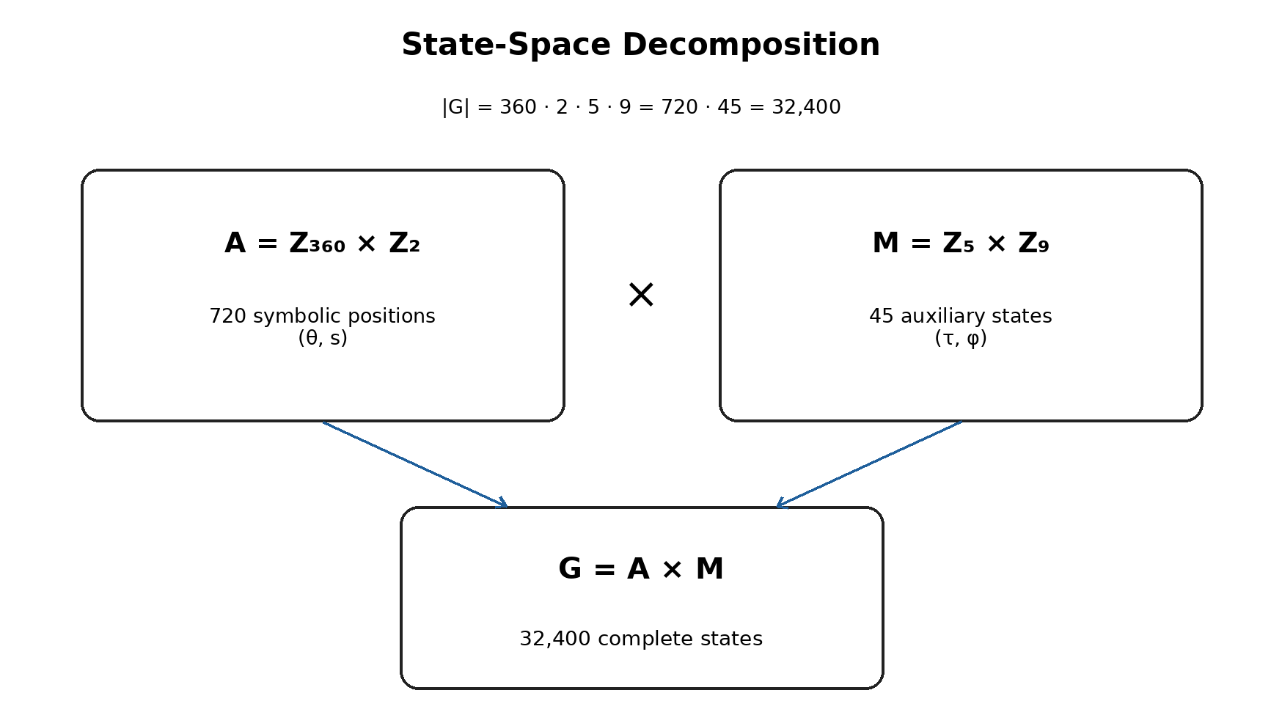
Figure 2. Decomposition of the HVE-720 state space.
3.2. Composition Law
The group operation is defined componentwise:
(θ,s,τ,φ) ⊕ (θ′,s′,τ′,φ′) = (θ+θ′ mod 360, s+s′ mod 2, τ+τ′ mod 5, φ+φ′ mod 9). (3)
The identity element is e = (0,0,0,0), and the inverse of g = (θ,s,τ,φ) is −g = (−θ mod 360, −s mod 2, −τ mod 5, −φ mod 9). Because each factor is a cyclic group, G is a finite Abelian group.
Proposition 1. G = Z₃₆₀ × Z₂ × Z₅ × Z₉, equipped with ⊕, is a finite Abelian group of order 32,400.
Proof. Each factor Zₙ is an Abelian cyclic group under modular addition. A finite direct product of Abelian groups is Abelian. The cardinality of the product is the product of the cardinalities: 360 · 2 · 5 · 9 = 32,400. ∎
3.3. Mixed-Radix Bijection
To convert the external polarity σ into a binary digit, we use s = (1 − σ)/2. Thus, σ = +1 corresponds to s = 0, and σ = −1 corresponds to s = 1.
We define the encoding function E: G → {0, …, 32,399} by:
E(θ,s,τ,φ) = (((θ · 2 + s) · 5 + τ) · 9 + φ). (4)
Figure 3 presents the direct construction of the monolithic index and the reverse order of the Euclidean divisions.
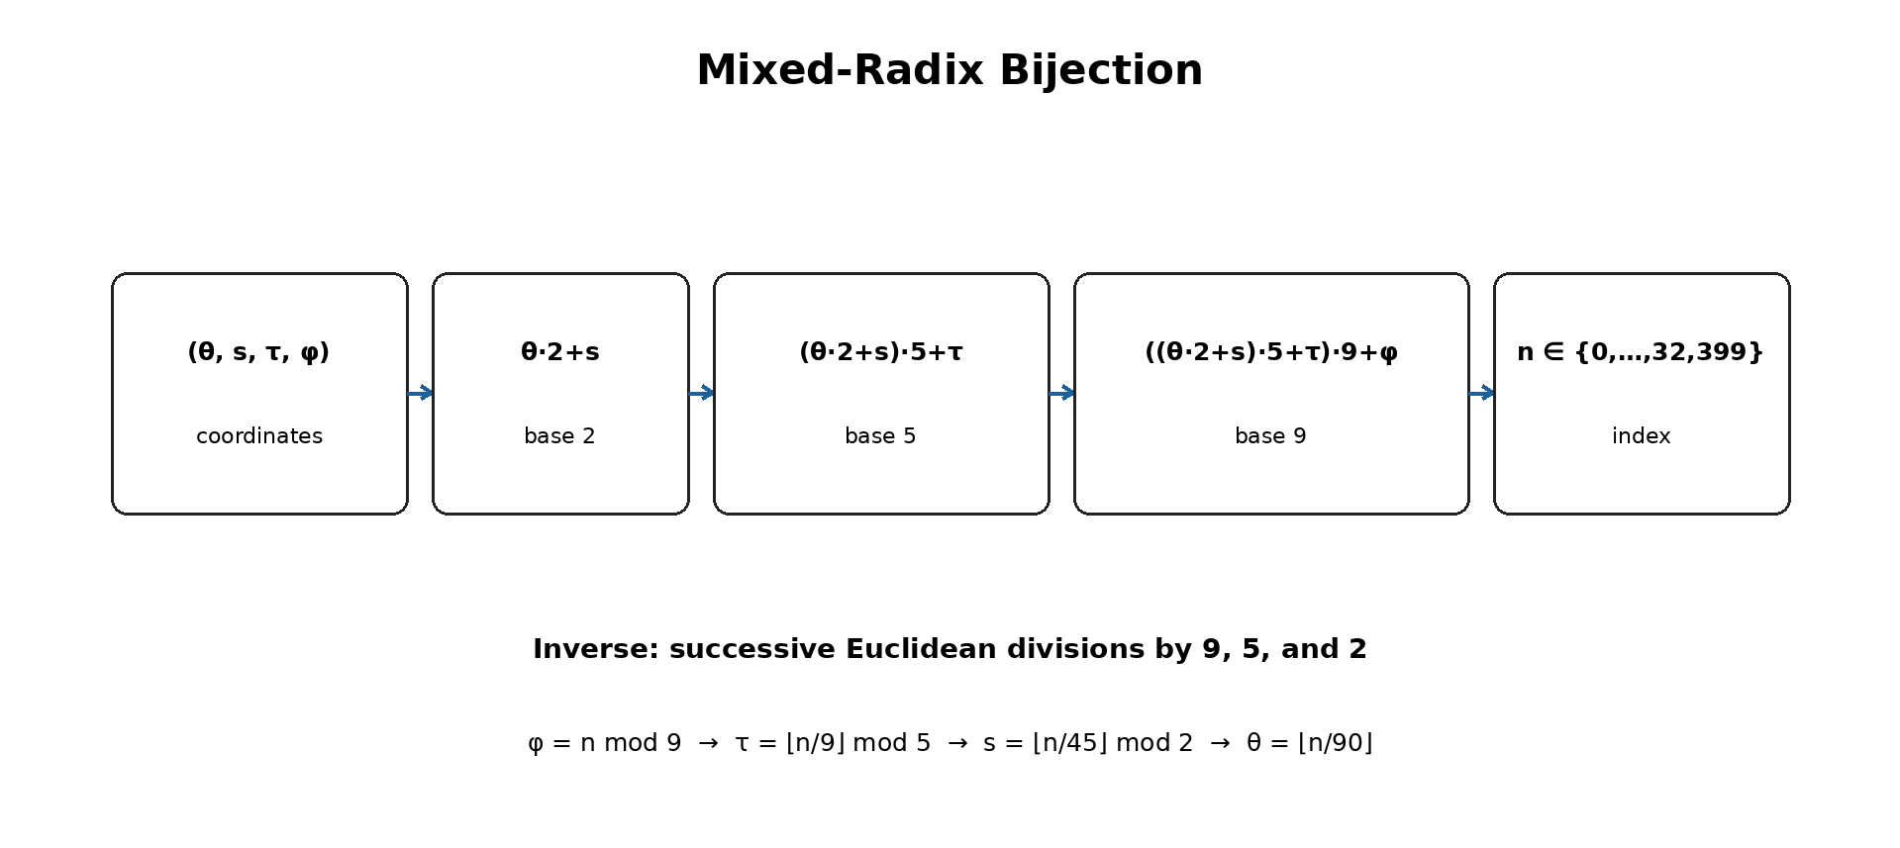
Figure 3. Mixed-radix bijection and coordinate recovery.
Theorem 1. The function E defined in (4) is bijective.
Proof. Every integer n in the interval 0 ≤ n < 32,400 admits successive Euclidean division by the bases 9, 5, 2, and 360. The remainders are unique and belong, respectively, to Z₉, Z₅, Z₂, and Z₃₆₀. Therefore, there is a unique quadruple (θ,s,τ,φ) associated with n. Conversely, each quadruple produces an integer in the specified interval. Hence, E is both injective and surjective. ∎
3.4. Inverse Function
Given n ∈ {0, …, 32,399}, the coordinates are recovered by:
φ = n mod 9; q₁ = ⌊n/9⌋, (5)
τ = q₁ mod 5; q₂ = ⌊q₁/5⌋, (6)
s = q₂ mod 2; θ = ⌊q₂/2⌋. (7)
The external polarity is then reconstructed by σ = (−1)ˢ.
3.5. Proof and Implementation Verification
Theorem 1 proves the correctness of the abstract specification. Exhaustive enumeration of the 32,400 states verifies a different property: that a particular computational implementation complies with the specification. Software verification does not replace the proof, but it is relevant for detecting implementation errors, incorrect bounds, and reversals in the order of the radices.
4. State Architecture
4.1. Visible Alphabet
The visible alphabet A contains 720 positions. It may be organized into two hemispheres of 360 positions: T⁺ for s = 0 and T⁻ for s = 1. The word “hemisphere” is an architectural convention; mathematically, A is the product Z₃₆₀ × Z₂.
Assigning categories to intervals of θ is a design choice, not a necessary consequence of the algebra. It must be documented in a versioned canonical table. Proximity between two categories depends on that table and therefore constitutes semantics imposed by the protocol.
Table 2. Canonical category allocation in the T⁺ hemisphere.
θ range in T⁺ | Category | Quantity
0–9 | Digits | 10
10–35 | Uppercase Latin letters | 26
36–61 | Lowercase Latin letters | 26
62–92 | Punctuation | 31
93–118 | Portuguese extension | 26
119–121 | Spacing | 3
122–145 | Currencies | 24
146–193 | Greek | 48
194–213 | Arrows | 20
214–233 | Geometric symbols | 20
234–253 | Typographic symbols | 20
254–293 | Extended Latin | 40
294–333 | Cyrillic | 40
334–349 | Superscripts and subscripts | 16
350–359 | Pictograms | 10

Figure 4 shows the distribution of the fifteen categories of T⁺ across the 360 angular positions. The geometry represents the selected canonical table; it does not imply universal semantics.
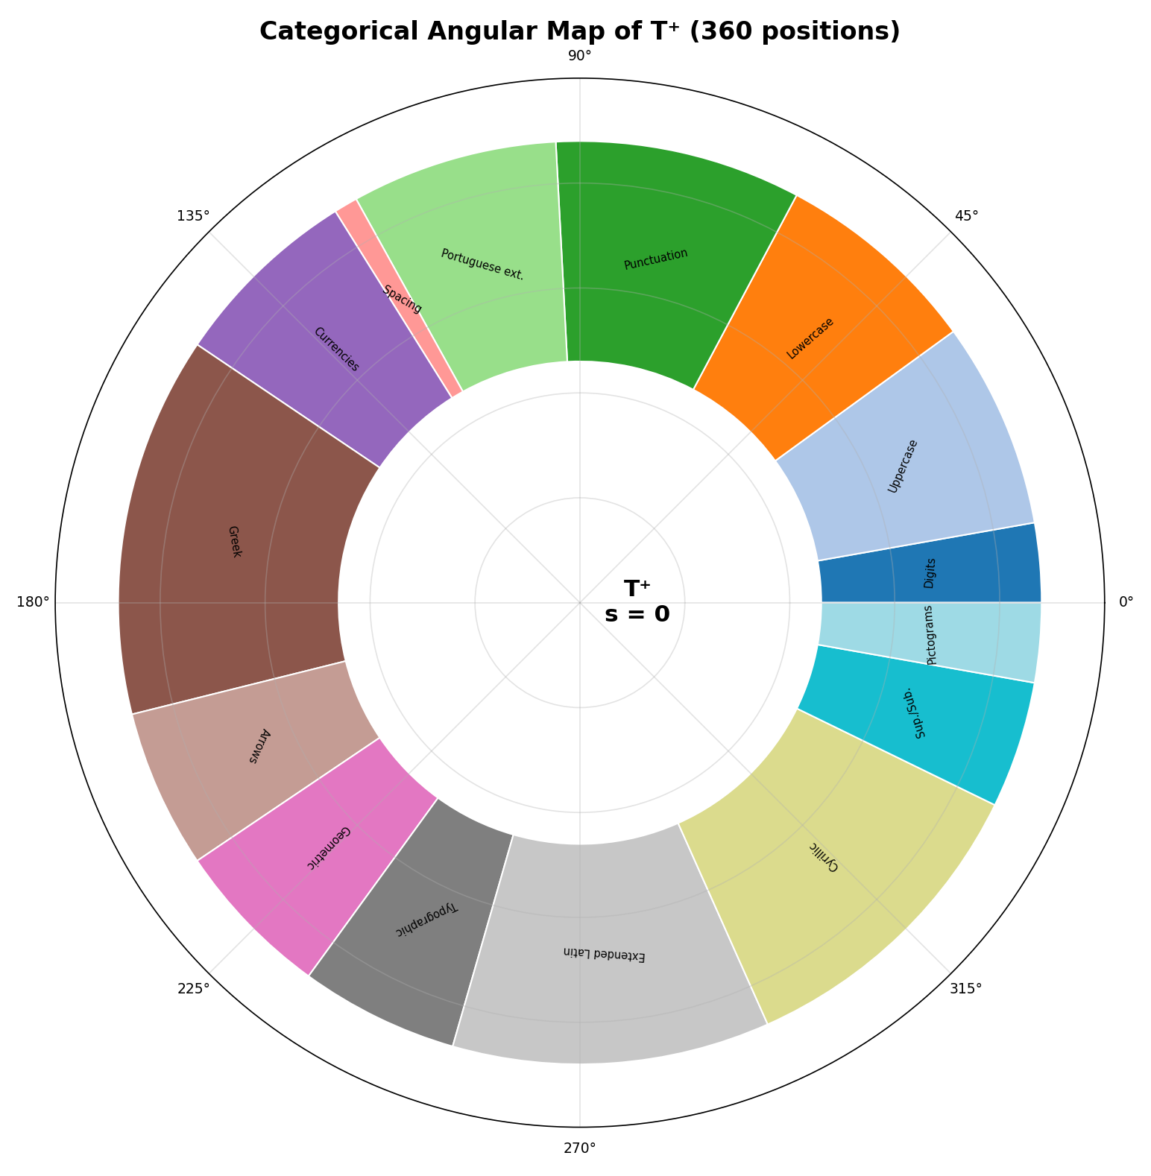
Figure 4. Categorical angular map of T⁺.
4.2. Auxiliary Space
The space M = Z₅ × Z₉ has 45 states. The interpretation of τ and φ must be determined by the protocol. Three uses are mathematically possible: (i) cyclic coordinates; (ii) ordered levels; or (iii) nominal categories. The choice changes the applicable metric.
When τ = 0 and φ = 0 represent the canonical text state, the remaining 44 states may carry auxiliary information. This information does not alter the projection onto the visible symbol, but it remains observable in the HVE stream. Therefore, such states should not be described as intrinsically invisible; they are invisible only after a projection that discards M.
4.3. Canonical Projections
π_A : G → A, π_A(θ,s,τ,φ) = (θ,s), (8)
π_M : G → M, π_M(θ,s,τ,φ) = (τ,φ). (9)
The projection πA provides the base symbol. For each a ∈ A, define the fiber F(a) = {g ∈ G : πA(g) = a}. The set F(a) contains exactly 45 states. This property is the precise mathematical formulation of the phrase “45 auxiliary states per symbol.”
Proposition 2. For every a ∈ A, |F(a)| = 45.
Proof. Once a = (θ,s) is fixed, the coordinates τ and φ may independently assume 5 and 9 values. Therefore, there are 5 · 9 = 45 states in the fiber. ∎
Figure 5 displays all 45 states in the fiber of a fixed symbol. The state (τ,φ) = (0,0) is the canonical representative; the remaining states are auxiliary states.
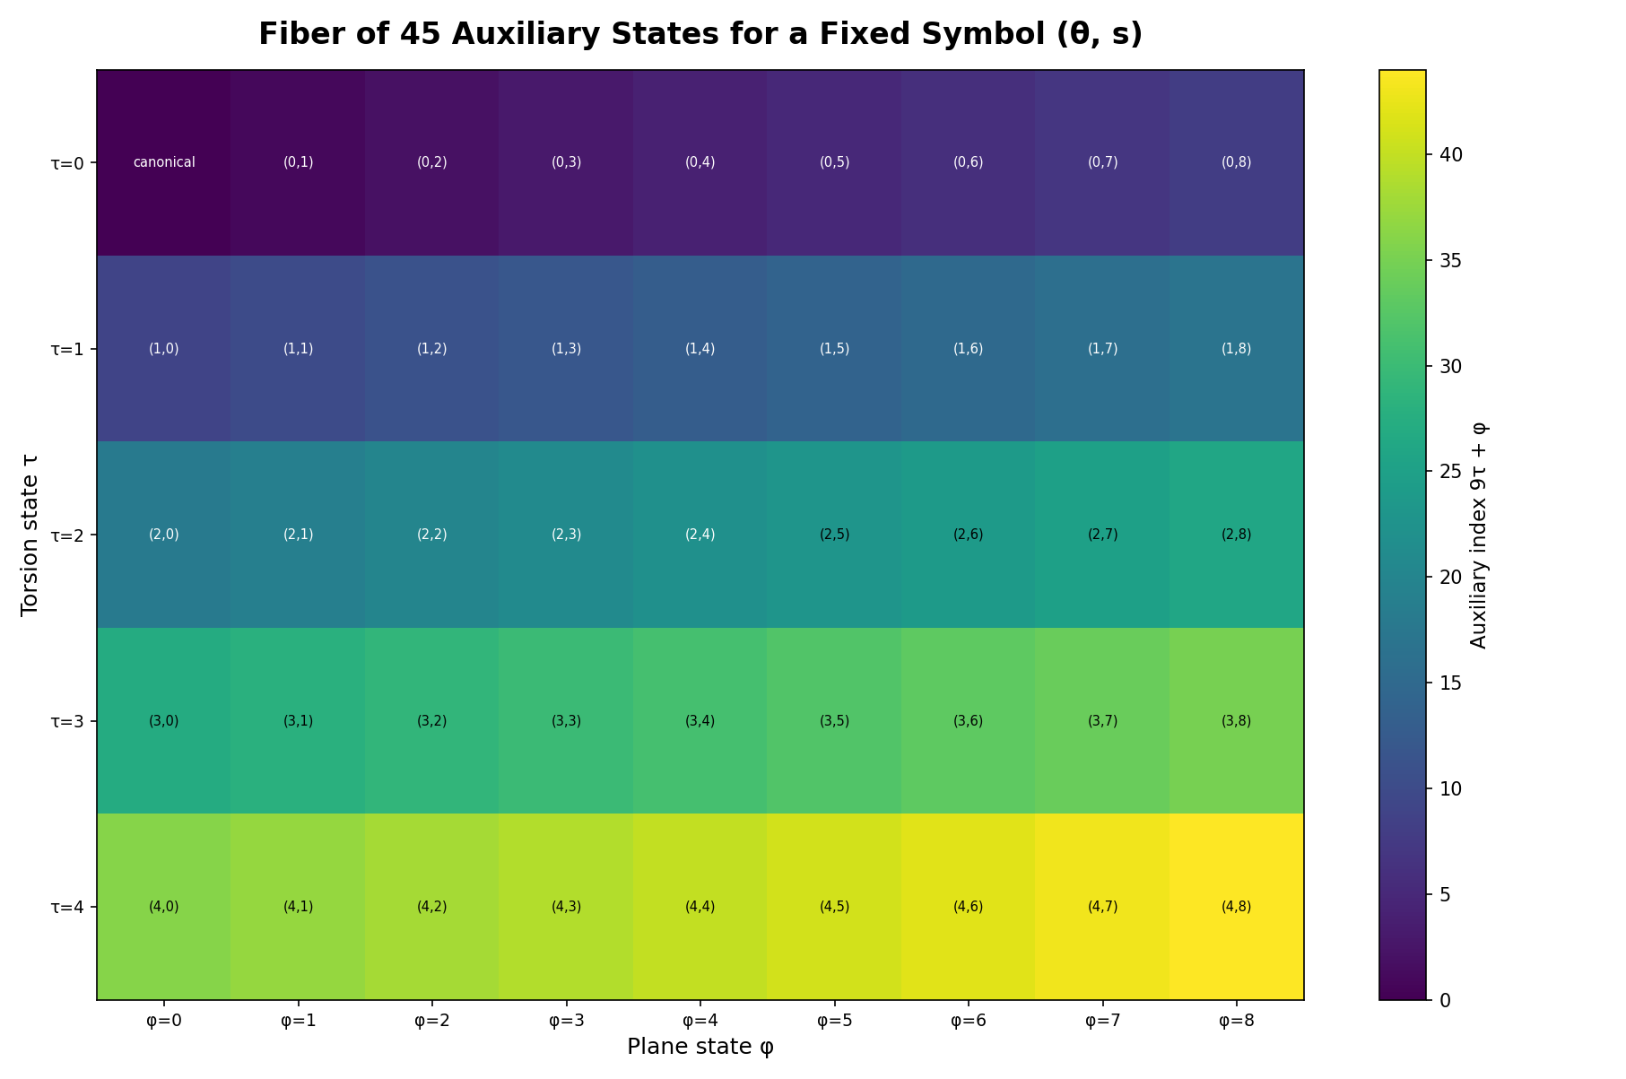
Figure 5. Complete fiber of 45 auxiliary states for a fixed symbolic position.
5. Discrete Geometry and Metrics
5.1. Circular Distance
Because θ belongs to a cycle, the absolute difference |θ−θ′| is not an appropriate angular distance. The points 0 and 359 must be neighbors. For Zₙ, we define:
δₙ(x,y) = min(|x−y|, n−|x−y|). (10)
A normalized version is given by:
δ̄ₙ(x,y) = δₙ(x,y) / floor(n/2). (11)
5.2. Weighted Product Metric
When all four coordinates are treated as cyclic, a weighted metric is:
d_w(g,h) = [wθ δ̄₃₆₀(θ,θ′) + ws δ̄₂(s,s′) + wτ δ̄₅(τ,τ′) + wφ δ̄₉(φ,φ′)] / (wθ+ws+wτ+wφ). (12)
The weights must be declared by the application. There is no universal choice. If τ or φ are nominal, the circular distance is replaced by the discrete distance, equal to zero for identical values and one for distinct values.
Proposition 3. If all weights are positive and each component uses a metric, then d_w is a metric on G.
Proof. A positive linear combination of metrics, normalized by a positive constant, preserves nonnegativity, identity of indiscernibles, symmetry, and the triangle inequality. ∎
5.3. Neighborhood Graph
An alternative combinatorial geometry is obtained by defining a graph Γ(G). Two states are adjacent when they differ by one modular unit in exactly one coordinate. The resulting graph is the Cartesian product, denoted by Cart(C₃₆₀, K₂, C₅, C₉).
Γ(G) = Cart(C₃₆₀, K₂, C₅, C₉). (13)
Proposition 4. The graph Γ(G) = Cart(C₃₆₀, K₂, C₅, C₉) is connected, 7-regular, has 32,400 vertices, 113,400 edges, and diameter 187.
Proof. Each factor is connected, so the Cartesian product is connected. The degrees of the factors are 2, 1, 2, and 2; therefore, the total degree is 7. By the handshaking lemma, |E| = 32,400·7/2 = 113,400. The diameter of the Cartesian product is the sum of the diameters: 180 + 1 + 2 + 4 = 187. ∎
Figure 6 represents the local neighborhood of a state. Drawing all 32,400 vertices on a single page would make the graph illegible; the Cartesian-product definition and the invariants above describe the complete graph.
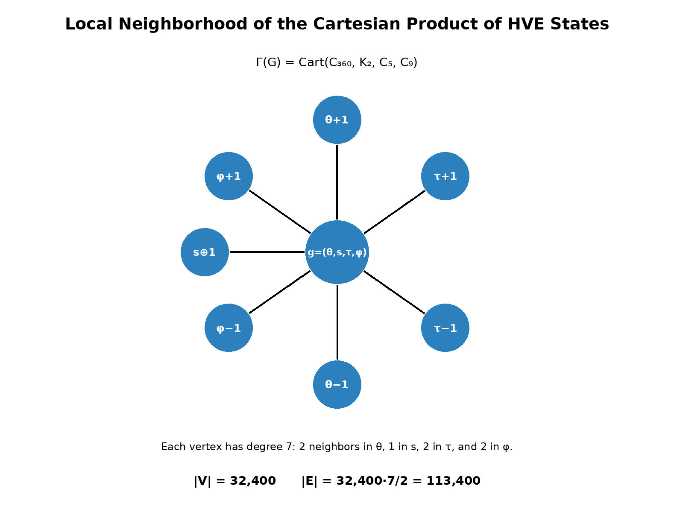
Figure 6. Local neighborhood and invariants of the technical state graph.
The global adjacency matrix can be written as a Kronecker sum:
AΓ = A₃₆₀⊗I₂⊗I₅⊗I₉ + I₃₆₀⊗A₂⊗I₅⊗I₉ + I₃₆₀⊗I₂⊗A₅⊗I₉ + I₃₆₀⊗I₂⊗I₅⊗A₉.
Consequently, the Laplacian is the Kronecker sum of the Laplacians of the four factors. This form makes it possible to calculate the global spectrum from the spectra of C₃₆₀, K₂, C₅, and C₉ without explicitly constructing a dense 32,400 × 32,400 matrix.
This representation makes it possible to define shortest paths, graph Laplacians, discrete diffusion, spectral regularization, and search algorithms without assuming a continuous manifold.
6. Harmonic Foundation
6.1. Group Characters
The term “harmonic” is grounded in harmonic analysis on finite Abelian groups. A character of G is a homomorphism χ: G → S¹. For k = (kθ,ks,kτ,kφ) in the dual group Ĝ, we define:
χ_k(g) = exp{2πi[kθθ/360 + kss/2 + kττ/5 + kφφ/9]}. (14)
The characters form an orthogonal basis for the space of complex-valued functions f: G → C. Thus, any function defined on HVE states admits a discrete spectral decomposition.
6.2. Discrete Harmonic Transform
f̂(k) = Σ_{g∈G} f(g) · overline{χ_k(g)}. (15)
f(g) = (1/|G|) Σ_{k∈Ĝ} f̂(k) · χ_k(g). (16)
This transform must not be confused with a statement about physical phenomena. It is a Fourier transform on a finite group. Its possible mathematical applications include pattern correlation, filtering, periodicity detection, construction of spectral embeddings, and analysis of the Laplacian of the graph Γ(G).
Figure 7 illustrates the real parts of four characters of the angular factor Z₃₆₀. These modes form components of the harmonic basis used in the decomposition of functions on G.
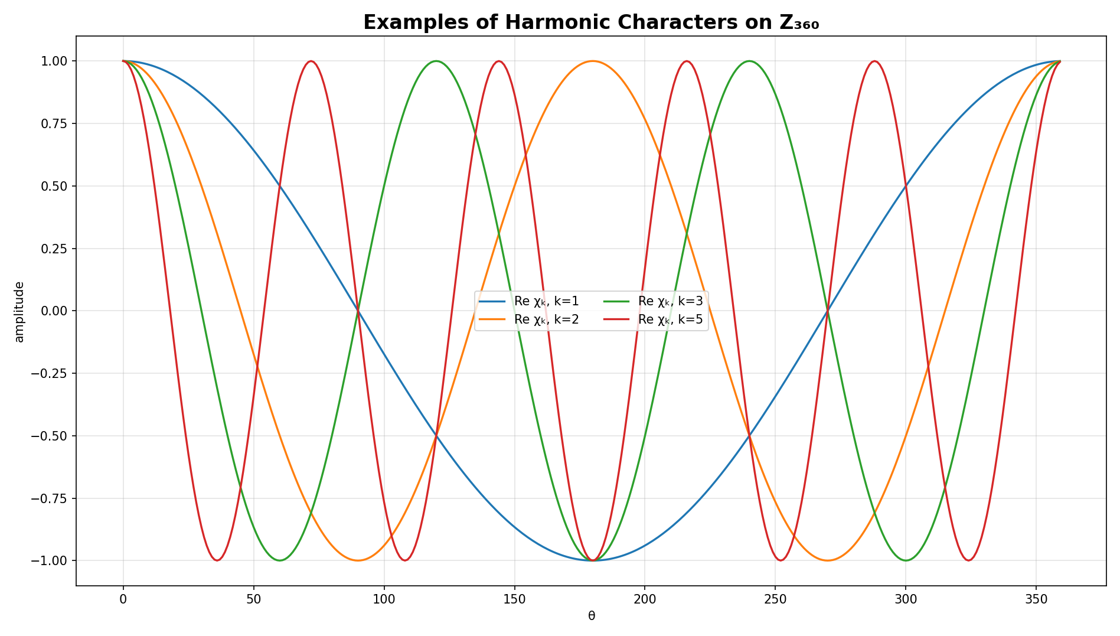
Figure 7. Examples of harmonic characters on the factor Z₃₆₀.
6.3. Convolution
(f * h)(g) = Σ_{u∈G} f(u) h(g−u). (17)
By the convolution theorem, the transform converts convolutions into pointwise products. This provides a clear mathematical foundation for filters and translation-invariant operators on the state space.
7. Refinement Hierarchy
7.1. Family Gₘ
For an angular resolution m times finer, we define:
Gₘ = Z₃₆₀ₘ × Z₂ × Z₅ × Z₉. (18)
|Gₘ| = 32,400 m. (19)
The BASE configuration corresponds to m = 1. The MICRO configuration uses m = 1,000. The NANO configuration described in the implementation uses m = 1,080,000.
Table 3. Named refinement levels and minimum addressing requirements.
Level | m | |Gₘ| | Minimum bits
BASE | 1 | 32,400 | 15
MICRO | 1,000 | 32,400,000 | 25
NANO | 1,080,000 | 34,992,000,000 | 36

Figure 8 presents the cardinality growth of the three named resolutions. The logarithmic scale prevents BASE and MICRO from disappearing relative to the magnitude of NANO.
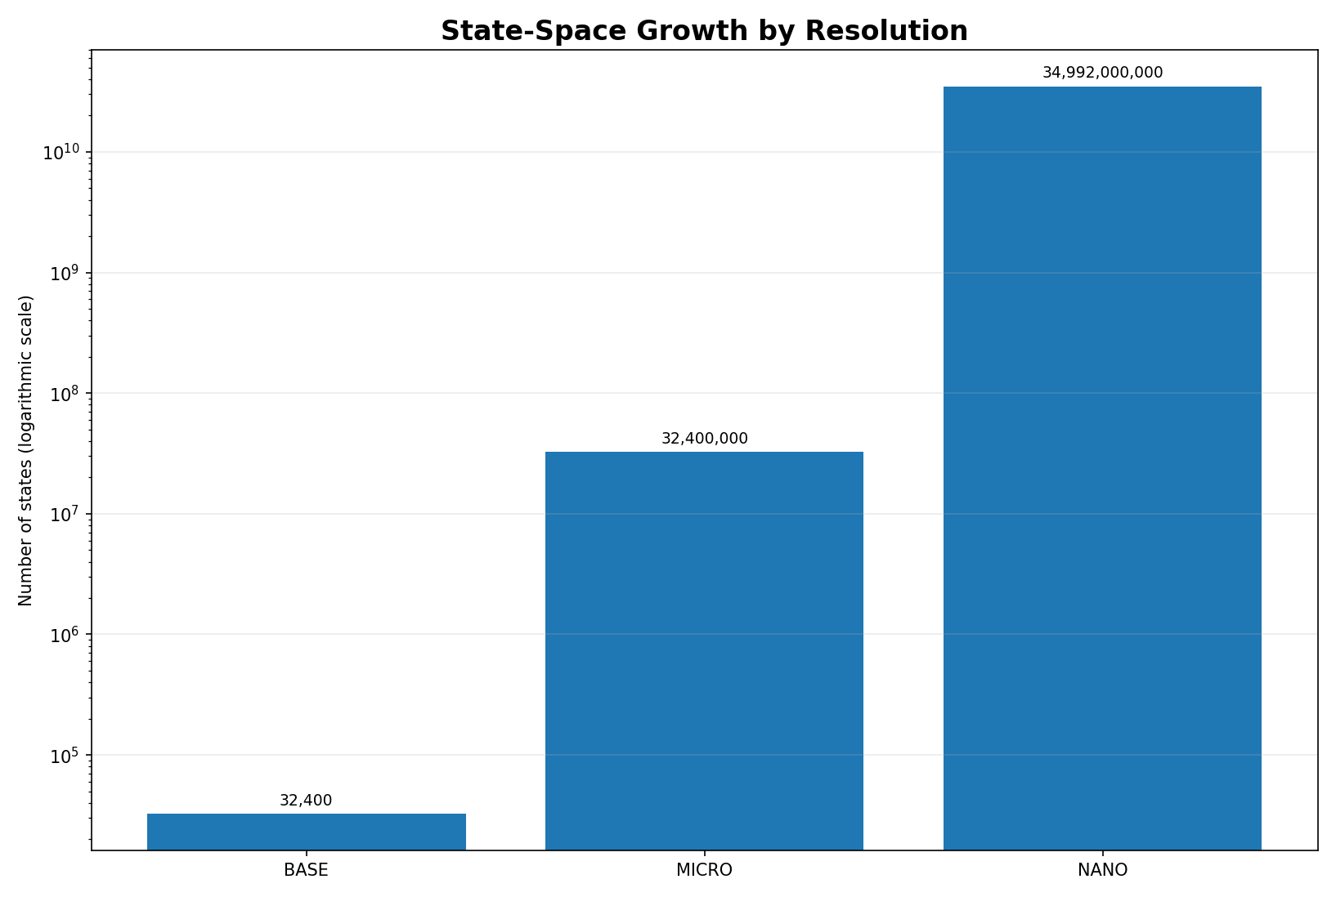
Figure 8. Growth in the number of states at the BASE, MICRO, and NANO resolutions.
7.2. Maps Between Resolutions
When m divides n, there is a natural inclusion that preserves the angular position:
i(m,n)(x,s,τ,φ) = ((n/m)x mod 360n, s, τ, φ). (20)
A projection from high to low resolution may be defined by quantization:
p(n,m)(x,s,τ,φ) = (floor((m/n)x) mod 360m, s, τ, φ). (21)
In general, applying i(m,n) first and then p(n,m) returns the original state in G_m. The composition in the opposite order is not the identity because the projection loses subangular information. The correct terminology is refinement hierarchy or multiscale quantization, not multiresolution analysis in the wavelet sense, unless nested function spaces and scaling relations are formally introduced.
8. Encoding and Protocol Specification
8.1. Canonical State
For ordinary textual use, it is recommended that each symbol have a canonical encoding with τ = 0 and φ = 0. Alternative states may be admitted only when the higher-layer protocol declares their meaning.
8.2. Canonical Table and Aliases
The mapping table must be versioned and unambiguous. If the same Unicode character appears in more than one HVE position, one position must be declared canonical and the others must be decoding aliases. Without this rule, the Unicode → HVE mapping is not a single-valued function.
8.3. 15-Bit Words
The 15-bit space contains 32,768 possible words, of which 32,400 are valid. Therefore, there are 368 reserved or invalid words.
η = 32,400 / 32,768 ≈ 0.98877. (22)
Binary-space occupancy is approximately 98.877%. Decoders must reject indices greater than 32,399 unless a future protocol version assigns meaning to part of the reserved interval.
Figure 9 shows the effective occupancy of the 15-bit binary space. The remaining 368 patterns must be treated as invalid or reserved.
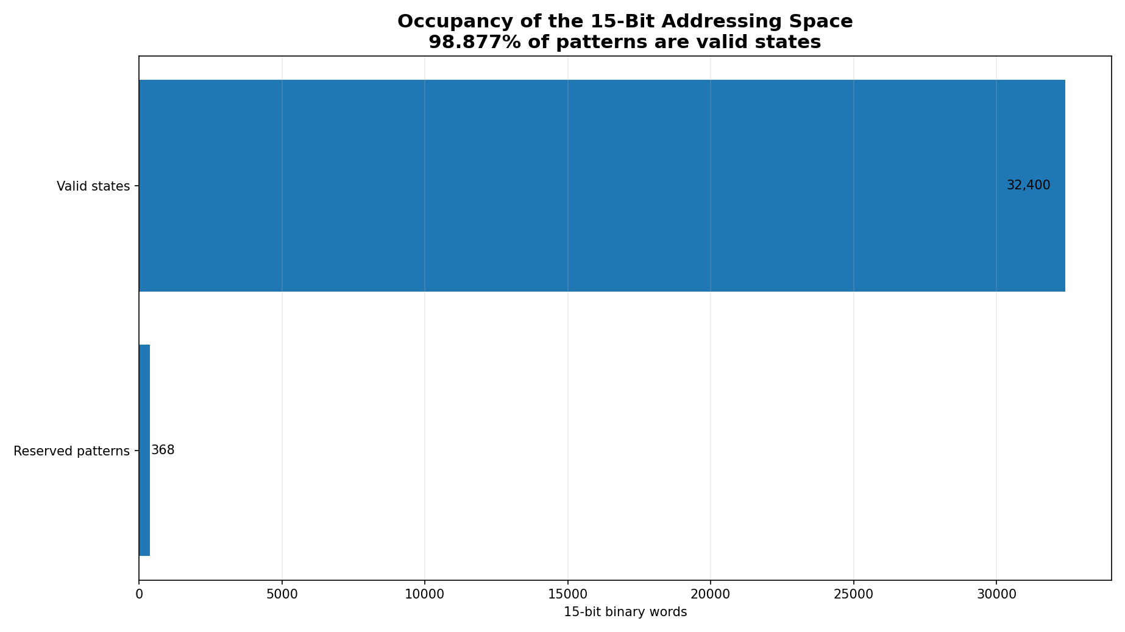
Figure 9. Occupancy of the 15-bit addressing space.
8.4. Packing
The ideal packing of eight 15-bit words uses 120 bits, that is, 15 bytes. The asymptotic cost is 1.875 bytes per state. For incomplete blocks, the protocol must declare length, padding, and bit order. This efficiency refers to the complete HVE state, not only to the alphabet of 720 symbols.
9. Comparisons and Correct Interpretation of Efficiency
9.1. HVE and UTF-8 Address Different Objectives
UTF-8 is a variable-length, octet-oriented, self-synchronizing encoding compatible with Unicode. HVE-720 is a fixed encoding of states belonging to a specialized alphabet. Size comparisons are valid only when they use the same corpus, the same symbolic coverage, and the same handling of unrepresentable characters.
9.2. Information Limit of the Visible Alphabet
⌈log₂ 720⌉ = 10. (23)
Ten bits are sufficient to index only the visible alphabet A. The 15 bits of the complete HVE exist because the state includes M, with 45 auxiliary combinations. Therefore, the five additional bits cannot simply be presented as the cost required to represent 720 characters.
9.3. Benchmark Requirements
A publishable benchmark must include:
- real corpora in different languages and domains;
- the coverage rate of the HVE alphabet in each corpus;
- the fallback cost for missing characters;
- header overhead and incomplete blocks;
- encoding and decoding time;
- comparison with uncompressed UTF-8 and, in a separate scenario, with general-purpose compressors;
- confidence intervals and release of reproduction scripts.
10. Structured Embeddings
10.1. Geometric Representation
A basic representation of a state may be constructed from periodic coordinates:
v(g) = [cos(2πθ/360), sin(2πθ/360), (−1)ˢ, cos(2πτ/5), sin(2πτ/5), cos(2πφ/9), sin(2πφ/9)]. (24)
This representation respects the circular closure of each component and avoids the artificial discontinuity between 359 and 0.
10.2. Limitation of the Categorical Experiment
If the categories are defined in advance as intervals of θ, a classifier trained to recover those categories merely confirms that the intervals were encoded in the input itself. This result is useful as a consistency test of the table, but it does not demonstrate general semantic capability.
10.3. Recommended Experimental Protocol
Future experiments should use tasks whose labels are not used to construct the mapping. Appropriate baselines include the normalized Unicode index, official properties from the Unicode Character Database, trainable random embeddings, hashing, and conventional categorical representations. Cross-validation, macro-F1, balanced accuracy, a confusion matrix, and a permutation test are recommended.
11. Separation Between Core and Applications
Table 4. Separation between mathematical core, protocol, applications, and security.
Layer | Elements | Scientific status
Mathematical core | G, bijection, metric, characters, refinement | central object of this paper
Protocol | table, aliases, validation, framing, serialization | necessary specification
Applications | VM, DSL, embeddings, steganography, fingerprint | higher layers
Security | modular transformations and fragmentation | must not be called secure cryptography without formal analysis

Transformations by modular addition are bijective and may be useful as coordinate permutations, but they must not be described as modern ciphers without a threat model, nonce, authentication, standardized key derivation, and cryptographic analysis. Likewise, splitting coordinates into fragments is not equivalent to Shamir's scheme, which depends on polynomials over finite fields and a threshold property.
12. Computational Verification
12.1. Exhaustive Bijection Test
The implementation must enumerate all states, calculate n = E(g), reconstruct g′ = E⁻¹(n), and verify g′ = g. It must also verify that the set of obtained indices has 32,400 distinct elements and coincides with {0, …, 32,399}.
In the reference routine used to check the formulation of this manuscript, all 32,400 BASE states were enumerated. The result was 32,400 distinct indices, with minimum 0, maximum 32,399, and zero round-trip errors.
12.2. Property Tests
- closure of ⊕ in G;
- associativity by randomized testing, although already guaranteed theoretically;
- identity and inverse for every state;
- symmetry and triangle inequality of the selected metric;
- round-trip between resolutions at points belonging to the image of the inclusion map i(m,n);
- rejection of the 368 invalid 15-bit indices;
- uniqueness of canonical Unicode encoding.
12.3. Reproducibility
The repository associated with the submission must contain an identified version, license, canonical table, test scripts, benchmark files, and reproduction instructions. The number of passed tests is evidence of implementation quality, but it does not replace a description of coverage, environment, and acceptance criteria.
12.4. Quantitative Scope of the Demonstration
The word “demonstrated” is used in two distinct senses: mathematical demonstration of cardinality and computational verification of individual states. The adopted scope is summarized in Table 5.
Table 5. Quantitative scope of the mathematical and computational demonstration.
Object | Cardinality | Form of demonstration | Individual coverage
BASE — complete space | 32,400 | formal proof and exhaustive verification | all states
Visible alphabet A | 720 | canonical table and projection πA | all positions
Auxiliary fiber per symbol | 45 | complete enumeration in Figure 5 | all states in the fiber
MICRO | 32,400,000 | proof by the formula |Gm| = 32,400m | not fully enumerated
NANO | 34,992,000,000 | proof by the formula |Gm| = 32,400m | not fully enumerated
Therefore, the paper mathematically demonstrates the entire BASE space of 32,400 states and verifies it state by state. The MICRO and NANO resolutions are demonstrated by the cardinality theorem and refinement maps; exhaustive enumeration at these scales would not add mathematical content proportional to the computational cost.
13. Chromatic Extension of the HVE Space
The HVE-χ layer extends the HVE-720 core without changing the 32,400 fundamental BASE states. It introduces an optional RGB coordinate and a distinguished no-color state, while preserving a reversible projection onto the original core.
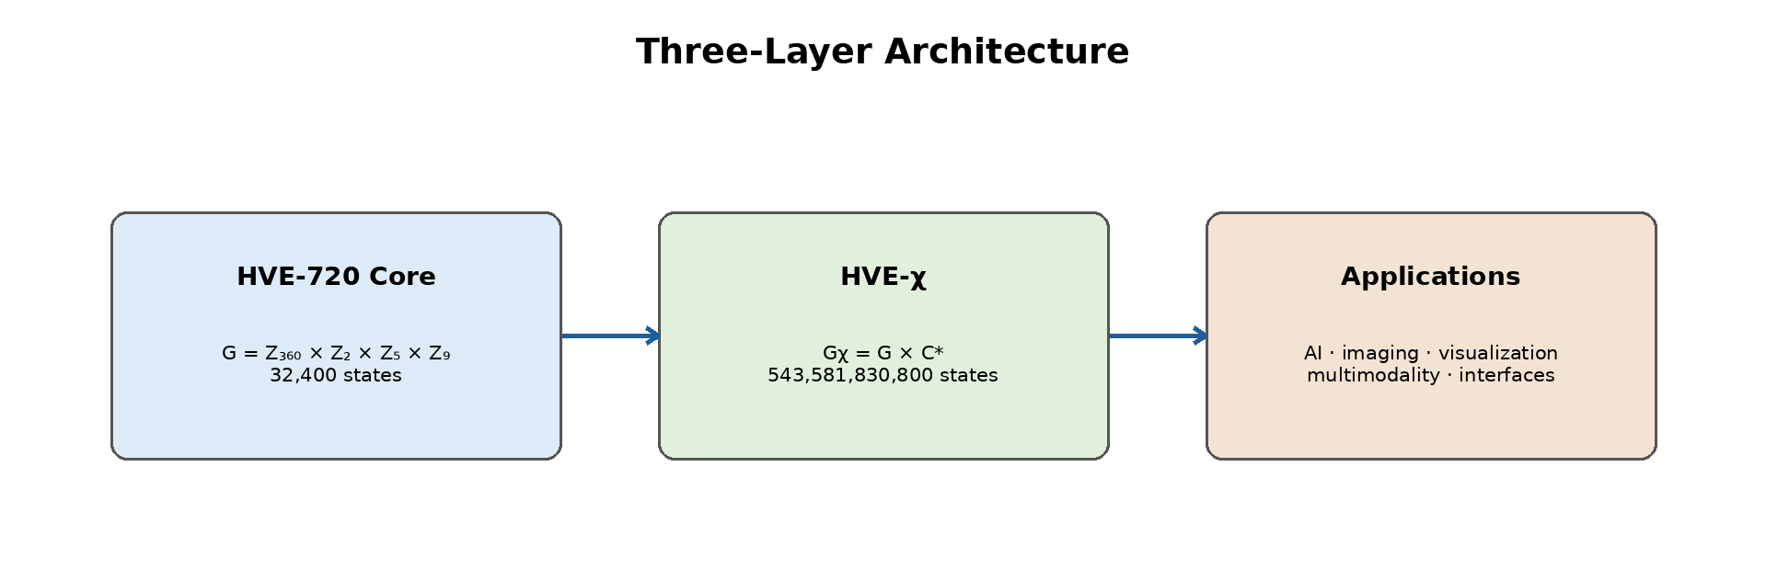
Figure 10. Three-layer architecture of the HVE-χ chromatic extension.
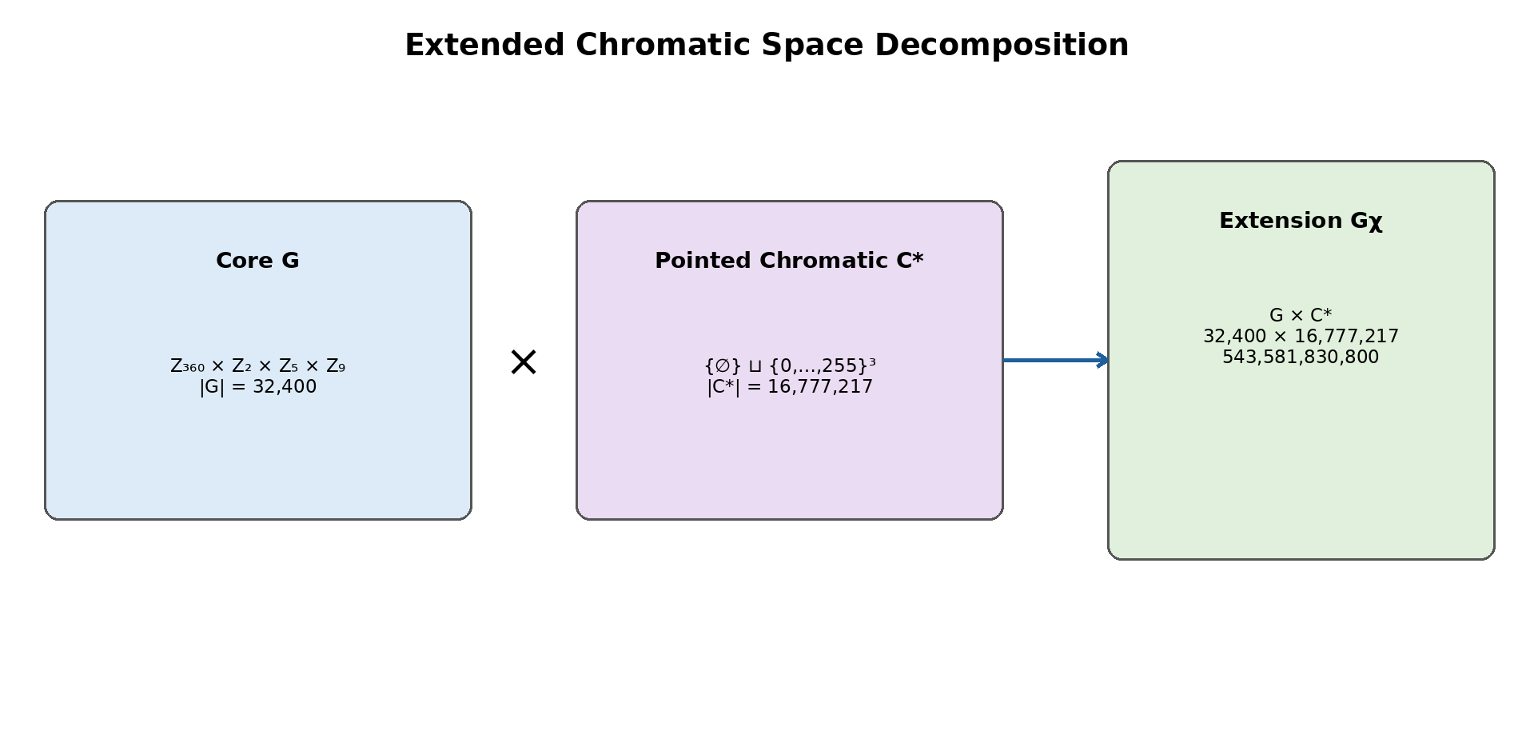
Figure 11. Decomposition of the core, chromatic set, and extended state space.
13.1. Definition of the Chromatic Space
Let R = G_c = B_c = {0,1,…,255} be the discrete domains of the red, green, and blue channels. The RGB chromatic set is defined by:
C = R × G_c × B_c = {0,…,255}³. (25)
Each element c = (r,g,b) ∈ C represents a triple of 8-bit channels. The notation G_c is used for the green channel to avoid confusion with the HVE core, denoted by G.
To distinguish the absence of chromatic information from any valid color, we introduce a null symbol ∅ that does not belong to C:
C* = {∅} ⊔ C. (26)
The union in (26) is disjoint. Thus, the protocol reserves one null state, denoted by the notation presented in (26). This state is not an RGB triple.
Definition 1. The set C* is the pointed chromatic space of the HVE-χ extension, with ∅ as its distinguished state or base state.
13.2. Cardinality
Because each channel has 256 independent values, the cardinality of C is:
|C| = 256³ = 2²⁴ = 16.777.216. (27)
Including the null state adds exactly one element:
|C*| = 2²⁴ + 1 = 16.777.217. (28)
Proposition 5. The pointed chromatic space C* contains exactly 16,777,217 states.
Proof. The Cartesian product of three sets with 256 elements has 256·256·256 = 2²⁴ elements. Because ∅ is external to this product, the disjoint union adds exactly one state. ∎
13.3. Direct Product with HVE
The HVE-720 core is the set:
G = Z₃₆₀ × Z₂ × Z₅ × Z₉, |G| = 32,400. (29)
The complete chromatic extension is defined by the Cartesian product:
Gχ = G × C*. (30)
An HVE chromatic state is therefore a pair (g,c), where g = (θ,s,τ,φ) belongs to the core and c is either ∅ or an RGB triple.
|Gχ| = |G|·|C*| = 32,400·16,777,217 = 543,581,830,800. (31)
Theorem 2. The HVE-χ extension has exactly 543,581,830,800 distinct states.
Proof. In the Cartesian product, each of the 32,400 core states may be independently associated with any of the 16,777,217 chromatic states. The product rule yields the stated cardinality. ∎
The structure Gχ is a finite set of states. It is not automatically a group because C* contains a special no-color state. Additional algebraic operations may be defined on the colored subset G × C, but these operations are not necessary for defining the protocol.
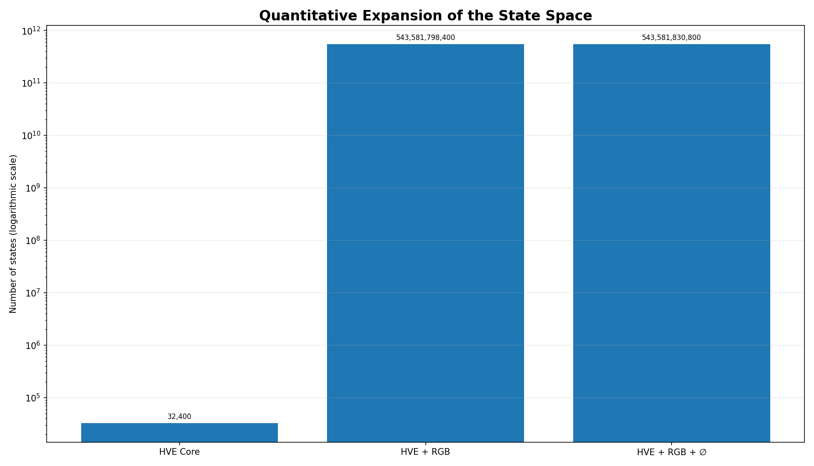
Figure 12. Growth in the number of states after introduction of the chromatic component.
13.4. Canonical Chromatic State
The canonical chromatic state for a symbol without color information is the null state. We adopt the empty-set symbol presented in (26) to represent it. Thus, the canonical inclusion of the core into the extended space is:
ιχ : G → Gχ, ιχ(g) = (g,∅). (32)
The projection that removes the chromatic layer is:
πG : Gχ → G, πG(g,c) = g. (33)
These maps guarantee backward compatibility: every HVE-720 state has a unique colorless representation in HVE-χ, and removing the chromatic component recovers exactly the core state.
Proposition 6. πG ∘ ιχ = id_G.
Proof. For every g ∈ G, πG(ιχ(g)) = πG(g,∅) = g. ∎
13.5. Encoding Function
Let E_G : G → {0,…,32,399} be the mixed-radix bijection of the HVE-720 core. We define a canonical ordering κ : C* → {0,…,2²⁴} by:
κ(∅) = 0, (34)
κ(r,g,b) = 1 + 65,536r + 256g + b. (35)
Consequently, black (0,0,0) receives κ = 1, while white (255,255,255) receives κ = 2²⁴. Let B = 2²⁴ + 1. The monolithic function of the extension is:
Eχ(g,c) = E_G(g)·B + κ(c). (36)
The image of Eχ is the integer interval {0,…,543,581,830,799}.
Theorem 3. The function Eχ is a bijection between Gχ and {0,…,543,581,830,799}.
Proof. E_G and κ are bijections. The expression in (36) is a two-position mixed-radix representation, with radices 32,400 and B. By uniqueness of the quotient and remainder in Euclidean division by B, each index has a unique pair (g,c), and each pair produces a unique index. ∎
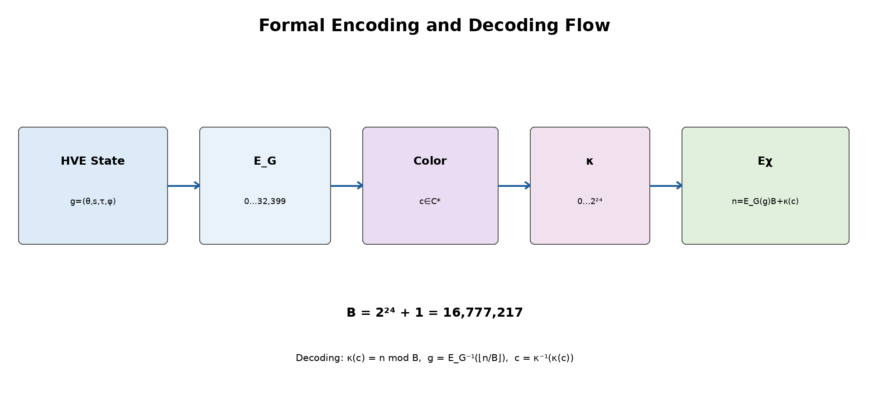
Figure 13. Formal flow of the HVE-χ encoding and decoding functions.
13.6. Inverse Function
Given n in the valid interval, we calculate:
q = ⌊n/B⌋, k = n mod B. (37)
The core state is recovered by g = E_G⁻¹(q). The chromatic component is recovered by:
κ⁻¹(0) = ∅. (38)
For k > 0, define u = k − 1 and calculate:
r = ⌊u/65,536⌋, (39)
g_c = ⌊(u mod 65,536)/256⌋, (40)
b = u mod 256. (41)
Then κ⁻¹(k) = (r,g_c,b). The inverse is total for indices between 0 and 543,581,830,799 and must reject values outside this interval.
13.7. Impact on the Number of Bits
The minimum number of bits required to identify a state is given by the ceiling of the binary logarithm of the cardinality.
Table 6. Cardinality and bit requirements of the chromatic extension.
Object | Cardinality | Minimum bits
Core G | 32,400 | 15
RGB C | 16,777,216 | 24
Pointed chromatic C* | 16,777,217 | 25 as an independent field
G × C | 543,581,798,400 | 39
Gχ = G × C* | 543,581,830,800 | 39 in a monolithic index

Although C* alone requires 25 bits, the complete product Gχ still fits within 39 bits because:
2³⁸ < 543,581,830,800 < 2³⁹. (42)
Two serialization profiles are recommended:
13.7.1. Compact 39-Bit Profile
It directly stores the Eχ index. It is theoretically minimal, but requires bit-level packing and handling of word boundaries.
13.7.2. Aligned 40-Bit Profile
It uses 15 bits for the HVE index, one presence bit P, and 24 RGB bits. The total is 40 bits, exactly five bytes. When P = 0, the RGB channels must be zero; when P = 1, the 24 bits represent a valid color. This profile is one bit larger, but much simpler for implementation, inspection, and transmission.
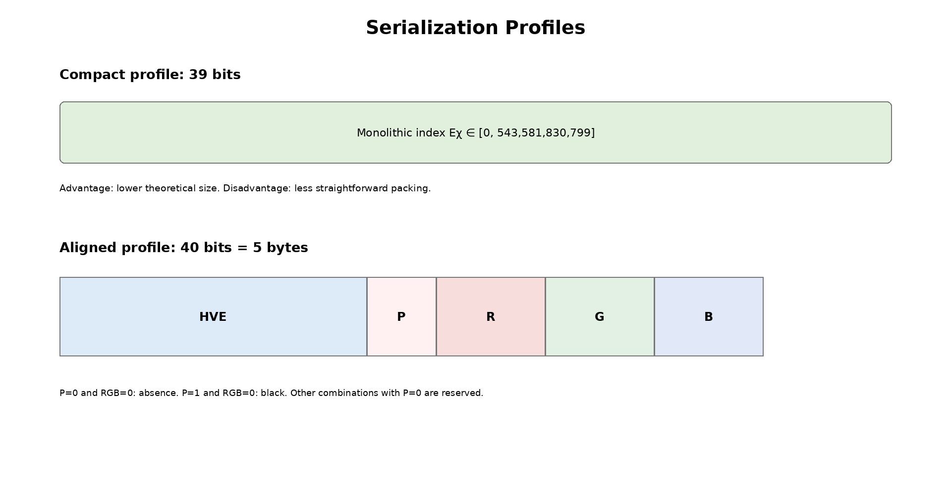
Figure 14. Comparison between the compact 39-bit and aligned 40-bit profiles.
13.8. Distinction Between Absence of Color and Black
The absence of color and the color black are semantically distinct states:
- The null state, represented by ∅, means that the protocol has not assigned chromatic information to the HVE state;
- The RGB triple (0,0,0) means that the protocol has explicitly assigned the color black.
Using RGB (0,0,0) as an absence marker would destroy this distinction and prevent unambiguous representation of black. For this reason, the rigorous formulation uses 2²⁴ + 1 chromatic states.
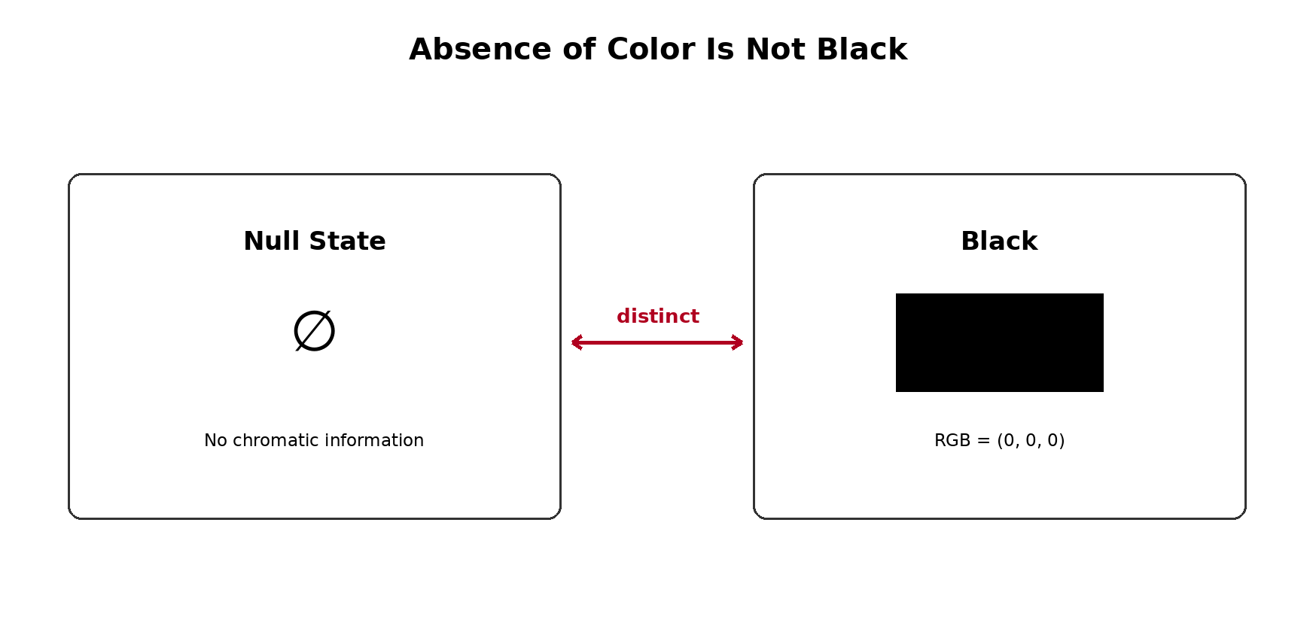
Figure 15. Protocol-level separation between absence of chromatic information and RGB black.
13.9. Limitations
The formal extension resolves the quantification and encoding of states, but it does not automatically solve every colorimetric problem. The main limitations are:
- an 8-bit RGB triple does not, by itself, identify the color space, transfer curve, white point, or device profile;
- the model does not include an alpha channel, transparency, HDR, bit depths greater than 8 bits, or colors outside the selected gamut;
- Euclidean distance in RGB does not necessarily correspond to perceptual distance between colors;
- the extension increases the state space, but does not guarantee compression, semantic efficiency, or improvement in AI models;
- independence between G and C* is an architectural hypothesis; applications may impose forbidden combinations or admissible subsets;
- the mathematical definition is not equivalent to a complete implementation: codecs, tests, validation, versioning, and interoperability must still be developed;
- the compact 39-bit profile is not naturally byte-aligned; the 40-bit profile introduces controlled redundancy;
- the chromatic interpretation must be declared by the application layer to prevent the same triple from being used with incompatible meanings.
13.10. Future Applications
HVE-χ is an architectural extension. Applications built on it remain future work until they are implemented and tested. The main directions are:
- multimodal tokens carrying symbolic identity and a chromatic attribute in the same state;
- annotation of images, diagrams, maps, charts, and technical documents;
- scientific visualization, with colors associated with classes, intensities, or computed states;
- computational interfaces and virtual machines with native graphical states;
- chromatic embeddings and neural networks that jointly process symbol and color;
- chromatic semantic metadata, provided that its ontology is explicitly versioned;
- protocols for rich text, terminals, editors, CAD systems, and multimodal representations;
- studies of compression and adaptive serialization for streams in which most symbols have no color.
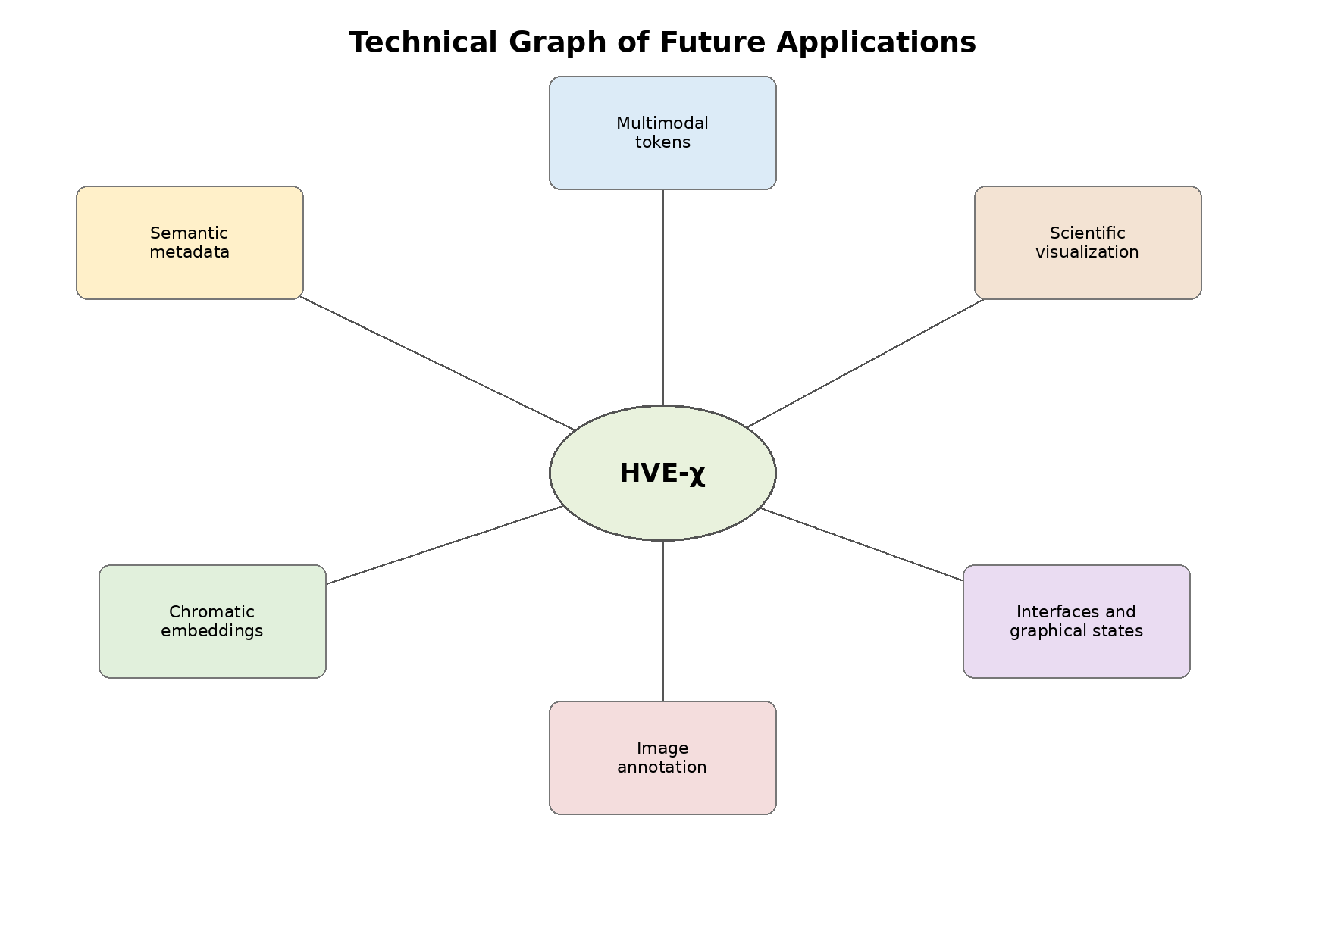
Figure 16. Technical graph of the principal future application classes.
14. Recommended Final Architecture
The organization of the ecosystem must remain hierarchical:
HVE-720 Core → HVE-χ Chromatic Extension → Applications. (43)
The extension does not alter the core count. The 32,400 states remain the fundamental states of HVE-720. The figure 543,581,830,800 corresponds exclusively to the extended HVE-χ space.
Table 7. Recommended layered architecture of HVE-720, HVE-χ, and applications.
Layer | Mathematical object | Responsibility
HVE-720 Core | G = Z₃₆₀ × Z₂ × Z₅ × Z₉ | identity and fundamental states
HVE-χ | Gχ = G × C* | optional addition of chromatic information
Applications | subsets, functions, and protocols over Gχ | AI, imaging, visualization, and interfaces
15. Minimum Implementation Requirements
For the extension to progress from a technical formulation to a demonstrated implementation, the software must include:
- distinct types for NoColor and RGBColor, preventing black from representing absence;
- implementation of κ, κ⁻¹, Eχ, and Eχ⁻¹;
- exhaustive validation of the chromatic domain at the boundaries and internal sample tests;
- exhaustive round-trip testing of the 32,400 core states for ∅, black, white, and boundary colors;
- property tests for random RGB values;
- a serialization profile identified by version;
- rejection of monolithic indices outside the valid interval;
- in the 40-bit profile, rejection of P = 0 with nonzero RGB;
- documentation of the adopted color space;
- separate benchmarks for colored, uncolored, and mixed streams.
The HVE-χ extension is mathematically quantifiable and preserves the HVE-720 core. Adding the null state ∅ to the 16,777,216 RGB triples produces a chromatic space with 16,777,217 states. Its product with the 32,400 fundamental states generates exactly 543,581,830,800 extended states.
The distinction between the absence of color and black is indispensable for an unambiguous protocol. The function Eχ provides a monolithic 39-bit bijection, while the aligned 40-bit profile provides a direct five-byte implementation. The extension must be treated as a formal technical layer; its practical applications remain future work until codecs, tests, and experiments are presented.
16. Discussion
The algebraic reformulation resolves four central ambiguities. First, it establishes that the four coordinates do not, by themselves, constitute a real vector space. Second, it identifies the correct structure as a finite Abelian group. Third, it separates the visible alphabet from the auxiliary states. Fourth, it gives precise mathematical content to the term harmonic through group duality and the discrete Fourier transform.
The categorical organization of the alphabet remains an engineering choice. The algebra guarantees operations, periodicity, and indexing; it does not guarantee that characters close in θ are semantically close. Any semantic claim must be validated empirically and compared with baselines.
The main architectural advantage of HVE is that it provides a fixed and decomposable state. Its main limitation is reduced coverage compared with Unicode. Therefore, HVE should be presented as a specialized encoding, an intermediate protocol, or a structured representation, and not as a universal replacement for UTF-8 without a complete extension and compatibility strategy.
17. Limitations
- the base alphabet covers only a subset of Unicode;
- the semantics of the coordinates τ and φ depend on an external specification;
- the categorical organization by intervals of θ is constructed, not discovered;
- fixed 15-bit packing is not naturally aligned with octets;
- efficiency results depend strongly on the symbol distribution;
- embeddings based on the categorical map do not, by themselves, constitute evidence of linguistic semantics;
- the harmonic analysis presented is finite and discrete; it does not imply continuous differential calculus.
18. Future Work
- formalize a canonical version of the HVE table with version control and normalization;
- implement the harmonic transform on G and evaluate spectral filters;
- study the spectrum of the Laplacian of the graph Γ(G);
- define error-detection codes using the 368 reserved patterns;
- evaluate real multilingual corpora and fallback costs;
- construct embeddings in tasks independent of the categorization used in the map;
- investigate coverage extensions through pages, planes, or compound identifiers;
- publish the virtual machine, the HVL language, and higher-layer applications separately.
19. Conclusions
The work presented establishes a mathematical formulation of HVE-720 and its HVE-χ chromatic extension. The central result is the demonstration that HVE can be treated as a finite, enumerable, and reversible state architecture constructed over explicitly defined coordinate domains. This formulation replaces excessively broad interpretations with a precise algebraic basis in which cardinalities, operations, projections, distances, refinements, and encoding functions can be demonstrated independently of the computational implementation.
In the HVE-720 core, the state space is formalized as the finite Abelian group G = Z₃₆₀ × Z₂ × Z₅ × Z₉. Its cardinality is exactly 32,400, obtained from the product 360 × 2 × 5 × 9. The decomposition G = A × M shows that the system contains a structural alphabet A = Z₃₆₀ × Z₂, with 720 symbolic positions, and an auxiliary space M = Z₅ × Z₉, with 45 states associated with each position. This distinction is essential: HVE-720 does not simply represent 32,400 independent characters, but 720 fundamental symbolic states, each accompanied by a fiber of 45 auxiliary configurations.
The correspondence between the four coordinates and the integer interval {0, …, 32,399} is guaranteed by a mixed-radix bijection. The formal proof follows from the uniqueness of successive Euclidean division, while exhaustive enumeration of the 32,400 states verifies that the implementation complies with the specification. Mathematical proof and software testing therefore assume complementary roles: the former demonstrates the abstract validity of the model; the latter confirms its computational realization.
The algebraic structure makes it possible to define modular translations, inverses, weighted circular metrics, and a global neighborhood graph. The graph Γ(G) = Cart(C₃₆₀, K₂, C₅, C₉) provides a combinatorial representation of the states and makes it possible to study paths, adjacency, diffusion, and spectrum without assigning HVE a continuous structure that it does not possess. Likewise, the term harmonic is rigorously grounded in the characters of the group and in the discrete Fourier transform on G. Thus, functions defined on HVE states can be decomposed, correlated, and filtered in a finite spectral domain.
The refinement family Gₘ = Z₃₆₀ₘ × Z₂ × Z₅ × Z₉ extends the same principle without altering the logic of the core. The general cardinality is |Gₘ| = 32,400m, producing 32,400 states at the BASE resolution, 32,400,000 at the MICRO resolution, and 34,992,000,000 in the adopted NANO configuration. These values are exactly quantifiable. Refinement increases angular granularity, but does not automatically transform the system into a differentiable manifold or multiresolution analysis in the wavelet sense; it is a discrete quantization hierarchy with maps defined between levels.
The HVE-χ chromatic extension expands this architecture through a new independent domain. The 24-bit RGB space is C_RGB = Z₂₅₆ × Z₂₅₆ × Z₂₅₆, with 16,777,216 possible colors. To prevent the incorrect identification of black with the absence of color, the pointed set C* = {∅} ∪ C_RGB is introduced as a disjoint union, with cardinality 16,777,217. The symbol ∅ represents the absence of chromatic information, while (0,0,0) represents the color black explicitly assigned.
The extended chromatic space is defined by Gχ = G × C*. Its cardinality is exactly 543,581,830,800 states in the BASE configuration. Each core state therefore has one colorless extension and 16,777,216 chromatic extensions. The mixed-radix encoding function and its inverse ensure that every combination is represented without collisions. The minimum global index requires 39 bits; an implementation using separate fields, with one explicit presence bit and 24 RGB bits, uses 40 bits. The difference arises from the combinatorial use of the unused capacity in the binary core space.
The resulting architectural contribution can be expressed in three layers: HVE-720 Core → HVE-χ Chromatic Extension → Applications. The core defines symbolic identity, discrete topology, and fundamental auxiliary states. The chromatic extension adds an optional, quantified, and reversible coordinate without retroactively changing the meaning of the core. Applications—such as image processing, scientific visualization, interfaces, multimodal embeddings, pattern classification, and semantic metadata—use these two layers, but are not part of the basic mathematical definition.
This separation also correctly delimits the scope of the results. HVE is not presented as a real vector space, a differentiable manifold, a universal replacement for Unicode, or automatic proof of semantic superiority. Its contribution is to provide a finite state space with an explicit algebraic structure, reversible encoding, modular organization, and the possibility of harmonic and spectral analysis. Categorical relationships imposed by the mapping table must be recognized as design choices and evaluated empirically in independent tasks.
From a computational perspective, HVE provides a specialized architecture in which symbolic identity, auxiliary state, refinement, and chromatic information can be represented uniformly. This organization creates conditions for protocols with rigorous validation, reserved words, version control, deterministic serialization, and compatible extensions. It also makes it possible to exploit unused binary patterns for error detection, version signaling, or future expansion, provided that these functions are formalized and tested.
The next scientific steps should focus on publishing a canonical and versioned specification, fully implementing encoders and decoders, exhaustively verifying the states, benchmarking real corpora, defining color profiles, analyzing the graph Laplacian, implementing the harmonic transform, evaluating embeddings on tasks that do not reproduce the categorization used to construct the table, and comparing the system with conventional representations under equivalent conditions. Extensions to RGBA, HDR, perceptual spaces, and spectral color should remain separate until their domains, cardinalities, and interoperability rules are formally defined.
In summary, HVE-720 and HVE-χ form a coherent, scalable, and exactly quantifiable mathematical architecture. The core establishes 32,400 structured states; the chromatic layer expands this space to 543,581,830,800 states, preserving the distinction between absence and black while maintaining bijective encoding. The scientific value of the system lies not only in the magnitude of its state space, but in the ability to demonstrate how each state is constructed, counted, related, encoded, and recovered. This combination of finiteness, modularity, reversibility, and extensibility provides a solid basis for the development of future protocols, algorithms, and applications without exceeding the limits of what has already been mathematically established in the HVE-720 Core → HVE-χ Chromatic Extension → Applications architecture.
Supplementary material
No supplementary material accompanies this manuscript.
CRediT authorship contribution statement
Conceptualization, methodology, software, validation, formal analysis, investigation, resources, data curation, writing—original draft preparation, writing—review and editing, visualization, project administration, and supervision, C.P.E. The author has read and agreed to the published version of the manuscript.
Funding
This research did not receive any specific grant from funding agencies in the public, commercial, or not-for-profit sectors.
Data availability
The implementation, canonical table, tests, and reproduction materials are available at https://github.com/CharlesEugeniodr/HVE-720-6480--Harmonic-Vector-Encoding-.
Declaration of generative AI and AI-assisted technologies in the manuscript preparation process
During the preparation of this manuscript, the author used OpenAI ChatGPT to assist with language editing, document restructuring, and preparation of selected diagrams. The author reviewed and edited all outputs and takes full responsibility for the content of this publication.
Declaration of competing interest
The author declares that he has no known competing financial interests or personal relationships that could have appeared to influence the work reported in this paper.
Abbreviations
The following abbreviations are used in this manuscript:
HVE | Harmonic Vector Encoding
HVE-χ | Chromatic extension of HVE
RGB | Red, green, and blue color channels
VM | Virtual machine
DSL | Domain-specific language
UTF-8 | Unicode Transformation Format—8 bit
BASE | Base angular resolution
MICRO | Refinement with 1,000 subdivisions per degree
NANO | Refinement with 1,080,000 subdivisions per degree
References
[1] A Coding-Efficiency Analysis of HEVC Encoder Embedded in High-End Mobile Chipsets. IEEE Transactions on Circuits and Systems for Video Technology, 2026. In press.
[2] AHO, A. V.; LAM, M. S.; SETHI, R.; ULLMAN, J. D. Compilers: Principles, Techniques, and Tools. 2nd ed. Boston: Addison-Wesley, 2006. ISBN 978-0-321-48681-3.
[3] AMERICAN NATIONAL STANDARDS INSTITUTE. ANSI X3.4-1986: American National Standard for Information Systems — Coded Character Sets — 7-Bit ASCII. New York: ANSI, 1986.
[4] BORMANN, C.; HOFFMAN, P. Concise Binary Object Representation — CBOR. RFC 8949. Internet Engineering Task Force, 2020.
[5] CHUNG, F. R. K. Spectral Graph Theory. Providence: American Mathematical Society, 1997.
[6] DIACONIS, P. Group Representations in Probability and Statistics. Hayward: Institute of Mathematical Statistics, 1988.
[7] EUGÊNIO, C. P. HVE-720/6480 — Harmonic Vector Encoding. GitHub repository, 2026.
[8] GOLDBERG, D. What Every Computer Scientist Should Know About Floating-Point Arithmetic. ACM Computing Surveys, vol. 23, no. 1, pp. 5–48, 1991.
[9] GROSS, J. L.; YELLEN, J.; ZHANG, P. Handbook of Graph Theory. 2nd ed. Boca Raton: CRC Press, 2013.
[10] HUFFMAN, D. A. A Method for the Construction of Minimum-Redundancy Codes. Proceedings of the IRE, vol. 40, no. 9, pp. 1098–1101, 1952.
[11] IEC. IEC 61966-2-1: Multimedia Systems and Equipment — Colour Measurement and Management — Part 2-1: Colour Management — Default RGB Colour Space — sRGB. Geneva: International Electrotechnical Commission.
[12] KNUTH, D. E. The Art of Computer Programming. Volume 2: Seminumerical Algorithms. 3rd ed. Boston: Addison-Wesley, 1997. ISBN 0-201-89684-2.
[13] LINDHOLM, T.; YELLIN, F. The Java Virtual Machine Specification. Reading: Addison-Wesley, 1997. ISBN 0-201-63452-X.
[14] LLM2Vec-Gen: Generative Embeddings from Large Language Models. arXiv preprint, 2026. In press.
[15] MALLAT, S. G. A Theory for Multiresolution Signal Decomposition: The Wavelet Representation. IEEE Transactions on Pattern Analysis and Machine Intelligence, vol. 11, no. 7, pp. 674–693, 1989.
[16] MARDIA, K. V.; JUPP, P. E. Directional Statistics. Chichester: John Wiley & Sons, 2000. ISBN 978-0-471-95333-3.
[17] MERNIK, M.; HEERING, J.; SLOANE, A. M. When and How to Develop Domain-Specific Languages. ACM Computing Surveys, vol. 37, no. 4, pp. 316–344, 2005.
[18] MIKOLOV, T.; CHEN, K.; CORRADO, G.; DEAN, J. Efficient Estimation of Word Representations in Vector Space. In: International Conference on Learning Representations — ICLR, 2013. arXiv:1301.3781.
[19] MUENNIGHOFF, N. et al. GritLM: Generative Representational Instruction Tuning. arXiv preprint, 2024. arXiv:2402.12354.
[20] ROSEN, K. H. Discrete Mathematics and Its Applications. New York: McGraw-Hill, consulted edition.
[21] SCHNEIER, B. Applied Cryptography: Protocols, Algorithms, and Source Code in C. 2nd ed. New York: John Wiley & Sons, 1996. ISBN 0-471-12845-7.
[22] SHANNON, C. E. A Mathematical Theory of Communication. Bell System Technical Journal, vol. 27, pp. 379–423 and 623–656, 1948.
[23] TERRAS, A. Fourier Analysis on Finite Groups and Applications. Cambridge: Cambridge University Press, 1999.
[24] THE UNICODE CONSORTIUM. The Unicode Standard, Version 15.1.0. Mountain View: Unicode Consortium, 2023. ISBN 978-1-936213-32-0.
[25] When Structure Does Not Help: LLMs Do Not Read Text-Attributed Graphs as Effectively as We Expected. arXiv preprint, 2026. In press.
[26] YERGEAU, F. UTF-8, a Transformation Format of ISO 10646. RFC 3629. Internet Engineering Task Force, 2003.

Highlights
HVE-720: Mathematical Foundations of a Harmonic Encoding over a Finite Abelian Group
- HVE-720 forms a finite Abelian group with exactly 32,400 states.
- A mixed-radix bijection maps each BASE state to a unique 15-bit index.
- The state graph is connected, 7-regular, and has 113,400 edges.
- Finite-group characters enable a discrete harmonic transform on HVE states.
- HVE-χ extends the BASE space to 543,581,830,800 chromatic states.

Declaration of Competing Interests
Manuscript: HVE-720: Mathematical Foundations of a Harmonic Encoding over a Finite Abelian Group
The author declares that he has no known competing financial interests or personal relationships that could have appeared to influence the work reported in this paper. The work was conducted independently, received no external funding, and is not associated with any patent application or registration.
Charles de Paula Eugênio
Independent Researcher
Parauapebas, PA, Brazil

HVE Embedded Profile 1.0
  - Especificação normativa, serialização e conformidade

Charles de Paula Eugênio
Independent Researcher — Parauapebas, Pará, Brazil

EXECUTABLE NORMATIVE DRAFT
Version 1.0 — July 2026

Resumo executivo
Este documento congela uma primeira especificação executável para o núcleo HVE-720 e para a extensão cromática HVE-χ. Ele não modifica os objetos matemáticos do manuscrito-base. O objetivo é eliminar ambiguidades de implementação: tipos, limites, ordem de bits, empacotamento, perfis, validação, enquadramento, integridade, erros e critérios de conformidade. A implementação de referência em C11 e a especificação executável em Python acompanham este documento.
As palavras DEVE, NÃO DEVE, DEVERÁ, PODE e RECOMENDA-SE são normativas. Uma implementação só é conforme quando satisfaz integralmente os requisitos do perfil que declara.

1. Escopo
- Representação do estado BASE g = (θ, s, τ, φ).
- Bijeção HVE-720 entre o domínio coordenado e os índices 0 a 32.399.
- Operações de grupo necessárias à biblioteca de referência.
- Empacotamento MSB-first de palavras BASE de 15 bits.
- Extensão cromática apontada C* = {NoColor} ⊔ RGB.
- Bijeção monolítica HVE-χ e perfis de 39 e 40 bits.
- Frame determinístico com versão, perfil, contagem e CRC-32.
- Semântica de rejeição, testes mínimos e níveis de conformidade.
Ficam fora deste perfil: a tabela canônica de símbolos, normalização Unicode, fallback de caracteres não representáveis, compressão, segurança criptográfica, ontologia dos campos τ e φ, perfis colorimétricos além do RGB de 8 bits e desempenho específico de plataforma.

2. Modelo matemático imutável
G = Z₃₆₀ × Z₂ × Z₅ × Z₉ (1)
|G| = 360 × 2 × 5 × 9 = 32.400 (2)
Um estado BASE é a tupla g = (θ, s, τ, φ) com os domínios abaixo.
Campo | Domínio | Bits de armazenamento | Regra
θ | 0…359 | 9 | posição angular
s | 0…1 | 1 | polaridade; σ = (−1)^s
τ | 0…4 | 3 | estado auxiliar
φ | 0…8 | 4 | estado auxiliar
Os tamanhos individuais não definem o formato serializado. O formato BASE normativo é o índice bijetivo de 15 bits.

3. Tipos abstratos e invariantes
Tipo | Campos | Invariantes
HVEState | theta, s, tau, phi | todos os campos nos domínios da Seção 2
NoColor | nenhum | estado cromático nulo, distinto de preto
RGBColor | r, g, b | cada canal em 0…255
HVEColor | present, r, g, b | present=0 implica r=g=b=0
Uma implementação NÃO DEVE usar RGB(0,0,0) como marcador de ausência. Preto é uma cor válida e distinta de NoColor.

4. Bijeção BASE
E(θ,s,τ,φ) = (((θ·2 + s)·5 + τ)·9 + φ) (3)
O codificador DEVE validar o estado antes do cálculo. O resultado DEVE pertencer a [0, 32.399].

4.1. Inversa
phi = n mod 9
q1 = floor(n / 9)
tau = q1 mod 5
q2 = floor(q1 / 5)
s = q2 mod 2
theta= floor(q2 / 2)
O decodificador DEVE rejeitar n ≥ 32.400. Os índices 32.400…32.767 são reservados e não representam estados BASE.

5. Operações de grupo
g ⊕ h = ((θ+θ′) mod 360, (s+s′) mod 2, (τ+τ′) mod 5, (φ+φ′) mod 9) (4)
−g = ((−θ) mod 360, (−s) mod 2, (−τ) mod 5, (−φ) mod 9) (5)
Essas operações pertencem à API matemática. Elas não alteram o formato de serialização e não constituem criptografia.

6. Perfil BASE15
Cada estado é transformado em um índice de 15 bits. A capacidade bruta é 2¹⁵ = 32.768 palavras; 32.400 são válidas e 368 são reservadas.
Intervalo | Status | Ação do decodificador
0…32.399 | válido | decodificar
32.400…32.767 | reservado | rejeitar

6.1. Ordem de bits
O fluxo BASE15 DEVE ser MSB-first. O primeiro bit transmitido é o bit 14 da primeira palavra. Não há alinhamento por palavra.

6.2. Comprimento
bytes(N) = ceil(15N / 8) (6)
O número N de estados é informação externa ao payload ou é obtido do frame da Seção 10.

6.3. Padding
Se 15N não for múltiplo de 8, os bits menos significativos não utilizados do último byte DEVEM ser zero. O decodificador DEVE rejeitar padding não nulo.

7. Espaço cromático apontado
C* = {NoColor} ⊔ {0,…,255}³ (7)
|C*| = 2²⁴ + 1 = 16.777.217 (8)

7.1. Ordenação κ
κ(NoColor) = 0 (9)
κ(r,g,b) = 1 + 65.536r + 256g + b (10)
Estado | κ
NoColor | 0
RGB(0,0,0) — preto | 1
RGB(255,255,255) — branco | 16.777.216

8. Bijeção HVE-χ
Gχ = G × C* (11)
|Gχ| = 32.400 × 16.777.217 = 543.581.830.800 (12)
Eχ(g,c) = E(g)·16.777.217 + κ(c) (13)
O intervalo monolítico válido é 0…543.581.830.799. Valores superiores DEVEM ser rejeitados.

9. Perfis cromáticos

9.1. CHI39
O índice Eχ usa 39 bits significativos. Na representação unitária em cinco bytes, o bit mais significativo do primeiro byte DEVE ser zero. O valor inteiro é armazenado em ordem de rede. O perfil compacto contínuo pode eliminar esse bit entre estados, desde que a contagem esteja disponível.

9.2. CHI40 alinhado
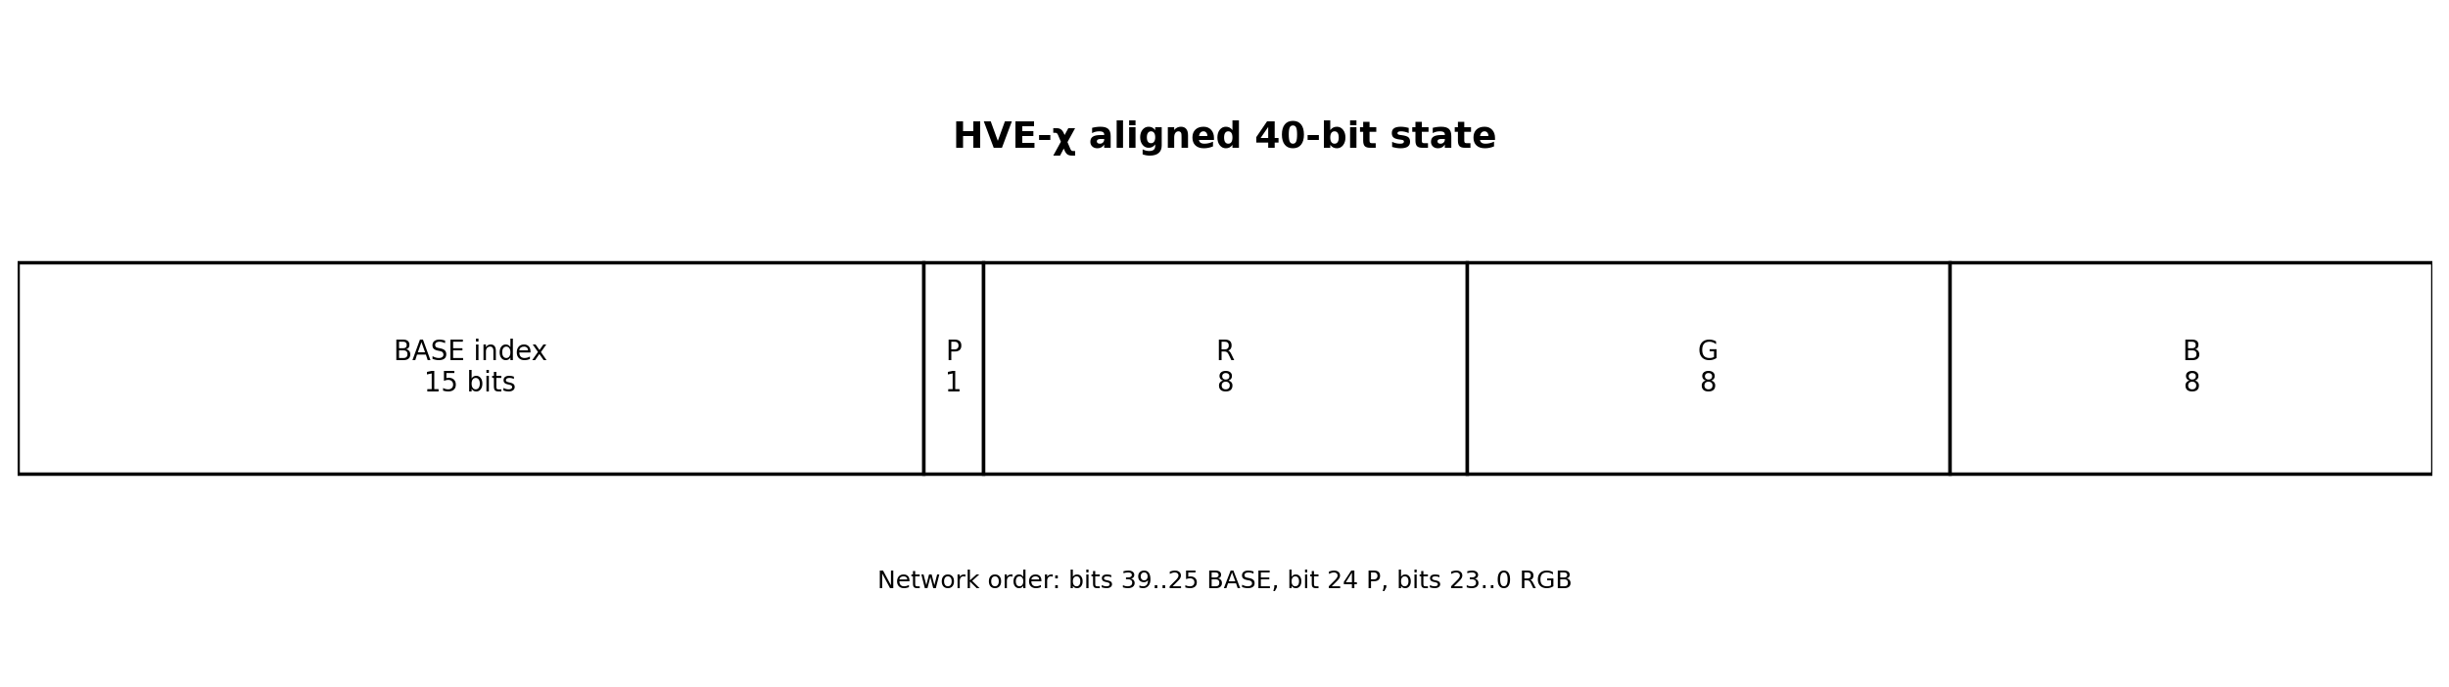
Layout normativo: bits 39…25 = índice BASE; bit 24 = P; bits 23…16 = R; bits 15…8 = G; bits 7…0 = B.
Condição | Significado | Validade
P=0, RGB=0 | NoColor | válido
P=0, RGB≠0 | estado não canônico | inválido; rejeitar
P=1, RGB=qualquer | cor explícita | válido

10. Frame HVE1
O frame transporta um payload BASE15 ou CHI40 sem alocação dinâmica obrigatória. Todos os inteiros multibyte usam big-endian.
Offset | Tamanho | Campo | Regra
0 | 4 | Magic | ASCII HVE1
4 | 1 | Versão principal | 1
5 | 1 | Perfil | 0x01 BASE15; 0x02 CHI40
6 | 2 | Flags | reservadas; big-endian
8 | 4 | State count | uint32; big-endian
12 | 4 | CRC-32 | CRC-32/ISO-HDLC do payload
16 | variável | Payload | comprimento derivado
payload(BASE15,N) = ceil(15N/8) (14)
payload(CHI40,N) = 5N (15)
O parser DEVE verificar magic, versão, perfil, comprimento exato e CRC antes de entregar o payload à aplicação.

11. Semântica de erros
Erro | Causa mínima
NULL | ponteiro obrigatório ausente
RANGE | coordenada fora do domínio
BUFFER_TOO_SMALL | buffer insuficiente
INVALID_WORD | índice reservado ou fora do intervalo
INVALID_COLOR | cor ou marcador NoColor inconsistente
INVALID_PADDING | bits reservados não nulos
INVALID_FRAME | magic, versão ou comprimento inválido
CRC_MISMATCH | integridade do payload falhou
UNSUPPORTED_PROFILE | perfil desconhecido
OVERFLOW | cálculo de tamanho não representável
A implementação NÃO DEVE corrigir silenciosamente estados inválidos. Rejeição explícita é parte da interoperabilidade.

12. Critérios de conformidade
Nível | Requisitos
Core | validação, E, E⁻¹, rejeição 368, testes exaustivos
Serialization | Core + BASE15 MSB-first + padding zero
Chromatic | Serialization + κ + Eχ + CHI39/CHI40 + distinção NoColor/preto
Framed | Chromatic + frame HVE1 + CRC-32
Embedded | Framed + execução em alvo declarado + limites de memória/tempo documentados
Hardware | Framed + RTL simulado/sintetizado + recursos, frequência e potência documentados

13. Testes normativos mínimos
1. Enumerar os 32.400 estados BASE e provar computacionalmente unicidade e round-trip.
2. Rejeitar individualmente os 368 índices reservados.
3. Testar limites inferiores e superiores de todas as coordenadas.
4. Testar grupo: identidade e inverso para todos os estados; associatividade por amostragem determinística.
5. Testar BASE15 para contagens que cruzem fronteiras de byte e bloco, incluindo padding corrompido.
6. Testar NoColor, preto, branco e cores de fronteira.
7. Testar Eχ e inversa em limites e por amostragem pseudoaleatória reprodutível.
8. Testar CHI40 com P=0 e RGB não nulo, que deve ser rejeitado.
9. Testar CRC com vetor conhecido '123456789' = 0xCBF43926 e corrupção de payload.
10. Comparar ao menos duas implementações independentes por vetores dourados.

14. Segurança e limites
- CRC detecta corrupção acidental; não fornece autenticidade.
- Aritmética modular e permutações HVE não são, isoladamente, criptografia.
- O frame não define confidencialidade, nonce, MAC ou assinatura.
- A tabela simbólica e a semântica de τ/φ devem ser versionadas separadamente.
- Comparações com UTF-8 exigem cobertura e função equivalentes.
- O perfil não declara superioridade de compressão, semântica ou energia sem experimento.

15. Compatibilidade e evolução
A versão principal muda somente quando um decodificador 1.x não puder interpretar corretamente o frame. Novos perfis devem receber novos códigos. Os 368 códigos BASE reservados não podem ser atribuídos informalmente: qualquer uso futuro exige versão ou perfil normativo.

Apêndice A — API C mínima
hve_base_encode(state, &index)
hve_base_decode(index, &state)
hve_base15_pack(indices, count, out, out_size, &written)
hve_base15_unpack(in, in_size, count, indices, capacity, &written)
hve_chi_encode(state, color, &index64)
hve_chi_decode(index64, &state, &color)
hve_chi40_pack(state, color, bytes5)
hve_chi40_unpack(bytes5, &state, &color)
hve_frame_write_header(profile, flags, count, payload, size, header)
hve_frame_parse(frame, frame_size, &info, &payload)

Apêndice B — Evidência da implementação de referência
- C11 compilado com avisos estritos tratados como erro.
- Suite C executada com validação exaustiva BASE e 100.000 casos HVE-χ.
- Suite C executada adicionalmente sob AddressSanitizer e UndefinedBehaviorSanitizer.
- Suite Python executada com validação exaustiva BASE e 100.000 casos HVE-χ.
- Cross-check C/Python executado para todos os 32.400 estados BASE.
- Vetores dourados gerados em JSON.
- RTL Verilog fornecido como referência, sem alegação de síntese física nesta etapa.

HVE Embedded Reference Architecture 1.0
  - Relatório técnico de implementação, validação e transição para sistemas embarcados

Charles de Paula Eugênio
Independent Researcher — Parauapebas, Pará, Brazil

TECHNICAL IMPLEMENTATION REPORT
Version 1.0 — July 2026

Resumo
O trabalho converte a formulação HVE-720/HVE-χ em uma arquitetura executável e auditável. Foi construída uma biblioteca C11 sem alocação dinâmica, uma especificação executável Python, empacotadores BASE15, CHI39 e CHI40, enquadramento com CRC-32, testes exaustivos, vetores dourados, cross-check entre linguagens, benchmark de host e módulos RTL de referência. O núcleo foi mantido independente de aplicações, plataformas e semânticas externas.
A etapa concluída demonstra correção funcional de software em ambiente host. Resultados de microcontrolador, FPGA, energia e tempo real não são inventados: estão especificados como próxima fase física, com protocolo de medição reproduzível.

1. Objetivo de engenharia
O risco central de uma arquitetura matemática inédita é permanecer apenas como definição. A implementação de referência reduz esse risco por quatro mecanismos:
1. congela decisões de serialização que a matemática não determina sozinha;
2. fornece duas implementações independentes;
3. transforma propriedades matemáticas em testes executáveis;
4. separa evidência concluída de resultados físicos ainda pendentes.

2. Arquitetura em camadas
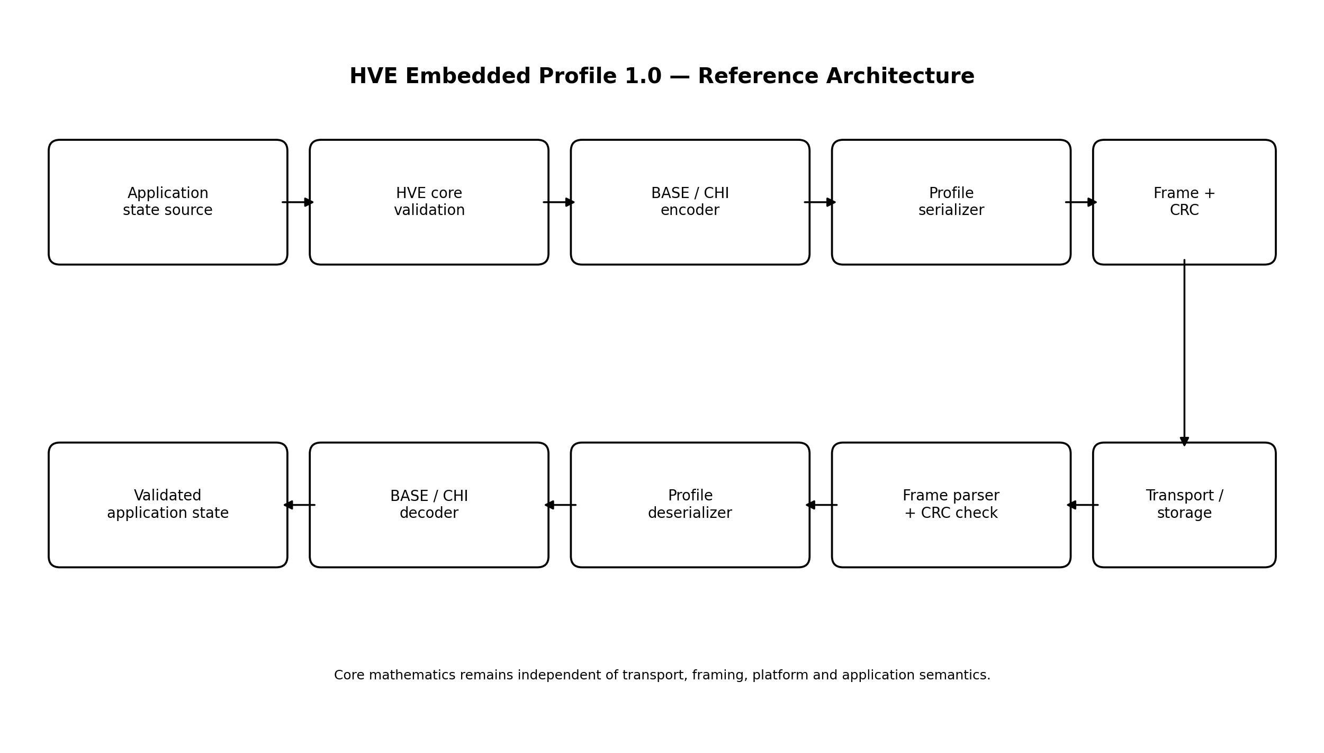
Camada | Responsabilidade | Não deve conter
Core | tipos, limites, E/E⁻¹, grupo, κ/Eχ | I/O, rede, tabela semântica
Serialization | BASE15, CHI39, CHI40 | política de aplicação
Frame | versão, perfil, contagem, CRC | criptografia implícita
Platform adapter | UART/SPI/CAN/TCP, buffers, RTOS | alteração do modelo
Application | semântica de símbolos, τ, φ e cor | redefinição silenciosa do protocolo

3. Decisões arquiteturais

3.1. C11 sem alocação dinâmica
A API usa buffers fornecidos pelo chamador. Isso favorece microcontroladores, análise estática, limites previsíveis de memória e integração com RTOS.

3.2. Validação antes da transformação
Estados inválidos são rejeitados. A biblioteca não aplica módulo automaticamente a coordenadas de entrada, porque isso esconderia erros e destruiria interoperabilidade.

3.3. Ordem de rede e MSB-first
Uma única ordem elimina divergência entre plataformas little-endian e big-endian. BASE15 usa fluxo MSB-first; CHI40 usa cinco bytes big-endian.

3.4. NoColor como tipo distinto
NoColor não é codificado como preto. No perfil CHI40, a regra P=0 ⇒ RGB=0 cria uma representação canônica única e permite rejeição de estados redundantes.

3.5. CRC separado de segurança
CRC-32 detecta corrupção acidental. O relatório não o classifica como autenticação ou criptografia.

4. Componentes implementados
Componente | Arquivo principal | Status
C API | include/hve.h | construído
C core | src/hve.c | compilado e testado
C tests | tests/test_hve.c | executado
Python reference | python/hve_ref.py | executado
Python tests | python/test_hve_ref.py | executado
Cross-check | tools/crosscheck_ctypes.py | executado
Golden vectors | tests/golden_vectors.json | gerado
Benchmark | benchmarks/benchmark_hve.c | executado em host
RTL | hdl/*.v | autoria concluída; simulação física pendente
Embedded stub | examples/embedded_loop.c | integração demonstrativa

5. Evidência de correção
Teste | Cobertura executada | Resultado
BASE bijection | 32.400 estados | zero colisões e zero erros de round-trip
Reserved words | 368 índices | todos rejeitados
Group operations | 10.000 triplas pseudoaleatórias + inversos | aprovado
BASE15 packing | contagens 0,1,2,7,8,9,31,257 | round-trip e padding aprovados
HVE-χ C | limites + 100.000 amostras | aprovado
HVE-χ Python | limites + 100.000 amostras | aprovado
C/Python | 32.400 estados BASE + fronteiras χ | equivalência aprovada
Sanitizers | suite C completa | sem erro detectado
CRC | vetor padrão e corrupção | aprovado

6. Benchmark preliminar de host
O benchmark serve somente para verificar que a instrumentação funciona. Em uma execução de host Linux com GCC 14.2.0, cinco milhões de pares encode+decode produziram aproximadamente 147 milhões de estados BASE/s e 135 milhões de estados HVE-χ/s. Esses números não são resultados de microcontrolador, não são comparativos e não devem ser usados no artigo final sem repetição controlada, intervalos e descrição completa do hardware.

7. Tradução para microcontrolador
- Nenhuma função principal requer heap.
- O estado BASE ocupa poucos bytes na estrutura C; o índice ocupa 16 bits em memória e 15 bits no fluxo.
- Divisões são por constantes pequenas; o compilador pode substituí-las por multiplicação, deslocamento ou rotinas determinísticas.
- O frame permite processar payload por blocos e validar CRC antes da aplicação.
- A API pode ser chamada em bare metal ou protegida por filas em RTOS.

7.1. Alvos mínimos sugeridos
Classe | Exemplo de papel experimental | Métrica central
Cortex-M0+/M3 | custo mínimo | ciclos, flash, RAM
Cortex-M4/M7 | throughput e RTOS | latência, jitter, energia
ESP32/RISC-V | rede/edge | throughput fim a fim
Linux ARM | gateway | integração e concorrência

8. Tradução para FPGA
O encoder é um encadeamento de multiplicações por constantes e somas. O decoder de referência usa divisão e módulo por 9, 5 e 2. Para otimização física, há três estratégias:
1. operadores constantes deixados ao sintetizador;
2. recíprocos multiplicativos e correção;
3. máquina sequencial de divisões reduzidas, trocando latência por área.
O RTL incluído é intencionalmente legível. A versão de publicação deve reportar síntese em uma família declarada e comparar ao menos duas microarquiteturas.

9. Protocolo de medição física
Métrica | Procedimento mínimo | Unidade
Latência | GPIO de início/fim + analisador lógico; 10⁴ repetições | ns ou ciclos
Throughput | lote ≥10⁶ estados, excluindo setup | estado/s
Jitter | distribuição p50, p95, p99 e máximo | ns ou ciclos
Flash | map file do linker | bytes
RAM | estática + pico de stack medido | bytes
Energia | shunt/medidor, potência integrada por lote | nJ/estado
FPGA area | relatório pós-síntese | LUT, FF, BRAM, DSP
FPGA timing | pior slack e Fmax | ns, MHz
Cada resultado deve declarar compilador, flags, clock, tensão, temperatura, placa, revisão de silício, sistema operacional/RTOS e estado de cache.

10. Desenho experimental para a JSA
O artigo de arquitetura de sistemas deve usar um caso real, não apenas o codec isolado. O caso recomendado é uma cadeia edge com estados simbólicos, auxiliares e cromáticos:
1. nó sensor ou interface produz HVEState;
2. firmware codifica BASE15 ou CHI40;
3. frame HVE1 é transmitido por UART/SPI/CAN/TCP;
4. gateway valida CRC, decodifica e registra;
5. aplicação usa τ/φ e cor como metadados versionados.
Baselines: estrutura binária equivalente, CBOR/MessagePack para objetos estruturados e UTF-8 somente quando a função comparada for texto. Não se compara cobertura desigual como se fosse função idêntica.

11. Riscos e controles
Risco | Controle
confundir novidade arquitetural com novidade de cada operação | seção explícita de contribuição integrada
overclaim de desempenho | separar host preliminar de hardware medido
semântica indefinida de τ/φ | perfil de aplicação versionado
incompatibilidade de packing | vetores dourados e ordem normativa
black/NoColor colidirem | tipo distinto e validação P=0
CRC ser tratado como segurança | ameaças e não-claims explícitos
FPGA não otimizado | duas arquiteturas e relatório pós-síntese

12. Próxima fase obrigatória
1. Selecionar duas placas MCU e uma FPGA.
2. Portar a biblioteca e congelar toolchains.
3. Executar o protocolo físico e armazenar dados brutos.
4. Gerar scripts estatísticos e intervalos de confiança.
5. Completar o artigo JSA com resultados reais e comparação justa.
6. Publicar repositório versionado e arquivar release com DOI.

Conclusão
O HVE deixou de ser apenas uma formulação abstrata: existe agora uma especificação de perfil, código executável em duas linguagens, testes exaustivos, serialização, enquadramento e RTL de referência. O limite preservado é científico: desempenho embarcado e hardware não foi presumido. A arquitetura está tecnicamente pronta para a fase física e para a construção de um artigo orientado à Journal of Systems Architecture.

HVE Embedded — Protocolo Experimental de Hardware
  - MCU, RTOS, transporte, FPGA e energia

Charles de Paula Eugênio
Independent Researcher — Parauapebas, Pará, Brazil

LABORATORY EXECUTION PROTOCOL
Version 1.0 — July 2026

1. Regra de integridade
Nenhum número de hardware pode ser inserido no artigo sem arquivo bruto, configuração reproduzível e identificação do alvo. Este protocolo define o mínimo aceitável.

2. Matriz de alvos
ID | Classe | Requisito
MCU-A | microcontrolador de baixo consumo | bare metal, clock fixo
MCU-B | microcontrolador/edge | RTOS e comunicação
FPGA-A | FPGA de uso geral | síntese de encoder/decoder
HOST | referência | Linux, compilador e CPU declarados

3. Build congelado
- hash do commit e tag;
- versão do compilador/sintetizador;
- flags completas;
- linker script, bibliotecas e RTOS;
- clock, tensão e configuração de memória/cache;
- arquivo binário e map file arquivados.

4. Casos de carga
Caso | Descrição
B0 | BASE encode somente
B1 | BASE decode somente
B2 | BASE encode+pack+frame
B3 | frame parse+unpack+decode
C0 | CHI40 encode
C1 | CHI40 decode
C2 | CHI encode monolítico
E0 | pipeline fim a fim com transporte

5. Latência e throughput
1. Executar 1.000 ciclos de aquecimento.
2. Executar no mínimo 10.000 amostras de latência individual.
3. Executar lote de pelo menos 1.000.000 estados para throughput.
4. Usar contador de ciclos e GPIO externo quando possível.
5. Reportar média, desvio, mediana, p95, p99, máximo e intervalo de confiança.

6. Memória
- flash/text/rodata/data/bss pelo map file;
- stack por canário ou ferramenta do RTOS;
- heap deve permanecer zero na biblioteca de referência;
- buffers de aplicação devem ser reportados separadamente.

7. Energia
Medir potência de repouso e potência ativa. Integrar energia sobre lote conhecido e subtrair baseline equivalente. Reportar instrumento, taxa de amostragem, shunt, calibração, tensão e incerteza.

8. FPGA
- simulação exaustiva do testbench BASE;
- lint e síntese sem warnings críticos;
- relatório de recursos e timing;
- duas microarquiteturas do decoder;
- testes em hardware com vetores dourados;
- potência estática e dinâmica sob atividade declarada.

9. Baselines
- estrutura binária fixa contendo exatamente os mesmos campos;
- CBOR ou MessagePack para objeto estruturado equivalente;
- UTF-8 somente para fluxo textual e com fallback contabilizado;
- nenhuma comparação pode omitir metadados transportados pelo HVE.

10. Artefatos de publicação
1. dados brutos CSV/JSON;
2. scripts de análise;
3. gráficos gerados automaticamente;
4. logs de build e síntese;
5. binários e bitstreams;
6. fotos da bancada e esquema de medição;
7. README de reprodução;
8. release arquivado com DOI.

HVE-720 Embedded: A Deterministic Modular Encoding Architecture for Structured Symbolic and Chromatic States
  - Journal of Systems Architecture-oriented research manuscript

Charles de Paula Eugênio
Independent Researcher — Parauapebas, Pará, Brazil

DRAFT — NOT READY FOR SUBMISSION UNTIL HARDWARE RESULTS ARE INSERTED
Version 1.0 — July 2026

Abstract
This paper presents HVE-720 Embedded, a deterministic software and serialization architecture derived from a finite modular state model. The core state space is G = Z360 × Z2 × Z5 × Z9, containing 32,400 states and admitting an exact mixed-radix bijection to 15-bit indices. The architecture separates the mathematical core, serialization profiles, integrity framing, platform adapters, and application semantics. A pointed chromatic extension distinguishes the absence of color from RGB black and supports both a compact 39-bit monolithic index and a byte-aligned 40-bit profile. We provide an allocation-free C11 implementation, an independent Python executable specification, exhaustive verification of all BASE states, rejection tests for all reserved words, deterministic randomized chromatic tests, cross-language conformance, and reference RTL. The current work establishes functional correctness and an auditable embedded architecture. Physical MCU and FPGA measurements are specified as a reproducible protocol and must be completed before submission.
Keywords: embedded encoding; finite Abelian group; deterministic serialization; software architecture; symbolic states; chromatic metadata; FPGA; reproducibility

1. Introduction
Conventional character encodings prioritize symbol identity and interoperability. Embedded applications may additionally require compact auxiliary state, deterministic validation, fixed representations, explicit invalid regions, and optional multimodal attributes. HVE-720 was formulated as a finite symbolic-state architecture rather than as a replacement for Unicode. The systems problem addressed here is how to turn that formal object into a portable, testable, and platform-independent embedded architecture without weakening its mathematical invariants.
The contribution is not the isolated use of cyclic groups, mixed-radix arithmetic, CRCs, or bit packing. It is the coordinated architecture that binds a finite state model, a reversible index, explicit invalid words, distinct color absence, byte- and bit-level profiles, deterministic framing, allocation-free software, independent conformance implementations, and a path to hardware realization.

1.1. Contributions
- a layered embedded architecture that preserves the HVE mathematical core;
- a normative BASE15 stream profile and two HVE-chi profiles;
- a canonical distinction between NoColor and RGB black;
- a fixed HVE1 frame with exact length derivation and CRC validation;
- an allocation-free C11 implementation and independent Python specification;
- exhaustive BASE verification and cross-language conformance;
- reference Verilog modules and a hardware measurement protocol.

2. Formal state model
G = Z₃₆₀ × Z₂ × Z₅ × Z₉, |G| = 32,400 (1)
E(θ,s,τ,φ) = (((θ·2+s)·5+τ)·9+φ) (2)
The inverse is obtained by successive Euclidean divisions by 9, 5, and 2. The valid index interval is [0, 32399]; the remaining 368 words in the 15-bit space are invalid or reserved.

3. Architectural separation

The architecture enforces a strict boundary between formal state validity and application meaning. The core does not know UART, TCP, Unicode mappings, display semantics, or an ontology for auxiliary coordinates. Conversely, platform adapters cannot redefine valid states or bit order.

4. Serialization profiles

4.1. BASE15
BASE indices are concatenated MSB-first. The payload length for N states is ceil(15N/8). Unused least-significant bits in the last byte are zero and validated.

4.2. Pointed chromatic extension
C* = {NoColor} ⊔ {0,…,255}³ (3)
Eχ(g,c) = E(g)(2²⁴+1) + κ(c) (4)
κ(NoColor)=0 and κ(r,g,b)=1+65536r+256g+b. Consequently, NoColor and black are distinct states.

4.3. CHI39 and CHI40

CHI40 uses a 15-bit BASE index, one presence bit, and 24 RGB bits. P=0 with nonzero RGB is rejected to preserve a unique representation.

5. HVE1 framing
Field | Bytes | Purpose
Magic | 4 | HVE1
Version | 1 | major compatibility
Profile | 1 | BASE15 or CHI40
Flags | 2 | profile extensions
State count | 4 | exact payload derivation
CRC-32 | 4 | accidental corruption detection
The parser validates all header fields, exact frame size, and CRC before exposing the payload. CRC is not presented as authentication.

6. Reference software architecture
The C implementation uses caller-owned buffers and no mandatory dynamic allocation. Error codes distinguish invalid coordinates, reserved words, insufficient buffers, invalid color states, padding violations, malformed frames, CRC failures, unsupported profiles, and size overflow. The Python implementation mirrors the same invariants and serves as an executable specification rather than a wrapper around the C code.
hve_base_encode / hve_base_decode
hve_base15_pack / hve_base15_unpack
hve_chi_encode / hve_chi_decode
hve_chi40_pack / hve_chi40_unpack
hve_frame_write_header / hve_frame_parse

7. Verification methodology
Property | Method
BASE bijection | exhaustive enumeration of 32,400 states
invalid interval | exhaustive rejection of 368 words
group operations | identity/inverse plus deterministic randomized associativity
bit packing | boundary counts and corrupted padding
chromatic mapping | NoColor, black, white, boundaries, 100,000 random cases per implementation
language conformance | exhaustive C/Python BASE cross-check
memory safety | AddressSanitizer and UndefinedBehaviorSanitizer
frame integrity | known CRC vector and payload corruption

8. Verified software results
The complete BASE domain produced 32,400 distinct indices and zero round-trip errors in both implementations. All 368 reserved words were rejected. C and Python agreed on every BASE state. Boundary and randomized chromatic tests passed, including the distinction between NoColor and black and the rejection of noncanonical P=0 states. The sanitized C suite completed without a reported memory or undefined-behavior fault.
A host benchmark confirmed that the measurement harness operates, but host throughput is not treated as an embedded-system result. Publication-quality performance claims require the physical protocol in Section 10.

9. Reference RTL
The encoder maps naturally to constant multipliers and additions. The decoder uses division and remainder by constants 9, 5, and 2. The provided RTL is deliberately transparent and can be transformed into reciprocal-based or sequential microarchitectures. No FPGA resource, frequency, latency, or power result is claimed in this draft because no synthesis tool or target board was available in the implementation environment.

10. Physical evaluation protocol
Target | Required result
MCU-A low-end | cycles/state, flash, RAM, energy/state
MCU-B RTOS/edge | latency distribution, jitter, throughput, network overhead
FPGA | LUT/FF/BRAM/DSP, Fmax, latency, throughput, power
Measurements shall report board, device revision, voltage, clock, compiler/tool version, optimization flags, cache state, RTOS configuration, sample count, warm-up, raw data, and statistical intervals. At least one equivalent fixed binary structure must be used as a structural baseline. CBOR or MessagePack may be used for object serialization. UTF-8 is a text baseline only under equivalent coverage and semantics.

11. Embedded case study design
The proposed case study is a deterministic edge pipeline that transports symbolic identity, auxiliary state, and optional color. A source device produces states, serializes them, frames them, and sends them to a gateway. The gateway validates CRC, rejects invalid states, reconstructs the exact HVE tuple, and exposes application metadata. The evaluation separates codec time, framing time, transport time, memory, and energy.
[RESULTS TO BE INSERTED AFTER PHYSICAL EXECUTION. NO PLACEHOLDER NUMBER MAY BE CONVERTED INTO A CLAIM.]

12. Discussion
The system-level novelty is the preservation of a finite algebraic state object across software and serialization layers with explicit invalid regions and canonical chromatic absence. The architecture is not a universal text replacement, does not infer semantics from coordinate proximity, and does not provide cryptographic protection. Its value must be evaluated where deterministic structured states are required.

13. Limitations
- the symbolic mapping table remains an external versioned artifact;
- the meanings of tau and phi are application-defined;
- RGB does not identify a complete colorimetric profile;
- BASE15 is not naturally byte-aligned;
- physical performance and energy remain unmeasured in this draft;
- RTL has not yet been simulator- and synthesis-verified in a vendor flow;
- comparative advantage depends on equivalent functional requirements.

14. Conclusion
HVE-720 Embedded converts a finite mathematical encoding architecture into a deterministic and testable systems design. The software core, serialization profiles, framing, and conformance evidence are complete at host level. The remaining work is physical rather than conceptual: MCU porting, FPGA synthesis, controlled measurements, and a real edge case study. The separation of completed evidence from pending measurements makes the architecture suitable for rigorous continuation rather than speculative presentation.

Declarations
Funding: No external funding was received for this work.
Competing interests: The author declares no competing interests.
Data and code availability: The submission version shall identify a public, versioned repository and archived release.
Use of AI tools: Language editing and document structuring assistance shall be disclosed according to the target journal's current policy; all technical content and claims remain the author's responsibility.

HVE Embedded — Parte II-A
  - Implementação do laboratório, firmware de referência e trilha FPGA

Charles de Paula Eugênio
Independent Researcher — Parauapebas, Pará, Brazil

IMPLEMENTATION AND LABORATORY START PACKAGE
Version 2.0-A — July 2026

Resumo executivo
A Parte II foi iniciada como uma fase de validação física controlada. Este pacote não inventa medições: ele constrói a infraestrutura que torna as medições possíveis, rastreáveis e publicáveis. Foram implementados um núcleo portátil de benchmark, duas linhas de portabilidade para microcontroladores, um protocolo de comando determinístico, coleta em JSONL, validação por esquema, análise estatística, integração de energia e uma microarquitetura FPGA sequencial que evita divisores genéricos no caminho de dados.
A evidência concluída nesta subfase é de software e modelagem independente. RP2040, STM32F446RE e iCEBreaker foram definidos como alvos de referência, mas seus números físicos só podem ser preenchidos após execução em placas reais e preservação dos arquivos brutos.

1. Objetivo e fronteira científica
- Transformar o protocolo experimental da Parte I em firmware, comandos, formatos de evidência e scripts executáveis.
- Preservar exatamente as invariantes HVE-720, BASE15, CHI40, NoColor e palavras reservadas.
- Separar custo do codec, custo de serialização, custo de frame, custo de transporte e custo de aplicação.
- Produzir baselines estruturalmente equivalentes sem reduzir artificialmente a função transportada.
- Não converter resultados do computador hospedeiro em alegações de MCU, FPGA, energia ou tempo real.

2. Estado da execução
Classe | Componente | Estado | Valor probatório
A | Biblioteca C, benchmark e protocolo | Compilado e testado no host | Correção da infraestrutura
A | Controller, schema e análise | Executado em 36 medições host-mock | Validação do fluxo de dados
B | Modelo Python do decoder sequencial | 32.400 válidos + 368 reservados | Validação algorítmica independente
C | Porta RP2040 | Código completo; SDK/placa pendentes | Implementação pronta para build físico
C | Porta STM32F446RE | Drop-in Cube; placa pendente | Implementação pronta para integração
C | RTL e fluxo iCEBreaker | Autoria concluída; simulador/síntese pendentes | Arquitetura pronta para ferramentas
D | Latência, energia, área e timing físicos | Não medidos | Nenhuma alegação permitida

3. Arquitetura da Parte II-A
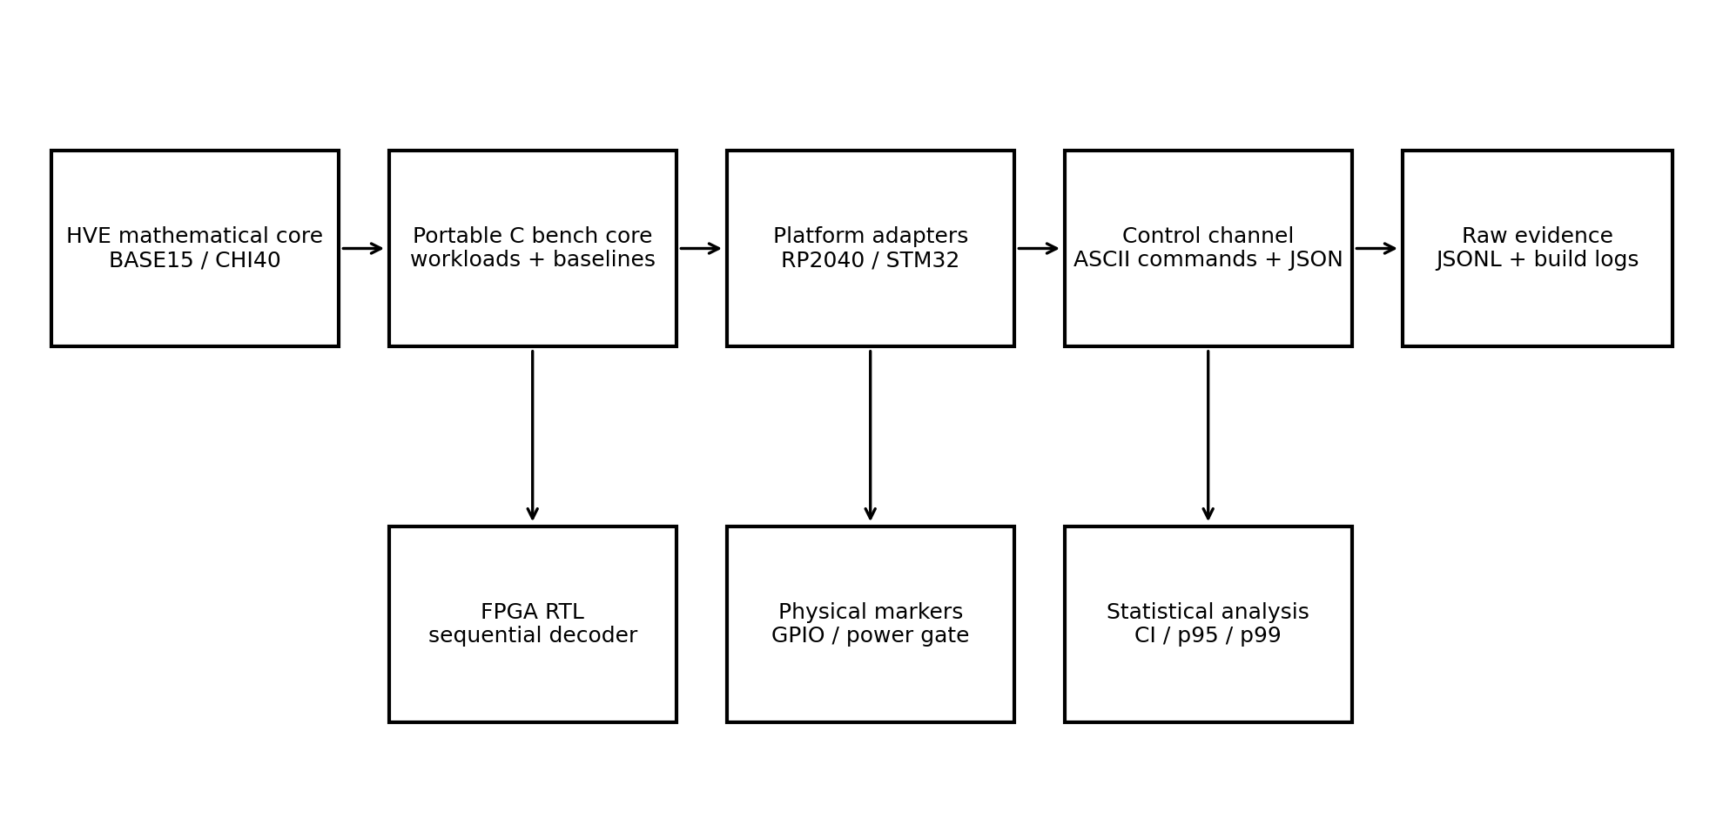
O núcleo matemático permanece independente. A camada de benchmark chama a mesma API C usada na Parte I. Adaptadores de plataforma fornecem apenas contador, frequência, GPIO de marcação e canal de texto. O computador de controle não calcula o resultado do codec; ele agenda execuções, registra respostas e verifica o esquema.

4. Alvos congelados para a primeira campanha
Alvo | Função | Temporização | Interface | Motivo
Raspberry Pi Pico / RP2040 | MCU simples, sem RTOS | timer de hardware em microssegundos | USB CDC | reprodutibilidade e baixo atrito
NUCLEO-F446RE | Cortex-M4 com contador de ciclos | DWT CYCCNT de 32 bits | ST-LINK VCP / USART2 | medição em ciclos e ecossistema industrial
iCEBreaker / iCE40UP5K | FPGA de referência | clock externo de 12 MHz | LED de autoteste e fluxo aberto | síntese auditável com Yosys/nextpnr
A seleção é uma referência de laboratório, não uma restrição do HVE. Outros alvos podem ser adicionados, mas um artigo não deve misturar placas sem congelar versões, clocks, tensões e toolchains.

5. Protocolo de controle
PING
INFO
SELFTEST
RUN <WORKLOAD> <ITERATIONS> <BATCH> <SEED> [WARMUP]
QUIT
Cada comando produz exatamente um objeto JSON em uma única linha. O firmware não recebe objetos JSON; isso evita incorporar um parser pesado no alvo. O controller converte um plano declarativo em comandos, adiciona data UTC, repetição, classe de ambiente e identificador do plano, e grava JSONL sem reescrever os campos produzidos pelo dispositivo.

6. Workloads implementados
Workload | Objeto medido | Unidade lógica
BASE_ENCODE | tupla para índice BASE | estado
BASE_DECODE | índice BASE para tupla | estado
BASE_ROUNDTRIP | encode + decode | estado
BASE15_PACK | empacotamento MSB-first | estado
BASE15_UNPACK | desempacotamento e validação | estado
CHI40_PACK | estado + cor para 5 bytes | estado cromático
CHI40_UNPACK | 5 bytes para estado + cor | estado cromático
FRAME_PARSE | cabeçalho, tamanho e CRC | frame
BASELINE17_* | bitfield direto de 17 bits | estado
BASELINE40_* | campos alinhados em 5 bytes | estado

7. Baselines e justiça comparativa
Dois baselines foram implementados. O FIELD17 armazena diretamente theta, s, tau e phi em 17 bits, sem explorar a cardinalidade conjunta do produto. O FIELD40 armazena theta em dois bytes e os três campos restantes em bytes separados. Ambos carregam exatamente as quatro coordenadas. Nenhum deles representa Unicode, compressão geral ou protocolo de objetos; por isso não devem ser apresentados como substitutos universais.
Formato | Bits significativos | Bytes unitários | Semântica
HVE BASE15 | 15 | fluxo bit-packed | índice bijetivo completo
FIELD17 | 17 | 3 quando serializado isoladamente | campos compactos diretos
FIELD40 | 40 | 5 | campos byte-aligned

8. Temporização e marcação física
- O alvo prepara vetores e buffers antes da região temporizada.
- O GPIO de marcação sobe imediatamente antes da leitura inicial do contador.
- Somente o workload é executado entre as duas leituras.
- O GPIO desce antes de qualquer saída serial.
- A resposta transporta ticks brutos, frequência do contador, largura do contador, operações e checksum.
- O computador converte ticks em tempo, sem apagar os valores originais.
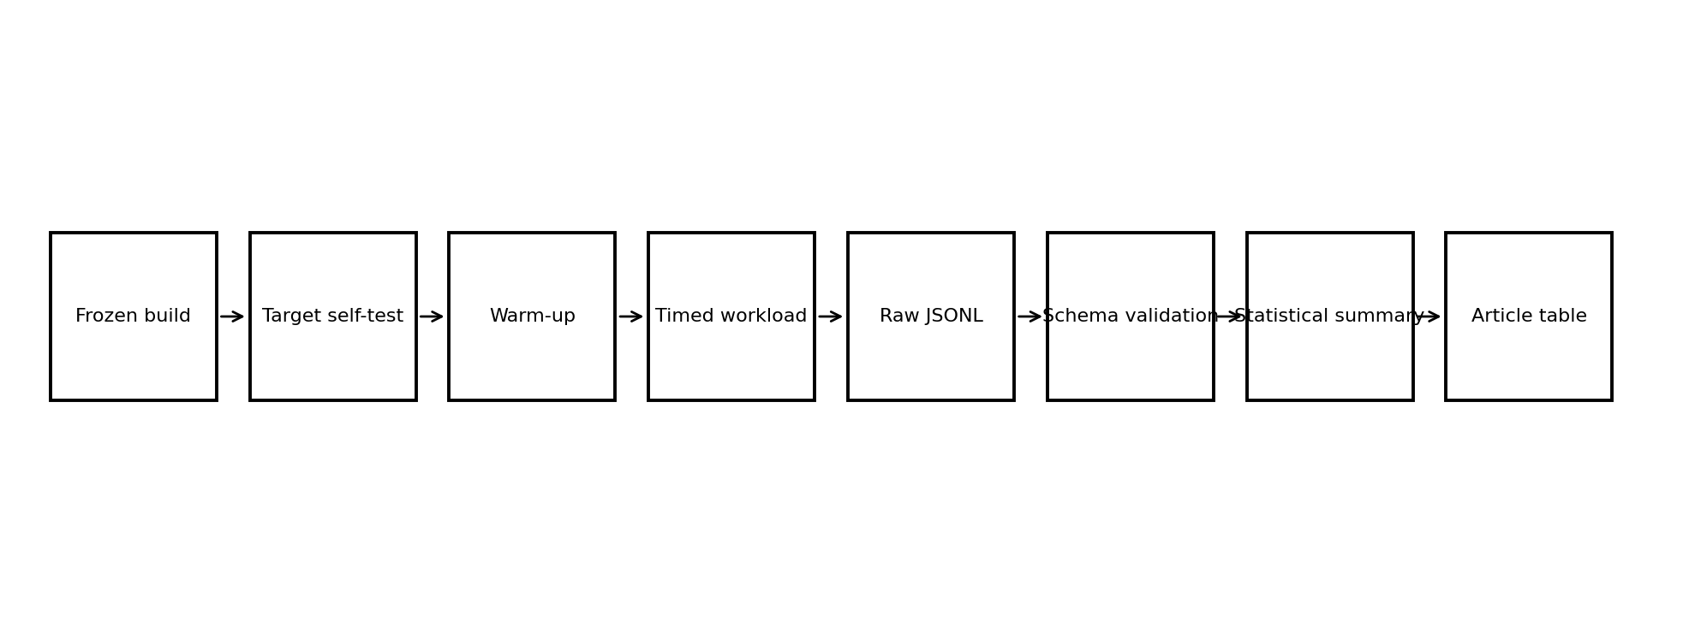

9. Particularidades dos microcontroladores

9.1. RP2040
O timer padrão possui resolução de microssegundos. Consequentemente, o alvo mede lotes grandes e não deve publicar uma latência individual obtida de uma única chamada. O clock do núcleo é lido em tempo de execução. O GPIO 2 foi reservado como marcador por padrão.

9.2. STM32F446RE
O adaptador habilita DWT CYCCNT e declara contador modular de 32 bits. Uma corrida deve terminar antes do wrap. O HCLK informado por HAL_RCC_GetHCLKFreq() é registrado como frequência do contador. USART2 e PA5 são ligações padrão do pacote, mas permanecem macros editáveis para o projeto Cube congelado.

10. Trilha FPGA
A Parte I usava divisão e módulo constantes diretamente no RTL combinacional. A Parte II-A adiciona um decoder sequencial por divisão restauradora. O índice é dividido por 9 em 15 ciclos; o quociente é dividido por 5 em outros 15 ciclos; s é o bit menos significativo do segundo quociente e theta é seu deslocamento à direita. O encoder usa pipeline de três estágios.
Módulo | Papel | Evidência atual
hve_divmod_const_seq | divisão restauradora por constante | modelo Python exaustivo
hve_base_decoder_seq | inversa BASE sem / ou % | RTL escrito; simulação pendente
hve_base_encoder_pipe | encoder com pipeline | RTL escrito; simulação pendente
hve_selftest_top | autoteste dos 32.768 words | bitstream pendente
tb_hve_seq | testbench exaustivo | Icarus/Verilator pendente
O modelo independente verificou 32.400 índices válidos, 368 reservados e zero falhas. Isso valida o algoritmo, não a sintaxe, a síntese, o timing ou a potência do HDL.

11. Dados, esquema e estatística
- JSONL bruto é imutável após coleta.
- JSON Schema valida tipos, limites e campos obrigatórios.
- O script deriva segundos, nanossegundos por operação e operações por segundo.
- Resumo inclui média, mediana, desvio padrão, p95, p99, mínimo, máximo e intervalo bootstrap de 95%.
- Cada gráfico e tabela deve ser regenerável diretamente do JSONL.
O conjunto host-mock acompanha o pacote apenas para demonstrar que o pipeline funciona. Sua classe de ambiente é host_harness e ele não pode ser transferido para a seção de resultados físicos do artigo.

12. Energia
O script power_integrate.py recebe amostras de tempo, tensão, corrente e marcador. A potência de baseline pode ser fornecida ou estimada pela mediana das amostras com marcador zero. A energia líquida é integrada apenas na janela ativa e dividida pelo número declarado de operações. O resultado preserva baseline, duração, energia total, energia por operação e incerteza relativa.
Para publicação, o instrumento, shunt, taxa de amostragem, calibração, tensão, temperatura e método de sincronização devem estar no manifesto da bancada.

13. Critérios de aceitação da Parte II-B física
Gate | Critério mínimo
MCU funcional | SELFTEST: 32.400 válidos, 368 reservados, zero falhas em cada placa
Reprodutibilidade | 30 repetições por workload e plano/manifesto arquivados
Timer | frequência e wrap documentados; nenhuma corrida ambígua
Memória | ELF, map, flash, data, bss e stack reportados
Energia | trace bruto com marcador e incerteza
FPGA simulação | testbench exaustivo sem falhas
FPGA síntese | logs Yosys/nextpnr, recursos, Fmax e bitstream
FPGA físico | LED de autoteste verde e captura da bancada
Artigo | nenhum placeholder transformado em número sem arquivo de origem

14. Procedimento imediato de laboratório
- Adquirir ou confirmar disponibilidade de Raspberry Pi Pico, NUCLEO-F446RE e iCEBreaker.
- Criar repositório versionado e registrar SHA-256 do pacote inicial.
- Congelar SDK Pico e STM32Cube em commits/versões identificadas.
- Compilar primeiro com o plano quick e executar INFO + SELFTEST.
- Validar o JSONL e repetir após power cycle.
- Executar publication_plan somente quando o contador e a duração estiverem dentro dos limites.
- Capturar map files e medir stack antes de energia.
- Instalar Icarus/Verilator e executar o testbench antes de síntese.
- Sintetizar e programar o iCEBreaker; arquivar todos os logs.
- Somente depois atualizar tabelas e conclusões do artigo JSA.

15. Limitações abertas
- Não há placa física conectada ao ambiente de construção deste pacote.
- O código STM32 depende do projeto Cube gerado e de seu clock tree explícito.
- O código RP2040 depende do Pico SDK e de uma compilação cruzada externa.
- O RTL ainda requer simulação e síntese em ferramenta real.
- A energia depende de instrumentação externa calibrada.
- O caso de uso edge completo permanece para a Parte II-C.

Conclusão
A Parte II não foi tratada como promessa. Ela foi iniciada por infraestrutura executável: firmware portátil, planos de carga, protocolo, coleta, schema, estatística, energia e FPGA. O HVE passa a ter uma rota de validação física com gates objetivos. O único elemento que permanece obrigatoriamente fora do pacote é o dado que só uma bancada real pode produzir.

Referências técnicas de plataforma
[1] Raspberry Pi Ltd. Pico SDK documentation: hardware timer, clocks and C/C++ SDK.
[2] STMicroelectronics. NUCLEO-F446RE product documentation and STM32Cube ecosystem.
[3] Arm. CMSIS-Core documentation for Cortex-M core register access.
[4] iCEBreaker FPGA documentation. iCE40UP5K board, clock, FTDI interface and open hardware resources.
[5] YosysHQ. nextpnr and the open-source iCE40 implementation flow.

HVE-720 Embedded: Physical Validation Framework for a Deterministic Modular State Architecture
  - Journal of Systems Architecture-oriented research manuscript

Charles de Paula Eugênio
Independent Researcher — Parauapebas, Pará, Brazil

DRAFT — PHYSICAL RESULTS NOT YET INSERTED
Version 2.0-A — July 2026

Abstract
This paper develops the physical-validation framework for HVE-720 Embedded, a deterministic encoding and serialization architecture derived from the finite state space G = Z360 × Z2 × Z5 × Z9. The architecture maps 32,400 complete BASE states bijectively to valid 15-bit indices, explicitly rejects 368 reserved words, and provides an aligned chromatic profile that distinguishes the absence of color from RGB black. The contribution of the present phase is a reproducible systems-evaluation layer: an allocation-free benchmark core, structurally equivalent fieldwise baselines, a line-oriented control protocol, machine-readable measurement records, schema validation, statistical analysis, marker-gated energy integration, complete RP2040 firmware, an STM32F446RE cycle-counter port, and a resource-predictable sequential FPGA decoder. Host execution validates the measurement pipeline and an independent cycle model exhaustively verifies the sequential decoding algorithm. Physical latency, memory, energy, FPGA resource and timing results remain deliberately unclaimed until target boards and synthesis tools are executed under the frozen protocol.
Keywords: embedded systems architecture; deterministic encoding; reproducible benchmarking; finite-state serialization; RP2040; STM32; FPGA; hardware validation

1. Introduction
A formal encoding can be mathematically correct and still remain unsuitable for systems research if its implementation boundary, measurement method, invalid-state behavior, and physical evidence are not specified. HVE-720 defines a finite modular state object rather than a universal text replacement. The systems question is whether the same object can be preserved across portable software, framing, microcontroller execution and FPGA realization while retaining exact validation rules.
The novelty claimed here is architectural. Established arithmetic components are coordinated into a versioned state system with a reversible compact index, explicit invalid regions, optional pointed color, deterministic wire profiles, independent conformance implementations, and a physical evaluation path that separates codec cost from transport and application cost.

1.1. Contributions of the physical-validation phase
- a platform-independent timing and workload layer that uses the production HVE C API;
- complete RP2040 firmware and an STM32F446RE DWT-based drop-in port;
- a minimal ASCII command protocol with single-line JSON evidence records;
- two equivalent direct-coordinate baselines, using 17 significant bits and 40 aligned bits;
- schema-validated JSONL capture and reproducible statistical analysis;
- marker-gated power integration with explicit baseline subtraction;
- a sequential constant-divider FPGA decoder and a three-stage pipelined encoder;
- objective publication gates that prevent host or simulated values from becoming hardware claims.

2. State and wire models
The BASE state is g = (theta, s, tau, phi), with cardinalities 360, 2, 5 and 9. The exact index is
E(theta,s,tau,phi) = (((theta·2+s)·5+tau)·9+phi).
Indices 0 through 32,399 are valid; 32,400 through 32,767 are invalid or reserved. BASE15 concatenates indices most-significant-bit first. CHI40 stores the BASE index, one color-presence bit and 24 RGB bits. A zero presence bit with nonzero RGB is noncanonical and rejected.

3. Evaluation architecture

Platform adapters provide only a monotonic counter, counter frequency, counter width, core clock, marker GPIO and line I/O. Workload preparation occurs before timing. The marker is asserted before the initial counter read and cleared immediately after the final read. Serialization of the result is outside the measured region.

4. Target platforms
Target | Counter | Control channel | Role
Raspberry Pi Pico / RP2040 | 64-bit hardware timer, microsecond ticks | USB CDC | batch timing on a low-complexity MCU
NUCLEO-F446RE | 32-bit DWT cycle counter | USART2 through ST-LINK VCP | cycle-level Cortex-M4 measurements
iCEBreaker / iCE40UP5K | declared FPGA clock | on-board pass/fail plus tool logs | open-flow RTL synthesis and physical self-test
Each publication run must archive the exact SDK or Cube version, compiler, flags, clock tree, voltage, board revision, binary hash, map file and reset state. Results from different timer modes are converted using the declared frequency while raw ticks remain available.

5. Workload design
Class | Workloads | Measured operation
BASE | encode, decode, round-trip | one complete HVE state
Stream | BASE15 pack and unpack | one packed state within a batch
Chromatic | CHI40 pack and unpack | one state with pointed color
Integrity | HVE1 frame parse | one complete frame
Baselines | FIELD17 and FIELD40 encode/decode | the same four coordinates
Input vectors are generated outside the timed region using a deterministic seed. Each timed loop updates a checksum that is returned in the evidence record, preventing dead-code elimination and exposing divergent runs.

6. Comparative baselines
FIELD17 directly allocates 9, 1, 3 and 4 bits to the four coordinates. FIELD40 stores theta as a 16-bit big-endian field and the remaining coordinates as individual bytes. These baselines preserve the same state information without the mixed-radix reduction. UTF-8, CBOR or MessagePack are not used as universal substitutes in the core microbenchmark because they solve different representation problems; they may be evaluated separately in an application-level case study.

7. Control protocol and evidence format
INFO
SELFTEST
RUN BASE_ENCODE 1000000 32 2001 10000
The target accepts a narrow command grammar and returns one JSON object per command. Measurement records include target, board, build identifier, workload, iteration and batch counts, seed, operations, raw ticks, timer frequency, counter width, core clock, checksum and status. The host controller adds UTC capture time, repetition, plan identifier and evidence class, then appends the record to immutable JSONL.

8. Statistical protocol
Publication runs use at least 30 repetitions per workload after a declared warm-up. Derived metrics include time per operation and operations per second. Reports include mean, median, standard deviation, 95th and 99th percentiles, extrema, and a deterministic 95% bootstrap confidence interval for the mean. Raw data are retained and all tables are regenerated by script.

9. Memory protocol
- archive ELF, binary and linker map files;
- report text, rodata, data and bss separately;
- measure maximum stack through a canary or RTOS-aware tool;
- confirm that the HVE core performs no mandatory dynamic allocation;
- report application buffers separately from library state.

10. Energy protocol
The marker GPIO defines the active integration window. Power is computed from synchronized voltage and current samples. Baseline power is either supplied from an independently measured idle interval or estimated from marker-low samples. Net energy is integrated after baseline subtraction and divided by the exact operation count. Instrument, shunt, sampling rate, calibration, voltage and uncertainty are mandatory metadata.

11. FPGA microarchitectures
The sequential decoder performs two restoring divisions over a fixed 15-bit width: first by 9 to obtain phi and q1, then by 5 to obtain tau and q2. The remaining coordinates are s = q2 mod 2 and theta = floor(q2/2). This architecture has deterministic control and avoids a generic combinational divider. The encoder is a three-stage pipeline implementing multiplications by 2, 5 and 9.
A physical self-test traverses the entire 15-bit space. Every valid word must decode and re-encode exactly, while every reserved word must be rejected. The open iCE40 flow archives simulation, synthesis, place-and-route and bitstream logs. Resource use, maximum frequency, latency and power remain pending physical execution.

12. Executed infrastructure validation
The portable C test suite passed on the build host. The controller captured 36 host-harness measurements across all workloads, the JSON Schema validator reported zero record errors, and the analysis scripts generated derived tables and plots. These observations validate the measurement pipeline only. They are not MCU performance results.
An independent Python cycle model exhaustively checked all 32,400 valid indices and all 368 reserved words for the sequential decoding algorithm with zero failures. This is algorithmic evidence and does not replace HDL simulation, synthesis or board execution.

13. Physical results
NO PHYSICAL RESULT IS INSERTED IN THIS DRAFT.
Target | Workload | Ticks/op | ns/op | Flash | RAM | Energy/op | Evidence file
RP2040 | Pending | — | — | — | — | — | —
STM32F446 | Pending | — | — | — | — | — | —
iCE40UP5K | Pending | — | — | — | — | — | —
The table may only be populated from schema-valid records or archived synthesis reports. Placeholder symbols must never be converted into estimated values.

14. Threats to validity
- timer resolution and wrap differ across targets;
- compiler optimization and constant propagation may change cycle cost;
- USB or UART activity must remain outside the timed region;
- clock, voltage, cache and wait-state configuration affect results;
- board-level energy includes regulators and interfaces unless rails are isolated;
- FPGA tool versions and placement randomness can alter timing and power;
- microbenchmarks do not establish application-level superiority.

15. Reproducibility package
- portable C core and target adapters;
- RP2040 build project and STM32 Cube drop-in port;
- run plans, controller, JSON Schema and validator;
- analysis and power-integration scripts;
- RTL, testbench, iCEBreaker constraints and Makefile;
- raw host-harness evidence labeled as non-physical;
- SHA-256 manifest for the complete release.

16. Conclusion
The physical-validation phase has been converted from a narrative requirement into an executable systems framework. HVE-720 Embedded now has portable workloads, fair direct-coordinate baselines, target ports, machine-readable evidence, statistical gates, energy integration and a deterministic FPGA path. The remaining evidence is irreducibly physical: boards, toolchains and instruments must execute the frozen protocol before performance or efficiency claims are submitted.

Declarations
Funding: No external funding was received for this work.
Competing interests: The author declares no competing interests.
Data and code availability: The submission version shall identify a public versioned repository and an archived release containing raw records, tool logs and hashes.
Use of AI tools: Language and document-structuring assistance shall be disclosed under the target journal's current policy. Technical claims remain the author's responsibility.

HVE Embedded — Parte II-B
Protocolo de execução física, rastreabilidade e cadeia de evidências

Charles de Paula Eugênio
Independent Researcher — Parauapebas, Pará, Brazil

Documento técnico operacional. Não contém resultados físicos inventados ou estimados.

Resumo executivo
A Parte II-B foi iniciada como uma camada operacional de validação física do HVE-720 Embedded. O objetivo não é apenas executar benchmarks, mas garantir que cada número futuro de latência, throughput, memória, energia, área lógica ou frequência máxima possa ser rastreado até uma placa, um binário, um plano experimental, um instrumento, um log bruto e um hash criptográfico.
Nesta entrega foram implementados controladores de sessão, inventário de hardware, bloqueio do experimento, coleta de mapa e stack, integração de energia por GPIO marcador, fluxo FPGA e gerador de tabelas que impede a promoção indevida de dados do computador hospedeiro a evidência embarcada.

1. Estado alcançado
Componente | Estado | Evidência
Núcleo C portátil | Executado | Compilação e testes aprovados
Autoteste HVE | Executado | 32.400 válidos; 368 reservados; zero falhas
Sessão de evidência host | Executada | JSONL, validação, análise e SHA-256
RP2040 | Preparado | Projeto, script de build e captura; hardware ausente
STM32F446RE | Preparado | Porta DWT e procedimento Cube; hardware ausente
FPGA iCE40UP5K | Preparado | RTL, testbench e fluxo; ferramentas/hardware ausentes
Energia | Preparado | Segmentação por GPIO marcador; instrumento ausente

2. Princípio de severidade científica
A execução física é considerada válida apenas quando seis elementos permanecem vinculados na mesma sessão: hardware declarado, fonte congelada, binário congelado, plano congelado, dados brutos e manifesto SHA-256. A ausência de qualquer um desses elementos impede o uso do resultado no artigo.
- Resultado host valida somente o pipeline de medição.
- Resultado sintético valida somente o algoritmo de análise.
- Resultado de modelo de ciclos valida somente a lógica abstrata.
- Resultado físico exige placa identificada e captura serial ou instrumental.
- Valor sem arquivo de evidência não entra no manuscrito.

3. Arquitetura de evidências
Cada execução cria um diretório independente com as subpastas raw, logs, analysis, metadata e artifacts. O controlador salva o transcript integral, o manifesto do alvo, a resposta INFO, o SELFTEST, o plano, o inventário, o conjunto JSONL, os relatórios derivados e o manifesto criptográfico.
Diretório | Função
raw | Dados imutáveis: JSONL, transcript e traços instrumentais.
logs | Comandos, stdout, stderr e códigos de retorno.
analysis | CSV, resumos estatísticos e figuras derivadas.
metadata | Plano, inventário, SDK, compilador, clock, tensão e ambiente.
artifacts | ELF, BIN, UF2, MAP, bitstream e relatórios de síntese.

4. Porta de entrada obrigatória: SELFTEST
Antes de qualquer benchmark, o alvo precisa demonstrar a correção integral do domínio BASE. O controlador interrompe a sessão quando os valores esperados não forem exatamente 32.400 estados válidos, 368 palavras reservadas e zero falhas. Esse teste impede a coleta de desempenho sobre uma implementação incorreta.

5. Planos experimentais

5.1 Triagem física
O plano physical_quick executa cinco repetições de cada workload. Ele serve para detectar problemas de porta serial, clock, wrap do contador, checksum, reinicialização e estabilidade antes do experimento de publicação.

5.2 Plano de publicação
O plano physical_publication_plan_v2 executa trinta repetições independentes por workload. Deve ser executado separadamente após cold boot e warm reset, sem alteração do binário, clock, tensão ou ambiente declarado.

6. Métricas
Métrica | Fonte primária | Regra
Ticks e tempo | Contador do alvo | Preservar ticks e frequência; não guardar apenas nanossegundos.
Throughput | Operações/tempo | Calcular a partir do dataset bruto.
Flash/RAM estática | ELF e MAP | Arquivar saída bruta de size e mapa.
Stack estática | Arquivos .su | Declarar que não prova a profundidade máxima da cadeia.
Energia | CSV do instrumento + marcador | Integrar por segmento e declarar incerteza.
Área/Fmax | Yosys/nextpnr | Publicar somente com logs e bitstream associados.

7. Comparações e baselines
Os baselines BASELINE17 e BASELINE40 carregam os mesmos campos estruturais em formatos diretos. A comparação não deve opor o HVE completo a uma codificação que represente menos informação. Para UTF-8, CBOR ou MessagePack, a equivalência funcional precisa ser definida por cenário, incluindo cobertura, fallback e metadados.

8. Execução RP2040
1. Congelar o commit do Pico SDK e registrar PICO_SDK_PATH.
2. Executar build_rp2040_evidence.sh.
3. Arquivar UF2, ELF, MAP, logs, memória, stack e hashes.
4. Gravar a placa e identificar a porta serial.
5. Executar physical_quick em cold boot.
6. Repetir em warm reset e comparar checksums.
7. Somente então executar o plano de publicação.

9. Execução STM32F446RE
A porta STM32 permanece deliberadamente integrada a um projeto Cube explícito, porque clock tree, startup, linker script, UART e GPIO precisam constar do arquivo experimental. O contador DWT fornece ciclos modulo 2^32; cada workload deve permanecer abaixo do wrap ou ser dividido.

10. Execução FPGA
1. Executar o testbench HDL e preservar o log completo.
2. Sintetizar com Yosys e preservar estatísticas de células.
3. Executar place-and-route com nextpnr e preservar timing.
4. Gerar bitstream e calcular SHA-256.
5. Programar a placa e registrar o autoteste físico.
6. Não inferir Fmax, área ou potência de um modelo Python.

11. Energia e instrumentação
O GPIO marcador delimita apenas a região medida. O CSV precisa conter tempo, tensão, corrente e marcador no mesmo eixo temporal. O script power_segment identifica cada janela ativa, estima a potência basal pelas amostras inativas e calcula energia líquida e energia por operação. Calibração e erro sistemático continuam obrigatórios.

12. Bloqueios atuais
- Não há placa física conectada a este ambiente.
- arm-none-eabi-gcc, Pico SDK e STM32CubeF4 não estão instalados.
- Icarus Verilog, Verilator, Yosys, nextpnr-ice40 e IceStorm não estão instalados.
- Não há instrumento de energia ou arquivo bruto real.
- Consequentemente, nenhuma métrica física foi alegada.

13. Critério de conclusão da Parte II-B
A Parte II-B será considerada concluída quando existirem, para pelo menos dois microcontroladores e uma FPGA, sessões físicas completas, resultados reproduzíveis, memória e stack documentadas, energia medida, simulação e síntese arquivadas, além de tabelas regeneráveis diretamente dos artefatos.

Apêndice A — Comandos essenciais
python tools/toolchain_probe.py --output evidence/toolchain_probe.json
./build_scripts/build_rp2040_evidence.sh
./build_scripts/run_physical_mcu_session.sh PORTA SERIAL cold_boot
./build_scripts/run_fpga_evidence.sh
python tools/power_segment.py trace.csv --operations-per-segment N --output energy.json

HVE-720 Embedded — Experimental Methods Addendum v3
Traceable physical validation for the Journal of Systems Architecture manuscript

Charles de Paula Eugênio
Independent Researcher — Parauapebas, Pará, Brazil

This addendum contains methods and insertion-ready text only. It contains no fabricated physical results.

1. Experimental design
The physical evaluation is organized as an evidence-preserving experiment rather than an isolated benchmark. Each session binds the source release, target board, board revision, serial number, supply voltage, clock, toolchain, SDK revision, compiler flags, binary artifacts, execution plan, raw output and derived statistics through a SHA-256 manifest.

2. Correctness gate
No performance measurement is accepted before the target completes an exhaustive BASE-domain self-test. The gate requires exactly 32,400 valid words, rejection of all 368 reserved 15-bit words, and zero encode-decode failures. This ordering prevents performance claims from being generated by a functionally incorrect implementation.

3. Targets
Target | Timing source | Build evidence | Status
RP2040 | 64-bit hardware timer | ELF, UF2, map, .su, logs | Awaiting physical execution
STM32F446RE | 32-bit DWT cycle counter | ELF, BIN, map, .su, Cube config | Awaiting physical execution
iCE40UP5K | Synthesis/P&R timing and physical self-test | simulation, Yosys, nextpnr, bitstream | Awaiting physical execution

4. Workloads and baselines
The workload set covers BASE encode, decode and round trip; 15-bit stream packing and unpacking; HVE-chi 40-bit packing and unpacking; frame parsing; and fieldwise 17-bit and 40-bit baselines that transport the same coordinate fields. The baselines therefore measure representation overhead without removing HVE information from the comparison.

5. Repetition protocol
A five-repetition bring-up plan is executed first. The publication plan is executed only after functional and transport checks pass, and contains 30 independent repetitions per workload. Cold-boot and warm-reset captures are stored as separate sessions. Seeds change between repetitions, while the binary, clock and voltage remain fixed.

6. Timing analysis
Raw counter ticks, counter frequency, operation count and checksum are preserved. Derived quantities include time per operation, throughput, median, standard deviation, 95th and 99th percentiles, extrema, and a nonparametric 95% bootstrap confidence interval for the mean. Raw ticks remain the primary evidence.

7. Memory and stack
Flash and static RAM are derived from the target ELF and linker map, with the complete size-tool output retained. GCC stack-usage files provide per-function static estimates. These estimates are reported separately from dynamic high-water measurements and are not treated as proof of maximum call-chain depth.

8. Energy
Energy traces contain a common time axis, voltage, current and a marker GPIO. Each active marker interval is integrated after baseline-power subtraction. Energy per operation is computed from the exact operation count executed in that interval. Instrument calibration, sample rate, range and relative uncertainty are archived with the trace.

9. FPGA validation
The HDL flow includes exhaustive functional simulation, Yosys synthesis, nextpnr place-and-route, timing closure, bitstream generation and a power-on self-test over the complete 15-bit input domain. Area, Fmax and latency are reported only when the corresponding logs and bitstream hashes exist.

10. Evidence boundary and threats to validity
- Host measurements validate the harness and are excluded from physical result tables.
- Datasheet values are not substituted for measured results.
- Different counter types are normalized to time while raw ticks remain available.
- USB or serial output occurs outside the timed region.
- Cross-platform comparisons declare clock, voltage, compiler and optimization differences.
- A missing tool or board is recorded as not executed, not as a negative HVE result.

11. Result-table insertion rule
The table generator selects only records explicitly labeled physical_mcu for MCU timing tables. When only host records are available, the physical table remains empty. This fail-closed behavior is part of the reproducibility design.

12. Current execution status
The complete non-physical pipeline has passed compilation, unit testing, self-test, dataset validation, statistical analysis, memory extraction, static stack extraction and evidence hashing. Physical MCU, FPGA and energy measurements remain pending because no laboratory hardware or cross-toolchains are present in the current environment.

- # HVE Embedded Part II-B status

- ## Started and executed in this release

- 1. Traceable evidence-session controller with immutable session directories.
- 2. Cold-boot, warm-reset and host-dry-run classifications.
- 3. Mandatory self-test gate: 32,400 valid states, 368 reserved words, zero failures.
- 4. Hardware inventory and experiment-lock templates.
- 5. Physical quick plan and 30-repetition publication plan.
- 6. Serial port inventory and resilient serial controller.
- 7. Toolchain and SDK readiness audit.
- 8. ELF/map memory evidence and GCC static stack-usage collection.
- 9. FPGA simulation/synthesis evidence driver with explicit not-executed state.
- 10. Marker-segmented power analysis with per-segment energy output.
- 11. Article-table generator that refuses to populate physical tables from host data.
- 12. End-to-end host dry-run evidence session, dataset validation and analysis.
- 13. SHA-256 chain of custody for every session.

- ## Results of the execution available here

- - Host build: passed.
- - Portable C tests: passed.
- - HVE self-test: 32,400 valid states, 368 reserved words, zero failures.
- - Host evidence session: complete.
- - JSON schema validation: passed.
- - Analysis pipeline: passed.
- - Memory and static stack extraction: passed for the host binary only.
- - FPGA physical flow: not executed because Icarus Verilog, Yosys, nextpnr and IceStorm are absent.
- - RP2040/STM32 cross-build: not executed because ARM toolchain and SDKs are absent.
- - MCU and FPGA physical measurements: not executed because no hardware is connected.

- ## Scientific boundary

- No value produced by the host dry-run is a physical MCU or FPGA result. Physical claims begin only after a declared hardware inventory, a frozen binary, a serial target capture, instrument metadata and artifact hashes exist in the same evidence session.

- ## Required external inputs for the next executable step

- 1. Exact board model/revision and serial number.
- 2. RP2040 Pico SDK and ARM GCC, or STM32CubeF4 and ARM GCC.
- 3. A connected serial port.
- 4. Supply voltage and clock configuration.
- 5. For energy: calibrated power instrument and marker capture.
6. For FPGA: Icarus/Verilator, Yosys, nextpnr-ice40, IceStorm and an iCE40UP5K board.

- # Procedimento operacional — HVE Parte II-B

- ## 1. Congelar o experimento

- - Copiar e preencher `lab/hardware_inventory.template.json`.
- - Registrar placa, revisão, número de série, tensão, clock e GPIO marcador.
- - Congelar SDK, compilador, flags, fonte e plano.
- - Não alterar o binário entre cold boot, warm reset e publicação.

- ## 2. Auditar o ambiente

- ```sh
- python tools/toolchain_probe.py --output evidence/toolchain_probe.json
- python tools/serial_probe.py --output evidence/serial_ports.json
- ```

- Um item ausente significa somente que a etapa não foi executada.

- ## 3. Compilar e arquivar

- RP2040:

- ```sh
- export PICO_SDK_PATH=/caminho/pico-sdk
- ./build_scripts/build_rp2040_evidence.sh
- ```

- STM32F446RE:

- - integrar os arquivos no projeto Cube;
- - ativar `-fstack-usage` e mapa do linker;
- - arquivar `.ioc`, ELF, BIN, MAP, `.su`, log e versão do compilador;
- - executar `map_metrics.py` e `stack_usage_collect.py`.

- ## 4. Executar a triagem física

- ```sh
- ./build_scripts/run_physical_mcu_session.sh PORTA NUMERO_DE_SERIE cold_boot
- ```

- A sessão é inválida quando:

- - o SELFTEST não verifica 32.400 estados;
- - algum dos 368 códigos reservados é aceito;
- - existe falha de round-trip;
- - o plano ou o binário muda durante a captura;
- - não há identificação da placa.

- ## 5. Publicação

- Após a triagem passar:

- ```sh
- ./build_scripts/run_physical_mcu_session.sh PORTA NUMERO_DE_SERIE cold_boot data/plans/physical_publication_plan_v2.json
- ./build_scripts/run_physical_mcu_session.sh PORTA NUMERO_DE_SERIE warm_reset data/plans/physical_publication_plan_v2.json
- ```

- Cada sessão deve permanecer separada. Não misturar repetições de placas, clocks ou tensões diferentes.

- ## 6. Energia

- O CSV bruto precisa conter:

- - `time_s`;
- - `voltage_v`;
- - `current_a`;
- - `marker`.

- Executar:

- ```sh
- python tools/power_segment.py trace.csv --operations-per-segment 1000000 --relative-uncertainty 0.02 --output energy.json
- ```

- Preservar o CSV original, a calibração, a taxa de amostragem e a sincronização do GPIO.

- ## 7. FPGA

- ```sh
- ./build_scripts/run_fpga_evidence.sh
- ```

- Somente publicar área, Fmax e timing quando os logs de simulação, Yosys e nextpnr existirem, estiverem associados ao mesmo bitstream e forem incluídos no manifesto SHA-256.

- ## 8. Inserção no artigo

- ```sh
- python tools/generate_publication_tables.py CAMINHO/summary.json --output-dir article_tables
- ```

O gerador deixa a tabela física vazia quando recebe apenas dados de host. Esse comportamento é intencional.

