The Tournament Handbook
Volume 2: Bout Pairings

Edition 0.4
September 2017

by
Tristan Grey of Manchester (Charles Farris)


Table of Contents
Introduction 8
Managing Expectations 8
Tracking the Tournament 8
Required Data 8
Optional Data 8
The List 8
The Cards 8
Pairing Goals 9
Aristomachy 9
Exagony 9
Fairness 9
Monagony 9
Monotony 9
Suspense 9
Incentivization 9
Inclusivity 9
Implementability 9
Pairing Goal Selection 10
Seeding 10
Rating vs Rank 11
Rating, Rank, and SCA Combat 11
Estimating Rating for SCA Combat 12
Pairing Methods 13
Fold Pairing 13
Slide Pairing 16
Adjacent Pairing 16
Random Pairing 18
The Not-So-Random List 18
Shuffles 18
Overhand Shuffle 18
Pile Shuffle 18
Top/Bottom Shuffle 18
Graph Theory 18
Example: Single Elimination with 5 Fighters 23
Tournament Formats 32
Round-Robin 32
Method #1: Manual Generation using Rotation System 32
Method #2: Use Precomputed Bout Tables 35
Method #3: Run the Tournament as Line Tournament 35
Method #4: Run the Tournament as a Challenge Tournament 35
Swiss-System 35
Method #1: Use the Round-Robin Precomputed Bout Tables 35
Method #2: Use Adjacent Pairing 35
Elimination Tournaments 41
Single Elimination 41
Double Elimination 41
Triple Elimination 41
Timed Tournaments 41
Multistage Tournaments 41
Appendix A 42
Precomputed Tables 42

Index of Tables
Table 1: Generalized Rapier Combat Rating System based on Awards 12
Table 2: Generalized Armored Combat Rating System based on Awards & Titles 12
Table 3: Pairing Methods List 13
Table 4: Fold Pairing Example 15
Table 5: Slide Pairing Example 16
Table 6: Adjacent Pairing Example 17
Table 7: Random Pairing Example 18
Table 8: Weight Sums 22
Table 9: Round-Robin List 23
Table 10: Matchings – Round #1 24
Table 11: Results – Round #1 25
Table 12: Matchings – Round #2 27
Table 13: Results – Round #2 28
Table 14: Matchings – Round #3 29
Table 15: Results – Round #3 30
Table 16: Total Matchings 31
Table 17: Round-Robin Rotation Table, n = 8 fighters, Round #1 32
Table 18: Round-Robin Rotation Table, n = 8 fighters, Round #2 32
Table 19: Round-Robin Rotation Table, n = 8 fighters, Round #3 33
Table 20: Round-Robin Rotation Table, n = 8 fighters, Round #4 33
Table 21: Round-Robin Rotation Table, n = 8 fighters, Round #5 33
Table 22: Round-Robin Rotation Table, n = 8 fighters, Round #6 33
Table 23: Round-Robin Rotation Table, n = 8 fighters, Round #7 33
Table 24: Round-Robin Bout Pairings, n=8 fighters 34
Table 25: Round-Robin Rotation Table, n = 9 fighters, Round 1 34
Table 26: Round-Robin Bout Pairings, n=9 fighters 34
Table 27: Swiss-5 Bout Pairings from Truncated Round-Robin 35
Table 28: Swiss-5 Tournament List – Adjacent Pairing Example 36
Table 29: Bout Pairings & Results – Round #1 36
Table 30: Swiss-5 Scores - Round #1 37
Table 31: Bout Pairings & Results - Round #2 37
Table 32: Swiss-5 Scores - Round #2 38
Table 33: Bout Pairings & Results - Round #3 38
Table 34: Swiss-5 Scores - Round #3 39
Table 35: Bout Pairings & Results - Round #4 39
Table 36: Swiss-5 Scores - Round #4 40
Table 37: Bout Pairings & Results - Round #5 40
Table 38: Swiss-5 Scores - Round #5 41
Table 39: Round-Robin Bout Pairings, n=4 fighters 42
Table 40: Round-Robin Bout Pairings, n=3 fighters 42
Table 41: Round-Robin Bout Pairings, n=3/4 fighters 42
Table 42: Round-Robin Bout Pairings, n=5/6 fighters 43
Table 43: Round-Robin Bout Pairings, n=7/8 fighters 43
Table 44: Round-Robin Bout Pairings, n=9/10 fighters 43
Table 45: Round-Robin Bout Pairings, n=11/12 fighters 44
Table 46: Round-Robin Bout Pairings, n=13/14 fighters 44
Table 47: Round-Robin Bout Pairings, n=15/16 fighters 45
Table 48: Round-Robin Bout Pairings, n=17/18 fighters 46
Table 49: Round-Robin Bout Pairings, n=19/20 fighters 47
Table 50: Round-Robin Bout Pairings, n=21/22 fighters 48
Table 51: Round-Robin Bout Pairings, n=23/24 fighters 49
Table 52: Round-Robin Bout Pairings, n=25/26 fighters 50
Table 53: Round-Robin Bout Pairings, n=27/28 fighters 51
Table 54: Round-Robin Bout Pairings, n=29/30 fighters 53
Table 55: Round-Robin Bout Pairings, n=31/32 fighters 55
Table 56: Round-Robin Bout Pairings, n=33/34 fighters 59
Table 57: Round-Robin Bout Pairings, n=35/36 fighters 63
Table 58: Round-Robin Bout Pairings, n=37/38 fighters 67
Table 59: Round-Robin Bout Pairings, n=39/40 fighters 71
Table 60: Round-Robin Bout Pairings, n=41/42 fighters 76
Table 61: Round-Robin Bout Pairings, n=43/44 fighters 82
Table 62: Round-Robin Bout Pairings, n=45/46 fighters 88
Table 63: Round-Robin Bout Pairings, n=47/48 fighters 94
Table 64: Round-Robin Bout Pairings, n=49/50 fighters 101

Table of Objects
Illustration Index
Illustration 1: Card Stack 13
Illustration 2: Graph G 19
Illustration 3: Complete Graph K 20
Illustration 4: Complete Weighted Graph K 20
Illustration 5: Matching M 21
Illustration 6: Maximum Perfect Matching 21
Illustration 7: Matching M1 21
Illustration 8: Matching M2 22
Illustration 9: Matching M3 22
Illustration 10: Weighted Graph – Round #1 23
Illustration 11: Annotated Weighted Graph – Round #1 24
Illustration 12: Matching M1 – Round #1 25
Illustration 13: Weighted Graph – Round #2 26
Illustration 14: Matching M10 – Round #2 27
Illustration 15: Weighted Graph – Round #3 28
Illustration 16: Matching M13 – Round #3 29
Illustration 17: Complete Weight Graph (8 Fighters) 30
Illustration 18: Round-Robin Rotation 32

Dedication

I dedicate this work to my wife Pam (also known as Arcadia) who patiently listened to me rant and rave about the mathematics and simulation of tournaments for months…

Introduction
“A man cannot be too careful in the choice of his enemies.” - Oscar Wilde
The Minister of the List (MoL) is responsible for three tasks for every tournament. First, they must check the eligibility of every fighter entering the tournament. At a minimum, a fighter must have a valid SCA membership, have signed the participation waiver, and be authorized in the tournament's style of combat. Depending on the tournament's convention, the MoL may also have to verify the fighter meets any additional entry requirements. Second, they must track the progress of the tournament. Every fighter's wins and losses are recorded and that data is used by the MoL to generate bout pairings, keep score, and eliminate fighters from the tournament. Finally, the MoL must submit a report summarizing the tournament to various local and kingdom officers.
This volume of The Tournament Handbook is focused on providing tools to help an MoL track the progress of a tournament by minimizing errors and increasing efficiency in order to maximize fighter satisfaction.

Managing Expectations
<To Do>

Tracking the Tournament
<To Do>

Required Data
<To Do>

Optional Data
<To Do>

The List
<To Do>

The Cards
<To Do>

Pairing Goals

Aristomachy
This goal seeks to maximize the number of bout pairings between top fighters, especially towards the end of the tournament.

Exagony
This goal seeks to minimize the number of bout pairings between fighters from the same group.

Fairness
This goal seeks to maximize the probability that a fighter's placement in the tournament results reflects the fighter's relative skill.

Monagony
This goal seeks to minimize the number of repeat bout pairings and the number of byes for each fighter in the tournament.

Monotony
This goal seeks to minimize the probability a less skilled fighter is more likely to become the overall winner than a higher skilled fighter will.

Suspense
This goal seeks to delay the outcome of the tournament as late as possible.

Incentivization
This goal seeks to prevent situations where a fighter would choose to lose in order to gain an advantage later in the tournament.

Inclusivity
This goal seeks to prevent pairing a fighter in contention for winning the tournament is prevented from winning the tournament even if they win the bout.

Implementability
This goal seeks to minimize the computational complexity required to generate bout pairings. Later on this handbook, I examine the use of graph theory to generate near-optimal bout pairings for a given round. The algorithm becomes very computationally expensive as the size of the tournament grows and requires the use of a computer for use in tournaments with more than a handful of fighters. With the prevalence of smart phones and high-speed wireless networks, writing an app to handle tournament scheduling would be relatively simple. This handbook, however, is going to only use the technology available to the medieval scribe – pen and paper.
Another aspect of implementability is the availability of data for each fighter. Several of the pairing goals described above require that the MoL know the relative skill of all the fighters in the tournament. In other sports and games, the relative skill of the players and teams is based on tracking their performance in standardized competition over a fixed period of time. In professional sports, for example, a team's win/loss record during a season determines both the team's eligibility and seeding for post-season tournament. For SCA tournaments, the lack of any standardization prevents the generation of meaningful statistics on fighter performance. This problem is addressed in the next chapter, “Seeding”.

Pairing Goal Selection
The selection of the pairing goals for a tournament depends primarily on the purpose of the tournament.
Determining the Winner | Interesting Tournaments | Execution
Aristomachy  Monotony  Fairness | Exagony  Monagony  Suspense  Incentivization | Implementability

For SCA tournaments, the most important goal will always be implementability. The time span of most SCA tournaments is measured in hours and given the predilection of manual scheduling, MoLs will need to choose a pair method which can be quickly done by hand.
Next, monagony is the next most important goal.
Exagony is the next most important goal. TODO
Fighter satisfaction

Seeding
In a seeded tournament, the fighters are paired according to their relative rating or rank. Most professional sports and gaming leagues use seeding to maximize aristomachy, monotony, fairness, suspense, and incentivization. Since top-seeded competitors often gain an advantage in the tournament, competitors are motivated to perform as well as possible during the season in order to maximize their rating. Stronger competitors are often matched against weaker competitors in the early rounds the tournament to maximize aristomachy, monotony, fairness, and suspense with overall goal of putting the two best competitors in the final round.

Rating vs Rank
When comparing the relative performance of two competitors, seeding systems can use either a rating or a rank. A rating is a numerical measure of a competitor's skill based on his or her past performance in competition. A rating is often represented as a numerical score based on a weighed sum of a competitor's wins, losses, and ties over some interval of time. By sorting a given population of competitors by their ratings, one can generate ordered list of competitors from best to worst. Ratings are constantly fluctuating since every time a player competes, the result of that competition changes their rating.
In contrast, a rank is awarded and is usually based on a competitor reaching a particular rating. Common examples of ranks include chess titles, go ranks, and martial arts belts. Unlike a rating which can be used to directly compare the performance of two competitors, ranks only allow for a general comparison between skill levels and often used for applying handicaps during competition.
Ratings and ranks are usually regulated by some form of governing body and only officially sanctioned competitions are used when computing a player's rating and/or rank. Competitors are required to register with the governing body and competitions are standardized with fixed formats, conventions, and rules to simplify the calculation of ratings.

Rating, Rank, and SCA Combat
For armored, rapier, and cut & thrust combat, there is no formal rating or ranking system within the SCA. Some kingdoms and groups within the SCA do maintain unofficial rank/rating systems.
An excellent example of a skill-based ranking system is the Black Scarf Program run by the Black Tigers, an inter-kingdom group focusing on rapier fighting and instruction. Ranks are awarded based on tests of skill and victory in tournaments of fixed sizes. Emphasis is placed on correctly learning and applying the style of rapier combat developed by the Black Tigers so any ranked fighter in the Black Scarf Program is also a qualified instructor.
Archery, however, does have an official rating and ranking system. Archers across the Knowne World compete in the Inter-Kingdom Archery Competition (IKAC) by entering official & standardized shoots. Scores from official shoots are tracked both at the kingdom and inter-kingdom level. Archers are awarded ranks based on the their scores.

Estimating Rating for SCA Combat
A common method of estimating rating for armored and rapier combat is use the highest level of martial award for that type of combat. This type of rating system assumes a rough correlation between a fighter's skill level and which martial awards they've received.

Award | Rating
Master of Defense (MoD) | 5
GoA Rapier Combat Award | 4
AoA Rapier Combat Award | 3
Baronial Rapier Combat Award | 2
No Rapier Combat Awards | 1
Table 1: Generalized Rapier Combat Rating System based on Awards

Award-based rating systems for armored combat usually take into account a fighter's success in a Crown tournament as well as their highest award related to armored combat.
Award/Title | Rating
Duke | 7
Count | 6
Knight (KSCA) | 5
GoA Armored Combat Award | 4
AoA Armored Combat Award | 3
Baronial Armored Combat Award | 2
No Armored Combat Awards | 1
Table 2: Generalized Armored Combat Rating System based on Awards & Titles

Cut & thrust combat draws fighters from both the armored and rapier combat communities so an award-based rating system would most likely combine the armored and rapier combat rating systems.
One of the benefits of using an award-based rating system the system requires minimal extra data collection. MoLs already collect information regarding a fighter's title for the purposes of field heraldry – expanding the data collection to include the highest martial award is trivial.

Pairing Methods
Each of the pairing methods below will use the following list in their examples.
Number | Name | Group | Rating
1 | Niccolo | College of Castle Keype | 3
2 | Baron Raphael | Barony of Green Isle | 7
3 | Dona Veronica | Barony of Haversport | 1
4 | Dona Fiona | Barony of Darkstone | 2
5 | The Honorable Lady Christina | Barony of Iron Hill | 4
6 | Mistress Patrice | Shire of Redgate | 6
7 | Lady Sabine | Barony of Green Isle | 5
Table 3: Pairing Methods List
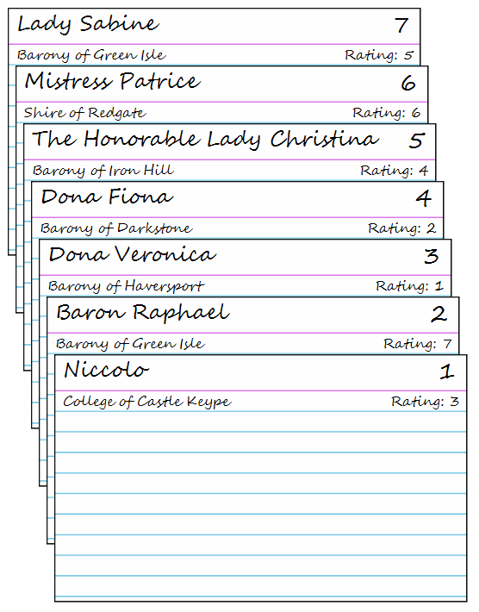Illustration 1: Card Stack

Fold Pairing
This seeded pairing method of generating pairings matches the best fighters against the worst fighters. Also known as “Slaughter Pairing”.
Implementation
- Sort the cards by the relative rating of the fighters in descending order (best to worst).
- Take the top card and bottom card from the stack and use them to create the first bout pairing.
- Construction of the pairings continues using the top and bottom cards until all fighters are matched. If there are an odd number of fighters, the last fighter on the stack gets the bye.
Cards |  | Bout
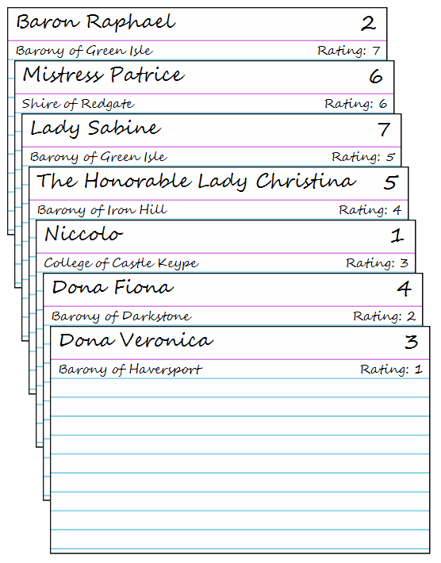 | ➔ | 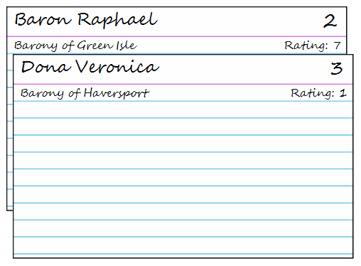
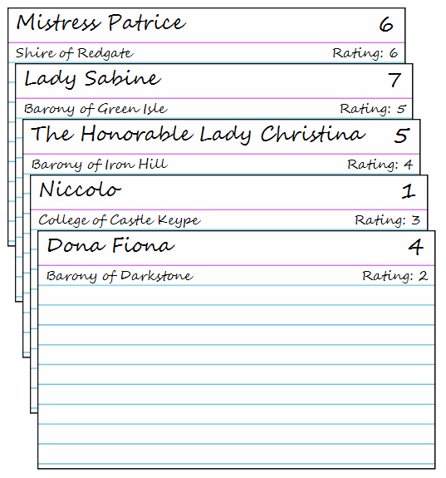 | ➔ | 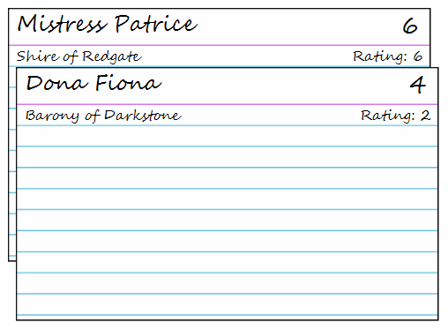
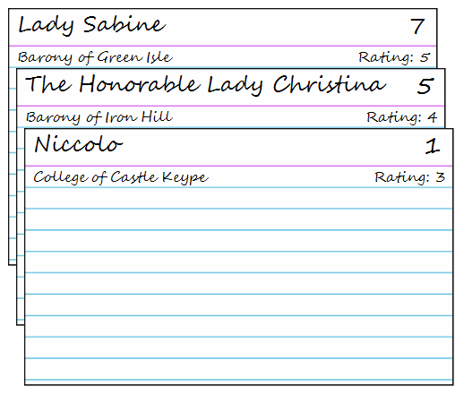 | ➔ | 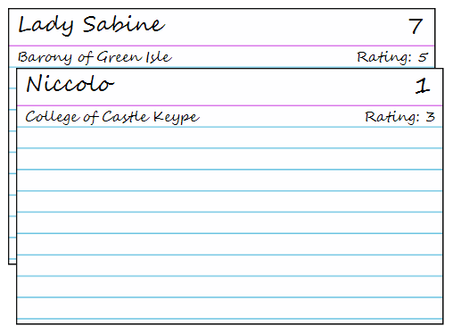
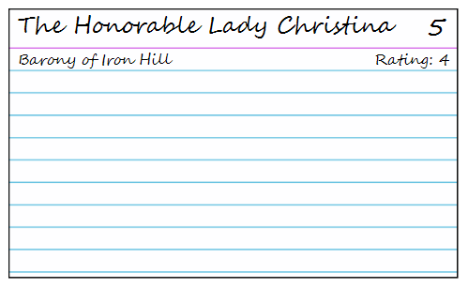 | ➔ | 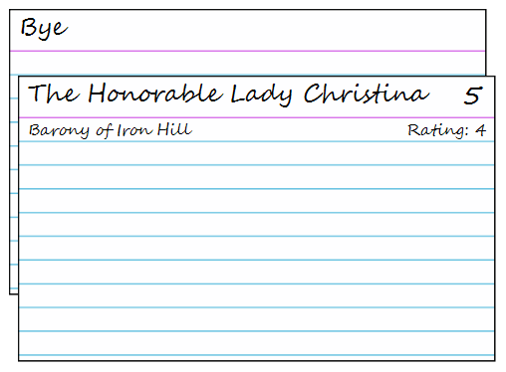
Table 4: Fold Pairing Example

Slide Pairing
This seeded pairing method divides the fighters into two sets with the best fighters in the first set and the worst fighters in the second set. Pairings are constructed by matching the best fighters from each set. Also know as “Cross Pairing”.
Implementation
- Sort the cards by the relative rating of the fighters in descending order (best to worst).
- Divide the stack into two equal halves.
- Take the top card from the each stack and use them to create the first bout pairing.
- Construction of the pairings continues using the top cards until all fighters are matched. If there are an odd number of fighters, the last fighter on the stack gets the bye.
Stack | Bout | Rating
T: 3₍₁₎, 4₍₂₎, 1₍₃₎, 5₍₄₎  B: 7_{(5),} 6₍₆₎, 2₍₇₎ | 3-7 | 1-5
T: 4₍₂₎, 1₍₃₎, 5₍₄₎  B: 6₍₆₎, 2₍₇₎ | 4-6 | 2-6
T: 1₍₃₎, 5₍₄₎  B: 2₍₇₎ | 1-2 | 3-7
T: 5₍₄₎  B: | 5-Bye | 4
Table 5: Slide Pairing Example

Round: 3-7, 4-6, 1-2, 5-Bye

Adjacent Pairing
This method of generating pairings selects the bouts by matching the best fighter against the next-best fighter until all fighters have been paired. Also known as “King of the Hill Pairing”.
Implementation
- Sort the cards by the relative rating of the fighters in descending order (best to worst).
- Take the top 2 cards from the stack and use them to construct the first bout pairing.
- Construction of the pairings continues by taking the top 2 cards until all fighters are matched. If there are an odd number of fighters, the last fighter on the stack gets the bye.
Stack |  | Bout
 | ➔ | 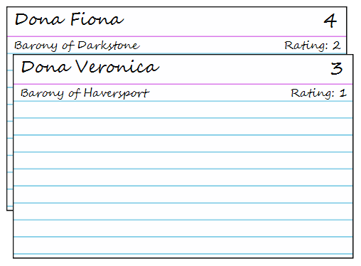
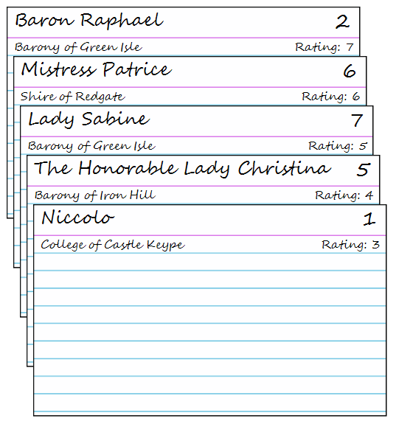 | ➔ | 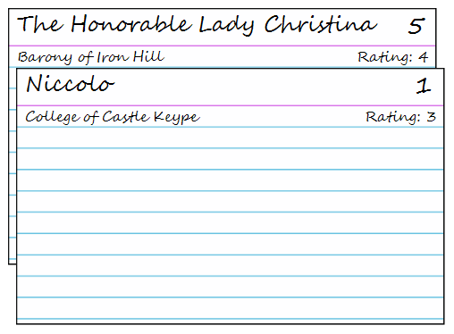
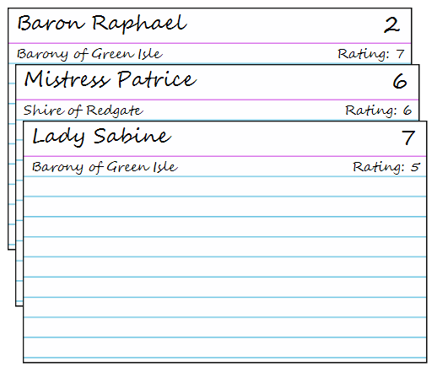 | ➔ | 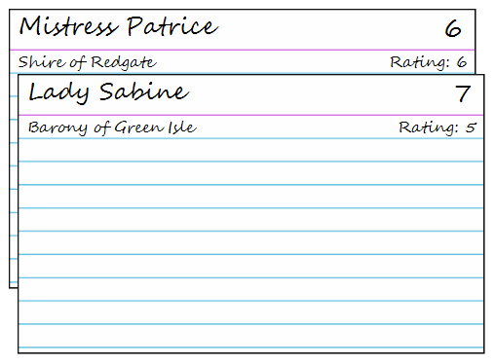
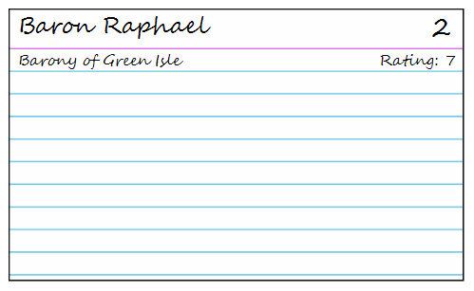 | ➔ | 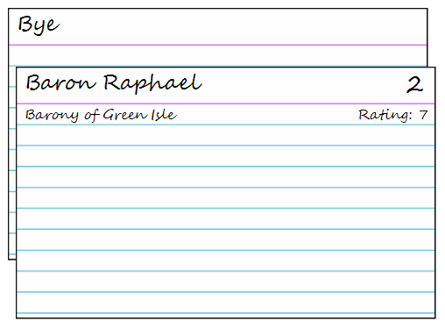
Table 6: Adjacent Pairing Example

Random Pairing
The method of generating pairing selects the bouts randomly. Random pairing is usually the only option for generating pairings when there is no way to rate the fighters.
Implementation
- Shuffle the stack of cards so the fighters are randomly ordered.
- Take the top 2 cards from the stack and use them to construct the first bout pairing.
- Construction of the pairings continues by taking the top 2 cards until all fighters are matched. If there are an odd number of fighters, the last fighter on the stack gets the bye.
Stack | Bout | Rating
4₍₂₎, 2₍₇₎, 7₍₅₎, 5₍₄₎, 1₍₃₎, 6₍₆₎, 3₍₁₎ | 4-2 | 2-7
7₍₅₎, 5₍₄₎, 1₍₃₎, 6₍₆₎, 3₍₁₎ | 7-5 | 5-4
1₍₃₎, 6₍₆₎, 3₍₁₎ | 1-6 | 3-6
3₍₁₎ | 3-Bye | 1
Table 7: Random Pairing Example

Round: 4-2, 7-5, 1-6, 3-Bye

The Not-So-Random List
"Byrdes of on kynde and color flok and flye allwayes together." – William Turner

Shuffles

Overhand Shuffle

Pile Shuffle

Top/Bottom Shuffle

Graph Theory
From a mathematical perspective, a tournament can be represented as a complete undirected weighted graph where the fighters are represented by the vertices and the possible bouts by the edges. If each edge is given a weight which represents how desirable that bout is, then the optimal bout pairing for that round is a maximum weight perfect matching. Thus finding the optimal bout pairings for a round is simply a matter of computing the maximum weight perfect matching. At the end of the round, the weights on the graph are updated to reflect the results of the bouts and the next set of bout pairings can then be computed from the updated graph.
Unless you've studied graph theory or combinatorics, the previous paragraph will make absolutely no sense. And in practice, this method of determining bout pairings is almost impossible without the use of a computer. But one must have a cursory understanding of how tournaments work in order to understand the assumptions used to derive the algorithms later on in the manual.
Let's start with the definition of a graph. In graph theory, a graph is a set of vertices which may be connected by a set of edges.[MAT00] Graphs are used extensively to solve problems in scheduling, networking, optimization, logistics, management, and transportation.[MAT00][MAT03] The diagram below illustrates a graph with 4 vertices and 4 edges. Using mathematical notation, the graph G is defined by a set of vertices V and a set of edges E connecting the vertices. For the graph below, G = (V, E) where V = {1, 2, 3, 4} and E = {{1-2}, {2-3}, {1-3}, {3-4}}.
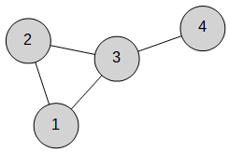Illustration 2: Graph G

A tournament can be represented by a complete undirected weighted graph. A complete graph is a graph where every pair of vertices is connected by an edge. Thus the graph above would be considered an incomplete graph. By adding edges, the graph can be made complete: K = (V, E) where V = {1, 2, 3, 4} and E = {{1, 2}, {1, 3}, {1, 4}, {2, 3}, {2, 4}}.
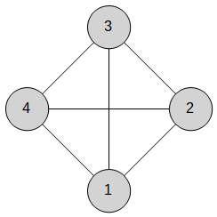Illustration 3: Complete Graph K
In an undirected graph, the edges do not have a direction. In the graph above, the edge between 1 and 2 is the same as the edge between 2 and 1. Since edges are used to represent possible bouts, the edge doesn't need a direction since a bout between 1 and 2 is the same as a bout between 2 and 1.
If a graph is weighted, then each edge is assigned a value which is used to define the relative relationship between the edges. The diagram below illustrates a completed weighted graph.
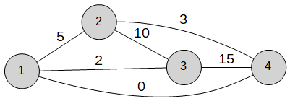Illustration 4: Complete Weighted Graph K
The layout of the graph has been changed so the weights on the labels are easier to read but the graph itself hasn't changed – the vertices and edges are exactly the same.
A matching is defined as a set of edges without common vertices.[MAT00] Using the previous graph, let's define a matching M as the set containing the edge between 1 and 2, (M = {{1,2}}). The diagram below shows M in red.
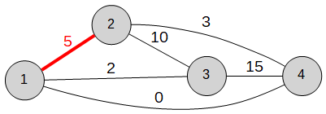Illustration 5: Matching M
If the set of vertices covered by the matching contains all the vertices in the graph, then the matching is considered perfect. Perfect matchings are only possible if the number of vertices is even. The total number of perfect matchings for a complete graph with an even number of vertices equals (n-1)!!.
In a maximum perfect matching, the matching contains the largest number of possible edges and matches all the vertices in the graph.
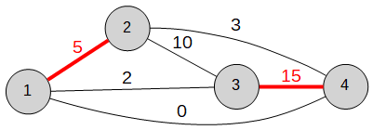Illustration 6: Maximum Perfect Matching
For the weighted graph example, there are 3 maximum perfect matchings: M₁ = {{1,2}, {3,4}}, M₂ = {{1, 4}, {2, 3}}, and M₃ = {{1,3}, {2,4}}.
Illustration 7: Matching M₁
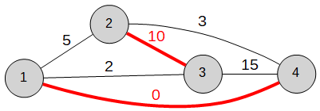Illustration 8: Matching M₂
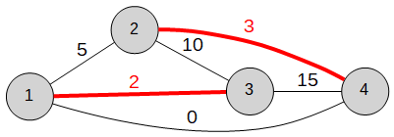Illustration 9: Matching M₃
By summing the weights on the edges in each pairing, the matching becomes a maximum weight perfect patching. The bigger the weight sum, the more desirable the matching.
Matching | Weights | Sum
M₁ = {{1,2}, {4,3}} | 5, 15 | 20
M₂ = {{1, 4}, {2, 3}} | 0, 10 | 10
M₃ = {{1,3}, {2,4}} | 2, 3 | 5
Table 8: Weight Sums
M₃ has the maximum weight sum and would be the most desirable of the three matchings. If two or more matchings have the same summed weights, then they are all equally desirable.
Now let's apply the theory to an actual tournament. In this example, a graph is used to determine the bout pairings for a single elimination tournament.

Example: Single Elimination with 5 Fighters
The Barony of Green Isle runs a single elimination tournament at their fighter practice and 5 fighters enter the list. Byes are non-destructive and will be fought with a bye fighter.
Number | Name | Group
1 | Lady Sabine | Barony of Green Isle
2 | Sir Karl | Barony of Iron Hill
3 | Dona Fiona | Barony of Darkstone
4 | Lord Galen | Barony of Darkstone
5 | Mistress Patrice | Shire of Redgate
6 | Bye
Table 9: Round-Robin List
The first step is created the complete undirected weighted graph from the list.
The only goal for the bout pairings is to prevent duplicate bouts so the edge weights will need take into account whether a bout has been fought before. For this example, the initial edge weights are set to 100. The initial weighted graph is shown in the diagram below.
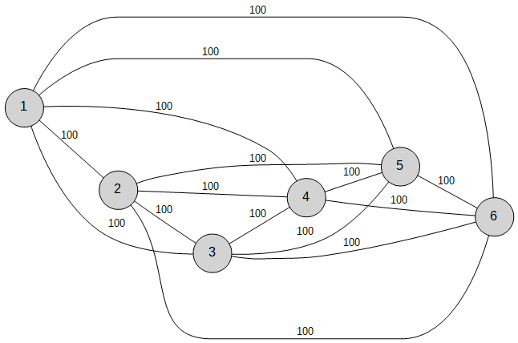Illustration 10: Weighted Graph – Round #1
The numbers on the vertices map back to the list so the graph could be visualized using the names of the fighters.
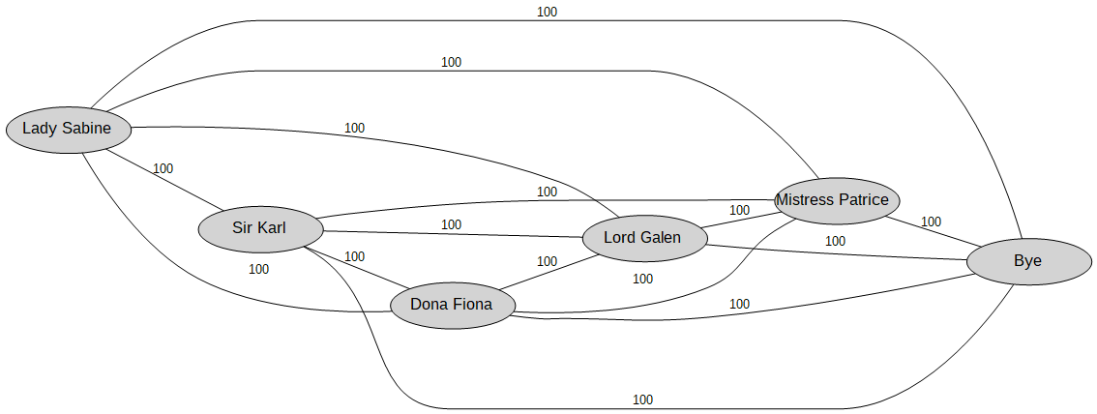Illustration 11: Annotated Weighted Graph – Round #1
Because the graph is small, the matchings can be constructed manually. Since the graph is a complete graph, the total number of matchings is 15.
Matching | Weights | Sum
M₁ = {{1, 2}, {3, 4}, {5, 6}} | 100, 100, 100 | 300
M₂= {{1, 2}, {3, 5}, {4, 6}} | 100, 100, 100 | 300
M₃= {{1, 2}, {3, 6}, {4, 5}} | 100, 100, 100 | 300
M₄= {{1, 3}, {2, 4}, {5, 6}} | 100, 100, 100 | 300
M₅= {{1, 3}, {2, 5}, {4, 6}} | 100, 100, 100 | 300
M₆= {{1, 3}, {2, 6}, {4, 5}} | 100, 100, 100 | 300
M₇= {{1, 4}, {2, 3}, {5, 6}} | 100, 100, 100 | 300
M₈ = {{1, 4}, {2, 5}, {3, 6}} | 100, 100, 100 | 300
M₉ = {{1, 4}, {2, 6}, {3, 5}} | 100, 100, 100 | 300
M₁₀ = {{1, 5}, {2, 3}, {4, 6}} | 100, 100, 100 | 300
M₁₁ = {{1, 5}, {2, 4}, {3, 6}} | 100, 100, 100 | 300
M₁₂ = {{1, 5}, {2, 6}, {3, 4}} | 100, 100, 100 | 300
M₁₃ = {{1, 6}, {2, 3}, {4, 5}} | 100, 100, 100 | 300
M₁₄ = {{1, 6}, {2, 4}, {3, 5}} | 100, 100, 100 | 300
M₁₅ = {{1, 6}, {2, 5}, {3, 4}} | 100, 100, 100 | 300
Table 10: Matchings – Round #1

To construct the bout pairings from the matching, any edge with a weight greater than 0 is a valid bout and the pairing becomes fighters associated with the vertices defining the edge.
All of the matchings have the same weight sum which means they are all equally desirable so the selected matching for Round #1 is M₁ = {{1,2}, {3,4}, {5,6}} so in the first round, Lady Sabine fights Sir Karl (1-2), Dona Fiona fights Lord Galen (3-4), and Mistress Patrice (5-Bye) has the bye. The diagram below illustrates the matching in red on the weighted graph.
Using those bout pairings, the first round is called and fought with the following results.
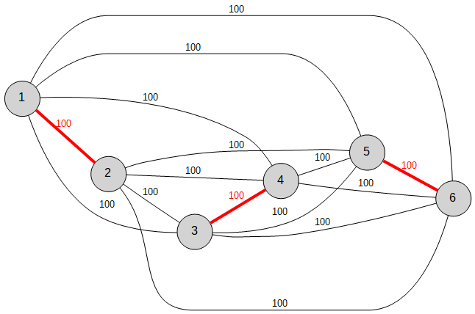Illustration 12: Matching M_{1 –} Round #1
Bout | Results
1-2 | W-L
3-4 | L-W
5-6 | W-L
Table 11: Results – Round #1
At the end of first round, the edge weights on the graph must be updated to reflect the results. Eliminated fighters will set the weight of their associated edges to 0. This weight change will make the weight sum for a matching which includes an eliminated fighter very small and thus prevent it from being selected as the maximum weight sum. For the fighter who had the bye, the weight on the edge to the bye fighter will be reduce by 5. This reduction in the weight makes any matching including this edge less desirable but still a possible maximum weight sum. The diagram below illustrates the graph at the start of round #2.
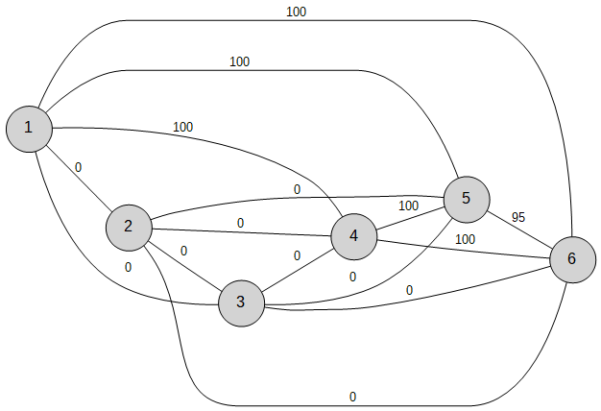Illustration 13: Weighted Graph – Round #2
In order to construct the bout pairings for the second round, the weight sums for the matchings are recomputed using the updated edge weights.
Matching | Weight | Sum
M₁₀ = {{1, 5}, {2, 3}, {4, 6}} | 100, 0, 100 | 200
M₁₃ = {{1, 6}, {2, 3}, {4, 5}} | 100, 0, 100 | 200
M₇= {{1, 4}, {2, 3}, {5, 6}} | 100, 0, 95 | 195
M₂= {{1, 2}, {3, 5}, {4, 6}} | 0, 0, 100 | 100
M₃= {{1, 2}, {3, 6}, {4, 5}} | 0, 0, 100 | 100
M₅= {{1, 3}, {2, 5}, {4, 6}} | 0, 0, 100 | 100
M₆= {{1, 3}, {2, 6}, {4, 5}} | 0, 0, 100 | 100
M₈ = {{1, 4}, {2, 5}, {3, 6}} | 100, 0, 0 | 100
M₉ = {{1, 4}, {2, 6}, {3, 5}} | 100, 0, 0 | 100
M₁₁ = {{1, 5}, {2, 4}, {3, 6}} | 100, 0, 0 | 100
M₁₂ = {{1, 5}, {2, 6}, {3, 4}} | 100, 0, 0 | 100
M₁₄ = {{1, 6}, {2, 4}, {3, 5}} | 100, 0, 0 | 100
M₁₅ = {{1, 6}, {2, 5}, {3, 4}} | 100, 0, 0 | 100
M₁ = {{1, 2}, {3, 4}, {5, 6}} | 0, 0, 95 | 95
M₄= {{1, 3}, {2, 4}, {5, 6}} | 0, 0, 95 | 95
Table 12: Matchings – Round #2
Since M₁₀ and M₁₃ have the same maximum weight sum, either one is a valid matching. Selecting M₁₀ for the matching generates the second round bout pairings – Lady Sabine fights Mistress Patrice (1-5) and Lord Galen has the bye.
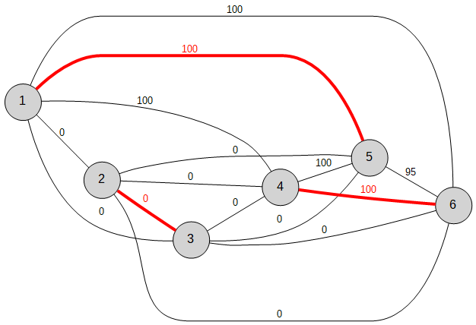Illustration 14: Matching M₁₀ – Round #2

Bout | Results
1-5 | L-W
4-Bye | W-L
Table 13: Results – Round #2
Using the results of Round #2, the edge weights are again updated.
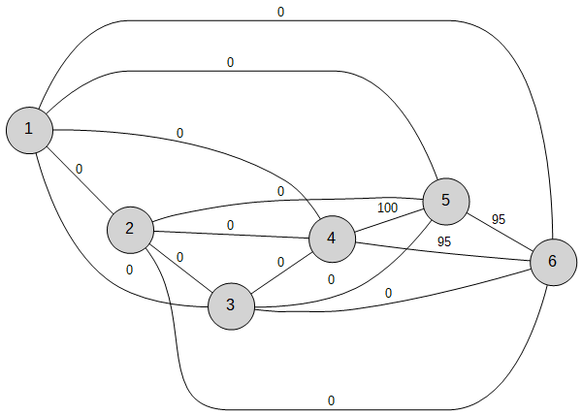Illustration 15: Weighted Graph – Round #3
Updating the existing weight sums for the existing matchings yields three maximum weight perfect matchings. However, all three matchings generate the same bout pairing.
Matching | Weight | Sum
M₁₃ = {{1, 6}, {2, 3}, {4, 5}} | 0, 0, 100 | 100
M₃= {{1, 2}, {3, 6}, {4, 5}} | 0, 0, 100 | 100
M₆= {{1, 3}, {2, 6}, {4, 5}} | 0, 0, 100 | 100
M₁₀ = {{1, 5}, {2, 3}, {4, 6}} | 0, 0, 95 | 95
M₇= {{1, 4}, {2, 3}, {5, 6}} | 0, 0, 95 | 95
M₂= {{1, 2}, {3, 5}, {4, 6}} | 0, 0, 95 | 95
M₅= {{1, 3}, {2, 5}, {4, 6}} | 0, 0, 95 | 95
M₁ = {{1, 2}, {3, 4}, {5, 6}} | 0, 0, 95 | 95
M₄= {{1, 3}, {2, 4}, {5, 6}} | 0, 0, 95 | 95
M₈ = {{1, 4}, {2, 5}, {3, 6}} | 0, 0, 0 | 0
M₉ = {{1, 4}, {2, 6}, {3, 5}} | 0, 0, 0 | 0
M₁₁ = {{1, 5}, {2, 4}, {3, 6}} | 0, 0, 0 | 0
M₁₂ = {{1, 5}, {2, 6}, {3, 4}} | 0, 0, 0 | 0
M₁₄ = {{1, 6}, {2, 4}, {3, 5}} | 0, 0, 0 | 0
M₁₅ = {{1, 6}, {2, 5}, {3, 4}} | 0, 0, 0 | 0
Table 14: Matchings – Round #3

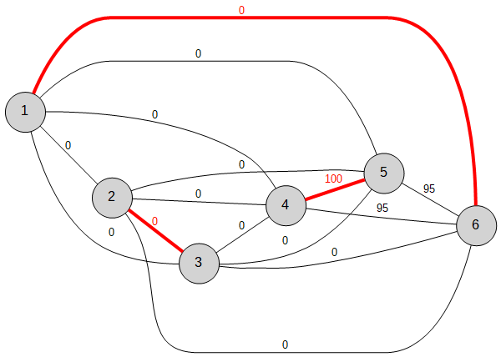Illustration 16: Matching M_{13 –} Round #3
Using M₁₃ to generate the bout pairings yields only one bout: Lord Galen (4) fights Mistress Patrice (5) in the 3rd and final round of the tournament.

Bout | Results
4-5 | W-L
Table 15: Results – Round #3

Lord Galen (4) defeats Mistress Patrice (5) in the final round and is declared the winner. In looking over the bout pairings, the selected matchings were a valid solution to the bout pairing problem because there were no duplicate bouts.

The use of maximum weight perfect matchings to determine bout pairings is not without its share of problems. First, the number of matchings increases dramatically with each new vertex. In the single elimination tournament example, the graph had 6 vertices, 15 edges, and 15 matchings. If the tournament had been run with 8 fighters, the graph would have had 8 vertices, 28 edges, and 105 matchings. The diagram below illustrates the complete weighted graph for a tournament with 8 fighters.
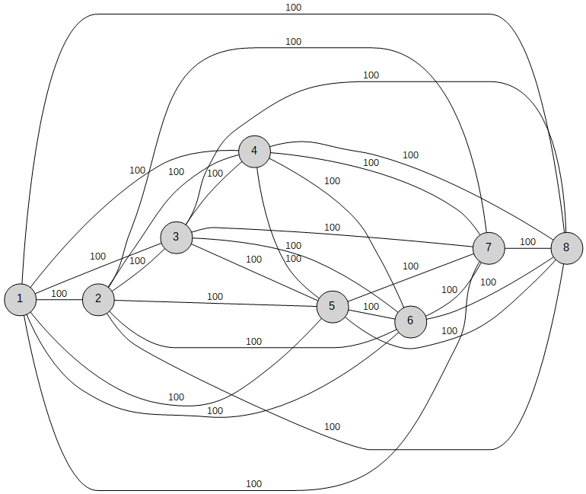Illustration 17: Complete Weight Graph (8 Fighters)
The construction of the matchings and computation of the weight sums manually are extremely difficult tasks. Fortunately, the matchings can be computed in advanced and stored as a set of tables much like the bout pairings for round-robin tournaments. However, the computation of the weight sums at the end of each round would still have to be done manually. The table below illustrates how quickly the number of matchings grows as the number of fighters entering the tournament increases.
Number of Fighters | Total Matchings
4 | 3
6 | 15
8 | 105
10 | 945
12 | 10395
14 | 135135
Table 16: Total Matchings

Second, the generation of the initial edge weights and how they are updated between rounds is also a difficult problem to solve manually. The single elimination example was satisfying only one pairing goal –monagony. The addition of other goals would have required carefully balancing the weight update rules to prevent undesirable matchings from being chosen based on the weight sums. While these rules could be designed and balanced prior to the tournament, using them to update a large graph manually would difficult and error-prone.

Third, when selecting a matching in the single elimination example, the assumption was made that any combination of the most desirable matchings would result in a valid solution. Since the only pairing goal was monagony for a single elimination tournament, the assumption was probably valid. Probably. To verify that assumption, one would have to exhaustively test all the possible solutions to determine if they were all valid – essentially running through every possible way the tournament could turned out.
Most modern tournament scheduling software will enumerate through the possible solutions and discard invalid solutions. A by-product of solution enumeration is calculation of the overall desirability for each solution. Not all solutions will maximize (or even satisfy) the pairing goals for the tournament so picking the most desirable matching at each round requires looking ahead to see how the selection affects overall solution.

Tournament Formats

Round-Robin

Method #1: Manual Generation using Rotation System
Round-robin bout pairings can be generated through a simple rotation algorithm. The fighters are numbered and ordered into a two-row table. The bout pairings are then generated by vertically pairing the fighters. To compute the next round, all the fighters are rotated one slot counterclockwise except for the first slot. That slot is the pivot and the fighter in that slot never shifts.[MAT01] This is essentially the pen & paper version of a Line Tournament.[TRN04]
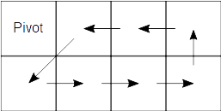Illustration 18: Round-Robin Rotation
Let's examine a round-robin tournament with 8 fighters. The fighters are inserted into the table in a clockwise order and fighter #1 is designated as the pivot.
1 (Pivot) | 2 | 3 | 4
8 | 7 | 6 | 5
Table 17: Round-Robin Rotation Table, n = 8 fighters, Round #1

Vertically pairing the fighters in each column generates the bout pairings for the first round.
Round #1: 1-8, 2-7, 3-6, 4-5
Using the first cell in the table as the pivot point, the algorithm rotates the remaining fighters in the table. In this example, the fighters are rotated counter-clockwise and yields the pairing table for the second round.
1 (Pivot) | 3 | 4 | 5
2 | 8 | 7 | 6
Table 18: Round-Robin Rotation Table, n = 8 fighters, Round #2

The fighters are again vertically paired in each column to generate the bout pairings for the second round.

Round #2: 1-2, 3-8, 4-7, 5-6

The algorithm continues until the table returns to the initial layout.

1 (Pivot) | 4 | 5 | 6
3 | 2 | 8 | 7
Table 19: Round-Robin Rotation Table, n = 8 fighters, Round #3

1 (Pivot) | 5 | 6 | 7
4 | 3 | 2 | 8
Table 20: Round-Robin Rotation Table, n = 8 fighters, Round #4

1 (Pivot) | 6 | 7 | 8
5 | 4 | 3 | 2
Table 21: Round-Robin Rotation Table, n = 8 fighters, Round #5

1 (Pivot) | 7 | 8 | 2
6 | 5 | 4 | 3
Table 22: Round-Robin Rotation Table, n = 8 fighters, Round #6

1 (Pivot) | 8 | 2 | 3
7 | 6 | 5 | 4
Table 23: Round-Robin Rotation Table, n = 8 fighters, Round #7

Combining all the rounds into a single table yields the bout pairings for a round-robin tournament with 8 fighters.
Round | Bouts
#1 | 1-8, 2-7, 3-6, 4-5
#2 | 1-2, 3-8, 4-7, 5-6
#3 | 1-3, 4-2, 5-8, 6-7
#4 | 1-4, 5-3, 6-2, 7-8
#5 | 1-5, 6-4, 7-3, 8-2
#6 | 1-6, 7-5, 8-4, 2-3
#7 | 1-7, 8-6, 2-5, 3-4
Table 24: Round-Robin Bout Pairings, n=8 fighters

In the case of an odd number of fighters, a bye fighter is inserted into the rotation table and the rotation algorithm is run just like the even number case.

1 (Pivot) | 2 | 3 | 4 | 5
Bye | 9 | 8 | 7 | 6
Table 25: Round-Robin Rotation Table, n = 9 fighters, Round 1

This generates the first round bout pairings and Fighter #1 has the bye.

Round #1: 1-Bye, 2-9, 3-8, 4-7, 5-6

Round | Bouts
#1 | 1-Bye, 2-9, 3-8, 4-7, 5-6
#2 | 1-2, 3-Bye, 4-9, 5-8, 6-7
#3 | 1-3, 4-2, 5-Bye, 6-9, 7-8
#4 | 1-4, 5-3, 6-2, 7-Bye, 8-9
#5 | 1-5, 6-4, 7-3, 8-2, 9-Bye
#6 | 1-6, 7-5, 8-4, 9-3, 2-Bye
#7 | 1-7, 8-6, 9-5, 4-Bye, 2-3
#8 | 1-8, 9-7, 6-Bye, 2-5, 3-4
#9 | 1-9, 8-Bye, 2-7, 3-6, 4-5
Table 26: Round-Robin Bout Pairings, n=9 fighters

Method #2: Use Precomputed Bout Tables
Since the round-robin bout pairings are only dependent on the number of fighters entering the tournament, the bout pairings can easily be computed. Appendix A contains the precomputed round-robin bout pairings for tournaments ranging from 4 to 50 fighters. For tournaments with more than 50 fighters, use Method #1 to generate a new table.

Method #3: Run the Tournament as Line Tournament
If the field is large enough and enough field marshals are available, the tournament can be run as a Line Tournament.[TRN04] The bout pairings for each round by actually moving the fighters from each field using the shifting method described in Method #1.

Method #4: Run the Tournament as a Challenge Tournament
Instead of scheduling rounds and bouts, the fighters schedule their own bouts via challenges with the results reported to the MoL.[TRN04]

Swiss-System

Method #1: Use the Round-Robin Precomputed Bout Tables
Since the Swiss-System tournaments are simply truncated round-robin tournaments, they can be scheduled using the Round-Robin tables from the previous section. Just use the first m rows to schedules the bouts for a Swiss-m Tournament. For example, a Swiss-5 tournament with 8 fighters would use the first 5 rows of the precomputed Round-Robin bout table for 8 fighters.

Round | Bouts
#1 | 1-8, 2-7, 3-6, 4-5
#2 | 1-2, 3-8, 4-7, 5-6
#3 | 1-3, 4-2, 5-8, 6-7
#4 | 1-4, 5-3, 6-2, 7-8
#5 | 1-5, 6-4, 7-3, 8-2
Table 27: Swiss-5 Bout Pairings from Truncated Round-Robin

Method #2: Use Adjacent Pairing
In this method, the MoL uses the Random Pairing method for the first round and then the Adjacent Pairing method for the remaining rounds. Since the Adjacent Pairing method requires seeding, the current score is used a rating for the Adjacent Pairing method. Unlike the truncated Round-Robin tables, this method is not deterministic since it relies on the bout outcomes to determine the ratings used in the Adjacent Pairing rounds. This method also decreases the likelihood of ties since Adjacent Pairing will always pair the best performing fighters against each other as the tournament progresses.
Number | Name | Group
1 | Don Quinn | Barony of Green Isle
2 | The Honorable Lady Christina | Barony of Iron Hill
3 | Dona Fiona | Barony of Darkstone
4 | Niccolo | College of Castle Keype
5 | Laurent | College of Castle Keype
6 | Mistress Patrice | Shire of Redgate
7 | Mistress Yasmina | Shire of Redgate
8 | Dona Veronica | Barony of Haversport
9 | Lord Magnus | Barony of Iron Hill
10 | Sir Wilhelm | Barony of Haversport
Table 28: Swiss-5 Tournament List – Adjacent Pairing Example

The MoL uses the Random Pairing method for the first round to construct the bout pairings.
Bout | Results
2-3 | L-W
5-8 | L-W
1-9 | W-L
4-7 | W-L
6-10 | L-W
Table 29: Bout Pairings & Results – Round #1
For the second round, the MoL switches to the Adjacent Pairing method using the current score for each fighter as their rating.
Number | Score
1 | 1
2 | 0
3 | 1
4 | 1
5 | 0
6 | 0
7 | 0
8 | 1
9 | 0
10 | 1
Table 30: Swiss-5 Scores - Round #1
Sorting the list by score yields the following stack and corresponding adjacent pairings:

Stack: 1, 3, 4, 8, 10, 2, 5, 6, 7, 9
Round #2: 1-3, 4-8, 2-10, 5-6, 7-9

The bouts are also checked at this point of duplicates since there is the potential for a duplicate bout based on score.

Bout | Results
1-3 | W-L
4-8 | W-L
2-10 | L-W
5-6 | W-L
7-9 | L-W
Table 31: Bout Pairings & Results - Round #2

Number | Score
1 | 2
2 | 0
3 | 1
4 | 2
5 | 1
6 | 0
7 | 0
8 | 1
9 | 1
10 | 2
Table 32: Swiss-5 Scores - Round #2
Stack: 1, 4, 10, 3, 5, 8, 9, 2, 6, 7
Round #3: 1-4, 3-10, 5-8, 2-9, 6-7

Since 5 and 8 were paired in Round #1, the MoL swaps some fighters to avoid a duplicate bout.

Round #3: 1-4, 3-10, 2-5, 8-9, 6-7

Bout | Results
1-4 | W-L
3-10 | W-L
2-5 | W-L
8-9 | L-W
6-7 | L-W
Table 33: Bout Pairings & Results - Round #3

Number | Score
1 | 3
2 | 1
3 | 2
4 | 2
5 | 1
6 | 0
7 | 1
8 | 1
9 | 2
10 | 2
Table 34: Swiss-5 Scores - Round #3
Stack: 1, 3, 4, 9, 10, 2, 5, 7, 8, 6
Round #4: 1-2, 3-4, 9-10, 5-7, 6-8

Bout | Results
1-2 | W-L
3-4 | L-W
9-10 | W-L
5-7 | L-W
6-8 | L-W
Table 35: Bout Pairings & Results - Round #4

Number | Score
1 | 4
2 | 1
3 | 2
4 | 3
5 | 1
6 | 0
7 | 2
8 | 2
9 | 3
10 | 2
Table 36: Swiss-5 Scores - Round #4

Stack: 1, 4, 9, 3, 7, 8, 10, 2, 5, 6
Bouts: 1-4, 3-9, 7-8, 2-10, 5-6

Round #5: 1-7, 4-9, 3-8, 5-10, 2-6

Bout | Results
1-7 | W-L
4-9 | W-L
3-8 | W-L
5-10 | W-L
2-6 | W-L
Table 37: Bout Pairings & Results - Round #5

Number | Score
1 | 5
2 | 2
3 | 3
4 | 4
5 | 2
6 | 0
7 | 2
8 | 2
9 | 3
10 | 2
Table 38: Swiss-5 Scores - Round #5

Elimination Tournaments
<To Do>

Single Elimination
<To Do>

Double Elimination
<To Do>

Triple Elimination
<To Do>

Timed Tournaments
<To Do>

Multistage Tournaments
<To Do>

Appendix A

This appendix contains the precomputed bout pairings for round-robin tournaments. If the number of fighters in the tournament is odd, use the table for the next largest tournament and replace the last fighter with a bye. For example, if the number of fighters in the tournament was 3, the MoL would select the pairing table for the 4 fighter round robin and replace the #4 fighter with a bye.
Here's the original table for a round robin tournament with 4 fighters.

Round | Bouts
#1 | 1-4, 2-3
#2 | 1-2, 3-4
#3 | 1-3, 4-2
Table 39: Round-Robin Bout Pairings, n=4 fighters

Here's the modified table for a round robin tournament with 3 fighters.

Round | Bouts
#1 | 1-B, 2-3
#2 | 1-2, 3-B
#3 | 1-3, B-2
Table 40: Round-Robin Bout Pairings, n=3 fighters

Precomputed Tables

Round | Bouts
#1 | 1-4, 2-3
#2 | 1-2, 3-4
#3 | 1-3, 4-2
Table 41: Round-Robin Bout Pairings, n=3/4 fighters

Round | Bouts
#1 | 1-6, 2-5, 3-4
#2 | 1-2, 3-6, 4-5
#3 | 1-3, 4-2, 5-6
#4 | 1-4, 5-3, 6-2
#5 | 1-5, 6-4, 2-3
Table 42: Round-Robin Bout Pairings, n=5/6 fighters

Round | Bouts
#1 | 1-8, 2-7, 3-6, 4-5
#2 | 1-2, 3-8, 4-7, 5-6
#3 | 1-3, 4-2, 5-8, 6-7
#4 | 1-4, 5-3, 6-2, 7-8
#5 | 1-5, 6-4, 7-3, 8-2
#6 | 1-6, 7-5, 8-4, 2-3
#7 | 1-7, 8-6, 2-5, 3-4
Table 43: Round-Robin Bout Pairings, n=7/8 fighters

Round | Bouts
#1 | 1-10, 2-9, 3-8, 4-7, 5-6
#2 | 1-2, 3-10, 4-9, 5-8, 6-7
#3 | 1-3, 4-2, 5-10, 6-9, 7-8
#4 | 1-4, 5-3, 6-2, 7-10, 8-9
#5 | 1-5, 6-4, 7-3, 8-2, 9-10
#6 | 1-6, 7-5, 8-4, 9-3, 10-2
#7 | 1-7, 8-6, 9-5, 10-4, 2-3
#8 | 1-8, 9-7, 10-6, 2-5, 3-4
#9 | 1-9, 10-8, 2-7, 3-6, 4-5
Table 44: Round-Robin Bout Pairings, n=9/10 fighters

Round | Bouts
#1 | 1-12, 2-11, 3-10, 4-9, 5-8, 6-7
#2 | 1-2, 3-12, 4-11, 5-10, 6-9, 7-8
#3 | 1-3, 4-2, 5-12, 6-11, 7-10, 8-9
#4 | 1-4, 5-3, 6-2, 7-12, 8-11, 9-10
#5 | 1-5, 6-4, 7-3, 8-2, 9-12, 10-11
#6 | 1-6, 7-5, 8-4, 9-3, 10-2, 11-12
#7 | 1-7, 8-6, 9-5, 10-4, 11-3, 12-2
#8 | 1-8, 9-7, 10-6, 11-5, 12-4, 2-3
#9 | 1-9, 10-8, 11-7, 12-6, 2-5, 3-4
#10 | 1-10, 11-9, 12-8, 2-7, 3-6, 4-5
#11 | 1-11, 12-10, 2-9, 3-8, 4-7, 5-6
Table 45: Round-Robin Bout Pairings, n=11/12 fighters

Round | Bouts
#1 | 1-14, 2-13, 3-12, 4-11, 5-10, 6-9, 7-8
#2 | 1-2, 3-14, 4-13, 5-12, 6-11, 7-10, 8-9
#3 | 1-3, 4-2, 5-14, 6-13, 7-12, 8-11, 9-10
#4 | 1-4, 5-3, 6-2, 7-14, 8-13, 9-12, 10-11
#5 | 1-5, 6-4, 7-3, 8-2, 9-14, 10-13, 11-12
#6 | 1-6, 7-5, 8-4, 9-3, 10-2, 11-14, 12-13
#7 | 1-7, 8-6, 9-5, 10-4, 11-3, 12-2, 13-14
#8 | 1-8, 9-7, 10-6, 11-5, 12-4, 13-3, 14-2
#9 | 1-9, 10-8, 11-7, 12-6, 13-5, 14-4, 2-3
#10 | 1-10, 11-9, 12-8, 13-7, 14-6, 2-5, 3-4
#11 | 1-11, 12-10, 13-9, 14-8, 2-7, 3-6, 4-5
#12 | 1-12, 13-11, 14-10, 2-9, 3-8, 4-7, 5-6
#13 | 1-13, 14-12, 2-11, 3-10, 4-9, 5-8, 6-7
Table 46: Round-Robin Bout Pairings, n=13/14 fighters

Round | Bouts
#1 | 1-16, 2-15, 3-14, 4-13, 5-12, 6-11, 7-10, 8-9
#2 | 1-2, 3-16, 4-15, 5-14, 6-13, 7-12, 8-11, 9-10
#3 | 1-3, 4-2, 5-16, 6-15, 7-14, 8-13, 9-12, 10-11
#4 | 1-4, 5-3, 6-2, 7-16, 8-15, 9-14, 10-13, 11-12
#5 | 1-5, 6-4, 7-3, 8-2, 9-16, 10-15, 11-14, 12-13
#6 | 1-6, 7-5, 8-4, 9-3, 10-2, 11-16, 12-15, 13-14
#7 | 1-7, 8-6, 9-5, 10-4, 11-3, 12-2, 13-16, 14-15
#8 | 1-8, 9-7, 10-6, 11-5, 12-4, 13-3, 14-2, 15-16
#9 | 1-9, 10-8, 11-7, 12-6, 13-5, 14-4, 15-3, 16-2
#10 | 1-10, 11-9, 12-8, 13-7, 14-6, 15-5, 16-4, 2-3
#11 | 1-11, 12-10, 13-9, 14-8, 15-7, 16-6, 2-5, 3-4
#12 | 1-12, 13-11, 14-10, 15-9, 16-8, 2-7, 3-6, 4-5
#13 | 1-13, 14-12, 15-11, 16-10, 2-9, 3-8, 4-7, 5-6
#14 | 1-14, 15-13, 16-12, 2-11, 3-10, 4-9, 5-8, 6-7
#15 | 1-15, 16-14, 2-13, 3-12, 4-11, 5-10, 6-9, 7-8
Table 47: Round-Robin Bout Pairings, n=15/16 fighters

Round | Bouts
#1 | 1-18, 2-17, 3-16, 4-15, 5-14, 6-13, 7-12, 8-11, 9-10
#2 | 1-2, 3-18, 4-17, 5-16, 6-15, 7-14, 8-13, 9-12, 10-11
#3 | 1-3, 4-2, 5-18, 6-17, 7-16, 8-15, 9-14, 10-13, 11-12
#4 | 1-4, 5-3, 6-2, 7-18, 8-17, 9-16, 10-15, 11-14, 12-13
#5 | 1-5, 6-4, 7-3, 8-2, 9-18, 10-17, 11-16, 12-15, 13-14
#6 | 1-6, 7-5, 8-4, 9-3, 10-2, 11-18, 12-17, 13-16, 14-15
#7 | 1-7, 8-6, 9-5, 10-4, 11-3, 12-2, 13-18, 14-17, 15-16
#8 | 1-8, 9-7, 10-6, 11-5, 12-4, 13-3, 14-2, 15-18, 16-17
#9 | 1-9, 10-8, 11-7, 12-6, 13-5, 14-4, 15-3, 16-2, 17-18
#10 | 1-10, 11-9, 12-8, 13-7, 14-6, 15-5, 16-4, 17-3, 18-2
#11 | 1-11, 12-10, 13-9, 14-8, 15-7, 16-6, 17-5, 18-4, 2-3
#12 | 1-12, 13-11, 14-10, 15-9, 16-8, 17-7, 18-6, 2-5, 3-4
#13 | 1-13, 14-12, 15-11, 16-10, 17-9, 18-8, 2-7, 3-6, 4-5
#14 | 1-14, 15-13, 16-12, 17-11, 18-10, 2-9, 3-8, 4-7, 5-6
#15 | 1-15, 16-14, 17-13, 18-12, 2-11, 3-10, 4-9, 5-8, 6-7
#16 | 1-16, 17-15, 18-14, 2-13, 3-12, 4-11, 5-10, 6-9, 7-8
#17 | 1-17, 18-16, 2-15, 3-14, 4-13, 5-12, 6-11, 7-10, 8-9
Table 48: Round-Robin Bout Pairings, n=17/18 fighters

Round | Bouts
#1 | 1-20, 2-19, 3-18, 4-17, 5-16, 6-15, 7-14, 8-13, 9-12, 10-11
#2 | 1-2, 3-20, 4-19, 5-18, 6-17, 7-16, 8-15, 9-14, 10-13, 11-12
#3 | 1-3, 4-2, 5-20, 6-19, 7-18, 8-17, 9-16, 10-15, 11-14, 12-13
#4 | 1-4, 5-3, 6-2, 7-20, 8-19, 9-18, 10-17, 11-16, 12-15, 13-14
#5 | 1-5, 6-4, 7-3, 8-2, 9-20, 10-19, 11-18, 12-17, 13-16, 14-15
#6 | 1-6, 7-5, 8-4, 9-3, 10-2, 11-20, 12-19, 13-18, 14-17, 15-16
#7 | 1-7, 8-6, 9-5, 10-4, 11-3, 12-2, 13-20, 14-19, 15-18, 16-17
#8 | 1-8, 9-7, 10-6, 11-5, 12-4, 13-3, 14-2, 15-20, 16-19, 17-18
#9 | 1-9, 10-8, 11-7, 12-6, 13-5, 14-4, 15-3, 16-2, 17-20, 18-19
#10 | 1-10, 11-9, 12-8, 13-7, 14-6, 15-5, 16-4, 17-3, 18-2, 19-20
#11 | 1-11, 12-10, 13-9, 14-8, 15-7, 16-6, 17-5, 18-4, 19-3, 20-2
#12 | 1-12, 13-11, 14-10, 15-9, 16-8, 17-7, 18-6, 19-5, 20-4, 2-3
#13 | 1-13, 14-12, 15-11, 16-10, 17-9, 18-8, 19-7, 20-6, 2-5, 3-4
#14 | 1-14, 15-13, 16-12, 17-11, 18-10, 19-9, 20-8, 2-7, 3-6, 4-5
#15 | 1-15, 16-14, 17-13, 18-12, 19-11, 20-10, 2-9, 3-8, 4-7, 5-6
#16 | 1-16, 17-15, 18-14, 19-13, 20-12, 2-11, 3-10, 4-9, 5-8, 6-7
#17 | 1-17, 18-16, 19-15, 20-14, 2-13, 3-12, 4-11, 5-10, 6-9, 7-8
#18 | 1-18, 19-17, 20-16, 2-15, 3-14, 4-13, 5-12, 6-11, 7-10, 8-9
#19 | 1-19, 20-18, 2-17, 3-16, 4-15, 5-14, 6-13, 7-12, 8-11, 9-10
Table 49: Round-Robin Bout Pairings, n=19/20 fighters
Round | Bouts
#1 | 1-22, 2-21, 3-20, 4-19, 5-18, 6-17, 7-16, 8-15, 9-14, 10-13, 11-12
#2 | 1-2, 3-22, 4-21, 5-20, 6-19, 7-18, 8-17, 9-16, 10-15, 11-14, 12-13
#3 | 1-3, 4-2, 5-22, 6-21, 7-20, 8-19, 9-18, 10-17, 11-16, 12-15, 13-14
#4 | 1-4, 5-3, 6-2, 7-22, 8-21, 9-20, 10-19, 11-18, 12-17, 13-16, 14-15
#5 | 1-5, 6-4, 7-3, 8-2, 9-22, 10-21, 11-20, 12-19, 13-18, 14-17, 15-16
#6 | 1-6, 7-5, 8-4, 9-3, 10-2, 11-22, 12-21, 13-20, 14-19, 15-18, 16-17
#7 | 1-7, 8-6, 9-5, 10-4, 11-3, 12-2, 13-22, 14-21, 15-20, 16-19, 17-18
#8 | 1-8, 9-7, 10-6, 11-5, 12-4, 13-3, 14-2, 15-22, 16-21, 17-20, 18-19
#9 | 1-9, 10-8, 11-7, 12-6, 13-5, 14-4, 15-3, 16-2, 17-22, 18-21, 19-20
#10 | 1-10, 11-9, 12-8, 13-7, 14-6, 15-5, 16-4, 17-3, 18-2, 19-22, 20-21
#11 | 1-11, 12-10, 13-9, 14-8, 15-7, 16-6, 17-5, 18-4, 19-3, 20-2, 21-22
#12 | 1-12, 13-11, 14-10, 15-9, 16-8, 17-7, 18-6, 19-5, 20-4, 21-3, 22-2
#13 | 1-13, 14-12, 15-11, 16-10, 17-9, 18-8, 19-7, 20-6, 21-5, 22-4, 2-3
#14 | 1-14, 15-13, 16-12, 17-11, 18-10, 19-9, 20-8, 21-7, 22-6, 2-5, 3-4
#15 | 1-15, 16-14, 17-13, 18-12, 19-11, 20-10, 21-9, 22-8, 2-7, 3-6, 4-5
#16 | 1-16, 17-15, 18-14, 19-13, 20-12, 21-11, 22-10, 2-9, 3-8, 4-7, 5-6
#17 | 1-17, 18-16, 19-15, 20-14, 21-13, 22-12, 2-11, 3-10, 4-9, 5-8, 6-7
#18 | 1-18, 19-17, 20-16, 21-15, 22-14, 2-13, 3-12, 4-11, 5-10, 6-9, 7-8
#19 | 1-19, 20-18, 21-17, 22-16, 2-15, 3-14, 4-13, 5-12, 6-11, 7-10, 8-9
#20 | 1-20, 21-19, 22-18, 2-17, 3-16, 4-15, 5-14, 6-13, 7-12, 8-11, 9-10
#21 | 1-21, 22-20, 2-19, 3-18, 4-17, 5-16, 6-15, 7-14, 8-13, 9-12, 10-11
Table 50: Round-Robin Bout Pairings, n=21/22 fighters
Round | Bouts
#1 | 1-24, 2-23, 3-22, 4-21, 5-20, 6-19, 7-18, 8-17, 9-16, 10-15, 11-14, 12-13
#2 | 1-2, 3-24, 4-23, 5-22, 6-21, 7-20, 8-19, 9-18, 10-17, 11-16, 12-15, 13-14
#3 | 1-3, 4-2, 5-24, 6-23, 7-22, 8-21, 9-20, 10-19, 11-18, 12-17, 13-16, 14-15
#4 | 1-4, 5-3, 6-2, 7-24, 8-23, 9-22, 10-21, 11-20, 12-19, 13-18, 14-17, 15-16
#5 | 1-5, 6-4, 7-3, 8-2, 9-24, 10-23, 11-22, 12-21, 13-20, 14-19, 15-18, 16-17
#6 | 1-6, 7-5, 8-4, 9-3, 10-2, 11-24, 12-23, 13-22, 14-21, 15-20, 16-19, 17-18
#7 | 1-7, 8-6, 9-5, 10-4, 11-3, 12-2, 13-24, 14-23, 15-22, 16-21, 17-20, 18-19
#8 | 1-8, 9-7, 10-6, 11-5, 12-4, 13-3, 14-2, 15-24, 16-23, 17-22, 18-21, 19-20
#9 | 1-9, 10-8, 11-7, 12-6, 13-5, 14-4, 15-3, 16-2, 17-24, 18-23, 19-22, 20-21
#10 | 1-10, 11-9, 12-8, 13-7, 14-6, 15-5, 16-4, 17-3, 18-2, 19-24, 20-23, 21-22
#11 | 1-11, 12-10, 13-9, 14-8, 15-7, 16-6, 17-5, 18-4, 19-3, 20-2, 21-24, 22-23
#12 | 1-12, 13-11, 14-10, 15-9, 16-8, 17-7, 18-6, 19-5, 20-4, 21-3, 22-2, 23-24
#13 | 1-13, 14-12, 15-11, 16-10, 17-9, 18-8, 19-7, 20-6, 21-5, 22-4, 23-3, 24-2
#14 | 1-14, 15-13, 16-12, 17-11, 18-10, 19-9, 20-8, 21-7, 22-6, 23-5, 24-4, 2-3
#15 | 1-15, 16-14, 17-13, 18-12, 19-11, 20-10, 21-9, 22-8, 23-7, 24-6, 2-5, 3-4
#16 | 1-16, 17-15, 18-14, 19-13, 20-12, 21-11, 22-10, 23-9, 24-8, 2-7, 3-6, 4-5
#17 | 1-17, 18-16, 19-15, 20-14, 21-13, 22-12, 23-11, 24-10, 2-9, 3-8, 4-7, 5-6
#18 | 1-18, 19-17, 20-16, 21-15, 22-14, 23-13, 24-12, 2-11, 3-10, 4-9, 5-8, 6-7
#19 | 1-19, 20-18, 21-17, 22-16, 23-15, 24-14, 2-13, 3-12, 4-11, 5-10, 6-9, 7-8
#20 | 1-20, 21-19, 22-18, 23-17, 24-16, 2-15, 3-14, 4-13, 5-12, 6-11, 7-10, 8-9
#21 | 1-21, 22-20, 23-19, 24-18, 2-17, 3-16, 4-15, 5-14, 6-13, 7-12, 8-11, 9-10
#22 | 1-22, 23-21, 24-20, 2-19, 3-18, 4-17, 5-16, 6-15, 7-14, 8-13, 9-12, 10-11
#23 | 1-23, 24-22, 2-21, 3-20, 4-19, 5-18, 6-17, 7-16, 8-15, 9-14, 10-13, 11-12
Table 51: Round-Robin Bout Pairings, n=23/24 fighters

Round | Bouts
#1 | 1-26, 2-25, 3-24, 4-23, 5-22, 6-21, 7-20, 8-19, 9-18, 10-17, 11-16, 12-15, 13-14
#2 | 1-2, 3-26, 4-25, 5-24, 6-23, 7-22, 8-21, 9-20, 10-19, 11-18, 12-17, 13-16, 14-15
#3 | 1-3, 4-2, 5-26, 6-25, 7-24, 8-23, 9-22, 10-21, 11-20, 12-19, 13-18, 14-17, 15-16
#4 | 1-4, 5-3, 6-2, 7-26, 8-25, 9-24, 10-23, 11-22, 12-21, 13-20, 14-19, 15-18, 16-17
#5 | 1-5, 6-4, 7-3, 8-2, 9-26, 10-25, 11-24, 12-23, 13-22, 14-21, 15-20, 16-19, 17-18
#6 | 1-6, 7-5, 8-4, 9-3, 10-2, 11-26, 12-25, 13-24, 14-23, 15-22, 16-21, 17-20, 18-19
#7 | 1-7, 8-6, 9-5, 10-4, 11-3, 12-2, 13-26, 14-25, 15-24, 16-23, 17-22, 18-21, 19-20
#8 | 1-8, 9-7, 10-6, 11-5, 12-4, 13-3, 14-2, 15-26, 16-25, 17-24, 18-23, 19-22, 20-21
#9 | 1-9, 10-8, 11-7, 12-6, 13-5, 14-4, 15-3, 16-2, 17-26, 18-25, 19-24, 20-23, 21-22
#10 | 1-10, 11-9, 12-8, 13-7, 14-6, 15-5, 16-4, 17-3, 18-2, 19-26, 20-25, 21-24, 22-23
#11 | 1-11, 12-10, 13-9, 14-8, 15-7, 16-6, 17-5, 18-4, 19-3, 20-2, 21-26, 22-25, 23-24
#12 | 1-12, 13-11, 14-10, 15-9, 16-8, 17-7, 18-6, 19-5, 20-4, 21-3, 22-2, 23-26, 24-25
#13 | 1-13, 14-12, 15-11, 16-10, 17-9, 18-8, 19-7, 20-6, 21-5, 22-4, 23-3, 24-2, 25-26
#14 | 1-14, 15-13, 16-12, 17-11, 18-10, 19-9, 20-8, 21-7, 22-6, 23-5, 24-4, 25-3, 26-2
#15 | 1-15, 16-14, 17-13, 18-12, 19-11, 20-10, 21-9, 22-8, 23-7, 24-6, 25-5, 26-4, 2-3
#16 | 1-16, 17-15, 18-14, 19-13, 20-12, 21-11, 22-10, 23-9, 24-8, 25-7, 26-6, 2-5, 3-4
#17 | 1-17, 18-16, 19-15, 20-14, 21-13, 22-12, 23-11, 24-10, 25-9, 26-8, 2-7, 3-6, 4-5
#18 | 1-18, 19-17, 20-16, 21-15, 22-14, 23-13, 24-12, 25-11, 26-10, 2-9, 3-8, 4-7, 5-6
#19 | 1-19, 20-18, 21-17, 22-16, 23-15, 24-14, 25-13, 26-12, 2-11, 3-10, 4-9, 5-8, 6-7
#20 | 1-20, 21-19, 22-18, 23-17, 24-16, 25-15, 26-14, 2-13, 3-12, 4-11, 5-10, 6-9, 7-8
#21 | 1-21, 22-20, 23-19, 24-18, 25-17, 26-16, 2-15, 3-14, 4-13, 5-12, 6-11, 7-10, 8-9
#22 | 1-22, 23-21, 24-20, 25-19, 26-18, 2-17, 3-16, 4-15, 5-14, 6-13, 7-12, 8-11, 9-10
#23 | 1-23, 24-22, 25-21, 26-20, 2-19, 3-18, 4-17, 5-16, 6-15, 7-14, 8-13, 9-12, 10-11
#24 | 1-24, 25-23, 26-22, 2-21, 3-20, 4-19, 5-18, 6-17, 7-16, 8-15, 9-14, 10-13, 11-12
#25 | 1-25, 26-24, 2-23, 3-22, 4-21, 5-20, 6-19, 7-18, 8-17, 9-16, 10-15, 11-14, 12-13
Table 52: Round-Robin Bout Pairings, n=25/26 fighters

Round | Bouts
#1 | 1-28, 2-27, 3-26, 4-25, 5-24, 6-23, 7-22, 8-21, 9-20, 10-19, 11-18, 12-17, 13-16, 14-15
#2 | 1-2, 3-28, 4-27, 5-26, 6-25, 7-24, 8-23, 9-22, 10-21, 11-20, 12-19, 13-18, 14-17, 15-16
#3 | 1-3, 4-2, 5-28, 6-27, 7-26, 8-25, 9-24, 10-23, 11-22, 12-21, 13-20, 14-19, 15-18, 16-17
#4 | 1-4, 5-3, 6-2, 7-28, 8-27, 9-26, 10-25, 11-24, 12-23, 13-22, 14-21, 15-20, 16-19, 17-18
#5 | 1-5, 6-4, 7-3, 8-2, 9-28, 10-27, 11-26, 12-25, 13-24, 14-23, 15-22, 16-21, 17-20, 18-19
#6 | 1-6, 7-5, 8-4, 9-3, 10-2, 11-28, 12-27, 13-26, 14-25, 15-24, 16-23, 17-22, 18-21, 19-20
#7 | 1-7, 8-6, 9-5, 10-4, 11-3, 12-2, 13-28, 14-27, 15-26, 16-25, 17-24, 18-23, 19-22, 20-21
#8 | 1-8, 9-7, 10-6, 11-5, 12-4, 13-3, 14-2, 15-28, 16-27, 17-26, 18-25, 19-24, 20-23, 21-22
#9 | 1-9, 10-8, 11-7, 12-6, 13-5, 14-4, 15-3, 16-2, 17-28, 18-27, 19-26, 20-25, 21-24, 22-23
#10 | 1-10, 11-9, 12-8, 13-7, 14-6, 15-5, 16-4, 17-3, 18-2, 19-28, 20-27, 21-26, 22-25, 23-24
#11 | 1-11, 12-10, 13-9, 14-8, 15-7, 16-6, 17-5, 18-4, 19-3, 20-2, 21-28, 22-27, 23-26, 24-25
#12 | 1-12, 13-11, 14-10, 15-9, 16-8, 17-7, 18-6, 19-5, 20-4, 21-3, 22-2, 23-28, 24-27, 25-26
#13 | 1-13, 14-12, 15-11, 16-10, 17-9, 18-8, 19-7, 20-6, 21-5, 22-4, 23-3, 24-2, 25-28, 26-27
#14 | 1-14, 15-13, 16-12, 17-11, 18-10, 19-9, 20-8, 21-7, 22-6, 23-5, 24-4, 25-3, 26-2, 27-28
#15 | 1-15, 16-14, 17-13, 18-12, 19-11, 20-10, 21-9, 22-8, 23-7, 24-6, 25-5, 26-4, 27-3, 28-2
#16 | 1-16, 17-15, 18-14, 19-13, 20-12, 21-11, 22-10, 23-9, 24-8, 25-7, 26-6, 27-5, 28-4, 2-3
#17 | 1-17, 18-16, 19-15, 20-14, 21-13, 22-12, 23-11, 24-10, 25-9, 26-8, 27-7, 28-6, 2-5, 3-4
#18 | 1-18, 19-17, 20-16, 21-15, 22-14, 23-13, 24-12, 25-11, 26-10, 27-9, 28-8, 2-7, 3-6, 4-5
#19 | 1-19, 20-18, 21-17, 22-16, 23-15, 24-14, 25-13, 26-12, 27-11, 28-10, 2-9, 3-8, 4-7, 5-6
#20 | 1-20, 21-19, 22-18, 23-17, 24-16, 25-15, 26-14, 27-13, 28-12, 2-11, 3-10, 4-9, 5-8, 6-7
#21 | 1-21, 22-20, 23-19, 24-18, 25-17, 26-16, 27-15, 28-14, 2-13, 3-12, 4-11, 5-10, 6-9, 7-8
#22 | 1-22, 23-21, 24-20, 25-19, 26-18, 27-17, 28-16, 2-15, 3-14, 4-13, 5-12, 6-11, 7-10, 8-9
#23 | 1-23, 24-22, 25-21, 26-20, 27-19, 28-18, 2-17, 3-16, 4-15, 5-14, 6-13, 7-12, 8-11, 9-10
#24 | 1-24, 25-23, 26-22, 27-21, 28-20, 2-19, 3-18, 4-17, 5-16, 6-15, 7-14, 8-13, 9-12, 10-11
#25 | 1-25, 26-24, 27-23, 28-22, 2-21, 3-20, 4-19, 5-18, 6-17, 7-16, 8-15, 9-14, 10-13, 11-12
#26 | 1-26, 27-25, 28-24, 2-23, 3-22, 4-21, 5-20, 6-19, 7-18, 8-17, 9-16, 10-15, 11-14, 12-13
#27 | 1-27, 28-26, 2-25, 3-24, 4-23, 5-22, 6-21, 7-20, 8-19, 9-18, 10-17, 11-16, 12-15, 13-14
Table 53: Round-Robin Bout Pairings, n=27/28 fighters
Round | Bouts
#1 | 1-30, 2-29, 3-28, 4-27, 5-26, 6-25, 7-24, 8-23, 9-22, 10-21, 11-20, 12-19, 13-18, 14-17, 15-16
#2 | 1-2, 3-30, 4-29, 5-28, 6-27, 7-26, 8-25, 9-24, 10-23, 11-22, 12-21, 13-20, 14-19, 15-18, 16-17
#3 | 1-3, 4-2, 5-30, 6-29, 7-28, 8-27, 9-26, 10-25, 11-24, 12-23, 13-22, 14-21, 15-20, 16-19, 17-18
#4 | 1-4, 5-3, 6-2, 7-30, 8-29, 9-28, 10-27, 11-26, 12-25, 13-24, 14-23, 15-22, 16-21, 17-20, 18-19
#5 | 1-5, 6-4, 7-3, 8-2, 9-30, 10-29, 11-28, 12-27, 13-26, 14-25, 15-24, 16-23, 17-22, 18-21, 19-20
#6 | 1-6, 7-5, 8-4, 9-3, 10-2, 11-30, 12-29, 13-28, 14-27, 15-26, 16-25, 17-24, 18-23, 19-22, 20-21
#7 | 1-7, 8-6, 9-5, 10-4, 11-3, 12-2, 13-30, 14-29, 15-28, 16-27, 17-26, 18-25, 19-24, 20-23, 21-22
#8 | 1-8, 9-7, 10-6, 11-5, 12-4, 13-3, 14-2, 15-30, 16-29, 17-28, 18-27, 19-26, 20-25, 21-24, 22-23
#9 | 1-9, 10-8, 11-7, 12-6, 13-5, 14-4, 15-3, 16-2, 17-30, 18-29, 19-28, 20-27, 21-26, 22-25, 23-24
#10 | 1-10, 11-9, 12-8, 13-7, 14-6, 15-5, 16-4, 17-3, 18-2, 19-30, 20-29, 21-28, 22-27, 23-26, 24-25
#11 | 1-11, 12-10, 13-9, 14-8, 15-7, 16-6, 17-5, 18-4, 19-3, 20-2, 21-30, 22-29, 23-28, 24-27, 25-26
#12 | 1-12, 13-11, 14-10, 15-9, 16-8, 17-7, 18-6, 19-5, 20-4, 21-3, 22-2, 23-30, 24-29, 25-28, 26-27
#13 | 1-13, 14-12, 15-11, 16-10, 17-9, 18-8, 19-7, 20-6, 21-5, 22-4, 23-3, 24-2, 25-30, 26-29, 27-28
#14 | 1-14, 15-13, 16-12, 17-11, 18-10, 19-9, 20-8, 21-7, 22-6, 23-5, 24-4, 25-3, 26-2, 27-30, 28-29
#15 | 1-15, 16-14, 17-13, 18-12, 19-11, 20-10, 21-9, 22-8, 23-7, 24-6, 25-5, 26-4, 27-3, 28-2, 29-30
#16 | 1-16, 17-15, 18-14, 19-13, 20-12, 21-11, 22-10, 23-9, 24-8, 25-7, 26-6, 27-5, 28-4, 29-3, 30-2
#17 | 1-17, 18-16, 19-15, 20-14, 21-13, 22-12, 23-11, 24-10, 25-9, 26-8, 27-7, 28-6, 29-5, 30-4, 2-3
#18 | 1-18, 19-17, 20-16, 21-15, 22-14, 23-13, 24-12, 25-11, 26-10, 27-9, 28-8, 29-7, 30-6, 2-5, 3-4
#19 | 1-19, 20-18, 21-17, 22-16, 23-15, 24-14, 25-13, 26-12, 27-11, 28-10, 29-9, 30-8, 2-7, 3-6, 4-5
#20 | 1-20, 21-19, 22-18, 23-17, 24-16, 25-15, 26-14, 27-13, 28-12, 29-11, 30-10, 2-9, 3-8, 4-7, 5-6
#21 | 1-21, 22-20, 23-19, 24-18, 25-17, 26-16, 27-15, 28-14, 29-13, 30-12, 2-11, 3-10, 4-9, 5-8, 6-7
#22 | 1-22, 23-21, 24-20, 25-19, 26-18, 27-17, 28-16, 29-15, 30-14, 2-13, 3-12, 4-11, 5-10, 6-9, 7-8
#23 | 1-23, 24-22, 25-21, 26-20, 27-19, 28-18, 29-17, 30-16, 2-15, 3-14, 4-13, 5-12, 6-11, 7-10, 8-9
#24 | 1-24, 25-23, 26-22, 27-21, 28-20, 29-19, 30-18, 2-17, 3-16, 4-15, 5-14, 6-13, 7-12, 8-11, 9-10
#25 | 1-25, 26-24, 27-23, 28-22, 29-21, 30-20, 2-19, 3-18, 4-17, 5-16, 6-15, 7-14, 8-13, 9-12, 10-11
#26 | 1-26, 27-25, 28-24, 29-23, 30-22, 2-21, 3-20, 4-19, 5-18, 6-17, 7-16, 8-15, 9-14, 10-13, 11-12
#27 | 1-27, 28-26, 29-25, 30-24, 2-23, 3-22, 4-21, 5-20, 6-19, 7-18, 8-17, 9-16, 10-15, 11-14, 12-13
#28 | 1-28, 29-27, 30-26, 2-25, 3-24, 4-23, 5-22, 6-21, 7-20, 8-19, 9-18, 10-17, 11-16, 12-15, 13-14
#29 | 1-29, 30-28, 2-27, 3-26, 4-25, 5-24, 6-23, 7-22, 8-21, 9-20, 10-19, 11-18, 12-17, 13-16, 14-15
Table 54: Round-Robin Bout Pairings, n=29/30 fighters
Round | Bouts
#1 | 1-32, 2-31, 3-30, 4-29, 5-28, 6-27, 7-26, 8-25, 9-24, 10-23, 11-22, 12-21, 13-20, 14-19, 15-18, 16-17
#2 | 1-2, 3-32, 4-31, 5-30, 6-29, 7-28, 8-27, 9-26, 10-25, 11-24, 12-23, 13-22, 14-21, 15-20, 16-19, 17-18
#3 | 1-3, 4-2, 5-32, 6-31, 7-30, 8-29, 9-28, 10-27, 11-26, 12-25, 13-24, 14-23, 15-22, 16-21, 17-20, 18-19
#4 | 1-4, 5-3, 6-2, 7-32, 8-31, 9-30, 10-29, 11-28, 12-27, 13-26, 14-25, 15-24, 16-23, 17-22, 18-21, 19-20
#5 | 1-5, 6-4, 7-3, 8-2, 9-32, 10-31, 11-30, 12-29, 13-28, 14-27, 15-26, 16-25, 17-24, 18-23, 19-22, 20-21
#6 | 1-6, 7-5, 8-4, 9-3, 10-2, 11-32, 12-31, 13-30, 14-29, 15-28, 16-27, 17-26, 18-25, 19-24, 20-23, 21-22
#7 | 1-7, 8-6, 9-5, 10-4, 11-3, 12-2, 13-32, 14-31, 15-30, 16-29, 17-28, 18-27, 19-26, 20-25, 21-24, 22-23
#8 | 1-8, 9-7, 10-6, 11-5, 12-4, 13-3, 14-2, 15-32, 16-31, 17-30, 18-29, 19-28, 20-27, 21-26, 22-25, 23-24
#9 | 1-9, 10-8, 11-7, 12-6, 13-5, 14-4, 15-3, 16-2, 17-32, 18-31, 19-30, 20-29, 21-28, 22-27, 23-26, 24-25
#10 | 1-10, 11-9, 12-8, 13-7, 14-6, 15-5, 16-4, 17-3, 18-2, 19-32, 20-31, 21-30, 22-29, 23-28, 24-27, 25-26
#11 | 1-11, 12-10, 13-9, 14-8, 15-7, 16-6, 17-5, 18-4, 19-3, 20-2, 21-32, 22-31, 23-30, 24-29, 25-28, 26-27
#12 | 1-12, 13-11, 14-10, 15-9, 16-8, 17-7, 18-6, 19-5, 20-4, 21-3, 22-2, 23-32, 24-31, 25-30, 26-29, 27-28
#13 | 1-13, 14-12, 15-11, 16-10, 17-9, 18-8, 19-7, 20-6, 21-5, 22-4, 23-3, 24-2, 25-32, 26-31, 27-30, 28-29
#14 | 1-14, 15-13, 16-12, 17-11, 18-10, 19-9, 20-8, 21-7, 22-6, 23-5, 24-4, 25-3, 26-2, 27-32, 28-31, 29-30
#15 | 1-15, 16-14, 17-13, 18-12, 19-11, 20-10, 21-9, 22-8, 23-7, 24-6, 25-5, 26-4, 27-3, 28-2, 29-32, 30-31
#16 | 1-16, 17-15, 18-14, 19-13, 20-12, 21-11, 22-10, 23-9, 24-8, 25-7, 26-6, 27-5, 28-4, 29-3, 30-2, 31-32
#17 | 1-17, 18-16, 19-15, 20-14, 21-13, 22-12, 23-11, 24-10, 25-9, 26-8, 27-7, 28-6, 29-5, 30-4, 31-3, 32-2
#18 | 1-18, 19-17, 20-16, 21-15, 22-14, 23-13, 24-12, 25-11, 26-10, 27-9, 28-8, 29-7, 30-6, 31-5, 32-4, 2-3
#19 | 1-19, 20-18, 21-17, 22-16, 23-15, 24-14, 25-13, 26-12, 27-11, 28-10, 29-9, 30-8, 31-7, 32-6, 2-5, 3-4
#20 | 1-20, 21-19, 22-18, 23-17, 24-16, 25-15, 26-14, 27-13, 28-12, 29-11, 30-10, 31-9, 32-8, 2-7, 3-6, 4-5
#21 | 1-21, 22-20, 23-19, 24-18, 25-17, 26-16, 27-15, 28-14, 29-13, 30-12, 31-11, 32-10, 2-9, 3-8, 4-7, 5-6
#22 | 1-22, 23-21, 24-20, 25-19, 26-18, 27-17, 28-16, 29-15, 30-14, 31-13, 32-12, 2-11, 3-10, 4-9, 5-8, 6-7
#23 | 1-23, 24-22, 25-21, 26-20, 27-19, 28-18, 29-17, 30-16, 31-15, 32-14, 2-13, 3-12, 4-11, 5-10, 6-9, 7-8
#24 | 1-24, 25-23, 26-22, 27-21, 28-20, 29-19, 30-18, 31-17, 32-16, 2-15, 3-14, 4-13, 5-12, 6-11, 7-10, 8-9
#25 | 1-25, 26-24, 27-23, 28-22, 29-21, 30-20, 31-19, 32-18, 2-17, 3-16, 4-15, 5-14, 6-13, 7-12, 8-11, 9-10
#26 | 1-26, 27-25, 28-24, 29-23, 30-22, 31-21, 32-20, 2-19, 3-18, 4-17, 5-16, 6-15, 7-14, 8-13, 9-12, 10-11
#27 | 1-27, 28-26, 29-25, 30-24, 31-23, 32-22, 2-21, 3-20, 4-19, 5-18, 6-17, 7-16, 8-15, 9-14, 10-13, 11-12
#28 | 1-28, 29-27, 30-26, 31-25, 32-24, 2-23, 3-22, 4-21, 5-20, 6-19, 7-18, 8-17, 9-16, 10-15, 11-14, 12-13
#29 | 1-29, 30-28, 31-27, 32-26, 2-25, 3-24, 4-23, 5-22, 6-21, 7-20, 8-19, 9-18, 10-17, 11-16, 12-15, 13-14
#30 | 1-30, 31-29, 32-28, 2-27, 3-26, 4-25, 5-24, 6-23, 7-22, 8-21, 9-20, 10-19, 11-18, 12-17, 13-16, 14-15
#31 | 1-31, 32-30, 2-29, 3-28, 4-27, 5-26, 6-25, 7-24, 8-23, 9-22, 10-21, 11-20, 12-19, 13-18, 14-17, 15-16
Table 55: Round-Robin Bout Pairings, n=31/32 fighters
Round | Bouts
#1 | 1-34, 2-33, 3-32, 4-31, 5-30, 6-29, 7-28, 8-27, 9-26, 10-25, 11-24, 12-23, 13-22, 14-21, 15-20, 16-19, 17-18
#2 | 1-2, 3-34, 4-33, 5-32, 6-31, 7-30, 8-29, 9-28, 10-27, 11-26, 12-25, 13-24, 14-23, 15-22, 16-21, 17-20, 18-19
#3 | 1-3, 4-2, 5-34, 6-33, 7-32, 8-31, 9-30, 10-29, 11-28, 12-27, 13-26, 14-25, 15-24, 16-23, 17-22, 18-21, 19-20
#4 | 1-4, 5-3, 6-2, 7-34, 8-33, 9-32, 10-31, 11-30, 12-29, 13-28, 14-27, 15-26, 16-25, 17-24, 18-23, 19-22, 20-21
#5 | 1-5, 6-4, 7-3, 8-2, 9-34, 10-33, 11-32, 12-31, 13-30, 14-29, 15-28, 16-27, 17-26, 18-25, 19-24, 20-23, 21-22
#6 | 1-6, 7-5, 8-4, 9-3, 10-2, 11-34, 12-33, 13-32, 14-31, 15-30, 16-29, 17-28, 18-27, 19-26, 20-25, 21-24, 22-23
#7 | 1-7, 8-6, 9-5, 10-4, 11-3, 12-2, 13-34, 14-33, 15-32, 16-31, 17-30, 18-29, 19-28, 20-27, 21-26, 22-25, 23-24
#8 | 1-8, 9-7, 10-6, 11-5, 12-4, 13-3, 14-2, 15-34, 16-33, 17-32, 18-31, 19-30, 20-29, 21-28, 22-27, 23-26, 24-25
#9 | 1-9, 10-8, 11-7, 12-6, 13-5, 14-4, 15-3, 16-2, 17-34, 18-33, 19-32, 20-31, 21-30, 22-29, 23-28, 24-27, 25-26
#10 | 1-10, 11-9, 12-8, 13-7, 14-6, 15-5, 16-4, 17-3, 18-2, 19-34, 20-33, 21-32, 22-31, 23-30, 24-29, 25-28, 26-27
#11 | 1-11, 12-10, 13-9, 14-8, 15-7, 16-6, 17-5, 18-4, 19-3, 20-2, 21-34, 22-33, 23-32, 24-31, 25-30, 26-29, 27-28
#12 | 1-12, 13-11, 14-10, 15-9, 16-8, 17-7, 18-6, 19-5, 20-4, 21-3, 22-2, 23-34, 24-33, 25-32, 26-31, 27-30, 28-29
#13 | 1-13, 14-12, 15-11, 16-10, 17-9, 18-8, 19-7, 20-6, 21-5, 22-4, 23-3, 24-2, 25-34, 26-33, 27-32, 28-31, 29-30
#14 | 1-14, 15-13, 16-12, 17-11, 18-10, 19-9, 20-8, 21-7, 22-6, 23-5, 24-4, 25-3, 26-2, 27-34, 28-33, 29-32, 30-31
#15 | 1-15, 16-14, 17-13, 18-12, 19-11, 20-10, 21-9, 22-8, 23-7, 24-6, 25-5, 26-4, 27-3, 28-2, 29-34, 30-33, 31-32
#16 | 1-16, 17-15, 18-14, 19-13, 20-12, 21-11, 22-10, 23-9, 24-8, 25-7, 26-6, 27-5, 28-4, 29-3, 30-2, 31-34, 32-33
#17 | 1-17, 18-16, 19-15, 20-14, 21-13, 22-12, 23-11, 24-10, 25-9, 26-8, 27-7, 28-6, 29-5, 30-4, 31-3, 32-2, 33-34
#18 | 1-18, 19-17, 20-16, 21-15, 22-14, 23-13, 24-12, 25-11, 26-10, 27-9, 28-8, 29-7, 30-6, 31-5, 32-4, 33-3, 34-2
#19 | 1-19, 20-18, 21-17, 22-16, 23-15, 24-14, 25-13, 26-12, 27-11, 28-10, 29-9, 30-8, 31-7, 32-6, 33-5, 34-4, 2-3
#20 | 1-20, 21-19, 22-18, 23-17, 24-16, 25-15, 26-14, 27-13, 28-12, 29-11, 30-10, 31-9, 32-8, 33-7, 34-6, 2-5, 3-4
#21 | 1-21, 22-20, 23-19, 24-18, 25-17, 26-16, 27-15, 28-14, 29-13, 30-12, 31-11, 32-10, 33-9, 34-8, 2-7, 3-6, 4-5
#22 | 1-22, 23-21, 24-20, 25-19, 26-18, 27-17, 28-16, 29-15, 30-14, 31-13, 32-12, 33-11, 34-10, 2-9, 3-8, 4-7, 5-6
#23 | 1-23, 24-22, 25-21, 26-20, 27-19, 28-18, 29-17, 30-16, 31-15, 32-14, 33-13, 34-12, 2-11, 3-10, 4-9, 5-8, 6-7
#24 | 1-24, 25-23, 26-22, 27-21, 28-20, 29-19, 30-18, 31-17, 32-16, 33-15, 34-14, 2-13, 3-12, 4-11, 5-10, 6-9, 7-8
#25 | 1-25, 26-24, 27-23, 28-22, 29-21, 30-20, 31-19, 32-18, 33-17, 34-16, 2-15, 3-14, 4-13, 5-12, 6-11, 7-10, 8-9
#26 | 1-26, 27-25, 28-24, 29-23, 30-22, 31-21, 32-20, 33-19, 34-18, 2-17, 3-16, 4-15, 5-14, 6-13, 7-12, 8-11, 9-10
#27 | 1-27, 28-26, 29-25, 30-24, 31-23, 32-22, 33-21, 34-20, 2-19, 3-18, 4-17, 5-16, 6-15, 7-14, 8-13, 9-12, 10-11
#28 | 1-28, 29-27, 30-26, 31-25, 32-24, 33-23, 34-22, 2-21, 3-20, 4-19, 5-18, 6-17, 7-16, 8-15, 9-14, 10-13, 11-12
#29 | 1-29, 30-28, 31-27, 32-26, 33-25, 34-24, 2-23, 3-22, 4-21, 5-20, 6-19, 7-18, 8-17, 9-16, 10-15, 11-14, 12-13
#30 | 1-30, 31-29, 32-28, 33-27, 34-26, 2-25, 3-24, 4-23, 5-22, 6-21, 7-20, 8-19, 9-18, 10-17, 11-16, 12-15, 13-14
#31 | 1-31, 32-30, 33-29, 34-28, 2-27, 3-26, 4-25, 5-24, 6-23, 7-22, 8-21, 9-20, 10-19, 11-18, 12-17, 13-16, 14-15
#32 | 1-32, 33-31, 34-30, 2-29, 3-28, 4-27, 5-26, 6-25, 7-24, 8-23, 9-22, 10-21, 11-20, 12-19, 13-18, 14-17, 15-16
#33 | 1-33, 34-32, 2-31, 3-30, 4-29, 5-28, 6-27, 7-26, 8-25, 9-24, 10-23, 11-22, 12-21, 13-20, 14-19, 15-18, 16-17
Table 56: Round-Robin Bout Pairings, n=33/34 fighters
Round | Bouts
#1 | 1-36, 2-35, 3-34, 4-33, 5-32, 6-31, 7-30, 8-29, 9-28, 10-27, 11-26, 12-25, 13-24, 14-23, 15-22, 16-21, 17-20, 18-19
#2 | 1-2, 3-36, 4-35, 5-34, 6-33, 7-32, 8-31, 9-30, 10-29, 11-28, 12-27, 13-26, 14-25, 15-24, 16-23, 17-22, 18-21, 19-20
#3 | 1-3, 4-2, 5-36, 6-35, 7-34, 8-33, 9-32, 10-31, 11-30, 12-29, 13-28, 14-27, 15-26, 16-25, 17-24, 18-23, 19-22, 20-21
#4 | 1-4, 5-3, 6-2, 7-36, 8-35, 9-34, 10-33, 11-32, 12-31, 13-30, 14-29, 15-28, 16-27, 17-26, 18-25, 19-24, 20-23, 21-22
#5 | 1-5, 6-4, 7-3, 8-2, 9-36, 10-35, 11-34, 12-33, 13-32, 14-31, 15-30, 16-29, 17-28, 18-27, 19-26, 20-25, 21-24, 22-23
#6 | 1-6, 7-5, 8-4, 9-3, 10-2, 11-36, 12-35, 13-34, 14-33, 15-32, 16-31, 17-30, 18-29, 19-28, 20-27, 21-26, 22-25, 23-24
#7 | 1-7, 8-6, 9-5, 10-4, 11-3, 12-2, 13-36, 14-35, 15-34, 16-33, 17-32, 18-31, 19-30, 20-29, 21-28, 22-27, 23-26, 24-25
#8 | 1-8, 9-7, 10-6, 11-5, 12-4, 13-3, 14-2, 15-36, 16-35, 17-34, 18-33, 19-32, 20-31, 21-30, 22-29, 23-28, 24-27, 25-26
#9 | 1-9, 10-8, 11-7, 12-6, 13-5, 14-4, 15-3, 16-2, 17-36, 18-35, 19-34, 20-33, 21-32, 22-31, 23-30, 24-29, 25-28, 26-27
#10 | 1-10, 11-9, 12-8, 13-7, 14-6, 15-5, 16-4, 17-3, 18-2, 19-36, 20-35, 21-34, 22-33, 23-32, 24-31, 25-30, 26-29, 27-28
#11 | 1-11, 12-10, 13-9, 14-8, 15-7, 16-6, 17-5, 18-4, 19-3, 20-2, 21-36, 22-35, 23-34, 24-33, 25-32, 26-31, 27-30, 28-29
#12 | 1-12, 13-11, 14-10, 15-9, 16-8, 17-7, 18-6, 19-5, 20-4, 21-3, 22-2, 23-36, 24-35, 25-34, 26-33, 27-32, 28-31, 29-30
#13 | 1-13, 14-12, 15-11, 16-10, 17-9, 18-8, 19-7, 20-6, 21-5, 22-4, 23-3, 24-2, 25-36, 26-35, 27-34, 28-33, 29-32, 30-31
#14 | 1-14, 15-13, 16-12, 17-11, 18-10, 19-9, 20-8, 21-7, 22-6, 23-5, 24-4, 25-3, 26-2, 27-36, 28-35, 29-34, 30-33, 31-32
#15 | 1-15, 16-14, 17-13, 18-12, 19-11, 20-10, 21-9, 22-8, 23-7, 24-6, 25-5, 26-4, 27-3, 28-2, 29-36, 30-35, 31-34, 32-33
#16 | 1-16, 17-15, 18-14, 19-13, 20-12, 21-11, 22-10, 23-9, 24-8, 25-7, 26-6, 27-5, 28-4, 29-3, 30-2, 31-36, 32-35, 33-34
#17 | 1-17, 18-16, 19-15, 20-14, 21-13, 22-12, 23-11, 24-10, 25-9, 26-8, 27-7, 28-6, 29-5, 30-4, 31-3, 32-2, 33-36, 34-35
#18 | 1-18, 19-17, 20-16, 21-15, 22-14, 23-13, 24-12, 25-11, 26-10, 27-9, 28-8, 29-7, 30-6, 31-5, 32-4, 33-3, 34-2, 35-36
#19 | 1-19, 20-18, 21-17, 22-16, 23-15, 24-14, 25-13, 26-12, 27-11, 28-10, 29-9, 30-8, 31-7, 32-6, 33-5, 34-4, 35-3, 36-2
#20 | 1-20, 21-19, 22-18, 23-17, 24-16, 25-15, 26-14, 27-13, 28-12, 29-11, 30-10, 31-9, 32-8, 33-7, 34-6, 35-5, 36-4, 2-3
#21 | 1-21, 22-20, 23-19, 24-18, 25-17, 26-16, 27-15, 28-14, 29-13, 30-12, 31-11, 32-10, 33-9, 34-8, 35-7, 36-6, 2-5, 3-4
#22 | 1-22, 23-21, 24-20, 25-19, 26-18, 27-17, 28-16, 29-15, 30-14, 31-13, 32-12, 33-11, 34-10, 35-9, 36-8, 2-7, 3-6, 4-5
#23 | 1-23, 24-22, 25-21, 26-20, 27-19, 28-18, 29-17, 30-16, 31-15, 32-14, 33-13, 34-12, 35-11, 36-10, 2-9, 3-8, 4-7, 5-6
#24 | 1-24, 25-23, 26-22, 27-21, 28-20, 29-19, 30-18, 31-17, 32-16, 33-15, 34-14, 35-13, 36-12, 2-11, 3-10, 4-9, 5-8, 6-7
#25 | 1-25, 26-24, 27-23, 28-22, 29-21, 30-20, 31-19, 32-18, 33-17, 34-16, 35-15, 36-14, 2-13, 3-12, 4-11, 5-10, 6-9, 7-8
#26 | 1-26, 27-25, 28-24, 29-23, 30-22, 31-21, 32-20, 33-19, 34-18, 35-17, 36-16, 2-15, 3-14, 4-13, 5-12, 6-11, 7-10, 8-9
#27 | 1-27, 28-26, 29-25, 30-24, 31-23, 32-22, 33-21, 34-20, 35-19, 36-18, 2-17, 3-16, 4-15, 5-14, 6-13, 7-12, 8-11, 9-10
#28 | 1-28, 29-27, 30-26, 31-25, 32-24, 33-23, 34-22, 35-21, 36-20, 2-19, 3-18, 4-17, 5-16, 6-15, 7-14, 8-13, 9-12, 10-11
#29 | 1-29, 30-28, 31-27, 32-26, 33-25, 34-24, 35-23, 36-22, 2-21, 3-20, 4-19, 5-18, 6-17, 7-16, 8-15, 9-14, 10-13, 11-12
#30 | 1-30, 31-29, 32-28, 33-27, 34-26, 35-25, 36-24, 2-23, 3-22, 4-21, 5-20, 6-19, 7-18, 8-17, 9-16, 10-15, 11-14, 12-13
#31 | 1-31, 32-30, 33-29, 34-28, 35-27, 36-26, 2-25, 3-24, 4-23, 5-22, 6-21, 7-20, 8-19, 9-18, 10-17, 11-16, 12-15, 13-14
#32 | 1-32, 33-31, 34-30, 35-29, 36-28, 2-27, 3-26, 4-25, 5-24, 6-23, 7-22, 8-21, 9-20, 10-19, 11-18, 12-17, 13-16, 14-15
#33 | 1-33, 34-32, 35-31, 36-30, 2-29, 3-28, 4-27, 5-26, 6-25, 7-24, 8-23, 9-22, 10-21, 11-20, 12-19, 13-18, 14-17, 15-16
#34 | 1-34, 35-33, 36-32, 2-31, 3-30, 4-29, 5-28, 6-27, 7-26, 8-25, 9-24, 10-23, 11-22, 12-21, 13-20, 14-19, 15-18, 16-17
#35 | 1-35, 36-34, 2-33, 3-32, 4-31, 5-30, 6-29, 7-28, 8-27, 9-26, 10-25, 11-24, 12-23, 13-22, 14-21, 15-20, 16-19, 17-18
Table 57: Round-Robin Bout Pairings, n=35/36 fighters
Round | Bouts
#1 | 1-38, 2-37, 3-36, 4-35, 5-34, 6-33, 7-32, 8-31, 9-30, 10-29, 11-28, 12-27, 13-26, 14-25, 15-24, 16-23, 17-22, 18-21, 19-20
#2 | 1-2, 3-38, 4-37, 5-36, 6-35, 7-34, 8-33, 9-32, 10-31, 11-30, 12-29, 13-28, 14-27, 15-26, 16-25, 17-24, 18-23, 19-22, 20-21
#3 | 1-3, 4-2, 5-38, 6-37, 7-36, 8-35, 9-34, 10-33, 11-32, 12-31, 13-30, 14-29, 15-28, 16-27, 17-26, 18-25, 19-24, 20-23, 21-22
#4 | 1-4, 5-3, 6-2, 7-38, 8-37, 9-36, 10-35, 11-34, 12-33, 13-32, 14-31, 15-30, 16-29, 17-28, 18-27, 19-26, 20-25, 21-24, 22-23
#5 | 1-5, 6-4, 7-3, 8-2, 9-38, 10-37, 11-36, 12-35, 13-34, 14-33, 15-32, 16-31, 17-30, 18-29, 19-28, 20-27, 21-26, 22-25, 23-24
#6 | 1-6, 7-5, 8-4, 9-3, 10-2, 11-38, 12-37, 13-36, 14-35, 15-34, 16-33, 17-32, 18-31, 19-30, 20-29, 21-28, 22-27, 23-26, 24-25
#7 | 1-7, 8-6, 9-5, 10-4, 11-3, 12-2, 13-38, 14-37, 15-36, 16-35, 17-34, 18-33, 19-32, 20-31, 21-30, 22-29, 23-28, 24-27, 25-26
#8 | 1-8, 9-7, 10-6, 11-5, 12-4, 13-3, 14-2, 15-38, 16-37, 17-36, 18-35, 19-34, 20-33, 21-32, 22-31, 23-30, 24-29, 25-28, 26-27
#9 | 1-9, 10-8, 11-7, 12-6, 13-5, 14-4, 15-3, 16-2, 17-38, 18-37, 19-36, 20-35, 21-34, 22-33, 23-32, 24-31, 25-30, 26-29, 27-28
#10 | 1-10, 11-9, 12-8, 13-7, 14-6, 15-5, 16-4, 17-3, 18-2, 19-38, 20-37, 21-36, 22-35, 23-34, 24-33, 25-32, 26-31, 27-30, 28-29
#11 | 1-11, 12-10, 13-9, 14-8, 15-7, 16-6, 17-5, 18-4, 19-3, 20-2, 21-38, 22-37, 23-36, 24-35, 25-34, 26-33, 27-32, 28-31, 29-30
#12 | 1-12, 13-11, 14-10, 15-9, 16-8, 17-7, 18-6, 19-5, 20-4, 21-3, 22-2, 23-38, 24-37, 25-36, 26-35, 27-34, 28-33, 29-32, 30-31
#13 | 1-13, 14-12, 15-11, 16-10, 17-9, 18-8, 19-7, 20-6, 21-5, 22-4, 23-3, 24-2, 25-38, 26-37, 27-36, 28-35, 29-34, 30-33, 31-32
#14 | 1-14, 15-13, 16-12, 17-11, 18-10, 19-9, 20-8, 21-7, 22-6, 23-5, 24-4, 25-3, 26-2, 27-38, 28-37, 29-36, 30-35, 31-34, 32-33
#15 | 1-15, 16-14, 17-13, 18-12, 19-11, 20-10, 21-9, 22-8, 23-7, 24-6, 25-5, 26-4, 27-3, 28-2, 29-38, 30-37, 31-36, 32-35, 33-34
#16 | 1-16, 17-15, 18-14, 19-13, 20-12, 21-11, 22-10, 23-9, 24-8, 25-7, 26-6, 27-5, 28-4, 29-3, 30-2, 31-38, 32-37, 33-36, 34-35
#17 | 1-17, 18-16, 19-15, 20-14, 21-13, 22-12, 23-11, 24-10, 25-9, 26-8, 27-7, 28-6, 29-5, 30-4, 31-3, 32-2, 33-38, 34-37, 35-36
#18 | 1-18, 19-17, 20-16, 21-15, 22-14, 23-13, 24-12, 25-11, 26-10, 27-9, 28-8, 29-7, 30-6, 31-5, 32-4, 33-3, 34-2, 35-38, 36-37
#19 | 1-19, 20-18, 21-17, 22-16, 23-15, 24-14, 25-13, 26-12, 27-11, 28-10, 29-9, 30-8, 31-7, 32-6, 33-5, 34-4, 35-3, 36-2, 37-38
#20 | 1-20, 21-19, 22-18, 23-17, 24-16, 25-15, 26-14, 27-13, 28-12, 29-11, 30-10, 31-9, 32-8, 33-7, 34-6, 35-5, 36-4, 37-3, 38-2
#21 | 1-21, 22-20, 23-19, 24-18, 25-17, 26-16, 27-15, 28-14, 29-13, 30-12, 31-11, 32-10, 33-9, 34-8, 35-7, 36-6, 37-5, 38-4, 2-3
#22 | 1-22, 23-21, 24-20, 25-19, 26-18, 27-17, 28-16, 29-15, 30-14, 31-13, 32-12, 33-11, 34-10, 35-9, 36-8, 37-7, 38-6, 2-5, 3-4
#23 | 1-23, 24-22, 25-21, 26-20, 27-19, 28-18, 29-17, 30-16, 31-15, 32-14, 33-13, 34-12, 35-11, 36-10, 37-9, 38-8, 2-7, 3-6, 4-5
#24 | 1-24, 25-23, 26-22, 27-21, 28-20, 29-19, 30-18, 31-17, 32-16, 33-15, 34-14, 35-13, 36-12, 37-11, 38-10, 2-9, 3-8, 4-7, 5-6
#25 | 1-25, 26-24, 27-23, 28-22, 29-21, 30-20, 31-19, 32-18, 33-17, 34-16, 35-15, 36-14, 37-13, 38-12, 2-11, 3-10, 4-9, 5-8, 6-7
#26 | 1-26, 27-25, 28-24, 29-23, 30-22, 31-21, 32-20, 33-19, 34-18, 35-17, 36-16, 37-15, 38-14, 2-13, 3-12, 4-11, 5-10, 6-9, 7-8
#27 | 1-27, 28-26, 29-25, 30-24, 31-23, 32-22, 33-21, 34-20, 35-19, 36-18, 37-17, 38-16, 2-15, 3-14, 4-13, 5-12, 6-11, 7-10, 8-9
#28 | 1-28, 29-27, 30-26, 31-25, 32-24, 33-23, 34-22, 35-21, 36-20, 37-19, 38-18, 2-17, 3-16, 4-15, 5-14, 6-13, 7-12, 8-11, 9-10
#29 | 1-29, 30-28, 31-27, 32-26, 33-25, 34-24, 35-23, 36-22, 37-21, 38-20, 2-19, 3-18, 4-17, 5-16, 6-15, 7-14, 8-13, 9-12, 10-11
#30 | 1-30, 31-29, 32-28, 33-27, 34-26, 35-25, 36-24, 37-23, 38-22, 2-21, 3-20, 4-19, 5-18, 6-17, 7-16, 8-15, 9-14, 10-13, 11-12
#31 | 1-31, 32-30, 33-29, 34-28, 35-27, 36-26, 37-25, 38-24, 2-23, 3-22, 4-21, 5-20, 6-19, 7-18, 8-17, 9-16, 10-15, 11-14, 12-13
#32 | 1-32, 33-31, 34-30, 35-29, 36-28, 37-27, 38-26, 2-25, 3-24, 4-23, 5-22, 6-21, 7-20, 8-19, 9-18, 10-17, 11-16, 12-15, 13-14
#33 | 1-33, 34-32, 35-31, 36-30, 37-29, 38-28, 2-27, 3-26, 4-25, 5-24, 6-23, 7-22, 8-21, 9-20, 10-19, 11-18, 12-17, 13-16, 14-15
#34 | 1-34, 35-33, 36-32, 37-31, 38-30, 2-29, 3-28, 4-27, 5-26, 6-25, 7-24, 8-23, 9-22, 10-21, 11-20, 12-19, 13-18, 14-17, 15-16
#35 | 1-35, 36-34, 37-33, 38-32, 2-31, 3-30, 4-29, 5-28, 6-27, 7-26, 8-25, 9-24, 10-23, 11-22, 12-21, 13-20, 14-19, 15-18, 16-17
#36 | 1-36, 37-35, 38-34, 2-33, 3-32, 4-31, 5-30, 6-29, 7-28, 8-27, 9-26, 10-25, 11-24, 12-23, 13-22, 14-21, 15-20, 16-19, 17-18
#37 | 1-37, 38-36, 2-35, 3-34, 4-33, 5-32, 6-31, 7-30, 8-29, 9-28, 10-27, 11-26, 12-25, 13-24, 14-23, 15-22, 16-21, 17-20, 18-19
Table 58: Round-Robin Bout Pairings, n=37/38 fighters
Round | Bouts
#1 | 1-40, 2-39, 3-38, 4-37, 5-36, 6-35, 7-34, 8-33, 9-32, 10-31, 11-30, 12-29, 13-28, 14-27, 15-26, 16-25, 17-24, 18-23, 19-22, 20-21
#2 | 1-2, 3-40, 4-39, 5-38, 6-37, 7-36, 8-35, 9-34, 10-33, 11-32, 12-31, 13-30, 14-29, 15-28, 16-27, 17-26, 18-25, 19-24, 20-23, 21-22
#3 | 1-3, 4-2, 5-40, 6-39, 7-38, 8-37, 9-36, 10-35, 11-34, 12-33, 13-32, 14-31, 15-30, 16-29, 17-28, 18-27, 19-26, 20-25, 21-24, 22-23
#4 | 1-4, 5-3, 6-2, 7-40, 8-39, 9-38, 10-37, 11-36, 12-35, 13-34, 14-33, 15-32, 16-31, 17-30, 18-29, 19-28, 20-27, 21-26, 22-25, 23-24
#5 | 1-5, 6-4, 7-3, 8-2, 9-40, 10-39, 11-38, 12-37, 13-36, 14-35, 15-34, 16-33, 17-32, 18-31, 19-30, 20-29, 21-28, 22-27, 23-26, 24-25
#6 | 1-6, 7-5, 8-4, 9-3, 10-2, 11-40, 12-39, 13-38, 14-37, 15-36, 16-35, 17-34, 18-33, 19-32, 20-31, 21-30, 22-29, 23-28, 24-27, 25-26
#7 | 1-7, 8-6, 9-5, 10-4, 11-3, 12-2, 13-40, 14-39, 15-38, 16-37, 17-36, 18-35, 19-34, 20-33, 21-32, 22-31, 23-30, 24-29, 25-28, 26-27
#8 | 1-8, 9-7, 10-6, 11-5, 12-4, 13-3, 14-2, 15-40, 16-39, 17-38, 18-37, 19-36, 20-35, 21-34, 22-33, 23-32, 24-31, 25-30, 26-29, 27-28
#9 | 1-9, 10-8, 11-7, 12-6, 13-5, 14-4, 15-3, 16-2, 17-40, 18-39, 19-38, 20-37, 21-36, 22-35, 23-34, 24-33, 25-32, 26-31, 27-30, 28-29
#10 | 1-10, 11-9, 12-8, 13-7, 14-6, 15-5, 16-4, 17-3, 18-2, 19-40, 20-39, 21-38, 22-37, 23-36, 24-35, 25-34, 26-33, 27-32, 28-31, 29-30
#11 | 1-11, 12-10, 13-9, 14-8, 15-7, 16-6, 17-5, 18-4, 19-3, 20-2, 21-40, 22-39, 23-38, 24-37, 25-36, 26-35, 27-34, 28-33, 29-32, 30-31
#12 | 1-12, 13-11, 14-10, 15-9, 16-8, 17-7, 18-6, 19-5, 20-4, 21-3, 22-2, 23-40, 24-39, 25-38, 26-37, 27-36, 28-35, 29-34, 30-33, 31-32
#13 | 1-13, 14-12, 15-11, 16-10, 17-9, 18-8, 19-7, 20-6, 21-5, 22-4, 23-3, 24-2, 25-40, 26-39, 27-38, 28-37, 29-36, 30-35, 31-34, 32-33
#14 | 1-14, 15-13, 16-12, 17-11, 18-10, 19-9, 20-8, 21-7, 22-6, 23-5, 24-4, 25-3, 26-2, 27-40, 28-39, 29-38, 30-37, 31-36, 32-35, 33-34
#15 | 1-15, 16-14, 17-13, 18-12, 19-11, 20-10, 21-9, 22-8, 23-7, 24-6, 25-5, 26-4, 27-3, 28-2, 29-40, 30-39, 31-38, 32-37, 33-36, 34-35
#16 | 1-16, 17-15, 18-14, 19-13, 20-12, 21-11, 22-10, 23-9, 24-8, 25-7, 26-6, 27-5, 28-4, 29-3, 30-2, 31-40, 32-39, 33-38, 34-37, 35-36
#17 | 1-17, 18-16, 19-15, 20-14, 21-13, 22-12, 23-11, 24-10, 25-9, 26-8, 27-7, 28-6, 29-5, 30-4, 31-3, 32-2, 33-40, 34-39, 35-38, 36-37
#18 | 1-18, 19-17, 20-16, 21-15, 22-14, 23-13, 24-12, 25-11, 26-10, 27-9, 28-8, 29-7, 30-6, 31-5, 32-4, 33-3, 34-2, 35-40, 36-39, 37-38
#19 | 1-19, 20-18, 21-17, 22-16, 23-15, 24-14, 25-13, 26-12, 27-11, 28-10, 29-9, 30-8, 31-7, 32-6, 33-5, 34-4, 35-3, 36-2, 37-40, 38-39
#20 | 1-20, 21-19, 22-18, 23-17, 24-16, 25-15, 26-14, 27-13, 28-12, 29-11, 30-10, 31-9, 32-8, 33-7, 34-6, 35-5, 36-4, 37-3, 38-2, 39-40
#21 | 1-21, 22-20, 23-19, 24-18, 25-17, 26-16, 27-15, 28-14, 29-13, 30-12, 31-11, 32-10, 33-9, 34-8, 35-7, 36-6, 37-5, 38-4, 39-3, 40-2
#22 | 1-22, 23-21, 24-20, 25-19, 26-18, 27-17, 28-16, 29-15, 30-14, 31-13, 32-12, 33-11, 34-10, 35-9, 36-8, 37-7, 38-6, 39-5, 40-4, 2-3
#23 | 1-23, 24-22, 25-21, 26-20, 27-19, 28-18, 29-17, 30-16, 31-15, 32-14, 33-13, 34-12, 35-11, 36-10, 37-9, 38-8, 39-7, 40-6, 2-5, 3-4
#24 | 1-24, 25-23, 26-22, 27-21, 28-20, 29-19, 30-18, 31-17, 32-16, 33-15, 34-14, 35-13, 36-12, 37-11, 38-10, 39-9, 40-8, 2-7, 3-6, 4-5
#25 | 1-25, 26-24, 27-23, 28-22, 29-21, 30-20, 31-19, 32-18, 33-17, 34-16, 35-15, 36-14, 37-13, 38-12, 39-11, 40-10, 2-9, 3-8, 4-7, 5-6
#26 | 1-26, 27-25, 28-24, 29-23, 30-22, 31-21, 32-20, 33-19, 34-18, 35-17, 36-16, 37-15, 38-14, 39-13, 40-12, 2-11, 3-10, 4-9, 5-8, 6-7
#27 | 1-27, 28-26, 29-25, 30-24, 31-23, 32-22, 33-21, 34-20, 35-19, 36-18, 37-17, 38-16, 39-15, 40-14, 2-13, 3-12, 4-11, 5-10, 6-9, 7-8
#28 | 1-28, 29-27, 30-26, 31-25, 32-24, 33-23, 34-22, 35-21, 36-20, 37-19, 38-18, 39-17, 40-16, 2-15, 3-14, 4-13, 5-12, 6-11, 7-10, 8-9
#29 | 1-29, 30-28, 31-27, 32-26, 33-25, 34-24, 35-23, 36-22, 37-21, 38-20, 39-19, 40-18, 2-17, 3-16, 4-15, 5-14, 6-13, 7-12, 8-11, 9-10
#30 | 1-30, 31-29, 32-28, 33-27, 34-26, 35-25, 36-24, 37-23, 38-22, 39-21, 40-20, 2-19, 3-18, 4-17, 5-16, 6-15, 7-14, 8-13, 9-12, 10-11
#31 | 1-31, 32-30, 33-29, 34-28, 35-27, 36-26, 37-25, 38-24, 39-23, 40-22, 2-21, 3-20, 4-19, 5-18, 6-17, 7-16, 8-15, 9-14, 10-13, 11-12
#32 | 1-32, 33-31, 34-30, 35-29, 36-28, 37-27, 38-26, 39-25, 40-24, 2-23, 3-22, 4-21, 5-20, 6-19, 7-18, 8-17, 9-16, 10-15, 11-14, 12-13
#33 | 1-33, 34-32, 35-31, 36-30, 37-29, 38-28, 39-27, 40-26, 2-25, 3-24, 4-23, 5-22, 6-21, 7-20, 8-19, 9-18, 10-17, 11-16, 12-15, 13-14
#34 | 1-34, 35-33, 36-32, 37-31, 38-30, 39-29, 40-28, 2-27, 3-26, 4-25, 5-24, 6-23, 7-22, 8-21, 9-20, 10-19, 11-18, 12-17, 13-16, 14-15
#35 | 1-35, 36-34, 37-33, 38-32, 39-31, 40-30, 2-29, 3-28, 4-27, 5-26, 6-25, 7-24, 8-23, 9-22, 10-21, 11-20, 12-19, 13-18, 14-17, 15-16
#36 | 1-36, 37-35, 38-34, 39-33, 40-32, 2-31, 3-30, 4-29, 5-28, 6-27, 7-26, 8-25, 9-24, 10-23, 11-22, 12-21, 13-20, 14-19, 15-18, 16-17
#37 | 1-37, 38-36, 39-35, 40-34, 2-33, 3-32, 4-31, 5-30, 6-29, 7-28, 8-27, 9-26, 10-25, 11-24, 12-23, 13-22, 14-21, 15-20, 16-19, 17-18
#38 | 1-38, 39-37, 40-36, 2-35, 3-34, 4-33, 5-32, 6-31, 7-30, 8-29, 9-28, 10-27, 11-26, 12-25, 13-24, 14-23, 15-22, 16-21, 17-20, 18-19
#39 | 1-39, 40-38, 2-37, 3-36, 4-35, 5-34, 6-33, 7-32, 8-31, 9-30, 10-29, 11-28, 12-27, 13-26, 14-25, 15-24, 16-23, 17-22, 18-21, 19-20
Table 59: Round-Robin Bout Pairings, n=39/40 fighters
Round | Bouts
#1 | 1-42, 2-41, 3-40, 4-39, 5-38, 6-37, 7-36, 8-35, 9-34, 10-33, 11-32, 12-31, 13-30, 14-29, 15-28, 16-27, 17-26, 18-25, 19-24, 20-23, 21-22
#2 | 1-2, 3-42, 4-41, 5-40, 6-39, 7-38, 8-37, 9-36, 10-35, 11-34, 12-33, 13-32, 14-31, 15-30, 16-29, 17-28, 18-27, 19-26, 20-25, 21-24, 22-23
#3 | 1-3, 4-2, 5-42, 6-41, 7-40, 8-39, 9-38, 10-37, 11-36, 12-35, 13-34, 14-33, 15-32, 16-31, 17-30, 18-29, 19-28, 20-27, 21-26, 22-25, 23-24
#4 | 1-4, 5-3, 6-2, 7-42, 8-41, 9-40, 10-39, 11-38, 12-37, 13-36, 14-35, 15-34, 16-33, 17-32, 18-31, 19-30, 20-29, 21-28, 22-27, 23-26, 24-25
#5 | 1-5, 6-4, 7-3, 8-2, 9-42, 10-41, 11-40, 12-39, 13-38, 14-37, 15-36, 16-35, 17-34, 18-33, 19-32, 20-31, 21-30, 22-29, 23-28, 24-27, 25-26
#6 | 1-6, 7-5, 8-4, 9-3, 10-2, 11-42, 12-41, 13-40, 14-39, 15-38, 16-37, 17-36, 18-35, 19-34, 20-33, 21-32, 22-31, 23-30, 24-29, 25-28, 26-27
#7 | 1-7, 8-6, 9-5, 10-4, 11-3, 12-2, 13-42, 14-41, 15-40, 16-39, 17-38, 18-37, 19-36, 20-35, 21-34, 22-33, 23-32, 24-31, 25-30, 26-29, 27-28
#8 | 1-8, 9-7, 10-6, 11-5, 12-4, 13-3, 14-2, 15-42, 16-41, 17-40, 18-39, 19-38, 20-37, 21-36, 22-35, 23-34, 24-33, 25-32, 26-31, 27-30, 28-29
#9 | 1-9, 10-8, 11-7, 12-6, 13-5, 14-4, 15-3, 16-2, 17-42, 18-41, 19-40, 20-39, 21-38, 22-37, 23-36, 24-35, 25-34, 26-33, 27-32, 28-31, 29-30
#10 | 1-10, 11-9, 12-8, 13-7, 14-6, 15-5, 16-4, 17-3, 18-2, 19-42, 20-41, 21-40, 22-39, 23-38, 24-37, 25-36, 26-35, 27-34, 28-33, 29-32, 30-31
#11 | 1-11, 12-10, 13-9, 14-8, 15-7, 16-6, 17-5, 18-4, 19-3, 20-2, 21-42, 22-41, 23-40, 24-39, 25-38, 26-37, 27-36, 28-35, 29-34, 30-33, 31-32
#12 | 1-12, 13-11, 14-10, 15-9, 16-8, 17-7, 18-6, 19-5, 20-4, 21-3, 22-2, 23-42, 24-41, 25-40, 26-39, 27-38, 28-37, 29-36, 30-35, 31-34, 32-33
#13 | 1-13, 14-12, 15-11, 16-10, 17-9, 18-8, 19-7, 20-6, 21-5, 22-4, 23-3, 24-2, 25-42, 26-41, 27-40, 28-39, 29-38, 30-37, 31-36, 32-35, 33-34
#14 | 1-14, 15-13, 16-12, 17-11, 18-10, 19-9, 20-8, 21-7, 22-6, 23-5, 24-4, 25-3, 26-2, 27-42, 28-41, 29-40, 30-39, 31-38, 32-37, 33-36, 34-35
#15 | 1-15, 16-14, 17-13, 18-12, 19-11, 20-10, 21-9, 22-8, 23-7, 24-6, 25-5, 26-4, 27-3, 28-2, 29-42, 30-41, 31-40, 32-39, 33-38, 34-37, 35-36
#16 | 1-16, 17-15, 18-14, 19-13, 20-12, 21-11, 22-10, 23-9, 24-8, 25-7, 26-6, 27-5, 28-4, 29-3, 30-2, 31-42, 32-41, 33-40, 34-39, 35-38, 36-37
#17 | 1-17, 18-16, 19-15, 20-14, 21-13, 22-12, 23-11, 24-10, 25-9, 26-8, 27-7, 28-6, 29-5, 30-4, 31-3, 32-2, 33-42, 34-41, 35-40, 36-39, 37-38
#18 | 1-18, 19-17, 20-16, 21-15, 22-14, 23-13, 24-12, 25-11, 26-10, 27-9, 28-8, 29-7, 30-6, 31-5, 32-4, 33-3, 34-2, 35-42, 36-41, 37-40, 38-39
#19 | 1-19, 20-18, 21-17, 22-16, 23-15, 24-14, 25-13, 26-12, 27-11, 28-10, 29-9, 30-8, 31-7, 32-6, 33-5, 34-4, 35-3, 36-2, 37-42, 38-41, 39-40
#20 | 1-20, 21-19, 22-18, 23-17, 24-16, 25-15, 26-14, 27-13, 28-12, 29-11, 30-10, 31-9, 32-8, 33-7, 34-6, 35-5, 36-4, 37-3, 38-2, 39-42, 40-41
#21 | 1-21, 22-20, 23-19, 24-18, 25-17, 26-16, 27-15, 28-14, 29-13, 30-12, 31-11, 32-10, 33-9, 34-8, 35-7, 36-6, 37-5, 38-4, 39-3, 40-2, 41-42
#22 | 1-22, 23-21, 24-20, 25-19, 26-18, 27-17, 28-16, 29-15, 30-14, 31-13, 32-12, 33-11, 34-10, 35-9, 36-8, 37-7, 38-6, 39-5, 40-4, 41-3, 42-2
#23 | 1-23, 24-22, 25-21, 26-20, 27-19, 28-18, 29-17, 30-16, 31-15, 32-14, 33-13, 34-12, 35-11, 36-10, 37-9, 38-8, 39-7, 40-6, 41-5, 42-4, 2-3
#24 | 1-24, 25-23, 26-22, 27-21, 28-20, 29-19, 30-18, 31-17, 32-16, 33-15, 34-14, 35-13, 36-12, 37-11, 38-10, 39-9, 40-8, 41-7, 42-6, 2-5, 3-4
#25 | 1-25, 26-24, 27-23, 28-22, 29-21, 30-20, 31-19, 32-18, 33-17, 34-16, 35-15, 36-14, 37-13, 38-12, 39-11, 40-10, 41-9, 42-8, 2-7, 3-6, 4-5
#26 | 1-26, 27-25, 28-24, 29-23, 30-22, 31-21, 32-20, 33-19, 34-18, 35-17, 36-16, 37-15, 38-14, 39-13, 40-12, 41-11, 42-10, 2-9, 3-8, 4-7, 5-6
#27 | 1-27, 28-26, 29-25, 30-24, 31-23, 32-22, 33-21, 34-20, 35-19, 36-18, 37-17, 38-16, 39-15, 40-14, 41-13, 42-12, 2-11, 3-10, 4-9, 5-8, 6-7
#28 | 1-28, 29-27, 30-26, 31-25, 32-24, 33-23, 34-22, 35-21, 36-20, 37-19, 38-18, 39-17, 40-16, 41-15, 42-14, 2-13, 3-12, 4-11, 5-10, 6-9, 7-8
#29 | 1-29, 30-28, 31-27, 32-26, 33-25, 34-24, 35-23, 36-22, 37-21, 38-20, 39-19, 40-18, 41-17, 42-16, 2-15, 3-14, 4-13, 5-12, 6-11, 7-10, 8-9
#30 | 1-30, 31-29, 32-28, 33-27, 34-26, 35-25, 36-24, 37-23, 38-22, 39-21, 40-20, 41-19, 42-18, 2-17, 3-16, 4-15, 5-14, 6-13, 7-12, 8-11, 9-10
#31 | 1-31, 32-30, 33-29, 34-28, 35-27, 36-26, 37-25, 38-24, 39-23, 40-22, 41-21, 42-20, 2-19, 3-18, 4-17, 5-16, 6-15, 7-14, 8-13, 9-12, 10-11
#32 | 1-32, 33-31, 34-30, 35-29, 36-28, 37-27, 38-26, 39-25, 40-24, 41-23, 42-22, 2-21, 3-20, 4-19, 5-18, 6-17, 7-16, 8-15, 9-14, 10-13, 11-12
#33 | 1-33, 34-32, 35-31, 36-30, 37-29, 38-28, 39-27, 40-26, 41-25, 42-24, 2-23, 3-22, 4-21, 5-20, 6-19, 7-18, 8-17, 9-16, 10-15, 11-14, 12-13
#34 | 1-34, 35-33, 36-32, 37-31, 38-30, 39-29, 40-28, 41-27, 42-26, 2-25, 3-24, 4-23, 5-22, 6-21, 7-20, 8-19, 9-18, 10-17, 11-16, 12-15, 13-14
#35 | 1-35, 36-34, 37-33, 38-32, 39-31, 40-30, 41-29, 42-28, 2-27, 3-26, 4-25, 5-24, 6-23, 7-22, 8-21, 9-20, 10-19, 11-18, 12-17, 13-16, 14-15
#36 | 1-36, 37-35, 38-34, 39-33, 40-32, 41-31, 42-30, 2-29, 3-28, 4-27, 5-26, 6-25, 7-24, 8-23, 9-22, 10-21, 11-20, 12-19, 13-18, 14-17, 15-16
#37 | 1-37, 38-36, 39-35, 40-34, 41-33, 42-32, 2-31, 3-30, 4-29, 5-28, 6-27, 7-26, 8-25, 9-24, 10-23, 11-22, 12-21, 13-20, 14-19, 15-18, 16-17
#38 | 1-38, 39-37, 40-36, 41-35, 42-34, 2-33, 3-32, 4-31, 5-30, 6-29, 7-28, 8-27, 9-26, 10-25, 11-24, 12-23, 13-22, 14-21, 15-20, 16-19, 17-18
#39 | 1-39, 40-38, 41-37, 42-36, 2-35, 3-34, 4-33, 5-32, 6-31, 7-30, 8-29, 9-28, 10-27, 11-26, 12-25, 13-24, 14-23, 15-22, 16-21, 17-20, 18-19
#40 | 1-40, 41-39, 42-38, 2-37, 3-36, 4-35, 5-34, 6-33, 7-32, 8-31, 9-30, 10-29, 11-28, 12-27, 13-26, 14-25, 15-24, 16-23, 17-22, 18-21, 19-20
#41 | 1-41, 42-40, 2-39, 3-38, 4-37, 5-36, 6-35, 7-34, 8-33, 9-32, 10-31, 11-30, 12-29, 13-28, 14-27, 15-26, 16-25, 17-24, 18-23, 19-22, 20-21
Table 60: Round-Robin Bout Pairings, n=41/42 fighters
Round | Bouts
#1 | 1-44, 2-43, 3-42, 4-41, 5-40, 6-39, 7-38, 8-37, 9-36, 10-35, 11-34, 12-33, 13-32, 14-31, 15-30, 16-29, 17-28, 18-27, 19-26, 20-25, 21-24, 22-23
#2 | 1-2, 3-44, 4-43, 5-42, 6-41, 7-40, 8-39, 9-38, 10-37, 11-36, 12-35, 13-34, 14-33, 15-32, 16-31, 17-30, 18-29, 19-28, 20-27, 21-26, 22-25, 23-24
#3 | 1-3, 4-2, 5-44, 6-43, 7-42, 8-41, 9-40, 10-39, 11-38, 12-37, 13-36, 14-35, 15-34, 16-33, 17-32, 18-31, 19-30, 20-29, 21-28, 22-27, 23-26, 24-25
#4 | 1-4, 5-3, 6-2, 7-44, 8-43, 9-42, 10-41, 11-40, 12-39, 13-38, 14-37, 15-36, 16-35, 17-34, 18-33, 19-32, 20-31, 21-30, 22-29, 23-28, 24-27, 25-26
#5 | 1-5, 6-4, 7-3, 8-2, 9-44, 10-43, 11-42, 12-41, 13-40, 14-39, 15-38, 16-37, 17-36, 18-35, 19-34, 20-33, 21-32, 22-31, 23-30, 24-29, 25-28, 26-27
#6 | 1-6, 7-5, 8-4, 9-3, 10-2, 11-44, 12-43, 13-42, 14-41, 15-40, 16-39, 17-38, 18-37, 19-36, 20-35, 21-34, 22-33, 23-32, 24-31, 25-30, 26-29, 27-28
#7 | 1-7, 8-6, 9-5, 10-4, 11-3, 12-2, 13-44, 14-43, 15-42, 16-41, 17-40, 18-39, 19-38, 20-37, 21-36, 22-35, 23-34, 24-33, 25-32, 26-31, 27-30, 28-29
#8 | 1-8, 9-7, 10-6, 11-5, 12-4, 13-3, 14-2, 15-44, 16-43, 17-42, 18-41, 19-40, 20-39, 21-38, 22-37, 23-36, 24-35, 25-34, 26-33, 27-32, 28-31, 29-30
#9 | 1-9, 10-8, 11-7, 12-6, 13-5, 14-4, 15-3, 16-2, 17-44, 18-43, 19-42, 20-41, 21-40, 22-39, 23-38, 24-37, 25-36, 26-35, 27-34, 28-33, 29-32, 30-31
#10 | 1-10, 11-9, 12-8, 13-7, 14-6, 15-5, 16-4, 17-3, 18-2, 19-44, 20-43, 21-42, 22-41, 23-40, 24-39, 25-38, 26-37, 27-36, 28-35, 29-34, 30-33, 31-32
#11 | 1-11, 12-10, 13-9, 14-8, 15-7, 16-6, 17-5, 18-4, 19-3, 20-2, 21-44, 22-43, 23-42, 24-41, 25-40, 26-39, 27-38, 28-37, 29-36, 30-35, 31-34, 32-33
#12 | 1-12, 13-11, 14-10, 15-9, 16-8, 17-7, 18-6, 19-5, 20-4, 21-3, 22-2, 23-44, 24-43, 25-42, 26-41, 27-40, 28-39, 29-38, 30-37, 31-36, 32-35, 33-34
#13 | 1-13, 14-12, 15-11, 16-10, 17-9, 18-8, 19-7, 20-6, 21-5, 22-4, 23-3, 24-2, 25-44, 26-43, 27-42, 28-41, 29-40, 30-39, 31-38, 32-37, 33-36, 34-35
#14 | 1-14, 15-13, 16-12, 17-11, 18-10, 19-9, 20-8, 21-7, 22-6, 23-5, 24-4, 25-3, 26-2, 27-44, 28-43, 29-42, 30-41, 31-40, 32-39, 33-38, 34-37, 35-36
#15 | 1-15, 16-14, 17-13, 18-12, 19-11, 20-10, 21-9, 22-8, 23-7, 24-6, 25-5, 26-4, 27-3, 28-2, 29-44, 30-43, 31-42, 32-41, 33-40, 34-39, 35-38, 36-37
#16 | 1-16, 17-15, 18-14, 19-13, 20-12, 21-11, 22-10, 23-9, 24-8, 25-7, 26-6, 27-5, 28-4, 29-3, 30-2, 31-44, 32-43, 33-42, 34-41, 35-40, 36-39, 37-38
#17 | 1-17, 18-16, 19-15, 20-14, 21-13, 22-12, 23-11, 24-10, 25-9, 26-8, 27-7, 28-6, 29-5, 30-4, 31-3, 32-2, 33-44, 34-43, 35-42, 36-41, 37-40, 38-39
#18 | 1-18, 19-17, 20-16, 21-15, 22-14, 23-13, 24-12, 25-11, 26-10, 27-9, 28-8, 29-7, 30-6, 31-5, 32-4, 33-3, 34-2, 35-44, 36-43, 37-42, 38-41, 39-40
#19 | 1-19, 20-18, 21-17, 22-16, 23-15, 24-14, 25-13, 26-12, 27-11, 28-10, 29-9, 30-8, 31-7, 32-6, 33-5, 34-4, 35-3, 36-2, 37-44, 38-43, 39-42, 40-41
#20 | 1-20, 21-19, 22-18, 23-17, 24-16, 25-15, 26-14, 27-13, 28-12, 29-11, 30-10, 31-9, 32-8, 33-7, 34-6, 35-5, 36-4, 37-3, 38-2, 39-44, 40-43, 41-42
#21 | 1-21, 22-20, 23-19, 24-18, 25-17, 26-16, 27-15, 28-14, 29-13, 30-12, 31-11, 32-10, 33-9, 34-8, 35-7, 36-6, 37-5, 38-4, 39-3, 40-2, 41-44, 42-43
#22 | 1-22, 23-21, 24-20, 25-19, 26-18, 27-17, 28-16, 29-15, 30-14, 31-13, 32-12, 33-11, 34-10, 35-9, 36-8, 37-7, 38-6, 39-5, 40-4, 41-3, 42-2, 43-44
#23 | 1-23, 24-22, 25-21, 26-20, 27-19, 28-18, 29-17, 30-16, 31-15, 32-14, 33-13, 34-12, 35-11, 36-10, 37-9, 38-8, 39-7, 40-6, 41-5, 42-4, 43-3, 44-2
#24 | 1-24, 25-23, 26-22, 27-21, 28-20, 29-19, 30-18, 31-17, 32-16, 33-15, 34-14, 35-13, 36-12, 37-11, 38-10, 39-9, 40-8, 41-7, 42-6, 43-5, 44-4, 2-3
#25 | 1-25, 26-24, 27-23, 28-22, 29-21, 30-20, 31-19, 32-18, 33-17, 34-16, 35-15, 36-14, 37-13, 38-12, 39-11, 40-10, 41-9, 42-8, 43-7, 44-6, 2-5, 3-4
#26 | 1-26, 27-25, 28-24, 29-23, 30-22, 31-21, 32-20, 33-19, 34-18, 35-17, 36-16, 37-15, 38-14, 39-13, 40-12, 41-11, 42-10, 43-9, 44-8, 2-7, 3-6, 4-5
#27 | 1-27, 28-26, 29-25, 30-24, 31-23, 32-22, 33-21, 34-20, 35-19, 36-18, 37-17, 38-16, 39-15, 40-14, 41-13, 42-12, 43-11, 44-10, 2-9, 3-8, 4-7, 5-6
#28 | 1-28, 29-27, 30-26, 31-25, 32-24, 33-23, 34-22, 35-21, 36-20, 37-19, 38-18, 39-17, 40-16, 41-15, 42-14, 43-13, 44-12, 2-11, 3-10, 4-9, 5-8, 6-7
#29 | 1-29, 30-28, 31-27, 32-26, 33-25, 34-24, 35-23, 36-22, 37-21, 38-20, 39-19, 40-18, 41-17, 42-16, 43-15, 44-14, 2-13, 3-12, 4-11, 5-10, 6-9, 7-8
#30 | 1-30, 31-29, 32-28, 33-27, 34-26, 35-25, 36-24, 37-23, 38-22, 39-21, 40-20, 41-19, 42-18, 43-17, 44-16, 2-15, 3-14, 4-13, 5-12, 6-11, 7-10, 8-9
#31 | 1-31, 32-30, 33-29, 34-28, 35-27, 36-26, 37-25, 38-24, 39-23, 40-22, 41-21, 42-20, 43-19, 44-18, 2-17, 3-16, 4-15, 5-14, 6-13, 7-12, 8-11, 9-10
#32 | 1-32, 33-31, 34-30, 35-29, 36-28, 37-27, 38-26, 39-25, 40-24, 41-23, 42-22, 43-21, 44-20, 2-19, 3-18, 4-17, 5-16, 6-15, 7-14, 8-13, 9-12, 10-11
#33 | 1-33, 34-32, 35-31, 36-30, 37-29, 38-28, 39-27, 40-26, 41-25, 42-24, 43-23, 44-22, 2-21, 3-20, 4-19, 5-18, 6-17, 7-16, 8-15, 9-14, 10-13, 11-12
#34 | 1-34, 35-33, 36-32, 37-31, 38-30, 39-29, 40-28, 41-27, 42-26, 43-25, 44-24, 2-23, 3-22, 4-21, 5-20, 6-19, 7-18, 8-17, 9-16, 10-15, 11-14, 12-13
#35 | 1-35, 36-34, 37-33, 38-32, 39-31, 40-30, 41-29, 42-28, 43-27, 44-26, 2-25, 3-24, 4-23, 5-22, 6-21, 7-20, 8-19, 9-18, 10-17, 11-16, 12-15, 13-14
#36 | 1-36, 37-35, 38-34, 39-33, 40-32, 41-31, 42-30, 43-29, 44-28, 2-27, 3-26, 4-25, 5-24, 6-23, 7-22, 8-21, 9-20, 10-19, 11-18, 12-17, 13-16, 14-15
#37 | 1-37, 38-36, 39-35, 40-34, 41-33, 42-32, 43-31, 44-30, 2-29, 3-28, 4-27, 5-26, 6-25, 7-24, 8-23, 9-22, 10-21, 11-20, 12-19, 13-18, 14-17, 15-16
#38 | 1-38, 39-37, 40-36, 41-35, 42-34, 43-33, 44-32, 2-31, 3-30, 4-29, 5-28, 6-27, 7-26, 8-25, 9-24, 10-23, 11-22, 12-21, 13-20, 14-19, 15-18, 16-17
#39 | 1-39, 40-38, 41-37, 42-36, 43-35, 44-34, 2-33, 3-32, 4-31, 5-30, 6-29, 7-28, 8-27, 9-26, 10-25, 11-24, 12-23, 13-22, 14-21, 15-20, 16-19, 17-18
#40 | 1-40, 41-39, 42-38, 43-37, 44-36, 2-35, 3-34, 4-33, 5-32, 6-31, 7-30, 8-29, 9-28, 10-27, 11-26, 12-25, 13-24, 14-23, 15-22, 16-21, 17-20, 18-19
#41 | 1-41, 42-40, 43-39, 44-38, 2-37, 3-36, 4-35, 5-34, 6-33, 7-32, 8-31, 9-30, 10-29, 11-28, 12-27, 13-26, 14-25, 15-24, 16-23, 17-22, 18-21, 19-20
#42 | 1-42, 43-41, 44-40, 2-39, 3-38, 4-37, 5-36, 6-35, 7-34, 8-33, 9-32, 10-31, 11-30, 12-29, 13-28, 14-27, 15-26, 16-25, 17-24, 18-23, 19-22, 20-21
#43 | 1-43, 44-42, 2-41, 3-40, 4-39, 5-38, 6-37, 7-36, 8-35, 9-34, 10-33, 11-32, 12-31, 13-30, 14-29, 15-28, 16-27, 17-26, 18-25, 19-24, 20-23, 21-22
Table 61: Round-Robin Bout Pairings, n=43/44 fighters
Round | Bouts
#1 | 1-46, 2-45, 3-44, 4-43, 5-42, 6-41, 7-40, 8-39, 9-38, 10-37, 11-36, 12-35, 13-34, 14-33, 15-32, 16-31, 17-30, 18-29, 19-28, 20-27, 21-26, 22-25, 23-24
#2 | 1-2, 3-46, 4-45, 5-44, 6-43, 7-42, 8-41, 9-40, 10-39, 11-38, 12-37, 13-36, 14-35, 15-34, 16-33, 17-32, 18-31, 19-30, 20-29, 21-28, 22-27, 23-26, 24-25
#3 | 1-3, 4-2, 5-46, 6-45, 7-44, 8-43, 9-42, 10-41, 11-40, 12-39, 13-38, 14-37, 15-36, 16-35, 17-34, 18-33, 19-32, 20-31, 21-30, 22-29, 23-28, 24-27, 25-26
#4 | 1-4, 5-3, 6-2, 7-46, 8-45, 9-44, 10-43, 11-42, 12-41, 13-40, 14-39, 15-38, 16-37, 17-36, 18-35, 19-34, 20-33, 21-32, 22-31, 23-30, 24-29, 25-28, 26-27
#5 | 1-5, 6-4, 7-3, 8-2, 9-46, 10-45, 11-44, 12-43, 13-42, 14-41, 15-40, 16-39, 17-38, 18-37, 19-36, 20-35, 21-34, 22-33, 23-32, 24-31, 25-30, 26-29, 27-28
#6 | 1-6, 7-5, 8-4, 9-3, 10-2, 11-46, 12-45, 13-44, 14-43, 15-42, 16-41, 17-40, 18-39, 19-38, 20-37, 21-36, 22-35, 23-34, 24-33, 25-32, 26-31, 27-30, 28-29
#7 | 1-7, 8-6, 9-5, 10-4, 11-3, 12-2, 13-46, 14-45, 15-44, 16-43, 17-42, 18-41, 19-40, 20-39, 21-38, 22-37, 23-36, 24-35, 25-34, 26-33, 27-32, 28-31, 29-30
#8 | 1-8, 9-7, 10-6, 11-5, 12-4, 13-3, 14-2, 15-46, 16-45, 17-44, 18-43, 19-42, 20-41, 21-40, 22-39, 23-38, 24-37, 25-36, 26-35, 27-34, 28-33, 29-32, 30-31
#9 | 1-9, 10-8, 11-7, 12-6, 13-5, 14-4, 15-3, 16-2, 17-46, 18-45, 19-44, 20-43, 21-42, 22-41, 23-40, 24-39, 25-38, 26-37, 27-36, 28-35, 29-34, 30-33, 31-32
#10 | 1-10, 11-9, 12-8, 13-7, 14-6, 15-5, 16-4, 17-3, 18-2, 19-46, 20-45, 21-44, 22-43, 23-42, 24-41, 25-40, 26-39, 27-38, 28-37, 29-36, 30-35, 31-34, 32-33
#11 | 1-11, 12-10, 13-9, 14-8, 15-7, 16-6, 17-5, 18-4, 19-3, 20-2, 21-46, 22-45, 23-44, 24-43, 25-42, 26-41, 27-40, 28-39, 29-38, 30-37, 31-36, 32-35, 33-34
#12 | 1-12, 13-11, 14-10, 15-9, 16-8, 17-7, 18-6, 19-5, 20-4, 21-3, 22-2, 23-46, 24-45, 25-44, 26-43, 27-42, 28-41, 29-40, 30-39, 31-38, 32-37, 33-36, 34-35
#13 | 1-13, 14-12, 15-11, 16-10, 17-9, 18-8, 19-7, 20-6, 21-5, 22-4, 23-3, 24-2, 25-46, 26-45, 27-44, 28-43, 29-42, 30-41, 31-40, 32-39, 33-38, 34-37, 35-36
#14 | 1-14, 15-13, 16-12, 17-11, 18-10, 19-9, 20-8, 21-7, 22-6, 23-5, 24-4, 25-3, 26-2, 27-46, 28-45, 29-44, 30-43, 31-42, 32-41, 33-40, 34-39, 35-38, 36-37
#15 | 1-15, 16-14, 17-13, 18-12, 19-11, 20-10, 21-9, 22-8, 23-7, 24-6, 25-5, 26-4, 27-3, 28-2, 29-46, 30-45, 31-44, 32-43, 33-42, 34-41, 35-40, 36-39, 37-38
#16 | 1-16, 17-15, 18-14, 19-13, 20-12, 21-11, 22-10, 23-9, 24-8, 25-7, 26-6, 27-5, 28-4, 29-3, 30-2, 31-46, 32-45, 33-44, 34-43, 35-42, 36-41, 37-40, 38-39
#17 | 1-17, 18-16, 19-15, 20-14, 21-13, 22-12, 23-11, 24-10, 25-9, 26-8, 27-7, 28-6, 29-5, 30-4, 31-3, 32-2, 33-46, 34-45, 35-44, 36-43, 37-42, 38-41, 39-40
#18 | 1-18, 19-17, 20-16, 21-15, 22-14, 23-13, 24-12, 25-11, 26-10, 27-9, 28-8, 29-7, 30-6, 31-5, 32-4, 33-3, 34-2, 35-46, 36-45, 37-44, 38-43, 39-42, 40-41
#19 | 1-19, 20-18, 21-17, 22-16, 23-15, 24-14, 25-13, 26-12, 27-11, 28-10, 29-9, 30-8, 31-7, 32-6, 33-5, 34-4, 35-3, 36-2, 37-46, 38-45, 39-44, 40-43, 41-42
#20 | 1-20, 21-19, 22-18, 23-17, 24-16, 25-15, 26-14, 27-13, 28-12, 29-11, 30-10, 31-9, 32-8, 33-7, 34-6, 35-5, 36-4, 37-3, 38-2, 39-46, 40-45, 41-44, 42-43
#21 | 1-21, 22-20, 23-19, 24-18, 25-17, 26-16, 27-15, 28-14, 29-13, 30-12, 31-11, 32-10, 33-9, 34-8, 35-7, 36-6, 37-5, 38-4, 39-3, 40-2, 41-46, 42-45, 43-44
#22 | 1-22, 23-21, 24-20, 25-19, 26-18, 27-17, 28-16, 29-15, 30-14, 31-13, 32-12, 33-11, 34-10, 35-9, 36-8, 37-7, 38-6, 39-5, 40-4, 41-3, 42-2, 43-46, 44-45
#23 | 1-23, 24-22, 25-21, 26-20, 27-19, 28-18, 29-17, 30-16, 31-15, 32-14, 33-13, 34-12, 35-11, 36-10, 37-9, 38-8, 39-7, 40-6, 41-5, 42-4, 43-3, 44-2, 45-46
#24 | 1-24, 25-23, 26-22, 27-21, 28-20, 29-19, 30-18, 31-17, 32-16, 33-15, 34-14, 35-13, 36-12, 37-11, 38-10, 39-9, 40-8, 41-7, 42-6, 43-5, 44-4, 45-3, 46-2
#25 | 1-25, 26-24, 27-23, 28-22, 29-21, 30-20, 31-19, 32-18, 33-17, 34-16, 35-15, 36-14, 37-13, 38-12, 39-11, 40-10, 41-9, 42-8, 43-7, 44-6, 45-5, 46-4, 2-3
#26 | 1-26, 27-25, 28-24, 29-23, 30-22, 31-21, 32-20, 33-19, 34-18, 35-17, 36-16, 37-15, 38-14, 39-13, 40-12, 41-11, 42-10, 43-9, 44-8, 45-7, 46-6, 2-5, 3-4
#27 | 1-27, 28-26, 29-25, 30-24, 31-23, 32-22, 33-21, 34-20, 35-19, 36-18, 37-17, 38-16, 39-15, 40-14, 41-13, 42-12, 43-11, 44-10, 45-9, 46-8, 2-7, 3-6, 4-5
#28 | 1-28, 29-27, 30-26, 31-25, 32-24, 33-23, 34-22, 35-21, 36-20, 37-19, 38-18, 39-17, 40-16, 41-15, 42-14, 43-13, 44-12, 45-11, 46-10, 2-9, 3-8, 4-7, 5-6
#29 | 1-29, 30-28, 31-27, 32-26, 33-25, 34-24, 35-23, 36-22, 37-21, 38-20, 39-19, 40-18, 41-17, 42-16, 43-15, 44-14, 45-13, 46-12, 2-11, 3-10, 4-9, 5-8, 6-7
#30 | 1-30, 31-29, 32-28, 33-27, 34-26, 35-25, 36-24, 37-23, 38-22, 39-21, 40-20, 41-19, 42-18, 43-17, 44-16, 45-15, 46-14, 2-13, 3-12, 4-11, 5-10, 6-9, 7-8
#31 | 1-31, 32-30, 33-29, 34-28, 35-27, 36-26, 37-25, 38-24, 39-23, 40-22, 41-21, 42-20, 43-19, 44-18, 45-17, 46-16, 2-15, 3-14, 4-13, 5-12, 6-11, 7-10, 8-9
#32 | 1-32, 33-31, 34-30, 35-29, 36-28, 37-27, 38-26, 39-25, 40-24, 41-23, 42-22, 43-21, 44-20, 45-19, 46-18, 2-17, 3-16, 4-15, 5-14, 6-13, 7-12, 8-11, 9-10
#33 | 1-33, 34-32, 35-31, 36-30, 37-29, 38-28, 39-27, 40-26, 41-25, 42-24, 43-23, 44-22, 45-21, 46-20, 2-19, 3-18, 4-17, 5-16, 6-15, 7-14, 8-13, 9-12, 10-11
#34 | 1-34, 35-33, 36-32, 37-31, 38-30, 39-29, 40-28, 41-27, 42-26, 43-25, 44-24, 45-23, 46-22, 2-21, 3-20, 4-19, 5-18, 6-17, 7-16, 8-15, 9-14, 10-13, 11-12
#35 | 1-35, 36-34, 37-33, 38-32, 39-31, 40-30, 41-29, 42-28, 43-27, 44-26, 45-25, 46-24, 2-23, 3-22, 4-21, 5-20, 6-19, 7-18, 8-17, 9-16, 10-15, 11-14, 12-13
#36 | 1-36, 37-35, 38-34, 39-33, 40-32, 41-31, 42-30, 43-29, 44-28, 45-27, 46-26, 2-25, 3-24, 4-23, 5-22, 6-21, 7-20, 8-19, 9-18, 10-17, 11-16, 12-15, 13-14
#37 | 1-37, 38-36, 39-35, 40-34, 41-33, 42-32, 43-31, 44-30, 45-29, 46-28, 2-27, 3-26, 4-25, 5-24, 6-23, 7-22, 8-21, 9-20, 10-19, 11-18, 12-17, 13-16, 14-15
#38 | 1-38, 39-37, 40-36, 41-35, 42-34, 43-33, 44-32, 45-31, 46-30, 2-29, 3-28, 4-27, 5-26, 6-25, 7-24, 8-23, 9-22, 10-21, 11-20, 12-19, 13-18, 14-17, 15-16
#39 | 1-39, 40-38, 41-37, 42-36, 43-35, 44-34, 45-33, 46-32, 2-31, 3-30, 4-29, 5-28, 6-27, 7-26, 8-25, 9-24, 10-23, 11-22, 12-21, 13-20, 14-19, 15-18, 16-17
#40 | 1-40, 41-39, 42-38, 43-37, 44-36, 45-35, 46-34, 2-33, 3-32, 4-31, 5-30, 6-29, 7-28, 8-27, 9-26, 10-25, 11-24, 12-23, 13-22, 14-21, 15-20, 16-19, 17-18
#41 | 1-41, 42-40, 43-39, 44-38, 45-37, 46-36, 2-35, 3-34, 4-33, 5-32, 6-31, 7-30, 8-29, 9-28, 10-27, 11-26, 12-25, 13-24, 14-23, 15-22, 16-21, 17-20, 18-19
#42 | 1-42, 43-41, 44-40, 45-39, 46-38, 2-37, 3-36, 4-35, 5-34, 6-33, 7-32, 8-31, 9-30, 10-29, 11-28, 12-27, 13-26, 14-25, 15-24, 16-23, 17-22, 18-21, 19-20
#43 | 1-43, 44-42, 45-41, 46-40, 2-39, 3-38, 4-37, 5-36, 6-35, 7-34, 8-33, 9-32, 10-31, 11-30, 12-29, 13-28, 14-27, 15-26, 16-25, 17-24, 18-23, 19-22, 20-21
#44 | 1-44, 45-43, 46-42, 2-41, 3-40, 4-39, 5-38, 6-37, 7-36, 8-35, 9-34, 10-33, 11-32, 12-31, 13-30, 14-29, 15-28, 16-27, 17-26, 18-25, 19-24, 20-23, 21-22
#45 | 1-45, 46-44, 2-43, 3-42, 4-41, 5-40, 6-39, 7-38, 8-37, 9-36, 10-35, 11-34, 12-33, 13-32, 14-31, 15-30, 16-29, 17-28, 18-27, 19-26, 20-25, 21-24, 22-23
Table 62: Round-Robin Bout Pairings, n=45/46 fighters
Round | Bouts
#1 | 1-48, 2-47, 3-46, 4-45, 5-44, 6-43, 7-42, 8-41, 9-40, 10-39, 11-38, 12-37, 13-36, 14-35, 15-34, 16-33, 17-32, 18-31, 19-30, 20-29, 21-28, 22-27, 23-26, 24-25
#2 | 1-2, 3-48, 4-47, 5-46, 6-45, 7-44, 8-43, 9-42, 10-41, 11-40, 12-39, 13-38, 14-37, 15-36, 16-35, 17-34, 18-33, 19-32, 20-31, 21-30, 22-29, 23-28, 24-27, 25-26
#3 | 1-3, 4-2, 5-48, 6-47, 7-46, 8-45, 9-44, 10-43, 11-42, 12-41, 13-40, 14-39, 15-38, 16-37, 17-36, 18-35, 19-34, 20-33, 21-32, 22-31, 23-30, 24-29, 25-28, 26-27
#4 | 1-4, 5-3, 6-2, 7-48, 8-47, 9-46, 10-45, 11-44, 12-43, 13-42, 14-41, 15-40, 16-39, 17-38, 18-37, 19-36, 20-35, 21-34, 22-33, 23-32, 24-31, 25-30, 26-29, 27-28
#5 | 1-5, 6-4, 7-3, 8-2, 9-48, 10-47, 11-46, 12-45, 13-44, 14-43, 15-42, 16-41, 17-40, 18-39, 19-38, 20-37, 21-36, 22-35, 23-34, 24-33, 25-32, 26-31, 27-30, 28-29
#6 | 1-6, 7-5, 8-4, 9-3, 10-2, 11-48, 12-47, 13-46, 14-45, 15-44, 16-43, 17-42, 18-41, 19-40, 20-39, 21-38, 22-37, 23-36, 24-35, 25-34, 26-33, 27-32, 28-31, 29-30
#7 | 1-7, 8-6, 9-5, 10-4, 11-3, 12-2, 13-48, 14-47, 15-46, 16-45, 17-44, 18-43, 19-42, 20-41, 21-40, 22-39, 23-38, 24-37, 25-36, 26-35, 27-34, 28-33, 29-32, 30-31
#8 | 1-8, 9-7, 10-6, 11-5, 12-4, 13-3, 14-2, 15-48, 16-47, 17-46, 18-45, 19-44, 20-43, 21-42, 22-41, 23-40, 24-39, 25-38, 26-37, 27-36, 28-35, 29-34, 30-33, 31-32
#9 | 1-9, 10-8, 11-7, 12-6, 13-5, 14-4, 15-3, 16-2, 17-48, 18-47, 19-46, 20-45, 21-44, 22-43, 23-42, 24-41, 25-40, 26-39, 27-38, 28-37, 29-36, 30-35, 31-34, 32-33
#10 | 1-10, 11-9, 12-8, 13-7, 14-6, 15-5, 16-4, 17-3, 18-2, 19-48, 20-47, 21-46, 22-45, 23-44, 24-43, 25-42, 26-41, 27-40, 28-39, 29-38, 30-37, 31-36, 32-35, 33-34
#11 | 1-11, 12-10, 13-9, 14-8, 15-7, 16-6, 17-5, 18-4, 19-3, 20-2, 21-48, 22-47, 23-46, 24-45, 25-44, 26-43, 27-42, 28-41, 29-40, 30-39, 31-38, 32-37, 33-36, 34-35
#12 | 1-12, 13-11, 14-10, 15-9, 16-8, 17-7, 18-6, 19-5, 20-4, 21-3, 22-2, 23-48, 24-47, 25-46, 26-45, 27-44, 28-43, 29-42, 30-41, 31-40, 32-39, 33-38, 34-37, 35-36
#13 | 1-13, 14-12, 15-11, 16-10, 17-9, 18-8, 19-7, 20-6, 21-5, 22-4, 23-3, 24-2, 25-48, 26-47, 27-46, 28-45, 29-44, 30-43, 31-42, 32-41, 33-40, 34-39, 35-38, 36-37
#14 | 1-14, 15-13, 16-12, 17-11, 18-10, 19-9, 20-8, 21-7, 22-6, 23-5, 24-4, 25-3, 26-2, 27-48, 28-47, 29-46, 30-45, 31-44, 32-43, 33-42, 34-41, 35-40, 36-39, 37-38
#15 | 1-15, 16-14, 17-13, 18-12, 19-11, 20-10, 21-9, 22-8, 23-7, 24-6, 25-5, 26-4, 27-3, 28-2, 29-48, 30-47, 31-46, 32-45, 33-44, 34-43, 35-42, 36-41, 37-40, 38-39
#16 | 1-16, 17-15, 18-14, 19-13, 20-12, 21-11, 22-10, 23-9, 24-8, 25-7, 26-6, 27-5, 28-4, 29-3, 30-2, 31-48, 32-47, 33-46, 34-45, 35-44, 36-43, 37-42, 38-41, 39-40
#17 | 1-17, 18-16, 19-15, 20-14, 21-13, 22-12, 23-11, 24-10, 25-9, 26-8, 27-7, 28-6, 29-5, 30-4, 31-3, 32-2, 33-48, 34-47, 35-46, 36-45, 37-44, 38-43, 39-42, 40-41
#18 | 1-18, 19-17, 20-16, 21-15, 22-14, 23-13, 24-12, 25-11, 26-10, 27-9, 28-8, 29-7, 30-6, 31-5, 32-4, 33-3, 34-2, 35-48, 36-47, 37-46, 38-45, 39-44, 40-43, 41-42
#19 | 1-19, 20-18, 21-17, 22-16, 23-15, 24-14, 25-13, 26-12, 27-11, 28-10, 29-9, 30-8, 31-7, 32-6, 33-5, 34-4, 35-3, 36-2, 37-48, 38-47, 39-46, 40-45, 41-44, 42-43
#20 | 1-20, 21-19, 22-18, 23-17, 24-16, 25-15, 26-14, 27-13, 28-12, 29-11, 30-10, 31-9, 32-8, 33-7, 34-6, 35-5, 36-4, 37-3, 38-2, 39-48, 40-47, 41-46, 42-45, 43-44
#21 | 1-21, 22-20, 23-19, 24-18, 25-17, 26-16, 27-15, 28-14, 29-13, 30-12, 31-11, 32-10, 33-9, 34-8, 35-7, 36-6, 37-5, 38-4, 39-3, 40-2, 41-48, 42-47, 43-46, 44-45
#22 | 1-22, 23-21, 24-20, 25-19, 26-18, 27-17, 28-16, 29-15, 30-14, 31-13, 32-12, 33-11, 34-10, 35-9, 36-8, 37-7, 38-6, 39-5, 40-4, 41-3, 42-2, 43-48, 44-47, 45-46
#23 | 1-23, 24-22, 25-21, 26-20, 27-19, 28-18, 29-17, 30-16, 31-15, 32-14, 33-13, 34-12, 35-11, 36-10, 37-9, 38-8, 39-7, 40-6, 41-5, 42-4, 43-3, 44-2, 45-48, 46-47
#24 | 1-24, 25-23, 26-22, 27-21, 28-20, 29-19, 30-18, 31-17, 32-16, 33-15, 34-14, 35-13, 36-12, 37-11, 38-10, 39-9, 40-8, 41-7, 42-6, 43-5, 44-4, 45-3, 46-2, 47-48
#25 | 1-25, 26-24, 27-23, 28-22, 29-21, 30-20, 31-19, 32-18, 33-17, 34-16, 35-15, 36-14, 37-13, 38-12, 39-11, 40-10, 41-9, 42-8, 43-7, 44-6, 45-5, 46-4, 47-3, 48-2
#26 | 1-26, 27-25, 28-24, 29-23, 30-22, 31-21, 32-20, 33-19, 34-18, 35-17, 36-16, 37-15, 38-14, 39-13, 40-12, 41-11, 42-10, 43-9, 44-8, 45-7, 46-6, 47-5, 48-4, 2-3
#27 | 1-27, 28-26, 29-25, 30-24, 31-23, 32-22, 33-21, 34-20, 35-19, 36-18, 37-17, 38-16, 39-15, 40-14, 41-13, 42-12, 43-11, 44-10, 45-9, 46-8, 47-7, 48-6, 2-5, 3-4
#28 | 1-28, 29-27, 30-26, 31-25, 32-24, 33-23, 34-22, 35-21, 36-20, 37-19, 38-18, 39-17, 40-16, 41-15, 42-14, 43-13, 44-12, 45-11, 46-10, 47-9, 48-8, 2-7, 3-6, 4-5
#29 | 1-29, 30-28, 31-27, 32-26, 33-25, 34-24, 35-23, 36-22, 37-21, 38-20, 39-19, 40-18, 41-17, 42-16, 43-15, 44-14, 45-13, 46-12, 47-11, 48-10, 2-9, 3-8, 4-7, 5-6
#30 | 1-30, 31-29, 32-28, 33-27, 34-26, 35-25, 36-24, 37-23, 38-22, 39-21, 40-20, 41-19, 42-18, 43-17, 44-16, 45-15, 46-14, 47-13, 48-12, 2-11, 3-10, 4-9, 5-8, 6-7
#31 | 1-31, 32-30, 33-29, 34-28, 35-27, 36-26, 37-25, 38-24, 39-23, 40-22, 41-21, 42-20, 43-19, 44-18, 45-17, 46-16, 47-15, 48-14, 2-13, 3-12, 4-11, 5-10, 6-9, 7-8
#32 | 1-32, 33-31, 34-30, 35-29, 36-28, 37-27, 38-26, 39-25, 40-24, 41-23, 42-22, 43-21, 44-20, 45-19, 46-18, 47-17, 48-16, 2-15, 3-14, 4-13, 5-12, 6-11, 7-10, 8-9
#33 | 1-33, 34-32, 35-31, 36-30, 37-29, 38-28, 39-27, 40-26, 41-25, 42-24, 43-23, 44-22, 45-21, 46-20, 47-19, 48-18, 2-17, 3-16, 4-15, 5-14, 6-13, 7-12, 8-11, 9-10
#34 | 1-34, 35-33, 36-32, 37-31, 38-30, 39-29, 40-28, 41-27, 42-26, 43-25, 44-24, 45-23, 46-22, 47-21, 48-20, 2-19, 3-18, 4-17, 5-16, 6-15, 7-14, 8-13, 9-12, 10-11
#35 | 1-35, 36-34, 37-33, 38-32, 39-31, 40-30, 41-29, 42-28, 43-27, 44-26, 45-25, 46-24, 47-23, 48-22, 2-21, 3-20, 4-19, 5-18, 6-17, 7-16, 8-15, 9-14, 10-13, 11-12
#36 | 1-36, 37-35, 38-34, 39-33, 40-32, 41-31, 42-30, 43-29, 44-28, 45-27, 46-26, 47-25, 48-24, 2-23, 3-22, 4-21, 5-20, 6-19, 7-18, 8-17, 9-16, 10-15, 11-14, 12-13
#37 | 1-37, 38-36, 39-35, 40-34, 41-33, 42-32, 43-31, 44-30, 45-29, 46-28, 47-27, 48-26, 2-25, 3-24, 4-23, 5-22, 6-21, 7-20, 8-19, 9-18, 10-17, 11-16, 12-15, 13-14
#38 | 1-38, 39-37, 40-36, 41-35, 42-34, 43-33, 44-32, 45-31, 46-30, 47-29, 48-28, 2-27, 3-26, 4-25, 5-24, 6-23, 7-22, 8-21, 9-20, 10-19, 11-18, 12-17, 13-16, 14-15
#39 | 1-39, 40-38, 41-37, 42-36, 43-35, 44-34, 45-33, 46-32, 47-31, 48-30, 2-29, 3-28, 4-27, 5-26, 6-25, 7-24, 8-23, 9-22, 10-21, 11-20, 12-19, 13-18, 14-17, 15-16
#40 | 1-40, 41-39, 42-38, 43-37, 44-36, 45-35, 46-34, 47-33, 48-32, 2-31, 3-30, 4-29, 5-28, 6-27, 7-26, 8-25, 9-24, 10-23, 11-22, 12-21, 13-20, 14-19, 15-18, 16-17
#41 | 1-41, 42-40, 43-39, 44-38, 45-37, 46-36, 47-35, 48-34, 2-33, 3-32, 4-31, 5-30, 6-29, 7-28, 8-27, 9-26, 10-25, 11-24, 12-23, 13-22, 14-21, 15-20, 16-19, 17-18
#42 | 1-42, 43-41, 44-40, 45-39, 46-38, 47-37, 48-36, 2-35, 3-34, 4-33, 5-32, 6-31, 7-30, 8-29, 9-28, 10-27, 11-26, 12-25, 13-24, 14-23, 15-22, 16-21, 17-20, 18-19
#43 | 1-43, 44-42, 45-41, 46-40, 47-39, 48-38, 2-37, 3-36, 4-35, 5-34, 6-33, 7-32, 8-31, 9-30, 10-29, 11-28, 12-27, 13-26, 14-25, 15-24, 16-23, 17-22, 18-21, 19-20
#44 | 1-44, 45-43, 46-42, 47-41, 48-40, 2-39, 3-38, 4-37, 5-36, 6-35, 7-34, 8-33, 9-32, 10-31, 11-30, 12-29, 13-28, 14-27, 15-26, 16-25, 17-24, 18-23, 19-22, 20-21
#45 | 1-45, 46-44, 47-43, 48-42, 2-41, 3-40, 4-39, 5-38, 6-37, 7-36, 8-35, 9-34, 10-33, 11-32, 12-31, 13-30, 14-29, 15-28, 16-27, 17-26, 18-25, 19-24, 20-23, 21-22
#46 | 1-46, 47-45, 48-44, 2-43, 3-42, 4-41, 5-40, 6-39, 7-38, 8-37, 9-36, 10-35, 11-34, 12-33, 13-32, 14-31, 15-30, 16-29, 17-28, 18-27, 19-26, 20-25, 21-24, 22-23
#47 | 1-47, 48-46, 2-45, 3-44, 4-43, 5-42, 6-41, 7-40, 8-39, 9-38, 10-37, 11-36, 12-35, 13-34, 14-33, 15-32, 16-31, 17-30, 18-29, 19-28, 20-27, 21-26, 22-25, 23-24
Table 63: Round-Robin Bout Pairings, n=47/48 fighters
Round | Bouts
#1 | 1-50, 2-49, 3-48, 4-47, 5-46, 6-45, 7-44, 8-43, 9-42, 10-41, 11-40, 12-39, 13-38, 14-37, 15-36, 16-35, 17-34, 18-33, 19-32, 20-31, 21-30, 22-29, 23-28, 24-27, 25-26
#2 | 1-2, 3-50, 4-49, 5-48, 6-47, 7-46, 8-45, 9-44, 10-43, 11-42, 12-41, 13-40, 14-39, 15-38, 16-37, 17-36, 18-35, 19-34, 20-33, 21-32, 22-31, 23-30, 24-29, 25-28, 26-27
#3 | 1-3, 4-2, 5-50, 6-49, 7-48, 8-47, 9-46, 10-45, 11-44, 12-43, 13-42, 14-41, 15-40, 16-39, 17-38, 18-37, 19-36, 20-35, 21-34, 22-33, 23-32, 24-31, 25-30, 26-29, 27-28
#4 | 1-4, 5-3, 6-2, 7-50, 8-49, 9-48, 10-47, 11-46, 12-45, 13-44, 14-43, 15-42, 16-41, 17-40, 18-39, 19-38, 20-37, 21-36, 22-35, 23-34, 24-33, 25-32, 26-31, 27-30, 28-29
#5 | 1-5, 6-4, 7-3, 8-2, 9-50, 10-49, 11-48, 12-47, 13-46, 14-45, 15-44, 16-43, 17-42, 18-41, 19-40, 20-39, 21-38, 22-37, 23-36, 24-35, 25-34, 26-33, 27-32, 28-31, 29-30
#6 | 1-6, 7-5, 8-4, 9-3, 10-2, 11-50, 12-49, 13-48, 14-47, 15-46, 16-45, 17-44, 18-43, 19-42, 20-41, 21-40, 22-39, 23-38, 24-37, 25-36, 26-35, 27-34, 28-33, 29-32, 30-31
#7 | 1-7, 8-6, 9-5, 10-4, 11-3, 12-2, 13-50, 14-49, 15-48, 16-47, 17-46, 18-45, 19-44, 20-43, 21-42, 22-41, 23-40, 24-39, 25-38, 26-37, 27-36, 28-35, 29-34, 30-33, 31-32
#8 | 1-8, 9-7, 10-6, 11-5, 12-4, 13-3, 14-2, 15-50, 16-49, 17-48, 18-47, 19-46, 20-45, 21-44, 22-43, 23-42, 24-41, 25-40, 26-39, 27-38, 28-37, 29-36, 30-35, 31-34, 32-33
#9 | 1-9, 10-8, 11-7, 12-6, 13-5, 14-4, 15-3, 16-2, 17-50, 18-49, 19-48, 20-47, 21-46, 22-45, 23-44, 24-43, 25-42, 26-41, 27-40, 28-39, 29-38, 30-37, 31-36, 32-35, 33-34
#10 | 1-10, 11-9, 12-8, 13-7, 14-6, 15-5, 16-4, 17-3, 18-2, 19-50, 20-49, 21-48, 22-47, 23-46, 24-45, 25-44, 26-43, 27-42, 28-41, 29-40, 30-39, 31-38, 32-37, 33-36, 34-35
#11 | 1-11, 12-10, 13-9, 14-8, 15-7, 16-6, 17-5, 18-4, 19-3, 20-2, 21-50, 22-49, 23-48, 24-47, 25-46, 26-45, 27-44, 28-43, 29-42, 30-41, 31-40, 32-39, 33-38, 34-37, 35-36
#12 | 1-12, 13-11, 14-10, 15-9, 16-8, 17-7, 18-6, 19-5, 20-4, 21-3, 22-2, 23-50, 24-49, 25-48, 26-47, 27-46, 28-45, 29-44, 30-43, 31-42, 32-41, 33-40, 34-39, 35-38, 36-37
#13 | 1-13, 14-12, 15-11, 16-10, 17-9, 18-8, 19-7, 20-6, 21-5, 22-4, 23-3, 24-2, 25-50, 26-49, 27-48, 28-47, 29-46, 30-45, 31-44, 32-43, 33-42, 34-41, 35-40, 36-39, 37-38
#14 | 1-14, 15-13, 16-12, 17-11, 18-10, 19-9, 20-8, 21-7, 22-6, 23-5, 24-4, 25-3, 26-2, 27-50, 28-49, 29-48, 30-47, 31-46, 32-45, 33-44, 34-43, 35-42, 36-41, 37-40, 38-39
#15 | 1-15, 16-14, 17-13, 18-12, 19-11, 20-10, 21-9, 22-8, 23-7, 24-6, 25-5, 26-4, 27-3, 28-2, 29-50, 30-49, 31-48, 32-47, 33-46, 34-45, 35-44, 36-43, 37-42, 38-41, 39-40
#16 | 1-16, 17-15, 18-14, 19-13, 20-12, 21-11, 22-10, 23-9, 24-8, 25-7, 26-6, 27-5, 28-4, 29-3, 30-2, 31-50, 32-49, 33-48, 34-47, 35-46, 36-45, 37-44, 38-43, 39-42, 40-41
#17 | 1-17, 18-16, 19-15, 20-14, 21-13, 22-12, 23-11, 24-10, 25-9, 26-8, 27-7, 28-6, 29-5, 30-4, 31-3, 32-2, 33-50, 34-49, 35-48, 36-47, 37-46, 38-45, 39-44, 40-43, 41-42
#18 | 1-18, 19-17, 20-16, 21-15, 22-14, 23-13, 24-12, 25-11, 26-10, 27-9, 28-8, 29-7, 30-6, 31-5, 32-4, 33-3, 34-2, 35-50, 36-49, 37-48, 38-47, 39-46, 40-45, 41-44, 42-43
#19 | 1-19, 20-18, 21-17, 22-16, 23-15, 24-14, 25-13, 26-12, 27-11, 28-10, 29-9, 30-8, 31-7, 32-6, 33-5, 34-4, 35-3, 36-2, 37-50, 38-49, 39-48, 40-47, 41-46, 42-45, 43-44
#20 | 1-20, 21-19, 22-18, 23-17, 24-16, 25-15, 26-14, 27-13, 28-12, 29-11, 30-10, 31-9, 32-8, 33-7, 34-6, 35-5, 36-4, 37-3, 38-2, 39-50, 40-49, 41-48, 42-47, 43-46, 44-45
#21 | 1-21, 22-20, 23-19, 24-18, 25-17, 26-16, 27-15, 28-14, 29-13, 30-12, 31-11, 32-10, 33-9, 34-8, 35-7, 36-6, 37-5, 38-4, 39-3, 40-2, 41-50, 42-49, 43-48, 44-47, 45-46
#22 | 1-22, 23-21, 24-20, 25-19, 26-18, 27-17, 28-16, 29-15, 30-14, 31-13, 32-12, 33-11, 34-10, 35-9, 36-8, 37-7, 38-6, 39-5, 40-4, 41-3, 42-2, 43-50, 44-49, 45-48, 46-47
#23 | 1-23, 24-22, 25-21, 26-20, 27-19, 28-18, 29-17, 30-16, 31-15, 32-14, 33-13, 34-12, 35-11, 36-10, 37-9, 38-8, 39-7, 40-6, 41-5, 42-4, 43-3, 44-2, 45-50, 46-49, 47-48
#24 | 1-24, 25-23, 26-22, 27-21, 28-20, 29-19, 30-18, 31-17, 32-16, 33-15, 34-14, 35-13, 36-12, 37-11, 38-10, 39-9, 40-8, 41-7, 42-6, 43-5, 44-4, 45-3, 46-2, 47-50, 48-49
#25 | 1-25, 26-24, 27-23, 28-22, 29-21, 30-20, 31-19, 32-18, 33-17, 34-16, 35-15, 36-14, 37-13, 38-12, 39-11, 40-10, 41-9, 42-8, 43-7, 44-6, 45-5, 46-4, 47-3, 48-2, 49-50
#26 | 1-26, 27-25, 28-24, 29-23, 30-22, 31-21, 32-20, 33-19, 34-18, 35-17, 36-16, 37-15, 38-14, 39-13, 40-12, 41-11, 42-10, 43-9, 44-8, 45-7, 46-6, 47-5, 48-4, 49-3, 50-2
#27 | 1-27, 28-26, 29-25, 30-24, 31-23, 32-22, 33-21, 34-20, 35-19, 36-18, 37-17, 38-16, 39-15, 40-14, 41-13, 42-12, 43-11, 44-10, 45-9, 46-8, 47-7, 48-6, 49-5, 50-4, 2-3
#28 | 1-28, 29-27, 30-26, 31-25, 32-24, 33-23, 34-22, 35-21, 36-20, 37-19, 38-18, 39-17, 40-16, 41-15, 42-14, 43-13, 44-12, 45-11, 46-10, 47-9, 48-8, 49-7, 50-6, 2-5, 3-4
#29 | 1-29, 30-28, 31-27, 32-26, 33-25, 34-24, 35-23, 36-22, 37-21, 38-20, 39-19, 40-18, 41-17, 42-16, 43-15, 44-14, 45-13, 46-12, 47-11, 48-10, 49-9, 50-8, 2-7, 3-6, 4-5
#30 | 1-30, 31-29, 32-28, 33-27, 34-26, 35-25, 36-24, 37-23, 38-22, 39-21, 40-20, 41-19, 42-18, 43-17, 44-16, 45-15, 46-14, 47-13, 48-12, 49-11, 50-10, 2-9, 3-8, 4-7, 5-6
#31 | 1-31, 32-30, 33-29, 34-28, 35-27, 36-26, 37-25, 38-24, 39-23, 40-22, 41-21, 42-20, 43-19, 44-18, 45-17, 46-16, 47-15, 48-14, 49-13, 50-12, 2-11, 3-10, 4-9, 5-8, 6-7
#32 | 1-32, 33-31, 34-30, 35-29, 36-28, 37-27, 38-26, 39-25, 40-24, 41-23, 42-22, 43-21, 44-20, 45-19, 46-18, 47-17, 48-16, 49-15, 50-14, 2-13, 3-12, 4-11, 5-10, 6-9, 7-8
#33 | 1-33, 34-32, 35-31, 36-30, 37-29, 38-28, 39-27, 40-26, 41-25, 42-24, 43-23, 44-22, 45-21, 46-20, 47-19, 48-18, 49-17, 50-16, 2-15, 3-14, 4-13, 5-12, 6-11, 7-10, 8-9
#34 | 1-34, 35-33, 36-32, 37-31, 38-30, 39-29, 40-28, 41-27, 42-26, 43-25, 44-24, 45-23, 46-22, 47-21, 48-20, 49-19, 50-18, 2-17, 3-16, 4-15, 5-14, 6-13, 7-12, 8-11, 9-10
#35 | 1-35, 36-34, 37-33, 38-32, 39-31, 40-30, 41-29, 42-28, 43-27, 44-26, 45-25, 46-24, 47-23, 48-22, 49-21, 50-20, 2-19, 3-18, 4-17, 5-16, 6-15, 7-14, 8-13, 9-12, 10-11
#36 | 1-36, 37-35, 38-34, 39-33, 40-32, 41-31, 42-30, 43-29, 44-28, 45-27, 46-26, 47-25, 48-24, 49-23, 50-22, 2-21, 3-20, 4-19, 5-18, 6-17, 7-16, 8-15, 9-14, 10-13, 11-12
#37 | 1-37, 38-36, 39-35, 40-34, 41-33, 42-32, 43-31, 44-30, 45-29, 46-28, 47-27, 48-26, 49-25, 50-24, 2-23, 3-22, 4-21, 5-20, 6-19, 7-18, 8-17, 9-16, 10-15, 11-14, 12-13
#38 | 1-38, 39-37, 40-36, 41-35, 42-34, 43-33, 44-32, 45-31, 46-30, 47-29, 48-28, 49-27, 50-26, 2-25, 3-24, 4-23, 5-22, 6-21, 7-20, 8-19, 9-18, 10-17, 11-16, 12-15, 13-14
#39 | 1-39, 40-38, 41-37, 42-36, 43-35, 44-34, 45-33, 46-32, 47-31, 48-30, 49-29, 50-28, 2-27, 3-26, 4-25, 5-24, 6-23, 7-22, 8-21, 9-20, 10-19, 11-18, 12-17, 13-16, 14-15
#40 | 1-40, 41-39, 42-38, 43-37, 44-36, 45-35, 46-34, 47-33, 48-32, 49-31, 50-30, 2-29, 3-28, 4-27, 5-26, 6-25, 7-24, 8-23, 9-22, 10-21, 11-20, 12-19, 13-18, 14-17, 15-16
#41 | 1-41, 42-40, 43-39, 44-38, 45-37, 46-36, 47-35, 48-34, 49-33, 50-32, 2-31, 3-30, 4-29, 5-28, 6-27, 7-26, 8-25, 9-24, 10-23, 11-22, 12-21, 13-20, 14-19, 15-18, 16-17
#42 | 1-42, 43-41, 44-40, 45-39, 46-38, 47-37, 48-36, 49-35, 50-34, 2-33, 3-32, 4-31, 5-30, 6-29, 7-28, 8-27, 9-26, 10-25, 11-24, 12-23, 13-22, 14-21, 15-20, 16-19, 17-18
#43 | 1-43, 44-42, 45-41, 46-40, 47-39, 48-38, 49-37, 50-36, 2-35, 3-34, 4-33, 5-32, 6-31, 7-30, 8-29, 9-28, 10-27, 11-26, 12-25, 13-24, 14-23, 15-22, 16-21, 17-20, 18-19
#44 | 1-44, 45-43, 46-42, 47-41, 48-40, 49-39, 50-38, 2-37, 3-36, 4-35, 5-34, 6-33, 7-32, 8-31, 9-30, 10-29, 11-28, 12-27, 13-26, 14-25, 15-24, 16-23, 17-22, 18-21, 19-20
#45 | 1-45, 46-44, 47-43, 48-42, 49-41, 50-40, 2-39, 3-38, 4-37, 5-36, 6-35, 7-34, 8-33, 9-32, 10-31, 11-30, 12-29, 13-28, 14-27, 15-26, 16-25, 17-24, 18-23, 19-22, 20-21
#46 | 1-46, 47-45, 48-44, 49-43, 50-42, 2-41, 3-40, 4-39, 5-38, 6-37, 7-36, 8-35, 9-34, 10-33, 11-32, 12-31, 13-30, 14-29, 15-28, 16-27, 17-26, 18-25, 19-24, 20-23, 21-22
#47 | 1-47, 48-46, 49-45, 50-44, 2-43, 3-42, 4-41, 5-40, 6-39, 7-38, 8-37, 9-36, 10-35, 11-34, 12-33, 13-32, 14-31, 15-30, 16-29, 17-28, 18-27, 19-26, 20-25, 21-24, 22-23
#48 | 1-48, 49-47, 50-46, 2-45, 3-44, 4-43, 5-42, 6-41, 7-40, 8-39, 9-38, 10-37, 11-36, 12-35, 13-34, 14-33, 15-32, 16-31, 17-30, 18-29, 19-28, 20-27, 21-26, 22-25, 23-24
#49 | 1-49, 50-48, 2-47, 3-46, 4-45, 5-44, 6-43, 7-42, 8-41, 9-40, 10-39, 11-38, 12-37, 13-36, 14-35, 15-34, 16-33, 17-32, 18-31, 19-30, 20-29, 21-28, 22-27, 23-26, 24-25
Table 64: Round-Robin Bout Pairings, n=49/50 fighters

Bibliography
MAT00: Bradley W. Jackson, Dmitri Thoro, Applied Combinatorics with Problem Solving, 1989
MAT03: V.K. Balakrishnan, Theory and Problems of Graph Theory, 1997
MAT01: Francis M. Rokosz, Procedures for Structuring and Scheduling Sports Tournaments : Elimination, Consolation, Placement, and Round-robin Design, 2000
TRN04: Charles Farris, The Tournament Handbook Volume 0: Glossary, Conventions, & Taxonomy, 2016
MOL03: , Minister of the List Handbook, , http://mol.atlantia.sca.org/ForMoLs/Publications/Handbook/MoLHandbook20150819.pdf

