Machine Learning Scenario Report: Poker Hand Classification

Charles Austin Gaines

Southern New Hampshire University

IT 460: Machine Learning

October 2026

Model and Dataset Identification and Defense

Introduction
This project examines automated classification of five-card poker hands using the Poker Hand dataset from the UCI Machine Learning Repository. Each record contains ten predictors representing the suits and ranks of five cards, along with the categorical target CLASS, coded from 0 through 9. The supplied files contain 25,010 designated training records and 1,000,000 separate testing records. The desired organizational outcome is reliable identification of the hand category, which could support gameplay validation and player training. The experiment uses Python and scikit-learn (SKLearn) to determine whether Linear Regression can provide this capability (Cattral & Oppacher, 2007).

Algorithm and Model Evaluation
The model evaluated in the previous milestones is ordinary least-squares Linear Regression. It combines numerical predictors to produce a continuous estimate. While it is straightforward to implement and provides a useful baseline, the Poker Hand target is categorical, not a continuous measurement. A prediction such as 0.60 is not a valid poker-hand category. In addition, the numerical suit codes are categories rather than measurements with meaningful intervals. These characteristics create a mismatch between the task and algorithm. A classifier, such as a decision tree, random forest, or multinomial logistic regression with appropriate feature representation, would be a more suitable candidate to investigate. This report retains Linear Regression to evaluate and document the actual completed experiment, rather than claiming to have trained an untested alternative.

Organizational Value
Accurate automated hand recognition could help a gaming or educational platform check hand rankings and provide timely feedback. It could also support auditing of processing mistakes. These are prospective applications, not measured outcomes of the present model. The weak observed performance means the fitted Linear Regression model should not be deployed to classify hands or make consequential decisions about players. Its immediate organizational value is diagnostic: it provides measurable evidence that a different modeling approach and careful validation are needed.

Use of Python and scikit-learn
The existing, commented script poker_final_project.py first imports pandas, NumPy, LinearRegression, train_test_split, mean_squared_error, and r2_score. It supplies column names because the poker files have no header, reads the 25,010-row training dataset, prints sample records and dimensions, checks for missing values, and examines the class distribution. It separates predictors from CLASS, creates an 80/20 split of the designated training file with random_state=42, fits LinearRegression, predicts the held-out values, and computes MSE and R². The same held-out subset is then used to compare fit_intercept and positive parameter choices. Finally, the chosen configuration is refit on all 25,010 training rows and assessed on the separate 1,000,000-row testing file. The program exports four CSV files and prints the actual-versus-predicted examples. Appendix A supplies screenshots of the code and outputs.

Tool Evaluation
Scikit-learn is freely available, integrates with pandas and NumPy, and exposes consistent fit, predict, and score interfaces. These features made the experiment reproducible and the alternatives easy to compare. Shortcomings for this specific exercise include the risk of applying an inappropriate estimator to category labels and the need to interpret regression metrics cautiously. Scikit-learn can also train appropriate classification algorithms, including random forests and logistic regression, which are practical next steps. PyTorch and TensorFlow offer more flexible neural-network architectures but would require additional development and are not necessary to establish the limitations of the present linear baseline (Pedregosa et al., 2011).

Model Execution and Evaluation

Initial Execution and Validation
The original Linear Regression fit used default parameters and the 80/20 split of the 25,010-row training file. The reported held-out validation MSE was approximately 0.6203 and R² approximately −0.0002. An R² below zero indicates worse squared-error performance than predicting the held-out target mean. The printed predictions were continuous numbers clustered near 0.6, despite actual classes being categorical values. This outcome is inconsistent with the objective of determining the correct poker hand.

Parameter Changes
Two built-in LinearRegression settings were compared against the same held-out validation data: fit_intercept and positive. The first controls whether the intercept is fitted, while the second constrains coefficients to be nonnegative. The experiments measured differences using validation MSE and R²; they did not directly measure classification accuracy.
Table 1. Parameter comparison on the validation subset
fit_intercept | positive | Validation MSE | Validation R²
True | False | 0.620346 | −0.000234
False | Not varied | 0.627159 | −0.011219
True | True | 0.620305 | −0.000168
Allowing an intercept improved MSE from about 0.627159 to 0.620346. With fit_intercept=True, restricting coefficients to positive values improved MSE slightly further to 0.620305. These changes were small compared with the fundamental problem of generating a continuous value for a categorical outcome. Only the settings shown were compared; the evidence does not establish a global optimum.

Parameter Confirmation and Separate Test
Among the configurations tested, fit_intercept=True and positive=True had the lowest observed validation MSE, so that setting was selected for final testing. The script retrained on all 25,010 records from the designated training file and evaluated on the separate 1,000,000-record test file. The observed results were:
Table 2. Final separate-test evaluation
Measure | Observed value
Training records | 25,010
Separate testing records | 1,000,000
Final test MSE | 0.598195
Final test R² | −0.000139
Training-mean baseline test MSE | 0.598130
The fitted model had a slightly higher test MSE than the constant training-mean baseline. Its negative test R² confirms that it offered no improvement on this regression-based criterion. In the ten displayed test examples, the actual classes were 0 or 1 while predictions ranged from approximately 0.59 to 0.63. Consequently, selecting the best tested parameter combination did not make Linear Regression an effective classifier.

Organizational Impact of the Findings
An organization should treat this result as a rejected candidate rather than a deployable solution. Automatically assigning labels from these continuous outputs could produce incorrect hand types and misleading player guidance. A follow-up experiment should use classification metrics appropriate to imbalanced multiclass targets, including a confusion matrix and per-class precision, recall, and F1 scores, and should pay particular attention to rare poker-hand categories. The current report makes no claim that those additional models or measures have already been executed.

Ethical Use Policy

Guidelines for Model Reuse and the Practitioner Cycle
Before reuse, practitioners should define the exact decision the model supports and whether automated decisions could affect players. They should document data provenance, usage rights, and permissible purposes; verify the meaning and encoding of each feature; check for missing or invalid card combinations and changes in class distribution; and protect any newly collected player-linked data. Data should then be partitioned into distinct training, validation, and final test sets, with preprocessing decisions fitted only on the relevant training data. Investigators should compare suitable algorithms against transparent baselines, record versions and parameter settings, review errors by hand category, and require independent approval before deployment. Once deployed, the system should be monitored for drift, errors, unintended uses, and needed retraining. Every version should be reproducible from documented source code and evaluation outputs.

Ethical Considerations and Safeguards
The data preparation and modeling process may be manipulated by removing inconvenient examples, selecting only favorable performance measures, or describing weak results as accurate. The algorithm may also be used outside the stated purpose to infer sensitive information about individuals or support unfair action against players. Safeguards should include source and transformation logs, peer review of the evaluation protocol, retention of both successful and unsuccessful experiments, restrictions on unauthorized sharing, and documented procedures for reporting misuse. Model confidence and limitations should be communicated accurately; stakeholders should not be told that a regression output is a verified hand class.

Ethical Use of Results
The organization should authorize use only for documented purposes such as investigating hand recognition and educational feedback. Any player-affecting decision must be reviewed by a responsible person rather than based solely on the current model. Personnel should have role-based access to data and model outputs, and secondary data use or transfers should require appropriate permission. Routine performance and ethical audits should ensure that no model is used to manipulate game outcomes, unfairly profile players, or conceal error rates. In light of the measured negative R², the present Linear Regression implementation should remain an experimental baseline, not a production classification system.

Conclusion
The final project demonstrates the machine learning practitioner cycle by inspecting the Poker Hand dataset, training an initial Linear Regression model, varying parameters, evaluating a chosen setting on a separate test set, and considering responsible use. The best tested settings produced a final test MSE of 0.598195 and R² of −0.000139, slightly worse than the mean baseline. The experiment therefore supports moving to a model designed for categorical classification. The retained script, output tables, and screenshots make the negative result auditable and provide a foundation for a properly evaluated future model.

References
Cattral, R., & Oppacher, F. (2007). Poker hand data set [Data set]. UCI Machine Learning Repository. https://archive.ics.uci.edu/dataset/158/poker+hand
Pedregosa, F., Varoquaux, G., Gramfort, A., Michel, V., Thirion, B., Grisel, O., et al. (2011). Scikit-learn: Machine learning in Python. Journal of Machine Learning Research, 12, 2825–2830. https://jmlr.org/papers/v12/pedregosa11a.html

Appendix A: Supplied Execution Screenshots
The following screenshots were supplied during the guided walkthrough. They document the source code and observed terminal results. Some captures show only part of a wider or longer view; the editable code and exported CSVs should be retained with the submission.
Figure A1. Dataset ingestion and initial inspection code (lines 1–29).
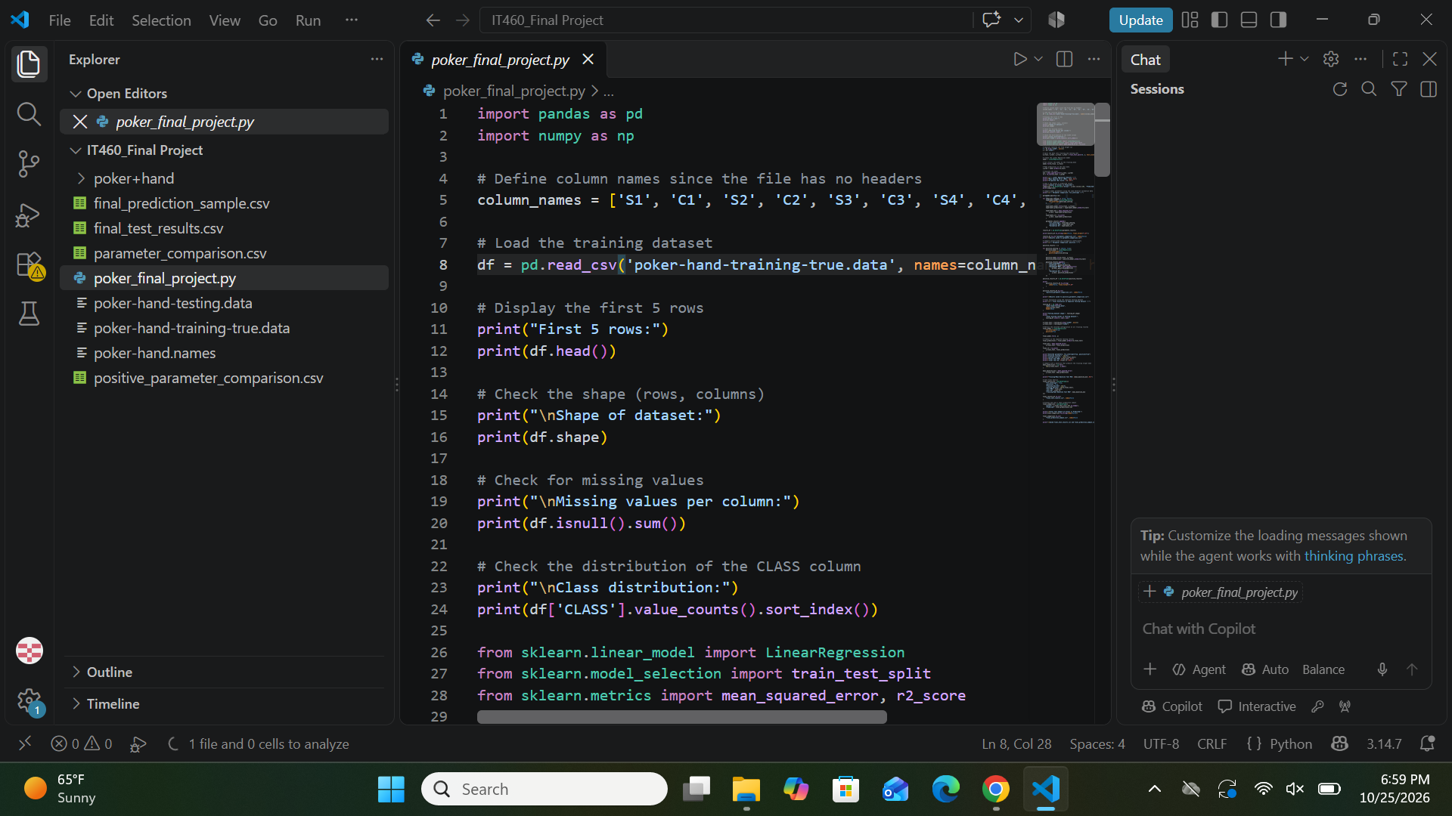

Figure A2. Initial model training and evaluation code.
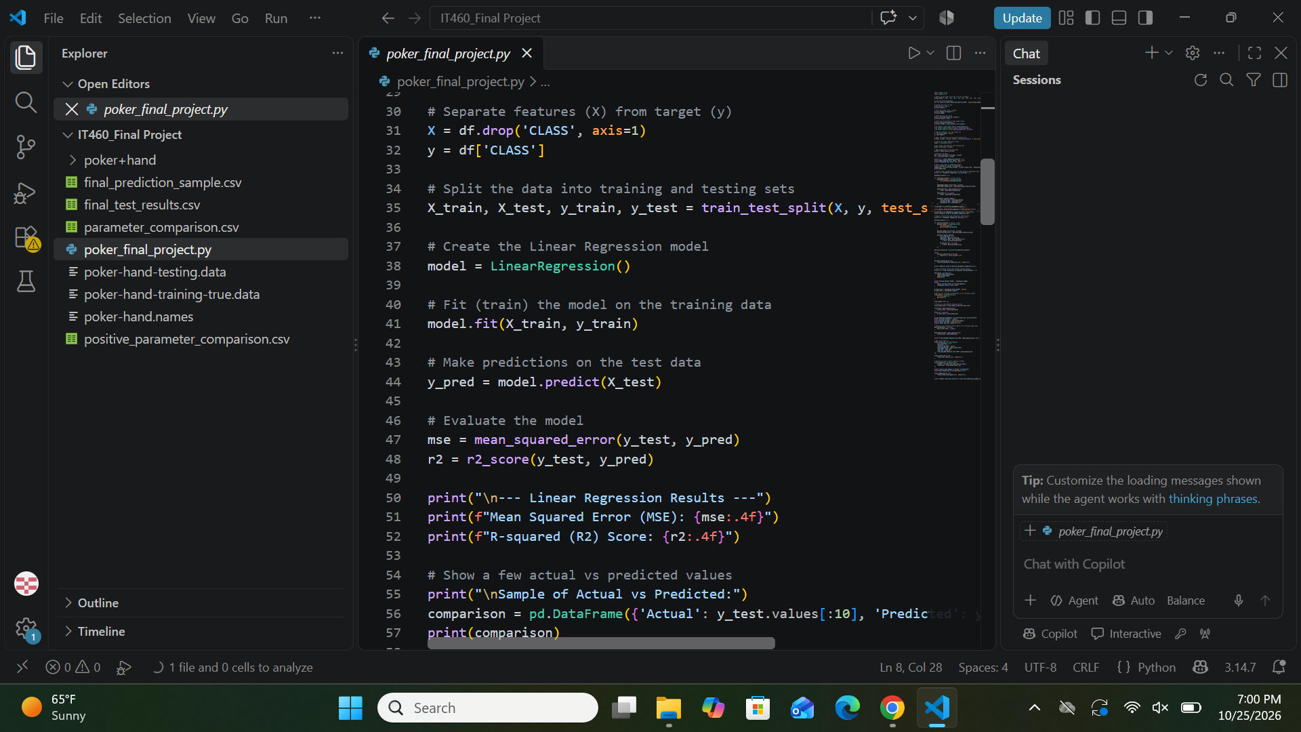

Figure A3. fit_intercept parameter comparison code.
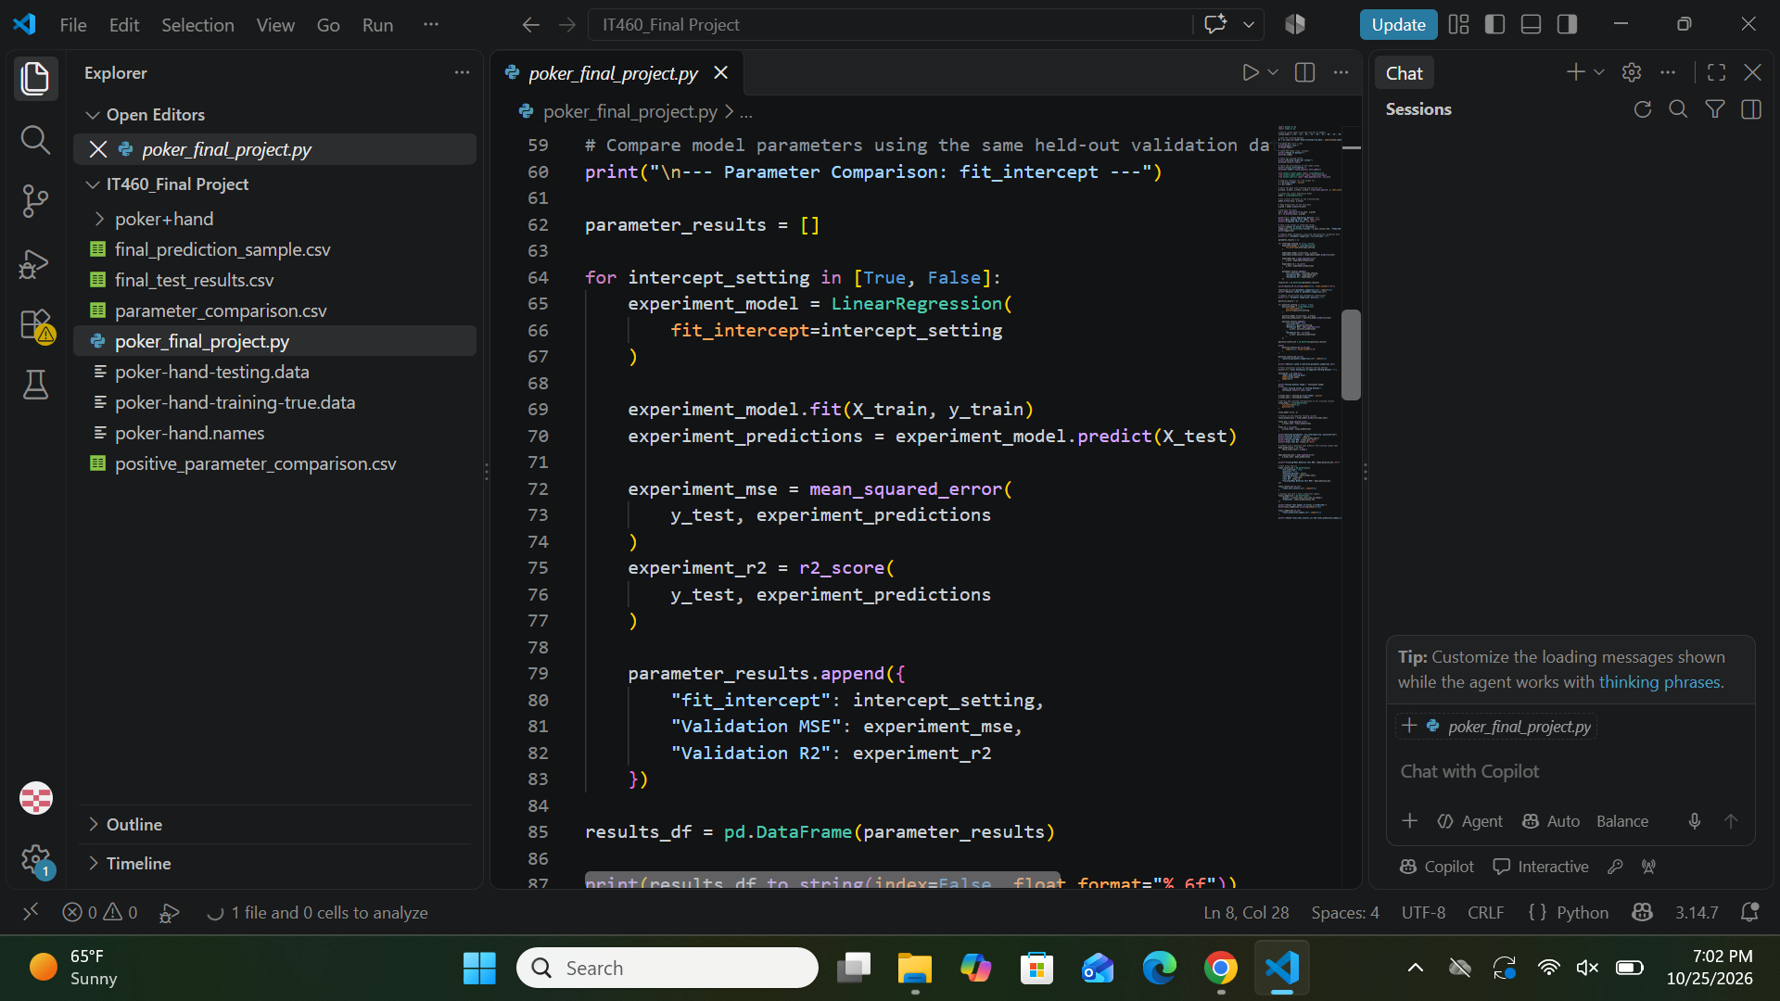

Figure A4. positive parameter comparison code.
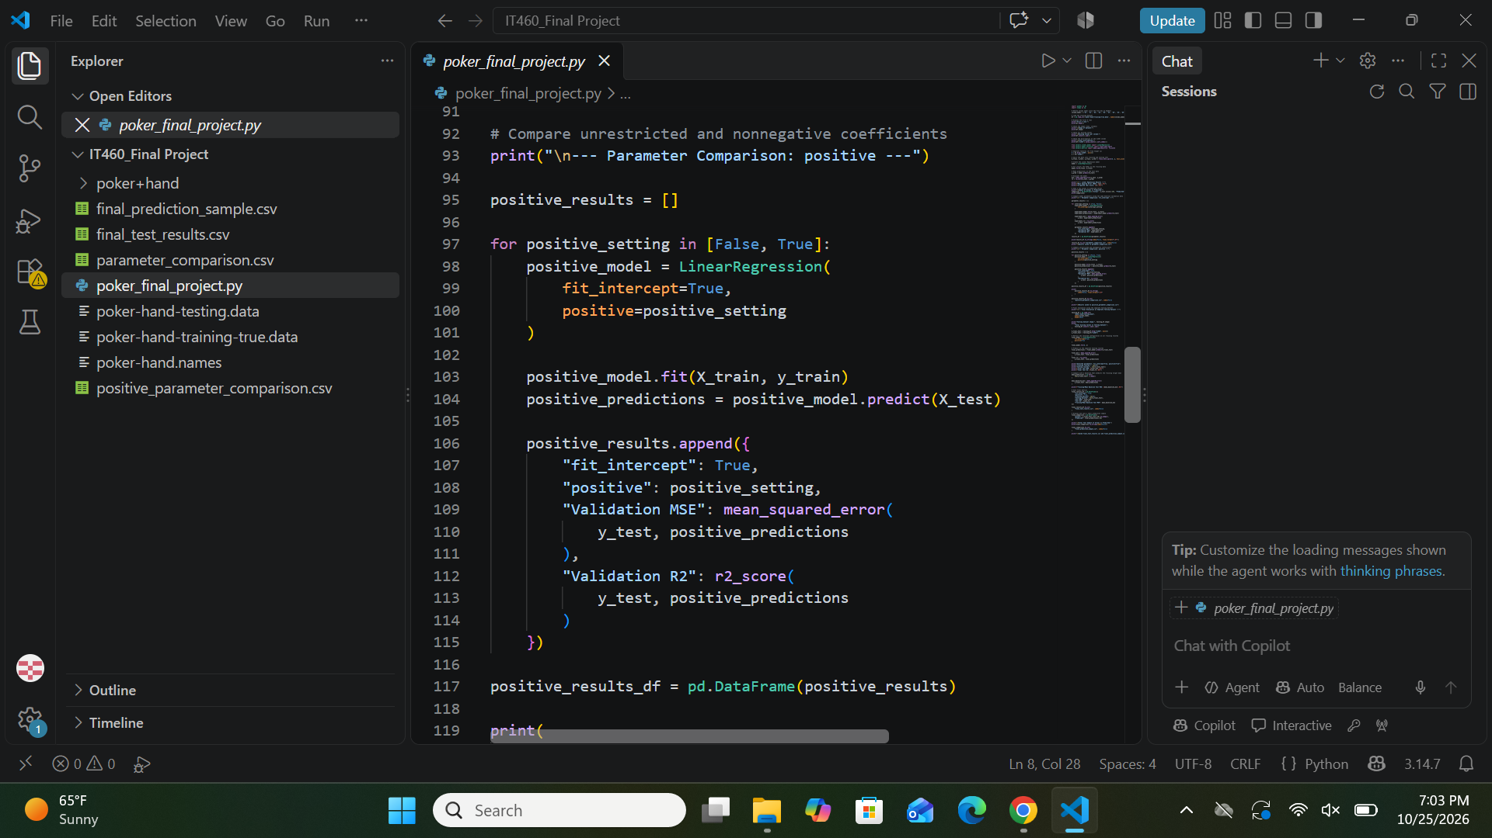

Figure A5. Separate test dataset and final model code.
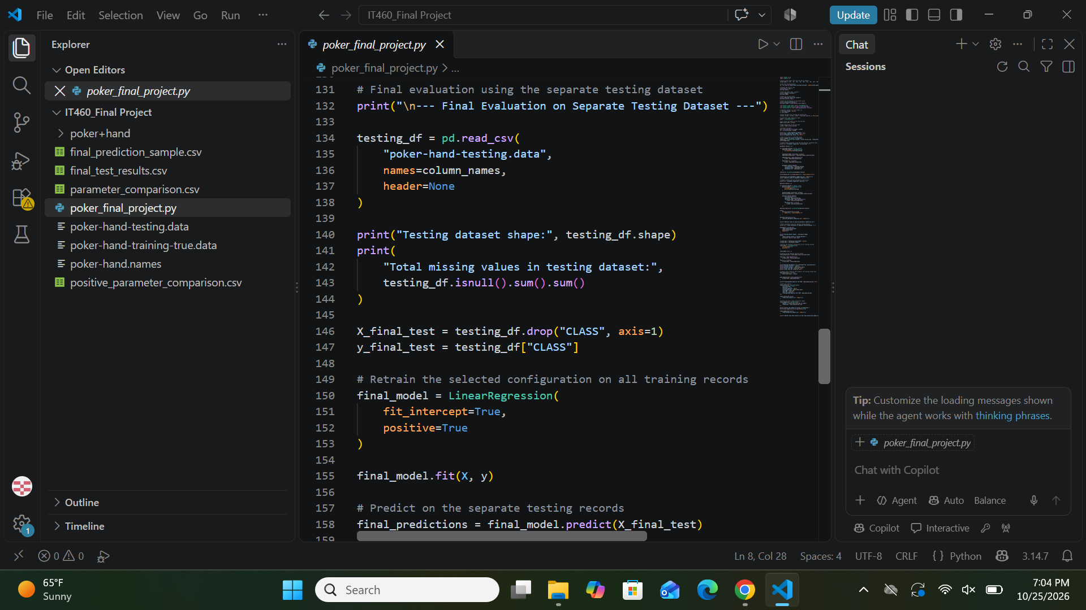

Figure A6. Final performance metrics and baseline calculation code.
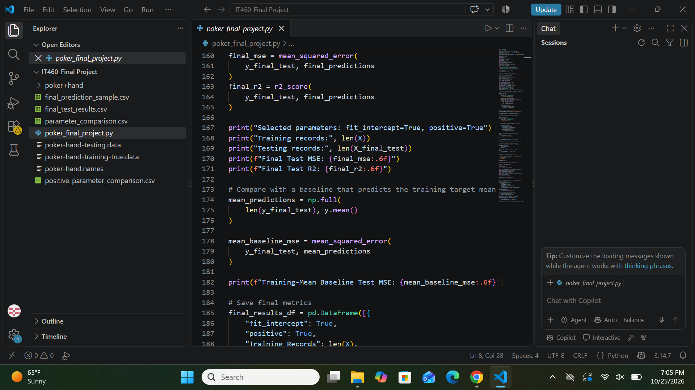

Figure A7. Final comparison output/export code (some left-hand text cropped in supplied image).
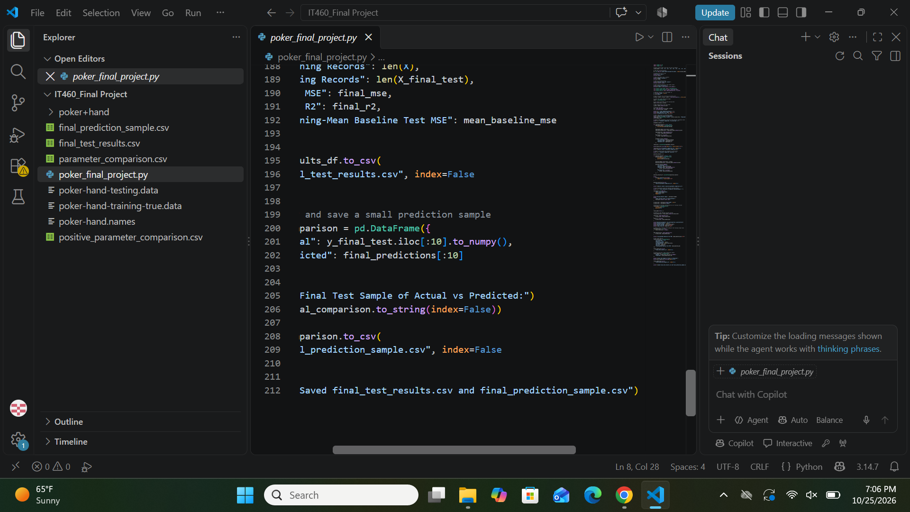

Figure A8. Final test execution, metrics, and examples.
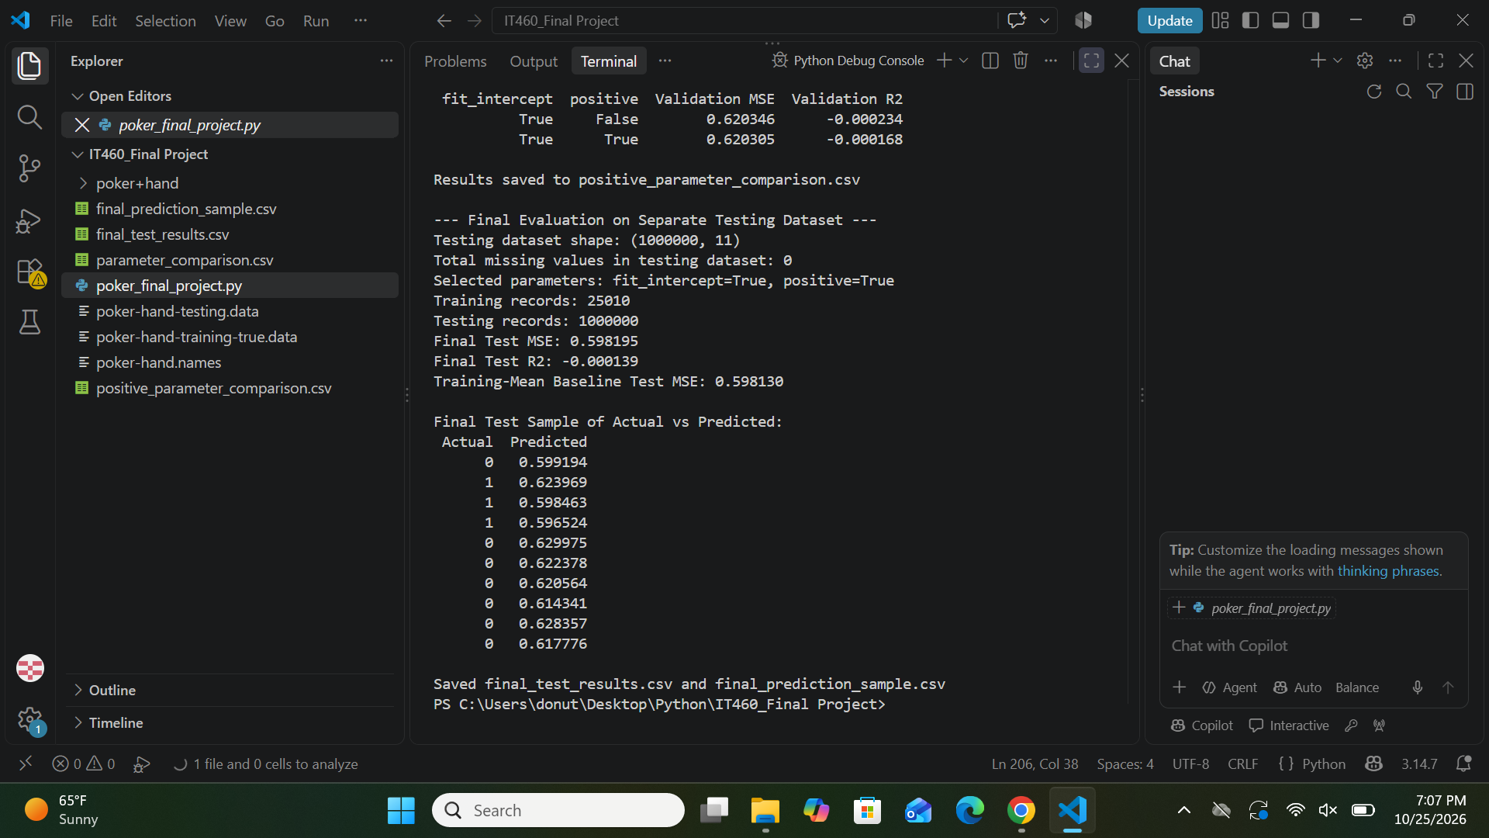

Figure A9. Parameter-comparison terminal output.
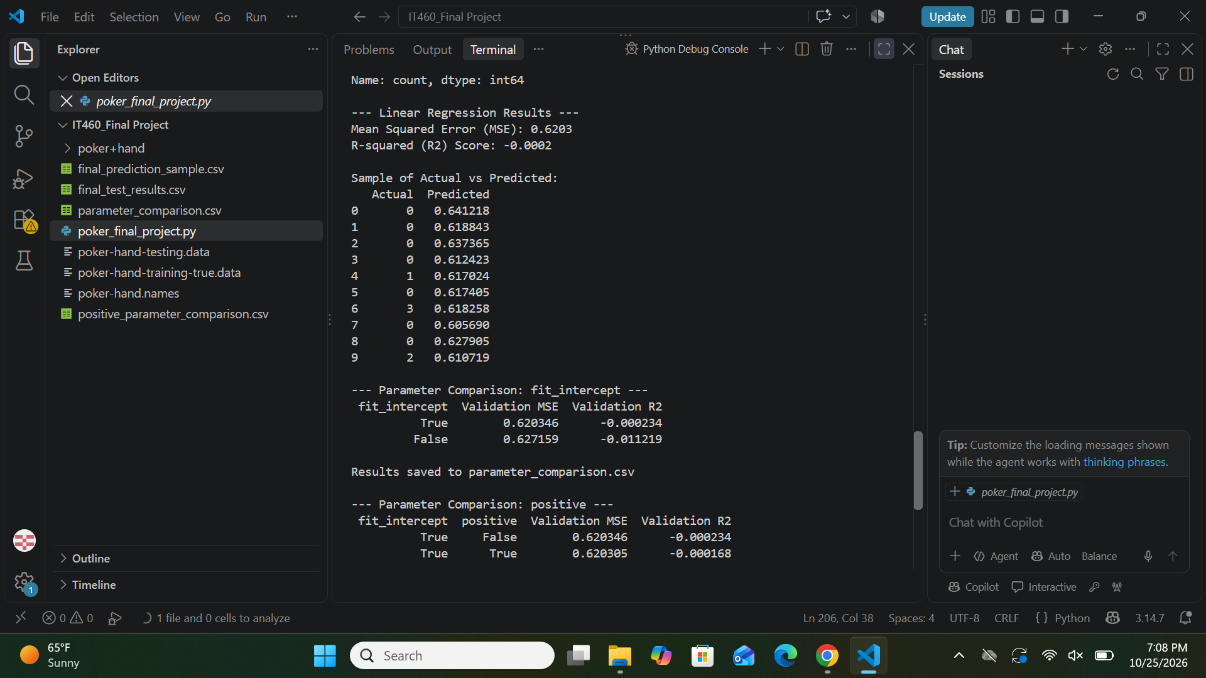

Figure A10. Initial dataset inspection output (lower class counts continue beyond this capture).


