Supplementary Information
PyMACS: A Python-Based Automation Suite for GROMACS Molecular Dynamics Setup, Simulation, and Analysis
Joseph M. Schulz¹, Robert C. Reynolds², Stephan C. Schürer* ^{1,3,4}
1. Department of Molecular and Cellular Pharmacology, University of Miami, Miami, FL, USA.
2. O’Neal Comprehensive Cancer Center, University of Alabama at Birmingham, Birmingham, AL 35205, USA
3. Sylvester Comprehensive Cancer Center, University of Miami Miller School of Medicine, Miami, FL, USA.
4. Frost Institute for Data Science & Computing, University of Miami, Miami, FL, USA.
*Corresponding author: sschurer@miami.edu

Supplementary Figures
Supplementary Figure S1. Representative interactive PyMACS setup run for a protein-ligand system.
Supplementary Figure S2. Representative interactive PyMACS simulation-execution run for the A1D protein-ligand example, shown through completed production MD.
Supplementary Figure S3. Representative PyMACS post-simulation analysis run for the A1D protein-ligand example.
Supplementary Figure S4. Representative PyMACS figurebook-generation run for the completed A1D/CPD32 ligand-bound example.
Supplementary Figure S5. Representative PyMACS cofactor-aware setup run for a multi-component receptor-ligand-cofactor system.
Supplementary Figure S6. Representative PyMACS simulation-execution run for the cofactor-aware A1E/CLR multi-component example.
Supplementary Figure S7. Representative PyMACS RNA-containing polymer-only setup run using the 1URN RNA-protein complex.
Supplementary Figure S8. Representative completed PyMACS biological-mode simulation-execution run for the 1URN RNA-protein example.
Supplementary Figure S9. PROTAC-aware Script 1 setup for a representative ternary-complex system.
Supplementary Figure S10. PROTAC-aware Script 2 simulation-execution workflow for a representative ternary-complex system.

Supplementary Figure S1
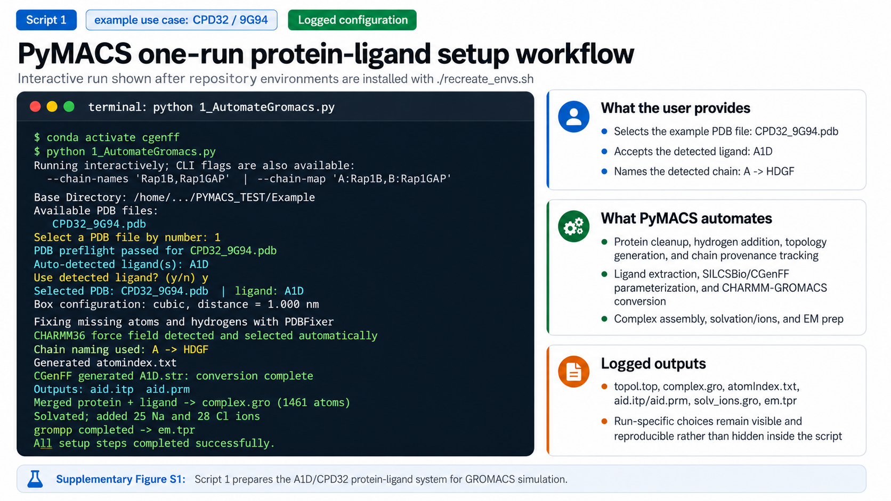
Supplementary Figure S1. Representative interactive PyMACS setup run for a protein-ligand system. After installing the repository environments with ./recreate_envs.sh, the user launches python 1_AutomateGromacs.py, selects the example structure CPD32_9G94.pdb, confirms the auto-detected ligand A1D, and assigns a descriptive chain name. PyMACS then performs PDB preflight checking, protein preparation, CHARMM36 topology generation, ligand extraction and SILCSBio/CGenFF parameterization, complex assembly, solvation, ion addition, and generation of energy-minimization inputs. This example illustrates that run-specific configuration choices remain visible in the run log while routine setup operations are automated.

Supplementary Figure S2
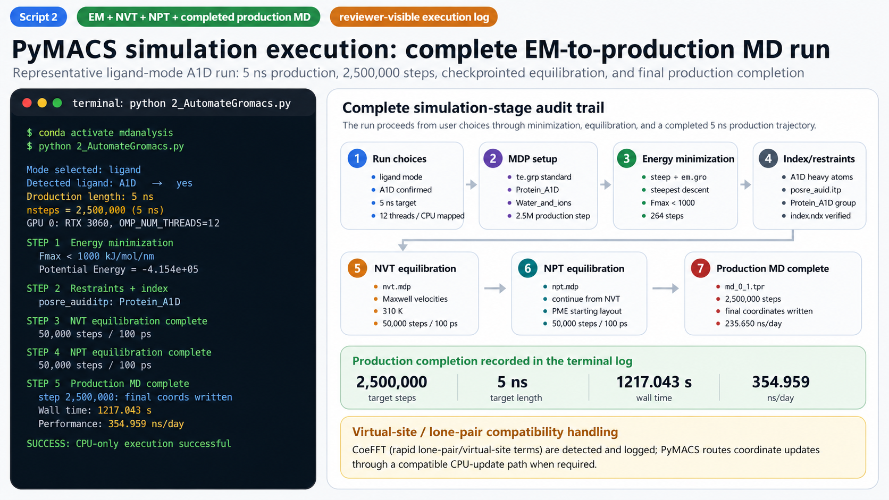
Supplementary Figure S2. Representative interactive PyMACS simulation-execution run for the A1D protein-ligand example, shown through completed production MD. After activating the mdanalysis environment, the user launches 2_AutomateGromacs.py, selects ligand mode, confirms A1D as the detected ligand, chooses a 5 ns production length, and maps execution to a single NVIDIA RTX 3060 with 12 OpenMP threads. PyMACS then standardizes MDP coupling/index groups, updates the topology and ligand restraints, performs energy minimization, builds clean index groups, completes NVT and NPT equilibration, and executes the full production MD run. In this representative run, energy minimization converged below the force threshold in 364 steps, NVT and NPT equilibration each completed 50,000 steps, and the production run completed 2,500,000 steps with final coordinates written and a reported performance of 354.959 ns/day. The log also records virtual-site/lone-pair-aware CPU-update handling, providing a reproducible audit trail for the simulation stage.

Supplementary Figure S3
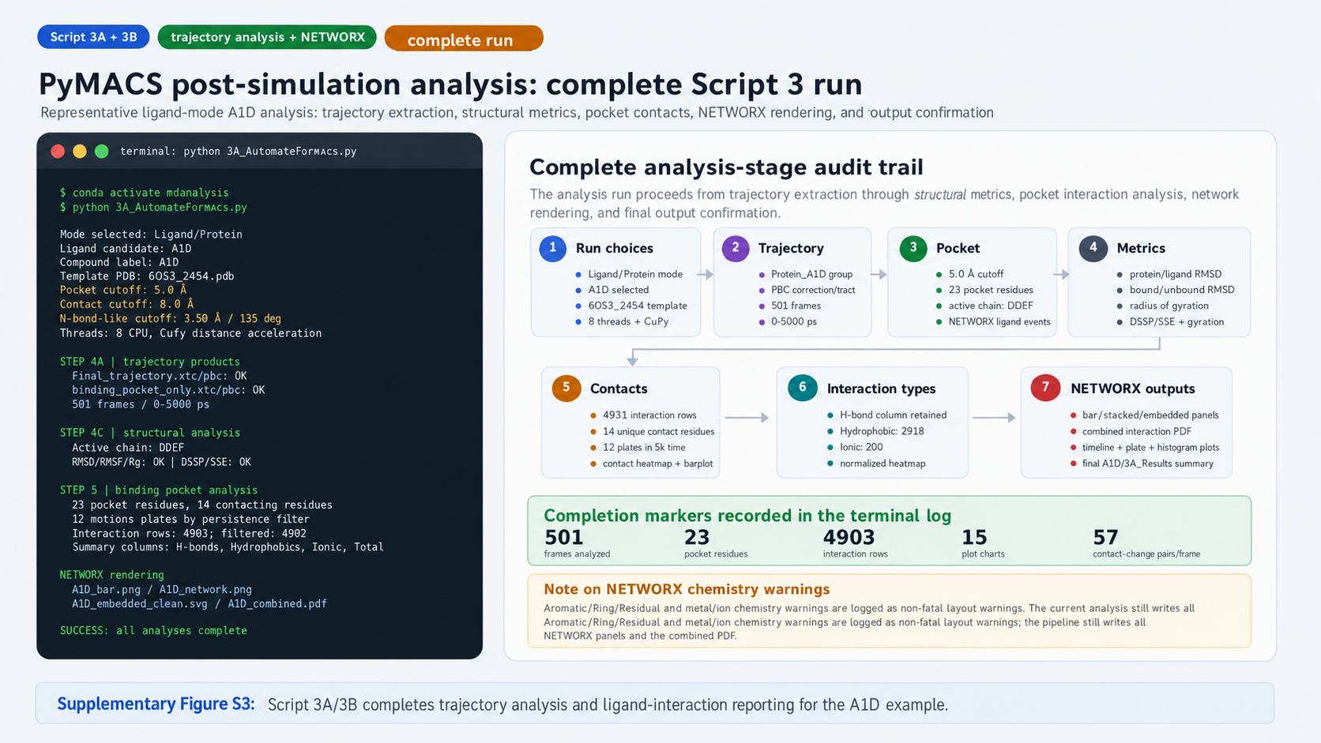
Supplementary Figure S3. Representative PyMACS post-simulation analysis run for the A1D protein-ligand example. Script 3A is executed in ligand-protein mode using ligand A1D, a 5.0 Å binding-pocket cutoff, a 4.0 Å contact cutoff, a 3.5 Å hydrogen-bond-like distance cutoff, and the CPD32_9G94.pdb residue-numbering template. The analysis run generates Final_Trajectory.xtc/.pdb and binding_pocket_only.xtc/.pdb files, identifies HDGF as the active binding chain, completes RMSD/RMSF, radius-of-gyration, DSSP/SSE, and ligand-pocket interaction analyses, and renders NETWORX bar, collapsed-network, expanded-network, clean-expanded-network, and combined-PDF outputs. The run concludes with timeline heatmaps, residue pie charts, distance distributions, binding-importance ranking, SSE-contact coupling analysis, and a final confirmation that all analysis outputs were saved to Analysis_Results.

Supplementary Figure S4
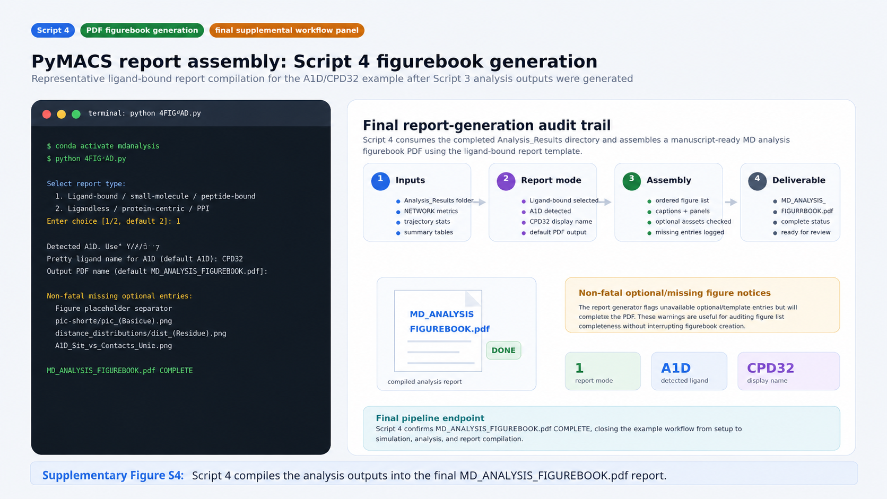
Supplementary Figure S4. Representative PyMACS figurebook-generation run for the completed A1D/CPD32 ligand-bound example. After the Script 3 analysis outputs have been written to Analysis_Results, Script 4 (4PDF4MD.py) is launched to compile the final analysis report. The user selects the ligand-bound/small-molecule report type, confirms the detected A1D ligand, assigns the display name CPD32, and accepts the default output file name, MD_ANALYSIS_FIGUREBOOK.pdf. During assembly, the script reports several non-fatal missing optional or template-specific figure entries, including residue-level placeholder patterns and an unavailable optional SSE-contact figure, but continues execution and confirms that the final MD_ANALYSIS_FIGUREBOOK.pdf was completed. This final panel closes the reproducible example workflow by showing conversion of the automated trajectory-analysis outputs into a consolidated figurebook suitable for inspection, sharing, and supporting documentation.

Supplementary Figure S5
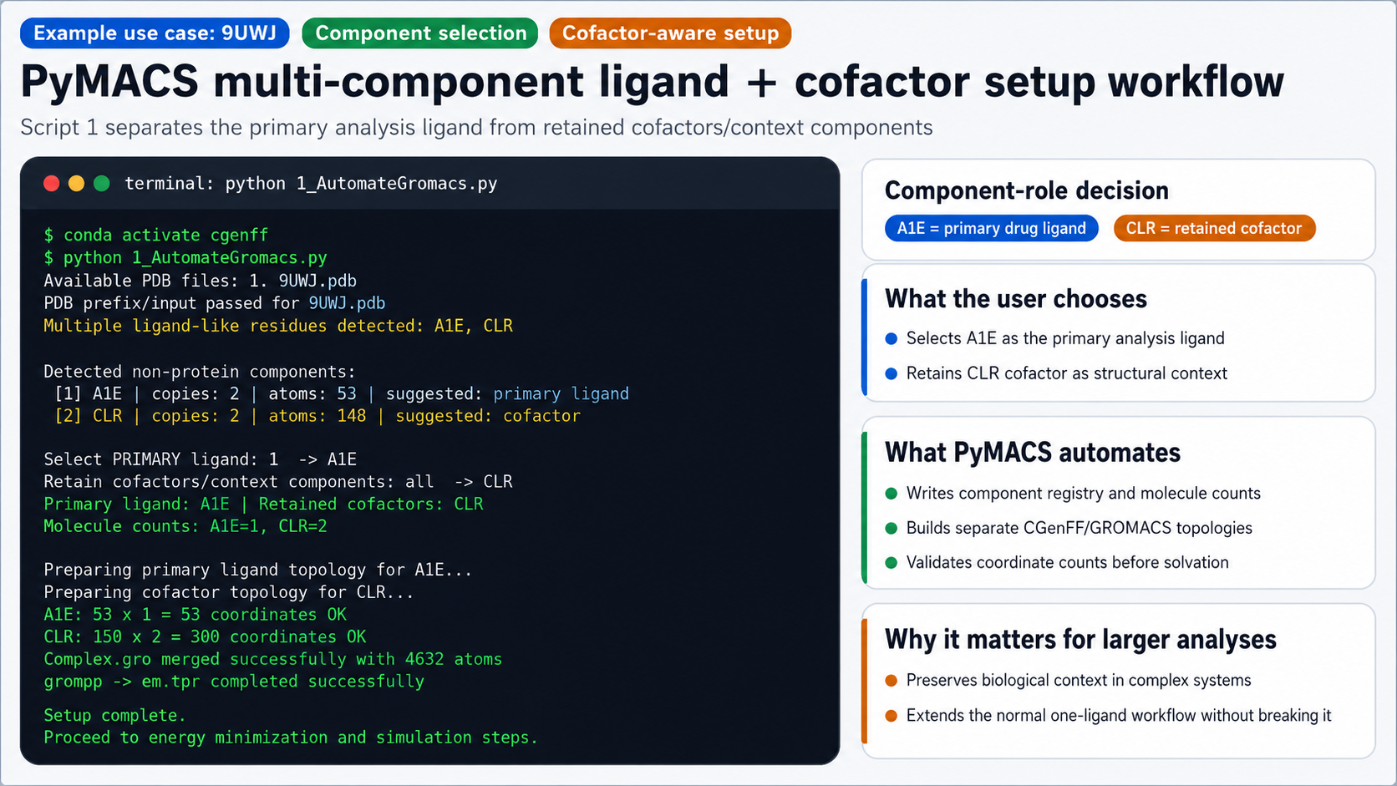
Supplementary Figure S5. Representative PyMACS cofactor-aware setup run for a multi-component receptor-ligand-cofactor system. Using 9UWJ as a representative input, Script 1 detects multiple non-protein components and presents them to the user for role assignment. A1E is selected as the primary ligand for downstream ligand-centered analysis, while two CLR molecules are retained as cofactors or context components rather than being mistaken for the primary drug ligand or discarded. PyMACS then removes the selected non-protein components before pdb2gmx, parameterizes A1E and CLR independently through the CGenFF/charmm2gmx workflow, validates topology-to-coordinate counts for both components, merges the protein with the retained components, and successfully generates the solvated, ionized energy-minimization input. This cofactor-aware path extends the standard one-ligand workflow to more complex receptor, cofactor-associated, or multi-component systems while preserving the normal behavior of routine protein-ligand runs when no cofactors are retained.

Supplementary Figure S6
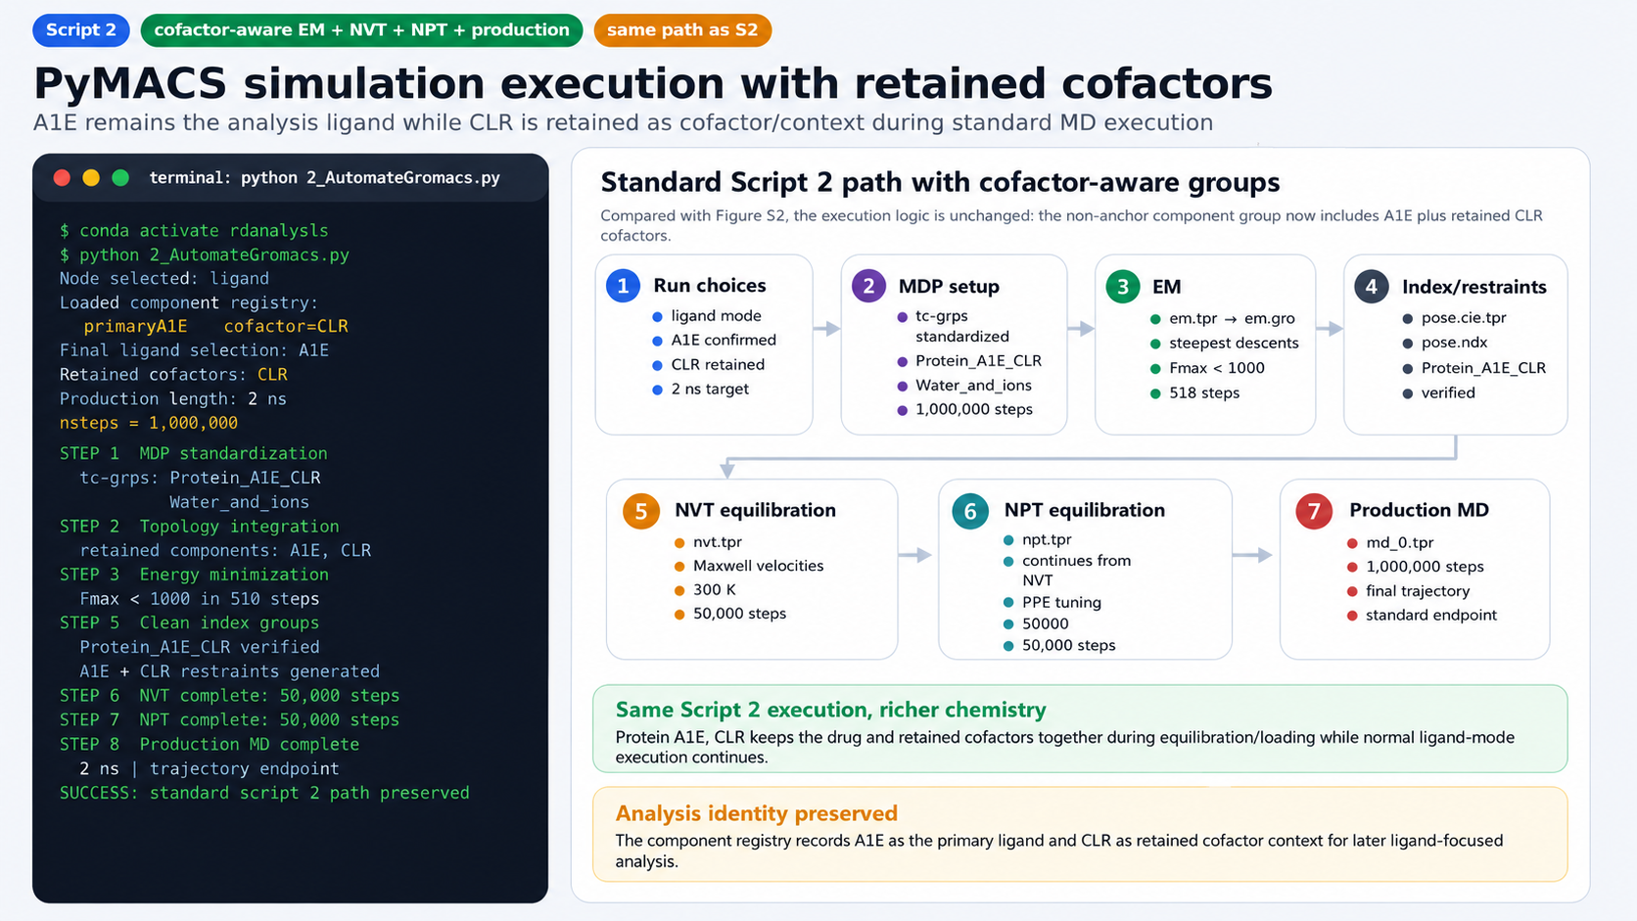
Supplementary Figure S6. Representative PyMACS simulation-execution run for the cofactor-aware A1E/CLR multi-component example. After activating the mdanalysis environment and launching 2_AutomateGromacs.py in ligand mode, PyMACS reads the component registry generated during setup, keeps A1E as the primary ligand of interest, and carries CLR forward as a retained cofactor/context component. The simulation workflow then follows the same overall sequence shown in Supplementary Figure S2: MDP standardization, topology integration, energy minimization, component restraint generation, clean index construction, NVT equilibration, NPT equilibration, and production MD. In this representative cofactor-aware run, the non-water coupling/index group is standardized as Protein_A1E_CLR, separate position restraints are generated for A1E and CLR, energy minimization converges below the force threshold in 518 steps, and NVT and NPT equilibration each complete 50,000 steps. The figure illustrates that adding retained cofactors extends the normal ligand-mode workflow without changing the standard execution logic, while preserving A1E as the molecule used for ligand-focused downstream analysis.

Supplementary Figure S7
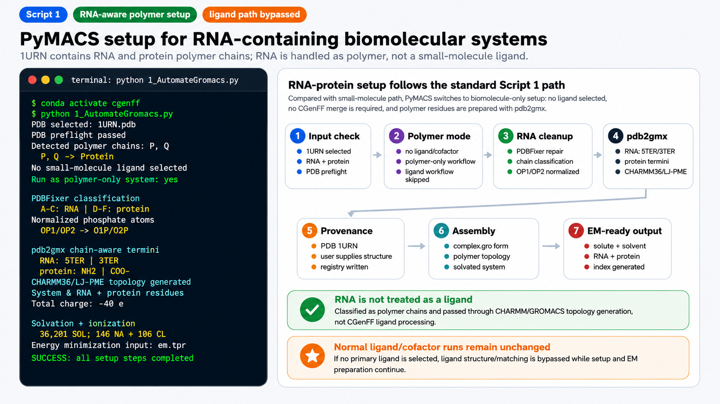
Supplementary Figure S7. Representative PyMACS RNA-containing polymer-only setup run using the 1URN RNA-protein complex. PyMACS detects three RNA chains and three protein chains, prompts the user to run the structure as a polymer-only/biomolecule-only system rather than as a ligand workflow, normalizes RNA/DNA phosphate atom names for CHARMM36 compatibility, applies chain-aware termini selection during pdb2gmx (5TER/3TER for RNA and NH2/COO- for protein), writes system and component registries, solvates and ionizes the mixed RNA-protein system, and generates energy-minimization inputs successfully. This example demonstrates that RNA-containing systems can proceed through the setup path without being misclassified as small-molecule ligands or cofactors, preserving the standard ligand/CGenFF workflow for separate small-molecule analyses.

Supplementary Figure S8
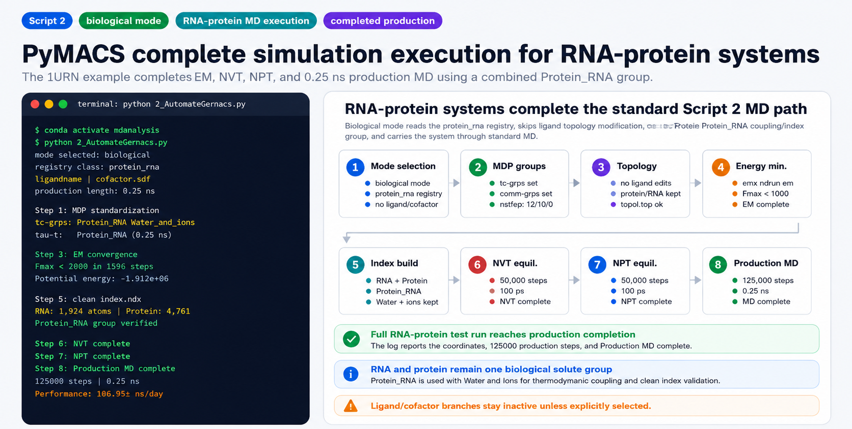
Supplementary Figure S8. Representative completed PyMACS biological-mode simulation-execution run for the 1URN RNA-protein example. After Script 1 prepared the mixed RNA-protein system, Script 2 was launched in biological mode and loaded a protein_rna system registry with no primary ligand or retained cofactor. The workflow standardizes tc-grps and comm-grps to Protein_RNA and Water_and_ions, completes energy minimization, builds and verifies clean RNA/protein index groups, performs NVT and NPT equilibration, and completes the 0.25 ns production MD run. The completion log reports 125000 production steps, final-coordinate writing, a production performance of approximately 106.954 ns/day, and successful Production MD completion. This example demonstrates that RNA-containing biological systems can follow the same EM, NVT, NPT, and production-MD logic used by the standard pipeline while keeping ligand/cofactor-specific branches inactive unless a primary ligand is selected.

Supplementary Figure S9
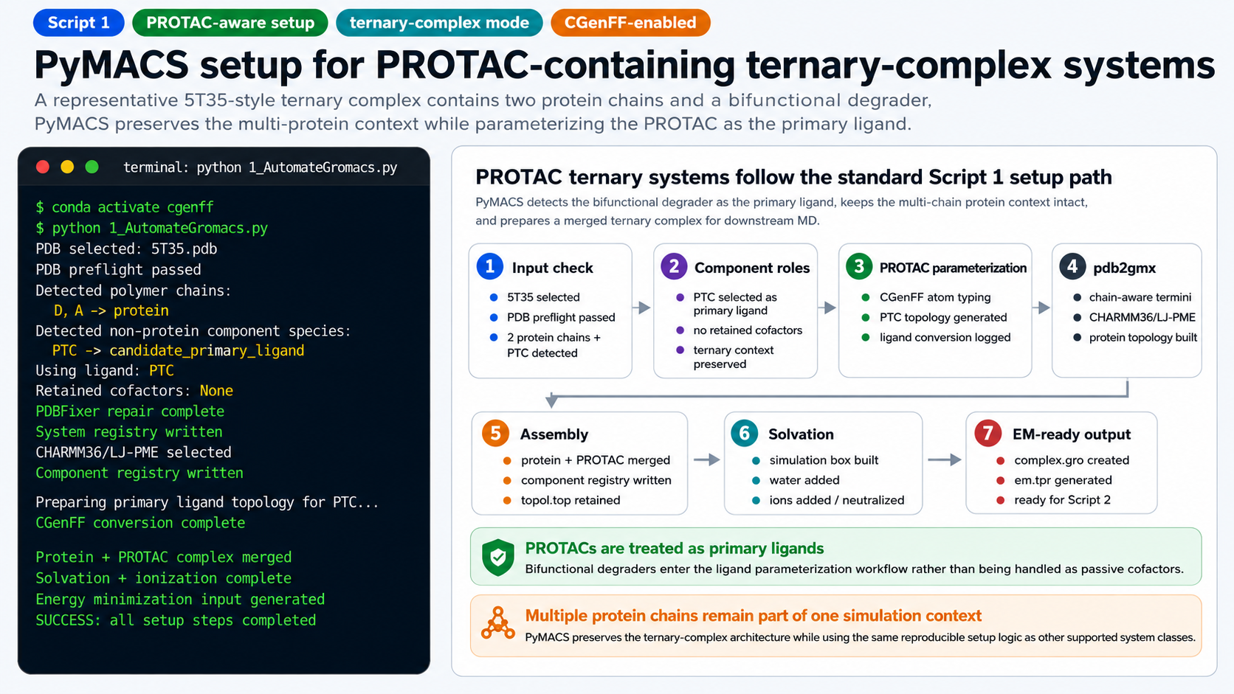
Supplementary Figure S9. PROTAC-aware Script 1 setup for a representative ternary-complex system. PyMACS detects two protein chains and the PTC degrader, assigns the PROTAC as the primary ligand, generates the CGenFF-based ligand topology, assembles the merged complex, and produces a solvated, ionized system ready for energy minimization.

Supplementary Figure S10
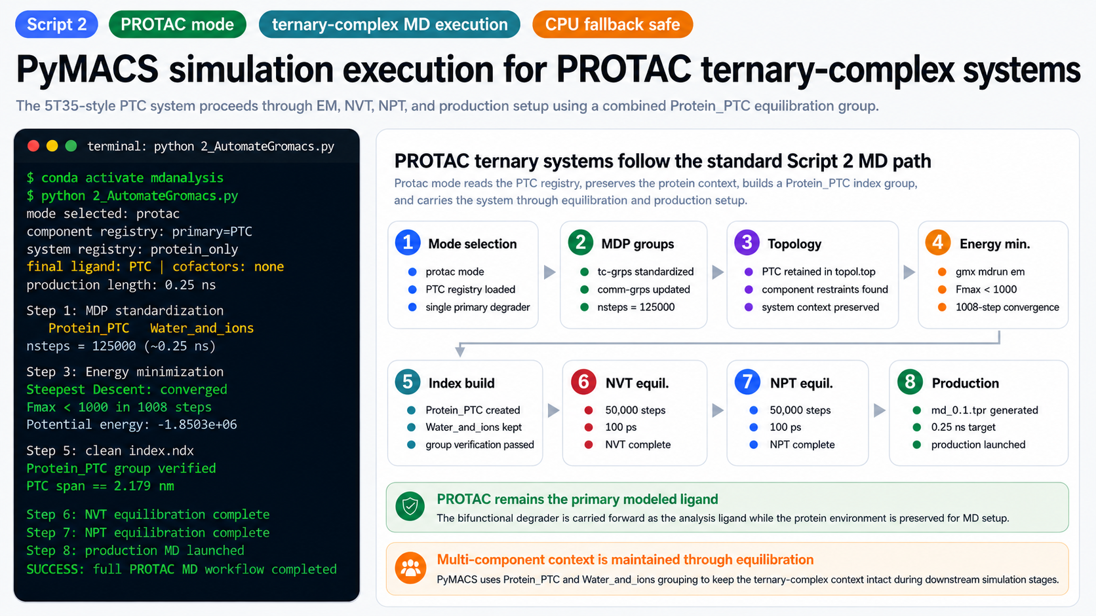
Supplementary Figure S10. PROTAC-aware Script 2 simulation-execution workflow for a representative ternary-complex system. Using the 5T35-style PTC example, PyMACS carries the prepared PROTAC-containing system through MDP standardization, energy minimization, Protein_PTC index construction, NVT and NPT equilibration, and production-MD launch, while preserving the multi-component ternary-complex context.

