|  |  |  |  |  |
| --- | --- | --- | --- | --- |
| Risk | Description | Risk Rating | Actions | Time cost |
| Hardware Failure | Time could be lost due to a hardware failure. For example, a hard drive being corrupted may lose the current unsaved work. | 5C | Consistent backups. Utilising the GitHub repository to maintain versions. | Ranging from <1 hour to a day. |
| Covid-19 | Time could be lost due to being incapacitated by Covid-19. | 3B | Adhere to government policies and social distancing guidelines. | Ranging from 0 to 7 days. |
| Insufficient time to perform proper testing | If there are unexpected issues within the development of the project, this may reduce the amount of time allocated for testing. | 2C | Maintain and consider the time per task throughout the entire development process. Making sure to apply AGILE development methodology throughout. |  |
| GitHub server failure | If the online repository was rendered unusable. | 1A |  | Potentially large. |
| Interacting with new technologies | If the technologies or techniques used are unfamiliar. This may expand the expected amount of time to complete tasks | 3C | Consider the actions that will be required throughout the development. Paying close attention to the more complex areas. | Varying throughout the development process. |
| First time project management | The development process may not be as accurate as it could be, due to this being the first time managing a project with an agile methodology | 3C | Consider the actions that will be required throughout the development. Paying close attention to the more complex areas. | Varying throughout the development process. |
| Incorrect pre-coding design | Basing the code of the design requires the design to be correct. It is a possibility that using it as a guideline results in an incorrect program | 1A | Consider the actions that will be required throughout the development. Paying close attention to the more complex areas. | Varying throughout the development process. |

Day One

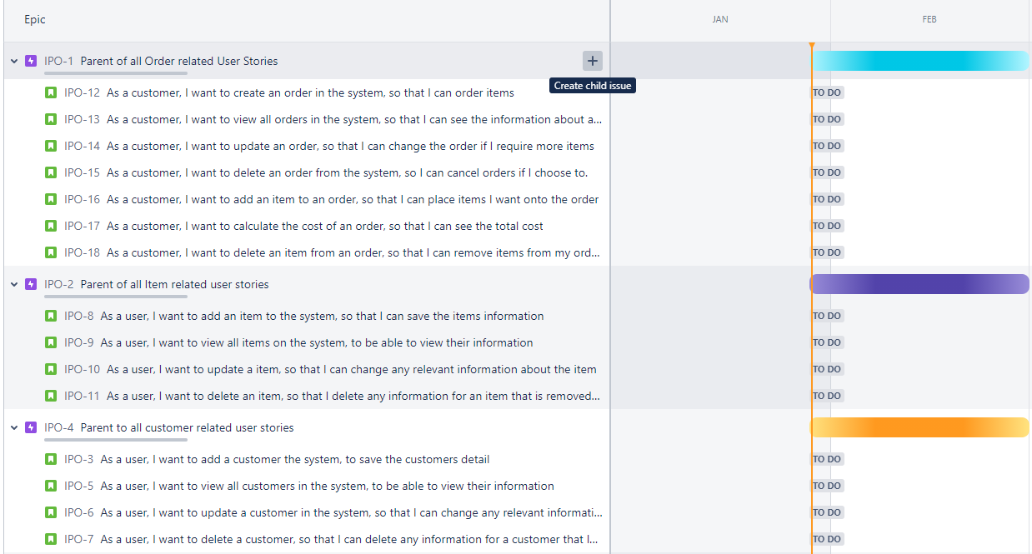

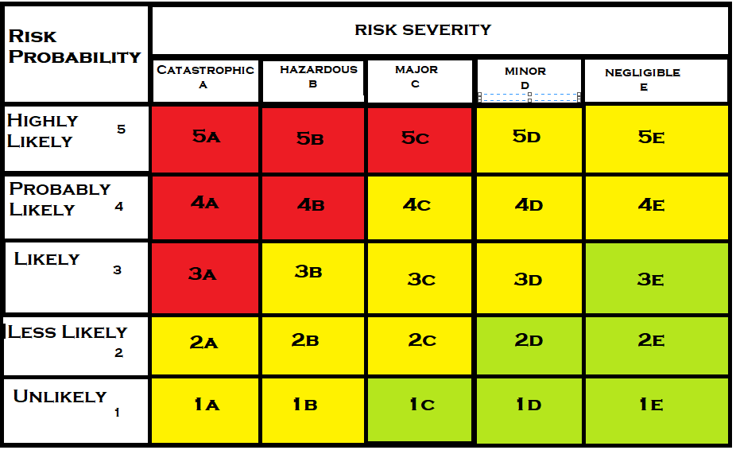

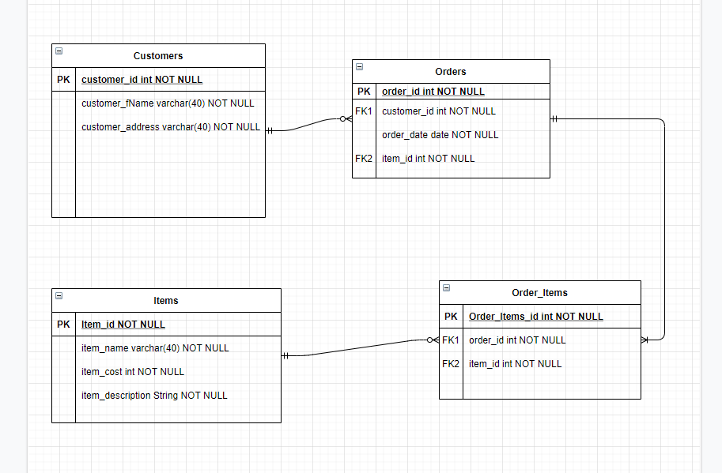

Day Two

Day Three

Day Four

Day Five

Day Six

Day Seven

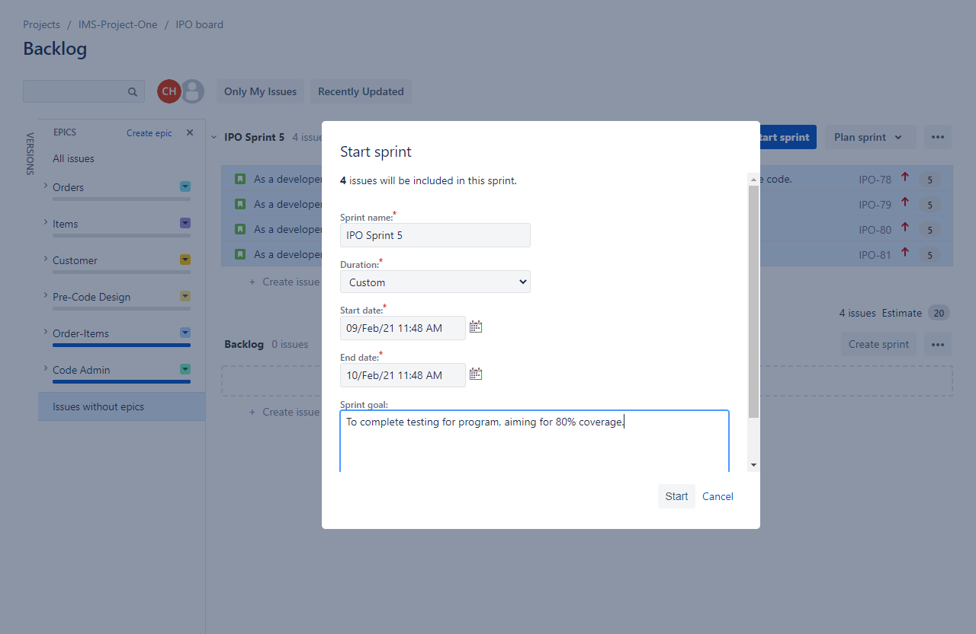

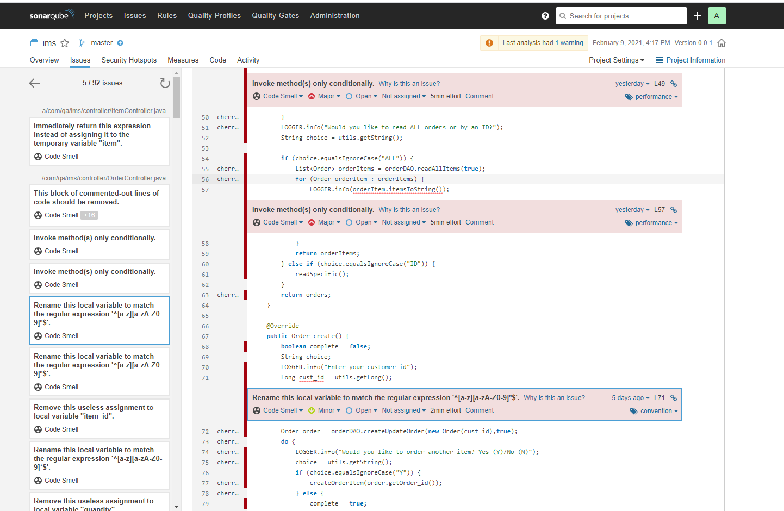

Day Eight

Day Nine

Day Ten