Structure

1. Introduction (200 words)

Outline the research context, a brief description of the dataset you choose, what methods you choose to conduct the analysis

1. Short literature review (300 words)
2. Methodology and Data (600 words)
3. Analysis and Results (600 words)
4. Conclusion and Limitations (300 words)

Notes

1. Filename of your coursework should be your 7 digit registration number plus _BE 277. For example, if your registration number is 2000000, then the filename is 2000000_BE277.
2. Attach your full source code (text, not a screenshot) as an Appendix. You can find how to do this properly on: <https://stackoverflow.com/questions/387453/how-do-you-display-code-snippets-in-ms-word-preserving-format-and-syntax-highlig>.

Or, you can upload your R file directly in Faser.

1. How to cite code <https://www.bibguru.com/g/harvard-computer-program-citation/>

How to cite code from Moodle example:

1. Comment every line of your code to describe clearly what your code is going to do.
2. Hi-resolution figures, each figure you include should have a caption, and correctly referred within text. For example,

In text “Figure 1 shows the trend of …”



Figure 1. Trend of …

1. Each table should have a caption and correctly referred.

In text “Table 1 presents the result of…”

|  |  |  |
| --- | --- | --- |
|  |  |  |
|  |  |  |
|  |  |  |
|  |  |  |

Table 1. Results of …

1. **Harvard reference style** is correctly applied.
2. If you have too many figures, include them in Appendix and only include the most important information in the main text.
3. Proofread your coursework before submitting. Don’t lose marks due to grammar problems.
4. No plagiarism!
5. No Fabricated data/result!

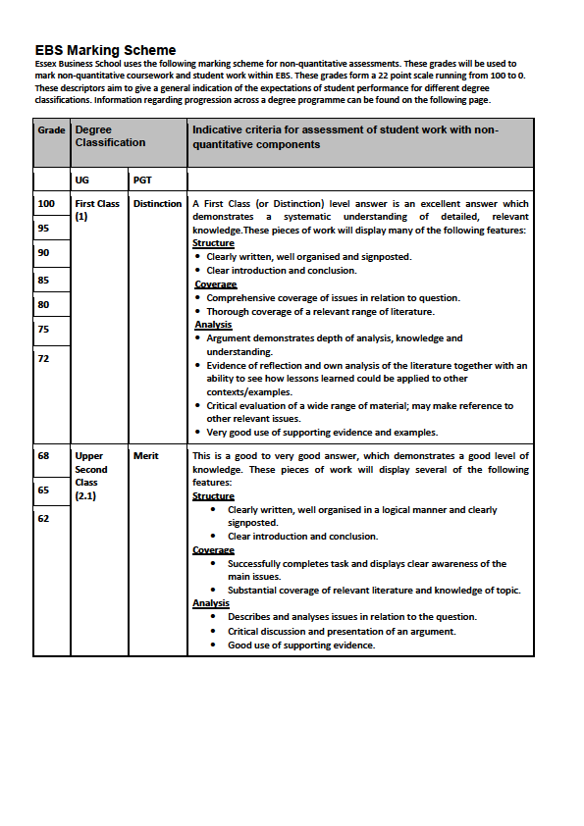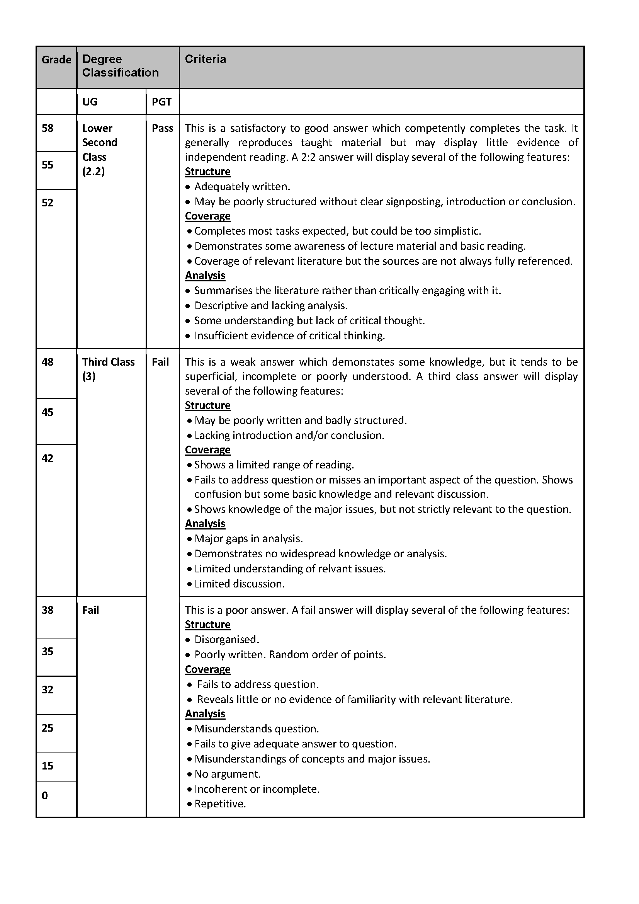

**How to tackle your coursework step by step**

Possible steps to tackle the coursework (this is just one possible process to solve the problem, it is more encouraged to form your own method):

1. **Introduction**
2. **Literature review**. Search the literature to find potential proper indicators. For example, if some research shows that ease of doing business is an important indicator for digital development aid, you can check: <https://www.doingbusiness.org/en/rankings>. This should give you an idea of how to choose countries.

For the purpose of this coursework, reading <https://www.worldbank.org/en/publication/wdr2016> will help you to get a better understanding of this problem.

1. **Decide indicators** **and selection criteria.** Either by checking the available data set or inspired from literature review, decide what indicators you want to use for analysis and the selection/ranking criteria. You can even combine different indicators and using regression to build your own selection criteria.
2. **Reduce the number of countries**. Working on more 200 countries could be difficult, no matter from which angles, it always makes more sense to choose countries with medium-low incomes, which should reduce the number a lot. Indicators for this choice could be GPD, GNI, etc. You can further reduce the number of countries by either using single indicator or other criteria, as long as you can justify that.
3. **Decide your methods.** Depend on what kind of analysis you want to conduct, you can either use prediction (time series analysis) or classification (logistic regression, neural network, decision tree, etc.), as long as you can justify your choice.

For example, if you use prediction analysis, you can check the time series data, based on your indicators, to predict what will happen in the future (ARIMA, smoothing, naïve forecasting, etc.) to each country in the next 5 years, and combine other information you believed useful, to select the 10 countries that World Bank should aid.

If you use classification analysis, by checking the relationship of different features (predictors) and your selection criteria, you can either build a logistic regression model, neural net or decision tree, to decide whether or not Word Bank should aid this country (binary classification problem). In this step, make sure you can get at least 10 countries, otherwise you may want to change your criteria a little bit. After you get these 10 countries, use a final indicator which you think proper to rank. Don’t forget to give your justifications.

Another method is to use AHP (session 10) to decide which country to aid and give them a rank.

1. **Give a clear conclusion.**

**(Depends on your writing style, you can decide how to allocate step 3, 4, 5 into different sections)**