|  |  |  |  |  |
| --- | --- | --- | --- | --- |
|  | | | | |
|  | | | | |
|  | | | | |
|  | |  | | |
| **Specification for Suppliers**  **Cover unit with integrated lining wear sensor for pneumatically operated disc brakes for commercial vehicles** | | | | |
|  | | | | |
|  |  | |  |  |
|  |  | |  |  |

**Modifications**

| Rev. | Date | Page | Name | Changes |
| --- | --- | --- | --- | --- |
| 000 | 23.06.2020 |  | Steinhuber T/WDD2.3 | Preliminary release to request |
| 001 | 02.08.2021 | - | Steinhuber T/R-WE-RD-SBD3 | General revision |
|  |  |  |  |  |
|  |  |  |  |  |
|  |  |  |  |  |

**TABLE OF CONTENTS**

1. Scope 5

1.1. Accompanying documents 5

2. General information 6

2.1. Cover unit overview 6

2.2. Function of the cover unit / sensor 6

2.3. Sensor variants 9

2.4. Sensor principle 10

2.5. Design strategy 10

2.6. Mounting location 10

2.7. Protection 10

2.8. Position at delivery 10

2.9. Materials 11

2.10. Fire resistance / ADR requirements 11

2.11. EMC type approval 11

2.12. Corrosion 11

2.13. Chemical resistance 11

2.14. Marking 11

2.15. Handling, transportation and packaging 12

2.16. Documentation, validation tests and reporting 12

2.16.1. Reporting requirements 12

2.16.2. Validation tests 12

2.16.3. Other technical documentation 12

2.16.4. Reliability 13

2.16.5. Drawings 13

2.17. Failure Mode and Effects Analysis (FMEA) 13

2.17.1. Sensor errors and their evaluation 13

2.17.2. Special (s/c) and critical (c/c) characteristics 13

2.17.3. Severity list Cover and Cover unit 14

2.18. Functional Safety 14

3. Ambient conditions 15

3.1. Temperature ranges 15

3.2. Operating life 15

3.3. Humidity 15

3.4. Operating temperature profile 15

4. Mechanical properties 16

4.1. Installation space / Mechanical interface 16

4.2. Plug connection 16

4.3. Working range (sensor) 16

4.4. Strain / Endurance 16

4.5. Gearing design 16

4.6. Friction Torque 17

5. Electrical properties 18

5.1. Electrical interface 18

5.2. Pin assignment 18

5.3. Pin coating 18

5.4. Electrical parameter 18

5.5. Loss of supply / ground 18

5.6. Short circuit protection 19

5.7. Overvoltage protection 19

5.8. Electrical components and solder joints 19

5.9. Immunity to electric and magnetic fields 20

5.10. Radiated emission 20

6. Functional data 20

6.1. Sensor characteristic 20

6.2. Signal precision 20

6.3. Failure recognition 20

7. Validation Tests 21

7.1. General 21

7.2. Standard test requirements 21

7.3. Climatic tests 22

7.3.1. Dry heat test / High Temperature 22

7.3.2. Cold test / Low temperature (with storage) 22

7.3.3. Thermal shock 23

7.3.4. Leakage test / Ice water shock test 23

7.3.5. Damp test, static 23

7.3.6. Damp heat test, cyclic 24

7.3.7. Thermal cycling test 24

7.3.8. Storage test 24

7.3.9. Temperature step test 25

7.4. Mechanical tests 25

7.4.1. Resonance test 25

7.4.2. Random vibration test 26

7.4.3. Sinus vibration test 26

7.4.4. Shock test 26

7.4.5. Drop test/ Mechanical Shock 27

7.4.6. Accelerated Lifetime 27

7.4.7. Degree of protection 28

7.4.8. Chemical resistance 28

7.4.9. Fire resistance test 28

7.4.10. Screw and service test 28

7.5. Endurance test 28

7.6. Electrical Loads 28

7.6.1. Disturbances by conduction and coupling 28

7.6.2. Overvoltage 28

7.6.3. Reset behavior at voltage drop 29

7.6.4. Short circuit protection 29

7.7. EMC/ESD Requirements 29

7.7.1. General 29

7.7.2. Radiated emission 30

7.7.3. Radiated immunity/ susceptibility 30

7.7.4. Immunity to electrostatic discharge 30

7.7.5. Immunity to low-frequency magnetic fields 31

7.7.6. Impact test cover unit 32

7.8. System release tests (performed by Knorr–Bremse) 32

7.8.1. Temperature cycling test (according Y048861) 33

7.8.2. Protection test (according Y048862) 33

7.8.3. Combination test (according Y048866) 34

7.8.4. Vibration test (according Y048867) 34

# Scope

This specification document covers the technical requirements for a cover unit with integrated lining wear sensor for pneumatically operated disc brakes for commercial vehicles. It is the suppliers responsibility to demonstrate adherence to all requirements listed and described in this document unless explicitly stated otherwise.

Other requirements, e.g. regarding commercial conditions, time schedule, reliability methods for quality assurance are not treated in the document. For these topics the MSA (Master Supply Agreement) and QMPP (Quality Management Program for Procurement) document is valid.

There are total of 7 different covers that can be combined with 6 different sensors variants. The exact assignment can be found in Y382864.

## Accompanying documents

The following Knorr-Bremse documents are also part of the technical product description and are provided separately:

Y382864 general project overview and all drawing documents contained therein.

Y095615 requirements for PCB`s and electronical assemblies

Y037150 rigid printed circuit boards for automotive applications

Y364100 screw and service test

Y420556 Severity list cover

Y420555 Severity list cover unit

Y420992 Additional document to drawing and severity list

Y421468 Chemical resistance

Y048862 Protection test

Y048861 Temperature cycling test

Y048866 Combination test

Y048867 Vibration test

# General information

## Cover unit overview

Exemplary representation for SN6 / 7 EVO cover unit

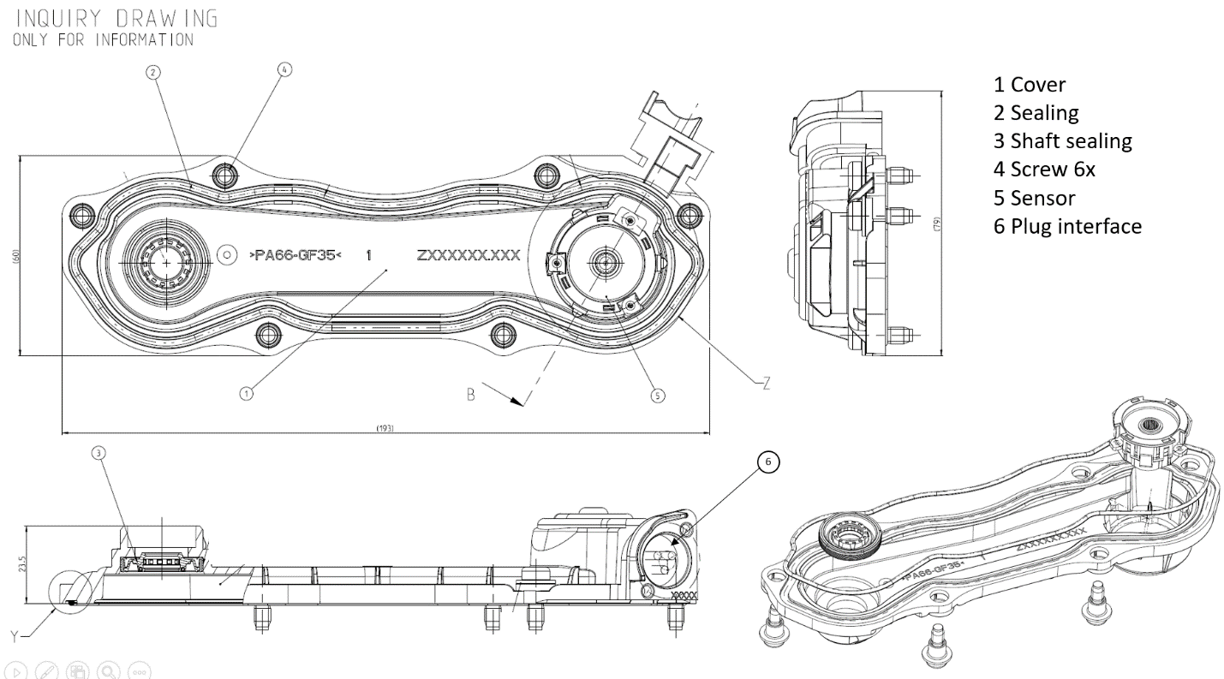

More detail can be found in Y382864 and the respective drawing of each cover unit.

The shaft sealing, the M5 screws with bushing and the sheet metal clamp are standard parts by Knorr-Bremse and can be taken over. The bushing with M5 screw firmly pressed (undetachable)in for transport and handling.

## Function of the cover unit / sensor

The function of the brake which is of the sliding caliper type, is characterized by the fact that the application force is induced by a lever on one side and is transferred onto one brake pad via a so-called "bridge" with the help of one or two threaded spindles equipped with a thrust member, whereas the opposite second brake pad is pressed against the brake disc due to the reaction force resulting on the caliper. The automatic wear adjuster which is integrated into one of the threaded spindles compensates for pad and disc wear by unscrewing the threaded spindles. The threaded spindle rotation is used as input parameter for indirect lining wear detection.

The sensor is installed in the cover unit to protect it from environmental influences. The cover unit in turn covers the installation openings of the adjuster and synchronization assembly. This is intended to protect the internal brake mechanics from environmental influences.

The following picture shows the structure of a complete air disc brake including the wear sensor cover unit:

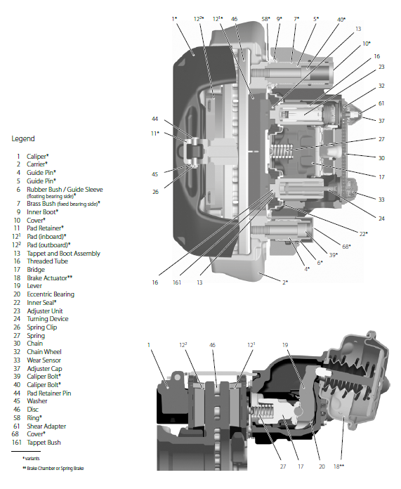

Cover

unit

The tightness requirements are described on the drawings of the cover unit.

Two different types of lining wear sensors are required:

a) Continuous lining wear sensor:

Intension of the sensor is to transfer the angle of rotation into an electrical output signal. The sensor shall continuously detect the pad and disc wear over the complete wearing range. In every possible operating and maintenance condition of a non-dismounted brake the sensor shall relate the wear state (→ angular position of the input port) to exactly one signal value.

The signal can be used for the following operations depending on the capacity of the diagnostic electronic control unit:

* continuous wear control with wear indication
* monitoring of the brake operation by plausibility comparison of different brakes
* simplification of service
* wear harmonization between several axles

During normal operation in the vehicle the sensor is powered up only temporarily after each brake application.

During the reset of the disc brake for exchange of worn out brake pads the sensor is not powered up.

b) Black/white lining wear sensor (switch):

Intension of the sensor is to detect and indicate the lining wear end point on the basis of the angle of the thread spindle rotation.

The signal can be used for the following operations:

* wear control with wear end point indication

For both sensor types different variants are required with respect to signal characteristic, connector design and / or pin assignment (see chapter 2.3).

## Sensor variants

The required sensor variants are shown in the following table:



The specified document numbers Zxxxxxx refer to the accompanying Knorr-Bremse documents defining sensor characteristic (see chapter 6.1), dimensions / interfaces (see chapter 4.1), and plug features (see chapter 5.1 - 5.3) for the different sensor variants.

## Sensor principle

a) Continuous sensor:

The sensor may base upon a rotary potentiometer with ohmic resistance path and wiper. Alternatively, the sensor may also use a contactless sensing principle like rotary hall technology with magnetic probe.

The electronic circuit of the sensor has to feature an active final stage (impedance converter/voltage follower) in order to provide a stabilized analog output voltage.

b) Black/white sensor (switch):

The sensor may base upon a rotary switch. The choice of technology and design is up to the supplier.

## Design strategy

The design of the cover and sensor should allow for the usage of as many common parts for the different sensor and cover variants as technically feasible as well as economically reasonable.

The supplier should point out any potential for improvement.

## Mounting location

The cover-unit is installed on the caliper of the disc brake (see picture chapter 2.2)

The rotation axis of the sensor runs parallel to the rotation axis of the respective vehicle wheel.

## Protection

Mounted to the brake caliper the cover unit shall fulfill protection class IP6K9K and IPx8.

Component test to be performed with the cover unit attached to an adequate adapter.

The connector interface of the cover unit must be watertight in the longitudinal direction (mating connector inserted and removed) in order to protect the sensor and the internal mechanics from the ingress of water.

The tightness requirements can be found in the drawing of each cover unit.

## Position at delivery

The sensor must be delivered in a defined initial position specified in the respective head curve document (see chapter 6.1). If required suitable measures must be taken to ensure this position during shipment and handling. At least a visual aid to verify the position shall be provided.

Detail solutions may be proposed by the supplier and must finally be agreed by Knorr-Bremse.

## Materials

The materials used for the cover unit and sensor have to comply with the following requirements:

* The cover unit and sensor must be compliant to the Knorr-Bremse standard N20000
* The cover unit and sensor must be RoHS compliant.
* Mold release agents are not allowed for production of plastic parts.
* All materials have to conform to fire protection classification according to DIN EN 60695-11-10 / UL 94: HB.
* The supplier shall provide the information of the materials used in an approved standardized format (e.g. IMDS data sheet, MSDS, etc).

## Fire resistance / ADR requirements

The sensor must be designed, constructed and protected so that under normal conditions it must not provoke any short-circuit, spark or thermal hotspots. These risks must also be minimized in case of damage, impact or deformation.

All components must be designed to comply with the ADR requirements and be conforming to fire protection classification according to DIN EN 60695-11-10 / UL 94: HB.

## EMC type approval

The product must comply with the automotive type approval according to the ECE R10 regulation that regulates the automotive EMC emission and immunity. An ECE R10 type approval requires EMC testing by a recognized technical service and approval by a notified body. Actions for the type approval are in the responsibility of the sensor supplier.

## Corrosion

There shall be no corrosion induced changes that could impair normal performance required to fulfill the electrical, mechanical, environmental and chemical resistance requirements.

## Chemical resistance

The air disc brake system is regularly exposed to the following media according Y421468.

In this document is explained a difference between inner and outer media exposure of the cover unit.

## Marking

The Cover unit shall be marked in a way which enables the unambiguous identification and retracing of each individual part and its subcomponents over its whole lifetime. Marking shall be according to Knorr-Bremse standard N10030 and contain at least:

* Knorr-Bremse logo
* Part number
* Date of manufacture, serial number
* Material-Type
* E-Certification number according to the ECE Regulation No. 10 - Rev.4 (see chapter 2.11)

The marking shall be placed so that it is visible when the sensor is mounted into the protective cover.

Labeling shall only be carried out after successfully passed end of line test. After the functional test has been passed, the cover unit should receive a marking (details can be found in the cover unit drawings)

Details must be discussed and agreed with Knorr-Bremse.

## Handling, transportation and packaging

Package for transportation and storage has to be agreed with Knorr-Bremse plant and Supplier Quality Department. Cleaning procedure for package has to be agreed with Knorr-Bremse.

The supplier has to take measures which keep the cover unit undamaged and clean throughout the production, handling, transportation and storage process.

## Documentation, validation tests and reporting

### Reporting requirements

Any changes of material, processes, design, layout, components, quality assurance, testing, etc., have to be agreed by Knorr-Bremse. See details in QMPP document

### Validation tests

The tests described in chapter 7.3 – 7.7 of this requirement specification must be done by the supplier and test requirements must be fulfilled.

Chapter 7.8 describes tests that Knorr Bremse carries out internally and there will be the cover unit mounted on a complete disc brake. The cover unit must withstand these tests undamaged and fully functional. During the project there will be a prompt mutual exchange of test results.

On request Knorr-Bremse must be authorized to participate at the tests. Comprehensive and conclusive test reports shall be provided to Knorr-Bremse.

### Other technical documentation

The supplier ensures that all technical documents if needed for the technical understanding will be provided to Knorr-Bremse during the development process, e.g.:

* Specification
* Functional description
* Qualification test plan, agreed with Knorr-Bremse
* Test reports / measurement reports
* 2D drawings on electronic media with dimensions and tolerances
* 3D models on an electronic media. Preferred format is ProEngineer/Wildfire, else Step 214.
* Handling and installation guidelines
* Scrapping and recycling information/disassembly manual

All documents shall be controlled by the supplier’s configuration management routines, such that Knorr-Bremse always automatically receives the valid version at every update.

Starting with B samples, all changes have to be documented in a change history sheet.

### Reliability

The quality targets are defined in the Knorr-Bremse QMPP (Quality Management Program for Procurement) document.

### Drawings

* General requirements for drawing:
  1. Minimum three views according to ISO with dimensions and tolerances
  2. Material to be specified in the parts list
  3. Required space for installing as well as for installed component (interface specification)
  4. Location and text and/or symbols of any labels or other markings
* Mechanical requirements for the drawing:
  1. Weight
  2. Any existence of lubricants. Position, name, type and amount.
* Electrical requirements and technical information on the drawing:
  1. Specification of connectors (Manufacturer and manufacturer part number)
  2. Operating voltage
  3. Operating temperature
* Administrative requirements on the supplier drawing:
  1. Suppliers part number
  2. KB part number
  3. Customer part number
  4. Reference number of the suppliers technical specification
  5. Reference to installation guideline
  6. Reference to this specification
  7. Change log

## Failure Mode and Effects Analysis (FMEA)

A list of failure modes and severity and their detectability will be provided by Knorr-Bremse. The supplier ensures that these failure modes are considered in its DFMEA and PFMEA and required values are met. The FMEA must be made available to Knorr-Bremse and its customers on request.

The DFMEA shall be available before the B sample phase, the PFMEA before the purchase of serial tooling. The supplier will submit the cover sheets with the relevant information of the DFMEA and PFMEA to Knorr-Bremse. Test results are to be considered in the FMEA.

### Sensor errors and their evaluation

|  |  |
| --- | --- |
| Failure mode: | Severity: |
| Sensor signal valid but wrong | 10 |

### Special (s/c) and critical (c/c) characteristics

See 8.3.3.3 QMPP edition 2018.

Special (s/c) and critical (c/c) characteristics derived from failure modes and severities are defined on the Knorr-Bremse order drawing.

### Severity list Cover and Cover unit

Severity for Cover and Cover unit are defined in Y420555 and Y420556.

See 8.3.3.2 QMPP edition 2018.

## Functional Safety

Development of the sensor must be in compliance with state of the art in science and technology. In particular, the sensor must be developed according to ISO26262 and IATF16949.

The sensor must be designed fail-safe, i.e. the sensor must not provide a faulty output signal within the measuring range. For the continuous sensor variants an electronic circuit has to be integrated in the sensor to detect internal failures. In case of errors the sensor must display an electrical signal within the diagnostic range (< 0.5 V or > 4.5 V) (Continuous sensor variants).

ASIL classification:

Functional safety classification is according to ASIL QM.

All safety relevant data shall be discussed with Knorr-Bremse.

# Ambient conditions

## Temperature ranges

Storage temperature: -40°C…+95°C

High temperature storage: 2h at 125°C

Operating temperature: -40°C…+85°C

## Operating life

Storage: 5 years

(Storage must have no impact on sensor properties / lifetime)

Lifetime: 15 years

Operating time: 45.000h

## Humidity

Humidity: 1 … 100% RF

## Operating temperature profile

The operating temperature profile over lifetime is broken down into temperature section as follows:

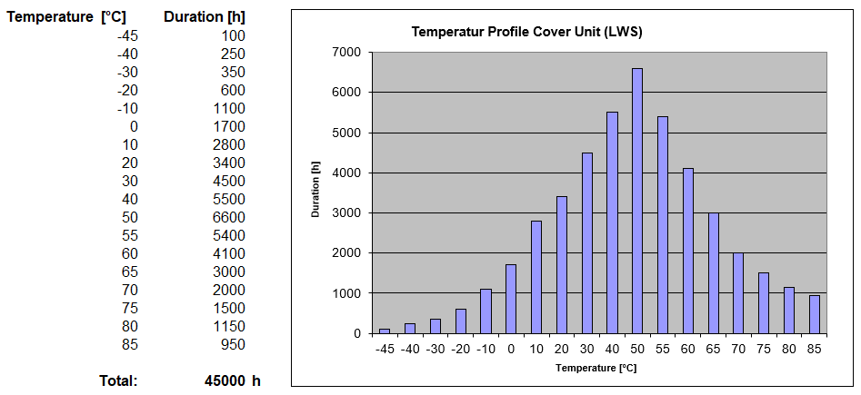

Test conditions for the Accelerated Lifetime Test (see chapter 7.4.6.) shall be derived from this profile.

# Mechanical properties

## Installation space / Mechanical interface

The installation space and mechanical interface is defined by the 3D-model`s and drawings of the RFQ package. Changes according that must be clarified with the Knorr-Bremse R&D department.

## Plug connection

The cover unit with integrated sensor is connected to the wiring harness of the vehicle via a 3-pole connector. To protect the sensor and the brake against ingress of water, the plug connection shall be longitudinally watertight (mating connector plugged and unplugged). Connector details are shown in the drawings of covers.

## Working range (sensor)

Mechanical working range (angle): Fully rotatable without arrestor

The sensor may need an integrated gearing mechanism in order to reduce the angle range of the threaded spindle (sensor input) of the disc brake to an angle range of the sensing element of <360° (see chapter 6.1 and 4.5).

## Strain / Endurance

The expected strain over lifetime due to normal operation is approximately:

Angular range and speed at sensor input:

Wear adjustment: 10 cycles with 5000°, angular speed 1500°/year

Reset: 10 cycles with 5000°, angular speed 360°/s

## Gearing design

The gearing mechanism integrated in the sensor has to comply with following requirements:

The gearing must be suitable to transfer the maximum angle range of 3150° at sensor input (see sensor characteristics for the different sensor variants in chapter 6.1) into an angle range that will render it possible for the selected sensing mechanism to relate the angular position to exactly one output signal value.

The design of this gearing mechanism (gearing type, reduction etc.) is up to the supplier.

## Friction Torque

The following requirements apply for the friction torque of the sensor drive:

Minimum friction torque: 5 Nmm (to prevent self rotation)

Maximum friction torque: 15 Nmm (overload protection for coupling device )

The maximum value applies for a sensor mounted to the brake system, the minimum value for a non-mounted sensor.

# Electrical properties

## Electrical interface

The lining wear sensor will be connected directly to the vehicles wiring harness via a 3-pole connector. The interfaces (pin dimensions etc.) are described and dimensioned in detail in the corresponding drawings of the respective sensor variants (see chapter 2.33 for the allocation of the Knorr-Bremse documents).

## Pin assignment

All continuous sensor variants must have three electrical connector pins. However, two different alternatives for pin definition must be realized. The two black/white sensor variants also have three electrical connector pins but only two of them are assigned. For the black/white sensors only one alternative for pin definition exists (See chapters 2.33 and 5.1).

## Pin coating

Two different pin coating materials must be realized. Some sensor variants require silver coating, other gold coating.

Pin coating for each sensor variant is described on the respective drawing (See chapters 2.3 and 5.1).

## Electrical parameter

a) Continuous sensor:

Supply voltage: 5 V ± 5%

(Stabilized supply voltage from the control unit that evaluates the sensor signal)

Current consumption: 15 mA max.

Output voltage: 0.5...4.5 V (see sensor characteristics, chapter 6.1)

Mostly linear ratio between output voltage and rotation angle

Output voltage ratiometric with supply voltage

Output current source: 5 mA max.

Output current sink: 5 mA max.

Signal precision: see chapter 6 Functional data

b) Black/white sensor (switch):

Operation Current: 10 mA ± 10%

(Stabilized current from the control unit that evaluates the sensor signal)

Maximum continuous current: 15 mA

Internal resistance: Switch closed: 125 Ω

Switch open: >100 kΩ

Signal precision: see chapter 6 Functional data

## Loss of supply / ground

Loss of power supply shall result in an output signal level below 10% of the supply voltage and loss of ground connection shall result in an output signal above 90%.

## Short circuit protection

All I/O and power lines shall withstand infinite short circuits of any input or output pin to either GND or supply voltage over the entire nominal operating voltage and temperature range. After a short circuit condition, the performance of the sensor must not be affected. The Sensor shall withstand infinite line interruptions, disconnections of sensor as well as connectors. The insulation resistance of the housing has to be >10MOhm.

## Overvoltage protection

Maximum voltage: ± 32V (60min at 65°C)

Maximum voltage: ± 45V (1 ms pulse)

## Electrical components and solder joints

* Active and passive electrical components have to be qualified according to automotive standards AEC-Q
* Lead free solder material and RoHS conforming components required
* Process qualification has to be done according to IEC60068-2-82
* Solderability according to IPC/EIA J-STD-001
* Acceptability for electronic assemblies: IPC A610 E, class 3
* The material used have to be compatible to a lead free soldering process
* Documentation for lead-free soldering has to be prepared for review at Knorr-Bremse
* Detailed description and documentation for components has to be provided, including essential data for active and passive components acc. Knorr-Bremse questionnaires
* Knorr-Bremse specification for electronic assemblies (Requirements for PCBs) Y095615 Rev.010 shall be fulfilled.
* Knorr-Bremse specification for rigid PCBs Y037150 Rev.002 shall be fulfilled.

Ceramic capacitors:

The spacing between ceramic capacitors and the PCB edge must be >3mm minimum. Single ceramic film capacitors must not be used between supply voltage and GND. This circuitry requires two capacitors connected in series, arranged 90° one to another or one ceramic film capacitor and a protection resistance in series.

## Immunity to electric and magnetic fields

The sensor and its signal accuracy must not be affected by technical magnetic fields, which occur in the environment (Requirements according to ISO 11452-8, see chapter 7.7.5).

Special attention must be paid to this topic if a magnetic sensor principle (such as Hall effect) is selected.

The sensor and its signal accuracy must not be affected by electrical fields, which occur in the environment (Requirements according to ISO 11452-2, ISO 11452-4, see chapter 7.7.3).

## Radiated emission

The sensor may not radiate any electric or magnetic fields which could be suitable to disturb other devices or components (Requirements according to CISPR 25, see chapter 7.7.2).

# Functional data

## Sensor characteristic

The required electrical output signal of the sensor versus the rotation angle (sensor input) as well as the acceptable tolerance limits are defined in the respective characteristic curves and specified in the accompanying Knorr-Bremse documents (see chapter 2.3 Sensor variants).

The angles specified in the characteristic curves are the rotation angles of the threaded spindle (sensor input) of the disc brake. Applying the gear reduction of the sensor this range will be reduced to an angle range of the sensing element of <360° (see chapter 4.5).

## Signal precision

Ratiometrical error: ≤ 5%

Resolution: ≤ 0.1°

Noise: ≤ 20mV

Response time: ≤ 10ms

Maximum deviations of the sensor signal from the defined head curve (5V=100%):

Due to hysteresis: ± 0.3%

Due to temperature drift: ± 0.3%

Due to magnetic fields (1000 A/m): ± 0.3%

Due to wear over lifetime: ± 0.2%

## Failure recognition

A defect or damaged sensor (continuous type) shall have a defined state for failure recognition, i.e. a signal value of less than 0.5 V or more than 4.5 V.

# Validation Tests

## General

The tests (chapter 7.3 - 7.7.57) are executed by the supplier. By the tests described in this section the supplier demonstrates that the required parameters are tested. All the tests have to be passed. The test reports are provided to Knorr-Bremse. If needed the supplier has to define additional tests to demonstrate that the performance of the sensor is ensured in all circumstances. The responsibility for the fulfillment of the requirements of this specification is not affected by the tests. On request the supplier enables the participation of Knorr-Bremse at the validation test. All test must be performed in fully mounted cover unit. Further details may be given in a separate test document.

In addition the cover unit with sensor has to pass the release tests on brake system level performed by Knorr-Bremse (s. chapter 7.88). The sensor must withstand these tests undamaged and fully functional.

## Standard test requirements

During the tests, no unit is allowed to fail. If not explicitly specified a failure is defined as an event where the cover unit and the sensor does not correctly meet the requirements of the specification or is damaged/transformed into a state where Knorr-Bremse doubts the fulfillment of these requirements over lifetime.

All test objects must be functionally tested before any other tests are performed. The product requirements of this specification must be fulfilled at all times. The correct functionality of each cover unit and sensor will be tested before and after each test. This includes all functions of the cover unit e.g. mechanical, visual, electrical etc. Head curves are to be recorded. If not stated differently the sensor signal is to be measured and recorded during each test. Details of the signal measuring may vary depending on the individual tests.

Any test object may be checked for compliance with these product requirements at any time during the tests.

Unless otherwise specified the tests may require to attach the cover unit or sensor to an adequate adapter that corresponds to the installation conditions in the brake of the vehicle.

The test conditions should be as given below if not specified otherwise:

Ambient temperature: + 20 - 25 °C

Humidity: 45 - 75%

## Climatic tests

The sensor is connected with the electrical supply during the tests, unless otherwise specified. The specimen shall be visually inspected and electrically and mechanically checked.

### Dry heat test / High Temperature

Test according to IEC 60068 - 2 - 2

Upper test temperature 100 °C

Test duration operational (Power supply) 72 h

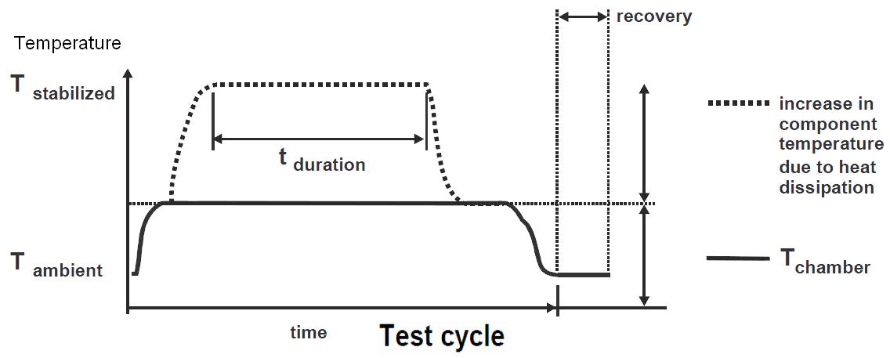

### Cold test / Low temperature (with storage)

Test according to IEC 60068 - 2 - 1

Lower test temperature -40 °C

Test duration operational (Power supply) 72 h

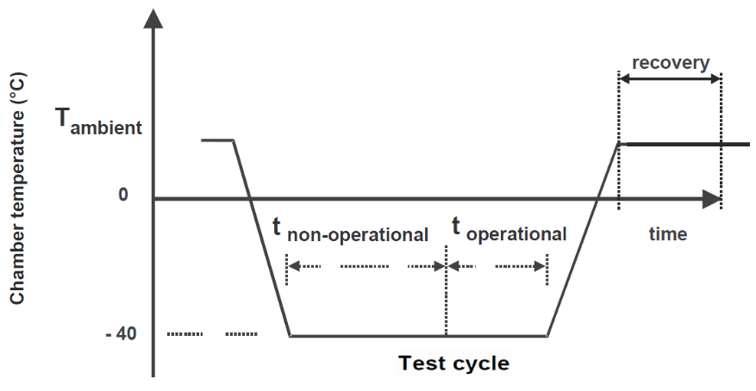

### Thermal shock

Test according to ISO 16750 - 4

Lower stressing temperature -40 °C

Upper stressing temperature +85 °C

Exposure time 60 min

Transient duration < 30 s

Number of temperature cycles 1000

### Leakage test / Ice water shock test

Test according to IEC60068-2-14 Nc

Lower stressing temperature (water temperature) 0 °C

Upper stressing temperature 85 °C

Holding time 0.5 h

Transition duration < 20 s

Splash duration 30 min

Number of temperature cycle 100

The Test is concluded with a visual inspection that no moisture has penetrated into the sensor housing.

### Damp test, static

Test according to IEC 60068 - 2 - 78

Duration Test cycle 24 h

Temperature high 40°C

Humidity high 93 %

### Damp heat test, cyclic

Test according to IEC 60068 - 2 - 30

IEC 60068 - 2 - 38

Preconditioning:

Upper test temperature / humidity 55°C / < 20%

Duration preconditioning >24 h

Duration Test cycle 24 h

Humidity high 93 %

Humidity low 80 % - 96 %

Temperature high 65 °C

Temperature low -10 °C

Time T transition 2 h

Time T duration > 3 h

Time H duration > 4 h

Recovery 2 h, 23 °C, 60 %

Number of cycles 10 cycle

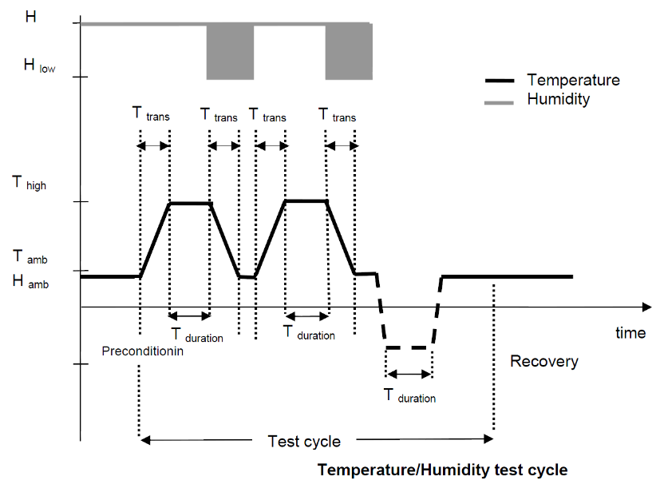

### Thermal cycling test

Pre-aging, test is also included in accelerated lifetime test.

Test according to IEC 60068-2-14 Nb

Lower stressing temperature -40 °C

Upper stressing temperature +85 °C

Exposure time 60 min

Temperature gradient < 1 K/min

Number of temperature cycles 100 cycles

### Storage test

Test according to IVECO 18 - 2252

Lower test temperature at power off -40°C

Upper test temperature at power off 110°C

Temperature gradient at power on < 10 K/min

Recovery 2 h, 23 °C, 60 %

### Temperature step test

This test shall prove if the sensor system fulfills its required function within the specified range of temperature. The increment of the temperature is 5°C over the whole temperature range (- 40°C up to 85° C). For each step the output signal has to be measured over the whole input angle range and the accuracy has to be monitored. Rate of temperature change: 1°C per minute. At each temperature step the sensor has to be completely tempered

Temperature tolerance: +/- 2.5°C at each specified temperature.

Period t1: test time (complete function test)

Period t2: total period (tempered time + period t1)

Number of cycles: 2 cycles



## Mechanical tests

The sensor is not connected with the electrical supply during the tests, unless otherwise specified.

The cover unit will be mounted on an adapter. All mechanical tests have to be performed including the adapter.

The specimen shall be visually inspected and electrically and mechanically checked.

### Resonance test

Test according to DIN 40046

Frequency range 5 Hz - 2000 Hz

Acceleration 20 m/s2

Sweep rate 1 octave/min

### Random vibration test

Test according to IEC 60068 - 2 - 34

Frequency range 5 Hz - 2000Hz

Test duration per main axis 50 h

RMS 161 m/s2

The results of the resonance test (7.4.1) shall be taken into account. Frequencies with big significance shall be added. Test will be performed along x,y,z axis.



### Sinus vibration test

Frequency critical frequencies of 7.4.1

Acceleration 5 g (g = 9.81 m/s2)

Load cycle 107

The sensor signal does not have to be measured during this test. Connector has to be attached.

### Shock test

Test according to IEC 60068 – 2 – 27

Peak acceleration (Test1, Test2) 500 m/s²

Duration of nominal pulse 11 ms

Pulse shape half-sine

Number of shocks per main axis and temperature 10 positive + 10 negative

Pass/Fail: According to ISO16750-3 Chapter 4.33. Hidden damages are not permitted. Minor damage of the housing is permitted as long as this does not affect the performance of the device. Proper performance shall be proven following the test. Functional status shall be class C as defined in ISO16750-1

### Drop test/ Mechanical Shock

Test according to ISO 16750 – 3

IEC 60068 - 2 – 32

Drop height 1 m

Orientation in the 3 sensor axis

Number of drops 1 drop per sensor

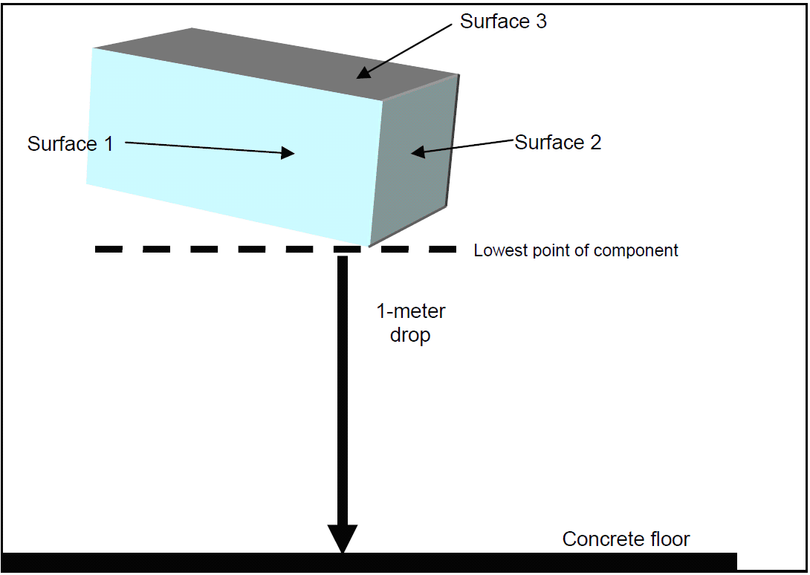

Pass/Fail: According to ISO16750-3 Chapter 4.33. Hidden damages are not permitted. Minor damage of the housing is permitted as long as this does not affect the performance of the device. Proper performance shall be proven following the test. Functional status shall be class C as defined in ISO16750-1. The sensor signal does not have to be measured during this test. Connector has to be attached.

### Accelerated Lifetime

A statistical approach (success run method) is used to calculate the required test time. This is necessary to ensure the target life time with a defined probability using a defined number of samples. In order to achieve feasible test times, the test is accelerated by increase of temperature (T2) acc. to the Arrhenius equation.



Ea: activation energy: 0.8 eV

k: Boltzmann constant: 0.00008617 eV/K

T1: field temperature: temperature profile acc. Chapter 3.4

T2: test temperature: resulting from temperature profile

Resulting Test time depending on test temperature

Functional Status shall be class A.

### Degree of protection

Test according to ISO20653

Protection class IP6K9K and IPx8

Test to be performed with the sensor attached to an adequate adapter.

### Chemical resistance

Test according to Y421468 KB document (related to ISO16750-5)

### Fire resistance test

Test according to DIN EN 60695-11-10 / UL 94: HB

The sensor signal does not have to be measured during this test. Connector has to be attached.

### Screw and service test

A screw service test must be performed according Y364100 with 3 different customer plugs and screws. The different type of screws and plugs for this test will be handed over from Knorr- Bremse.

## Endurance test

The specimens are stimulated at the input port with a typical course of rotation angle and speed. After the test the sensors shall be investigated for mechanical functionality with special attention to areas of great mechanical wear (e.g. bearing etc.) as well as electrical functionality according to specification.

The validation test has to assure the requirements in chapter 4.4. Definition of test set-up and parameters should be done together with Knorr-Bremse.

## Electrical Loads

Electrical loads is part of ISO 16750-2 (2006) and applies to electric and electronic systems/components for vehicles. It describes the potential environmental stresses and specifies tests and requirements recommended for the specific mounting location on/in the vehicle. The specimen shall be connected by a cable with minimum length of 1,5 meter and cross-section ≥ 1mm².

### Disturbances by conduction and coupling

Test according to ISO7637-3

### Overvoltage

This test simulates the condition where the generator regulator fails so that the output voltage of the generator rises above normal values.

**Test at T = 65°C**

Apply a voltage of 32 V for 60 min to all inputs of the specimen.

The functional status for the specimen shall be minimum class C as defined in ISO 16750-1.

**Test at room temperature**

Apply a voltage of 45V for 1ms ± 10 % to all relevant inputs of the specimen.

The functional status shall be minimum class D as defined in ISO 16750-1.

**Test at room temperature**

Apply pulses according to ISO7637-3:2007 Table B.2 Level 3: fast+-/CCC and slow+-/DCC

### Reset behavior at voltage drop

This test verifies the reset behavior of the specimen at different voltage drops.

Functional status shall be class C. t in ms. Us_min = 4,5 V.

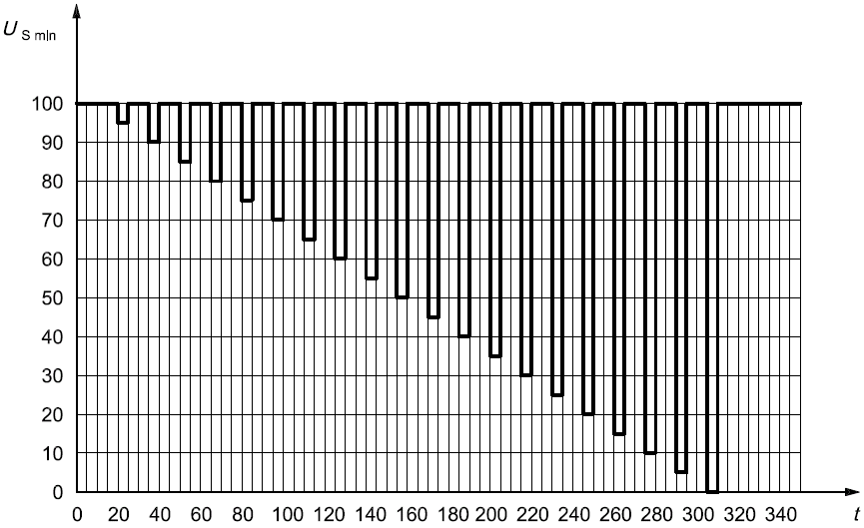

### Short circuit protection

These tests simulate short circuits to the inputs and outputs of a device.

#### Signal circuits

See ISO 16750-2

Connect all relevant inputs and outputs of the specimen in sequence for a duration of 60 s ± 10 % to USmax and to ground. All other inputs and outputs remain open or as agreed upon.

## EMC/ESD Requirements

### General

The supplier is responsible for full EMC compatibility of the sensor unit in the vehicle. Measurements on component level are necessary but might not be sufficient.

(In addition to the test listed below (see chapter 7.7.2 - 7.7.5 ) other EMC-test may become necessary in consultation with Knorr-Bremse.)

#### General test conditions

The ambient temperature during the test shall be (23  5) °C.

The test voltages shall be 5.0 0,5V unless otherwise stated.

### Radiated emission

The emission of components shall be measured in accordance with CISPR 25 class 5 in an absorber-lined shielded (ALSE) enclosure with antennas in the frequency range of 150 kHz to 3000 MHz.

### Radiated immunity/ susceptibility

This test is intended to check the immunity of the specimen to incoming radiation. Test shall be done according to ISO 11452-4 (BCI): 0.1 MHz-400 MHz, and ISO11452-2 (ALSE): 200 MHz-12.4 GHz.

### Immunity to electrostatic discharge

This test shall check the electrostatic discharge immunity of components. They are expected to be produced by operators during storage, handling, assembly and maintenance, checked with unpowered test. The ESD produced by occupants in or near the vehicle and customer service operation will be tested with powered specimen. The electrostatic discharge immunity test procedure shall be carried out using ISO 10605 for handling test (unpowered) and ISO 10605 for the operating test (powered) with the following conditions and requirements.

|  |  |  |  |
| --- | --- | --- | --- |
| **Test** | **Direct contact**  **Discharge sequence** | **Air contact**  **Discharge sequence** | **Specifications** |
| Unpowered tests  (handling test) | **± 4 / 8 KV**  On each connector pin and conductive surfaces of the equipment | **± 4 / 8 / 15 KV**  On all accessible points and other surfaces of the equipment | Supplier Test  Sequence with a series of 10 discharges for each negative and positive level (from the lowest level to the highest level)  Intervals between each discharge: 5 s minimum  Network: R = 330 Ω,  C = 150 pF |
| Requirements: functional class A after reconnection | | |
| Powered-up tests  (live and loaded conditions) | **± 4 / 8 KV**  (Equipment and remote inputs/outputs)  On all accessible points by vehicle occupants during maintenance and operation (determined in the test plan) | **± 4 / 8 / 15 KV**  (Equipment and remote inputs/outputs)  On all accessible points by vehicle occupants during maintenance and operation (determined in the test plan) | Supplier Test  Sequence with a series of 10 discharges for each negative and positive level (from the lowest to the highest level)  Intervals between each  discharge: 5 s minimum  Network: R = 330 Ω  C = 330 pF |
| Requirements**:**  ± 4 / 8 KV: FSC A  ± 15 KV: FSC B | | |

### Immunity to low-frequency magnetic fields

The sensor must withstand technical magnetic fields, which occurs in the environment.

Test is carried out in accordance with ISO 11452-8

**Operation mode:** Normal mode

**Length of harness:** maximum length of 200 cm

**Test parameter:**

AC field

Frequency range: 0.015 kHz - 150 kHz (sweep) + fixed frequencies 16 ⅔ Hz, 50 Hz and 60 Hz

Test level: Severity IV:

15 - 1000 Hz 1000 A/m

1 - 10 kHz 1000 (f/1000Hz)² A/m

10 - 150 kHz 10A/m

DC field

Test frequency: 0 Hz

Test level: Severity IV

3000 A/m

Optional: 25 mT (or threshold value when DUT becomes Status II)

**DUT orientation:** Measurement with 3 orthogonal orientations of DUT

**Test procedure:** Test can be performed either using a radiating loop (e.g. acc. to MIL STD 461F: 2007) or a Helmholtz coil pair. If using a radiating loop, place the DUT 5 cm in front of the loop. Focus point on DUT is the sensing element position. Apply the calibrated magnetic field with parameters as defined above. Perform the test in 3 orthogonal orientations of DUT. Monitor and record sensor signals.

### Impact test cover unit

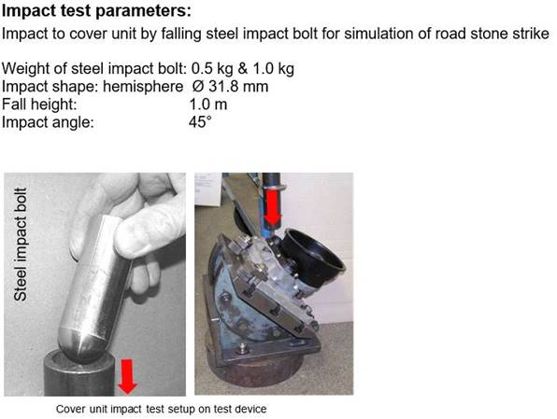

Location for the impact test (e.g. SN6/7 and SX7T cover unit)

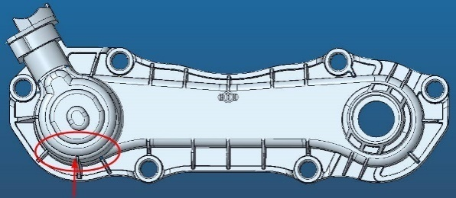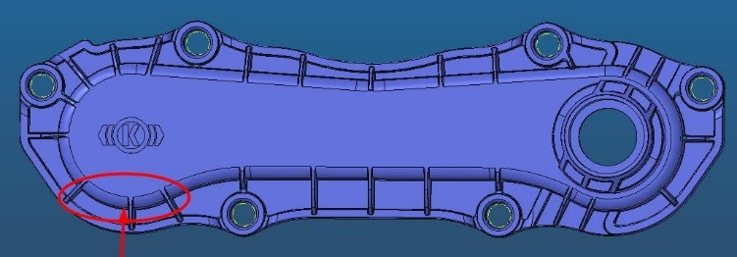

## System release tests (performed by Knorr–Bremse)

These tests will be performed with a complete disc brake system. During the tests the sensor is assembled into the cover unit which is installed on the caliper of the disc brake.

### Temperature cycling test (according Y048861)

Parameters:

Test according to DIN EN 600689-2-14

Test duration: 35 cycles (one cycle 8h)

Lower test temperature Tu = - 40°C

Upper test temperature To = + 80°C

relative humidity at To  75 - 85 %

the humidity is not regulated during the temperature change

600 applies / h=> application time 1sec. / 5sec.

released chamber size = clamping force depends on the brake typ

During the period x, the wear sensor is supplied with 5 volts.

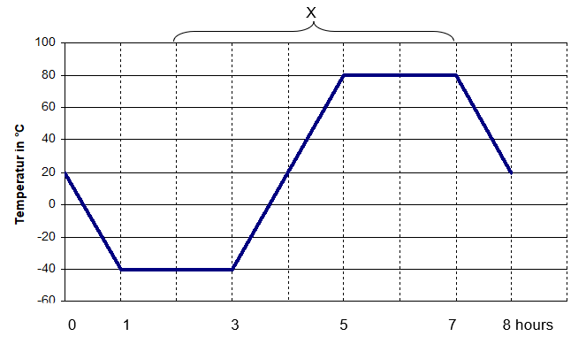

Purpose:

Evidence of the aging resistance of elastomers and plastics by rapid change of ambient temperature. In particular, a check is carried out to determine whether the tightness or firmness of the sealing elements is guaranteed as a result of the pressure difference between the internal and external pressure and what effect the formation of condensation has on the function of the brake, including the wear sensor. The component strength of elastomers and plastics is also tested at low temperatures.

### Protection test (according Y048862)

Check of tightness and adequate mechanical robustness due to cleaning-processes with standard pressure washer

Purpose:

* Functionality of the brake
* No mechanical damage
* No leakage permitted before / during and after the test

### Combination test (according Y048866)

To check the tightness, corrosion behavior and static fatigue the following test are performed in sequence.

Parameters:

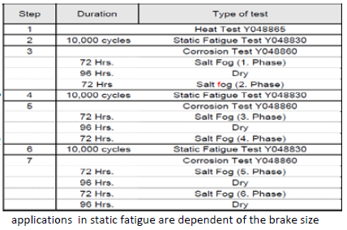

Heat test will be performed by 125°C and 0,5h.

Purpose:

* Functionality of the brake
* No mechanical damage
* No leakage permitted before / during and after the test

### Vibration test (according Y048867)

Evidence of component strength and function of the brake under vibration

Parameters:

Load cycles: 3,1Mio.

Frequency 40-30Hz sweep

Amplitudes: 13/17/20/23/26g

Actuation of the brake every 120s @ 2bar

Purpose:

* Functionality of the brake
* No mechanical damage