
College of Computer Studies

COMPUTER PROGRAMMING 1
(CCS00003)

<TITLE OF YOUR PROJECT HERE>

GRADE

Submitted by:

1X1
PICTURE

1X1
PICTURE

1X1
PICTURE

1X1
PICTURE

  Marcelo, Charles Giann L.  BSCSAI  TA02 | Pacalna, Zairyll Mikko L.  BSCSAI  TA02 |     Palaje, Adrian Paul B.  BSCSAI  TA02 |   Pascua, Lawrence Albert S.  BSCSAI  TA02
Submitted to:

Ms. Kim Giselle Bautista
Professor

Date of Defense
- Introduction

Your introduction gives a general description of your project. It can be useful in establishing your thoughts and setting out the direction you intend your project to go in. State the reasons/problems encountered why you chose the project.

- Description of the Project
This part states a description of the project – what it is all about. It should include a description of ALL the features present in the project.

.
- Objectives

The Objectives of the study includes the responses to solve the main or overall problem presented. It must be broad enough to include all aspects of the subject matter to be suited or investigated; yet it must be brief and concise as possible.

Example:
- To develop a program using C++ that enables to reserve customers their desired dates and rooms in the hotel.
- To utilize advance programming concepts such as structure, file handling and pointers to implement the system.

- Significance of the Study

This section the researchers expresses the value or the importance of the project. It is where the significant contribution of the results of the study is enumerated. It consists of explanation and discussion of the following: the rationale, timeless, and relevance of the study; who are the beneficiaries and what are their benefits; possible contribution to the body of knowledge and possible implications.

- Scope and Delimitations

The scope identifies the boundaries or coverage of the study while delimitations define the constraints or weaknesses which are not within the control of the researchers; therefore they are not expected to be covered by the study.
In other words the scope and delimitations defines what the study all about, where and when the study is to be conducted and who the subjects are or whom the study being made. Also included is a brief statement of the reason why the study is conducted and how it will be resolved. Discuss the features of the system.

- Screen Output

This should include the screen outputs of the features of the project along with detailed explanations.

Example:

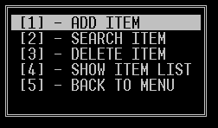
Figure 1. Menu for Item Management
Figure 1 shows the menu for item management that include the following:
- ADD ITEM – this menu will add item from the list that includes the id, name, price, and quantity available.
- SEARCH ITEM – this menu will ask the user to enter the id to be searched from the item list.
- DELETE ITEM – this menu will ask the user to enter the id to be deleted from the list of items.
- SHOW ITEM LIST – this menu will list down all items from the list.
- BACK TO MENU – this option will go back to the main menu of the program.

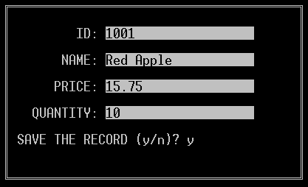
Figure 2 presents the add entry of the item. The system will ask the user if he or she wants to save the record.

- Source Code

This should include the source code of the project. Kindly put COMMENTS in each of the block of code about its functionality.

Example:
//this code enables to check if the entered data is valid or not

- Conclusion

Discuss the importance of understanding and applying advance programming concepts in development of systems using C++ programming language.

