LP2A report
Fernandez Charles
Cortier Baptiste

In this report we will explain how we chosed to models the Skyjo with java. To implement it we have make 7 class. We have cut the game in 4 different object. The first one is obviously the deck, to implement the deck we have make one class (Deck.java), but we also have another version of the deck that is more « memory friendly » however we will not talk about it (But still it is available in the file). The second object which work a bit like the deck is the discard, for this we also have only one class (Discard.java) . The third object that we will talk about will be the board, in this one we have use 3 different class. The first one is BoardCard.java it will allow us to have a card element. The second one will be BoardSet this one will represent the board of each player. And the last one BoardArray, which represent the boards of every player in the game. Then the last object that we have chose to implement is the point manager, with the PointManager.java, his name is explicit. This one will allow us to manage the point of each players. Then our last represent the game, it will glue up every object we have so we can finally models the skyjo game (Main.java).

The boards :

In this part we will deal with the class that permit us to models the boards in front of every player. Firstly we will talk about BoardCard this will represent the card of every player, then we will discuss about BoardSet this on represent the board in front of each player. After that we will finish with BoardArray this last class will implement a « board array » that will represent every players board.

BoardCard :

As we said before the goal of the BoardCard class is to implement the card object in the game, this class is very simple but central. Because our entire project will be articulated around it. That’s why we chosed a simple structure, so manipulating it will not be hard. So for us what define a card ?

-The value it represent obviously so going from {-2,-1,0,1,2,…}
-Wether it’s hidden or not.
So we chosed to models it has an int for the card value, and a boolean for the status hidden or not. So now that we have our structure, we can make simple getters and setters to manipulate this object. There are no algorithm in this class, nothing fancy. The complex things comes with the complementary classes.
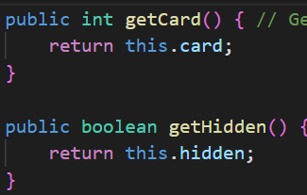
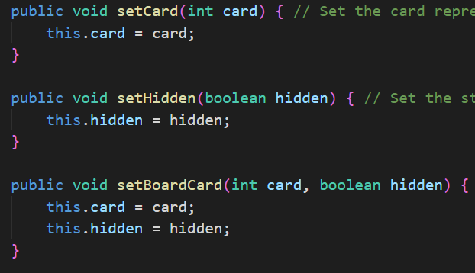

BoardSet :

This class will models the board of one player. It will use our new class BoardCard and because the a board is some sort of bidimensionnal array of card in skyjo game. We chosed to represent a board as a bidimensionnal array of BoardCard. This seems like a natural approach, but we needed complementary variable to know the size of this board. Because in the skyjo board are not 4x4 the entire game. They can be reduce that why we have a columnSize variable and a rowSize variable of type int :
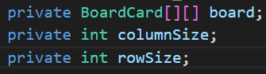

To begin to implement this class we needed to make a constructor that reproduce what we do when we play skyjo. When a player want to make a deck he take the deck and he display card in front of him. He dispatch them so they look like a bidimensionnal array as we said before. So we made thing so the constructor take the deck, draw 16 card inside of it and put them in each box of our bidemensionnal array. Note that he do no just put the value of the card he got from the deck, he make a new BoardCard that he construct with card he has draw in the deck. And the default true value for hidden because when we draw the card to make the board in skyjo they remain hidden has well ;
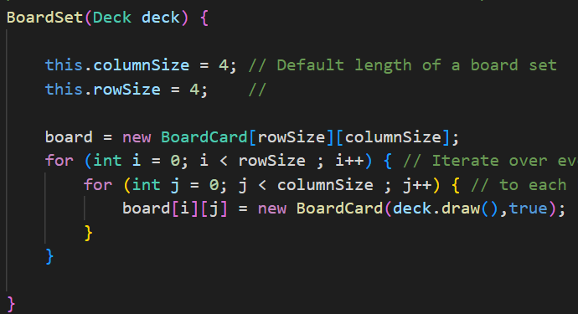

To parcours every single box of our array we just use two loop with the second one encapsulated in the first one. This is basic, the first loop iterate over every row of the matrix, and the second loop iterate over every column. We need to understand because this is the way we will manipulate our board inside almost every algorithm..

Then we have made 3 differents getters, we will not show them but they are of course inside our code. We have one of them that get us our board, another one that give us the number of column our matrix has. And the last one give us the BoardCard inside a specific box of the board.

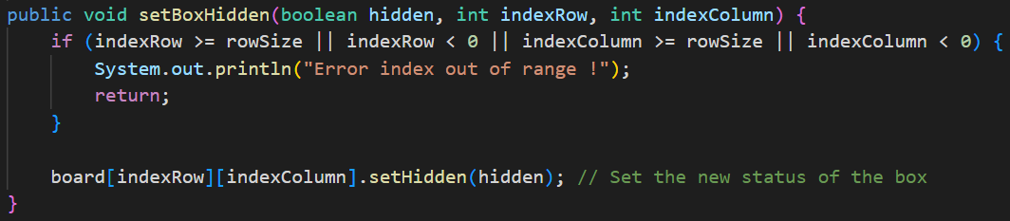
We have only one setters in this class, he is very important because he will allow us to change the status of a precised BoardCard element in the board (wether it’s hidden or not). It is very important to be able to make this because in the skyjo when we draw a card and we switch it or not we need anyway to reverse a card. So have a method that permit us to change the status of class, permit us to reverse a card.

Note that this method has an aquisition control but it’s useless because our program make the things so we are never out of range(It is here for development purpose). What we do in this method is that we take a specified BoardCard element from our board. And we use the setHidden method from BoardCard to change the status of the card.

Now that we have dealt with the getter setters and constructors. We can deal with the methods, there are 7 of them. We will go from the easiest to the hardest. Let start with the isEmpty() method her name is explicit, this method check if a board is empty or not. To know that it’s very simple we only need to check if the columnSize attribut from BoardSet is equal to 0, a matrix that has 0 column is obviously empty :
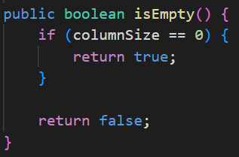

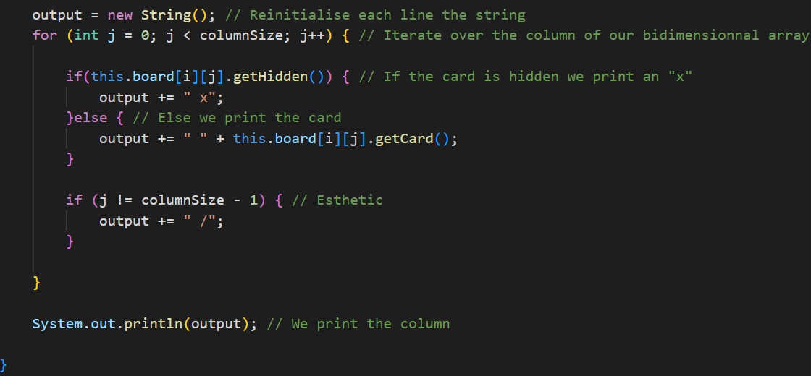
Let’s talk about another method displayBoardSet(), this method is very important because it allow us to display in the powershell the board. To do that we go through every box of the matrix, with our two loop. For each box we check the status of the BoardCard element, if it’s hidden we increment to a string a « x » because we can’t show the card. If it’s not we get the value of the card from the BoardCard element and we increment it to the string. When we have parcoured the line we print it and we reinitialise the string for the next line.

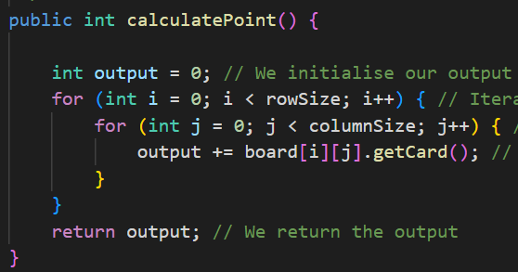
The next method we will see is calculatePoint the goal of this method is to calculate the number of points the board represent. It will be usefull when we end a skyjo round and we want to calculate the points every player scored. To do that again we will parkour every box of our matrix with two loops. We will increment every card value of every box into a variable and return this variable. We don’t pay attention to the status of the BoardCard element because we assume it’s the end of the game so every card must be reverse to count the point :

Now we will look out a very similar method, boardNotHidden. With this method we will know if every card of a board are reversed or not. This is a very usefull method because if every card of a board are revealed in the skyjo then we need to stop the round after every has play. Same as calculate point we go through every box of our matrix with the two loops. If we encounter one BoardCard that is hidden that mean, the entire board is not revealed so we return false. If we never encounter an hidden card then we return true. Because that means every card are revealed :
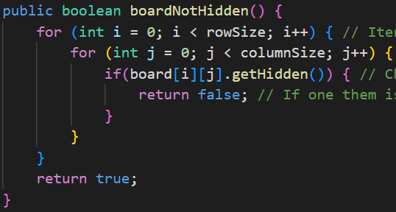

Now that we will go through a very important method that will allow us to switch a card from the board with a chosed card. Her name is switchCardBoard and it will allow us to exchange card with deck or the discard. First this method check if the position gaved in argument is not out of range(Again this acquisition is useless because our program manage everything but for development purpose it was very usefull). If it’s not then it’s affect the card in argument to the position chosed and return the card that was in the box. If this card was hidden then we set the status of the BoardCard element to not hidden because now that we have made the switch it’s not hidden anymore. And we have return the card that was in the box to facilitate the increment on the discard :
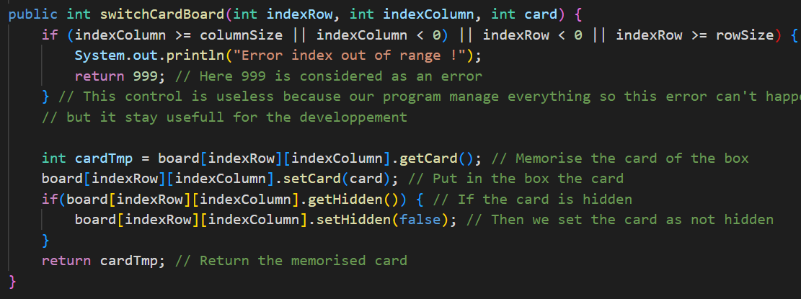
The two last methods that we will see work by pair even if they don’t make implicit call to each others. They are here to implement a very important rule in the skyjo, that is that when in the board there is a column entirely revealed and with the same card we simply erase this column from the board. To make that we used two methods first one checkColumn it’s purpose is to check wether a column got all her BoardCard element revealed and with the same value or not. And eraseColumn that as it name say will erase a precise column from the board.

Let’s begin with checkColumn, to iterate over a precise column we only need the index of the targeted column that is logic because this index will never change whereas the row index will. We memorise the first card of the column if she is not revealed then we return false because the column doesn’t match the requirement. If she is revealed we iterate over the rest of the column, to check if the card are the same and revealed. If we encounter one card that is not revealed or the same we return false. If everything is perfect then we logicaly return true.
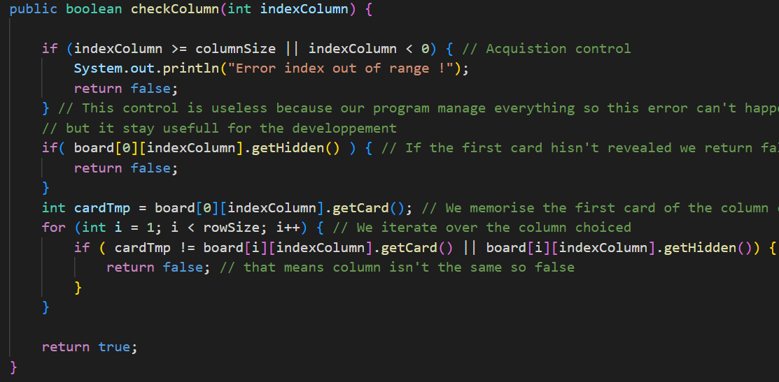
Now go look how erase column it’s a bit more complexe than just say this column is dead. What we do in real life is we reduce the matrix of one column. So the way we wanted to represent it was by making a new BoardCard bidimensionnal array but with a columnSize reduce by 1 (That is not said but the programme make the thing so this method is never called when a board is of size 0). In this new array we will copy each of the box from the old array that are not part of the specified column. Then we will affect the board as the board of the BoardSet element and we will let the garbage collector handle the ancient board :
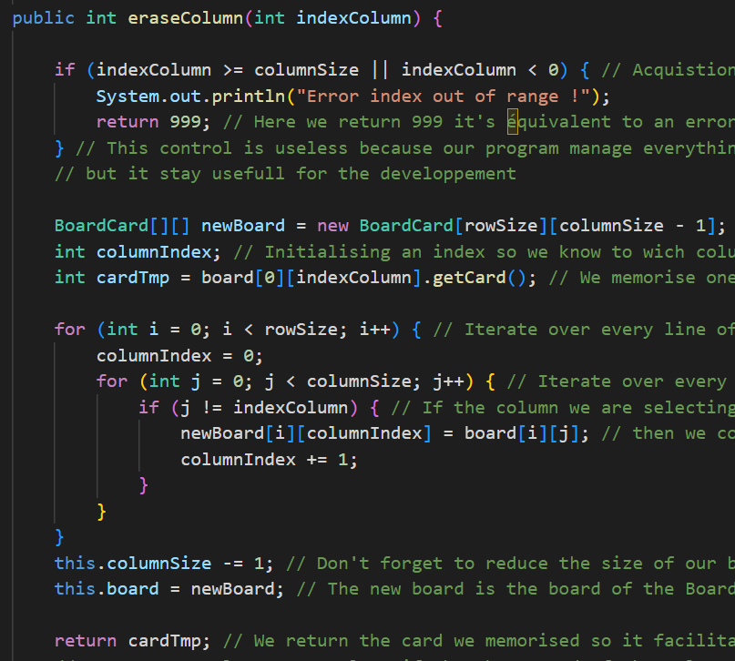

BoardArray :

Now that we are able to models the board of one player, we want to be able to make it but for multiple player. Because you don’t play skyjo alone. So to make that we have chosed to implement a new class BoardArray that will represent the boards of every player in the game. So the main element of this class will be the boards array. And another argument that we thought was really important for this class was the number of player so in someway the length of the array. At first we wanted to models the array of boards with a classical array like BoardSet []. But we have already done something similar for the bidimensionnal array in the previous class. So we through it would be nice to explore others structure that’s why we chose to use an extends on LinkedList type. It’s doesn’t make the code a lot more complex, and it was a nice way for us to explore another structure :
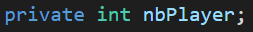

We have seen the structure of this class now let’s look at the constructors of this, tipically this class only need a number of player and a deck to be initialised. The deck so we can initialise new board and the number of players so we know how much boards we need to initialise and add to our linked list. So we came up with this :
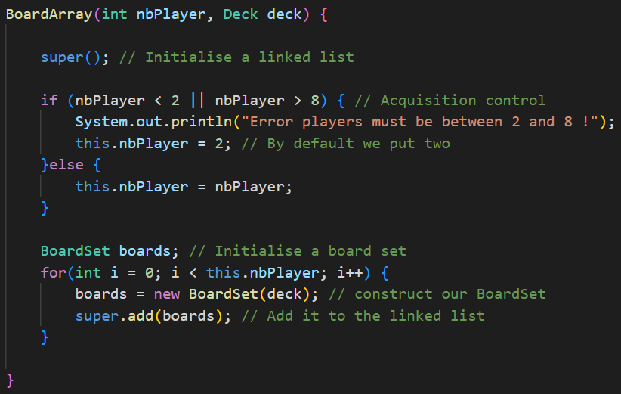

This class doesn’t has any getters or setters method because there a no others classes that use BoardArray and we the modification are applied to the BoardSet inside of BoardArray so there are no element that will really need BoardArray to modify it.

We can already go through the methods.There are 4 of them, like in BoardSet we will start with the easiest. Let’s start with isNotHidden, this class will check if one of the boards in the array of board s we got, got all his card revealed. So we will iterate through every boards of our linked list and check if a board is entirely revealed with a method from BoardSet if we encounter a board, that is entirely revealed we return true if we never encounter a board like this we return false :
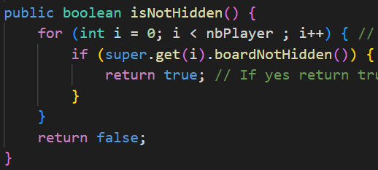

Let’s keep going with displayBoards, this methods purpose is to display the board of every player. So we will iterate through every board of our linked list and use the displayBoardSet from BoardSet on it :

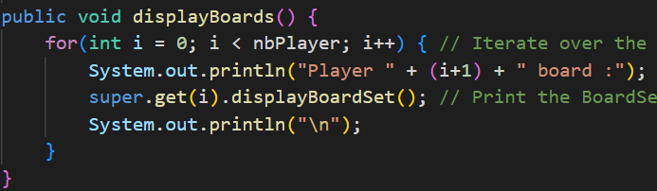

A method very similar would be displayTargetBoard this method is very simple it will just use displayBoardSet from BoardSet on a specified target but it will add up esthetic that is not present in BoardSet :
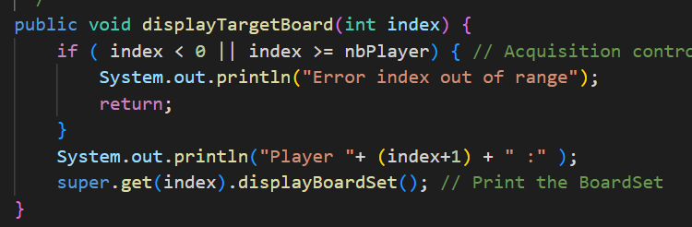

And now let’s see the last method of our card that is cardReverse this method permit us to reverse a specified card from the boar of a player. It allow us to models a new action of the game. Because in the skyjo when we draw a card and we don’t want to exchange it we need to reverse one of our card. This method return a boolean to let the program now if the position entered is in range or not or if the player has selected a card that is already reversed. If it’s not the program will keep asking the player new coordinate. When everything is perfect the program will reverse the card specified with methods from BoardCard and BoardSet.

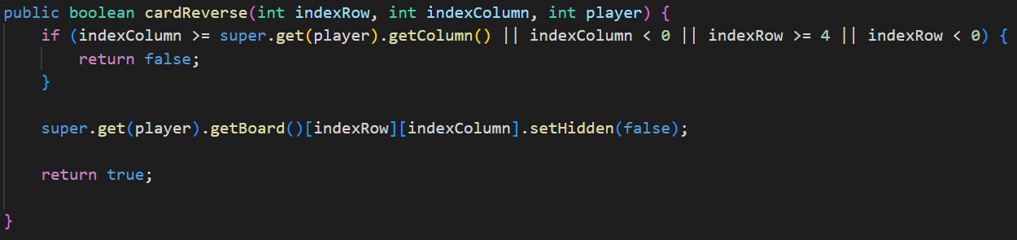
Class Deck
This class represent a stack of cards. It is set and shuffle in the constructor. We use the default collection’s method named shuffle.
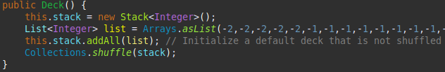

It has also 5 methods including setStack, getDeckCard, isEmpty, draw and toString.
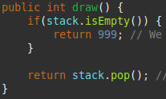
The method setStack allows to upgrade the deck as the game progresses, when the players pick a card in it. The method getDeckCard return the size of the stack associated. The method isEmpty return true is the stack is Empty and false else. The method draw pop the top card of the deck and return the number corresponding of this card. Firstly, it’s important to check if the deck is empty and return 999 because. There isn’t card with this number, so, it’s possible to know if si empty easily. If it isn’t empty that return the top card of the deck. For that, we use the default stack’s method named pop.

Class Discard:
The class discard is similar to the deck’s class. It represents by a stack which is empty at it initialization. It has also 5 methods including peek, isEmpty, push, draw and toString. The 2 methods isEmpty and draw are exactly the seems than the 2 methods of the class Deck. The methods peek return the value of the card on the top of the stack, we use the default stack’s method named peek. The method push add a new card in the stack. We use the default stack’s method named push.
The main class

For the main we need different method to respect the rule's game. Therefore to do that we have create different game tools which allow to play in the console. Each game tools have their own class.

Class StartGame:
This class allows have all of the methods necessary to start a game. It have two private variable; a char choice which is the choice of the user and a Scanner named scan, which define int the main method of the main class, which allows to recover what the user enter in the console.
Firstly, there is a constructor which set the variable scan. It also initialize the variable choice to the default value of the char in Java.
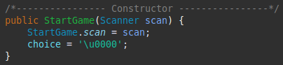

Secondly, there are 3 methods to start the game. The first one, named lauchGame, ask to the users is they want to play or not. So, that create a loop for knowing. It check all of the possibility to be sure than the input of the user is correct. That's why, there is a try/catch in order to do not create errors. The users have to enter ‘y’ or ‘Y’ for yes or ‘n’ or ‘N’ for no. So, these 4 choices are the only answers than the user have to enter and which are accepted by the methods.
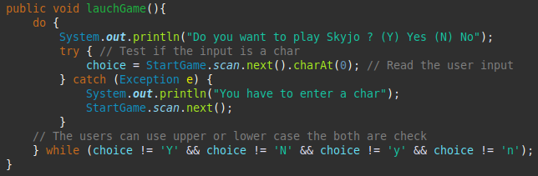
The second method, named hasSayYes, return a boolean to know the user’s choice. It return true, if the user has entered y’ or ‘Y’, else it return false.
The third method, named askNumberOfPlayers, is a static method which allows to enter the number of players who want to play, but a rule of the game obligate to choice a number of player between 2 and 8. To do that, there is a do while loop which continue while this rule is not respected. Moreover, there is a check-up try/catch to be sure than the input of the user is an integer, that allow not to have errors if it's not the case. With, we are sure than the user can create an errors, if he enters a char.

When the game was create the players the deck, the discard, the boards and the point system was initialize. Firstly, each players choice 2 cards to start. Therefore, the static method, named firstChoiceOfEachPlayer, of the class PlayMethods is call to ask of each players which cards they want to return. This method is a double for loop the first for each player and the second for the two first cards. The board of the player is print and he choice the row and the column of the card. After his choice, we check, if the card is already return or not. In the first case the player choose and other car, and in the second case the card was return.

Class ChoiceCard :

This class allows have all of the methods necessary to ask to the players which card he want to discover. To do that, there are 3 variables; 2 integers corresponding to the row and the column, and the last one is the scanner.
This class is called when the players have to choice a card.
Firstly, there are 2 getters for the row and the column to return the values of these 2 variables.
Secondly, there are 2 methods, which are similar, named scanRow and scanColumn. It recover the column in which the player want to play. It create a do while loop to be sure than the number enter by the play is between 1 and 4, because he can't go out of the grid play. Moreover, there is a check-up try/catch to be sure than the input of the user is an integer, that allow not to have errors if it's not the case.

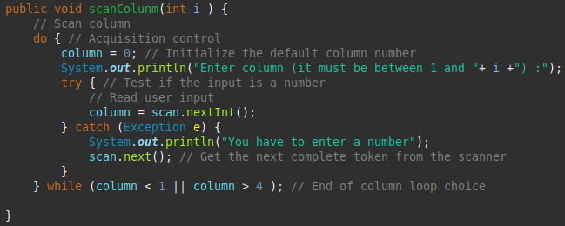

Back to the main class,
After that, the main while loop, or game loop, was start and check after each iteration if a player has one hundred point. In this case that player has win, else the game continue. Every players play turn by turn and they have the choice between several case/page to do what different action like draw a card in the deck or the discard, look the board of other player and look the points. To do that we was different case associate to a page which print and/or do what the player want.

Class Pages

This class contains all of pages necessary. So, we have 4 pages. This class is linked with and other class named CaseOfTheMainSwitch which, as it name indicates, contains all the different case of the main switch and allow to do the actions than the user want to do.
The first, named page1, print the board of the current player, check the peek of the discard in order to print it if there are cards. Afterwards, all of the different choice that the players can do are printed; Draw a card in the deck, Draw a card in the discard, Look every players boards and Look points.
The second, named page2, print the boards of all the players and print the possibility of choice of the player; Look your board and look points.
The third, named page3, print the points of all the players and print the possibility of choice of the player; Look your board and Look every players boards.
The fourth, named page4, print the board of the current player and propose him to switch a card. So, he choice a card in his grid with and object ChoiceCard. The method return an integers array of the row and the column.
To illustrate that, this is the page 4 as example :
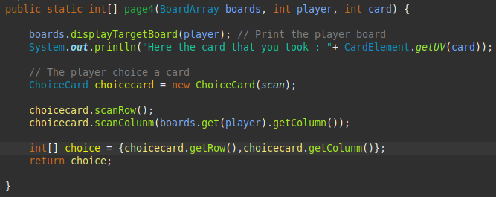
Class CaseOfTheMainSwitch:
This class is linked with the class Pages explain just before. It use all of the different pages defined. The first case, named case1, print the page 1 and recover the input corresponding of the choice of the player. A do while loop is create to be sure that the choice do by the user corresponding to a possible choice. Moreover, to be sure to haven’t error, there are a try/catch to check if the input of the player is an integer. After, the chose is verified to by the methods acquisitionControl of the PlayMethods.
The second and the third cases are similar than the first case the only difference is the page printed which are respectively the page 2 and the page 3. Also, the do while loops are only between 1 and 2 because there are only two chose.
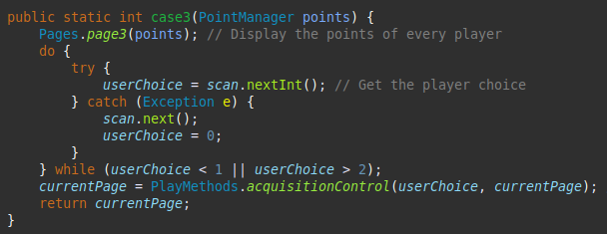

The fourth case is different than the others because a card of the deck is draw and the player have the choice to switch or not. For that, a do while loop is create and run while the choice is different of y, Y, n or N. Also to be sure that don’t create errors there is a try/catch. If he want to switch the page 4 is print and do what it has to do. After, the card older card of the player is push in the discard. If he don’t want to switch he can choice a card which isn’t yet revealed. The card don’t pick is push in the discard. To finish, this method return an integer array corresponding of his choice.

Back to the main.
For the last case, in the switch’s main there are specific rules to know is the player has win.
At the end of a round, the points of each player are calculate.

Class EndOfTheGame:

This class contains two static methods which are uses at the end of the game.
The first method, checkLowest, check if the player that finished first has the lower point. For each players a for loop check if a player has less points that the player who has finished. It return a boolean which is true if the player that finished first has the lower point and false else.
The second method, named victoryScreen, display the points of each players and the player who has won. With this methods the users can replay if they want. For that, a do while loop is create and run while the choice is different of y, Y, n or N. Also to be sure that don’t create errors there is a try/catch. If they want to restart the main is called and a new game start.

Ressource package

This package contains only a propertie file with all of uv use in the game. All fields are named UVCardValue in order to easily find the cards an we print it. For exemple, the uv LP2A is assiate to the card values -1, so, the name of the field is UV-1.

