How To Open Projects:

After you have installed Greenfoot click on the greenfoot icon and you should see this screen.

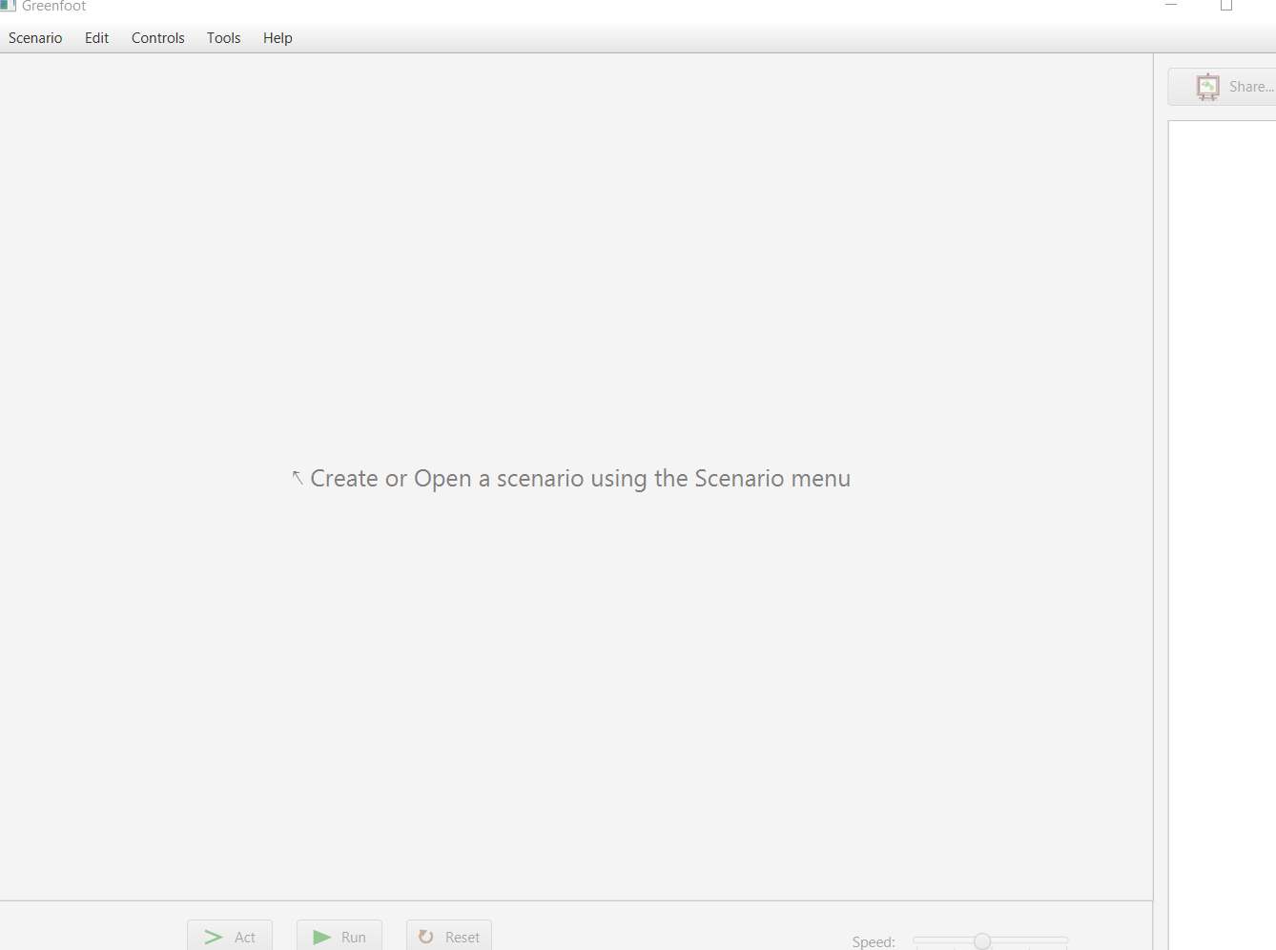

Click on the Scenario button and chose Open.

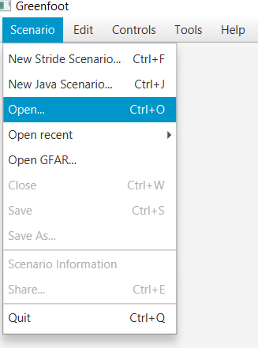

Locate the AI_Projects folder and double click it. Then select one of the project folders and click Select Folder.

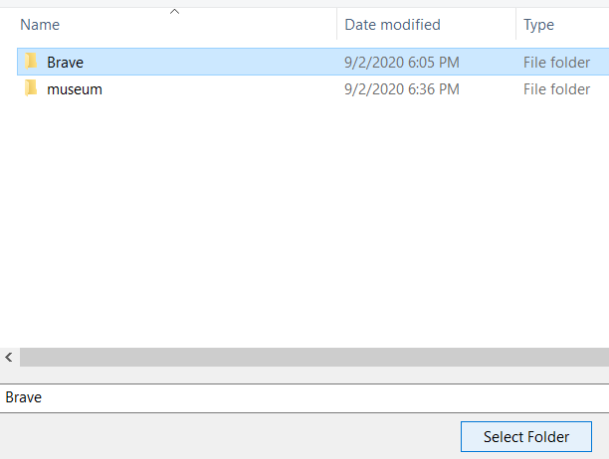

You should see this if you chose Brave.

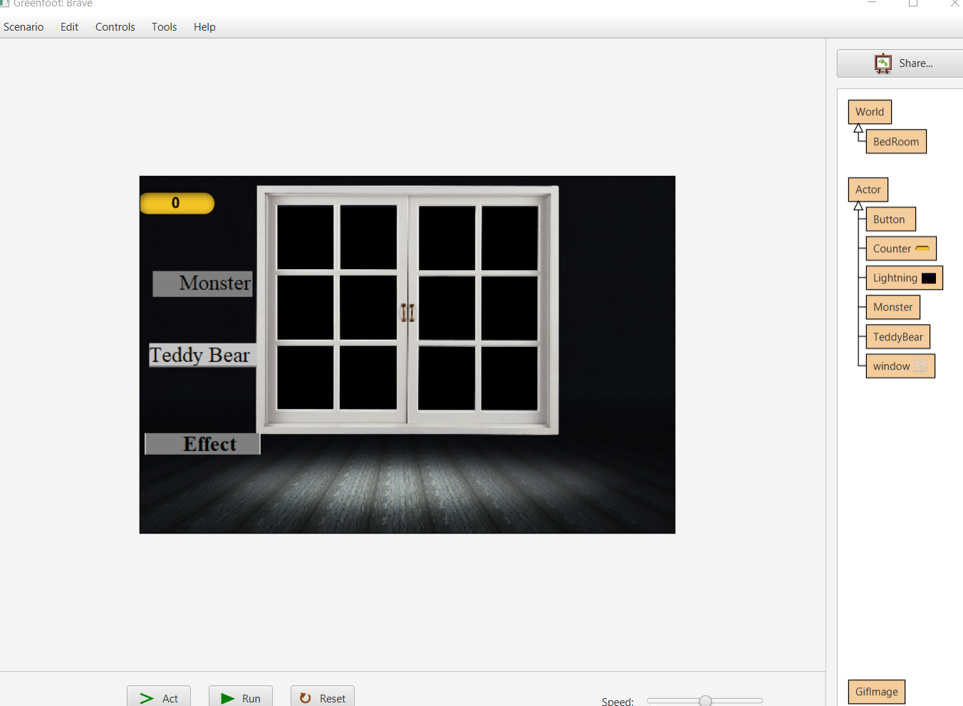

Or this if you chose museum.

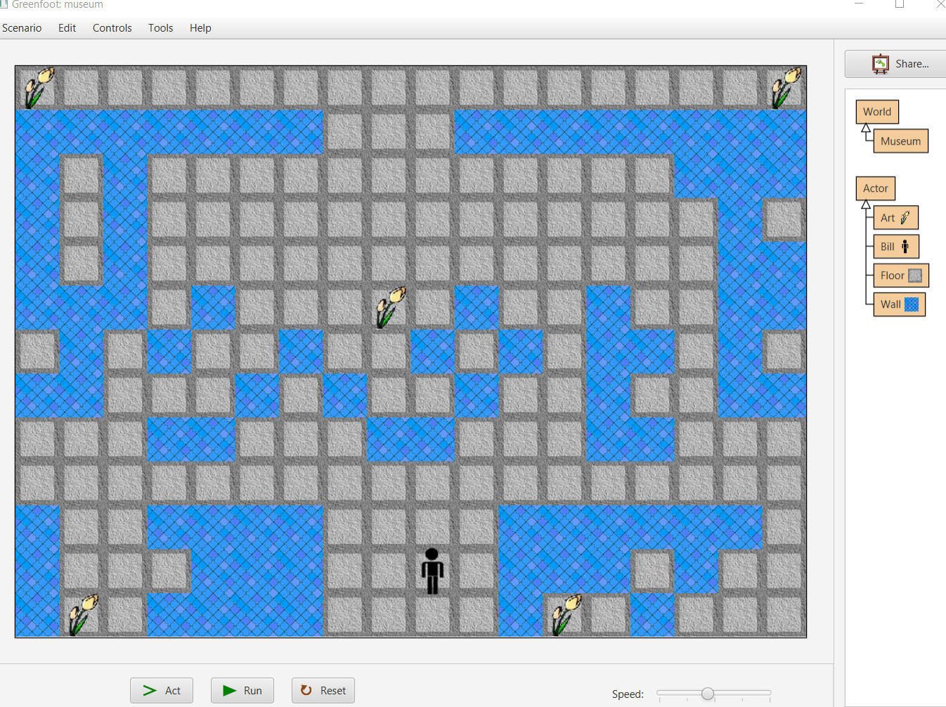

How to Run Programs:

Click the run button to start the program and reset to reset the current state of the program to the default state (what you first see when you open the project). You can pause the program by clicking run again. The programs speed can be adjusted by changing the speed bar (left decreases the speed while right increases the speed).



The source code can be viewed by double clicking the icons to the far right.

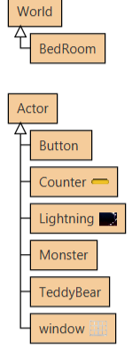 Shows icons of the Brave project