How to run Program:

Click on the run button and click on an art piece (the flower) and bill (the black figure) will travel to that location. This applies to all art pieces regardless of bill’s position. You can move bill and the art to any location while the program is paused. If you move an art piece into an unreachable area like this (far left)

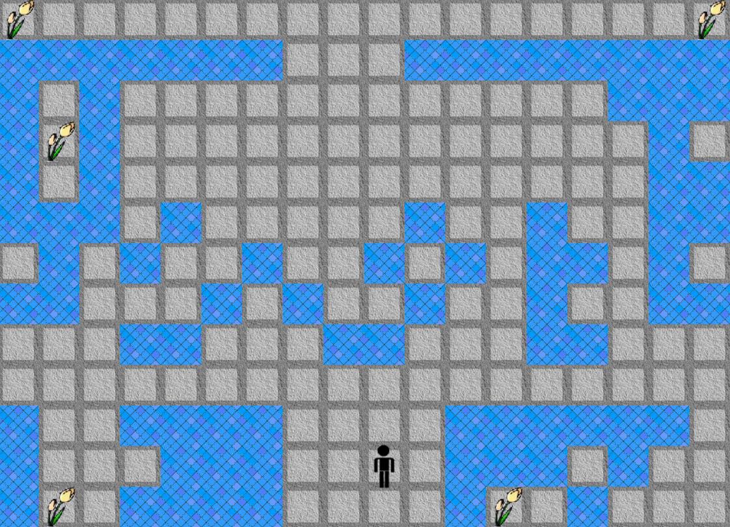

And you click on the art, bill will try in vane but will never reach it. When this occurs, you will hear a sound bite that indicates that bill couldn’t find the art piece. If you paused the program, move the art to a reachable area, clicked the run button and the art piece, bill should be able to reach it now.

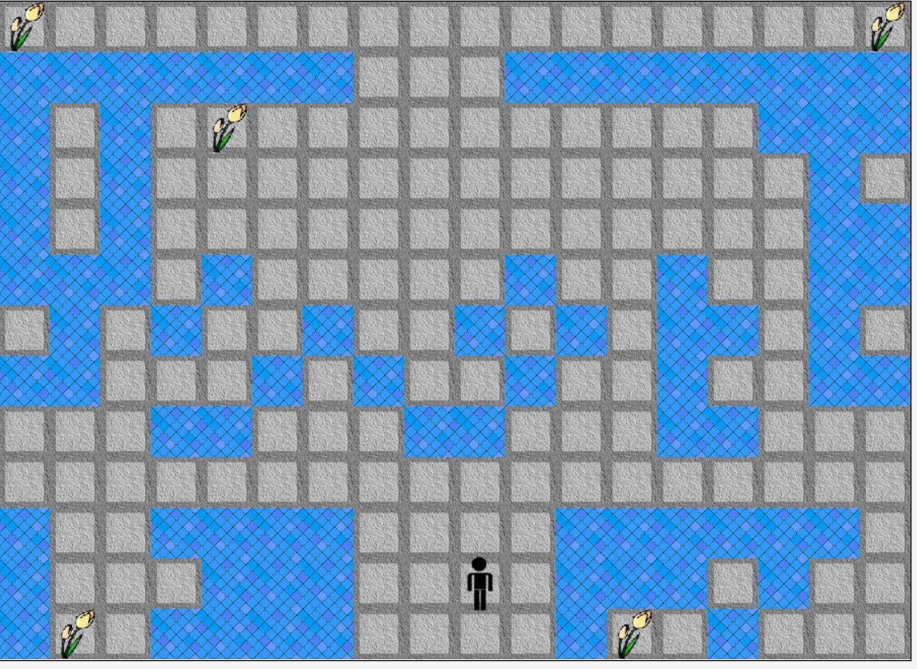

Software components:

Bill: Bill can move in eight directions and can reach any reachable art piece regardless of his location. A sound will play if he can’t find the art. Bill can be move with the mouse while the program is paused.

Art: This object can be move with the mouse while the program is paused.

Floor/Wall: These classes are merely for aseities and don’t do anything meaningful. While you can move them, it is advised that you don’t. If you make any mistakes click the reset button.