CS 340 — Advanced MongoDB Queries
Jordan Valladares | Southern New Hampshire University
Database: companies Collection: research
1. Dataset Import and Verification
The companies.json dataset was imported using mongoimport into the companies database and research collection. The terminal confirmed that 18,801 documents were imported successfully and zero failed.
Import command:
mongoimport --db companies --collection research --file /home/codio/workspace/datasets/companies.json
Verification queries:
db.research.find({"name" : "AdventNet"})
db.research.find({"founded_year" : 1996},{"name" : 1}).limit(10)
The first query locates AdventNet; the second retrieves up to ten company names founded in 1996.
Import confirmation
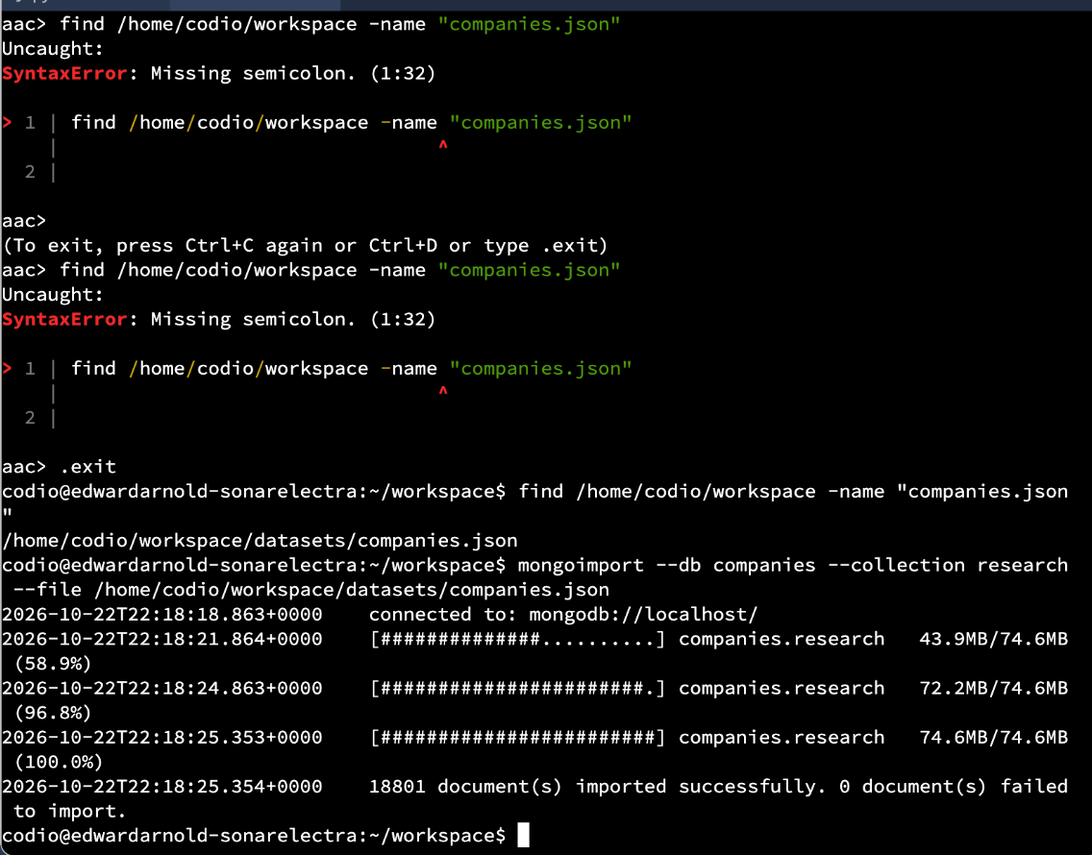
AdventNet verification
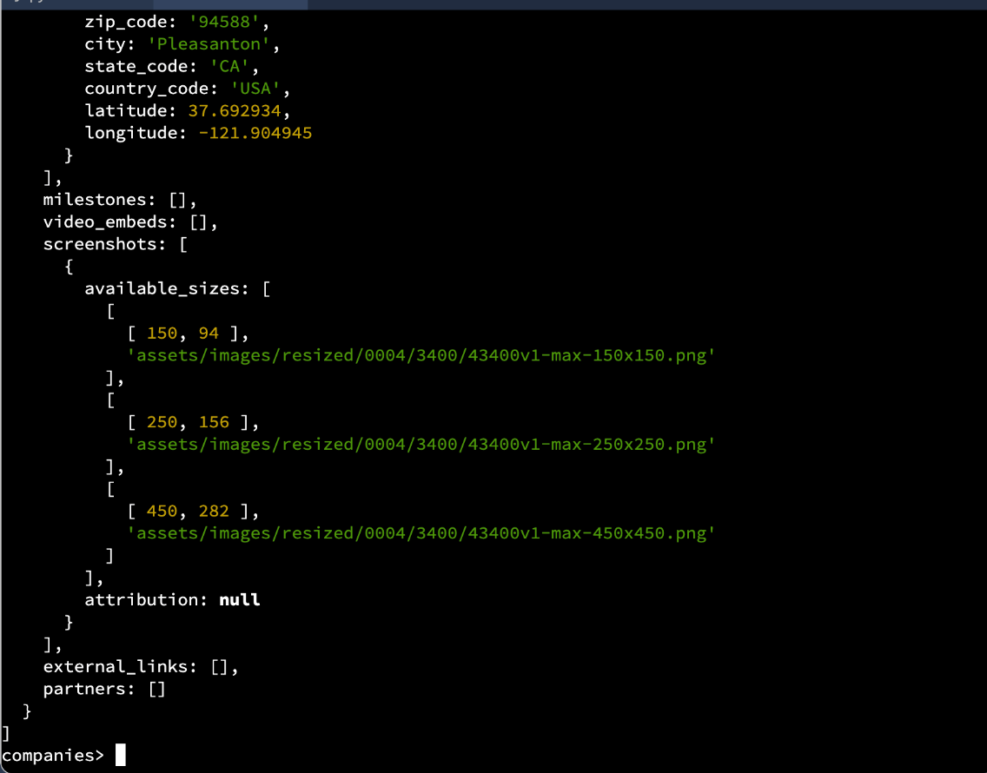
Founded in 1996
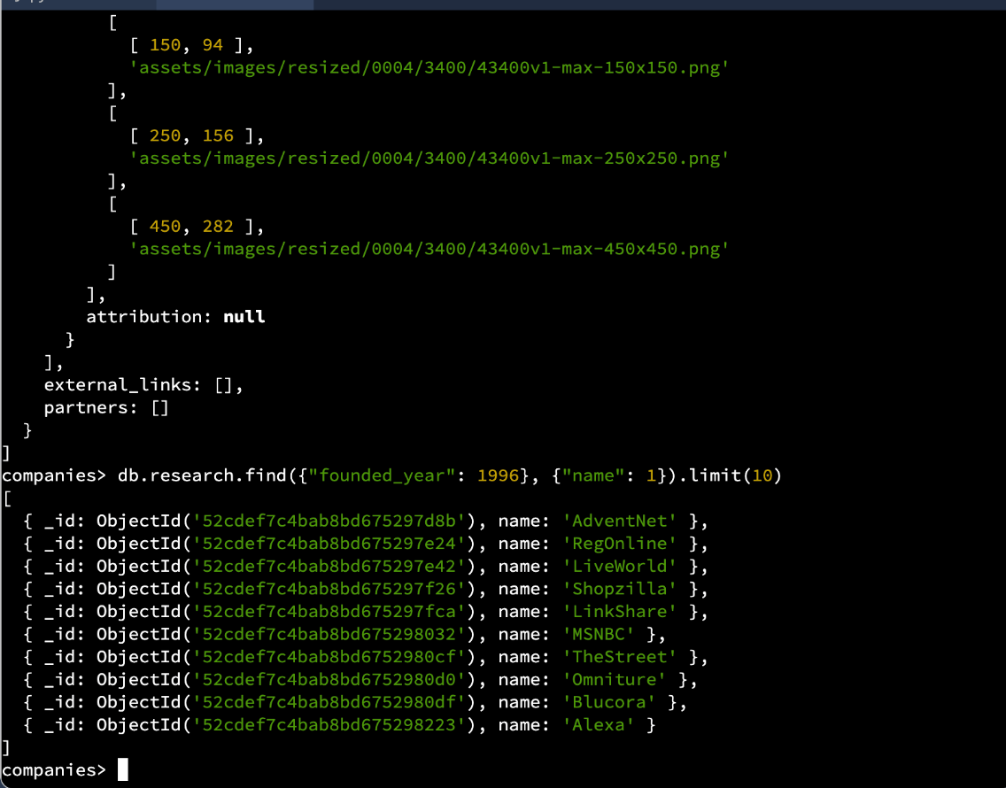
2. Advanced Queries
Companies founded after 2010
db.research.find({ founded_year: { $gt: 2010 } }, { _id: 0, name: 1 }).sort({ name: 1 }).limit(20)
The $gt operator selects companies founded after 2010. Projection returns only the company name, alphabetical sorting uses name: 1, and limit(20) restricts the output to twenty records.
Founded after 2010
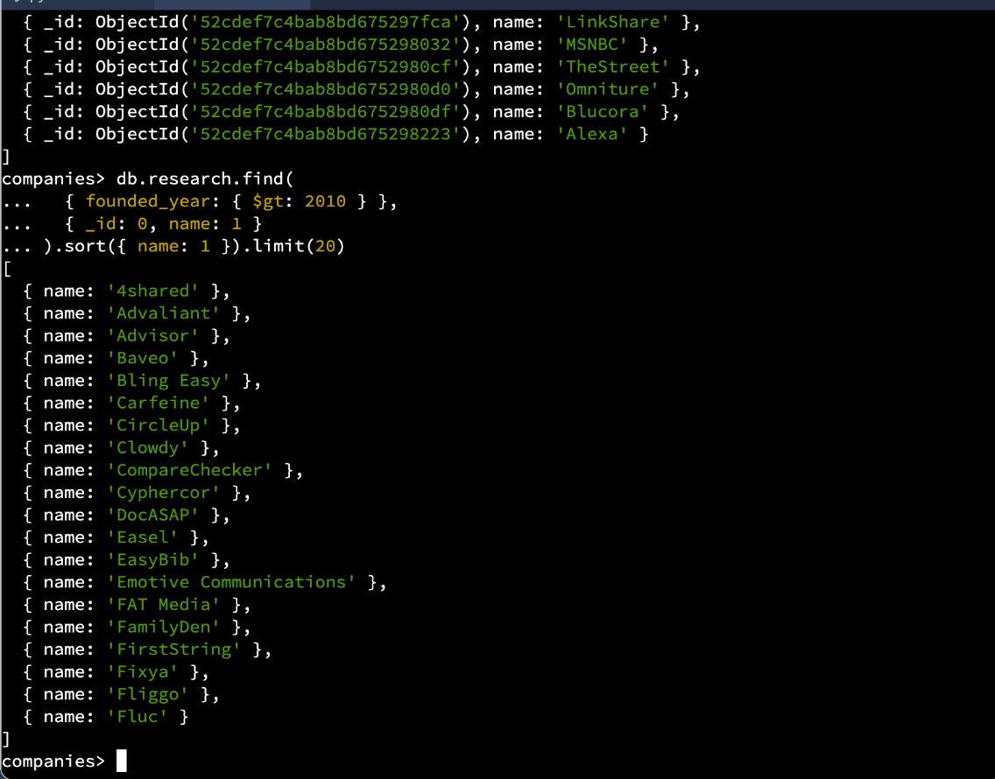
Companies with offices in California or Texas
db.research.find({ "offices.state_code": { $in: ["CA", "TX"] } }, { _id: 0, name: 1, number_of_employees: 1 }).sort({ number_of_employees: -1 }).limit(20)
The $in operator finds companies with at least one office in California or Texas. The results include names and employee counts, sorted from highest to lowest using -1 and limited to twenty companies.
California or Texas offices
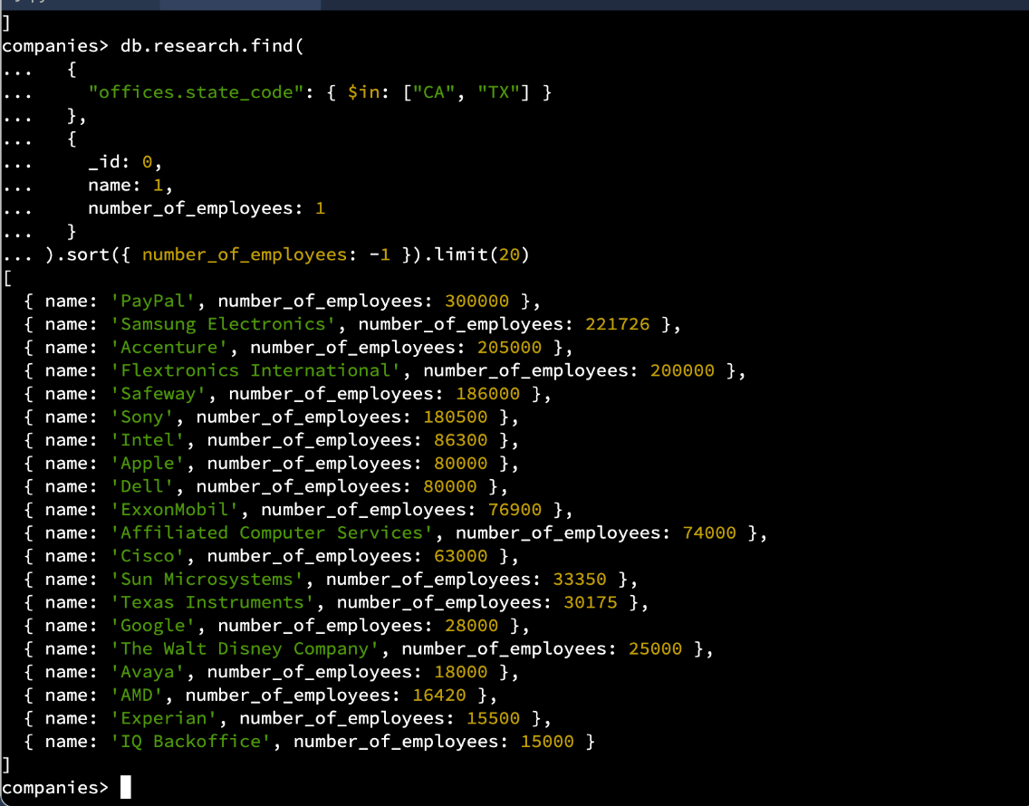
3. Aggregation Pipeline: U.S. Offices by State
db.research.aggregate([
{ $unwind: "$offices" },
{ $match: { "offices.country_code": "USA", "offices.state_code": { $nin: [null, ""] } } },
{ $group: { _id: "$offices.state_code", total_offices: { $sum: 1 } } },
{ $sort: { total_offices: -1 } }
])
The $unwind stage separates each element of the offices array, ensuring that multiple offices belonging to the same company are each counted. The $match stage retains only offices in the United States with nonempty state codes. The $group stage combines offices by state and uses $sum: 1 to count each office. Finally, $sort orders the state totals from largest to smallest.
California had 3,903 offices, followed by New York (1,084), Massachusetts (623), Texas (500), and Washington (415). The three screenshots below show all batches of the aggregation results, including the additional results obtained with the mongosh it command.
Aggregation results, first batch
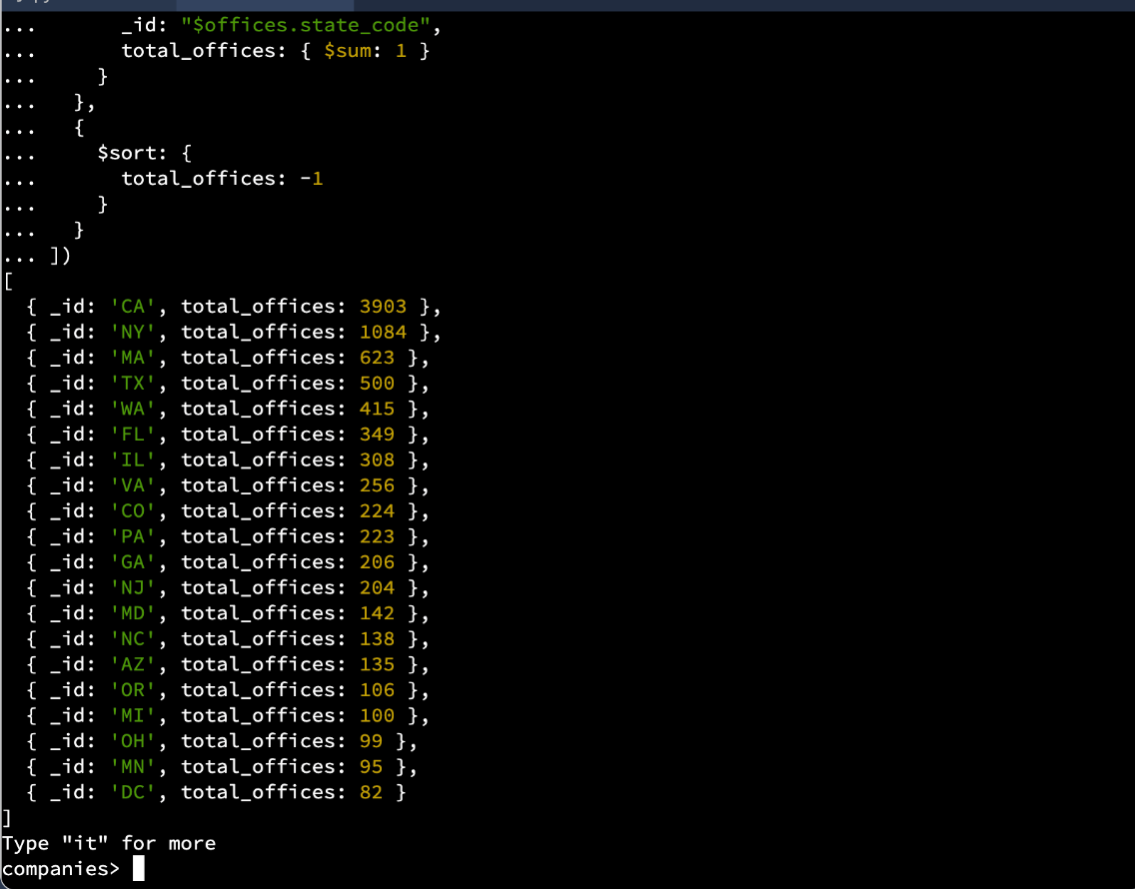
Aggregation results, second batch
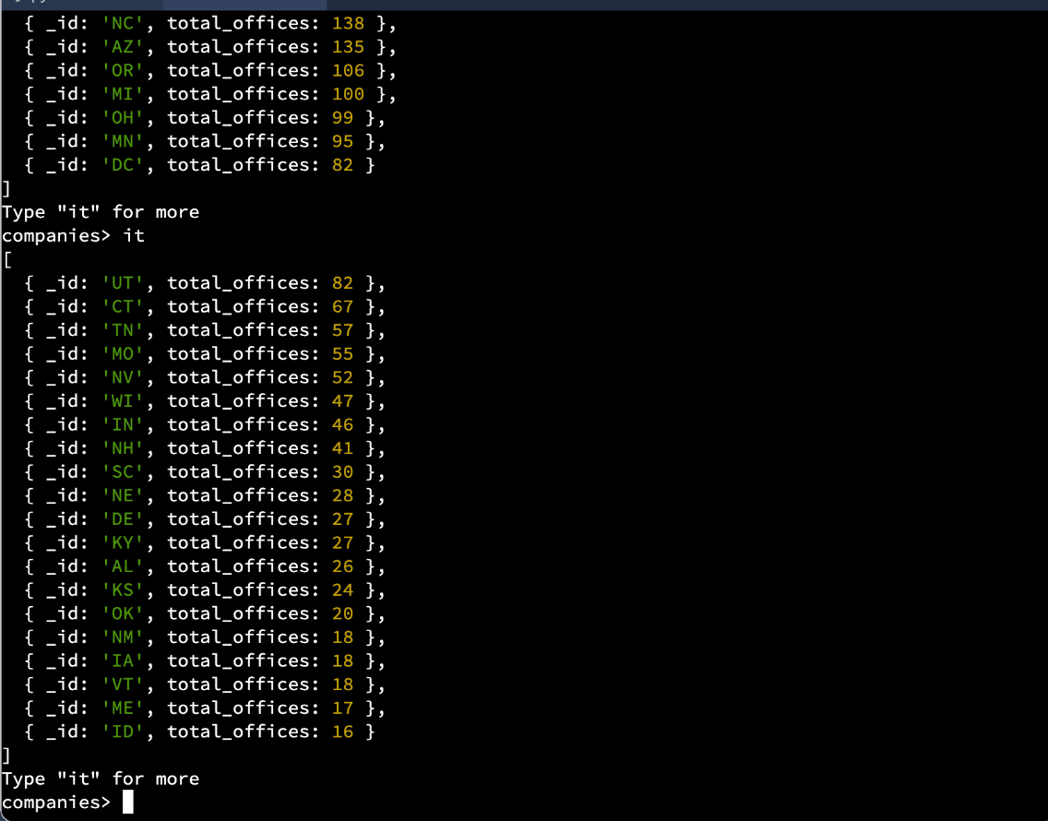
Aggregation results, final batch
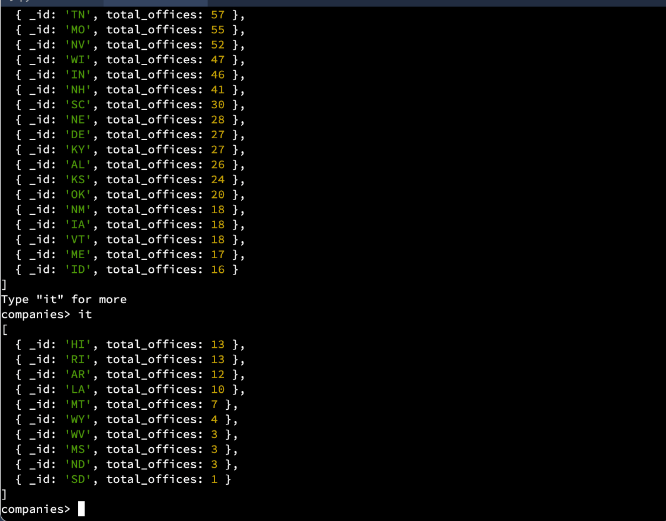
Note: Screenshots are cropped to show only the Codio terminal and its MongoDB output; unrelated windows and chat content are excluded.

