Known Issues:

* Currently the client is unable to send messages to other users

Working Functions:

* Server provides errors specified in requirements
* Clients are able to log on and receive a list of online users
* Other clients are broadcast a sign-on messages for new users
* Status check
* Server activity is kept in a logfile

Server

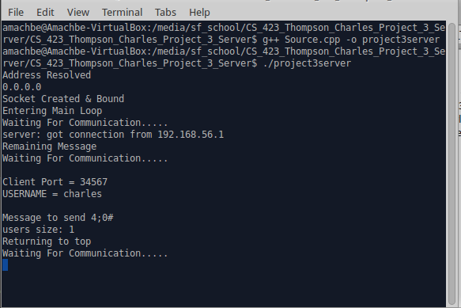

Log File

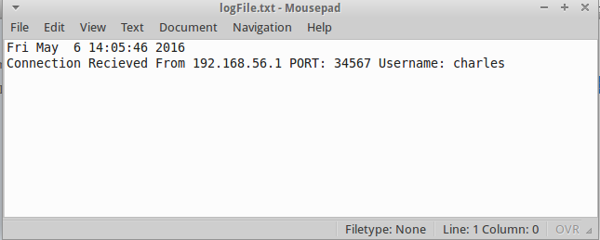

Client

