**Project 2 – Movie Rental System** *Study the following description*

A shop rents out DVD movies to customers. The management decided to get a computerized system. The system should keep track of the movies the shop rents out. Each movie has a title, a list of main actors and actresses, duration, year of production, and language. To help a customer find an interesting movie, movies can be found using keywords (tags). Here are a few examples on keywords associated with movies:

# Keyword Movies

Suspenseful Life of Pi, The Impossible

Breathtaking The Impossible

Heartbreaking Life of Pi

Movies can be classified by type. For instance, they can be horror, action, drama, etc. Movies can also be classified by rating. For instance, these are some possible ratings:

# Rating Meaning

G General. People of different ages are allowed to watch the movie

PG Parental Guidance Suggested. Some Material May Not Be Suitable For Children.

PG-13 Parents Strongly Cautioned. Some Material May Be Inappropriate For Children Under 13. R Restricted. Children Under 17 Require Accompanying Parent or Adult Guardian.

# Customers

Customers can rent a movie for typically a week for a standard price ($2). However, they can extend the rental for another week as well provided no body requested the movie. One of the problems customers face is that they forget to return a DVD movie on time. If customers don’t return a movie on time, they have to pay a 10-cent penalty for each late day.

If the movie is not available (either because all the DVDs are rented out or simply it is unavailable in the inventory), customers can request it. The employees will look at the request and make a decision about whether they want to order a new movie, let the customer wait, or simply inform him that that it won’t be possible to provide it. The problem is the employees might forget to inform the customer on the request status.

The customer can rent multiple DVD movies online. The customer might ask to receive the rented movies by mail or go to the shop to pick them up. If he chooses to pick them up, the employees will have them ready for him to check out. The customer can pay online or at the counter. The customer can return the movies by dropping them at a drop box at the shop or by shipping them.

Only after the customer has returned the movie, can he rate it on a scale 0-10, and write a short review.

# Employees

Employees help the customers find a movie to rent, for instance by telling him where to find the movie (on which shelf/section). Further, they help the customers with checking a movie out.

Employees also look at the rental orders customers made online, and prepare them for shipment or for the customers so that they don’t have to wait much when they arrive to check a movie out. Employees might also need to order a DVD that a customer has requested. However, it is hard for the employee to make a decision about which DVD to order. One solution is to prioritize the ones that are requested often.

Finally, Employees look at the returned movies (either in the drop box or by mail) and record that they are returned.

Figure 1 shows the domain model of the problem. Figure 2 shows the names of the customer and employee use cases. Figure 3 and 4 show the employee use cases.

**Requirements**

# (Weight: 30%) Make a sequence diagram(s) for the following functionalities (Note: it is okay to break it down to more than one sequence diagram)

**1.1. (Customer)** **Rent Movie :** These are the steps of the process:

* The customer wants to find movies based on different things (e.g. keyword, year, actors, rating, etc.)
* The system displays movies that match the information the user provided (the system tells the customer which ones are available and which aren’t).
* The customer indicates that she wants to rent one of the movies the system displayed. The customer also tells the system whether they want the movie to be mailed to them or whether they want to pick it up at store.
* The customer might request a movie that’s not currently available.
* The system creates a rental record with a rental period that starts from today’s date and ends in a week.
* The system asks the customer to make a payment.
* The customer makes a payment.
* If the customer fails to make a payment, the system cancels the rental.

# (Weight: 20%) Make a collaboration diagram(s) for the following functionalities (Note: it is okay to break it down to more than one collaboration diagram)

**2.1. (Employee)** **Return Movie :** These are the steps of the process:

* The employee wants to find the to-be-returned DVD. The employee provides the ID of the DVD to the system.
* The system finds the DVD.
* The employee tells the system to mark the DVD as returned.
* If the DVD is returned late, the system marks the DVD as late. The return date is a valid date the user passes in.
* The system might display late fees (1 cent per day).

**3.** (Weight: 50%) Write Java code for the system. This is what your code should implement:

* These concepts of the system should be represented as classes: Movie, DVD, Customer, Actor, Rental, Request, and Keyword.
* Write code that keeps track of actors, keywords, customers, movies and DVDs (meaning, your code should support adding, deleting, finding based on ID,
* Write code that implements the rent movie process (defined above).
* Write code that implements the return movie process (defined above).
* **Note: don’t implement a graphical user interface. Just simulate the interaction either by hard coding the requests (i.e. by invoking functions in the controller) or by using console functions (readLine, or System.out.println).**

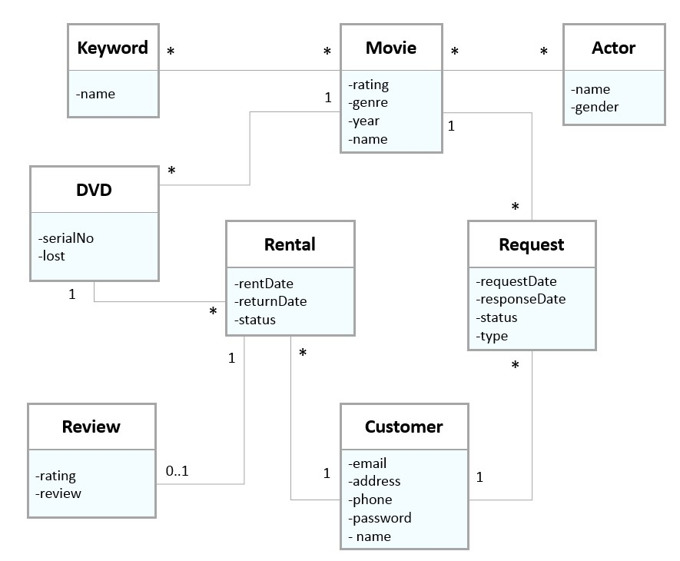

**Figure 1:** The domain model of the movie rental system

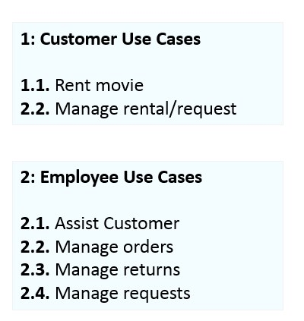

**Figure 2:** The use cases of the system

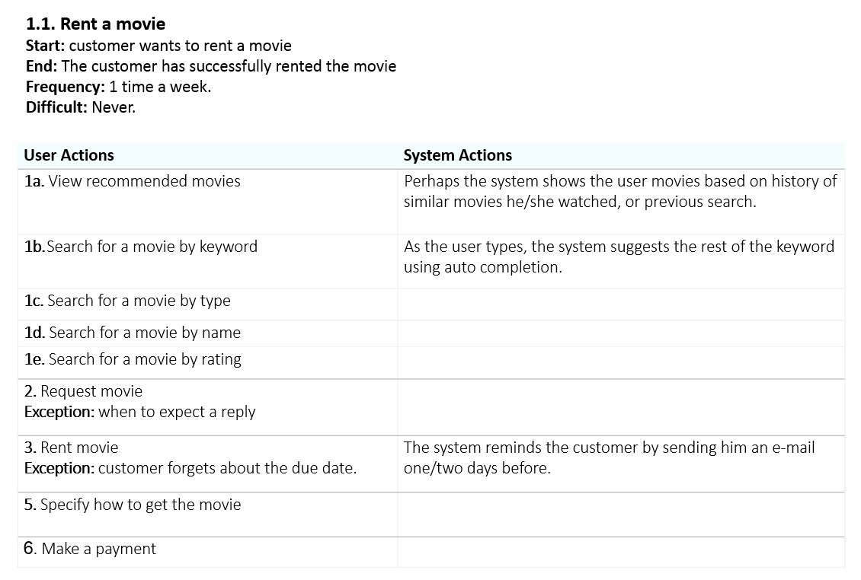

**Figure 3:** The rent movie use case

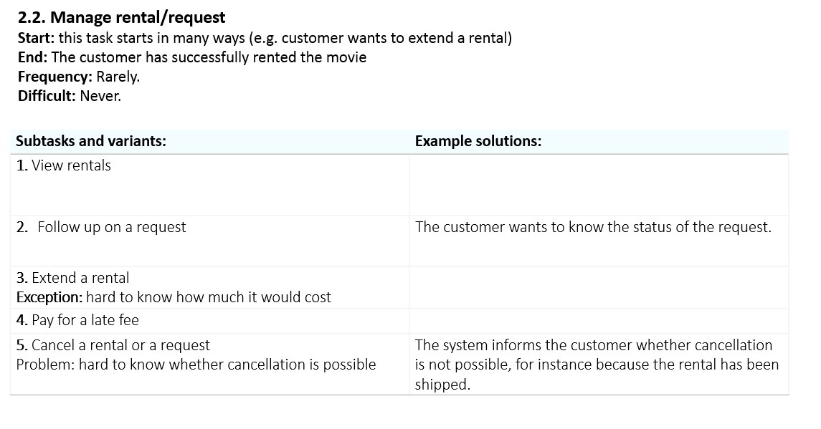

**Figure 4:** The manage rental/request use case