***Supporting Information***

**Nb2CT*x* MXene : High** [**Capacity**](D:/Dict/8.7.0.0/resultui/html/index.html#/javascript:;) **and Ultra-long Cycle Capability for** [**Lithium**](D:/Dict/8.5.1.0/resultui/html/index.html#/javascript:;)**-**[**Ion**](D:/Dict/8.5.1.0/resultui/html/index.html#/javascript:;)[**Battery**](D:/Dict/8.5.1.0/resultui/html/index.html#/javascript:;) **by Regulation of Functional Groups**

Jiabao Zhaoa, Jing Wena, Junpeng Xiaoa, Xinzhi Maa, Jiahui Gaoa, Lina Baia, Hong Gaoa, *, Xitian Zhanga, Zhiguo Zhangb

a *Key Laboratory for Photonic and Electronic Bandgap Materials, Ministry of Education, School of Physics and Electronic Engineering, Harbin Normal University, Harbin 150025, Heilongjiang, China*

b *School of Instrumentation Science and Engineering, Harbin Institute of Technology, Harbin 150001, Heilongjiang, China*

Table S1. XPS peak fitting results for O 1*s* region of various Nb2CT*x*samples.

|  |  |  |  |
| --- | --- | --- | --- |
| **Sample** | **BE [eV]** | **Assigned to** | **Reference** |
| **Nb2CT*x*** | 530.10 | NbO*x* | [1] |
| 531.00 | Nb2CO*x* | [2] |
| 532.30 | Nb2C(OH) *x* | [3] |
| 533.50 | H2O | [4] |
| **Li-Nb2CT*x*** | 529.15 | Nb2COLi*x* | [5] |
| 529.95 | NbO*x* | [1] |
| 530.80 | Nb2CO*x* | [2] |
| 532.20 | Nb2C(OH) *x* | [3] |
| 533.50 | H2O | [4] |
| **Li-Nb2CT*x*-200** | 529.20 | Nb2COLi*x* | [5] |
| 530.00 | NbO*x* | [1] |
| 530.80 | Nb2CO*x* | [2] |
| 532.20 | Nb2C(OH)x | [3] |
| **Li-Nb2CT*x*-300** | 529.30 | Nb2COLi*x* | [5] |
| 530.10 | NbO*x* | [1] |
| 530.80 | Nb2CO*x* | [2] |
| 532.20 | Nb2C(OH) *x* | [3] |
| **Li-Nb2CT*x*-400** | 529.33 | Nb2COLi*x* | [5] |
| 530.13 | NbO*x* | [1] |
| 530.80 | Nb2CO*x* | [2] |
| 532.20 | Nb2C(OH) *x* | [3] |
| **Li-Nb2CT*x*-500** | 529.35 | Nb2COLi*x* | [5] |
| 530.17 | NbO*x* | [1] |
| 530.80 | Nb2CO*x* | [2] |
| 532.20 | Nb2C(OH) *x* | [3] |
| **Nb2CT*x*-400** | 530.13 | NbO*x* | [1] |
| 530.80 | Nb2CO*x* | [2] |
| 532.20 | Nb2C(OH) *x* | [3] |

Table S2. XPS peak fitting results for F 1*s* region of various Nb2CT*x*samples.

|  |  |  |  |
| --- | --- | --- | --- |
| **Sample** | **BE [eV]** | **Assigned to** | **Reference** |
| **Nb2CT*x*** | 684.45 | Nb2CF*x* | [6] |
| **Li-Nb2CT*x*** | 684.50 | Nb2CF*x* | [6] |
| 685.47 | LiF | [7] |
| **Li-Nb2CT*x*-200** | 684.50 | Nb2CF*x* | [6] |
|  | 685.49 | LiF | [7] |
| **Li-Nb2CT*x*-300** | 684.50 | Nb2CF*x* | [6] |
| 685.50 | LiF | [7] |
| **Li-Nb2CT*x*-400** | 684.50 | Nb2CF*x* | [6] |
| 685.51 | LiF | [7] |
| **Li-Nb2CT*x*-500** | 684.50 | Nb2CF*x* | [6] |
| 685.53 | LiF | [7] |
| **Nb2CT*x*-400** | 684.50 | Nb2CF*x* | [6] |

Table S3 shows the content of O element and its constituents in each sample in XPS. The content of −O, −OH, NbO*x*, O-Li and H2O in the table is obtained by quantitative analysis of the area of each peak under O 1*s* in XPS.

Table S3. The content of O element and its constituents in each sample in XPS.

|  |  |  |  |  |  |  |
| --- | --- | --- | --- | --- | --- | --- |
| **sample/content** | **O 1*s*** | **-O** | **-OH** | **NbO*x*** | **O-Li** | **H2O** |
| **Nb2CT*x*** | 29.7% | 50.0% | 21.8% | 21.2% | 0.00% | 7.0% |
| **Li-Nb2CT*x*** | 43.8% | 35. 6% | 28.4% | 26.0% | 6.1% | 4.0% |
| **Li-Nb2CT*x*-200** | 41.8% | 37.4% | 29.6% | 27.9% | 5.1% | 0.0% |
| **Li-Nb2CT*x*-300** | 45.7% | 38.7% | 22.5% | 30.6% | 8.6% | 0.0% |
| **Li-Nb2CT*x*-400** | 47.5% | 60.0% | 5.5% | 29.5% | 5.0% | 0.0% |
| **Li-Nb2CT*x*-500** | 46.0% | 45.1% | 5.6% | 43.0% | 6.3% | 0.0% |
| **Nb2CT*x*-400** | 32.8% | 61.6% | 8.2 % | 30.2% | 0.0% | 0.0% |

Table S4. The content of F element and its constituents in each sample in XPS.

|  |  |  |  |
| --- | --- | --- | --- |
| **sample/content** | **F 1*s*** | **-F** | **Li-F** |
| **Nb2CT*x*** | 10.6% | 100% | 0 |
| **Li-Nb2CT*x*** | 4.5% | 70.7% | 29.4% |
| **Li-Nb2CT*x*-200** | 6.2% | 51.0% | 49.0% |
| **Li-Nb2CT*x*-300** | 3.5% | 74.0% | 26.0% |
| **Li-Nb2CT*x*-400** | 2.0% | 35.8% | 64.3% |
| **Li-Nb2CT*x*-500** | 1.7% | 39.3% | 60.7% |
| **Nb2CT*x*-400** | 3.1% | 100% | 0 |

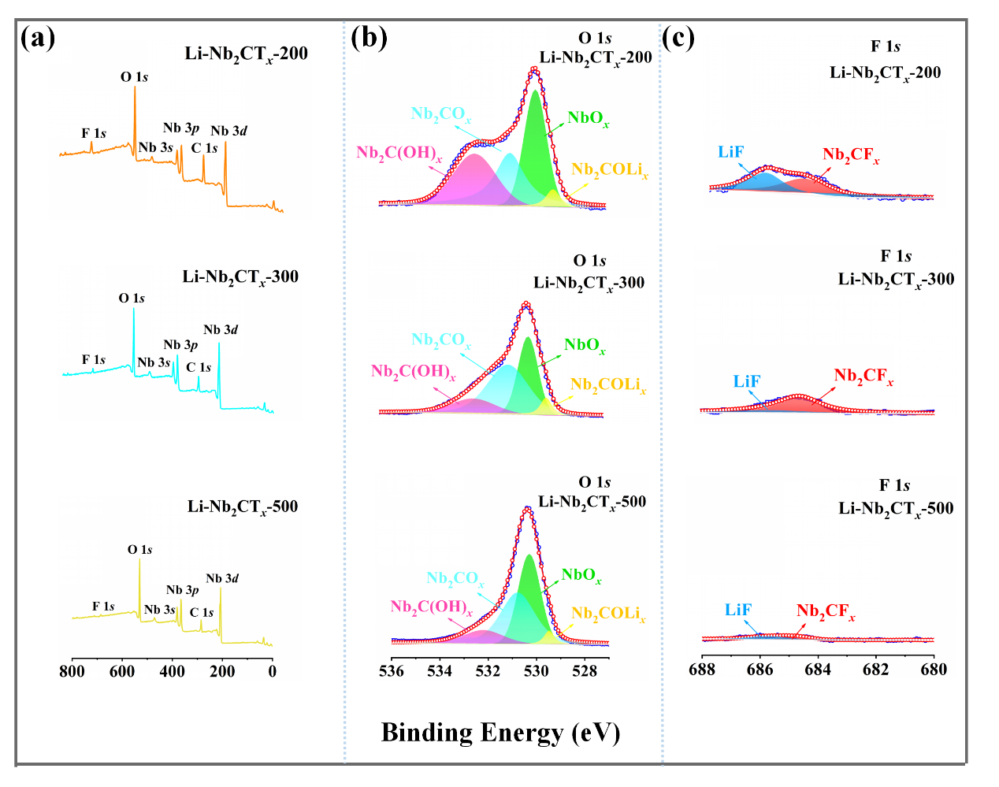

Fig. S1. (a) Survey XPS spectrum, (b) O 1*s* spectra, (c) F 1*s* spectra of Li-Nb2CT*x*-200, Li-Nb2CT*x*-300 and Li-Nb2CT*x*-500.

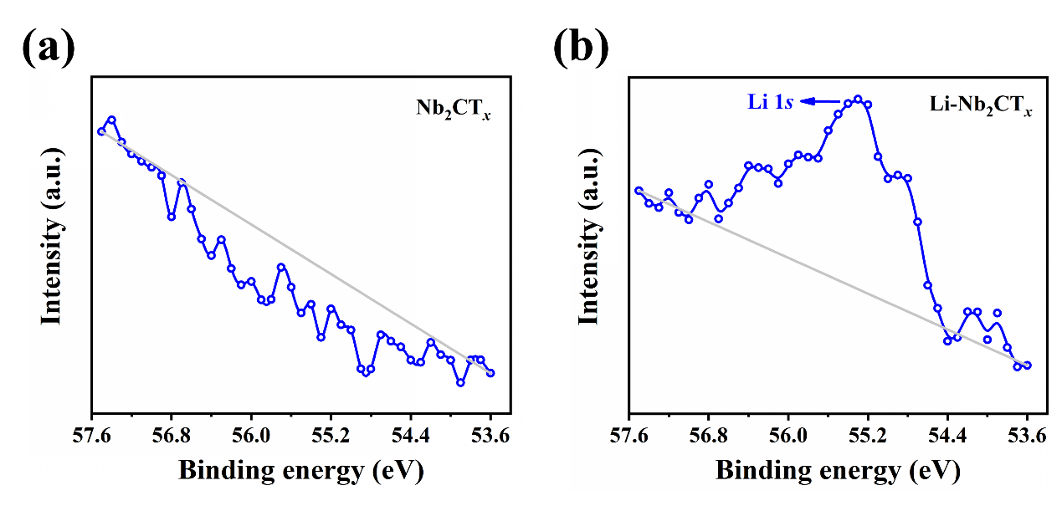

Fig. S2. The Li 1*s* spectrum of (a) Nb2CT*x*and (b) Li-Nb2CT*x* in XPS.

For the Nb2CT*x*, the (002) peak of untreated Nb2CT*x* after 400 ℃ annealing is shifted to a larger angle with interlayer spacing about 7.62 Å due to the removal of water between layers (Fig. S3a). Meanwhile, the SEM images of untreated Nb2CT*x* annealed at 400 is shown in Fig. S3b, and Nb2CTx-400 maintains a good layered structure. O− and F−high resolution spectra are shown in Fig. S3c and d, respectively. The contents of −O ,−OH and −F functional groups of Nb2CT*x*-400 are 20.2%, 2.7% and 3.1%, respectively. As shown in Fig. S3e, at a current density of 0.05 A g-1, the specific capacity of Nb2CT*x*-400 can reach 257 mAh g-1 after 50 cycles. Nb2CT*x*-400 exhibits stable and durable capacity at different current densities (0.05~2A g-1) and decreases steadily as current density increases (Fig. S3f). At the same time, the ultra-long cycle stability of Nb2CT*x*-400 electrode under high current density of 2 A g-1 was tested, too. After the ultra-long cycle of 2000 cycle, the specific capacity was maintained at 186 mAh g-1 (Fig. S3g).

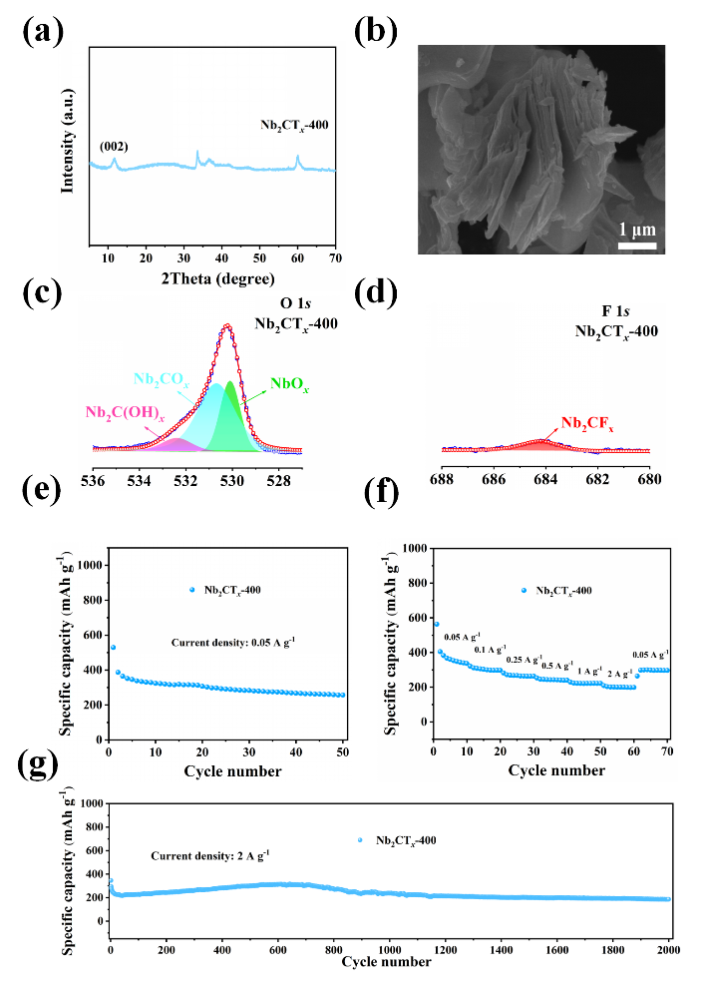

Fig. S3. (a) XRD, (b) SEM, (c) O 1*s* spectra, (d) F 1*s* spectra, (e) Cycling properties at 0.05 A g-1, (f) Rate performance and (g) Cycling performance at 2.0 A g-1 of Nb2CT*x*-400.

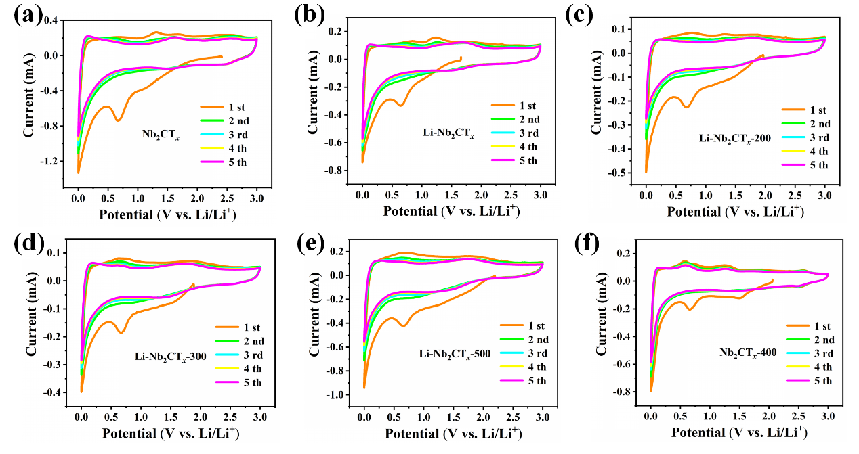

Fig. S4. CV curves of (a) Nb2CT*x*, (b) Li-Nb2CT*x*, (c) Li-Nb2CT*x*-200, (d) Li-Nb2CT*x*-300, (e) Li-Nb2CT*x*-500 and (f) Nb2CT*x*-400 at 0.5 mV s-1.

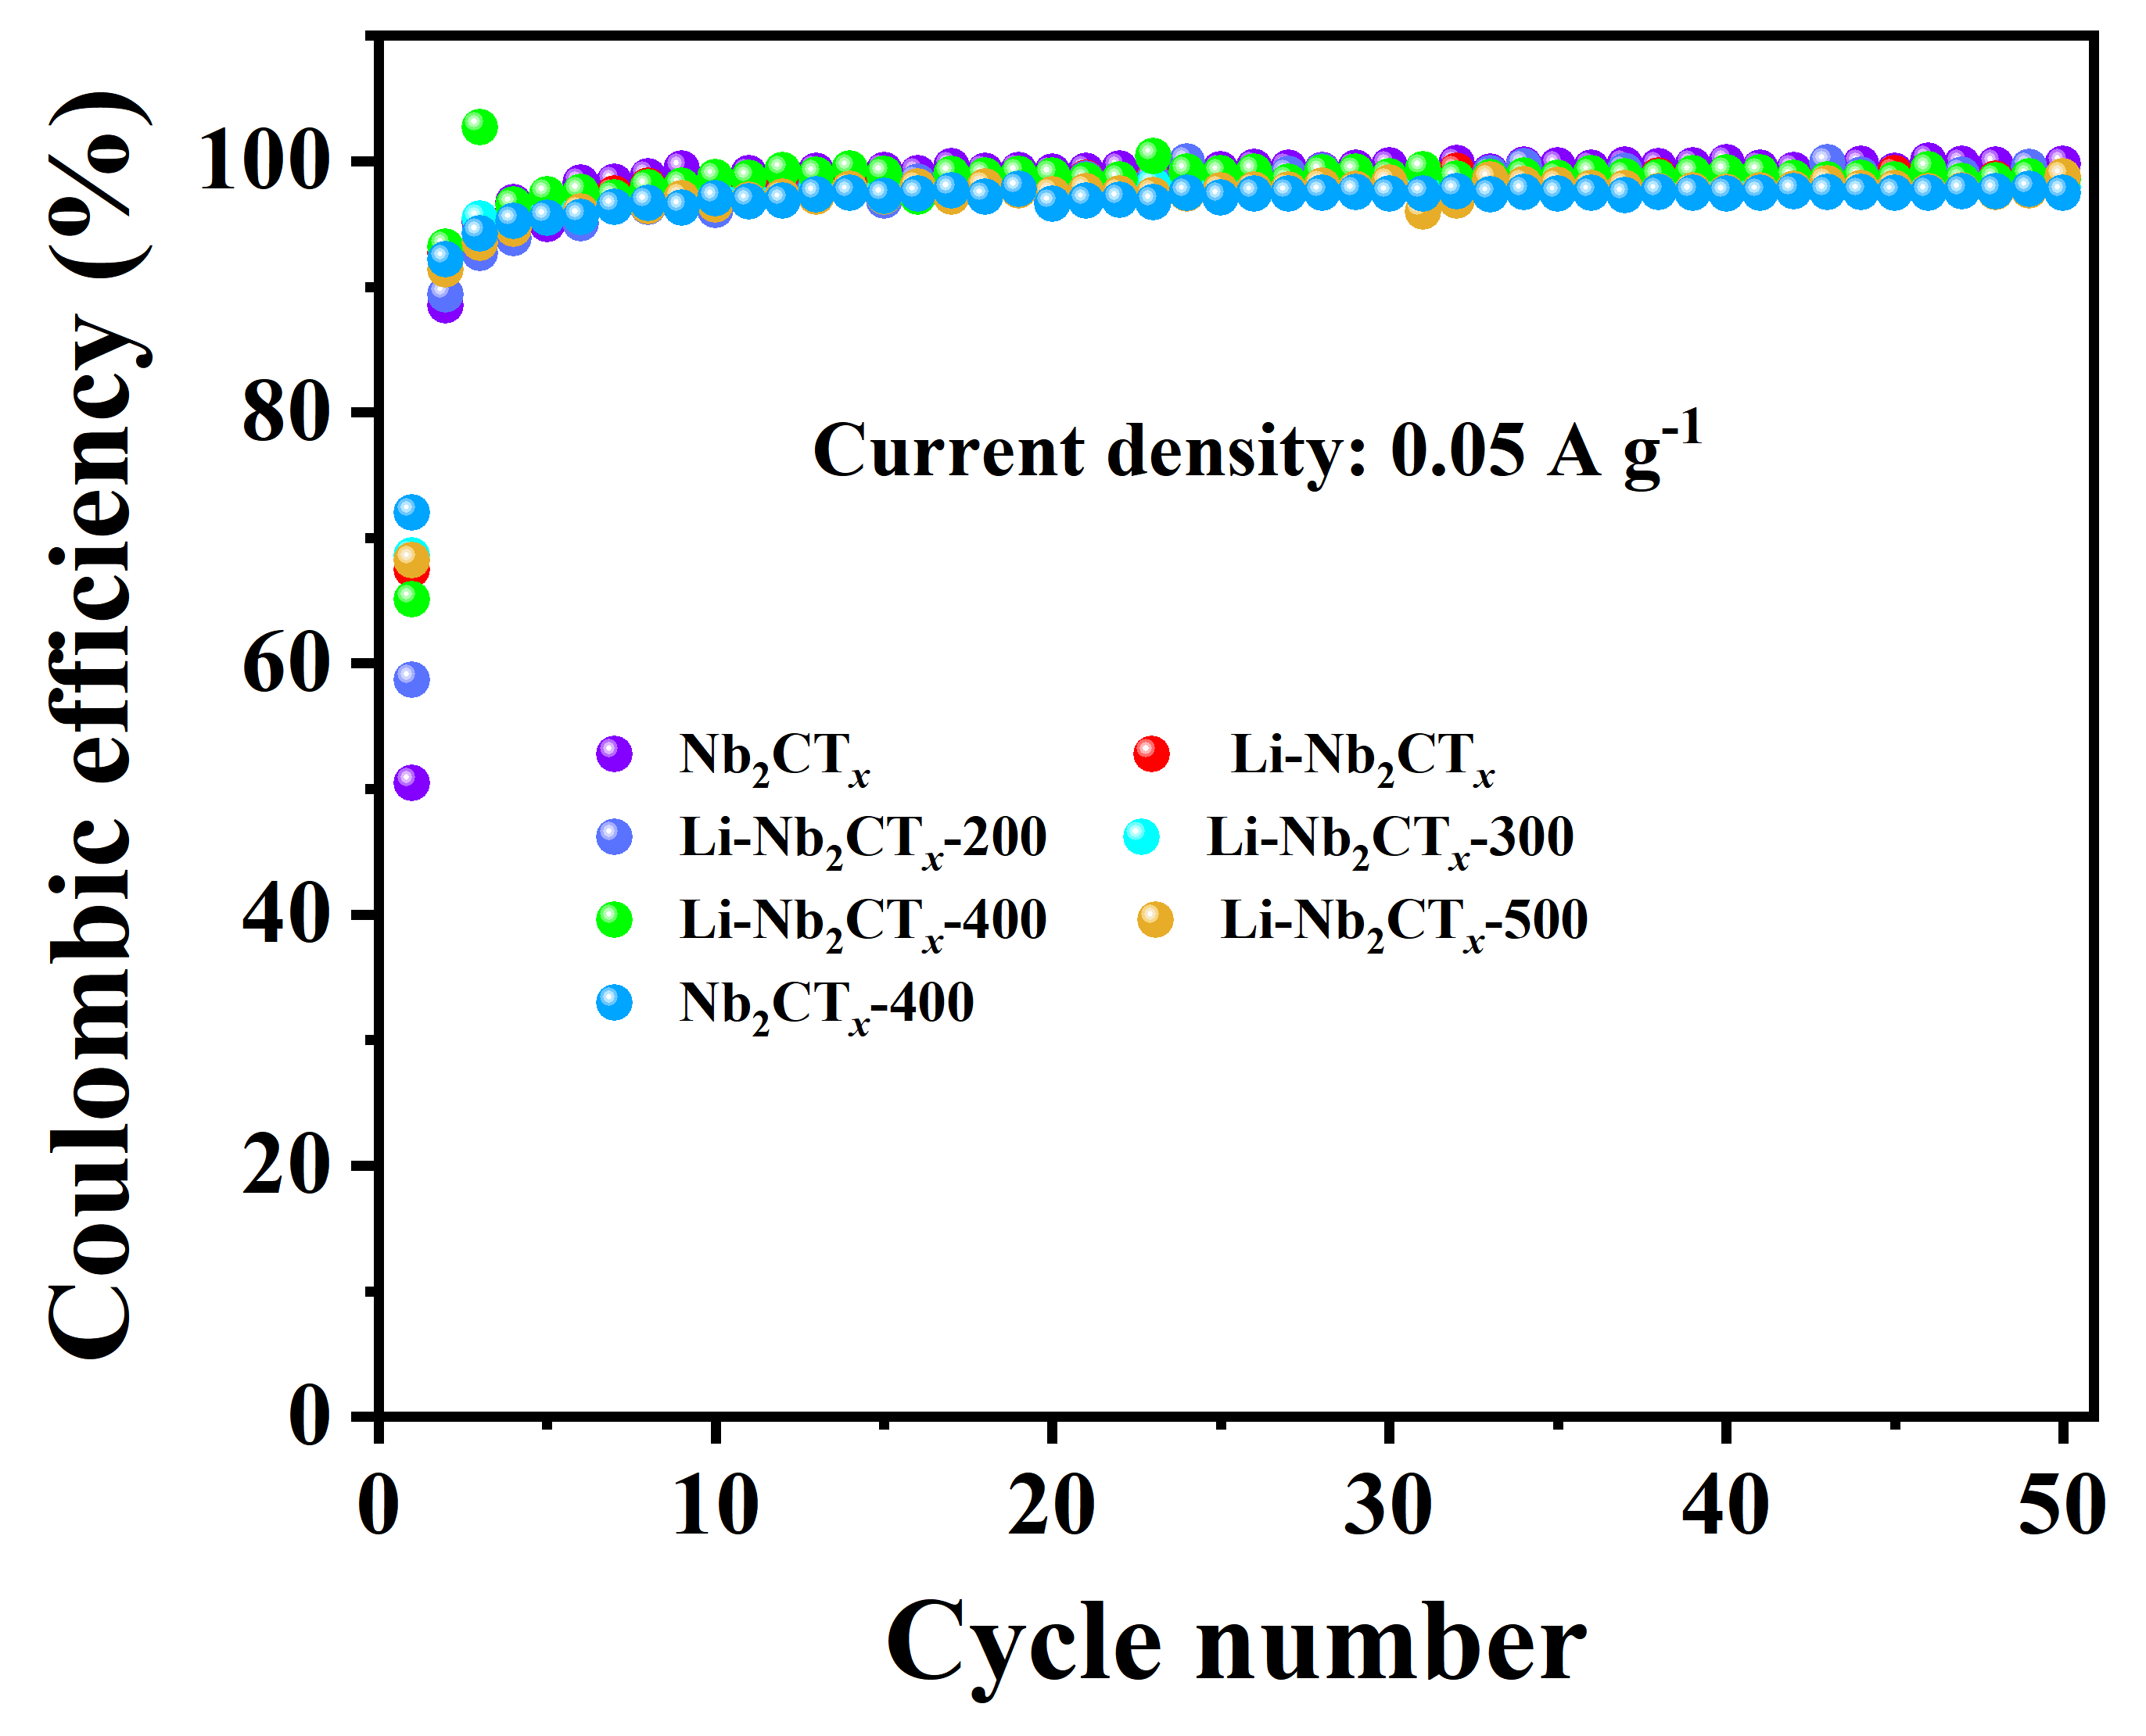

Fig. S5. The corresponding coulombic efficiency of different Nb2CT*x*MXene at 0.05 A g-1.

**References**

1. T.M. Su, R. Peng, Z.D. Hood, M. Naguib, I.N. Ivanov, J.K. Keum, Z.Z. Qin, Z.H. Guo, Z.L. Wu, ChemSusChem 11 (2018) 688−699.
2. H.R. Byon, B.M. Gallant, S. Woo and Y. Shao-Horn, Adv. Funct. Mater. 23 (2013) 1037−1045.
3. J. Halim, K.M. Cook, M. Naguib, P. Eklund, Y. Gogotsi, J. Rosen and M.W. Barsoum, Appl. Surf. Sci. 362 (2016) 406−417.
4. J. Halim, S. Kota, M. R. Lukatskaya, M. Naguib, M. Q. Zhao, E. J. Moon, J. Pitock, J. Nanda, S. J. May, Y. Gogotsi and M. W. Barsoum, Adv. Funct. Mater. 26 (2016) 3118.
5. B. Heim, C.N. Taylor, D.M. Zigon, S. O'Dell, J.P. Allain, Nucl. Instrum. Meth. B. 269 (2011) 1262−1265.
6. Y.D. Agnese, M.R. Lukatskaya, K.M. Cook, P.L. Taberna, Y. Gogotsi, P. Simon, Electrochem. Commun. 48 (2014) 118−122.
7. P. Niehoff, S. Passerini, M. Winter, Langmuir 29 (2013) 5806−5816.