ECS132

Weili Yin

HW3

A:

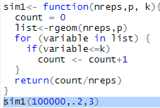 Simulation:

B: $cov\left(D,N\right)=E\left(DN\right)-E\left(D\right)E\left(N\right)$

$where E\left(D\right)=\sum_{i=1}^{11}{\left(11-i\right){\left(1-p\right)}^{i-1}p+}\sum_{12}^{∞}{\left(i-11\right){\left(1-p\right)}^{i-1}p}=6.56$

$E\left(ND\right)=\sum_{i=1}^{11}{i\left(11-i\right){\left(1-p\right)}^{i-1}p+}\sum_{12}^{∞}{i\left(i-11\right){\left(1-p\right)}^{i-1}p}=43.17$

$E\left(N\right)=\frac{1}{p}=6.67, Thus Cov\left(D,N\right)=-.59$