Solful Sessions
Terpene Juice Recipe Book
24 Strains × Terpene-Matched Juice Recipes
The same molecule. Every plant. One body.
Charles Pelletier-Gagné · Solful Dispensary · 2026

Mike's Bomba
Glentucky Family Farm · Sonoma
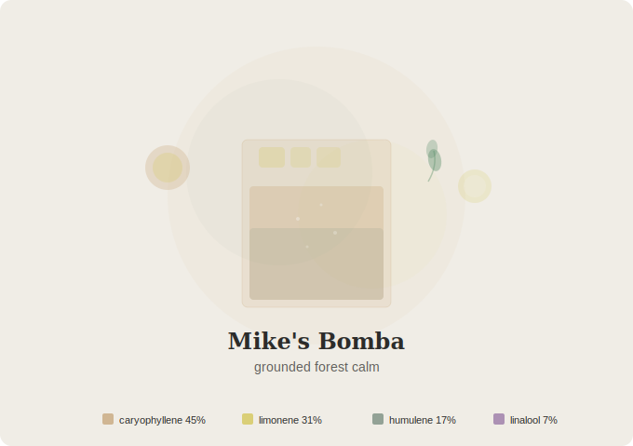
“Grounded calm with clear mental edges”
Energy: LOW · Relaxed, Calm, Alert
Aroma: Fuel, Lemon Cream, Forest Floor
THC: 28.76% | CBD: 0.09%
Terpene Profile
Terpene | % | Ratio
β-Caryophyllene | 0.47% | 45%
Limonene | 0.32% | 31%
α-Humulene | 0.18% | 17%
Linalool | 0.07% | 7%
Total Terpenes: 1.38%
Essential Oil Blend: Black Pepper (20), Lemon (10), Sage (8), Lavender (2)
Juice Recipe
2.5 oz pink grapefruit juice · 1 oz lemon juice · 0.75 oz fresh ginger juice · 1 fresh rosemary sprig · 0.25 oz honey · pinch sage powder · pinch black pepper · 2 drops lavender flavor · 2 oz sparkling water
1. Press 1 oz fresh ginger root through a fine grater or juicer
2. Steep rosemary sprig in 1 oz warm water for 3 min, strain and cool
3. Combine grapefruit juice, lemon juice, and ginger juice
4. Add rosemary water, honey, sage powder, black pepper, and lavender flavor
5. Pour over ice in a rocks glass, top with sparkling water down the side
6. Garnish with rosemary sprig
Terpene Map: β-Caryophyllene (black pepper, ginger, rosemary) · Limonene (grapefruit, lemon) · α-Humulene (sage, ginger) · Linalool (lavender flavor)

Natty Bumppo
Moon Gazer Farms · Mendocino
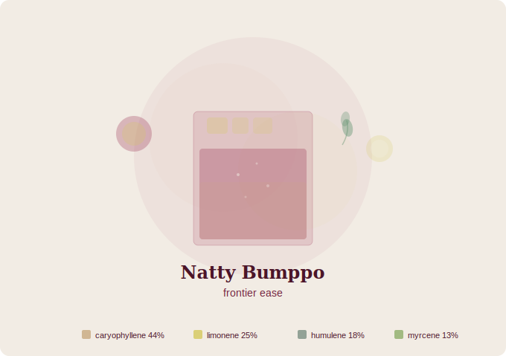
“Loose and easy, happily untethered”
Energy: LOW · Happy, Carefree, Physically Relaxed
Aroma: Kerosene, Musk, Sour Plum
THC: 32.00%
Terpene Profile
Terpene | % | Ratio
β-Caryophyllene | 0.63% | 44%
Limonene | 0.35% | 25%
α-Humulene | 0.25% | 18%
Myrcene | 0.19% | 13%
Total Terpenes: 1.86%
Essential Oil Blend: Black Pepper (14), Lemon (10), Sage (6), Lemongrass (6), Geranium (4)
Juice Recipe
2.5 oz tart cherry juice · 0.5 oz lemon juice · 0.5 oz cardamom-vanilla syrup · 0.5 oz fresh ginger juice · pinch black pepper · 1 fresh rosemary sprig · 2 oz mineral water
1. Make cardamom-vanilla syrup: crack 5 pods in 4 oz water + 2 oz honey + 0.5 tsp vanilla, simmer 5 min
2. Press fresh ginger to yield 0.5 oz
3. Steep rosemary in 1 oz warm water for 2 min, strain
4. Combine tart cherry juice, lemon juice, ginger juice, rosemary water, and syrup
5. Add black pepper, stir with ice for 8 seconds
6. Strain into rocks glass with large ice, add mineral water
Terpene Map: β-Caryophyllene (cardamom, black pepper, ginger) · Limonene (lemon, tart cherry) · α-Humulene (ginger) · Myrcene (rosemary)

Black Lime Chem
Moon Gazer Farms · Mendocino
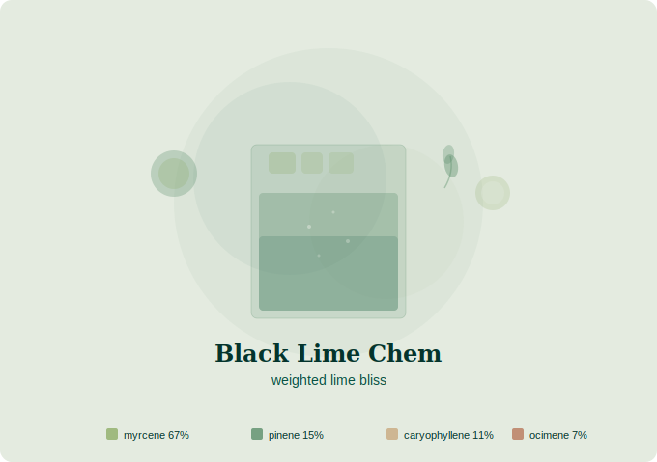
“Weighted bliss melting toward rest”
Energy: LOW · Heavy, Blissful, Sleepy
Aroma: Sharp Lime, Rhubarb, Glue
THC: 19.00%
Terpene Profile
Terpene | % | Ratio
Myrcene | 1.69% | 67%
α-Pinene | 0.39% | 15%
β-Caryophyllene | 0.27% | 11%
β-Ocimene | 0.19% | 7%
Total Terpenes: 3.08%
Essential Oil Blend: Lemongrass (16), Pine (8), Black Pepper (6), Basil (6), Lemon (4)
Juice Recipe
2 oz lime juice · 1.5 oz green apple juice · 1 rosemary sprig · 4 basil leaves · 0.25 oz cinnamon-honey syrup · pinch cinnamon · 1 oz mineral water
1. Make cinnamon-honey syrup: simmer 1 cinnamon stick in 2 oz water + 1 oz honey, 5 min
2. Press 1 green apple, blend and strain
3. Steep rosemary in 1 oz warm water for 2 min, strain
4. Gently muddle basil leaves
5. Combine all with cinnamon. Stir with ice
6. Strain into rocks glass, add mineral water
Terpene Map: Myrcene (lime, rosemary, basil) · α-Pinene (rosemary, basil) · β-Caryophyllene (cinnamon, basil) · β-Ocimene (basil)

Guava Gift
Alpenglow Farms · Humboldt
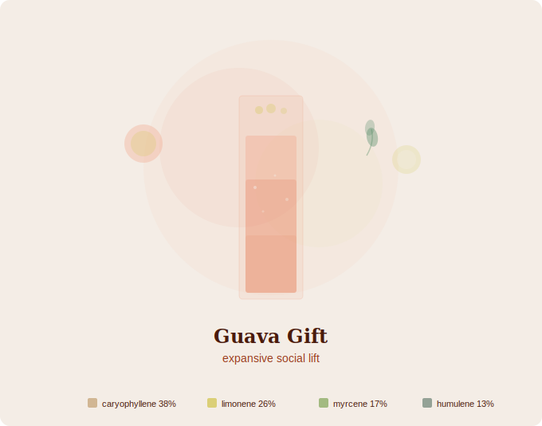
“Open and expansive, easy social lift”
Energy: HIGH · Social, Inspiring, Euphoric
Aroma: Fresh Guava, Lemon Rind, Tamarind
THC: 29.00% | CBD: 0.08%
Terpene Profile
Terpene | % | Ratio
β-Caryophyllene | 0.73% | 38%
Limonene | 0.50% | 26%
Myrcene | 0.33% | 17%
α-Humulene | 0.25% | 13%
Total Terpenes: 2.34%
Essential Oil Blend: Black Pepper (14), Grapefruit (10), Lemongrass (8), Basil (6), Rosemary (2)
Juice Recipe
2.5 oz guava puree · 1 oz grapefruit juice · 0.5 oz lime juice · 0.5 oz ginger juice · 4 basil leaves · 1 rosemary sprig · pinch black pepper · 0.25 oz honey · 1.5 oz sparkling water
1. Halve 3-4 guavas, scoop flesh, blend and strain
2. Steep rosemary in 1 oz cool water for 2 min, strain. Muddle basil
3. Combine guava, grapefruit, lime, ginger, rosemary water, basil, pepper, honey
4. Stir with ice, strain into highball, top with sparkling water
5. Garnish with basil leaf and lime wheel
Terpene Map: β-Caryophyllene (black pepper, ginger, rosemary) · Limonene (grapefruit, lime, guava) · Myrcene (basil, rosemary) · α-Humulene (ginger)

Mule Fuel
Alpenglow Farms · Humboldt
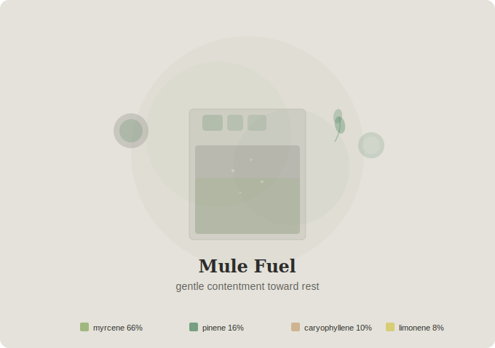
“Gentle contentment settling toward rest”
Energy: LOW · Happy, Hungry, Sleepy
Aroma: Skunk, Diesel, Lemon, Leather
THC: 28.69% | CBD: 0.07%
Terpene Profile
Terpene | % | Ratio
Myrcene | 2.22% | 66%
α-Pinene | 0.54% | 16%
β-Caryophyllene | 0.34% | 10%
Limonene | 0.28% | 8%
Total Terpenes: 3.97%
Essential Oil Blend: Lemongrass (20), Pine (8), Black Pepper (6), Lemon (6)
Juice Recipe
4 lemongrass stalks · 1 oz lemon juice · 2 rosemary sprigs · 4 basil leaves · pinch black pepper · pinch cinnamon · 0.25 oz honey · 1.5 oz mineral water
1. Peel and smash lemongrass, cold press or blend with 1 oz water, strain
2. Steep rosemary in 1.5 oz cool water for 3 min, strain
3. Muddle basil. Combine all juices, herbs, pepper, cinnamon, honey
4. Stir with ice 10 seconds, strain into rocks glass, add mineral water
5. Garnish with rosemary sprig
Terpene Map: Myrcene (lemongrass, basil, rosemary) · α-Pinene (rosemary, basil) · β-Caryophyllene (black pepper, cinnamon) · Limonene (lemon)

Satsuma Sherbet
Alpenglow Farms · Humboldt
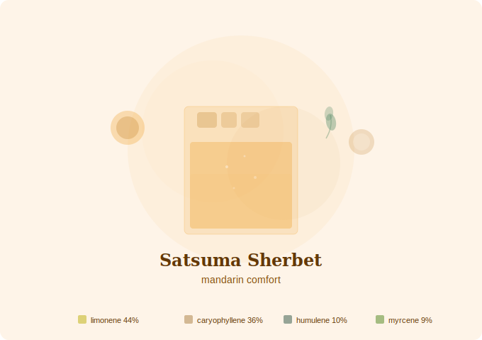
“Quiet ease with thoughtful undertones”
Energy: LOW · Happy, Contemplative, Comfortable
Aroma: Mandarin Orange, Mochi, Mint
THC: 26.00%
Terpene Profile
Terpene | % | Ratio
Limonene | 0.55% | 44%
β-Caryophyllene | 0.45% | 36%
α-Humulene | 0.13% | 10%
Myrcene | 0.11% | 9%
Total Terpenes: 1.85%
Essential Oil Blend: Sweet Orange (16), Black Pepper (12), Sage (4), Lemongrass (4), Peppermint (4)
Juice Recipe
4 oz mandarin juice · 0.5 oz lemon juice · 4 spearmint leaves · 0.25 oz honey · pinch cinnamon · pinch black pepper · 1.5 oz mineral water
1. Gently muddle spearmint leaves in a tall glass
2. Add mandarin juice and lemon juice
3. Stir in honey, cinnamon, and black pepper
4. Add ice, pour mineral water down the side, garnish with spearmint and cinnamon dust
Terpene Map: Limonene (mandarin, lemon, spearmint) · β-Caryophyllene (cinnamon, black pepper) · α-Humulene (black pepper) · Myrcene (spearmint)

Tropical Sleigh Ride
Greenshock Farms · Mendocino
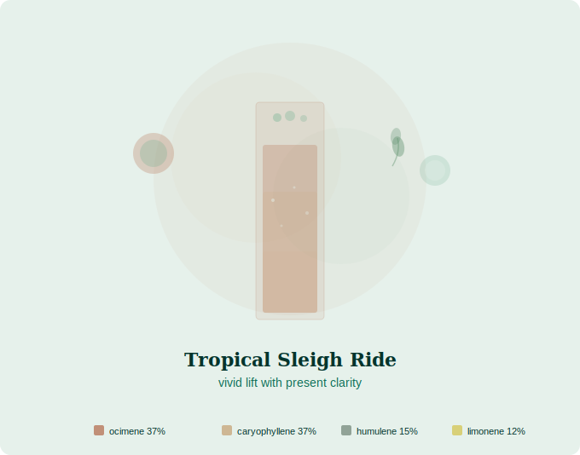
“Vivid lift with present clarity”
Energy: HIGH · Joyful, Alert, Euphoric
Aroma: Peppermint, Honeysuckle, Hint of Ginger
THC: 17.00%
Terpene Profile
Terpene | % | Ratio
β-Ocimene | 0.71% | 37%
β-Caryophyllene | 0.70% | 37%
α-Humulene | 0.28% | 15%
Limonene | 0.22% | 12%
Total Terpenes: 2.35%
Essential Oil Blend: Basil (14), Black Pepper (12), Peppermint (6), Grapefruit (4), Geranium (4)
Juice Recipe
2 oz grapefruit juice · 0.5 oz ginger juice · 8 spearmint leaves · 5 basil leaves · 0.5 oz mint tea · 0.25 oz honey · pinch black pepper · 2 oz sparkling water
1. Muddle spearmint and basil leaves gently for 3 seconds
2. Add grapefruit juice, ginger juice, mint tea, honey, and black pepper
3. Shake with ice 8 seconds, strain into highball over crushed ice
4. Top with sparkling water, garnish with mint sprig and grapefruit wheel
Terpene Map: β-Ocimene (basil, spearmint) · β-Caryophyllene (ginger, black pepper) · α-Humulene (ginger) · Limonene (grapefruit)

Purple Candy Cane
Greenshock Farms · Mendocino
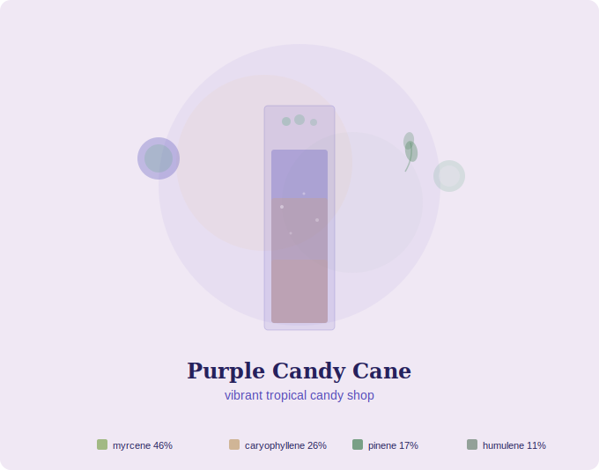
“Vibrant and vocal, fully awake”
Energy: HIGH · Energized, Invigorated, Talkative
Aroma: Mango, Peppermint Candy, Orange Blossom
THC: 22.00%
Terpene Profile
Terpene | % | Ratio
Myrcene | 0.54% | 46%
β-Caryophyllene | 0.31% | 26%
α-Pinene | 0.20% | 17%
α-Humulene | 0.13% | 11%
Total Terpenes: 1.55%
Essential Oil Blend: Lemongrass (12), Black Pepper (8), Sweet Orange (8), Pine (6), Peppermint (4), Sage (2)
Juice Recipe
1.5 cups mango chunks · 1 oz mandarin juice · 6 spearmint leaves · 1 rosemary sprig · 0.5 oz mint tea · 3 drops orange flavor · pinch cinnamon · 0.25 oz honey · 1 oz mineral water
1. Blend mango until smooth, strain through fine mesh
2. Steep rosemary in 1 oz cool water for 2 min, strain
3. Muddle spearmint. Combine mango, mandarin, rosemary water, mint tea, orange flavor, cinnamon, honey
4. Pour over crushed ice, add mineral water, garnish with mint and cinnamon dust
Terpene Map: Myrcene (mango, spearmint, rosemary) · β-Caryophyllene (cinnamon, rosemary) · α-Pinene (rosemary) · α-Humulene (cinnamon)

Carambola
Higher Heights · Mendocino
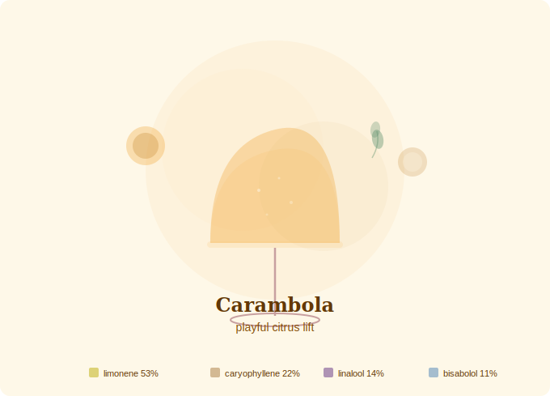
“Light and playful, effervescent energy”
Energy: HIGH · Energetic, Fun, Giggly
Aroma: Orange, Diesel, Incense
THC: 20.00%
Terpene Profile
Terpene | % | Ratio
Limonene | 0.44% | 53%
β-Caryophyllene | 0.18% | 22%
Linalool | 0.12% | 14%
α-Bisabolol | 0.09% | 11%
Total Terpenes: 1.45%
Essential Oil Blend: Sweet Orange (16), Rosemary (8), Lavender (6), German Chamomile (6), Black Pepper (4)
Juice Recipe
3 oz mandarin juice · 1 oz grapefruit juice · 0.5 oz lemon juice · 0.5 oz cardamom-honey syrup · 1 oz chamomile tea · 3 drops orange flavor · 2 drops lavender flavor · 3 lemon verbena leaves · 2 oz sparkling water
1. Make cardamom-honey syrup: crack 3-4 pods in 2 oz warm water + 1 tbsp honey, steep 5 min
2. Brew chamomile tea strong, cool completely
3. Combine mandarin, grapefruit, and lemon juices
4. Add syrup, chamomile tea, orange flavor, lavender flavor. Bruise lemon verbena and add
5. Shake with ice 8 seconds, strain over fresh ice
6. Top with sparkling water, garnish with lemon verbena
Terpene Map: Limonene (mandarin, grapefruit, lemon) · β-Caryophyllene (cardamom) · Linalool (lavender flavor) · α-Bisabolol (chamomile)

Pineapple Mojito
Higher Heights · Mendocino
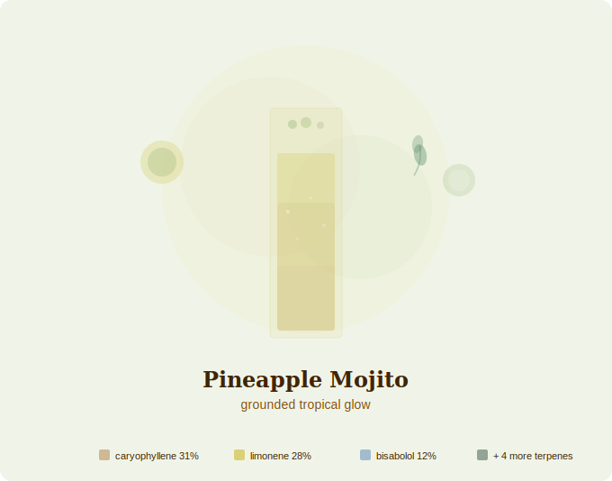
“Rooted ease with a quiet glow”
Energy: MEDIUM · Relaxed, Grounded, Euphoric
Aroma: Pineapple, Ginger, Mint, Gas
THC: 24.00% | CBG: 1% | THCv: 1% | CBC: 1%
Terpene Profile
Terpene | % | Ratio
β-Caryophyllene | 0.63% | 31%
Limonene | 0.56% | 28%
α-Bisabolol | 0.24% | 12%
α-Humulene | 0.19% | 9%
Total Terpenes: 2.55%
Essential Oil Blend: Black Pepper (12), Sweet Orange (10), German Chamomile (6), Sage (4), Lavender (4), Pine (2), Lemongrass (2)
Juice Recipe
2.5 oz pineapple juice · 0.5 oz lime juice · 0.5 oz lemon juice · 0.75 oz ginger juice · 8 spearmint leaves · 0.5 oz chamomile tea · 0.25 oz honey · 2 drops lavender flavor · 2 oz sparkling water
1. Muddle spearmint leaves gently in highball glass
2. Add lime, lemon, pineapple, and ginger juices
3. Stir in chamomile tea, honey, and lavender flavor
4. Fill with crushed ice, top with sparkling water, stir gently
5. Garnish with mint sprig and lime wheel
Terpene Map: β-Caryophyllene (ginger, mint) · Limonene (lime, lemon, pineapple) · α-Bisabolol (chamomile) · α-Humulene (ginger)

Rasta Governmint
Higher Heights · Mendocino
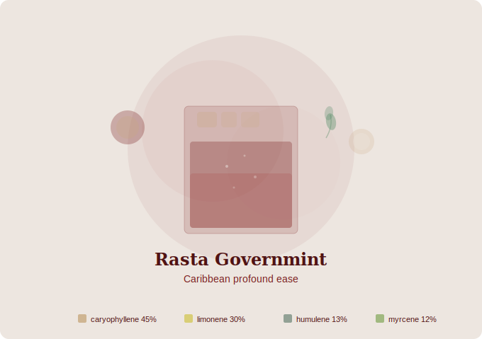
“Profound ease with cushioned edges”
Energy: LOW · Euphoric, Supremely Relaxed, Comforted
Aroma: Sour Cherry, Frankincense, Oak
THC: 19.00%
Terpene Profile
Terpene | % | Ratio
β-Caryophyllene | 0.60% | 45%
Limonene | 0.39% | 30%
α-Humulene | 0.17% | 13%
Myrcene | 0.16% | 12%
Total Terpenes: 1.92%
Essential Oil Blend: Black Pepper (14), Lemon (10), Rosemary (6), Sage (6), Geranium (4)
Juice Recipe
3 oz tart cherry juice · 0.5 oz lime juice · 0.5 oz cardamom-honey syrup · 0.25 oz vanilla extract · pinch cinnamon · pinch black pepper · 1 sage leaf · 1 rosemary sprig · 1 oz mineral water
1. Steep rosemary and sage in 1 oz warm water for 2 min, strain
2. Combine tart cherry, lime, cardamom-honey syrup, and vanilla
3. Add herb water, cinnamon, and black pepper. Stir with ice 8 seconds
4. Strain into rocks glass, add mineral water, garnish with cinnamon stick
Terpene Map: β-Caryophyllene (cinnamon, cardamom, black pepper, rosemary) · Limonene (lime, cherry) · α-Humulene (sage) · Myrcene (rosemary)

Pink Rider
Higher Heights · Mendocino
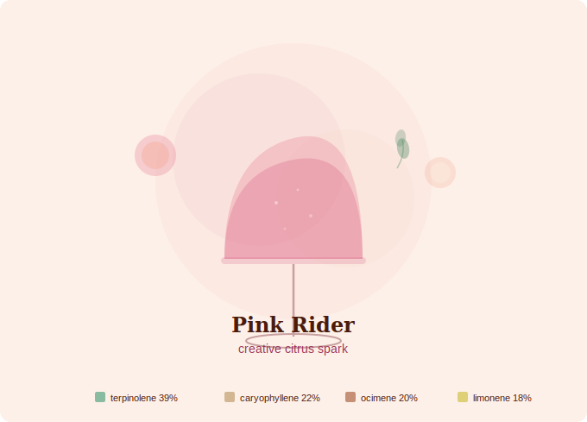
“Vivid creative lift with social magnetism”
Energy: HIGH · Motivated, Creative, Social
Aroma: Lemon Bar, Pink Grapefruit, Sugar Cookie
THC: 26.00%
Terpene Profile
Terpene | % | Ratio
Terpinolene | 0.38% | 39%
β-Caryophyllene | 0.22% | 22%
β-Ocimene | 0.20% | 20%
Limonene | 0.18% | 18%
Total Terpenes: 1.44%
Essential Oil Blend: Tea Tree (12), Black Pepper (8), Basil (8), Lemon (6), Lavender (4), Geranium (2)
Juice Recipe
2.75 oz pink grapefruit juice · 0.75 oz lemon juice · 0.75 oz green apple juice · 0.25 oz vanilla extract · 0.25 oz honey · 3 basil leaves · 1 rosemary sprig · pinch black pepper · 1.5 oz mineral water
1. Press 2-3 green apples, blend and fine-strain
2. Squeeze fresh grapefruit, combine with lemon and apple juice
3. Gently muddle basil and rosemary for 2 seconds
4. Add vanilla, honey, and black pepper. Stir with ice 8 seconds
5. Strain into glass over fresh ice, add mineral water
6. Garnish with grapefruit wheel and basil leaf
Terpene Map: Terpinolene (green apple, lemon, grapefruit) · β-Caryophyllene (black pepper, basil) · β-Ocimene (basil) · Limonene (grapefruit, lemon)

Strawberry Biscotti
Happy Day Farms · Mendocino
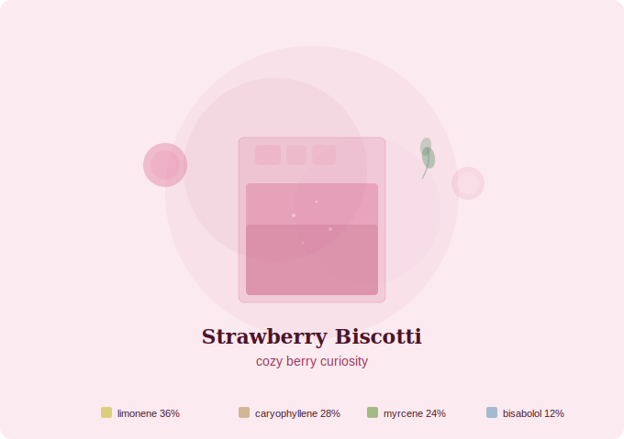
“Cozy anchor with a curious mind”
Energy: MEDIUM · Comforting, Mentally Engaging, Appetite Inducing
Aroma: Kettle Corn, Fuel, Sour Strawberry Candy
THC: 32.00% | CBG: 2%
Terpene Profile
Terpene | % | Ratio
Limonene | 0.38% | 36%
β-Caryophyllene | 0.29% | 28%
Myrcene | 0.25% | 24%
α-Bisabolol | 0.13% | 12%
Total Terpenes: 1.48%
Essential Oil Blend: Bergamot (14), Black Pepper (10), Lemongrass (8), German Chamomile (6), Clove (2)
Juice Recipe
1 cup frozen berry blend · 1 oz grapefruit juice · 0.5 oz lemon juice · 1 oz chamomile tea · 0.25 oz cinnamon-honey syrup · 0.25 oz vanilla extract · pinch black pepper · pinch cinnamon
1. Thaw berry blend slightly, blend until smooth, strain
2. Combine berry juice with grapefruit, lemon, and chamomile tea
3. Stir in cinnamon-honey syrup, vanilla, black pepper, and cinnamon
4. Pour over ice in rocks glass, garnish with berry and cinnamon dust
Terpene Map: Limonene (grapefruit, lemon, strawberry) · β-Caryophyllene (cinnamon, black pepper) · Myrcene (blueberry) · α-Bisabolol (chamomile)

Avenue of the Giants
Happy Day Farms · Mendocino
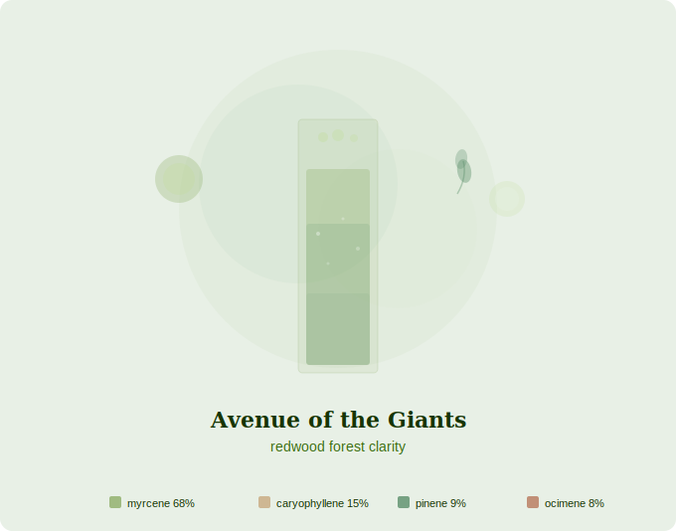
“Forward momentum with electric clarity”
Energy: HIGH · Energizing, Buzzy, Motivating
Aroma: Pine Needles, Menthol, Jasmine
THC: 22.00% | CBG: 2%
Terpene Profile
Terpene | % | Ratio
Myrcene | 1.94% | 68%
β-Caryophyllene | 0.43% | 15%
α-Pinene | 0.26% | 9%
β-Ocimene | 0.24% | 8%
Total Terpenes: 3.48%
Essential Oil Blend: Lemongrass (16), Pine (8), Black Pepper (6), Basil (4), Peppermint (4), Geranium (2)
Juice Recipe
4 lemongrass stalks · 1 oz lime juice · 0.5 oz mint tea · 2 rosemary sprigs · 5 basil leaves · 3 spearmint leaves · pinch black pepper · 0.25 oz honey · 2 oz sparkling water
1. Peel and smash lemongrass, cold press or blend, fine-strain
2. Steep rosemary in 1 oz cool water for 2 min, strain
3. Muddle basil and spearmint gently for 3 seconds
4. Add lemongrass juice, lime, mint tea, rosemary water, pepper, honey. Stir with ice
5. Strain into highball, top with sparkling water
6. Garnish with rosemary, basil, lime wheel. Drink within 30 min
Terpene Map: Myrcene (lemongrass, basil, spearmint, rosemary) · α-Pinene (rosemary, basil) · β-Ocimene (basil, spearmint) · β-Caryophyllene (black pepper)

Peach Flambé
TBD · Emerald Triangle
“Warm euphoric glow”
Energy: HIGH · Euphoric, Bright, Joyful
Aroma: Peach, Bergamot, Warm Spice
THC: 19.00%
Terpene Profile
Terpene | % | Ratio
Limonene | — | dominant
β-Caryophyllene | — | secondary
β-Ocimene | — | tertiary
α-Humulene | — | trace
Total Terpenes: 1.05%
Essential Oil Blend: TBD
Juice Recipe
1 cup frozen peach slices · 1.5 oz grapefruit juice · 0.5 oz lemon juice · 0.5 oz ginger juice · 3 basil leaves · pinch cinnamon · 0.25 oz honey · pinch black pepper · 1.5 oz sparkling water
1. Blend frozen peaches until smooth, strain
2. Press ginger. Gently muddle basil
3. Combine peach puree, grapefruit, lemon, ginger, basil, cinnamon, pepper, honey
4. Stir with ice, strain into glass, top with sparkling water
5. Garnish with basil leaf
Terpene Map: Limonene (grapefruit, lemon, peach) · β-Caryophyllene (cinnamon, ginger, black pepper) · β-Ocimene (basil) · α-Humulene (ginger)

Tropicanna Cherry
Sunrise Gardens · Mendocino
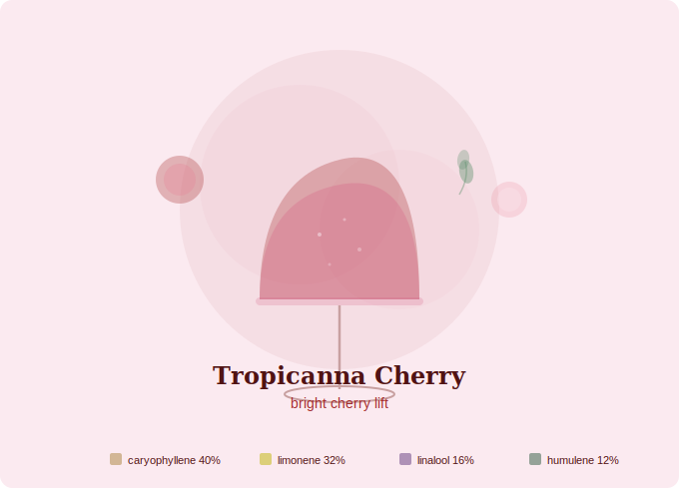
“Bright lift with clear, lively edges”
Energy: HIGH · Euphoric, Cerebral, Cheerful
Aroma: Sour Cherry, Sweet Citrus, Nutmeg
THC: 27.00%
Terpene Profile
Terpene | % | Ratio
β-Caryophyllene | 0.37% | 40%
Limonene | 0.29% | 32%
Linalool | 0.15% | 16%
α-Humulene | 0.11% | 12%
Total Terpenes: 1.18%
Essential Oil Blend: Black Pepper (12), Sweet Orange (10), Lavender (6), Geranium (6), Sage (4), Clove (2)
Juice Recipe
2.5 oz tart cherry juice · 1 oz grapefruit juice · 0.5 oz lemon juice · 3 drops lavender flavor · pinch nutmeg · 1 sage leaf · pinch black pepper · 0.25 oz honey · 1.5 oz sparkling water
1. Combine tart cherry, grapefruit, and lemon juices
2. Add lavender flavor, nutmeg, pepper, honey. Bruise sage leaf and add
3. Stir with ice 10 seconds, strain into coupe
4. Top with sparkling water, garnish with nutmeg dust
Terpene Map: β-Caryophyllene (black pepper, nutmeg, sage) · Limonene (grapefruit, lemon, cherry) · Linalool (lavender flavor) · α-Humulene (sage)

Pink Jesus Reserve
Sonoma Hills Farm · Sonoma
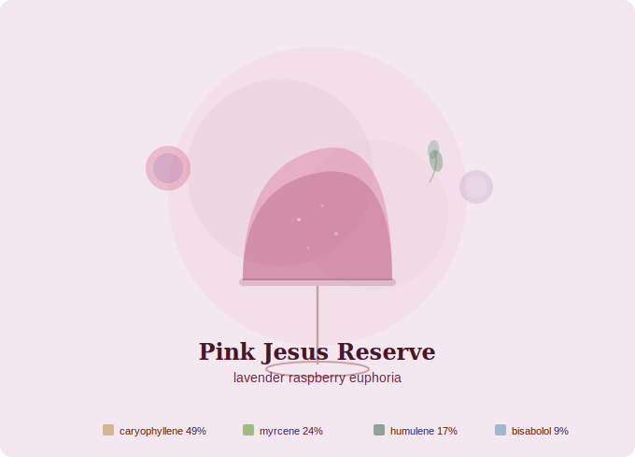
“Buoyant and warm, ready to share”
Energy: HIGH · Social, Uplifting, Euphoric
Aroma: Raspberry, French Lavender, Pineapple
THC: 23.00%
Terpene Profile
Terpene | % | Ratio
β-Caryophyllene | 0.78% | 49%
Myrcene | 0.38% | 24%
α-Humulene | 0.27% | 17%
α-Bisabolol | 0.15% | 9%
Total Terpenes: 1.89%
Essential Oil Blend: Black Pepper (14), Lemongrass (8), Lavender (6), Sage (6), German Chamomile (4), Geranium (2)
Juice Recipe
1 cup frozen raspberries · 1.5 oz pineapple juice · 0.5 oz lemon juice · 4 drops lavender flavor · 0.5 oz ginger juice · 1 sage leaf · 0.5 oz chamomile tea · 0.25 oz honey · pinch black pepper
1. Blend frozen raspberries, fine-strain to remove seeds
2. Press ginger. Gently bruise sage leaf
3. Combine raspberry puree, pineapple, lemon, ginger, chamomile tea, lavender flavor, pepper, sage, honey
4. Shake with ice 8 seconds until frothy, fine-strain into coupe
5. Garnish with raspberries
Terpene Map: β-Caryophyllene (black pepper, ginger, lavender, sage) · Myrcene (raspberry, ginger) · α-Humulene (sage, ginger) · α-Bisabolol (chamomile)

Love and Laughter
Heartrock Mountain Farm · Mendocino
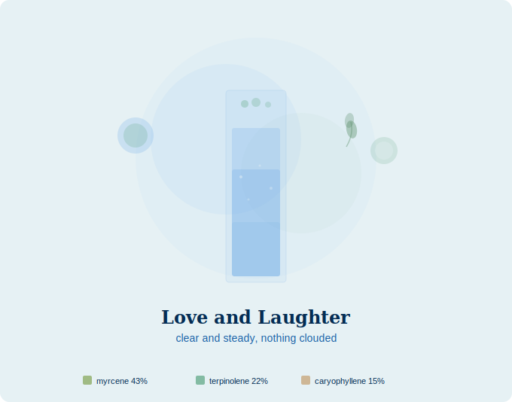
“Clear and steady, nothing clouded”
Energy: MEDIUM · Energizing, Focusing, Non-Intoxicating
Aroma: Flowers, Eucalyptus, Berries
THC: 1.00% | CBD: 19.00%
Terpene Profile
Terpene | % | Ratio
Myrcene | 0.56% | 43%
Terpinolene | 0.28% | 22%
β-Caryophyllene | 0.20% | 15%
Total Terpenes: 1.72%
Essential Oil Blend: TBD (CBD strain)
Juice Recipe
1 cup frozen berry blend · 1 oz grapefruit juice · 0.5 oz lemon juice · 1 rosemary sprig · 3 basil leaves · 0.5 oz mint tea · 2 drops lavender flavor · pinch black pepper · 0.25 oz honey · 1.5 oz sparkling water
1. Blend berry blend until smooth, strain
2. Steep rosemary in 1 oz cool water for 2 min, strain. Muddle basil
3. Combine berry juice, grapefruit, lemon, rosemary water, mint tea, basil, lavender flavor, pepper, honey
4. Stir with ice, strain into highball, top with sparkling water
5. Garnish with basil leaf and berries
Terpene Map: Myrcene (berries, basil, rosemary) · Terpinolene (grapefruit, lemon) · β-Caryophyllene (black pepper, rosemary)

Glitter Bomb
Sol Spirit Farm · Trinity
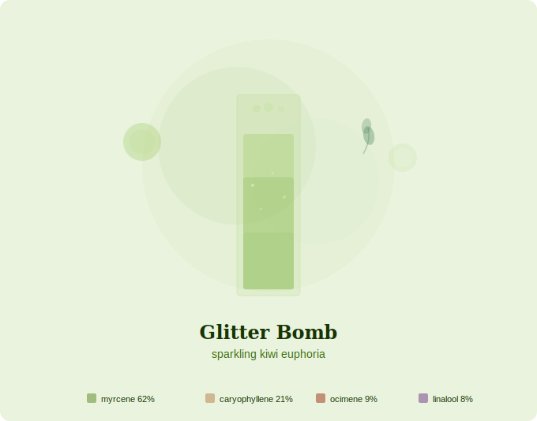
“Body at ease, mind sparkling”
Energy: HIGH · Physically Relaxing, Cerebral, Euphoric
Aroma: Kiwi, Pine, Musk
THC: 26.00%
Terpene Profile
Terpene | % | Ratio
Myrcene | 1.23% | 62%
β-Caryophyllene | 0.42% | 21%
β-Ocimene | 0.17% | 9%
Linalool | 0.15% | 8%
Total Terpenes: 2.39%
Essential Oil Blend: Lemongrass (18), Black Pepper (10), Basil (4), Lavender (4), Pine (4)
Juice Recipe
3 fresh kiwis · 1 rosemary sprig · 4 basil leaves · 2 drops lavender flavor · pinch black pepper · 0.25 oz honey · 0.5 oz lime juice · 2 oz sparkling water
1. Peel and blend kiwis, strain through fine mesh
2. Steep rosemary in 1 oz cool water for 2 min, strain
3. Muddle basil. Add kiwi juice, rosemary water, lime, lavender flavor, pepper, honey
4. Stir with ice, strain into highball over crushed ice
5. Top with sparkling water, garnish with kiwi wheel and basil
Terpene Map: Myrcene (kiwi, basil, rosemary) · β-Caryophyllene (black pepper, rosemary) · β-Ocimene (basil) · Linalool (lavender flavor)

Moonlight
Moon Gazer Farms · Mendocino
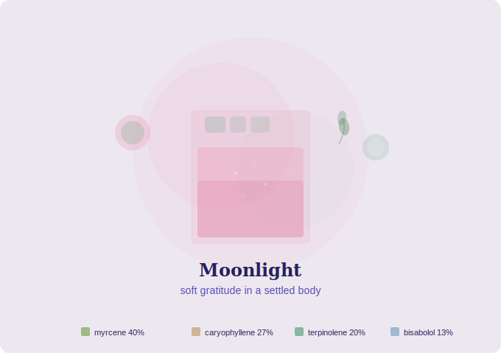
“Soft gratitude in a settled body”
Energy: LOW · Physically Relaxed, Calm, Grateful
Aroma: Watermelon Candy, Citrus Zest, Earl Grey
THC: 26.00%
Terpene Profile
Terpene | % | Ratio
Myrcene | 0.74% | 40%
β-Caryophyllene | 0.51% | 27%
Terpinolene | 0.38% | 20%
α-Bisabolol | 0.24% | 13%
Total Terpenes: 2.67%
Essential Oil Blend: Lemongrass (12), Black Pepper (10), Tea Tree (8), German Chamomile (6), Bergamot (4)
Juice Recipe
3 oz watermelon juice · 1 oz Earl Grey tea · 0.5 oz lemon juice · 0.5 oz chamomile tea · pinch cinnamon · pinch black pepper · 0.25 oz honey · 1 oz mineral water
1. Blend 2 cups cubed watermelon, strain. Brew Earl Grey double-strength, cool
2. Combine watermelon juice, Earl Grey, lemon, and chamomile tea
3. Stir in cinnamon, black pepper, and honey
4. Pour over ice, add mineral water, garnish with watermelon wedge
Terpene Map: Myrcene (watermelon, chamomile) · β-Caryophyllene (cinnamon, black pepper) · Terpinolene (Earl Grey, lemon) · α-Bisabolol (chamomile)

Mandarin Cherry Tree
Sticky Fields · Mendocino
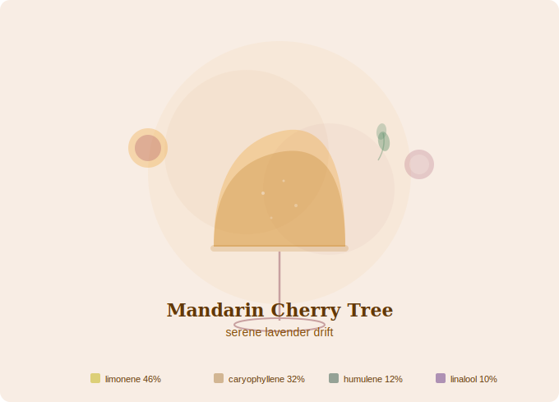
“Settled body, gently wandering mind”
Energy: LOW · Full Body Relaxation, Serenity, Creativity
Aroma: Mandarin Orange, Sandalwood, Lavender
THC: 28.00%
Terpene Profile
Terpene | % | Ratio
Limonene | 0.52% | 46%
β-Caryophyllene | 0.36% | 32%
α-Humulene | 0.13% | 12%
Linalool | 0.11% | 10%
Total Terpenes: 1.75%
Essential Oil Blend: Sweet Orange (16), Black Pepper (10), Lavender (6), Sage (4), Ylang Ylang (4)
Juice Recipe
3 oz mandarin juice · 1 oz tart cherry juice · 0.5 oz lemon juice · 3 drops lavender flavor · pinch black pepper · 1 sage leaf · 0.25 oz honey · 1 oz mineral water
1. Combine mandarin, tart cherry, and lemon juices
2. Bruise sage leaf. Add to juice with lavender flavor, pepper, and honey
3. Pour over ice, add mineral water, garnish with sage leaf
Terpene Map: Limonene (mandarin, lemon, cherry) · β-Caryophyllene (black pepper, lavender) · α-Humulene (sage) · Linalool (lavender flavor)

Pinnacle
Dos Rios Farms · Mendocino
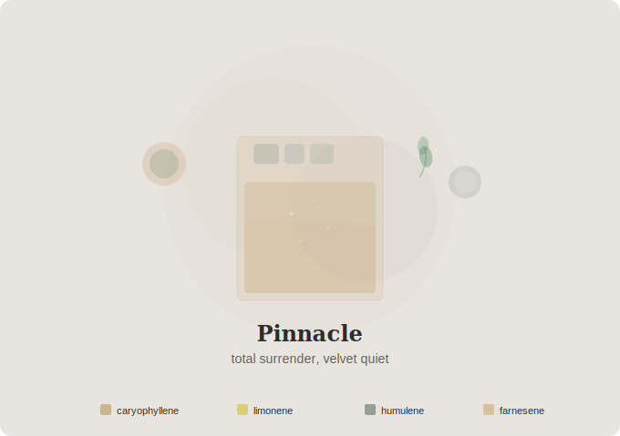
“Total surrender, velvet quiet”
Energy: LOW · Blissful, Sedated, Content
Aroma: Sweet Cream, Nutmeg, Earth
THC: 20.00%
Terpene Profile
Terpene | % | Ratio
β-Caryophyllene | — | dominant
Limonene | — | secondary
α-Humulene | — | tertiary
trans-β-Farnesene | — | trace
Total Terpenes: TBD
Essential Oil Blend: Black Pepper, Rosemary, Sweet Orange, Sage, Ylang Ylang
Juice Recipe
2 oz mandarin juice · 1 oz tart cherry juice · 0.5 oz lemon juice · 1 rosemary sprig · 1 sage leaf · pinch nutmeg · pinch black pepper · 0.25 oz vanilla extract · 0.25 oz honey · 1 oz mineral water
1. Steep rosemary and sage in 1 oz warm water for 3 min, strain
2. Combine mandarin, tart cherry, and lemon juices
3. Add herb water, nutmeg, pepper, vanilla, and honey
4. Pour over large ice in rocks glass, add mineral water, garnish with nutmeg dust
Terpene Map: β-Caryophyllene (black pepper, rosemary, nutmeg) · Limonene (mandarin, lemon, cherry) · α-Humulene (sage, nutmeg) · Farnesene (vanilla + nutmeg)

Blueberry Muffin
TBD · Emerald Triangle
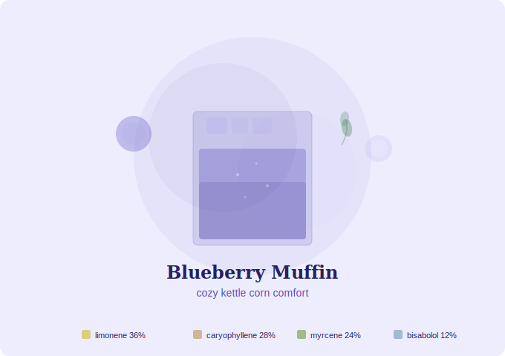
“Cozy comfort with warm blanket energy”
Energy: LOW · Comforting, Cozy, Warm
Aroma: Blueberry, Vanilla, Cinnamon
THC: N/A
Terpene Profile
Terpene | % | Ratio
Limonene | ~0.38% | ~36%
β-Caryophyllene | ~0.29% | ~28%
Myrcene | ~0.25% | ~24%
α-Bisabolol | ~0.13% | ~12%
Total Terpenes: TBD
Essential Oil Blend: TBD
Juice Recipe
1 cup frozen blueberries · 1 oz grapefruit juice · 0.5 oz lemon juice · 1 oz chamomile tea · 0.25 oz cinnamon-honey syrup · 0.25 oz vanilla extract · pinch black pepper · 1 oz mineral water
1. Thaw blueberries slightly, blend until smooth, strain
2. Combine blueberry juice with grapefruit, lemon, and chamomile tea
3. Stir in cinnamon-honey syrup, vanilla, and black pepper
4. Pour over ice, add mineral water, garnish with blueberries and cinnamon dust
Terpene Map: Limonene (grapefruit, lemon) · β-Caryophyllene (cinnamon, black pepper) · Myrcene (blueberry) · α-Bisabolol (chamomile)

Lemon Papaya Banana
TBD · Emerald Triangle
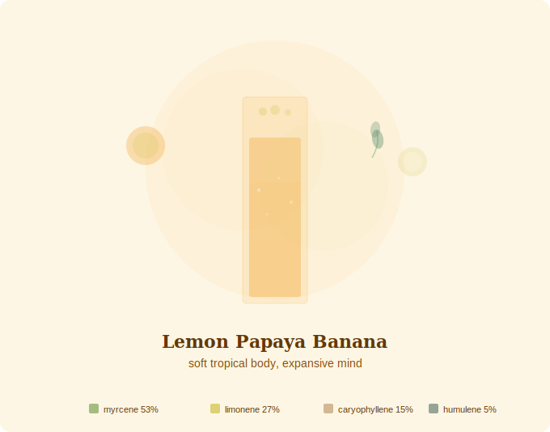
“Soft tropical body, expansive mind”
Energy: LOW · Physically Relaxed, Spacey, Euphoric
Aroma: Papaya, Honeydew Melon, Lemon Zest
THC: 27.00%
Terpene Profile
Terpene | % | Ratio
Myrcene | 0.57% | 53%
Limonene | 0.29% | 27%
β-Caryophyllene | 0.16% | 15%
α-Humulene | 0.05% | 5%
Total Terpenes: 1.38%
Essential Oil Blend: Lemongrass (14), Lemon (10), Black Pepper (6), Geranium (6), Ylang Ylang (4)
Juice Recipe
1 cup fresh papaya · 0.75 cup frozen banana slices · 0.75 oz lemon juice · 0.5 oz green apple juice · 0.25 oz vanilla extract · pinch cinnamon · 0.25 oz honey · 1 oz mineral water
1. Blend papaya and frozen banana until smooth
2. Press green apple for juice
3. Combine puree with lemon, apple juice, vanilla, cinnamon, and honey
4. Add mineral water, stir gently
5. Pour over crushed ice, garnish with banana wheel and cinnamon dust
Terpene Map: Myrcene (papaya, banana) · Limonene (lemon, papaya, green apple) · β-Caryophyllene (cinnamon)

